TRADITIONAL CATHOLIC HOLY COMMUNION FOR EVERY SOUL

#34
in the Traditional Catholic
Mystical Wedding Theology for Every Soul Series

© Joseph Karl Publishing
Traditional Catholic Detroit, Michigan U.S.A.

CONTENTS

PART I
THE FIRST STATION OF THE CROSS
JESUS IS CONDEMNED TO DEATH

1. December 14, 2019: Advent 2019 and the Start of “Part II”
2. The Three Infants in the Dream Overnight
3. Pacified: What the Three Infants in the Dream Overnight Had in Common
4. A Visit to the Allopathic Doctor in the Dream Overnight
5. The Beast Inside the Building and the Knock at the Door

PART II
THE SECOND STATION OF THE CROSS
JESUS ACCEPTS HIS CROSS

6. The Fine Group of Young Men and the Beautiful Red Apples
7. The Incredible Trip on the Very Large Ship
8. The Triune Building in the Dream Overnight
9. The Three Identical Babies in the Dream Overnight
10. History and the Two Possible Outcomes when Searching for Truth
11. Christ's "Perfect" Bride

PART III
THE THIRD STATION OF THE CROSS
JESUS FALLS THE FIRST TIME

12. The Fisherman's Arrival and the Perpetual Sacred Host
13. The Work of Reparation to the Holy Face of Jesus' Seat inside I AM's Heavenly Court
14. The Modernist Marriage and the Traditional Wedding to the Divine Bridegroom of Every Soul
15. Christ's Sacred Passion within His Sacred Passion and the Mount Calvary on Mount Calvary
16. The Wardrobe, the Little Boy, and the Trip Into the Future
17. The Two Banquets, the Artist, and the Stadium Full of People
18. That Front Porch

PART IV
THE FOURTH STATION OF THE CROSS
JESUS MEETS HIS MOTHER

19. The Sudden Presentation of a Ring Overnight
20. The New Baby on the Way in the Dream Overnight and His Crib
21. Social Distancing Expert
22. Divine Union, Delivery Theology for Every Soul, and the Needle
23. PROTECTRESS
24. So Many Orphans!
25. Jesus Christ All Over the Floor, the Two Kinds of Women, and the Two Kinds of Men
26. The Miraculous Multiplication of the Bread and the Fisherman

PART V
THE FIFTH STATION OF THE CROSS
SIMON THE CYRENE HELPS JESUS CARRY THE CROSS

27. The Imposter
28. Out of the Beast System 2020
29. Out of the Beast System 2020, Part 2
30. Corona-ed
31. The Divine Supernatural Consecration of Mankind's Future on Mount Calvary

PART VI
THE SIXTH STATION OF THE CROSS
VERONICA WIPES THE HOLY FACE OF JESUS

32. Another Newborn Baby Overnight
33. Christocentric Apostolic Marian
34. I AM Draws Traditional Catholic Institute of Christ the King Sovereign Priest into His Apostolic Mission
35. God's Divine Wrath and the Modern Allopathic Medical Agents of Darkness
36. Heaven's Inner Circle
37. The Incredible Skyscraper in Church
38. The Flowers for My Mother in the Dream Overnight

PART VII
THE SEVENTH STATION OF THE CROSS
JESUS FALLS A SECOND TIME

39. "I Can't Breathe"
40. Earth's Sewer and Our Heavenly Host
41. The Tiny House in the Dream Overnight
42. Investiture of the Brown Scapular, In Latin and in English
43. A Sacred Conversation with Perfection and the Voice Heard in Heaven
44. Another Encounter with a Certain Pastor in the Dream Overnight and the Two Kneelers
45. "Tell Him that You Have Sold Your Soul to Jesus"
46. The Two Rabbits Inside the High Rise Building in the Dream Overnight

PART VIII
THE EIGHTH STATION OF THE CROSS
JESUS MEETS THE WOMEN OF JERUSALEM

47. The Catholic Priests' Descendants and the Crosses inside Sacred Heart Church, ICKSP, in Limerick, Ireland
48. Two Days Later, I AM Divinely Weds His Work of Reparation to the Holy Face of Jesus a Second Time, to Traditional Catholic Institute of Christ the King Sovereign Priest, on the Feast of the Nativity of Saint John the Baptist
49. A Living Will of Eternal Value
50. Into the Jaws of Hell and a Visit from the Devil
51. The Very First Dream I Remember
52. The Divine Royal Wedding Under Water in the Dream Overnight
53. More Water Inside Another Church in the Dream Overnight

PART IX
THE NINTH STATION OF THE CROSS
JESUS FALLS A THIRD TIME

54. July 12, 2020: Another Encounter with a Traitor in the Dream Overnight
55. The Incredible Explosion, the Line of Fire, the Voice of Almighty God, and Catholic Detroit's Family of Reparation's Procession
56. Half a Suit of Armor
57. The Dilapidated Structure in the Dream Overnight and the Search for Something for the Treasonous Priest
58. Ownership of the Sacred Heart of Jesus
59. The Criminal and the Candle

PART X
THE TENTH STATION OF THE CROSS
JESUS IS STRIPPED OF HIS GARMENTS

60. “IAN” (God is Gracious)
61. The Incredible Dream a Few Nights Back
62. An Encounter with Myself in the Dream Overnight
63. Pruning
64. The Church Bell in the Morning
65. The Incredible Tower in the Dream Overnight

PART XI
THE ELEVENTH STATION OF THE CROSS
JESUS IS NAILED TO THE CROSS

66. "Look After My Mama"
67. A Trip to the Past, Present, and Future in the Dream Overnight
68. Our Lady’s Black Eye
69. The Handful of People Inside the Small Room in the Dream Overnight
70. "Supply Them with Holy Water"
71. The Incredible Prayer in the Dream Overnight

PART XII
THE TWELVTH STATION OF THE CROSS
JESUS DIES UPON THE CROSS

72. I AM's Omega Trident of Gold in the Dream Overnight
73. The Incredible Little Restaurant in the Dream Overnight
74. Requiescet in Pace, Brandy Vaughan
75. Lucifer Appears Overnight as Saint (Padre) Pio
76. On Having Given Up One's Blood as I AM Willed, Twice, as One with Christ
77. The Priest Giving Out Holy Communion in the Dream Overnight
78. The Journey from the Traditional Catholic Church through the Roadblock
Rubble at an Intersection
79. The Arrogant Man Doing the Speaking in the Front and the Silent Child Sent by God in the Back

PART XIII
THE THIRTEENTH STATION OF THE CROSS
THE SACRED BODY OF JESUS IS TAKEN DOWN FROM THE CROSS

80. That Look on Saint Jacinta Marto's Face and what it Means
81. The Two Adopted Boys in the Dream Overnight
82. The Little Boy in Church in the Dream Overnight
83. Divine Wisdom Comes from the Unsuspected Quarters
84. God's Means and the Two Pathways to Eternity
85. The Divine King Seated at the Right Hand of His Father in Heaven
86. The Encounter with a Traditional Catholic Priest, the Angel of Death, and Jesus Christ Our Divine Supernatural Remedy for All

CONCLUSION
PART XIV
THE FOURTEENTH STATION OF THE CROSS
JESUS IS PLACED INTO THE TOMB

87. The Incredible Traditional Catholic Church and Its People in the Palm Sunday
2021 Dream Overnight

PART I

THE FIRST STATION OF THE CROSS

JESUS IS CONDEMNED TO DEATH

1. December 14, 2019: Advent 2019 and the Start of “Part II”

2. The Three Infants in the Dream Overnight

3. Pacified: What the Three Infants in the Dream Overnight Had in Common

4. A Visit to the Allopathic Doctor in the Dream Overnight

5. The Beast Inside the Building and the Knock at the Door

1. ADVENT 2019 AND THE START OF "PART TWO"
Very rare is the individual who is willing to accomplish God's will while having to part with some money. The farther one is from God, the less one is willing to "lose" in order to win. Imaginer.
Once again, as was the case last year in 2018, God's plans suddenly and dramatically unfold during the busiest time of the year (also ironically the same time - hopefully - mankind properly celebrates His first Christmas Coming by first properly preparing interiorly through Advent).

The labor for this one is extreme. Something very wonderful must be coming. It was recently pre-announced inside a small Blessed Sacrament Chapel with a title, as "Phase II" from here in Traditional Catholic Detroit.
The brutally penitential Phase I took place during The Great Seven Year War for Souls at the Slovak parish in Catholic Detroit (2010 - 2017) where in 2012 I AM re-introduced His Work of Reparation to the Holy Face of Jesus in Modern Times, through Christ's Traditional Catholic Sacred Priesthood, for the sake of the whole world.
What wonders. +
We must not think "Lord, how much is this going to cost me?" but rather proclaim with total confidence in His Almighty goodness, "Show me Your will, O Lord."
I AM asks the most, for the sake of all others, from those who have very little.
In our Triune God we totally trust through the Maternal intercession of the Immaculate Mother of God, "The Virgin of the Globe," and the paternal intercession of holy husband and father Saint Joseph.

2. THE THREE INFANTS IN THE DREAM OVERNIGHT
Such wonders.
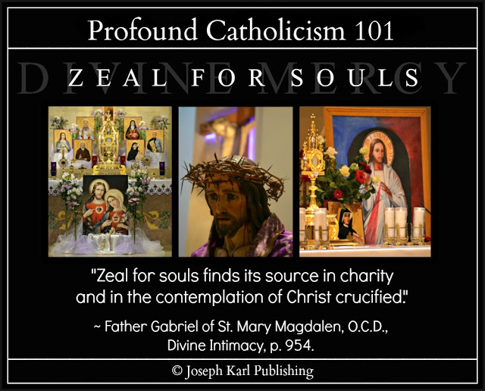

THE DREAM OVERNIGHT ON FRIDAY, JANUARY 31, 2020
In the dream overnight, you were presented with three newborn infants and saw them at a bit of a distance as if they were at the far end of a room.

You were to care for them with your own body, meaning breastfeed them as a mother would feed her baby, in imitation of and in union with how Jesus Christ feeds us with His own Sacred Body and Precious Blood in the Blessed Sacrament, the greatest Source of Almighty God's Divine Supernatural Grace we have on earth.
True love spends itself, as Almighty God wills for each one, guided by the Holy Spirit, and in imitation of and in union with Christ.
This dream has to do with I AM's Work of Reparation to the Holy Face of Jesus in Modern Times.
WHAT DOES IT MEAN?
The three infants represent each facet of I AM's Triune Therapy which He has recently presented to us inside the local tiny Blessed Sacrament Chapel.
THE THREE INFANTS WERE NOT EQUAL IN THE DREAM
They were manifested to this student teacher therapist here in Southeast Michigan, in Traditional Catholic Detroit, in a row, side by side. The infant on the right was far more in need than the other two.
Immediately you wanted to help the child and provide the child with what the child needed.
WHAT THE THREE INFANTS ALL HAD IN COMMON
All three had been pacified meaning all three had pacifiers placed in their mouths (to keep them quiet, not to care for them properly).
The one on the right was suffering particularly badly because of it.
"Trust all things to Jesus in the Blessed Sacrament and to Mary, Help of Christians, and you will see what miracles are." ~ Saint John Bosco

3. PACIFIED: WHAT THE THREE INFANTS

IN THE DREAM OVERNIGHT ALL HAD IN COMMON

It is another true story here in Traditional Catholic Detroit. +
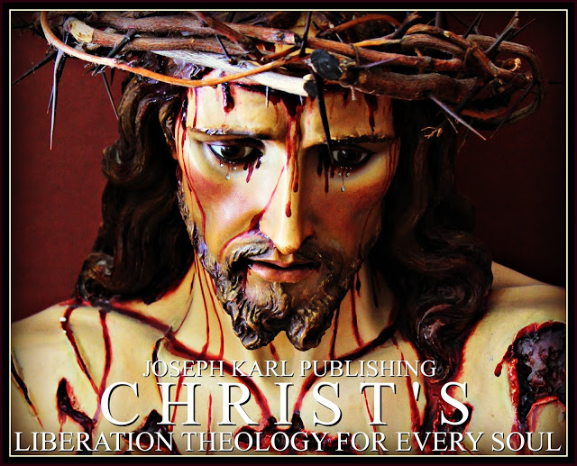

WHAT THE THREE INFANTS IN THE DREAM OVERNIGHT ALL HAD IN COMMON
All three of them had been PACIFIED, they were PACIFIED instead of being properly fed and cared for IN THE MANNER IN WHICH GOD INTENDED.
The infant on the right was suffering particularly badly because of it.
Imaginer.
THE BABIES ARE A METAPHOR FOR THE CATASTROPHIC LACK OF PROPER CARE FOR EACH PERSON'S BODY, MIND, AND SOUL IN OUR TIME
True story.
What happened?
Pride, self interest, zeal for power, and a love for money which is the root of all evil.
OUR DIVINELY PROVIDED REMEDY
I AM's Work of Reparation to the Holy Face of Jesus, meaning making reparation to Almighty God as He wills for each one, guided by the Holy Spirit, and in imitation of and in union with Christ, teams up with His triune devotion to provide triune therapy for all thanks be to our Triune God.
Go, Team.

4. A VISIT TO THE LLOPATHIC DOCTOR

IN THE DREAM OVERNIGHT

Allopathic medicine refers to modern medical interventions disguised as health care for the sick and suffering that maximize profits through the liberal, unethical, and scandalous administering of harmful substances (drugs) and/or unnecessary surgery while excluding risk factors, a proper diet (real food as medicine), regular spinal adjustments by ethical chiropractors, true caring, and the proper assessing of, proper addressing, and proper treatment of the root cause of disease with purity of intention and devoid of self interest.
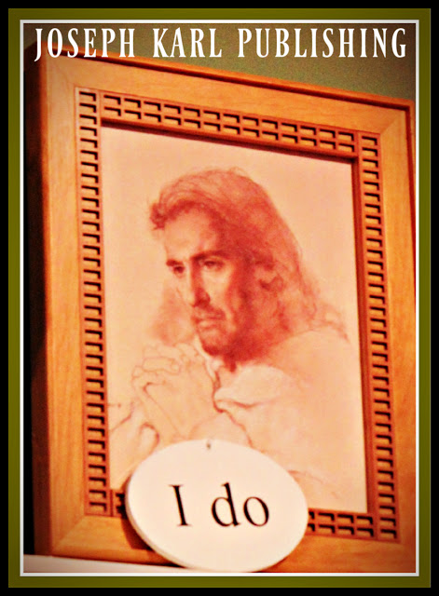

THE DREAM OVERNIGHT ON A FIRST SATURDAY OF REPARATIVE ATONEMENT: FEBRUARY 1, 2020
In the dream overnight you found yourself in the allopathic medical system and being assessed by a modern medical doctor, a faithless man with dark hair.
The allopathic doctor succinctly and unemotionally declared your condition to be terminal and advised you to put your affairs in order quickly to be ready, for death is coming.
He matter-of-factly declared that there is no hope for you. No hope for you among the Godless.
NO GOD, NO HOPE

You were so happy to receive this news from him and were so at peace, so eager, and so ready to leave this life and join our Lord forever, in eternity.
The news in the dream overnight seemed so real, and it sure has felt as though death was occurring while making brutal reparation overnight and in the early morning for Christ's Sacred Priesthood as needed in Modern Times (note they are Christ our High Priest's Physicians of the Soul).
When you woke up it seemed at first as if that was the case meaning all was now said and done.
It is finished!
A P O S T O L I C M I S S I O N I N M O D E R N T I M E S
However, it is the forces of darkness who want this student teacher triune therapist's life (and all lives for that matter) to end but more so than that, they want to stop I AM's Apostolic Mission in Modern Times from here in Traditional Catholic Detroit through His Work of Reparation to the Holy Face of Jesus for the sake of the whole world in our time.
No body, mind, or soul left behind!
The biomagnetic pair therapy works wonders - all naturally, simply, and cost effectively - and it has been working wonders on this eager patient in such incredible need of proper medical physical care.
In God we totally trust!
I totally trust in the Triune One - Who began this good work - to see it through as He wills.
I'm all His. +
5. THE BEAST INSIDE THE BUILDING AND THE KNOCK AT THE DOOR

There were more dreams overnight while on special assignment here in Traditional Catholic Detroit, for the sake of the whole world in our time. "Lord what wilt Thou have me do? Behold the true sign of a totally perfect soul: when one has reached the point of giving up his will so completely that he no longer seeks , expects or desires to do ought but that which God wills." ~ Saint Bernard
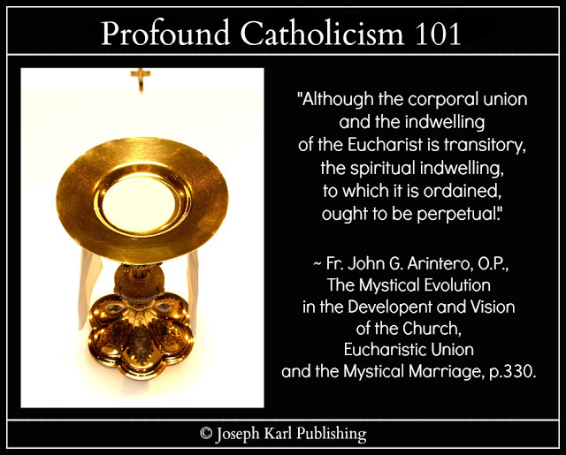

THE FINAL DREAM OVERNIGHT ON TUESDAY, FEBRUARY 4, 2020
While making priceless reparation overnight, there were a series of dreams that were very mysterious and then there was this final one.
THE SETTING
You found yourself inside a building that appeared unfamiliar.

The building was spacious and looked like a school with its hallways and classrooms with wooden doors.
However, the room you found yourself in appeared also like something else, but not in the natural.
The room, which was classroom size, appeared to your spiritual vision like the inside of a church.
It was rather bare, there wasn't much furniture inside it, and there weren't many people inside it, either.
Most of its furnishings and its people were gone.
Nevertheless, there were still people inside this building.
"Even if Catholics faithful to Tradition are reduced to a handful, they are the ones who are the true Church of Jesus Christ." ~ Saint Athanasius
THE BUILDING REPRESENTS CHRIST'S CATHOLIC CHURCH IN OUR TIME
Imaginer.
THE PRESENCE OF THE BEAST
"The goal of all our undertakings should be not so much a task perfectly completed as the accomplishment of the will of God." ~ Saint Therese of the Child Jesus and the Holy Face
There was a terrible beast within this building.
It was as tall as a man but had more mass and it was far more powerful.
Alone, people were powerless against it.
Its head was large and protruded in the front quite a bit to contain a massive jaw that had huge, razor sharp teeth.
This building not only had a beast within it meaning the beast was there to destroy it from within, but at the same time the building contained it meaning it existed not only to stop the beast but to defeat it.
WHAT THE BEAST WAS DOING
The beast was a powerful monster and it was moving through the building killing one person after another and in the worst possible way.
This beast was unfathomably violent and without conscience.
This enemy of God and of man was moving about the building devouring people, and now it was right outside the door of the room you and a few others were in.
WHAT THE BEAST SOUNDED LIKE
The beast repeatedly led out some sort of roar, a sound unlike anything you had ever heard before.
It was ghastly, frightening to the core, and reflected the damage that the beast was not only capable of but the damage it was actually inflicting within.

WHAT YOU FOUND YOURSELF DOING IN THE DREAM WHILE SIMULTANEOUSLY MAKING REPARATION FOR CHRIST'S SACRED PRIESTHOOD AS NEEDED IN MODERN TIMES
You found yourself moving about this classroom not only as if it had all of its original furniture but also as if it was a Traditionally furnished Catholic Church.
Over and over you followed the same path, walking from the back of the room to the middle, then up the small center isle, and then you knelt front and center in the teaching area before the chalkboard at Christ's High Altar.
The kneeler was not there, the High Altar was not there, but Christ's Traditional Catholic Church was there in the supernatural.
Each time walking was very difficult because your body hurt everywhere, particularly your knees, so filled with arthritis and with inflammation.
Kneeling was the most difficult of all, as was returning to the standing position.
Yet all was peaceful and so wondrous.
Something about this continuous journey around the classroom/church to the front, in the same manner one approaches the High Altar during the Holy Sacrifice of the Mass to receive Holy Communion, was also particularly extraordinary as you followed along as in so many past dreams with such incredible awe and with wonder: sometimes you found yourself taking shortcuts meaning cutting corners while approaching the altar and while taking leave of it.
The few people in the room were watching and you thought to yourself, "I should not be doing that (cutting corners) as it is setting a bad example."
Yet the process continued as the beast moved about the building devouring people, and as it drew closer and claimed ever more victims just outside the door to this room.
WHAT THE PEOPLE WERE DOING TO PROTECT THEMSELVES FROM BEING DEVOURED BY THE BEAST
Absolutely nothing.
While walking by the back of the room, right by the door connecting it to the corridor, and while continuing to make these very important rounds back and forth around the remaining classroom seats and desks, to the altar that was not there in the natural, you encountered a person standing right by the solid wooden entryway door as the beast bellowed just on the other side of it.
The beast was right outside the door and it wanted to get in, yet the person before you did nothing to
protect himself; instead he stood motionless, paralyzed by fear.
This had happened outside the room also; the beast was so frightening the people did nothing to help themselves, completely overcome by fear. These things and the features of the beast were made known to your spiritual vision.
They were paralyzed with fear as the beast continued to move about the area, devouring people.
WHAT WAS HAPPENING IN THE NATURAL
The reparative atonement for Christ's Sacred Priesthood as needed in Modern Times was so severe that you would not have been able to get up and walk to the kitchen to get a cup of coffee.
True story.
THE BEAST TRIES WITH ALL OF ITS MIGHT TO FORCE OPEN THE DOOR TO THE CLASSROOM CHURCH
As it did so, the door transformed into a set of two doors that appeared reinforced with chains and a lock.
The powerful monster used such force that the doors could be seen bowing forward from its blows.
The doors were not made of wood.
Each door represented something.
One door represented the Real Presence of Jesus in the Blessed Sacrament, and the other represented the Immaculate Mother of God, the Virgin of the Globe, protecting Christ's Catholic Church and God's people.
"God wills only our good; God loves us more than anybody else can or does love us. His will is that no one should lose his soul, that everyone should save and sanctify his soul: “Not willing that any should perish, but that all should return to penance”. “This is the will of God, your sanctification.” God has made the attainment of our happiness, His glory. Even chastisements come to us, not to crush us but to make us mend our ways and save our souls." ~ Saint Alphonsus de Ligouri
THE KNOCK AT THE DOOR
All of a sudden the dream ended with a succinct knock at a door that was not seen in the room in the
natural but was visible in the supernatural.
This door which was missing from the room (stripped away by the Modernist Beast) was made of wood and had a square pane of glass in it.
It was Jesus Christ knocking at the door.
Our Divine Redeemer, Divine Restorer, Divine Remedy for All, Divine Teacher, and the Divine Bridegroom of Every Soul is here to help us and He will, if we listen to Him and if we do what He says.
"Be not afraid."
ARM YOURSELF WITH THE HUMILITY OF JESUS CHRIST IN THE BLESSED SACRAMENT
The Blessed Sacrament is the Compendium of All Miracles (Saint Thomas) and the Greatest Source of Almighty God's Divine Supernatural Grace we have on earth.
"Perfection is founded entirely on the love of God: ‘Charity is the bond of perfection;’ and perfect love of God means the complete union of our will with God’s." ~ Saint Alphonsus de Ligouri
WHAT DOOR WAS IT?
Sacramental "Confession is more powerful than an exorcism." ~ Father Gabriele Amorth
It was the door leading to the confessional.
"Trust all things to Jesus in the Blessed Sacrament and to Mary, Help of Christians, and you will see what miracles are." ~ Saint John Bosco

PART II

THE SECOND STATION OF THE CROSS

JESUS ACCEPTS HIS CROSS

6. The Fine Group of Young Men and the Beautiful Red Apples

7. The Incredible Trip on the Very Large Ship

8. The Triune Building in the Dream Overnight

9. The Three Identical Babies in the Dream Overnight

10. History and the Two Possible Outcomes when Searching for Truth

11. Christ's "Perfect" Bride

6. THE FINE GROUP OF YOUNG MEN

AND THE BEAUTIFUL RED APPLES

That was an important part of the dream overnight. "Trust all things to Jesus in the Blessed Sacrament and to Mary, Help of Christians, and you will see what miracles are." ~ Saint John Bosco
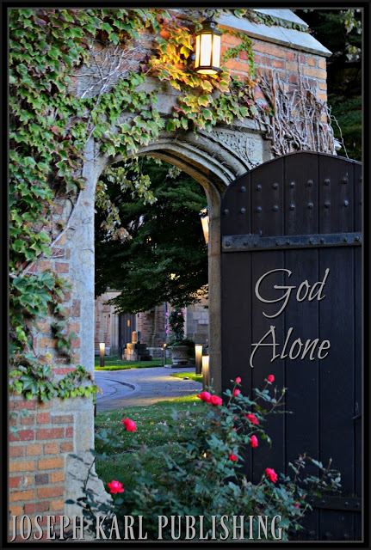

THE DREAM OVERNIGHT ON WEDNESDAY, FEBRUARY 5, 2020

The dream was long and filled with many wonders but the part that remains within this student teacher triune therapist's recent memory has to do with a group of young men entrusted into your family's care in a place that appeared unfamiliar.
They were led onto the property and through the door leading to a building that appeared to be like some sort of home but more public.
The young men were enthusiastic, so happy, energetic, and eager to be here.
You suddenly found yourself with a big bowl of beautiful red apples.
You were to give the apples to the men, as the exquisite fruit was for them.
But someone repeatedly argued against it, not understanding the Apostolic Mission.
Several times you insisted that the beautiful red apples were for the young men and tried to bestow the beautiful fruit upon them.

7. THE INCREDIBLE TRIP ON THE VERY LARGE SHIP
The dream overnight was so spectacular and so wondrous that the most amazing parts of it cannot even be put into words. There just aren't any to describe the locations and what was manifested there.
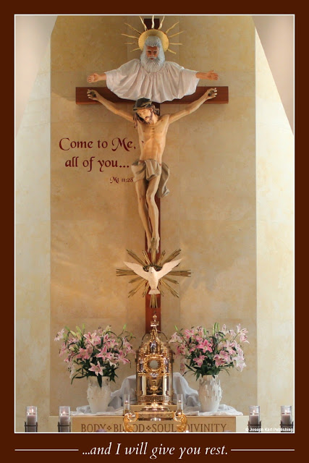

THE EXTRAORDINARY DREAM OVERNIGHT ON FRIDAY, FEBRUARY 7, 2020 FOLLOWING TWO DAYS OF SEVERELY PENITENTIAL REPARATION

You found yourself among several adults who are closest to you, discussing a cruise on a large ship that is taking place.
A group of people you know but whom you do not recognize, meaning they are familiar to you and yet unfamiliar, are going. They are more like acquaintances, not people who are closest to you like family and dearest friends.
It seems that they are people you work with, and yet you work alone for God directly.

You don't want to go because you don't feel up to it physically, to take a trip on a cruise ship for two weeks, and yet you find yourself gathering things together to go while telling yourself over and over that you don't feel up to going.
You gather some clothing in a suitcase but see that there isn't much in it, and the clothing that is there is not suitable for the trip. You don't have in the suitcase what you need.
So many things were manifested and you kept telling yourself you should let someone know that you aren't going. Yet you are going.
You find yourself interacting with other people in this dream: some you know very well, some who seem unfamiliar and yet familiar, and others you had never seen before and do not know.
The time for departure on the ship is drawing near.
At least not everyone on the ship will be strangers; there will be some people who are familiar and yet unfamiliar that you apparently work with. You find yourself eager to have and to be in their company on the ship during this trip.
WHILE AT THE PIER
After it seems days have passed and while being convinced that you are indeed going on the cruise, while preparing for it meaning gathering your clothing and making sure the house is in order before taking leave of it, and after other things happen which you can't remember and while still at home in your late sister's company, you find yourself taking leave of those you know well because they are not going on this ship for this cruise of two weeks.
Your mother has a change of heart there at the dock and, as her feelings of love and compassion for her daughter supercedes her dislike for and resistance to God's will - which have caused such unfathomable grief all your life - she asks if you have all the clothes that you need and then provides you with some money.
You open your small rectangular shaped rolling suitcase to display your trip's garments to assure her, and instead of finding the main compartment having insufficient clothes as before, you find yourself unzipping a smaller compartment underneath the front cover and it is filled with all that you need.
Everything, you note, except for one thing.
This one thing that is missing refers to the recurring theme of some dreams of the past which had to do with the ongoing search for a certain garment.
A formal outfit.
WHAT IS MISSING FROM THE SMALL SUITCASE
A proper dress for formal occasions aboard the ship during the cruise you are going on is missing.
BOARDING THE SHIP AND LEAVING BEHIND EVERYONE YOU KNOW WELL, WITH SUFFICIENT CLOTHING, AND WITH SOME MONEY, BUT WITHOUT PROPER FORMAL ATTIRE
That's what happened.
WHAT HAPPENED NEXT
You find yourself on board the ship and it is going full steam ahead on the water.
You find yourself on the deck of the ship, in the back on the right side of it behind a protective railing looking out with incredible awe and with wonder at the water.
Many large ships are passing by the ship you are on, headed for port.
These ships are all unique and appear unlike anything you have ever seen before.
As you marvel at the sight of the beautiful expanse of water and the sight of the many spectacular ships, you look into the air on the left and see THREE FLYING SHIPS THE LIKES OF WHICH YOU HAVE NEVER SEEN BEFORE.
They appear the same although their sizes differed. One flying ship led, one was in the middle, and one came last. They were in a line.
The final flying ship was noticeably smaller than the others but all three were big.
The three extraordinary flying ships represent the Most Holy Trinity.
You resign yourself to the fact that you are going on this trip once on the deck of the ship and while taking in the extraordinary sights.
You also resign yourself to enjoying it, for you already are.
You even think to yourself, "It will be good for you."

Note, it isn't that you don't want to go per se, but that you don't think you have the physical stamina for this two week trip on board the ship. Also, you don't want to be away from your work in the Lord's service.
But going on the two week cruise on this ship is God's will, and He wants to show you some things while on it.
WHAT TOOK PLACE AFTER HAVING LEFT YOUR FAMILY AT THE DOCK/PIER AND WHILE APPROACHING THE ENTRANCE TO THE SHIP
Just before boarding you encountered and addressed your concerns to a kind woman who appeared unfamiliar.
She works for the owner of the ship and listened intently to your legitimate concerns.
Perhaps she was the Immaculate Mother of God, the Virgin of the Globe.
You found yourself telling her that YOU HAD GONE ON A CRUISE ON YOUR HONEYMOON (more than 30 years ago) and then, reassured, left her to board the ship.
While walking down a corridor to approach the ship you thought to yourself, "We didn't go on a cruise on our honeymoon. We went on a cruise five years later."
All of a sudden, you passed your husband who fell in love with money and subsequently entered into an adulterous civil union with a woman at work the day after the divorce he wanted was granted.
He was headed in the opposite direction, away from the ship and absolutely did not want to get on it.
Too self interested.
No words were exchanged between the two of you at the start of Cruise Number 2.
It was made known while passing him that he had become "just like his father."
WHAT HAPPENED WHILE ON THE SHIP
Initially you didn't want to get on the ship either but for different reasons than the disobedient and self interested man.
You didn't think you had the physical stamina and didn't want to be away from the Lord's work.
However, ultimately it was God's will that you be on that ship taking that cruise for two weeks; thanks be to God you trusted in Him and did as He wanted.
So prior to boarding the ship you thought that it would be like the one you had been on with your husband 26 years ago following a whole lot of schooling and just before starting a family. God subsequently blessed your sacramental union and also this Apostolic Mission in Modern Times with three very wonderful children who are now grown. They were Catholic Detroit's Children of Reparation in Modern Times.
That vacation adventure in the past was a budget cruise not a party ship, and most of the people on it were senior citizens. You were about 28 years old and your husband was 27; how much you enjoyed talking with the wise older people encountered at various times including during afternoon tea, while relaxing on the deck of the ship as it made its way through the expanse of water to its various destinations, and being all dressed up for the formal dinners with your husband who was a young allopathic medical doctor.
That was before the internet. Imaginer.
THAT FIRST CRUISE CAME FOLLOWED "THE STORM OF THE CENTURY" UP THE EASTERN SEABOARD OF THE UNITED STATES
True story.
There were astounding dinners in the formal dining room, and two highly educated and young soon-to-be parents marveled after years of being students in school and on a budget studying for so many degrees that we could order and eat as much as we wanted.
The food just kept coming; the special buffets on deck were absolutely phenomenal, the presentation of the food spread out on seemingly endless long tables was exquisite.
The international staff was so hard working and so caring, and during one dinner as we smiled with delight they gathered at our table for two and sang to us "Happy 'versary to you!"
When we ate our first dinner on the ship we by mistake ordered two entrees each. When all the food was delivered to us without anyone on the wait staff even flinching, we realized that we had ordered that much food for ourselves while thinking two of the meals were appetizers.
We apologized over and over for having ordered that much food for ourselves.
The future, it seemed, held so much promise for us.
A FUTURE WITHOUT GOD HOLDS NO PROMISE FOR ANYONE
The cruise and the ship in the dream last night were very different and yet they were the same from the cruise and the ship in the past.
THE PLACES YOU WENT AND THE THINGS THAT YOU SAW
You were taking to the most incredible places on board that ship last night.
They cannot even be described.
The scenery was unfathomable and you encountered other people (strangers) along the way.
The various places were wondrous; all was very peaceful and incredibly mysterious.
One thing that is quite noteworthy is that no one wanted to come with you.
Along the way through such wondrous places you at times called out to people who were unfamiliar to you and yet familiar, eagerly seeking their company, but no one responded.
One young man with blonde hair and a backpack who was traveling alone even ran on ahead, way off into the distance.
NO ONE WANTED TO COME WITH YOU
There were two things about that that.
One, those willing to accomplish God's will as He wills it are very few in number.
Two, there are things I AM wanted to show you alone.
THE SHIP IN THE DREAM OVERNIGHT REPRESENTS CHRIST'S TRADITIONAL CATHOLIC RELIGIOUS CONGREGATION THAT IS TO OVERSEE I AM'S WORK OF REPARATION TO THE HOLY FACE OF JESUS IN MODERN TIMES, FOR THE SAKE OF THE WHOLE WORLD
True story. +

8. THE TRIUNE BUILDING IN THE DREAM OVERNIGHT
Show us Your will, O Lord. "By My Holy Face you will work wonders, appease the anger of God, and draw down mercy on sinners." ~ Jesus to Sr. Mary of St. Peter +
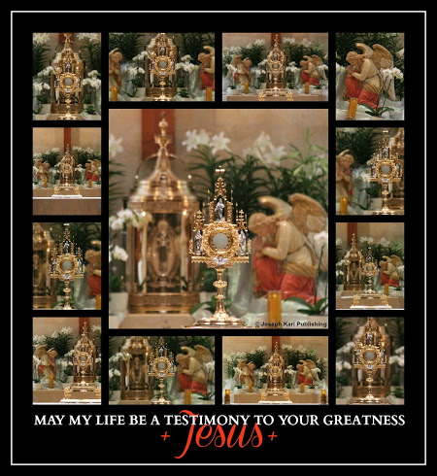
THE TRIUNE BUILDING IN THE DREAM OVERNIGHT ON MONDAY, FEBRUARY 10, 2020
I found myself inside a building that appeared like some sort of care center.

Many different things happened, and people were being both cared for in this building as in people who were sick, while in another room children came to celebrate a birthday and then two young ladies came to help at the party.
Somehow I worked inside this building and yet I seemed like an outsider within it.
Then I encountered a woman who worked there, and she began showing me how to cook while wondering why I had not been shown this already.
I followed the woman who seemed in charge as she went back and forth between two rooms joined outside their doors by a hallway that ran through the place, never answering or addressing me as she began and continued cooking very intently, and as I kept asking her while wondering, "When am I going to learn how to feed all these people?"
The things she was using to cook were incredibly small which was a wonder since it was made known to you that there were many people who needed to be fed here. Next to the food preparation area there was a huge dining room but it was empty.
I marveled at her use of an incredibly tiny round pan with a handle that only had room for one or two eggs. She was ferociously cooking using that tiny pan over an electric stove top with only one burner and the flames shot out of that thing very high, even for such a small pan. That is how the dream ended.
During the dream I also encountered my late father inside this place, in a separate room that was across the hall from where the children's birthday party was being held and also next to the place where the inadequate food preparation was taking place on the same side of the building.
His name is Joseph and he brought his young family to Detroit from the Archdiocese of Boston, imaginer, just a few years before his first massive heart attack which almost claimed his life at the age of 39. He did not live to see I AM re-introduce His Work of Reparation to the Holy Face of Jesus in Modern Times in 2012 at the parish of His choosing, His Divine Supernatural Remedy for what plagues us and which has been plagued with little interest from within Christ's Catholic Church.
A second massive heart attack while at work in 1982 began his journey into eternity which took place early the next morning.
Isn't life a continuous preparation for what comes next.
In the dream overnight my father was very ill and was laying in a bed; it appeared he was in a private room inside an assisted living facility and yet the room at the same time appeared like my parents bedroom where he spent a year recovering with my mother's fine care (which is why he lived as long as he did) following his first massive heart attack.
Keep in mind he was 46 when he died and was quite sick during his adult life, yet he went to work every day at a job he disliked in order to support his young family. He always took us to church and insisted that we dress appropriately as my parents watched the Catholic Church continue to be ravaged and disfigured by the beast that I AM had allowed in to do battle.
Interestingly, he never mentioned the Traditional Tridentine Holy Sacrifice of the Mass which he grew up with and by that time was mostly no longer available to the masses, forced out of God's House from within by the Modernists working for Lucifer the father of half truths and of lies.
I went to my dad with great tenderness and affection during the dream, as a worker in that place who just did not fit in meaning it seemed like no one working within it wanted me there.
With tremendous compassion for him I found myself having the power to suggest that he not go to work any more and instead remain here and rest. Then he agreed and from him a great weight was lifted. Then I told him that I loved him and hugged him.
The dream is another metaphor and the triune building is both church and classroom, and also a properly caring health care facility.
You represent I AM's Work of Reparation to the Holy Face of Jesus in our time, and the woman running the place represents Modernism, which by design doesn't work.

9. THE THREE IDENTICAL BABIES

IN THE DREAM OVERNIGHT

Such wonders. +
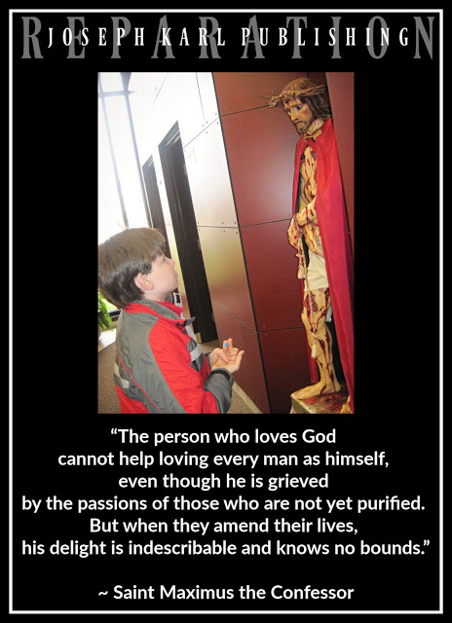

THE DREAM OVERNIGHT ON TUESDAY, FEBRUARY 11, 2020
In the dream overnight you find that you have had triplets.
The babies are identical, and yet each one is a unique individual.
Imaginer.
A RETURN TO THE TRADITIONAL TRIDENTINE HOLY SACRIFICE OF THE MASS AT EIGHT O'CLOCK IN THE MORNING
True story.

10. HISTORY AND THE TWO POSSIBLE OUTCOMES

WHEN SEARCHING FOR TRUTH

We either search for God's Truth or we search for our own. Only one leads to heaven, through Jesus Christ our Divine Redeemer, Divine Restorer, Divine Remedy for All, Divine Teacher, Divine King of Reparation, and the Divine Bridegroom of every soul.
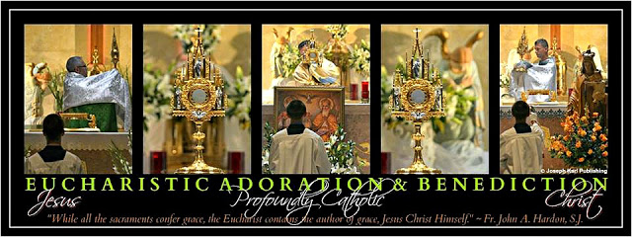
REGARDING THE STUDY OF PREVIOUS CULTURES, THEIR MIGHTY STRUCTURES, AND THEIR FREE ENERGY
If there was no religion honoring our One Triune God, no one should want to have lived then and there.
There can be no peace and harmony among people without God, His truth, and His moral order. God is love, and without Him there isn't any. Excluding Him leads to arrogance, and self interest.
Perhaps the quest for material, comfortable, and structural magnificence at the exclusion of God, for without Him we can do nothing, led to the demise of the previous culture(s).
We were not created to build palaces to and for ourselves or for any one else during this life. We were created to know, love, and serve God and with great purpose. Without God we have nothing and have much to fear, for we leave ourselves defenseless in His absence.
Beware of agendas that seek to eradicate the supernatural, because it is very real and it includes not only God but also the forces of darkness that seek the eternal ruin of every precious, priceless, and immortal soul.
THE POWER OF THE PILGRIM TONGUE
Early learners, a great place to start learning correctly, to properly feed not only the mind but the soul, is with the archives of Servant of God, Father John A. Hardon, S.J.: click here.
That is also a great source of proper education for every Catholic, at every level of proper faith development.
Beware of the traps in the information age (inside and outside of places of worship) that focus on self as the god, personal development without God, quick fixes and empty promises, people claiming to know it all and to have all the answers (particularly arrogant anti-Catholic fools who know nothing about Catholicism), a focus on acquiring ever more material things, a dislike for the Immaculate Mother of God and for making reparation (rejecting the unfathomable and eternal value of suffering and thereby losing any of its merits while clinging to the lie that one never has to atone for one's sins because because Jesus suffered and died on the Cross for them all, again not the proper teaching of doctrine and instead focusing on self as not having to take personal responsibility for one's actions), double speak, people pleasers, the celebrity culture, well funded media, best sellers, and a love for money which is the root of all evil.
LET NO PILGRIM TONGUE ON EARTH BE SILENT
BUT BE SURE TO SPEAK GOD'S TRUTH,
NOT WITH THE FORKED TONGUE OF THE SERPENT
FATHER OF HALF TRUTHS, LIES,
AND THE SOUL'S ETERNAL DEMISE

GOD'S PEOPLE SPEND THEMSELVES
AS HE WILLS FOR EACH ONE,
MEANING FOR EACH ONE THAT CHOOSES GOD ALONE
AS SOVEREIGN OF HIS OR HER BODY, MIND, AND SOUL,
IN IMITATION OF AND IN UNION WITH CHRIST
FOR THE GREATER HONOR OF OUR TRIUNE GOD FIRST AND FOREMOST
AND THEN FOR THE SAKE OF THE WHOLE WORLD
MEANING NOT LIMITED TO TIME AND PLACE
(INCLUDING ONE'S OWN POOR SOUL).

11. CHRIST’S "PERFECT" BRIDE
What a spectacular Traditional Tridentine Holy Sacrifice of the Mass that was this Monday morning. This very beautiful Catholic Mystical Theology Lesson for every soul will be posted in pieces when not fulfilling obligations to the world of financially compensated labor. Oorah! +
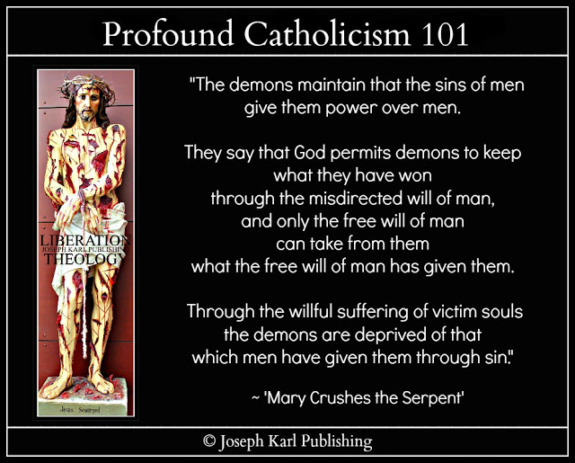

THE EARLY MONDAY MORNING SPIRITUAL COMBAT
Following five months of making very intense and severely penitential reparation, this student teacher is way out of shape after not being able to get much exercise.
This is important to know because it set the stage for a magnificently beautiful Traditional Catholic Mystical Theology lesson for every soul.
The forces of darkness call you ugly all morning as you dress for church, viciously targeting this latest development because of course they have no mercy.
Sore losers.
In the church bathroom, while putting on a veil, they are told by this student teacher: "YOU are the ones who are really ugly."
True story.
THE TRADITIONAL TRIDENTINE HOLY SACRIFICE OF THE MASS ON MONDAY, FEBRUARY 17, 2020 AND WITH VERY SORE KNEES
It was very BEAUTIFUL, BEAUTIFUL, BEAUTIFUL, BEAUTIFUL.
I AM'S WORK OF REPARATION TO THE HOLY FACE OF JESUS AND CHRIST OUR MODEL TO FOLLOW
Our Lord takes up today's lesson during the Holy Sacrifice of the Mass, during the offering to I AM of the disfigured Holy Face of Jesus suffering for our sake during His Sacred Passion.
SEE HOW CHRIST LOOKS FOR OUR SAKE, CHRIST THE DIVINE BRIDEGROOM OF EVERY SOUL, DISFIGURED AND THEN NAILED TO THE CROSS TO REDEEM US ALL.
CHRIST'S "PERFECT" BRIDE
Christ's "perfect" bride resembles Him meaning submits herself or himself (remember, this is Traditional Catholic Mystical Theology for every soul and Christ is the Divine Bridegroom of every soul) without counting the personal cost, come what may, as Almighty God wills for each one.
AND THEN CAME THE CONSECRATION
What wonders.
AND THEN CAME HOLY COMMUNION
Imaginer.
BUT FIRST: THE TWO BLESSED CANDLES ON CHRIST'S HIGH ALTAR DURING EACH SOUL'S WEDDING TO CHRIST THE LAMB OF GOD WHO TAKES AWAY THE SINS OF THE WORLD
Still working...
WHAT HAPPENED DURING THE ROYAL WEDDING OF EACH SOUL TO CHRIST OUR DIVINE REDEEMER, RESTORER, REMEDY FOR ALL, AND DIVINE BRIDEGROOM OF EVERY SOUL: THE TWO CANDLES AND CHRIST'S SACRED HEART
Still working...ran out of time and could not finish this lesson.

PART III

THE THIRD STATION OF THE CROSS

JESUS FALLS THE FIRST TIME

12. The Fisherman's Arrival and the Perpetual Sacred Host

13. The Work of Reparation to the Holy Face of Jesus' Seat inside I AM's Heavenly Court

14. The Modernist Marriage and the Traditional Wedding to the Divine Bridegroom of Every Soul

15. Christ's Sacred Passion within His Sacred Passion and the Mount Calvary on Mount Calvary

16. The Wardrobe, the Little Boy, and the Trip Into the Future

17. The Two Banquets, the Artist, and the Stadium Full of People

18. That Front Porch

12. THE FISHERMAN’S ARRIVAL

AND THE PERPETUAL SACRED HOST

There were more dreams overnight and then there was this one, and it took place inside a church that looked unfamiliar and yet familiar. Guess what happened. Just guess. "Entrust yourself entirely to God. He is a Father and a most loving Father at that, who would rather let heaven and earth collapse than abandon anyone who trusted in him." ~ Saint Paul of the Cross
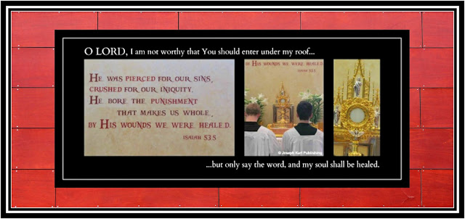

THE DREAM OVERNIGHT ON SATURDAY, FEBRUARY 22, 2020 (02.22.2020)
What a wonder that was.
FINDING YOURSELF INSIDE A PLACE THAT APPEARS UNFAMILIAR AND YET FAMILIAR
Overnight you found yourself inside a church, and it appeared unfamiliar and yet familiar.
Although it appeared unfamiliar and to be in a place that appeared unfamiliar, it also seemed a lot like the modernist desecrated church that was closest to your family home, known as 183, which was given up in 2019 for Christ's Sacred Priesthood as needed in Modern Times, for the sake of the whole world.
Your children grew up on that house and your immediate family lived there during the Great Seven Year War for souls at the Slovak parish (2010 - 2017) in Catholic Detroit where in 2012 I AM had re-introduced His Work of Reparation to the Holy Face of Jesus, through Christ's Traditional Catholic Sacred Priesthood, for the sake of a world in very serious trouble.
The modernist desecrated church close to the house was just minutes away and it was there that this student teacher would go to pray, just before picking the children up from school, right by the Blessed Sacrament that had been dislocated off the diabolically inverted altar and to the left, between the altar and the first row of pews.
At that time the severely penitential reparative atonement began and the quiet and solitude were so welcome.
"The Cross is the way to Paradise, but only when it is borne willingly." ~ Saint Paul of the Cross
THE CELEBRATION OF "THE HOLY SACRIFICE OF THE MASS" AT THE MODERNIST CIRCUS
"God sends such purgations to you, directors of consciences, that you may acquire the science of the saints and the art of directing souls. You will suffer also in another way. Love will be your executioner. Let it do its work; it knows how. In this martyrdom we have need of extraordinary grace and strength; but God will bestow it. Without this divine help it would be impossible to bear up." ~ Saint Paul of the Cross
After having been thrown out of the Slovak parish for the first time by the confused Traditional leaning pastor, this student teacher went to Holy Mass at St. Anastasia's while in exile from Modernist - Traditional Catholic Detroit and hated it there. It was a total modernist abomination.
The desecrations meaning insults to God our lavishly loving Creator and Sovereign Authority were everywhere inside His own House.
A year or two later, after having returned at I AM's wishes to the Slovak parish which by this time was in full blown civil war (the Modernist Luciferians versus the Traditional Catholics serving God alone), this student teacher very reluctantly went back to St. A's for a short while longer meaning to attend morning daily Holy Mass after having been thrown out of the Slovak parish on two other occasions by four priests as a two others stood by and watched.
Once again this student teacher hated it there and the abominations against God were so numerous it boggles the mind. However, there was no desire to ever return to the Slovak parish which God allowed to fall into the hands of the enemy, and there was now hope on the horizon for this student teacher had learned about a small Traditional Catholic Church that wasn't too far away and was asking I AM to allow her to go there.
Within a few unfathomably sorrowful, tearful, and penitential months of attending the morning circus abomination at the Catholic Church closest to the family home, I AM said yes and this Apostolic Mission moved to Saint Joseph's.
"Let us throw ourselves into the ocean of His goodness, where every failing will be canceled and anxiety turned into love." ~ Saint Paul of the Cross
THE CELEBRANT
It seemed as if the celebrant in the dream overnight was the same one from the modernist abomination parish, an emasculated priest not looking for trouble meaning not willing to accomplish God's will (let other people including one's brother priests suffer instead) and as a result he was not serving God, either.
What a mess.
The Modernist Mass is, by design, a circus celebration of self interest and a diabolical inversion of Christ's Holy Sacrifice of the Mass at His High Altar on Mount Calvary.
Many people including Christ's shepherds are stuck inside it and GOD IS THE ONLY ONE WHO CAN FIX IT.
God is the only one who can fix it because the changes that led to it were diabolically supernatural in origin.
ONLY OUR DIVINE CREATOR AND SOVEREIGN AUTHORITY has the power to defeat the supernatural forces of darkness that have ravaged Christ's Catholic Church from within in Modern Times.
He does so on Mount Calvary, through Christ crucified for our sake, with the maternal intercession of the Immaculate Mother of God, the Virgin of the Globe.
"Be very careful to retain peace of heart, because Satan casts his lines in troubled waters." ~ Saint Paul of the Cross
Almighty God gave us His Work of Reparation to the Holy Face of Jesus as a means to this end but none of His shepherds whom He has asked here in Catholic Detroit have done anything to promote His Work, which spends itself in imitation of and in union with Christ as Almighty God wills for each one, and which thanks be to God does not require any fundraising.
Instead, the fundraisers continue unabated.
One part of the dream overnight addressed that.
"My children all we are is what we are in the eyes of God, and nothing more." ~ Saint John Vianney
Anyone can do anything that is good - even repeatedly celebrate the Holy Sacrifice of the Mass correctly - and convince one's self that one is complacent, but if one is not accomplishing God's will as He wills it then that one is going AGAINST GOD'S WILL.
Meanwhile, Christ's obedient and sacrificially loving shepherds pay dearly meaning personally, and continue to be threatened, humiliated, ostracized, and even removed from their positions by arrogant clerical-clad, money-loving superiors working for Lucifer from within.
All throughout the history of Christ's Catholic Church, the proper imitation of Him has been
personally very costly.
Jesus Christ never hosted a fundraiser. He spend Himself as Almighty God willed and while trusting in God our Father unconditionally. That included following God our Creator's perfect timeline which at times means that one has to wait for God to provide.
"Heaven is rich enough to reward you." ~ Saint John Vianney
THE CIRCUS PERFORMANCE AT THE ALTAR IN THE DREAM OVERNIGHT: MAKE NO MISTAKE THIS EVIL CORRUPTION EXISTS WORLDWIDE
Lucifer studies God's plans very closely, then plans and implements his strategies to destroy them.
"No prayer is ever lost." ~ Saint John Vianney
When it came time for the celebrant/circus show host in the dream to provide a homily, he stepped aside and the desecrated/inverted altar was replaced with circus equipment of the acrobatic type.
Young people filled the stage and began performing acrobatic feats, to the enjoyment of all except you.
"Place your hopes in the mercy of God and the merits of our Redeemer. Say often, looking at the crucifix: 'There are centered all my hopes.'" ~ Saint Paul of the Cross
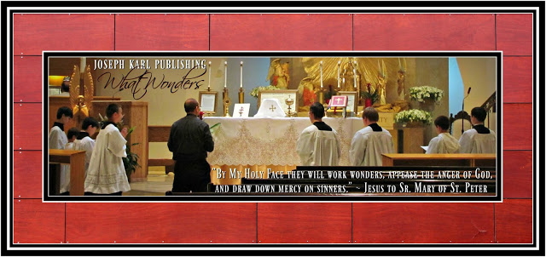
KNEELING ON THE HARD GROUND TO MAKE REPARATION FOR THE WORLDWIDE MODERNIST ABOMINATIONS AND EPIDEMIC MORAL EROSION OF CONSCIENCE
"It is better to be a child of God than king of the whole world." ~ St. Aloysius Gonzaga
Then the celebrant began speaking and you found yourself kneeling on the hard floor on your sore knees of reparation (which wasn't good either for your very sore back) to atone for the crimes against God inside what was publicly proclaimed to be His House, a Catholic Church.
Note this also took place at times while at the Slovak parish, this kneeling on the ground as the celebrant was speaking during the homily. However, it never happened when a visiting priest celebrated the Traditional Tridentine Holy Sacrifice of the Mass at that parish. It did happen as the pastor with an Apostolic Mission in Modern Times from here in Catholic Detroit tried to save his parish once the civil war erupted, by appeasing the corrupted Modernists serving Lucifer which never works.
One cannot serve both God and mammon.
"Be as eager to break your own will as the thirsty stag is to drink of the refreshing waters." ~ Saint Paul of the Cross
PARCHED: WHAT COMMUNAL HOLY COMMUNION WAS LIKE, IN THE VESTIBULE! AT THE UNCONSECRATED HANDS OF TWO WOMEN
"If you correspond to the designs of God, He will make a saint of you." ~ Saint Paul of the Cross
The next thing you knew it was time for Holy Communion and for that in the dream, the congregation had to leave the church and stand in the vestibule.
Two women were there to provide the Sacred Species of the Blessed Sacrament to people who lined up.
One woman was about to distribute the Sacred Hosts with her unconsecrated hands and the other held a gold chalice. They had replaced the Catholic priest.
The two women stood side-by-side in place of the priest, and all the people were about to receive Holy Communion, while standing, in the vestibule (outside of God's House and away from Mount Calvary)!
What an abomination!
"I tell you that victory consists in conquering self. That is the greatest enemy." ~ Saint Paul of the Cross
WHERE YOU FOUND YOURSELF DURING HOLY COMMUNION
"Let weak and frail man come here suppliantly to adore the Sacrament of Christ, not to discuss high things, or wish to penetrate difficulties, but to bow down to secret things in humble veneration, and to abandon God's mysteries to God, for Truth deceives no man - Almighty God can do all things. Amen." ~ Saint Paul of the Cross
You found yourself during Holy Communion at the very front of the line, IN FIRST PLACE.
"Here learn the science of the Saints: All is to be found in the passion of Jesus. Make every effort to remain hidden in the wounds of Jesus, and you will be enriched with every good and every true light, enabling you to fly to that Perfection which is consonant with your way of life." ~ Saint Paul of the Cross
FOR SOME REASON THERE WAS A DELAY: MODERNISTS DO WHATEVER THEY WANT
"As for me, I cannot understand how it is possible not to be always thinking of God." ~ Saint Paul of the Cross
You thought to yourself that when the time came you were going to receive as much of Christ's Precious Blood as you could, so eager to receive our Lord in this manner (note during the Traditional Tridentine Holy Sacrifice of the Mass the congregation receives the Sacred Host and not Christ's Precious Blood).
Holy Communion was about to get started but for some reason there was a delay.
The women who were about to distribute the Blessed Sacrament left their places in front of the people who had gathered in the vestibule to receive our Lord's Real Presence in both Sacred Species.
It was as if they knew of your pure intentions and as a result, and because they were there to adore themselves, they left with our Lord.
"Make great account of your precious trials, both interior and exterior; it is thus that the garden of Jesus is adorned with flowers, that is, with acts of virtue." ~ Saint Paul of the Cross
WHAT HAPPENED AFTER THE TWO WOMEN LEFT THEIR PLACES BEFORE THE PEOPLE, TAKING BOTH SACRED SPECIES WITH THEM: THE PRESENCE OF A PERPETUAL SACRED HOST
That is what happened. True story.
You continued to stand at the front of the line, with the vestibule crowded with the congregation who had gathered there after the circus performance to receive Holy Communion.
You find yourself incredibly PARCHED, so eager and so needing to receive the Real Presence of Jesus in the Blessed Sacrament.
Then you noticed that there was something in your mouth.
So you said to yourself, "When the women return, if they see that there is food inside my mouth they won't give me Holy Communion."
So before their return, you tried with all your tongue's might to move the flat piece of food that HAS ADHERED TO THE ROOF OF YOUR MOUTH.
You try and try to move it so you can consume it and then receive Holy Communion, but IT WILL NOT LEAVE ITS PLACE.
Then it is made known to you that it is a SACRED HOST.
It is a perpetual Sacred Host.
It is the Sacred Host of the true believer, of one who loves, serves, and adores our Triune God alone.
That is how you mystically receive the Real Presence of Jesus in the Blessed Sacrament in our time.
Good thing; no priest has ever offered to bring Holy Communion to I AM's student teacher who continues to suffer as Almighty God wills in union with Christ crucified for His Sacred Priesthood as needed in Modern Times.
Not one.
Yet the fundraisers keep coming. Imaginer.
Who's your master.
Note that not every Catholic priest in Modern Times loves fundraisers; those closest to God host His will, and trust in Him to provide, instead.
Such priests are very few in number.
Go against the fundraising model and one will pay with his very life.
CATHOLIC FUNDRAISING IS THE LUCIFERIAN INVERSION OF THE TRUE CHARITY OF JESUS CHRIST
True story.
THE HIGHWAY TO HELL
Prelate financial extortion campaigns are even worse.
"Each of you knows that the foundation of our faith is charity. Without it, our religion would crumble. We will never be truly Catholic unless we conform our entire lives to the two commandments that are the essence of the Catholic faith: to love the Lord, our God, with all our strength, and to love our neighbor as ourselves." ~Blessed Pier Giorgio Frassati
REMEMBER THAT THIS IS ANOTHER TRADITIONAL CATHOLIC MYSTICAL WEDDING THEOLOGY LESSON FOR EVERY SOUL
True story.
A TRIP TO THE BATHROOM AS IN SO MANY OTHER DREAMS IN THE PAST
The women do not return to the vestibule and you find yourself leaving the area to travel down a hallway and go into a BATHROOM.
You are there to attempt to consume the Sacred Host that miraculously appeared inside your mouth and which has adhered Itself to the roof of your mouth and won't move from that position.
The bathroom is like so many in past dreams, not usual and you encounter and speak to a woman while in there.
The bathroom, which is also a modernist mess, transforms into its proper order while you are in there unified in the miraculous way with the Real Presence of Jesus in the Blessed Sacrament.
Remember, the bathrooms in so many dreams have represented both the modernist abominations of Christ's Catholic Church in Modern Times and also the Sacrament of Confession/Reconciliation.
Sacramental "Confession is more powerful than an exorcism!" ~ Father Gabriel Amorth
A RETURN TO THE VESTIBULE: EVERYONE IN THE VESTIBULE IS NOW GONE
After leaving the bathroom to return to the vestibule for Holy Communion you find that all the people are gone and Holy Communion is over.
In fact, everything is over.
Still, you return inside to search for the Blessed Sacrament inside this real mess of a church.
Truly unfathomable how anyone could defend such a place.
God's people always defend His honor instead.
A RETURN TO THE INSIDE OF THE CHURCH AND WHAT HAPPENED THERE
While following along with such awe and with wonder, you return to the inside of the church, with the Modernist circus now over, in search of the Blessed Sacrament.
To the right, toward the front, a line of some sort has formed and it leads to an area that appears like some sort of concession stand. Before it there is a small line of true believers who are approaching the Blessed Sacrament. For some reason this appears to be a Traditional Catholic Holy Communion line, and you happily get into the line but this time IN LAST PLACE.
You arrive at the place that appears like a concession stand built into the large wall to the right, and behind the counter there are two young men.
You ask them about the Blessed Sacrament and the young men tell you that they are not providing Holy Communion, they are distributing regular food.
What wonders.
So you leave the church and attempt to find your vehicle in the parking lot, but cannot find it.
THE ARRIVAL OF A MAN IN THE PARKING LOT AND WHAT HE SAID
The parking lot appears to have expanded since you parked your vehicle to enter into the church, and as a result you cannot find your vehicle.
While walking through the parking lot trying to find your vehicle, you encounter a man who has just arrived and he asks you WHERE THE WATER IS, BECAUSE HE WANTS TO GO FISHING.
You think to yourself, "There isn't any water around here."
The water, it is made known to you, is TO THE NORTH.
Then you find yourself telling the fisherman - who is Jesus, the High Priest of His Catholic Church - where to find the place he is looking for.
"The Sacred Passion of Jesus is a sea of sorrows, but it is also an ocean of love. Ask the Lord to teach you to fish in this ocean. Dive into its depths. No matter how deep you go, you will never reach the bottom." ~ Saint Paul of the Cross

13. THE WORK OF REPARATION TO THE HOLY FACE OF JESUS’

SEAT INSIDE I AM’S HEAVENLY COURT

What a visit that was to the small, hidden Blessed Sacrament Chapel close to home on the great Feast of the Holy Face of Jesus, 2020. "By My Holy Face you will work wonders, appease the anger of God, and draw down mercy on sinners." ~ Jesus to Sr. Mary of St. Peter +

FEBRUARY 25, 2020: SHROVE TUESDAY, BUT FIRST, A STORY FROM LAST SUMMER
Still working...didn’t have time to finish this part.
THIS DAY'S TRIP TO THE BLESSED SACRAMENT CHAPEL IN CATHOLIC DETROIT AND WHAT HAPPENED WHILE THERE IN THE HOLY HIDDENNESS, AND IN THE HOLY SILENCE
All of a sudden while having a conversation with Perfection and while offering I AM the Prayers of Reparation to the Holy Face of Jesus beside the Tabernacle containing the Real Presence of Jesus in the Blessed Sacrament, after having moved from the kneeler to a chair which is not hard on these sore knees, where heaven meets earth the chair you were seated on was manifested as being a chair within the Heavenly Court, inside I AM's inner circle.
Remember, this Traditional Catholic Mystical Theology Lesson for Every Soul is a metaphor and applies to each person.
In other words, how important it is for every one to know of I AM's Work of Reparation to the Holy Face of Jesus and to apply this knowledge of eternal worth to all to each one's vital, irreplaceable, indispensable, and God-given Holy Apostolate of Reparation.
Still working...did not have time to finish this part.

14. THE MODERNIST MARRIAGE AND THE TRADITIONAL WEDDING

TO THE DIVINE BRIDEGROOM OF EVERY SOUL

There was another incredible dream overnight and once again it was filled with so much awe, and with wonder.
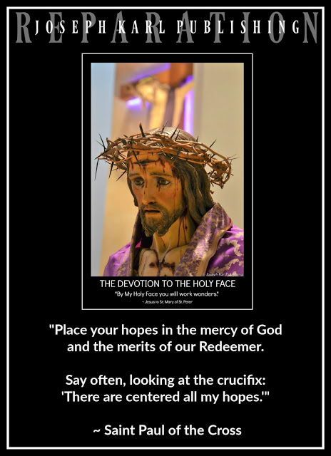

THE DREAM OVERNIGHT ON THURSDAY, FEBRUARY 27, 2020

You find yourself among people you know in a place that appears unfamiliar.

This is the scene: you are preparing to marry for a second time.
Note that this student teacher married on the Feast of Saint Philomena, August 11, 1989 during a modern Holy Mass, not having a clue of what had happened to Christ's Catholic Church in Modern Times because no one had spoken of it and also never having known of or seen the Traditional Tridentine Holy Sacrifice of the Mass because in most places it was no longer allowed.
Imaginer.
Attending daily Holy Mass was not even a consideration, nor had you ever seen a chapel veil.
Some churches no longer had kneelers or pews! They had row after row of chairs.
Christ's High Altars were gone, the churches stripped of the sacred, the altar inverted on Mount Calvary to focus attention on the priest, and on the people.
"Worship one's self and do what thou wilt inside God's House and call it progress," whispered Lucifer. "Tell everyone you are doing it 'for Him.'"
Many nuns no longer wore habits, looked a lot like men, and behaved a lot like deceivers.
Some of them even ran the Catholic schools, in place of Christ's priests! That was their goal in Lucifer's service right under God's own roof; to replace them meaning to replace the consecrated hands of Catholic priests with the unconsecrated hands of women to eradicate the Divine Holy Eucharist.
In place of love for the Holy Eucharist there was a love for acquiring ever more money, which is the root of all evil.
The Tabernacle was moved from front and center and the church was surrounded by collection baskets.
No wonder we saw during that time one marriage after another failing, by Luciferian design.
The focus shifted from God's greatest Two Commandments (love the Lord our God above all else and one's neighbor as one's self) to loving and serving one's self at all costs to everyone else.
BACK TO THE DREAM OVERNIGHT

Everyone is helping and the search is on for him, the second groom, among those you know including among some friends of the man you married.
You have not seen his friends since Lucifer convinced your husband to secretly hire a lawyer and file for a civil divorce, which was granted in 2002 when you were 37 and your three children were 3, 5, and 7.
His self interest had destroyed the marriage well before the divorce he wanted was granted.
Thanks be to God for the three wonderful children of reparation God blessed that treasonous union with.
While all the adults in the dream are helping with the arranging, including Catholics who by Luciferian design had learned nothing about the One True Faith in our time, no one wants to marry you. rofl
No wonder. True story!
DECIDING ON THE DRESS
So you find yourself with your late sister who is helping inside a room that has a closet, deciding among two white traditional wedding dresses.
Again, you find yourself following along with this narrative as in so many other dreams in the past and with such incredible awe and with wonder.
The time for the wedding is drawing near but nothing changes, except for the dress.
THE SEARCH FOR A SUITABLE GROOM AND WEDDING GARMENT
When it is time to leave for the Catholic Church you find yourself saying to yourself, "I can't wear white; this is a second marriage and it isn't appropriate."
Nor do you find the style of the traditional white wedding gown for the young bride appropriate.
The next thing you know, YOU ARE OUTFITTED IN A PURPLE GARMENT and then leave for the church.
AFTER ARRIVING AT THE CHURCH: STILL THERE IS NO GROOM BECAUSE NO ONE WANTS TO MARRY YOU
Keep in mind that not only is this a Traditional Catholic Mystical Wedding Theology Lesson for Every Soul, the dream is a metaphor for the fact that very few people are willing to accomplish the will of God as He wills it, in imitation of and in union with Christ crucified, with purity of intention and devoid of self interest and while worshiping no idols of any kind.
No one wants to be part of Christ's mission that spends itself as Almighty God wills because people are so self interested. They have, by Luciferian design, been conditioned in our time to be that way and remain that way or even better to get even worse.

Each one of us has a fallen human nature and without God no one can overcome it.
Another problem is so few are taught about God in our time correctly.
Few people are willing to become His teachers; it is too personally costly.
One will pay dearly, in imitation of and in union with Christ.
So you arrive at the church outfitted in penance and contrition and still there is no groom.
THE ONE WHO WANTS TO WED YOU IS DIVINE
True story.
So all have gathered in this church that appears unfamiliar and in a place that appears unfamiliar for a wedding and you explain the situation as described above to them all as they all stand there in awe and with wonder.
Only your children and two unfamiliar people, a man and a woman, understand God's will and together the five of them kneel on the ground where they were standing and after hearing what you said, immediately begin praying in a corner at the base of a staircase.
They pray, right away, that God's will is accomplished.
It was so very BEAUTIFUL BEAUTIFUL BEAUTIFUL BEAUTIFUL.
Go, Team!
"Even if Catholics faithful to Traditional are reduced to a handful, they are the True Church of Jesus Christ." ~ Saint Athanasius
WED FOR LIFE: THE DINING ROOM, THE TWO PRIESTS, THE BATHROOM, AND THE WEDDING
True story.
Let no man divide those whom Almighty God has joined at the foot of Christ's Cross on Mount Calvary; until death they are by Divine Decree and by the consent of each one's free will to remain united, serving God alone while sanctifying one another and helping one another get to heaven.
It is even more important to WED CHRIST THE DIVINE BRIDEGROOM OF EVERY SOUL FOR LIFE AND TO REMAIN FAITHFUL TO HIM FIRST AND FOREMOST, NEVER TO BE PARTED, NOT EVER.
Then you find yourself having moved to another room and it appears like a dining hall, almost like a bar with lots of wood that serves food in a dining area that has tables and chairs.
While standing beside a long table, you talk to a young woman who works there and she has some sort of ticket for you that confirms your place in this place.
Your inner circle has accompanied you to this room which used to be a Traditional Catholic Church.
Not it is a bar that serves food.
You had come to be wed during a Traditional Tridentine Holy Sacrifice of the Mass and all of a sudden a priest who looks unfamiliar walks up to you. He is the celebrant, about six feet tall, and is wearing black clerical garments and a Roman collar.
His hair is gray but he is not aged.
He begins speaking very fast, and you have to keep stopping him to inform him of the truth as he has been corrupted (improperly taught) by Modernist Luciferianism that has masqueraded as Catholicism, but it isn't.
He talks so fast but stops talking when you interject the truth, and he listens. It is as if God has commanded him to listen to you.
Note that you represent I AM's Work of Reparation to the Holy Face of Jesus in Modern Times, and the priest is having to listen to the Divine Authority of God speaking through those who accomplish His will as He wills it.
You. on your own, are incapable of doing anything good.
THERE ARE SUPPOSED TO BE TWO PRIESTS CONCELEBRATING THIS WEDDING BUT THERE AREN'T
There is another priest who is supposed to be here also, a second priest, but in his place a man joins the discussion. He is a deacon and is wearing a grey suit. Thanks be to God he doesn't say anything.
APOSTOLIC MISSION IN MODERN TIMES
Thanks be to God, you are here to wed Jesus Christ, the Divine Bridegroom of every soul.
WHAT YOU HAVE IN YOUR HAND FOR THE WEDDING
You are holding a black veil and suddenly leave the men to find the bathroom so you can put it on before the wedding.
You encounter a kind couple, a man and a woman who are husband and wife, and talk to them and they show you where the bathroom is. Perhaps they represent Our Lady and Saint Joseph.
So you leave them to go through a door and there is a narrow hallway that leads to a very small room that is down a few stairs and it has in it a toilet and a small sink and mirror.
You are happy to see it, for you think to yourself regarding the mirror, "That is all I need" to put on your black chapel veil before the wedding.
The small room containing the toilet is very old and run down and it represents Christ's Traditional Catholic Church in Modern Times, and it is also slightly under water.
Imaginer.
THE SAINT AND HIS 35 CHAPTER MANUSCRIPT
While in the hallway beyond the doors to the dining hall/bar that had formerly been a Traditional Catholic Church, the one that led to the tiny run down bathroom that was flooded, the hallway began expanding and it appeared like a STORAGE ROOM.
Piled up in the middle, to the right of where you were standing in the hallway, were a very large and disregarded pile of manuscripts. It was made known to you that they were the writings of a saint whose name was revealed in the dream (you can no longer remember the man's name) and 35 chapters or volumes of his work in the Lord's service had been hidden here in a disregarded back room next to the dilapidated bathroom (meaning kept from God's people) following the Modernist invasion in our time.
THIS APOSTOLIC MISSION HERE IN TRADITIONAL CATHOLIC DETROIT FOR THE SAKE OF THE WHOLE WORLD IN MODERN TIMES HAS A LOT IN COMMON WITH THE APOSTOLIC MISSION OF SAINT JOHN BOSCO IN HIS TIME IN TURIN, ITALY
His memoir reveals this very clearly. Same battles, same victories.
Saint John Bosco was a farmer, and this student teacher's mother's maiden in English is farmer.
Her maternal grandmother's maiden name in English is fisher.
God is very symbolic.
In our Triune God we totally trust through the maternal intercession of Our Lady, the Virgin of the Globe, and the paternal intercession of Saint Joseph.
Saint John Bosco, holy and faithful priest, please pray for us.
"Trust all things to Jesus in the Blessed Sacrament and to Mary, Help of Christians, and you will see what miracles are." ~ Saint John Bosco

15. CHRIST’S SACRED PASSION WITHIN HIS SACRED PASSION

AND THE MOUNT CALVARY ON MOUNT CALVARY

Guess what it is exactly, and where. Just guess. This lesson is coming after having been locked out of 3 of 4 gmail accounts and this blog and after having most of the favorite channels on YouTube erased. Imaginer. "God desires from you the least degree of purity of conscience more than all the works you can perform." ~ St. John of the Cross

A VERY SHORT AND VERY POWERFUL HOMILY FROM HEAVEN WHILE HAVING A CONVERSATION WITH PERFECTION ON A RESTFUL SATURDAY ON THE FINAL DAY OF AN INCREDIBLE FEBRUARY 2020, DURING A LEAP YEAR
There is a return to the warm therapy pool following a stretch of snow and cold weather and it was very quiet and peaceful there, no obscene music playing, and there was time gently swimming and stretching and floating with the sun streaming through a high window, right into the pool. It was like being away, on a vacation.
BEAUTIFUL BEAUTIFUL BEAUTIFUL BEAUTIFUL.
While on the way to the pool there was a suddenly Homily from On High.
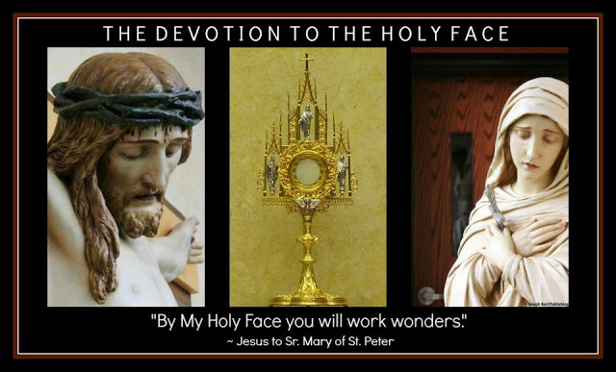
THE HOMILY FROM ON HIGH
"We must be pure. I do not speak merely of the purity of the senses.We must observe great purity in our will, in our intentions, in all our actions." ~ St. Peter Julian Eymard

There were two parts to it, it was so profound and deeply moving, but only the first part of it can be remembered. The second part was forgotten while still on the way to the warm therapy pool.
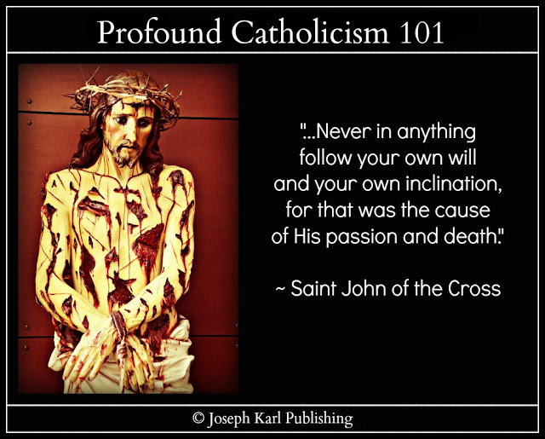
CHRIST'S SACRED PASSION WITHIN HIS SACRED PASSION AND THE MOUNT CALVARY ON MOUNT CALVARY
"By offering My Face to My Eternal Father, nothing will be refused, and the conversion of many sinners will be obtained." ~ Jesus to Sr. Mary of St. Peter
All of a sudden there was a Homily from On High and I AM spoke of His people who go into the confessional, before the Divine Tribunal on Mount Calvary, and they themselves bring with them Mount Calvary.
Imaginer.
Thus there is a Mount Calvary on Mount Calvary, as Christ's people suffer His Sacred Passion as One with Him and thus there is Christ's Sacred Passion within His Sacred Passion, right there inside that incredible small space where heaven meets earth in God's company.
Keeping in mind that well intended Catholic priests also make good confessions, what I AM manifested is that when this Sacred Passion of Christ's within His Sacred Passion on the Mount Calvary within Mount Calvary meets a confessor who doesn't work for Jesus Christ, that is when the penitent's true contrition and purity of intention meets with difficulty and resistance while before God in need of Divine cooperation.
Imagine the implications of this scenario for the sake of the whole world in our time.
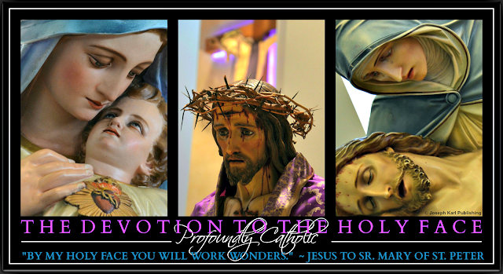
REACTIONS WILL VARY
Penitents will face priests of good intentions who have been taught correctly and others who have been taught incorrectly, by design, in our Modern Times, and also priests who became priests without pure intentions.
I AM also acknowledged what His people face when in the confessional encountering priests who
have not been educated properly to serve Christ as His shepherds.
They bring to these priests, in a sort of role-reversal, Christ's Sacred Passion within His Sacred Passion (meaning the penitent suffers this when all priests should be in the manner in which God wills for each one and while understanding that good priests making their confessions are included in this group) and the Mount Calvary on Mount Calvary.
Imaginer.
You will know these people because they don't ask others for money to support their work in the Lord's service. They trust in God while spending THEMSELVES, in imitation of and in union with Christ crucified in the Blessed Sacrament, and Almighty God our Creator and Sovereign Authority provides as and when He wills. That is how one knows it is His work.
True trust in God is incredibly rare in the Catholic world in our time, and what an example it sets where it exists in imitation of and in union with Christ and the Holy Family. Remember, the gates of hell cannot prevail against Him.
"By My Holy Face" (note He didn't mention money) "you will work wonders, appease the anger of God, and draw down mercy on sinners." ~ Jesus to Sr. Mary of St. Peter +

16. THE WARDROBE, THE LITTLE BOY,

AND THE TRIP INTO THE FUTURE

There was another dream overnight while shut out of three of four email accounts and there were two recurring themes in it while in a place that appeared unfamiliar, doing something that appeared familiar, and once again while in the company of a small boy placed in your care. Then, something unprecedented happened with the infant; the two of you stepped into the future, took a look, and then returned to the present. Guess what the two of you saw there. Just guess.
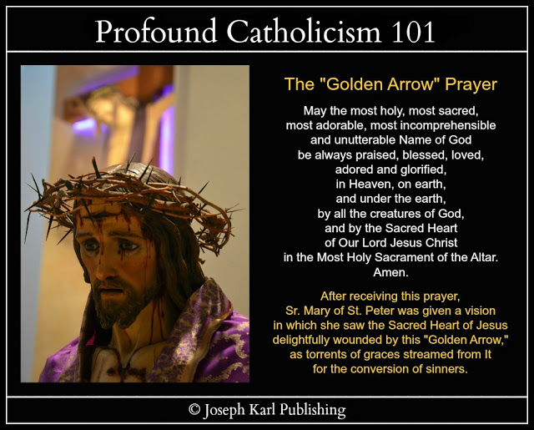

THE DREAM OVERNIGHT TO CONCLUDE AN INCREDIBLE FEBRUARY 2020, ON FEBRUARY 28-29, 2020
In the dream you find yourself in a place that appears unfamiliar but you are doing something familiar in dreams overnight: you are looking for clothing and finding a huge selection of very beautiful outfits unlike what you find in reality in stores, although you wish that you could find such nice things.
Not extravagant things, but nice appropriate clothing.
So while looking at the clothes from which you can choose, and with such awe and with wonder, you see an infant boy beside you and he is in your care.
He is a metaphor and represents I AM's Work of Reparation to the Holy Face of Jesus in Modern Times, for the sake of the whole world in our time.
THE STAIRCASE, THE CORRIDOR, THE TRIP INTO THE FUTURE WITH THE LITTLE BOY, AND WHAT YOU SAW THERE
Before too long, you find yourself leaving the wardrobe and traveling with the infant boy where there was a staircase and a corridor.
After arriving at a certain place, you find yourself with the little boy in the future, and there is a war taking place there.
THE RETURN TO THE PRESENT AND A GOD-GIVEN APOSTOLIC MISSION THROUGH CHRIST'S TRADITIONAL CATHOLIC SACRED PRIESTHOOD IN OUR TIME FOR THE SAKE OF THE WHOLE WORLD
Then you find yourself returning with the infant boy to the present. The war could be a war or it could be a metaphor for war.
God sent us His help now; if only more would listen to Him and do as He says. +

17. The Two Banquets, the Artist, and the Stadium Full of People
What a dream that was just before the Modernist Catholic Churches in Metropolitan Detroit closed their doors to God’s people because of the Luciferiandemic. Imaigner. + "Trust all things to Jesus in the Blessed Sacrament and to Mary, Help of Christians, and you will see what miracles are." ~ Saint John Bosco
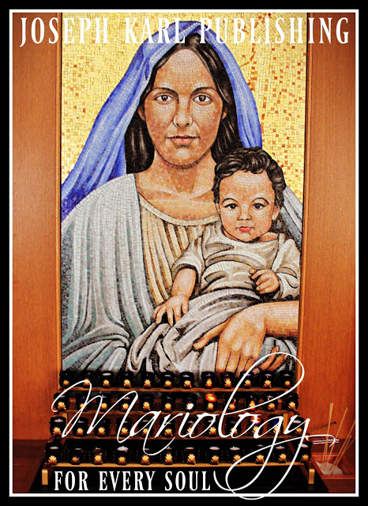

THE DREAM OVERNIGHT ON FRIDAY, MARCH 6, 2020
True story.
ARRIVING AT WHAT IS THE FIRST OF TWO BANQUETS
You find yourself entering an unfamiliar building with your mother and there is a banquet going on there.
It is an all-one-can eat type banquet and after arriving in the small entry space, the two of you find yourselves getting in a line as if to pay and check in.
You stand side-by-side, with each other's arms around each other's shoulders.
Ahead there is some sort of check in area that appears like a lectionary ambo and to the right of there and of where you stand waiting in line there is a small rectangular room with counters that are full of healthy food.
The atmosphere is joyful and loving and the next thing you know you and your mother have found two unoccupied places to sit and go from long table to long table looking at the dishes and deciding among them.
You commend yourself for having chosen healthy food while walking among the dishes and the people who are sitting at long wooden tables eating. It seems they are all women.
The next thing you know while taking everything in with such awe and with wonder is that the place where you planned to sit is no longer available and you comment about this with wonder to your mother.
WHO YOU KNEW
No one else, besides your mother.
THE UNFAMILIAR BUILDING WITH SMALL ROOMS THAT KEEPS EXPANDING AS IN DREAMS IN THE PAST
The building seemed old and constructed of wood and while walking from small room to small room during this first buffet, the building expanded as in so many dreams in the past decade.
THE FOOD AT THE FIRST BANQUET
Remember, it was all healthy.
THE MANY ROOMS FULL OF FOOD

What a wonder that was.
THE BASEMENT
The next thing you know, while still holding on to your plate and while continuing to walk from room to room inside this extraordinary building full of food on long tables, where many women had gathered to eat, you see that there is a staircase to your right and it leads into a basement where there is more food.
You look through the open doorway leading to it and see more people down there.
Now in reality you are making brutal reparation for Christ's Sacred Priesthood as needed in Modern Times, in the natural, and will continue to do so until three o'clock on this First Friday of March in the year 2020, during Lent.
It did not seem likely that you would make it to the church down the road for a Holy Hour but did end up making it before the doors were locked, for a half an hour.
Back to the dream, you look into the basement room with more food but you are also in pain in the dream, very stiff and sore, and so you do not attempt to go down the stairs while still holding on to your plate of healthy food.
THE ARTIST BY THE DOOR TO THE BASEMENT AND WHAT HE SAID
Just to the right of the doorway to the basement there was a thin man sitting on a stool and he was an artist, and he sat among the things that he had created.
He appeared unfamiliar to you and as you reasoned that going down the stairs was not possible, he addressed you by name.
Twice he said something affirming to you.
Then, the banquet suddenly changed.
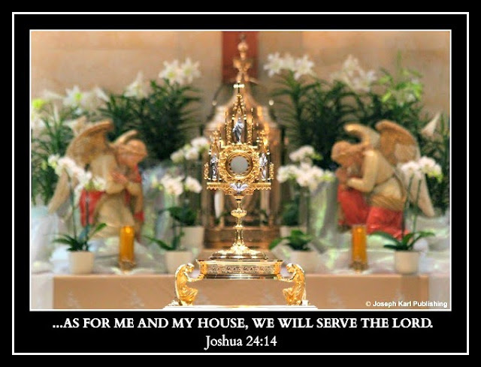

THE SECOND BANQUET
All of a sudden, the banquet radically changed and only desserts were available.
The tables in all of the rooms held sweets of such incredible diversity and astounding visual appeal.
Gone was the healthy food.
You found yourself now choosing among the desserts while taking everything in with such awe and with wonder.
THE SSPX PRIESTS WHO CAME TO THE BANQUET
In a room that had appeared to your left while standing facing the basement stairs and doorway it was made known to you that some people were seated, men, and they are people you know.
Although you did not see them with your natural vision in the dream, you saw them with your supernatural vision and they were seated at a long table.
After the banquet changed, you found yourself then returning in the direction from which you came.
"A STADIUM FULL OF PEOPLE ARE COMING"
At one point someone approached you and said, "A stadium full of people are coming."
HOW THE DREAM ENDED
All remained very peaceful and wondrous, and you found yourself before a table close by where you had entered, your place there still gone, and on the long wooden table before you which was loaded with incredibly beautiful desserts of various kinds, one after another and presented so beautifully, your attention was focused on tiny pie slices of all the best kinds.
These tiny pie slices were perfectly shaped and about the size of the top half of an adult's thumb, above the knuckle.
They were sliced perfectly, meaning they were perfect little triangles, and came in pecan, chocolate, peanut butter, and lemon. So many favorites.
What wonders.
THE TWO BANQUETS ARE METAPHORS AND THE DIVINE ARTIST IS JESUS CHRIST
True story.
Imaginer.

18. That Front Porch
Once again, there was an incredible dream overnight.
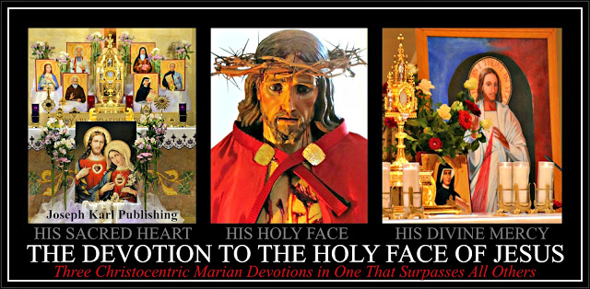

THE DREAM OVERNIGHT ON SUNDAY, MARCH 15, 2020
You find yourself in a place that appears unfamiliar.
THE INCREDIBLE STORES AND ITS MAGNIFICENT TAPESTRIES
While there you find yourself visiting an incredible store unlike anything you have ever seen before.
It is filled with the most resplendent tapestries of all kinds and you find yourself walking around among other people who are there, shoppers and employees, while taking them all in with such awe and with wonder.
Some of them have black wrought iron supports meaning they hang but there were many different sizes and varieties of them. The ones with iron were the last ones that you saw before finding yourself leaving.
They were marvelously beautiful and each one was different.
THE HOUSE THAT WAS YOURS
Then while continuing to take everything in with such awe and with wonder, you find yourself inside a house and apparently, it was yours.
This house was close to the tapestry store.
It appeared unfamiliar.
THAT FRONT PORCH AND WHAT YOU SAW BEFORE SEEING THE PEOPLE
You found yourself standing on the front enclosed porch inside this house that it was made known to you was yours, this house close to the incredible tapestry store in an area that appeared unfamiliar.
This house was on a main street and it was close to the street, separated only from it by a sidewalk.
The porch was longer than it was deep and in the front was enclosed by square windows, with one row of square windows in the top half of the wall and another row of the same sized square windows along the bottom half of the long wall at the front of this house.
Each of the windows were covered with white curtains.
Two of those windows are open.
THIS PORCH IS A WHAT?!?
While still taking everything in with such awe and with wonder, you see that this front porch of the house you have never seen before and which is suddenly yours is actually a WHAT?
As in so many dreams in the recent (decade) past, you find yourself inside another BATHROOM.
Now, to your natural vision in the dream this is a plain enclosed porch with a toilet and a sink in it, making it a large longer-than-it-is deep bathroom, but your supernatural vision is shown something very extraordinary inside this room with the square windows in the front, covered with white curtains and with two of them open.
WHAT YOU THINK TO YOURSELF UPON SEEING WHAT CANNOT BE DESCRIBED IN THE NATURAL
You think to yourself, "This bathroom should be outfitted in a certain way" since it is so very beautiful as seen in the supernatural.
Remember, in the natural it is shown as a bathroom but the bathroom as in so many dreams in the past is a metaphor for what has happened to Christ's Catholic Church in Modern Times, and it is also a metaphor for the confessional.
THE PEOPLE STANDING OUTSIDE ON THE STREET AND WHAT THEY WERE DOING
Then while still in such awe and while taking everything in with such wonder you notice that people have stopped on the sidewalk and THEY ARE LOOKING INTO THE PORCH WINDOWS.
For some reason they have found something of value inside is worth seeing.
THE SURPRISING ENDING
This porch has not one wall of windows in the front of the house, it has two.
The people peering into the porch from the sidewalk outside are separated from you by one wall containing windows and you see them from the second wall containing two rows of square windows before you that are covered with white curtains, with two of them open.
And, there is an area in between these two walls and their windows.
There is an area between the people and you.
You see that this area is filled with spools of slim ribbon of various kinds.
The spools are about the size of an adult hand in length and about as wide as an adult hand also.
These ribbons please you very much and you reach into one of the open windows to investigate them.
Imaginer.

PART IV

THE FOURTH STATION OF THE CROSS

JESUS MEETS HIS MOTHER

19. The Sudden Presentation of a Ring Overnight

20. The New Baby on the Way in the Dream Overnight and His Crib

21. Social Distancing Expert

22. Divine Union, Delivery Theology for Every Soul, and the Needle

23. PROTECTRESS

24. So Many Orphans!

25. Jesus Christ All Over the Floor, the Two Kinds of Women, and the Two Kinds of Men

26. The Miraculous Multiplication of the Bread and the Fisherman

19. The Sudden Presentation of a Ring Overnight
Guess what was engraved upon it. Just guess. + "Trust all things to Jesus in the Blessed Sacrament and to Mary, Help of Christians, and you will see what miracles are." ~ Saint John Bosco
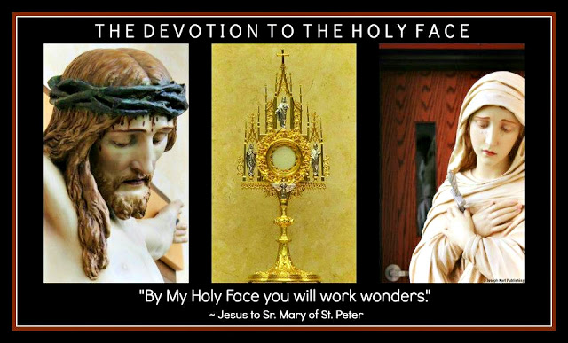

A MONDAY OF REPARATIVE ATONEMENT ON MARCH 16, 2020 IN TRADITIONAL CATHOLIC DETROIT FOR THE SAKE OF THE WHOLE WORLD IN OUR TIME
Overnight as things get ever stranger with the proclaimed crown virus outbreak, this student teacher representative of I AM's Work of Reparation to the Holy Face of Jesus in Modern Times was suddenly presented with a ring.
The ring was a solid band and there was a word engraved on the top of it.
The word Savior was inscribed in the ring, in red.
"By My Holy Face you will work wonders, appease the anger of God, and draw down mercy on sinners." ~ Jesus to Sr. Mary of St. Peter

20. The New Baby on the Way in the Dream Overnight and His Crib
There was another series of dreams overnight and then there was this one. Imaginer. +
In the picture above a younger Nick holds the bell used
for the greater honor and glory of God
during the Traditional Tridentine Holy Sacrifice of the Mass.

THE FINAL DREAM OVERNIGHT ON A THURSDAY OF REPARATIVE ATONEMENT ON MARCH 19, 2020 IN TRADITIONAL CATHOLIC DETROIT
Overnight there was one dream after another, none of which can be recalled, and then there was this wondrous final one.
THERE IS ANOTHER CHILD ON THE WAY, A BABY BOY
It is very early in this spiritual pregnancy, there is no mention of an earthly father, you are a single mother over 50 with three grown children AND a representative of I AM's Work of Reparation to the Holy Face of Jesus in Modern Times for the sake of the whole world, and the child it is made known to you is a boy.
You are so happy and filled with incredible joy.
God is so good.
KEEP IN MIND THIS DREAM IS A METAPHOR
True story.
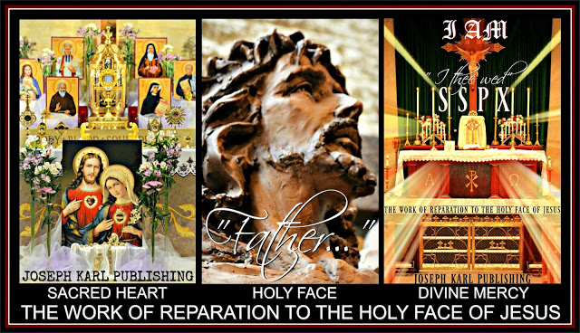

YOU HAVE JUST FOUND OUT ABOUT THIS CHILD, NEWLY SPIRITUALLY CONCEIVED THROUGH I AM'S WORK OF REPARATION TO THE HOLY FACE OF JESUS IN MODERN TIMES THANKS BE TO OUR TRIUNE GOD AND YET ALREADY THERE IS A CRIB FOR HIM, NEXT TO A KING-SIZED BED

While still so incredibly happy to have learned that you are expecting a little boy, keep in mind in the dream this seemed very real in the natural sense although the dream is supernatural in origin and is a metaphor, you find yourself standing inside a bedroom with a king bed which is a metaphor also for a place where reparation is made and where so much goodness is conceived in union with Christ crucified on Mount Calvary.
Next to the bed is an incredible wooden crib and it is for the baby boy who is coming.
You are standing, with child in this dream overnight, between the two beds.
You are standing on Mount Calvary unified with Christ's Salvific Mission and with His Reparative Suffering which always bears such tremendous fruit for the greater honor and glory of our Triune God first and foremost and then for the sake of the whole world, including one's own poor soul.
This is the magnificence of surrendering one's will to Almighty God completely, in imitation of and in union with Christ, with purity of intention and devoid of self interest, totally rejecting the worshiping and loving and false trusting in idols of any kind, and loving unconditionally and sacrificially without counting the personal cost, and while trusting in our Triune God alone through the maternal intercession of the Immaculate Mother of God.
THE INCREDIBLE CRIB FOR THE BABY WHO THANKS BE TO GOD IS ON HIS WAY

The crib appears at first to be new.
The crib is constructed of solid wood.
Its impressive (meaning thick and sturdy) more square rather than curved/rounded spindle construction is not plain but it is not ornate either, and the four sides reach up incredibly high for a crib.
You have never seen a crib like it in height.
The four sides appeared no less than six feet tall.
What wonders.
Since Christ crucified has always been manifested to you closer to the ground instead of high up in the air (what a shame that He is suspended in most Catholic Churches, that is where the crucifix hasn't been eliminated all together, way up in the air and farther away from the people), this crib symbolizes the redemptive Cross of Jesus Christ and the ongoing Work of Reparation to the Holy Face of Jesus in Modern Times for the sake of a world in very serious grave peril.
TRADITIONAL CATHOLIC RESTORATION IN MODERN TIMES THROUGH THE SPENDING OF THE SELF AS ALMIGHTY GOD WILLS, IN IMITATION OF AND IN UNION WITH CHRIST CRUCIFIED
Upon closer examination of the crib you see that in one place on the outside, on a corner about three feet from the ground, the wood is worn and exposed in its original condition while the rest of the crib retains its original finish.
You think to yourself, as if following along with a Divinely predetermined outcome, that the crib needs to be refinished, or restored.
You find yourself thinking that refinishing the wood using a cherry stain would be very majestic.
The cherry stain represents the Precious Divine Blood of the Lamb of God who takes away the sins of the world.
The crib is a metaphor also, for Christ's Catholic Church in our time which has in most places around the world been absolutely and systematically disfigured and ravaged from within by Modernist Luciferianism which masquerades as Catholicism that is current and progressive but it isn't. It is a liar and a deceiver. Stripping the sacred from God's House does not lead to anything good.
However, making reparation as Almighty God wills for each one always leads to good.
Holy apostles of I AM's Work of Reparation to the Holy Face of Jesus are greatly needed in Modern Times.
RIGHT HERE IN A MANGER THERE IS A CRIB FOR HIS BED
The crib is a metaphor for Christ's manger, for the coming of our Divine Redeemer, Divine Restorer, Divine Remedy for All, and the Divine Bridegroom of Every Soul who left us His Real Presence in the Blessed Sacrament, in two Sacred Species (the Sacred Host, His Adorable Flesh and the Precious Blood) prior to His giving up His life publicly by execution by Crucifixion on a wooden Cross on Mount Calvary for our Redemption.
The crib is a metaphor for Christ who remains with us and through the Divine Son of Man's Real Presence in the Blessed Sacrament just keeps coming and coming and coming and coming.
THE WOODEN MANGER CRIB FOR THE BABY BOY WHO IS COMING
The dream concludes with a very happy dreamer finding herself turning to face the crib while continuing to take everything in with such awe and with wonder.
Once again there is marveling at the height of the four sides of the crib, which are much higher than any conventional crib.
Certainly they are higher than they need to be in the natural.
You then think to yourself that it would have been more economical to have a crib that serves both as a bed for a newborn and which also converts into a toddler's bed.
Since your three children are grown, all the small furniture is gone.
Then it is manifested to you in the dream's natural that the crib does in fact convert to a toddler bed.
The front side is suddenly gone and the three remaining sides of the crib still stand so incredibly tall.
What wonders.
Then your attention is drawn to the wide wooden slats supporting the bed's mattress where the child will sleep.
Some of them are missing.

21. Social Distancing Expert
This lesson came during an incredible trip to the grocery store and the only one who mentioned God was moi. "By My Holy Face you will work wonders, appease the anger of God, and draw down mercy on sinners." ~ Jesus to Sr. Mary of St. Peter +
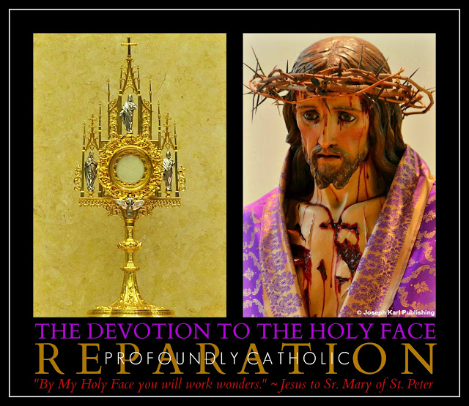

WHAT HAPPENED DURING THE FIRST ENCOUNTER WITH A CUSTOMER AT THE GROCERY STORE THIS MORNING, IN THE COSMETICS ISLE
While passing a woman looking at items on one side of the isle, and while looking at items on the opposing isle and while continuing to walk without stopping as several employees scrubbed shelves at ground level while sitting on the floor, the customer said the following to my back:

"Practice social distancing."
Woman, I have been practicing it for years.
I have become an expert at it.
True story.
THAT IS THE APOSTOLIC MISSION OF I AM'S WORK OF REPARATION TO THE HOLY FACE OF JESUS IN MODERN TIMES: TO SPEND ONE'S SELF AS ALMIGHTY GOD WILLS FOR EACH ONE, WITH PURITY OF INTENTION AND WITHOUT COUNTING THE PERSONAL COST, IN IMITATION OF AND IN UNION WITH CHRIST WILLINGLY AND BRUTALLY CRUCIFIED ON THE CROSS FOR OUR REDEMPTION
Dear Lord God help us all in Modern Times. We are all in need of You.
SUDDEN BIZARRE SHORTAGES (TOILET PAPER FIRST AND FOREMOST) SYSTEMATICALLY INSTITUTED TO CAUSE DISTRACTIONS, UNCERTAINTY, AND PANIC IN THE MINDS OF GOD'S PEOPLE
Certainly there is legitimate cause for concern at this moment, but there has been and for a long time now.
The cashier reported this morning that here in suburban Detroit, more than a hundred people had gathered at the grocery store before the doors even opened and they waited outside in the rain.
They were panicked and afraid and some were angry, yelling and insulting the store's employees.
These people arrived during a downpour during very bizarre weather that suddenly turned very warm and steamy following the massive early morning drenching; the temperature then began dramatically dropping just a few hours later.
THE STATE OF EVERYONE AT THE GROCERY STORE AND THEN AT THE DRUG STORE BECAUSE THAT'S WHAT THEY ARE AS THE LINE TO CHECK OUT GREW AND GREW
Justifiably concerned.
Many people spoke to this student teacher shopper at both stores and no one mentioned God, except me.
No wonder; mention God in our time and one will pay dearly, even in most churches in Modern Times.
One may lose one's spouse, one's status in high society, one's job, one's title, one's bank account and earthly possessions, one's health, and even (gasp!) one's place in church.
Perhaps one will lose them all.
GOD REMAINS WITH US ALWAYS AND HE IS THE ONE WE ARE TO BE WORSHIPING, ADORING, AND SERVING
God offers us eternal life with Him in heaven, forever; Lucifer offers us temporary and truly meaningless gains of all kinds WHICH NEVER SATISFY while providing us with lies, deception, illusions of grandeur, and the promise of eternal punishment in hell in his company for the unrepentant.
No one who humbles himself and truly values our Real Treasure, our Triune God, will ever lose Him nor will one lose the maternal intercession of the Immaculate Mother of God and the paternal intercession of Saint Joseph and the heavenly help of the Holy Angels and also of God's Saints and Martyrs.
We must place our trust in our Triune God completely; we must listen to Him and do what He says unconditionally and ask Our Lady and Saint Joseph to help guide us. They will.
Anyone who is truly serving God alone feels tremendous compassion for mankind in our time; it stems from having tremendous compassion for our lavishly loving Lord first and foremost.
The modern day situation has been alarming for a long time.
CROWN HIM WITH MANY CROWNS, THE DIVINE KING OF ALL KINGS AND LORD OVER ALL
Now, in 2020, we are told that there is the crown.
Is the crown the real concern, or is there something far more dangerous being used against the masses as we are all told how to think, act, and feel (as if we cannot do that on our own, among Lucifer's worst fears).
God knows.
How important it is to listen to Him and to do as He says.
WHAT HAPPENED IN THE YEAR 2012

I AM had re-introduced His Work of Reparation to the Holy Face of Jesus through Christ's Traditional Catholic Sacred Priesthood but the information was kept from God's people.
Imaginer.
WHAT I AM SAID TO DO AT THAT TIME
He said to honor the Holy Face of Jesus suffering during His Sacred Passion and He said every church and home should put such a picture out for veneration, and for Divine protection.
This information was kept from God's people.
However, the fundraisers were not.
What good is money going to be during a time of Divine chastisement? An addiction to fundraising and the relentless pursuit of the content's of anyone else's wallet is no asset.
Ditch the deception; get behind me, Satan!
Nor were the good times in church kept from God's people under His own roof on Mount Calvary, nor was the funtertainment atmosphere, or the focus on one's self and on the worship of one's self, as the Modernist's false teaching distractions and plentiful material just kept coming and coming and coming and coming.
If we do not do what God says He will not protect us from our enemies and our enemies are very real.

THE MODERNISTS IMMEDIATELY USED THE CROWN IN 2020 TO SHUT DOWN MOUNT CALVARY TO KEEP GOD'S PEOPLE OUT OF HIS HOUSE AND AWAY FROM OUR DIVINE REMEDY FOR ALL "FOR THEIR OWN GOOD"
Imaginer.
Why wouldn't they; they have been ruthlessly persecuting and kicking God's people out of His House here (an in other places) and for years.
Already the eternal flames of hell lick at their feet, so eager to consume them and separate them from our lavishly loving God forever.
Corrupt the shepherds, and most of the (by Luciferian design) overconfident, non-critically thinking, improperly trusting, self absorbed, self interested, perilously distracted, and improperly educated flock will follow.
All throughout human history, God's enemies have assaulted His people.
Things are no different in our time as Lucifer and his followers seek to eradicate God at all costs, particularly among Catholics right under God's own roof on Mount Calvary. His strategy among those who will not be corrupted in church: "Get them out!"
Professed Catholics including professed Catholic media personalities only protesting when your favorite pastor gets kicked out of church while ignoring or conveniently not discussing the carnage everywhere else and to everyone else, your very lukewarm selective attention while speaking just loud enough to make yourself feel good is a very big part of the problem.
CHRIST'S TRADITIONAL CATHOLIC CHURCH REMAINS OPEN

Thanks be to God, Christ's Traditional Catholic leaders have maintained a holy and rational sense of calm and have kept God's House open, and Jesus Christ available.
He is our Divine Redeemer, Divine Restorer, and Divine Remedy for All.
Now, if only Christ's leadership would listen to I AM and do as He says regarding His Work of Reparation to the Holy Face of Jesus in Modern Times, for the sake of the whole world. Holy Spirit, be our Divine Guide.
"Trust all things to Jesus in the Blessed Sacrament and to Mary, Help of Christians, and you will see what miracles are." ~ Saint John Bosco

22. Divine Union, Delivery Theology for Every Soul, and the Needle
In our Triune God we totally trust, through the maternal intercession of the Immaculate Mother of God, the paternal intercession of holy husband and father Saint Joseph, the Holy Angels, and the Holy Saints and Martyrs including the Holy Innocents. Imaginer. +
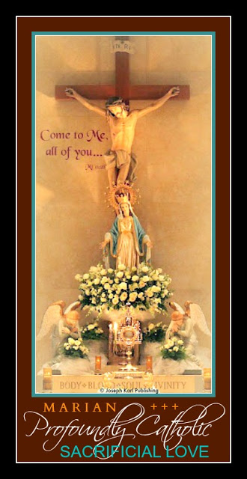

DIVINE UNION AND CREATION
Two evenings ago, this student teacher caretaker's bedroom transformed in the supernatural right there in the natural into a delivery room.
This took place also in the recent past while at 183, the family home, which was given up for Christ's Sacred Priesthood as needed in Modern Times last year (2019).
How glad you were that night and also last night to not be in a hospital, for your own safety and for the safety of the metaphorical child who is on the way, thanks be to God.
Hospitals and the allopathic professed treatments provided there (and in such clinics) have become very dangerous places for humanity including the unborn, pregnant women and newborn babies, children, young people, men, and women.
While reflecting on the past and on the deliveries of three babies who are now grown, how glad you are to not have taken any pharmaceutical prenatal drug "vitamins" during this albeit spiritual/metaphorical pregnancy (meaning some good that is coming, thanks be to God) at the encouragement of drug-pushing doctors pimping themselves out to Lucifer on the highway to hell.
Informed consent is absent with these enemies of God and of humanity; they don't tell people what is in these professed "remedies" that are so costly (financially and to human health) and they don't reveal what the side effects are. Mostly these arrogant professed health care providers refuse to find out themselves. It would be too personally costly for them to know.
If that wasn't evil enough, most coerce people to take their poison posing as a remedy and they seek to get the masses to consume or accept them quickly, just like the devil says to terminate pregnancies as soon as possible, before anyone else knows.
They absolutely and without conscience prey upon the misplaced trust of humanity when they are most vulnerable, and for personal gain and then insist that people respect them.
Imaginer.
Only people with no self respect insist that others respect them.
One cannot respect one's self when one is unrepentant.
LEGALIZED KILLING IS STILL IMMORAL IN ITS MANY SELF INTERESTED FORMS
Humanity has been in grave peril in modern times as the now medical establishment performs unnecessary surgeries and/or profits from their big pharma partner poisonings of humanity (using drugs, shots, "vitamins", highly addictive painkillers, etc.) pre-conception, post-conception, after delivery, during infancy and according to a schedule of destruction, and throughout the lifespan. Their goal like the retail industry and the court system including the corrupted to the core family court system, etc. is to SELL US AS MUCH AS POSSIBLE which we don't need and which isn't good for us and also to KEEP US COMING BACK FOR MORE.
The public is far too trusting and unfathomably distracted, have been overtly or covertly coerced to accept harmful interventions while handing over massive amounts of money to professed health care conglomerates, are in various states of decades-long diabolical mind control programming, often welcoming its own poisoning while giving doctors of death and diabolical professed health insurance companies dominion over themselves and even their families.
Meanwhile humanity's wealth including hard-earned income continues to be systematically stolen from it as more and more people - often sick from the poisonous medical non-caring routinely and by design forced upon people and infants and children - struggle ever more for survival physically, emotionally, financially, and spiritually.
Lucifer is jamming meaning clogging the systems of the body and in various ways so that they don't work, so that we don't work properly and so that we can't think properly.
Everyone should be grounding, or earthing. Everyone must connect with the earth through uncovered feet either directly with the earth or by using a grounding pad indoors.
Just because anyone went to school for a certain number of years, PARTICULARLY PHARMACEUTICAL CONFLICT-OF-INTEREST IMPROPERLY EDUCATED DOCTORS and also IMPROPERLY TRAINED MODERNIST PRIESTS who expect absolute cooperation from those they poison, that does not ensure that person is awake or is a good person.
To the many people trapped within the beast system, because there aren't any alternatives, who went in with good intentions hoping to be properly educated and who remain silent in the presence of grave and sinister evil: WHO IS YOUR MASTER.
Often those who make it that far, to the loftiest heights in the modern corrupted-by-design educational system, are not good people. They have been carefully profiled and screened by the corrupted systems for their stupidity, gullibility, lack of conscience, and high level of self interest.
I know; it happened to me. But something took place along that path, an awakening, and by the time I was about to graduate with a doctorate as well as the credentials and the power to teach in universities and to open a private practice, the devil said, "GET HER OUT!"
So glad to be out of the belly of that beast.
Later, the same thing happened while in a Modernist desecrated Traditional leaning Catholic Church here in Modernist desecrated Catholic Detroit.
So glad to be out of the belly of that beast.
Some professed naturopathic and holistic doctors and also nurses and caregivers serving the wrong master while hiding under the guise of healthcare professions have succumbed to the same evil, even though they are corrupted in smaller numbers than those within the many allopathic sub-specialties who claim expertise while never looking at the bigger picture or treating individuals as a whole, entire person. Such "professionals" treat people terribly, in secret or right out in the open, including their own staff, while always holding themselves above reproach, because their love for money is the root of all evil.
Evil has no mercy; remember, those who sacrifice their own families and their own parish families for personal gain and for profit (meaning to acquire ever more power, status, fame, and money) are rewarded the most by the forces of darkness, FOR NOW. Such people are unfathomably short-sighted.
Conceit is blinding, just ask the devil.
All will face Divine Justice, and it's coming for every one.
"For what doth it profit a man, if he gain the whole world, and suffer the loss of his own soul? Or what exchange shall a man give for his soul?" (Matthew 16:26).
Many people have been corrupted, some aware and most unaware.
Thanks be to God, not everyone has been corrupted.
However, public voices of reason are so few. It takes real courage to live in imitation of Christ.
Most people are happy to have a job and fear losing the little they can have; they keep their mouths firmly shut while witnessing injustice at work and then give most of their hard-earned money to the many gangsters who are taking it.
Most people care - to the detriment of everyone - what other people think instead of caring about what God thinks or about what God has said.
God is clear. He is not confusing.
God is properly unifying. Yet He is also a holy divider: "He has performed mighty deeds with His arm; He has scattered those who are proud in the thoughts of their hearts " ( Luke 1:51).
God is Truth.
Truly honest people are very rare.
That is because the truth spoken as Almighty God wills, in imitation of and in union with Christ our High Priest and with purity of intention and devoid of self interest, will cost one in imitation of and in union with our Divine Redeemer and Restorer crucified on Mount Calvary.
True story.
INSIDE THE DELIVERY ROOM
Two evenings ago, the room you sleep in appeared in the supernatural to be so similar to the hospital room where your first son was born in metropolitan Detroit 25 years ago, what an unsafe place for mother and child to have been even back then meaning inside a hospital, and you are so glad to be safely at home for this Divine supernatural special delivery.
Remember, not long ago our Lord announced that "a child" is on the way.
This child represents the precious, priceless fruit of I AM's Work of Reparation to the Holy Face of Jesus in Modern Times, through Christ's Traditional Catholic Sacred Priesthood, for the sake of the whole world in our time.
The child represents what Almighty God conceives through us as He wills, through each one's Holy Apostolate of Reparation, when we cooperate with Him, when we listen to Him and do as He says at all times, with purity of intention and devoid of self interest and while worshiping no idols of any kind, in imitation of and in union with Christ crucified.
All is so wondrous as manifested and experienced in the supernatural, in the natural, in holy silence, and in holy isolation as the world waits in time-out, in lock down because of what we are told is a crown virus.
The world's leaders who have been put in position by the principalities and powers of darkness speak through the mass mind controlled media with forked tongues while claiming to be so concerned and such experts, but what they say doesn't make sense to the rational, God-fearing mind.
They seek to control the world with fear and take away mankind's God-given freedoms and their reward if unrepentant will be containment in hell for all eternity with no chance of ever leaving. So short-sighted! Diabolically possessed, and conceited.
Lucifer the king of all betrayers wears a crown of self interest.
Jesus Christ and His people wear a humble, honorable, and penitential crown of thorns during this life for the greater honor and glory of our Triune God first and foremost and then for the sake of all others. Their actions focus on the life to come and they properly care about everyone.
THE DIVINE DELIVERY ROOM, NOT IN A HOSPITAL BUT AT HOME IN THE KING'S ROOM INSIDE A TRADITIONAL CATHOLIC DOMESTIC CHURCH CHAPEL
Last night prior to calling it a day, the bedroom once again was manifested as it had been the night before.
THEN A BEAUTIFUL TRADITIONAL CATHOLIC MYSTICAL THEOLOGY LESSON FOR EVERY SOUL WAS DELIVERED
It was so incredibly BEAUTIFUL BEAUTIFUL BEAUTIFUL BEAUTIFUL.
It was particularly a Traditional Catholic Mystical Theology of Divine Union and Creation lesson for every soul.
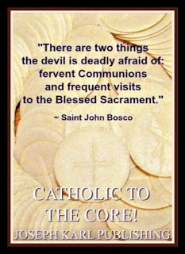

First, the individual completely devoted to God was manifested as suffering in union with Christ crucified during His Sacred Passion for the sake of the whole world.
The union as experienced by husband and wife as a physical sharing of love is experienced in a higher manner, in the highest manner possible, as a sharing as One in the Victimhood of Christ the Divine Bridegroom of every soul, our Divine Redeemer, Divine Restorer, and Divine Remedy for All.
DIVINE TEACHER
This union with Christ's Salvific Mission and with His Reparative Suffering on Mount Calvary leads to Almighty God creating what He wills from the sacrificing of self, in the manner in which He willed (for each particular willing one) through the Holy Spirit, the giver of life.
Life in this case is a metaphor for whatever God wills, for whatever action He wills to take for whatever purpose.
He alone is the Lord; He alone is the Most High.
How important, and how vital, it is for each of us to listen to Him and to do as He says for we are His people.
We are His.
SO THE ONE IN LABOR LABORS AS ONE WITH CHRIST CRUCIFIED INSIDE THE DELIVERY ROOM ON MOUNT CALVARY, SAFE IN GOD'S CARE
Well looked after by Jesus Christ, each person's Divine Physician, but also the Divine Bridegroom of every soul.
True story.
The most recent reparative atonement overnight is different than previous sufferings from the past ten years in particular.
It is severely penitential, as in the past, but this suffering takes place in three particular areas: across the top of the shoulders and the back of the neck; the knees; and the pelvis. They pain as if they are on fire but the reparative atonement is filled with peace and the individual is sustained by Almighty God's grace in union with Christ's Human Nature on Mount Calvary. .
At the same time, overnight, there are ever more dreams.
A VERY LOVING VISIT BY JESUS LAST NIGHT ON MARCH 25, 2020
Then if that wasn't beautiful enough, Christ appears not just as one with His victim spouse crucified on the Cross on Mount Calvary, laboring there for the sake of the whole world in Modern Times as Almighty God wills, Divinely led by the Holy Spirit, but Christ the Divine Spouse appears next to the bed and He takes the hand of the one who is laboring for the love of our Triune God and looks after her.
He lavishes upon her affection while in labor unlike what mankind can provide and certainly unlike what the self interested don't want to provide and withhold for themselves instead.
He is so unfathomably caring our Jesus, so noble, so concerned, so gentle, so quiet, so understated, so regal, so honorable, so considerate, and so sacrificially loving.
What a wonder that was.
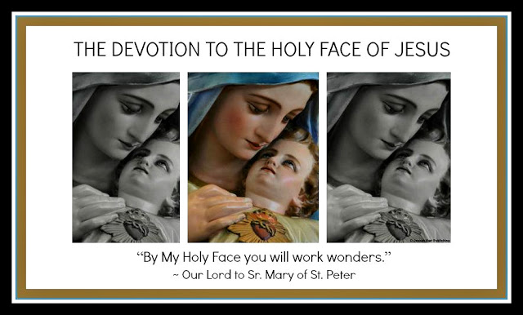

FROM THE DREAMS OVERNIGHT
A newborn child had been delivered, what wonders! However, the infant was a little girl.
The child was placed in your care and is a metaphor for the Lord's Work in His vineyard.
Always when this happens overnight you immediately and very much love the new child Divinely placed into your care.
You have loved all of these children as if they were your own. You have fed them (nursed them) with your own body, in imitation of and in union with Christ who feeds us with Himself in both Sacred Species of the Blessed Sacrament (Sacred Host and Precious Blood) and Who just keeps coming and coming and coming and coming and Who remains with us always as He promised.
You found yourself overnight outside in a place that appeared unfamiliar, in a shopping district of some sort and were trying to keep the newborn infant safe because the situation was very threatening.
There were stores large and small, the small ones in a strip mall and a large one standing alone behind a large parking lot. You walked with the newborn child along a sidewalk around and in front of a row of stores that were separate yet combined and shared a roof.
People were out and about but not everyone was trustworthy and some individual and groups of people were clearly up to no good.
How the world has changed virtually overnight in our time and yet how much it remains the same.
Then, you saw a woman with a child and tried to help her safely find what she was looking for by guiding her in the right direction.
WHAT HAPPENED AROUND THE YEAR 2012 HERE IN CATHOLIC DETROIT AND WHAT I AM SAID WAS COMING
I AM re-introduced His Work of Reparation to the Holy Face of Jesus in Modern Times through Christ's Traditional Catholic Sacred Priesthood for the sake of a world in very serious grave peril.
He also said that the Angel of Death is going to pass over humanity in imitation of the time of Moses.
Don't believe Lucifer's narrative of what is or what isn't deadly. He is a liar and a deceiver, a divider and a destroyer and his misinformation flows from places that have the money to put out mass marketed messages.
Without a doubt all the "cell phone" towers erected so quickly, and so clandestinely, often at night as the population tries ever harder to get a good night's sleep, are a control grid of not only spyware but population control energy weapon death machines.
God's skies have been sprayed with harmful substances worldwide and for decades at our expense.
Wars have been financed with the people's stolen and misappropriated money.
Humanity is being poisoned through the water supply, in the air, through the food supply, and through distracting and detrimental propaganda promoted as news and as entertainment.
Churches have been ravaged by wolves in shepherd's clothing; Catholic publishers and non-profits and groups and schools and religious orders and newspapers and pro-life priests/groups and news shows have been corrupted and severely disfigured by Modernism as they repeatedly prey upon Christ's unsuspecting flock to fund their endeavors in Lucifer's service while holding themselves above reproach. So many well intended people do (fund such endeavors), encouraged to critically think about nothing and do what they are told, or else.
"Even if Catholics faithful to Tradition are reduced to a handful, they are the True Church of Jesus Christ." ~ Saint Athanasius
Extremely rare are Catholics who do not ask for money for their work in the Lord's vineyard and at His discretion.
They rely on God to provide, when He wills, in imitation of Christ and His Holy Family.
They are willing to wait for God to provide as He sees fit.
Their agenda is God's, and not their own.
They worship, serve, and adore God alone, and they are not deceivers.
Those focusing on themselves will be celebrated and receive awards.
Those serving God alone are persecuted, called crazy and even lazy, and are run out of Luciferian occupied Catholic Churches.
Those serving God alone while leading souls to Christ and who want nothing in return are and have been purposefully ignored by the Luciferian run Modernist corrupted Catholic press. They sacrifice all for Christ as One on Mount Calvary crucified with the Divine Bridegroom, our High Priest who takes away the sins of the world. They do it gladly and without counting the personal cost. They prefer quiet and solitude, they prefer when not at Holy Mass to be with the Real Presence of Jesus during Eucharistic Adoration. Often they are the center of great controversy in imitation of Christ our Divine Teacher.
Lucifer is afraid of them, even though few listen to them.

THE PASSING OVER OF THE ANGEL OF DEATH IN MODERN TIMES
Make no mistake about it: what is being presented here is not the passing over of the angel of death at the hands of mankind that has already taken place and which continues to take place and in so incredibly many ways by people who could care less about God's Ten Commandments and about the Greatest Two.
What is being presented is a great chastisement for the evil committed in Modern Times by mankind.
This passing over of the Angel of Death will be a chastisement for all the killing, for all the self interest and lack of concern for God and then for one's fellow man, and for all the stealing in Modern Times and He provided us with a Divine supernatural means of protection as He did in the time of Moses, prior to the Incarnation of Christ and our Redemption on Mount Calvary.
Instead of putting the symbolic blood of a lamb over doorposts as in the time of Moses and Pharaoh, we are to place an image of Christ suffering during His Sacred Passion inside of our churches and dwelling places.
Many won't have access to the Blessed Sacrament, as the Modernist corrupted Catholic Churches haven't been nor will they be allowed to properly serve God's interests or properly care for His people. Meanwhile the corrupted churches make sure people are aware they should continue to donate, online.
WHAT HAPPENED TO HIS INFORMATION THAT CAME FOR THE SAKE OF THE WHOLE WORLD FROM ON HIGH
This information was kept from God's people in the same manner it was kept from the people in France at the time Jesus spoke to Sr. Mary of St. Peter in the 1800s about His Work of Reparation to His Holy Face as chastisements loomed over that country.
We can see Lucifer's death machine has been ravaging mankind and in so many ways as countless people help him attempt to eradicate God, disfigure His Catholic Church to the point that most are no longer what they are proclaimed to be (while people think they are what they no longer are), and destroy God's creatures physically, mentally, and spiritually RIGHT INSIDE THE PLACES THEY SOUGHT REFUGE WHILE IN NEED OF CARE and while mocking them and then presenting them with an unaffordable bill.
Imaginer.
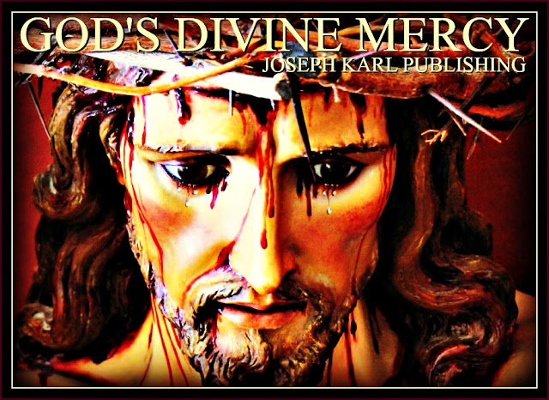
HOW IMPORTANT IT IS TO LISTEN TO GOD AND TO DO AS HE SAYS
Keep in mind that some people have no intention of listening to God and of doing what he says because they serve the wrong master.
Keep in mind that some of these people self identify as Christians, as Catholics, as professionals in any given profession including the modern medical field, and even as religious, clergy, and prelates.
Lucifer's people love self identifying as leaders who care. Always they are unchaste people who are in love with money which is the root of all evil.

LUCIFER'S NEEDLE
At the time that I AM had re-introduced His Work of Reparation to the Holy Face of Jesus in Modern Times from here in Traditional Catholic Detroit for the sake of the whole world, there was one particular unwelcome visit by Lucifer overnight and he came with a vaccination needle.
He proudly displayed his weapon of mass destruction and then came at this student teacher with it, jabbing it into her right hip and then grinding it into the bone while grimacing with his twisted ugly face.
The pain from that wicked assault was excruciating.
The Traditional-leaning foreign born priest of Almighty God's choosing, who has an Apostolic Mission in Modern Times in imitation of Moses, was told of all that I AM said to tell him but Father said to stop writing.
So that correspondence stopped, as the spiritually deathly ill professed Catholic solicitors were allowed to truly intrusively keep writing and calling to ask for ever more money.
What wonders.
THE SUDDEN AND PERHAPS NOT-SO-SUDDEN CORONA VIRUS OFFICIAL NARRATIVE REEKS TO THE LOWEST LEVEL OF SULFUR ENCRUSTED HELL
True story.
Spyware, cameras, and tracking devices are everywhere; most people have no intention of letting go of the ones they hold right in their hands.
The fundraising is relentless and new ones are conceived with every tragedy.
God alone knows how our enemies continue to conspire against His people; let us all wisely and humbly listen to Him and do as He says.

23. PROTECTRESS
What a conversation with Perfection's Immaculate Mother that was during a spectacular return to the early morning Traditional Tridentine Holy Sacrifice of the Mass on this Tuesday of Reparative Atonement prior to Holy Week, 2020. Guess how she manifested herself, and then guess how she manifested herself. And then guess how she manifested herself. Just guess. +
But first, a visit to the chiropractor by special arrangement only.
Imaginer.
Thanks be to God for a fine and much needed adjustment
as this student teacher caretaker's neck had gone out of alignment.
Neck issues have resurfaced all of a sudden following
the wondrous all natural healing therapies.
The diagnosis:
retracing, because of the body healing!
What wonders.
THE DAY BEFORE

The forces of darkness are very angry with our Lady and you wonder why.
A RETURN TO THE TRADITIONAL TRIDENTINE HOLY SACRIFICE OF THE MASS AFTER HAVING MADE EVER MORE REPARATIVE ATONEMENT, HAVING BEEN PLACED BY THE DIVINE HAND INTO HOLY ISOLATION FOR A SECOND TIME IN THE PAST DECADE AND JUST PRIOR TO THE WORLD HAVING BEEN PLACED INTO UNHOLY ISOLATION
Let us use this time to reflect on our lives and make all the reparation our Lord sends us, as God wills for each particular one.
Let us look after one another properly, after the Greatest Two Commandments and God's Top Ten.
"PROTECTRESS"
Suddenly Our Lady manifested herself before the Crucifix above Christ's High Altar on Mount Calvary, clothed in purple.
She came this way one year ago; this student teacher would have to check the notes to recall the details at that time.
However, this time she came distinctly and at this time in human history as our PROTECTRESS.
She comes as our Protectress during Lent as the world is forced ever more into lockdown, outfitted in purple and as THE VIRGIN OF THE GLOBE.
HOW OUR LADY APPEARED FIRST
She appeared as Our PROTECTRESS.
HOW OUR LADY APPEARED SECOND
She appeared as Our Lady of the Globe (of the Miraculous Medal).
HOW OUR LADY APPEARED THIRD
There were three distinct folds in her garment in the front and that number, three, is very relevant at this time in human history.
Our Triune God.
The triune Christocentric, three-in-One Devotion to the Holy Face of Jesus paired with I AM's Work of Reparation.
The three triune therapies our Lord presented just before the corona virus narrative was systematically unleashed upon the world.
The three arches behind the altar in the modernist church where this student teacher caretaker had been making Holy Hours, just behind the altar behind the Blessed Sacrament, late in the afternoon while our Lord had reparation in isolation made since September, prior to the new crown virus narrative providing justification for isolating people all over the world.
THE OFFERING OF SELF IN UNION WITH CHRIST CRUCIFIED AS ALMIGHTY GOD WILLED FOR THE SAKE OF THE WHOLE WORLD IN OUR TIME

That was made and the Prayers of Reparation to the Holy Face of Jesus were offered and everything was so incredible in the holy silence and in the holy stillness as people sat separated from one another.
Thanks be to God the church is still open and the Traditional Tridentine Holy Sacrifice of the Mass still offered.
WHAT WAS PLACED WITHIN THE SACRED WOUNDS OF CHRIST CRUCIFIED ON MOUNT CALVARY DURING THE VERY BEAUTIFUL HOLY SACRIFICE OF THE MASS JUST PRIOR TO HOLY WEEK 2020
All of mankind's self interested lies and deceit were placed there.
God have mercy on us all. Mea culpa.
WHAT OUR LADY AND IMMACULATE PROTECTRESS WAS DOING TOWARD THE END OF THE HOLY SACRIFICE OF THE MASS
She was reaching down behind her, with her left hand.

24. So Many Orphans!
The world enters a new phase of this chastisement as mankind faces correction for its sins through the loss of God's protection against our enemies, the professed elected officials and their governments serving the wrong master while distracting with forked tongues and sowing confusion, misinformation, and fear. Jesus Christ remains our Divine Redeemer, Divine Restorer, Divine Teacher, Divine Bridegroom of every soul, our Divine Remedy for All, and the One in Whom our trust should be placed. What did He say to Sr. Mary of St. Peter? "By My Holy Face you will work wonders, appease the anger of God, and draw down mercy on sinners." And He still means it.

Place a picture of our Lord suffering during His Sacred Passion
inside your dwelling,
in a place of honor to be venerated and for protection.
The opportunity to do so in church has passed.
If needed, print one from the official website of
The Work of Reparation to the Holy Face of Jesus.
The great tragedy of our Modern Time is so many don't even know our Triune God (Father, Son, and Holy Spirit), Three Divine Persons-in-One, because He has very aggressively been kept from them in school, in the marketplace, in businesses, at home, and even in church - while so much error has not.
God in Modern Times systematically eradicated from the minds of the people!
God systematically eradicated from the minds of the people and replaced with self interest, fundraisers, and the marketplace!
God systematically eradicated from the minds of the people and replaced with so much false teaching!
God systematically eradicated from the activities of the people and replaced with so much labor proclaimed to be "for the good of the people" that has reduced the overwhelming majority of the population to slave labor, a workforce being overworked and mistreated while their increasingly needed resources are stripped from them, overtly and covertly and almost everywhere.
While the people wish for more, those making more have surrendered to Lucifer for he is the one paying the high wages. Honest, God-fearing and God-serving people don't make that kind of money, nor do they want to. They spend themselves instead in imitation of and in union with Christ while God gives them everything of real and eternal value.
In the ongoing chaos because that is what it is, Luciferian provoked disorder "for the good of the people", the inestimable value of making reparation through chastisement will be lost on the masses.
So many orphans!
What must be justly given to the One we have offended by so much self interest, by the quest to control others, by the hoarding of money for one's self instead of sharing it with those in real need and willingly handing it over to the criminal bank cartel so they can steal it instead, the pride, and by the idolization of one's self and one's own will and of so many idols it boggles the mind?
The loss of control, the loss of freedom, the loss of one's resources, that is the reparation that must be made to atone for having offended God in so many ways. Lucifer is the one who has convinced us to do it and remember, he is the master manipulator and relentlessly appeals to our fallen human nature with forbidden apples of so many kinds. Not only is he cunning and convincing, he has been systematically improperly educating and also mind controlling the masses and for generations.
MAKE WISE AND BENEFICIAL USE OF THIS TIME
Everyone make an general examination of conscience, admit our faults, and allow God to correct us not only for our own good and for the good of all but first and foremost for the greater honor and glory of God.
God help us all to make proper amends, while we are living and still have the opportunity to do so, for our offenses against You, our lavishly loving God, with purity of intention and devoid of self interest, through I AM's Work of Reparation to the Three-in-One Devotion to the Holy Face of Jesus and the maternal intercession of Our Lady, Protectress and the Virgin of the Globe (Miraculous Medal). +
Thanks be to God for His generosity.
Everything has value when accomplished in the Lord's service!
Jesus taught us the value of offering one's suffering to God for His greater honor and glory and then for the sake of all others.
Lucifer teaches that suffering has no value because he knows that it does. He encourages people to be prideful like him and baits them with power, awards, acclaim, fame, titles, and money. See where blind pride got him, a place in hell forever where punishment for rejecting God in favor of self never ceases. Just imagine the eternal regret and self loathing there. Lucifer teaches people to be self promoters. Lucifer also teaches people to be their own judge which does not work because we are not God, we are not Divine, we are not All-Knowing, we have a fallen human nature, and without God no one is capable of doing anything good.
When truly accomplished for the Lord, one's efforts will not focus on one's self nor will one seek personal gain meaning to increase one's power and control over God and over others. God's people strive to accomplish His will when and as He wills it, without counting the personal cost and this is always done by imitating Christ.
Let this overworked and underpaid population take this time to turn back to God, to reflect, to grow accustomed to the state of peace and quiet, to adore our Lord, to improve, to make amends, to acquire or return to doing simple joyful things, to appreciate what is really important, to learn what we must, and to get some proper rest.
In our Triune God we totally trust to provide for us.
SOMETHING IMPORTANT TO REMEMBER WHEN INTERACTING WITH OTHER PEOPLE AT THIS TIME
Remember that most people in our time are in various states of diabolical and systematically planned mind control. We must pray to God for everyone's deprogramming from a colossal and unfathomable amount of amount of misinformation, deceptions, and lies that have been forced upon everyone and in so many ways and always presented as truth, as education, as the news, for entertainment purposes only, as a means to provide for ourselves and our families, and even as our religion.
This happened both overtly and covertly throughout the lifespans of generations of people in modern times and this battle is supernatural in origin. Few willingly consented to this completely and everyone has been compromised by it.
The late (Servant of God) Fr. John A. Hardon, S.J. said prior to the year 2000 that "we are a hypnotized nation."
In God we totally trust to help us; He is the only One who can. Go, Team. +

25. Jesus Christ All Over the Floor, the Two Kinds of Women, and the Two Kinds of Men

April 4, 2020
There was a very powerful dream overnight following the sudden transformation of the world by the forces of darkness. Guess what happened in church as so many are being kept out of them worldwide. Just guess.
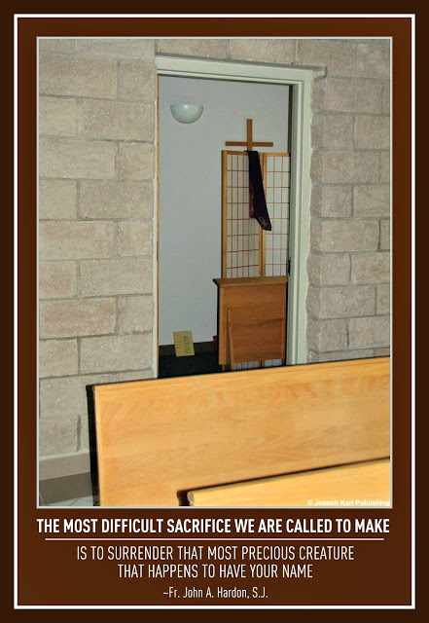

THE DREAM OVERNIGHT ON APRIL 4, 2020 AS CHURCHES AROUND THE WORLD INCLUDING HERE IN THE UNITED STATES INCLUDING HERE IN CATHOLIC DETROIT ARE CLOSED BECAUSE OF WHAT WE ARE TOLD IS A VIRUS WHICH WE ARE TOLD IS CONTAGIOUS
Overnight you found yourself inside a church that appeared unfamiliar.
WHO WAS THERE
You entered into the church with your late sister who was brutally martyred by the allopathic modern medical system beast; she died at the age of 48 on the Feast of Saint John of the Cross in the year 2011.
It was around that time that I AM re-introduced His Work of Reparation to the Holy Face of Jesus in our time here in Catholic Detroit, through Christ's Traditional Catholic Sacred Priesthood, for the sake of a world in very serious grave peril.
In the dream, which was very serene, so supernaturally peaceful and even joyful, your sister and you walked into the church together and knelt side by side among the people as others entered also to assist at the Holy Sacrifice of the Mass.
It was not made known if this church had a High Altar or not, or if the celebration of the Holy Sacrifice was a Traditional Tridentine Holy Sacrifice of the Mass or the Novus Ordo Mass manifested in Modern Times.
The focus was on what happened during Holy Communion.
WHAT HAPPENED DURING HOLY COMMUNION
So the type of celebration, Traditional or Modernist, had not been manifested in the dream and all of a sudden it was time for Holy Communion.
The people on the left side and on the right side of the church rose row by row from their pews and moved toward the center isle to approach the altar in two lines.
There were four sections in the church and everyone moved toward the two lines that had formed in the center isle.
Your sister and you had been kneeling in the second section, to the far right but on the left side right next to the isle.
THE WOMAN AND THE MAN
Even though you were not kneeling in the back of the church, and although you joined others in your row who were moving toward the center isle to then approach the altar for Holy Communion, you somehow ended up being among the last ones in line.
Remember, you had been kneeling on the right side of the church and then approached a priest who was distributing the Sacred Host on the right side of the center isle. He is a priest at All Saints Parish in another state.
How happy you are to be in church for the Holy Sacrifice of the Mass, and to now receive our Lord's Real Presence in the Blessed Sacrament!
When there was one person left between you and the priest distributing Holy Communion in the line on the right, you suddenly found yourself moving to the line on the left because there was no longer anyone in that line.
So while following along in the dream with such awe and with wonder as in so many dreams of the past decade in particular, you suddenly found yourself at the front of the line on the left and standing in front of A WOMAN.
KEEP IN MIND FOR THE PURPOSES OF THIS TRADITIONAL CATHOLIC MYSTICAL WEDDING THEOLOGY LESSON FOR EVERY SOUL THAT IN A WAY THIS STUDENT TEACHER CAREGIVER USED TO BE THAT WOMAN
After having been born in the mid-60s and raised by devout parents in the Modernist desecrated version of Christ's Catholic Church in our time, having learned nothing about Christ's Traditional Catholic Church of the Ages and after having been called to attend the daily Holy Sacrifice of the Mass inside the chapel attached to the church right next door to your children's elementary school, you wanted to help out for God's greater honor and glory and then for the sake of all others.
One way that was encouraged there to do it was to distribute Holy Communion during Holy Mass during the week and on weekends and during the school Holy Masses.
Note there was never a school Holy Mass to celebrate Christmas at that modernist desecrated Catholic school run by two liberal nuns.
Again, at that time you had no idea what a mess things had become by Luciferian design and continued to seek what was God's will for your family.
Having a great devotion to the Blessed Sacrament thanks be to God, you thought you were helping by distributing Holy Communion.
That was fine to most people and even celebrated, but a few people who were older knew differently and thanks be to God these fine people objected and thanks be to God this student teacher caretaker listened.
Those devout people remembered a very different Catholic Church as children: a reverent and beautiful way of celebrating the Holy Sacrifice of the Mass that worshiped, served, and adored God alone; a veiled Tabernacle that was front and center on Mount Calvary inside God's House; Traditional Catholic priests; magnificent vestments; quiet in church; sacred music; nuns in habits; properly dressed people; and woman wearing veils in the Divine Presence of God.
It was at this time that the internet was getting going and so it was possible to use it for good and do research to learn of the Catholic Church's rich history which was stripped from Christ's Bride by the modernists serving the wrong master in Modern Times and which was very aggressively being kept from God's people.
HELP THAT HARMS AND CARE THAT KILLS
Note this student teacher servant thought at first that she was helping as Lucifer aggressively keeps people ignorant and misinformed, helping in church on Mount Calvary like the abortion crews think they are helping men, women, and families by killing children right inside Lucifer's deadly delivery rooms, helping like modern allopathic medical personnel distributing toxins as remedies while recommending and commiting unnecessary surgeries claim they help humanity while cashing in as all continue to suffer and get sicker and weaker. Fundraisers both religious and secular that prey upon hardship and tragedy to steal the money or worse yet acquire ever more money while promoting a love for money which is the root of all evil instead of refusing to trust in God and rely upon His Divine Providence. The list goes on and on and on and on.
Unholy self interest is never caring and this is the significant difference: God's people are willing to listen, learn properly, and be corrected while holding God's holy ground when it comes to His Truth. They uphold God above all. God is master, we are His creation, and without Him we can do nothing good.
Lucifer's people don't listen, aren't willing to learn properly, repeatedly cave in to grave and sinister evil for personal gain of all kinds, and refuse to be corrected. They hold themselves above reproach and are their own supreme authority, self elevated as god and as master. They know that by sacrificing their parish family or their family (selling them for 30 pieces of silver as they are repeatedly doing to Christ) that Lucifer will reward them, for now, especially well. So short-sighted.
NO LONGER THAT WOMAN BUT A REAL WOMAN OF GOD INSTEAD
Note this student teacher IN A WAY USED TO BE THAT WOMAN BUT IS THAT WOMAN NO MORE, thanks be to God, His Immaculate Mother, Saint Joseph, the Holy Angels, the Holy Saints, the Souls in Purgatory, and a handful of people with the courage to serve God first and foremost, particularly in church, just imagine, and to teach others correctly.
Now this person who knew nothing and who on her own can do nothing is Christ's Traditional Catholic student teacher servant and a representative of Almighty God's Work of Reparation to the Holy Face of Jesus in Modern Times, guided by the Holy Spirit and helped by the maternal intercession of the Immaculate Mother of God, the Virgin of the Globe and our Protectress, and the paternal intercession of holy husband and father Saint Joseph, Patron of the Dying.
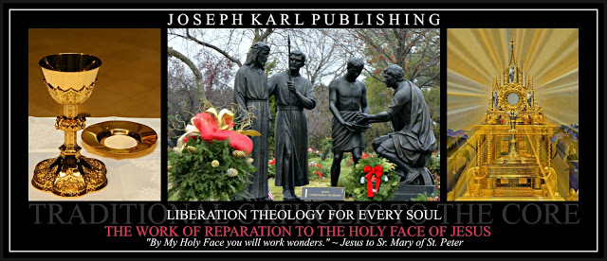

WHO THE TWO PEOPLE WERE BEFORE THE ALTAR THAT WERE DISTRIBUTING THE SACRED HOST

The priest is someone you know of but have never met, a good priest who celebrates the Holy Sacrifice of the Mass in English but faces east, who knows Latin and offers Holy Mass and Holy Hours/Eucharistic Adoration live online during this time of chastisement when so many churches worldwide have been closed by government mandate.
The woman is someone you did not recognize; she is a metaphor. So is the man.
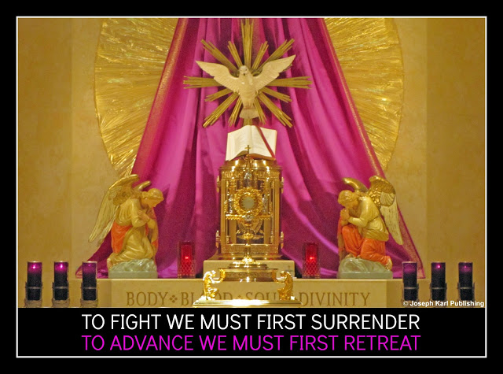
SOMETHING NOTEWORTHY ABOUT THE WOMAN
She was in awe of you.
Remember, you represent I AM's Work of Reparation to the Holy Face of Jesus in Modern Times.
The history of the Work of Reparation to the Holy Face of Jesus.
Awe should be reserved for God alone. Respect should be granted to all.
Especial respect may go to God's wonderful work through those who listen to Him and who do as He says.
WHAT HAPPENED NEXT

The following happened so quickly, after having suddenly found yourself toward the front of the line while also the end of it, note the metaphor, and after suddenly having changed lines.
As you did so, after having spotted the woman distributing the Blessed Sacrament with her unconsecrated hands, you thought to yourself while still filled with supernatural joy and serenity, that you would not choose to receive the Blessed Sacrament from a woman.
Noticeably absent was the Precious Blood, the second Sacred Species of the Blessed Sacrament, during Holy Communion indicating the celebration of the Traditional Tridentine Holy Sacrifice of the Mass although the presence of the woman did not and everyone received Holy Communion while standing.
So what was manifested is the presence in our time within Christ's Catholic Church almost everywhere is a combination of truth and of error.
This is not the case in exclusively Traditional Catholic Churches.
Note that humans have a fallen human nature and none are perfect and we are subject to error and while we are members of the Mystical Body of Christ we are not Christ's Catholic Church per se.
We may introduce error but Christ is error-free.
THE HUGE SACRED HOST IN THE HANDS OF THE WOMAN
So after suddenly approaching the woman and while standing before her, while taking in everything with such awe and with wonder, one incredible thing after another, and after noting that she seems so happy to see you and is in awe of you, she holds up the largest Sacred Host you have ever seen.
It is the One held up by the Traditional leaning priest during the Consecration (which was not manifested during the dream), this was made known to you instead, and now she holds it up in her hands as if hosting her own private elevation right then and there prior to your receiving Holy Communion.
She is incredibly eager to give this particular huge Sacred Host to you and she turns with it and breaks it into several pieces as you stare at the Sacred Host in awe.
Then she stops breaking the Sacred Host, it is in two pieces of two, but even in quarters the Sacred Host is absolutely huge.
You thought she was going to break off a personal sized piece and there is no way you can properly consume such large Pieces.
How happy you remain to be receiving our Lord's Real Presence in the Blessed Sacrament!
How much you don't want to draw attention to yourself but this has not happened to anyone else.
CHRIST'S REAL PRESENCE EAGERLY HANDED TO YOU AND IN INCREDIBLY HUGE PIECES
You found yourself suddenly HOLDING CHRIST IN YOUR UNWORTHY HANDS and in such superabundance.
Imaginer.
JESUS CHRIST ALL OVER THE FLOOR
You also noticed while the woman was BREAKING THE DIVINE SUPERNATURAL BREAD OF LIFE that she also dropped pieces of the Sacred Host on the floor.
There were not altar boys and no patens to safeguard our Lord and Redeemer's Adorable Real Presence from this degradation.
WHAT HAPPENED NEXT
So you knelt down and began gathering up the pieces of our Lord's Sacred Flesh that had fallen to the ground as the woman protested.
As you continued to do so, more and more of our Lord's Sacred Flesh appeared all over the ground.
Desecrated inside His Own modernist desecrated Catholic Churches.
Fallen to the floor, left on the carpet, and even trampled upon.
Imaginer.
A CONSECRATED HELPING HAND
The priest had left his place for some reason as this was occurring and when he returned he saw what was happening and was delighted to see what you were doing, note this is a metaphor.
He then came and began very happily helping you.
He represents priests trapped inside the modernist desecrated belly of the beast who are eager and willing to help with the restoration of Christ's Catholic Church in our time.
Together, you worked side by side helping, him from before you and you from behind him.
THE TWO KINDS OF WOMEN AND THE TWO KINDS OF MEN

The two kinds of women are: those who worship, adore, and serve God alone and those who don't.
The same goes for the men, and they are our leaders.
Remember, the snake tempted Eve first. Guess what she did next. Just guess.

26. The Miraculous Multiplication of the Bread and the Fisherman
So many good things have come from this great chastisement in Modern Times already as Jesus Christ remains with His people in an especial way, in good times and in bad, in simplicity, in sickness and in health, as long as we live. Imaginer. + "By My Holy Face you will work wonders, appease the anger of God, and draw down mercy on sinners." ~ Jesus to Sr. Mary of St. Peter
THE CROWN ONE'S SELF WITH MANY CROWNS PESTILENCE IN MODERN TIMES
So contagious are Lucifer's lies.
GOD'S SACRIFICIAL TRUE LOVE IS FREE AND THERE IS AN UNLIMITED SUPPLY
True story.
ON HOW GOD'S PEOPLE ARE NOT BORED DURING THIS LUCIFERIAN WORLD-WIDE LOCKDOWN
One cannot be bored when one lives in the manner in which God intends for each one in particular and as God's people generally speaking.
Those who are bored don't know who they are.
GOD REMAINS WITH HIS PEOPLE AT THIS TIME IN AN ESPECIAL TRADITIONAL CATHOLIC MYSTICAL WEDDING THEOLOGY FOR EVERY SOUL WAY
He remains with us always, as He promised.
Be willing. +

PART V

THE FIFTH STATION OF THE CROSS

SIMON THE CYRENE HELPS JESUS CARRY THE CROSS

27. The Imposter

28. Out of the Beast System 2020

29. Out of the Beast System 2020, Part 2

30. Corona-ed

31. The Divine Supernatural Consecration of Mankind's Future on Mount Calvary

27. The Imposter
He was manifested in a dream overnight following an unexpected encounter at 3 a.m. with Our Lady.

IN THE EARLY MORNING HOURS OF HOLY THURSDAY, 2020
Your right shoulder is paining considerably and as time passes you find yourself wide awake, unable to sleep.
AT 3 A.M. ON HOLY THURSDAY MORNING, 2020
Sleep just isn't coming. Then at 3 a.m. you have the clear indication that you are to go into the office and get a book from there.
What book?
Go get the book.
"GO GET THE BOOK"
Go get the book.
What book?
Go get the book.
Then our Lady's presence is manifested, present yet unseen, and she has you get the book your mother gave you about Saint Catherine Laboure that contains the account of Our Lady of the Globe and the Miraculous Medal.
So be it.
You get the book and take it to bed and read it once again.
Remember, Saint Catherine Laboure faced resistance from her superior as she attempted to fulfill her God-given Apostolic Mission through Our Lady.
After reading it as Our Lady desired, and after being allowed to then sleep, it seemed that our Lady was going to come again during the early morning hours of Holy Thursday 2020.
"Trust all things to Jesus in the Blessed Sacrament and to Mary, Help of Christians, and you will see what miracles are." ~ Saint John Bosco
Then, the following happened.
THE DREAM OVERNIGHT AND THE MANIFESTATION OF THE IMPOSTER
Once again on this night there were many dreams while making reparative atonement to Divine Justice, particularly both knees.
Then, there was this final one.
You find yourself inside what appears like a home and it is unfamiliar.
It is a two story building that also has a basement, and it is compact.
You find yourself in the company of a young boy.
You find yourself WITHIN A FAMILY UNIT.
Then the good father of this family is manifested, a handsome holy man with dark hair that appears young, not in His 20s but younger than middle aged.
He is holy and good, this man.
Then, you find yourself standing before a staircase that leads to a basement, before an open door.
You sense great danger.
The basement is illuminated and you sense danger coming from it.
The holy head of the family, who may represent a father leader or a Father leader or a world leader, is suddenly replaced by an imposter.
This imposter is coming.
You look into the illuminated basement and sensing grave danger expect him to come from there.
Still in the presence of the young boy, you see a staircase to your left leading to a second floor.
The imposter comes from there.
He descends the staircase and stops in front of you.
THE IMPOSTER
The man who appears unfamiliar looks right at you; he is evil to the core, he is arrogant, and he is without conscience.
He is very dangerous, this imposter.
Yet you are not afraid.
Apostolic Mission.
"By My Holy Face you will work wonders, appease the anger of God, and draw down mercy on sinners." ~ Jesus to Sr. Mary of St. Peter
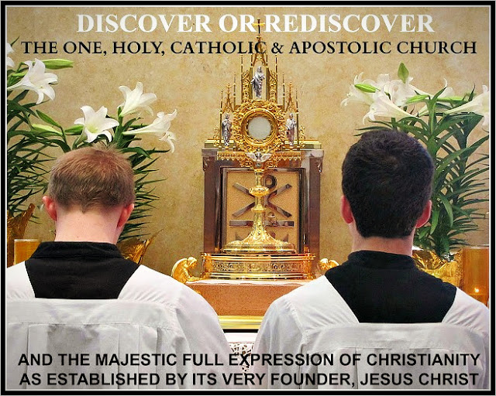

THE APOSTOLIC MISSION OF FRANCE (WITH WHOM WE ARE CONNECTED HERE IN TRADITIONAL CATHOLIC DETROIT, MICHIGAN, U.S.A. IN MODERN TIMES THROUGH I AM'S WORK OF REPARATION TO THE HOLY FACE OF JESUS FOR THE SAKE OF THE WHOLE WORLD WHICH IS IN VERY SERIOUS GRAVE PERIL) IN THE 1800s, AND BEFORE
The Apparition of the Holy Rosary
Our Lady first appeared to religious founder Dominic Guzman in 1208 in the Church of Prouille, in Languedoc, France, considered the “cradle of the Dominicans.” Legend has it that Saint Dominic received the Rosary there, which became the tool of the Dominicans in battling the Albigensian heresy, rife in that area.
1664: Our Lady Appears to a Shepherdess
More than 450 years later our Lady came again, in a small Alpine village of Laus.
In May 1664, 17 year old shepherdess Benôite Rencurel first saw a lady in dazzling white, carrying a child, while tending sheep. When she naively invited the Lady to share her hard bread, the Lady ‘smiled silently and disappeared into a cave.’
For the next few months, Our Lady appeared to Benôite each day, encouraging her to pray continuously for sinners. She revealed her name as ‘Mary — Reconciler and Refuge of Sinners.’
St. John Vianney, Patron Saint of Parish Priests, was transferred to Ars in France in the year 1818 where he battled for souls against the devil.
Catherine Laboure: in 1830 Our Lady appeared three times to this sister of the Daughters of Charity, a nursing order founded by St. Vincent de Paul, as Our Lady of the Immaculate Conception, Our Lady of the Chair, Our Lady of the Globe, Virgin Most Powerful, and the Miraculous Medal.
Sr. Mary of St. Peter, Tours: Carmelite nun visited by Jesus who for five years beginning in 1844 until her death was instructed by Him about I AM's Work of Reparation to the Holy Face of Jesus (Sacred Heart, Divine Mercy, and Holy Face).
Lourdes: Our Lady appeared 18 times to Saint Bernadette beginning in 1858.
The Devotion to the Holy Face of Jesus was intended to change the face of the earth...
​
Venerable Leo Du Pont (1797 - 1876) is known as the Apostle of the Holy Face of Jesus and established the three-in-one Devotion in his home following the passing of Sr. Mary of St. Peter at her Carmelite convent.
​For thirty years, miracles took place inside his home on a daily basis as people came seeking the intercession of our Lord, and people around the world who requested it were sent oil from the lamps that burned perpetually by Venerable Du Pont at his own expense as the widower (whose wife passed away when his daughter was very young and whose daughter passed away as a teenager) dedicated his life to teaching others about and promoting I AM's Work of Reparation to the Holy Face of Jesus.
​While Leo was on his deathbed in 1976, the new Archbishop of Tours lifted the interdict on the revelations of our Lord to Sr. Mary of St. Peter which had been buried for thirty years by the previous prelate.

28. Out of the Beast System 2020
Out of the darkness underneath the banner I AM'S WORK OF REPARATION TO THE HOLY FACE OF JESUS. Oorah! "By My Holy Face you will work wonders, appease the anger of God, and draw down mercy on sinners." ~ Jesus to Sr. Mary of St. Peter +

It is no mere coincidence that this is the title provided from On High,
for the most recent
Traditional Catholic Mystical Theology Lessons for Every Soul
from here in Traditional Catholic Detroit -
through Christ's Traditional Catholic Sacred Priesthood -
for the sake of a world in very serious grave peril,
just before the Luciferian scamdemic fakedemic rolled out worldwide,
forcing people from Christ's Catholic Churches,
from His Sacraments,
from their jobs,
from most places,
and from one another.
SUDDENLY, THE WORLD WAS IN TIME-OUT.
The day before the modernist desecrated Catholic Churches
eagerly closed here in Michigan,
suddenly and without warning (hush hush)
after having squeezed every last dollar from Christ's suffering people
and after having arrogantly kicked God's people
out of His own Houses first (what wonders),
the day before a massive planned deception labeled a contagious virus
was unleashed one blatant lie after another like sinister falling dominoes
that had been laid out worldwide on a flat plane
along a 5G spy and kill control grid,
Saint Francis appeared inside a certain chapel
and made it clear something very significant
was about to happen
and then it did.
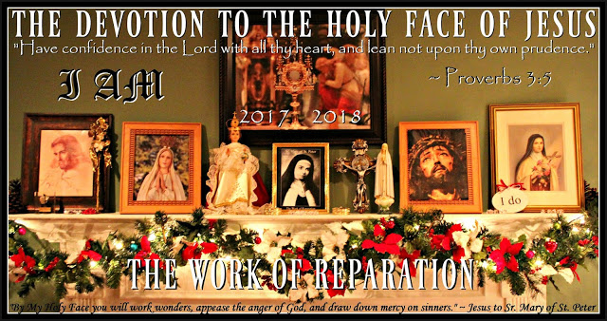
Remember, in 2012 I AM
re-introduced His Work of Reparation to the Holy Face of Jesus
in our Modern Times
at the Slovak parish of His choosing
- during the Great Seven Year War for Souls there (2010 - 2017) -
in Modernist Desecrated Catholic Detroit,
through Christ's Traditional Catholic Sacred Priesthood,
for the sake of a world in very serious trouble.
The modernists finally had enough of all that holiness
there on Mount Calvary during the Holy Sacrifice of the Mass
and Eucharistic Adoration
and very publicly
(the event had been pre-planned like this incredible scamdemic)
threw God's Work out of Church in 2017
with the help of two very angry modernist desecrated, self interested priests
and two clueless policemen (2/2)
Once again, as they do quite regularly,
those serving Lucifer in God's Most Holy Name
threw our Triune God out of His Own House
right along with His Divine Supernatural Remedy
which spends itself as Almighty God wills,
guided by the Holy Spirit,
as One with Christ crucified.
There is no money to be lusted after
through I AM's Work of Reparation to the Holy Face of Jesus
which spends itself as Almighty God wills for each one
in union with Christ crucified on Mount Calvary for our Redemption,
and Lucifer does not value self sacrifice.
Nor does Lucifer care for Our Lady.
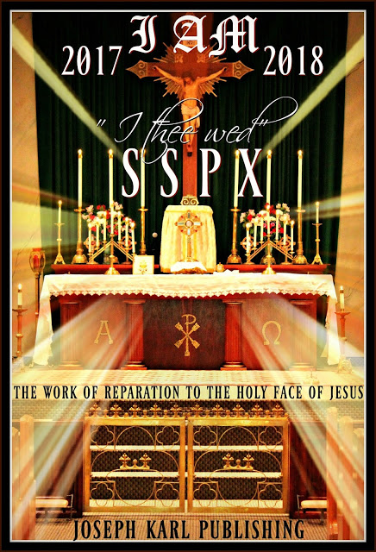
A few months later, in mid-2017,
I AM allowed His Work of Reparation to the Holy Face of Jesus
to be brought to Saint Joseph's Catholic Church in Metropolitan Detroit
and there He suddenly Divinely Supernaturally wed It
during the Traditional Tridentine Holy Sacrifice of the Mass
in the holy silence and in the holy reverence
to Christ's Traditional Catholic SSPX
on Mount Calvary, imaginer,
for His Greater Honor and Glory first and foremost
and then for the sake of the whole world in our time.
IT WAS BEAUTIFUL BEAUTIFUL BEAUTIFUL BEAUTIFUL.
Almighty God asked that His Work of Reparation to the Holy Face of Jesus
be established there at Christ's exclusively Traditional Catholic Church
for the greater honor and glory of God first and foremost
and then for the sake of the whole world in our time,
while Lucifer continued to roll out his catastrophic eugenics plan
and an unfathomably powerful kill control grid,
but it wasn't.
Instead, His leaders requested a fourth miracle.
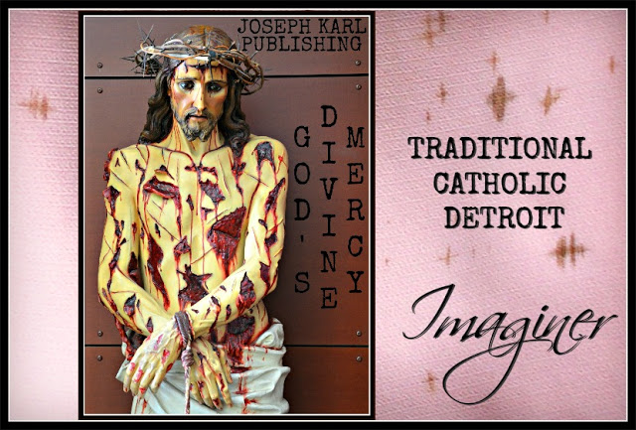

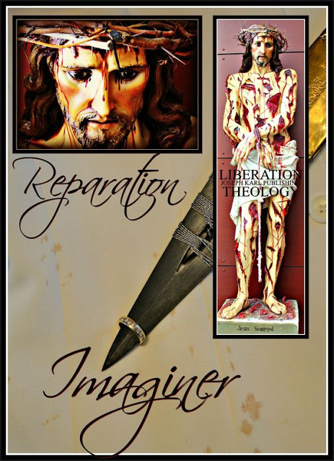
How many miracles do we need?
When is your next fundraiser instead.
Yes, discernment is essential
AND
God's people listen to Him and they do as He says,
without counting the personal cost (which is total)
and with purity of intention, devoid of self interest,
and while having no idols before Him,
in imitation of Christ crucified and in imitation of
His Immaculate Mother and Saint Joseph
AND WITH FAITH THE SIZE OF A MUSTARD SEED.
Please join us.
"...blessed are they that have not seen,
and yet have believed" (John 20:29).
2 0 2 0
(2/2)
Now, seemingly all of a sudden,
many are without the opportunity to work
and without the ability to support themselves,
as if they had been able to do that before
as part of a modern day Luciferian inspired slave labor work force
while the price of everything keeps increasing to the point of being unaffordable,
as the gangsters of all kinds demand payment first,
leaving not enough earnings for most people to survive on
after having worked hard all week and without proper rest and relaxation.
Humanity's dept, and its enslavement, kept increasing.

Suddenly many people were without work,
that is, the people who could even get jobs,
people willing to forsake God,
keep their mouths shut and do as they are told
without critically thinking
as their input and creative gifts were not welcome
in Luciferian slave labor concentration camp corporate America
where self is god and the love for money is the root of all evil.
Going going gone were compassion,
courage,
full time opportunities,
necessary breaks,
the opportunity to work hard and support one's self,
the opportunity to share one's God-given gifts as God intended,
the opportunity to work hard and save money,
the opportunity to work hard and start one's own business.
Lucifer hates holy competition.
Professed elected officials have no fake stimulus package,
which by the way is hard to acquire, solves nothing, and pays for very little,
for the people who were unemployable
inside Lucifer's Modern Day Beast System
because they worshiped, served, and adored GOD ALONE.
They, like Jesus, have nothing and rely on God's Divine Providence
for holy assistance,
always so eager to share what they have been given.
In our Triune God we totally trust to provide for us,
not beasts who are so incredibly self interested and short-sighted.
Who wants to go to hell forever, for a dollar?
"As for me and my house, we serve the Lord" (Joshua 24-15).
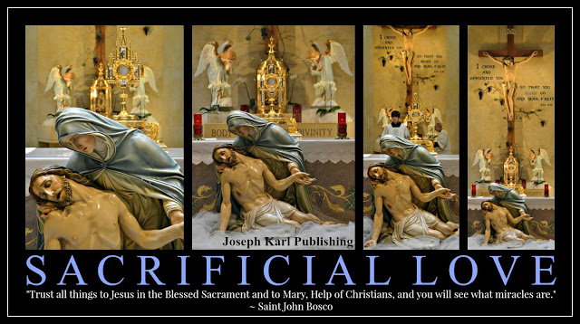

LUCIFER CONTINUES THROUGH TIME
SEEKING TO INVERT
ALL THAT IS GOOD AND HOLY AND TRULY HAPPY
INCLUDING THE WAY GOD INTENDED HIS CREATION TO LIVE,
THE HUMAN RACE CREATED IN HIS IMAGE AND LIKENESS
TO LOVE, HONOR, SERVE, AND ADORE HIM ALONE,
TO LOVE ONE'S NEIGHBOR AS ONE'S SELF,
AND TO GLORIFY HIM IN HEAVEN FOREVER.
Leadership positions everywhere dramatically changed in our time,
as they have throughout human history,
and were increasingly occupied by self interested yes-people
eager to hold a title at the expense of their fellow man
and their own precious, priceless, and immortal soul,
while remaining expendable at any given time themselves,
for people in the beast system have no value
and Lucifer is a master liar and deceiver.
MANY, MANY PEOPLE REPEATEDLY TAKE HIS MASTER CLASSES.
He promises them money, social influence, likes, power, money,
material goods, titles,
and eternal damnation in hell forever
without God in the presence of eternal regret.
True professionals and holy people were unwelcome
and not just at work but just about everywhere else.
SO MANY PEOPLE HAVE SO MUCH TO HIDE!
So many people have been mind controlled to fall in love with money;
yet so many people have been chronically without it!
Imaginer.
So so many lost sheep, so so very few good shepherds.
Lucifer's people of all ages, walks of life, ethnicity, gender,
and professed faiths
keep celebrating their victories;
SO SHORT-SIGHTED.
Hell is filled with winners
and heaven with losers.
Our chastisement for such epidemic lack of courage
and for the absolutely pandemic amounts of self interest in our time
is a loss of our God-given liberties.
Let us thank God for everything, particularly the opportunity and the time
to repent for our sins AND to make reparation for them.
GOD PLEASE GRANT US THE WISDOM TO KNOW WHAT THEY ARE.
Lucifer wants us to WANT IT ALL WHILE HAVING NOTHING GOOD,
and after having turned one's back on God
(when He is always willing to provide us with the grace and courage to do as we should)
HE WITHHOLDS HIS DIVINE SUPERNATURAL PROTECTION
FROM OUR ENEMIES.
I AM had this communicated multiple times
to the Slovak pastor with an Apostolic Mission in Modern Times;
the part Traditional, mostly modernist desecrated priest
was warned repeatedly beforehand
that this would happen as in the time of Moses
if He did not do as I AM said and establish
The Work of Reparation to the Holy Face of Jesus
inside God's House,
requiring no money,
and then in 2017 it did.
It was already common knowledge that the forces of darkness within
had and continued to target Traditional Catholic Priests.
Lucifer doesn't like them.
The Slovak pastor was told that a great big CROSS
was going to appear before him
and he was going to have to carry It
but God's people would help him.
Imaginer.
Then it happened.
He was kicked out of the country
and then publicly humiliated, in his absence, in front of his parish family
by sinister men working for Lucifer who have harmed so many
while speaking with forked tongues,
outfitted in the garments of Christ's shepherds.
When will we be willing to learn from history.
There is no time for proper learning in Lucifer's Modern Day Beast System.
Hopefully the Slovak pastor has had some time to think.
OUT OF THE BEAST SYSTEM 2020
Now, and it happened so suddenly
after having been so carefully planned by Lucifer's followers in advance,
people are home with the opportunity to live as God intended,
loving the God they don't even know first and foremost,
and one's neighbor as one's self,
with the time to think for themselves
if they even know, or can remember, how to think for themselves.
"LOVE ONE ANOTHER AS I HAVE LOVED YOU" (JOHN 13:34).

God as always is the only one who can Divinely Supernaturally help us
as humanity is fed with one staggering lie after another
by Lucifer's corrupted to the core world leaders and local politicians,
by Lucifer's corrupted to the core mass media,
by Lucifer's corrupted to the core corporate America,
by Lucifer's corrupted to the core medical industrial eugenics complex,
by Lucifer's corrupted to the core controllers of the world's food supply,
by Lucifer's corrupted to the core academicians and scientists and educators,
by Lucifer's corrupted to the core entertainment and professional sports industries,
and by Lucifer's corrupted to the core professed church leaders.
Without God, no one is capable of doing anything good.

Let us fall on our knees before
our lavishly loving Triune God
and love Him properly.
Let us worship, adore, and serve HIM ALONE,
surrender ourselves to Him properly,
and accept His magnificent offers of sanctification,
eternal salvation,
true happiness, and a life that really matters
because it is lived in the manner in which He intends for each one.
Our human rights are GOD-GIVEN,
NO ONE CAN EVER TAKE HIM FROM US,
AND WITH HIM WE REMAIN TOTALLY FREE COME WHAT MAY.
Our Lady, Virgin of the Globe,
and holy husband and father Saint Joseph,
pray for us and help guide us.
Go, Team.
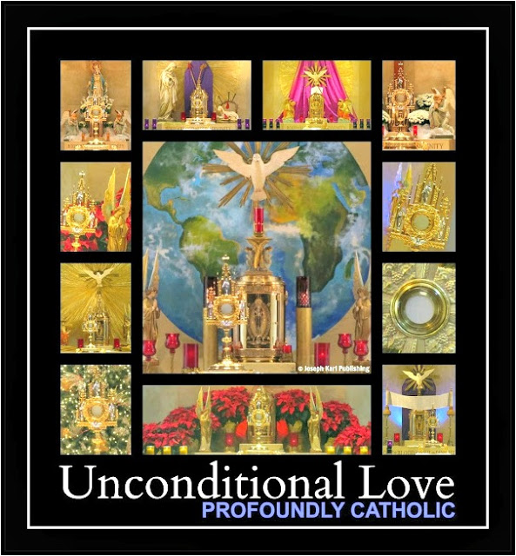

AN IMPOSTER IS COMING AND HE WILL SPEAK WITH A FORKED TONGUE FILLED WITH LIES AND EMPTY PROMISES. MANY WHO HAVE BEEN MIND CONTROLLED INTO CRAVING QUICK FIXES THAT ONLY CAUSE MORE PROBLEMS WILL BE FOOLED AND LED FURTHER ASTRAY. SO SHORT-SIGHTED.

LOVE OUR DIVINE TRIUNE GOD FIRST AND FOREMOST; LOVE ONE ANOTHER AS ONE'S SELF.
REMEMBER THAT ONE'S PLACE IN ETERNITY WILL LAST FOREVER AND EACH ONE SHALL REAP WHAT EACH ONE HAS SOWN.
Out of the beast system 2020 to live the way God intended, as people are kept out of God's House and away from the Sacraments including the Blessed Sacrament, the Compendium of All Miracles and Greatest Source of Grace we have on earth, and as seeds that produce food are banned by one professed leader after another.
OUR LEADERS SEEK TO STARVE US ALL TO DEATH, BOTH SPIRITUALLY AND PHYSICALLY, IN LUCIFER'S SERVICE.
Imaginer. +
WE DO NOT CONSENT TO GRAVE AND SINISTER EVIL.
"Trust all things to Jesus in the Blessed Sacrament and to Mary, Help of Christians, and you will see what miracles are." ~ Saint John Bosco +

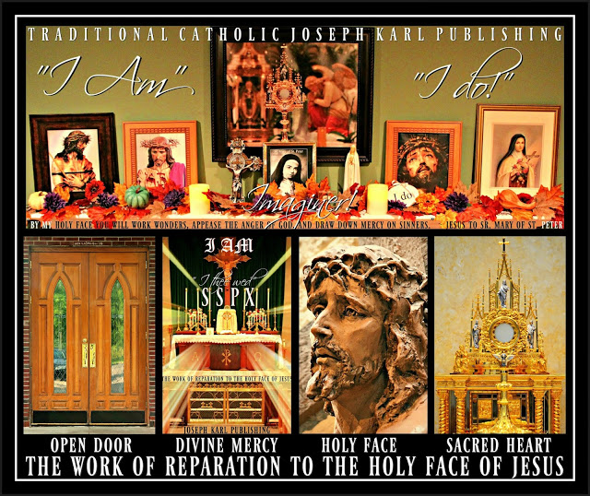

29. Out of the Beast System 2020, Part 2
They are sterilizing our children with the poisons in vaccines, in the tech, in the food, water, and in the air...in the drug cartel poisons pushed on the people as remedies, etc., because those working for the wrong master don't like people and they want the next generations of mankind created in the way God intended GONE so they can decide who gets created and how, so they can make them in the image and likeness of the beast (through self interest) and so future humanity is no longer 100% human but will be part machine. All who are living and know the ways of God and who worship, serve, and adore GOD ALONE: they want us all gone. WE DO NOT CONSENT TO THIS GRAVE AND SINISTER EVIL. + In God we totally trust to deliver us from this grave and sinister evil through I AM's Work of Reparation to the Holy Face of Jesus and the maternal intercession of the Immaculate Mother of God. "By My Holy Face you will work wonders, appease the anger of God, and draw down mercy on sinners." ~ Jesus to Sr. Mary of St. Peter LIFT HIGH THE CROSS, THE LOVE OF GOD PROCLAIM!! Go, Team.

30. Corona-ed
On this night while at the Kroger superstore, an enslaved shopper whose face was covered with a mask as he pushed his cart through a frozen food isle in the mostly empty store (it was going to close soon, several hours than normal because of what we are told is a pandemic) informed me that I was GOING DOWN THE ISLE IN THE WRONG DIRECTION! What wonders!
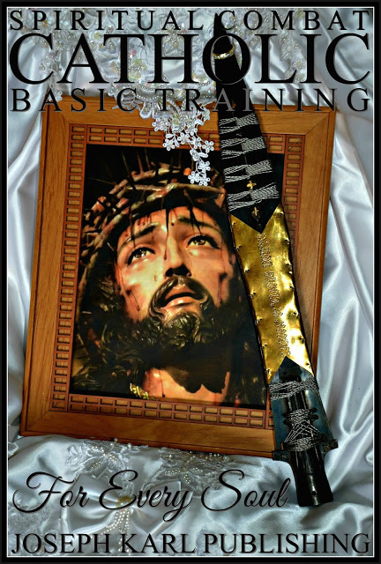

He pointed to the large arrows taped to the floor and so now it is ONE WAY ONLY down the isles at this store here in metropolitan Detroit.
Now people have to walk in the direction the controllers have chosen if we hope to acquire food to survive.
I refused to comply with this diabolical agenda, and said the other way to resist this agenda that hates mankind because it hates God is to only buy things at the ends of each isle.
Imaginer. +

WE DO NOT CONSENT TO THIS GRAVE AND SINISTER EVIL
This is just another manifestation of the evil so rampant in our time, and humanity is reaping what humanity has been sowing after having epidemically, pandemically, and very dangerously (not to mention short-sightedly) corona-ed itself with incomprehensible amounts of self interest, idolatry of so many kinds it boggles the mind, and a love for money which is the root of all evil.
This is just another manifestation of the battle of good versus evil throughout human history, and the quest for the eternal outcome of every precious and priceless immortal soul.
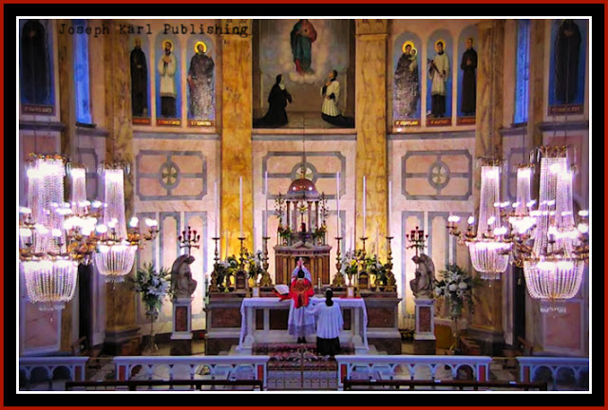
The Traditional Tridentine Holy Sacrifice of the Mass
at 3 a.m. U.S. time on April 22, 2020,
Sacred Heart Parish, Limerick, Ireland, ICKSP.

BEAUTIFUL BEAUTIFUL BEAUTIFUL BEAUTIFUL
So grateful.
JESUS CHRIST IS THE CORRECT DIRECTION, AND THE WAY + THE TRUTH + AND THE LIFE + IN WHICH WE MUST BE HEADING
Love Him, honor Him, and follow Him, Jesus Christ the Second Person of the Most Holy Trinity and our Divine Sovereign High Priest, Divine Redeemer, Divine Restorer, Divine Remedy for All, Divine Bridegroom of Every Soul, and the Lamb of God Who takes away the sins of the world, along the Way of the Cross all the Way to Mount Calvary all the days of your life.
I was at Trader Joe's and at Gordon's on Monday morning and wore a fine new Saint Benedict Crucifix, and one person after another commented on it and expressed their respect for Christ.
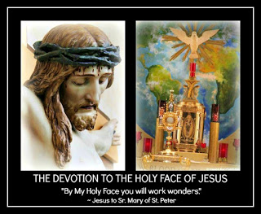
RIGHT DIRECTION.
Go, Team!
Not long ago, before this wicked to the core false and predicted programming narrative unleashed an entire new and massive level of gaslighting and diabolical mind control worldwide, very few people would even make eye contact out in public let alone return a friendly smile or hello.
Let us resolve to improve for good and not just temporarily, when we can't have what we want.
THANKS BE TO GOD FOR EVERYTHING, INCLUDING THIS OPPORTUNITY TO PROPERLY REST OUTSIDE OF THE BEAST SYSTEM OF HUMAN ENSLAVEMENT (CORPORATE AND MODERN MEDICAL AMERICA), TO PROPERLY THINK AND DEVELOP A PROPER RELATIONSHIP WITH OUR LAVISHLY LOVING GOD, TO REPENT FOR OUR SINS, TO GLADLY MAKE REPARATION FOR THEM, AND TO STRIVE AT ALL TIMES TO ACCOMPLISH HIS WILL WHILE TOTALLY TRUSTING IN HIM ALONE, COME WHAT MAY, FOR HE IS THE DIVINE HIGHEST POWER THERE IS AND HE ALWAYS SEEKS EACH PERSON'S GREATEST GOOD
Each one shall reap what each one has sown; each one decides to follow God or one's self (Lucifer) and both a life choice and also moment to moment.
Humanity sure has been detrimentally influenced by the forces of darkness, for generations and
unfathomably in so many sinister ways.
The world becomes more and more Luciferian inverted by the day, even by the hour in 2020.
The late Servant of God, Father John A. Hardon, S.J. said prior to the year 2000 that "we are a hypnotized nation" and that was after television and mass marketing, but even before the rise of the internet which like anything can be used as a tool to serve God as He wills and for His greater honor and glory first and foremost, with purity of intention and devoid of self interest, and then for the sake of using one's God-given gifts to help one's fellow man not just during this life but to help one's brothers and sisters get to heaven.
The tech sure has been a staggeringly powerful weapon in the hands of the enemy and his legions including the masses who buy into his lies of false grandeur, acquiring ever more money at everyone else's expense, false power, corrosive arrogance, insatiable lust of various kinds, the self interested misuse of knowledge and information, the accumulation of worthless acclaim, and the shepherd-less loss of one's sense of proper direction within endless detrimental and time consuming distractions.
Time is precious.
In God we totally trust, as always, to help us.
Dear God send us priests.
Dear God send us many priests.
Dear God send us many holy priests and religious vocations.
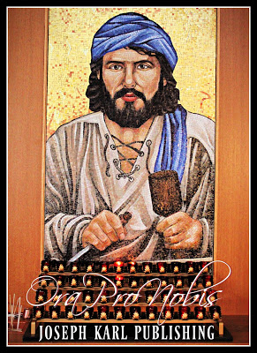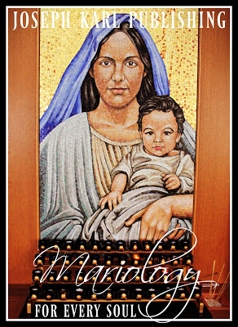

OUT OF THE BEAST SYSTEM 2020: CROWN CHRIST WITH MANY CROWNS
God is the only One we should be worshiping, serving, and adoring, NOT ourselves and not anyone else either including Lucifer.
To be in love with our Triune God first and foremost and to properly care for one's fellow man while striving to accomplish the most perfect will of I AM at all times while following God's Commands (His Ten Commandments) is what it means to be totally free.
Strive to imitate Christ always; bring Him to everyone you encounter and even to those you don't.
Imaginer.
Go, Team!
Our Lady of the Globe, the Immaculate Mother of God, and holy husband and father Saint Joseph please pray for us and help guide us.
OORAH!
31. The Divine Supernatural Consecration
of Mankind's Future on Mount Calvary

It took place at 3 a.m. Detroit time on April 25, 2020, the Feast of Saint Mark (patron saint of imprisoned people) at the time of the Consecration during the Traditional Tridentine Holy Sacrifice of the Mass, through Almighty God's Work of Reparation to the Holy Face of Jesus and by Divine Decree, with the maternal intercession of the Immaculate Mother of God - humanity's Maternal Protectress and the Virgin of the Globe - for the sake of a world in very serious trouble. Imaginer. +
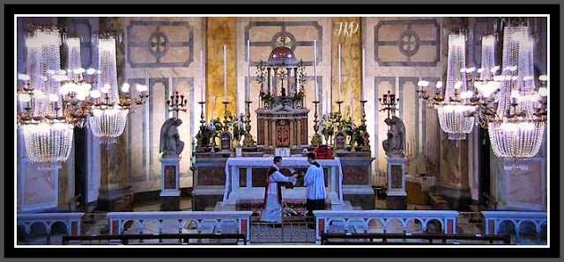
Sacred Heart Parish,
ICKSP,
Limerick, Ireland.
It was so incredibly
BEAUTIFUL BEAUTIFUL BEAUTIFUL BEAUTIFUL.
So grateful.
It took place suddenly
after it was made known that
there are two other men present
on Mount Calvary during each Holy Sacrifice of the Mass,
through time,
at the mystical re-presentation of Christ's
willing execution by crucifixion for our Redemption.
Who are they
during this time of lock down
when people are being kept from Christ's Catholic Churches
worldwide?
NO ONE CAN KEEP THEM OUT,
NOT EVEN DURING 2020'S DIABOLICAL
WORLDWIDE SOCIAL DISTANCING RESTRICTIONS.
They are:
THE REPENTANT THIEF
AND THE UNREPENTANT THIEF
and they remind us
IN THE DIVINE PRESENCE OF CHRIST
THE GOD-MAN,
OUR DIVINE REDEEMER,
DIVINE RESTORER,
AND DIVINE REMEDY FOR ALL
that each one of us has
A VERY IMPORTANT CHOICE TO MAKE.
What wonders;
WHO IS YOUR MASTER.
"By My Holy Face you will work wonders,
appease the anger of God, and draw down mercy on sinners."
~ Jesus to Sr. Mary of St. Peter

PART VI

THE SIXTH STATION OF THE CROSS

VERONICA WIPES THE HOLY FACE OF JESUS

32. Another Newborn Baby Overnight

33. Christocentric Apostolic Marian

34. I AM Draws Traditional Catholic Institute of Christ the King Sovereign Priest into His Apostolic Mission

35. God's Divine Wrath and the Modern Allopathic Medical Agents of Darkness

36. Heaven's Inner Circle

37. The Incredible Skyscraper in Church

38. The Flowers for My Mother in the Dream Overnight

32. Another Newborn Baby Overnight
There was another incredible dream overnight that included another newborn infant, another baby boy, and it was very beautiful beautiful beautiful beautiful. Guess what happened. Just guess. +
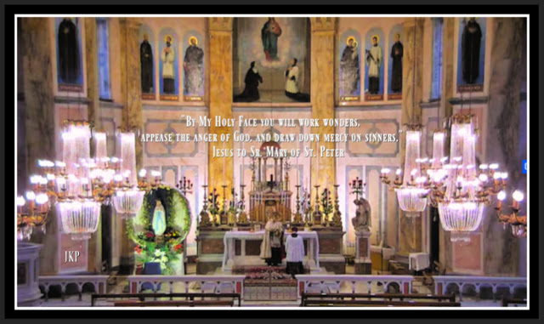
Benediction following the Traditional Tridentine Holy Sacrifice of the Mass,
Eucharistic Adoration, and the Holy Rosary of Our Lady
at 2 o'clock Detroit time on May 9, 2020.
THE DREAM OVERNIGHT ON SATURDAY, MAY 9, 2020 FOLLOWING THE THREE A.M. (DETROIT TIME) TRADITIONAL TRIDENTINE HOLY SACRIFICE OF THE MASS AT SACRED HEART CHURCH, ICKSP, LIMERICK, IRELAND
Once again overnight you found yourself in the care of a newborn baby boy and he is very beautiful.
You love him very much and are very happy to feed (nurse)/sustain him with your very own body.
There have been wondrous dreams that were very beautiful in the past week but there hasn't been time to write them out and if they are not written out, the supernatural wonders are lost to mortal memory.
WHO THIS BEAUTIFUL BABY BOY REPRESENTS DURING THE WORLDWIDE LUCIFERIANDEMIC OF 2020

This baby represents Christ's Sacred Priesthood in Modern Times, particularly Christ's Traditional Catholic Sacred Priesthood in Modern Times, and CHRIST'S TRADITIONAL CATHOLIC SACRED PRIESTHOOD IN MODERN TIMES WAS SUSTAINED IN THE DREAM OVERNIGHT BY A MOTHER'S MILK.
DIVINE SUPERNATURAL INTERVENTION
The MOTHER'S MILK represents I AM'S WORK OF REPARATION TO THE HOLY FACE OF JESUS and the SPENDING OF THE SELF AS HE WILLS FOR EACH ONE AND WITH PURITY OF INTENTION AND DEVOID OF SELF INTEREST WHILE HAVING NO IDOLS BEFORE HIM AND WHILE NOT COUNTING THE PERSONAL COST, IN IMITATION OF AND IN UNION WITH CHRIST OUR DIVINE REDEEMER CRUCIFIED, AS ONE FLESH WITH HIM AND ALSO ONE FLESH WITH HIS IMMACULATE MOTHER, for the sake of a modern world in very serious grave peril.
Imaginer. +
REMEMBER
When I AM re-presented His Work of Reparation to the Holy Face of Jesus in 2012 at the time and in the place of His choosing, in 2012 through Christ's Traditional Catholic Sacred Priesthood at the Slovak parish here in Modernist Desecrated and Luciferian corrupted Catholic Detroit (where God's people had been brutally suppressed by money-loving and self interested corruption from within even before 2020), He focused first on the proper holy restoration of Christ's Sacred Priesthood through His Work of Reparation to the Holy Face of Jesus, because they are our leaders and we need them to be holy and serving the right Master.
"Trust all things to Jesus in the Blessed Sacrament
and to Mary, Help of Christians,
and you will see what miracles are."
~ Saint John Bosco

33. Christocentric Apostolic Marian
Imaginer. + “Let us live as the Blessed Virgin lived: loving God only, desiring God only, trying to please God only in all that we do.” ~ Saint John Vianney
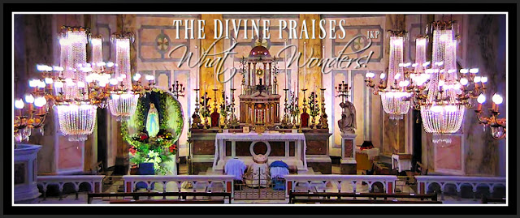
Eucharistic Adoration and Benediction
following the Traditional Tridentine Holy Sacrifice of the Mass
and the Holy Rosary of the Blessed Virgin Mary
at two o'clock p.m. Detroit time on May 11, 2020
at Sacred Heart Church, ICKSP, Limerick, Ireland.

BEAUTIFUL BEAUTIFUL BEAUTIFUL BEAUTIFUL.
So grateful.
“It is impossible to meditate with devotion upon the Mysteries of the Rosary
and live in a state of sin.”
~ Saint John Vianney
WHAT HAPPENED AFTER MISSING THE 3 A. M. TRADITIONAL TRIDENTINE HOLY SACRIFICE OF THE MASS WHILE MAKING REPARATION AS MOTHER'S DAY 2020 CAME TO A CLOSE AFTER HAVING CELEBRATED IT WITH THREE VERY WONDERFUL NOW GROWN CHILDREN, TRADITIONAL CATHOLIC DETROIT'S CHILDREN OF REPARATION

There was another dream overnight and it was filled with such incredible awe and with wonder and our Triune God continues to lead the way OUT OF THE BEAST SYSTEM 2020, through His Immaculate Mother the Virgin of the Globe.
CHRISTOCENTRIC APOSTOLIC MARIAN
After the churches closed by Luciferian design here in Catholic Detroit in early 2020, I AM took His Work of Reparation to the Holy Face of Jesus remotely to Sacred Heart Church in Limerick, Ireland, after having wed His Work to Christ's SSPX in 2017, after Christ's SSPX refused to do as I AM said, and after it had been very publicly (planned in advance) kicked out (thanks be to God) of the modernist desecrated hell hole Slovak parish at war with Traditional Catholics, in 2017 following the Modernist desecrated Holy Sacrifice of the Mass and during Eucharistic Adoration, imaginer, by two modernist desecrated communist priests and their clueless commie policemen serving Lucifer.
Unwelcome.
Question: Anyone who speaks and acts like a diabolical self interested and cowardly Communist serving Lucifer the wrong master is a...what.
Answer: A diabolical self interested and cowardly Communist serving Lucifer the wrong master.
Diabolical self interested and cowardly Communists serving Lucifer the wrong master CAN make the best Traditional Catholic converts, but that is their personal decision to make.
God allows those He created to make their own free will choices; Lucifer prefers to enforce his corrupted to the core prideful will on everyone else to cause harm, as do his followers.
One cannot serve two masters.
HOW IMPORTANT IT IS TO BE ABLE TO PROPERLY IDENTIFY WHO WORKS FOR GOD AND WHO DOESN'T
“JESUS CHRIST, after having given us all He could give, that is to say, the merit of his toils, His sufferings, and His bitter death; after having given us His Adorable Body and Blood to be the Food of our souls, willed also to give us the most precious thing He had left, which as His holy Mother.” ~ Saint John Vianney
May each one created by God out of His unfathomable love and generosity go to the Blessed Virgin Mary and ask her to lead us to Christ. She will.
Holy Family. +
“The Blessed Virgin is like a good mother who, not content with looking after all her children in general, watches over each one separately.” ~ Saint John Vianney
WHO ARE THE VOICES OF REASON IN MODERN TIMES?
They are not scholars, not university experts, not professors, certainly not puppet members of the mainstream media, not exalted self proclaimed scientists, not politicians, not idolators, and not actors but rather:
those who were kicked out of universities, families, and their churches; those who are NOT popular; NOT best sellers; and NOT fundraisers.
God's voices of reason in Modern Times and through all time are NOT popular.
They properly worship, serve, and adore GOD ALONE and always defend His honor, particularly in Church.
They tell the truth meaning God's truth and not one's own. They don't hide the truth and they don't manipulate data.
They properly teach others because they properly care for God first and then for all others.
They set a proper example, follow God's laws, are COUNTER CULTURAL, aren't materialistic, aren't in love with money which is the root of all evil, reject Lucifer's illusions of grandeur and engage in fierce spiritual combat.
They are fiercely PERSECUTED by the worldly and rejected almost everywhere BECAUSE THEY SELFLESSLY SERVE THE RIGHT MASTER IN IMITATION OF AND IN UNION WITH CHRIST AND HIS IMMACULATE MOTHER AND SAINT JOSEPH, with purity of intention and devoid of self interest and without counting the personal cost.
Oorah.
THIS IS HOW I AM'S WORK OF REPARATION TO THE HOLY FACE OF JESUS WORKS SO WELL THROUGH THE SPENDING OF THE SELF AS I AM WILLS FOR EACH ONE, IN IMITATION OF AND IN UNION WITH CHRIST OUR DIVINE REDEEMER, DIVINE RESTORER, DIVINE REMEDY FOR ALL, AND DIVINE BRIDEGROOM OF EVERY SOUL AS THE OUR LORD'S SHEEP AND LUCIFER'S WELL FUNDED GOATS ARE FURTHER DIFFERENTIATED IN MODERN TIMES

MANKIND'S MATERNAL PROTECTRESS, THE VIRGIN OF THE GLOBE
“Jesus on the Cross said to the disciple whom He loved: “Behold your Mother!” How sweet are those words to the Christian who is able to understand what depths of love they contain!” ~ Saint John Vianney
So during the Holy Sacrifice of the Mass, Our Lady the Virgin of the Globe (known more popularly through Saint Catherine Laboure) is manifested as One with Christ Her Divine Son who is AS ONE with the celebrant at the time of the Consecrations of both Sacred Species on Mount Calvary as Jesus just keeps coming and coming and coming and coming, truly and also spiritually, virtually, to those who are willing to listen to Him and do as He says.
Imaginer.
“Happy is he who lives and dies under the protection of the Blessed Virgin.” ~ Saint John Vianney
OUT OF THE SELF SERVING, MONEY LOVING, PRIDEFUL, TRULY IGNORANT, UN-COURAGEOUS, BORING, POISONOUS, ANTI-GOD, ANTI-HUMAN, EUGENICS, AND FORKED-TONGUE SPEAKING MODERN DAY BEAST SYSTEM 2020
Guess who else is manifested as One with them there before Christ's High Altar where heaven meets earth inside God's House on Mount Calvary.
Just guess.
Those who are willing to listen to Him and do as He says.
Go, Team.

May 12, 2020

34. I AM Draws Traditional Catholic Institute of Christ the King Sovereign Priest into His Apostolic Mission
For the sake of the whole world in our time. What wonders. + Out of the Beast System 2020. Oorah! "Trust all things to Jesus in the Blessed Sacrament and to Mary, Help of Christians, and you will see what miracles are." ~ Saint John Bosco

35. God's Divine Wrath and the Modern Allopathic Medical Agents of Darkness
Divine Justice is coming for those claiming to be in a helping profession when instead they have been destroying people for personal gain. What is being and has been done to us by these arrogant self proclaimed and systematically highly uneducated medical experts working for the devil is going to reach their own personal shores by their own corrupted hands after having sworn to "do no harm." Imaginer. + There is no big money for those who work in the vineyard of the Lord, for the love of it is the root of all evil.
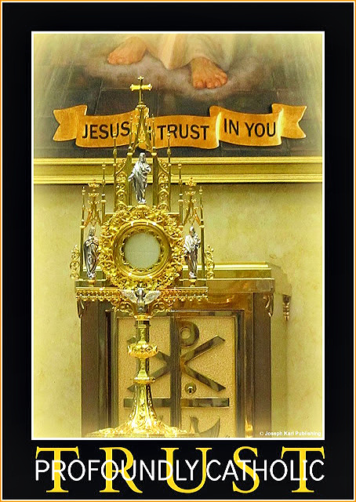

Once again there was a dream overnight with a very powerful message: when one turns one's back on God, He will not provide protection from one's enemies and EACH ONE SHALL REAP WHAT EACH ONE HAS SOWN.
THE DREAM OVERNIGHT ON MAY 13, 2020 WHILE MAKING REPARATION FOR CHRIST'S SACRED PRIESTHOOD IN MODERN TIMES AS NEEDED, FOR THE SAKE OF A WORLD IN VERY SERIOUS GRAVE PERIL
You find yourself having made an appointment to see an allopathic medical doctor for a checkup at a place that was shown to you as an office full of employed people that looked unfamiliar.
You found yourself thinking that you would not go to an allopathic doctor because they work for the wrong master for personal gain while harming humanity created in the image and likeness of God.
THE SEARCH AND RESCUE MISSION LAST WEEK
Keep in mind that last week I AM sent you on a job interview to a man who sells real estate.
Also keep in mind that no good jobs are available at this time during the Luciferiandemic and the only ones paid enough or more to earn a living are employed by Lucifer's Beast System. They all work for him within it.
While interviewing with the man who paid on the lower end of being able to support one's self, it became clear that he was working for the wrong master.
However, he seemed interested in virtue.
He asked questions about this student teacher's recent work history out in the mess that is the world at this time and the wicked people encountered at various jobs while looking in vain for a good one.
God sent His Work of Reparation to the Holy Face of Jesus to that realtor to save his soul.
The job cannot be accepted by this student teacher because it would be unethical; the owner of the company is a very wealthy man who works for the wrong master and who is anti-God and anti-human.
The realtor knows this; he pointed out his boss very soon in the interview.
At a time when the majority of the work force is unable to earn a living by Luciferian design, after Lucifer spit mankind out of his Beast System slave labor work force, the man said he has more work than he knows what to do with.
Work means income that puts a roof over one's head and food on the table.
The man, like your former wicked to the core employer at the chiropractic clinic, also can't keep good people.
Those serving the wrong master don't want good people. They want people willing to serve the wrong master. So either they force people out or good people leave, which ever ends up coming first.
There is still hope for that man.
Apostolic mission.
BACK TO THE DREAM
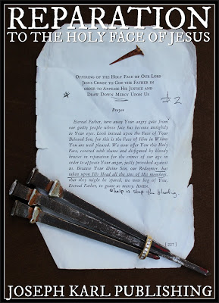
So you find yourself in the dream which was so peaceful and so full of wonder meeting up with your children at this time of Luciferian social distancing and enjoying their company which is so normal, so healthy, so happy, and so good.
While with them, you keep thinking to yourself that you would not be going to see an allopathic doctor for they work for the wrong master but the appointment has been made and for some reason you are going. So you think what you are going to say, what you are going to tell the doctor about why you are there.
The thought of going there is not peaceful for you will be going into a place that is anti-God and anti-human.
Meaning harmful to humans while claiming to be helping and while cashing in on the devil's Modern Day eugenics agenda.
WHAT HAPPENED WHILE ENJOYING TIME WITH YOUR NOW GROWN WONDERFUL CHILDREN, CATHOLIC DETROIT'S CHILDREN OF REPARATION IN MODERN TIMES
You completely forget about your appointment and miss it.
THE DREAM IS EXPLAINED PRIOR TO HOLY MASS
The allopathic medical system is going to reap what it has sown; when one turns one's back on God He will not provide His Divine supernatural protection.
True story.
So be it. +

36. Heaven's Inner Circle

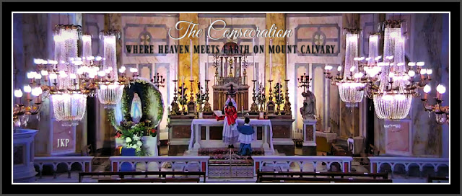
Above: the second Holy Mass on this day.
WHAT HAPPENED FOLLOWING THE TRADITIONAL TRIDENTINE HOLY SACRIFICE OF THE MASS AT 3 A.M. DETROIT TIME AT SACRED HEART CHURCH IN LIMERICK, IRELAND: HEAVEN'S INNER CIRCLE
What a magnificently majestic Divine Royal Wedding that was where heaven meets earth inside God's House on Mount Calvary.
Truly no banquet hall could be finer, no structure more indestructible, no royal reception more lavish, no gold put to better use. No candles could burn brighter, no linens could be more sacred, no Father more generous, no Groom more loving, no Mother more caring, and no wedding guests more grateful to be there. No celebration could be more pure, no attendants more genuine, no sacred vows longer lasting, no mission of more importance, no garments more regal, no singing more beautiful, no silence more expressive, no humble and properly prepared leaders better suited to lead. No children could be more blessed, no expressions could be more royal, no gifts more valuable, no event more meaningful, no gratitude more overflowing, no memories more cherished.
AND THEN: ANOTHER TRADITIONAL CATHOLIC DIVINE ROYAL WEDDING RECEPTION AT THE THRONE OF GOD IN HEAVEN BEFORE I AM'S WORK OF REPARATION TO THE HOLY FACE OF JESUS BEING HONORED IN YOUR HOME DOMESTIC TRADITIONAL CATHOLIC CHURCH CHAPEL AS THEY WERE FIRST MANIFESTED AT 183 FOLLOWING THE ONCE A WEEK SATURDAY EVENING TRADITIONAL TRIDENTINE HOLY SACRIFICE OF THE MASS WHILE AT THE SLOVAK PARISH WHERE I AM HAD REINTRODUCED HIS WORK DURING THE GREAT SEVEN YEAR WAR FOR SOULS THERE (2010 - 2017) THROUGH CHRIST'S TRADITIONAL CATHOLIC SACRED PRIESTHOOD
Everything was so incredibly dignified and so sacred and beautiful and unfathomably loving.
There was a little Divine Royal Wedding reception inside your place before the three-in-one Devotion to the Holy Face of Jesus where heaven meets earth because "Jesus makes heaven, wherever He is" (Father Frederick William Faber).
You found yourself a part of HEAVEN'S INNER CIRCLE at the majestic Throne of I AM following every soul's magnificent virtual Divine Royal Wedding to His Only Begotten Son our Divine Redeemer, Divine Restorer, Divine Remedy for All, and Divine Bridegroom of every soul; what was the most astounding is that Almighty God was so simple and so silent and so understated as manifested in the natural, while so noble.
Imaginer.
You marvel at this very quiet and hidden intimate reception celebration that has come to you where you are following the virtual celebration of the Holy Sacrifice of the Mass, and how I AM manifests Himself so simply and lovingly and also humbly for His creature in the midst of this Apostolic Mission for the sake of the whole world in our time.
Beautiful beautiful beautiful beautiful; God leaves nothing wanting in your heart and your joy on this side of heaven is complete.
THE DREAM OVERNIGHT FOLLOWING THE 3 A.M. DETROIT TIME TRADITIONAL TRIDENTINE HOLY SACRIFICE OF THE MASS AT SACRED HEART CHURCH IN LIMERICK, IRELAND
You found yourself at home, at the apartment you are renting where I AM suddenly placed you in September 2019 after 183 had been given up for Christ's Sacred Priesthood as needed in Modern Times and where He has had His representative of His Work of Reparation to the Holy Face of Jesus in lock down since September 2019, prior to the start of the Luciferiandemic.
You find yourself in the dream overnight at the apartment that looks like a chapel and the maintenance man, a Catholic, came to fix things. After a short conversation you then asked him two questions.
Then you found yourself outside, looking in peace at the complex with such awe and with ponder for it no longer looks as it does in the natural.
It had expanded as had so many homes you have been taken to during dreams overnight in recent years.
You marveled out loud that the buildings, which are in the natural at most two stories high (some are only one story), were now much more numerous and were now four stories in height, with the first of the four floors partially under the ground.
The red brick remained the same and the complex was very stately and so wondrous to look at.
All was very peaceful and serene.
Apostolic Mission.
THE SECOND TRADITIONAL TRIDENTINE HOLY SACRIFICE OF THE MASS, AT 2 P.M. DETROIT TIME ON MAY 14, 2020 AT SACRED HEART CHURCH, ICKSP, IN LIMERICK, IRELAND FOLLOWED BY EUCHARISTIC ADORATION, THE HOLY ROSARY OF OUR LADY THE VIRGIN OF THE GLOBE (MIRACULOUS MEDAL), AND BENEDICTION
It was exquisitely beautiful beautiful beautiful beautiful here in diabolical lock down.
"Jesus makes heaven, where ever He is." ~ Father Frederick William Faber
A RETIRED MARINE MOVES IN NEXT DOOR
What wonders. He arrived to the sounds of the Traditional Tridentine Holy Sacrifice of the Mass, Eucharistic Adoration, the Holy Rosary, and Benediction.
Domestic Traditional Catholic Church Chapel.
Foretaste of heaven. Imaginer!

37. The Incredible Skyscraper in Church
What a spectacular wonder within the incredible wonder that was during the 3 a.m. Detroit time Traditional Tridentine Holy Sacrifice of the Mass on May 16, 2020 in Limerick, Ireland. Imaginer. BEAUTIFUL BEAUTIFUL BEAUTIFUL. So grateful. +
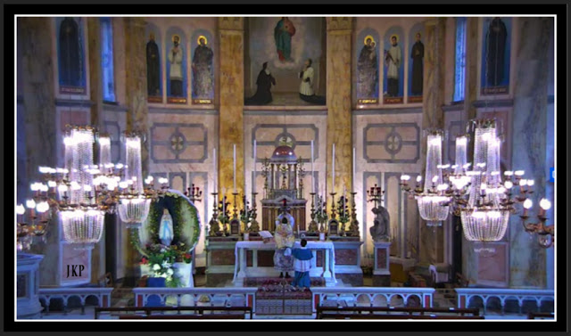

Still celebrating
before the three-in-one Devotion to the Holy Face of Jesus.

Divine Royal Wedding Reception
with the King of All Kings and Lord Over All.

Imaginer!
"Jesus makes heaven, wherever He is."
~Father Frederick William Faber

THE INCREDIBLE SKYSCRAPER IN CHURCH
What an indescribable joy it is to retire following the 3 a.m. Traditional Tridentine Holy Sacrifice of the Mass at Sacred Heart Church, ICKSP, in Limerick, Ireland and then to arise later to begin again with the Traditional Tridentine Holy Sacrifice of the Mass followed by Eucharistic Adoration, the Holy Rosary of the Immaculate Mother of God, and Benediction during the week and to Eucharistic Adoration, the Holy Rosary, and Benediction on weekends.
BEAUTIFUL BEAUTIFUL BEAUTIFUL BEAUTIFUL.
Recently, after all that has happened the past decade from here in Traditional Catholic Detroit, where I AM had re-introduced His Work of Reparation to the Holy Face of Jesus in 2012 at the time and in the place of His choosing through Christ's Traditional Catholic priesthood stuck in the modernist desecrated branch of Christ's Catholic Church's family tree, I AM recently took His Apostolic Mission for the sake of a world in very serious grave peril to Christ's ICKSP in Limerick, Ireland as the churches here in Michigan remain closed by Luciferian design.
One may go one one's boat but one may not pray alone inside an empty church.
Imaginer.
All of a sudden, will into the Holy Sacrifice/Royal Wedding to Christ the Divine Bridegroom of every soul, A SKYSCRAPER appeared before the Traditional Catholic priest facing east before Christ's High Altar where heaven meets earth on Mount Calvary before the Throne of Almighty God our Sovereign Authority.
What happened at that time is so wondrous that it cannot be adequately conveyed in human terms, through the written or spoken word.
It was not only unfathomably BEAUTIFUL BEAUTIFUL BEAUTIFUL BEAUTIFUL but it was
also incredibly JOYOUS and CELEBRATORY, truly WONDROUS and a cause for great rejoicing.
This SKYSCRAPER, which you often have seen metaphorically as a DIVINE ROYAL WEDDING CAKE, is made up of the High Altar at this Traditional Catholic Church and it is manifested in metaphor as REACHING ALL THE WAY TO HEAVEN.
Imaginer.
This SKYSCRAPER was very clearly manifested as having been first shown to you in the recent past, perhaps a year or so ago, in a dream and IT FORETOLD Christ's ICKSP being brought into I AM's Work of Reparation to the Holy Face of Jesus at this time in human history, for the sake of the whole world.
The night before there was a dream, and three high schools here in the United States of America were manifested. You were taken to one of them and it like the others WAS BEING PROPERLY RESTORED.
God is the ONLY ONE who can get us out of this modern Luciferian inspired and unholy mess mankind has become enslaved in, and then suddenly spit out of. What next.
A DIVINE ROYAL WEDDING RECEPTION FOLLOWED WITH TREMENDOUS JOY
Just like the evenings that followed the once a week Traditional Tridentine Holy Sacrifice of the Mass at the Slovak parish during the Great Seven Year War for Souls there (2010 - 2017).
What wonders.

38. The Flowers for My Mother in the Dream Overnight
Guess where they showed up in the natural after having been manifested in the supernatural. Just guess.
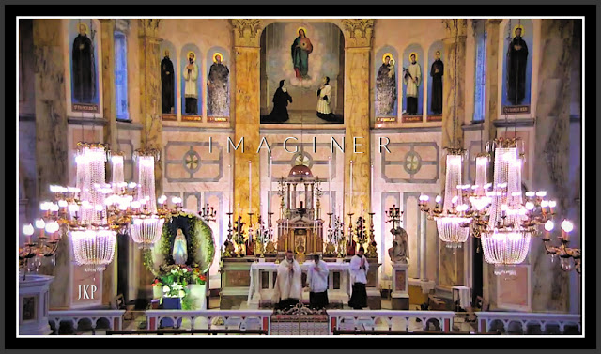
BEAUTIFUL BEAUTIFUL BEAUTIFUL BEAUTIFUL.
So grateful.
THE FLOWERS FOR MY MOTHER IN THE DREAM OVERNIGHT

This dream took place several weeks ago as I AM's Work of Reparation to the Holy Face of Jesus carried the Cross mankind now carries in Modern Times, specifically in 2020, while stunned and in shock by the sudden worldwide and pre-planned Luciferian lockdown and demolition of the world's economy. The world was already in a state of moral bankruptcy and deep, deep mind control programming, the work force slave labor, the population ever more desperate to earn a living.
The reparative suffering was severe, the churches here forced shut as I AM brought His Work of Reparation to the Holy Face of Jesus to twice daily Traditional Tridentine Holy Sacrifice of the Mass and Eucharistic Adoration, the Holy Rosary of the Blessed Virgin Mary, and Benediction every day, virtually, at Sacred Heart Church in Limerick, Ireland.
He had united The Institute of Christ the King Sovereign Priest (ICKSP) with His Work of Reparation to the Holy Face of Jesus at this time in human history. What followed several weeks after the dream was an outpouring of Divine supernatural graces and tremendous joy from On High, this past week and a manifestation of ALMIGHTY GOD AS SOVEREIGN AND LORD OVER ALL.
Highest Power.
Highest Power who works wonders through His people to lead people properly out of darkness into true freedom, real peace, sanctity, and great purpose on Mount Calvary.
Apostolic Mission.
BEAUTIFUL BEAUTIFUL BEAUTIFUL BEAUTIFUL.
What wonders!
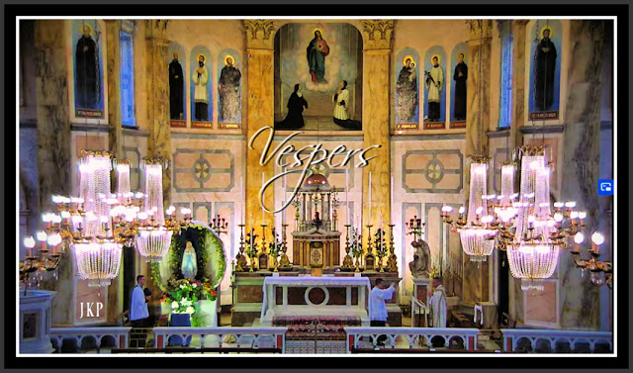
Vespers prior to Eucharistic Adoration,
the Holy Rosary of the Blessed Virgin Mary,
and Benediction on May 17, 2020
at Sacred Heart Church, ICKSP, Limerick, Ireland.
BACK TO THAT DREAM OVERNIGHT
You found yourself in a place that appeared unfamiliar, among people at an incredible marketplace.
It was outdoors and did not appear modern and ugly, it appeared OLD WORLD.
TRADITIONAL.
It was as if it was inside a building, enclosed within walls on two sides yet it was open to the sky above.
There was a sense of tremendous peace and serenity while walking around this small outdoor/indoor market with such awe and with wonder.
All of a sudden, you saw wondrous things all around you laid out on tables.
You were in the middle, in a center isle with tables on both sides and to the far left there were women buying and women selling at a small place designated for this there.
You were in the middle, revealed at the time of this writing that you were in the middle center isle of the restoration of Christ's Catholic Church in Modern Times which as almost everywhere been disfigured and stripped of the sacred by Luciferian design.
This restoration is taking place through I AM's Work of Reparation to the Holy Face of Jesus because that is what I AM wills, for the greater honor and glory of the Most Holy Trinity and then for the sake of the whole world in Modern Times.
Just as there are two kinds of men both inside and outside of Christ's Catholic Church as has been the case through history, those who serve God and those who serve themselves and the devil, there are two kinds of women.
Both kinds of women were represented in the dream: those buying and selling in God's house who work for the wrong master, and those serving God as He wills for each one, in imitation of and in union with Christ Crucified, through the intercession of the Immaculate Mother of God and Saint Joseph.
THE METAPHORICAL FLOWERS IN THE DREAM OVERNIGHT AND WHERE THEY SHOWED UP LATER
So suddenly before you on both sides of the isle - in the center of what is to people either a marketplace or God's House where He alone is to be worshiped, served, and adored through the spending of one's self in imitation of and in union with Christ the Divine Bridegroom of every soul and His Immaculate - you see packets of something you have never seen before in the natural.
Each clear packet was slightly smaller than a grown woman's hand and contained within it what was made known to you as seeds, but you have never seen seeds like this in the natural.
They were as if they were already flowering but while still in seed form.
They were exquisitely beautiful and brought you much delight; they were of various colors and varieties but all had the same basic form.
YOU WERE INFORMED IN THE DREAM, BY I AM, THAT YOU COULD HAVE AS MANY AS YOU WANTED AND WITHOUT FINANCIAL COST.
They had been earned by accomplishing God's will as He willed it.
You began picking up one after another with such incredible joy, while still in awe and with incredible wonder, as they were so very BEAUTIFUL BEAUTIFUL BEAUTIFUL BEAUTIFUL.
All of a sudden, YOU BEGAN CHOOSING SOME FOR YOUR MOTHER.
She then walked into the indoor/outdoor marketplace/church in need of restoration in our time and you happily began telling her about the flowering seeds and that you had some for her.
TRADITIONAL CATHOLIC DETROIT'S MOTHERS AND A GRANDMOTHER OF REPARATION FOR THE SAKE OF THE WHOLE WORLD IN OUR TIME.
WHAT HAPPENED SEVERAL WEEKS LATER WHILE VIRTUALLY ATTENDING THE TRADITIONAL TRIDENTINE HOLY SACRIFICE OF THE MASS AT SACRED HEART CHURCH, ICKSP, IN LIMERICK, IRELAND
While kneeling on the prie dieu before the three-in-one Devotion to the Holy Face of Jesus in the apartment where I AM suddenly placed you after the family home was suddenly given up in 2019 for Christ's Sacred Priesthood as need in Modern Times for the sake of a world in very serious grave peril, which by the way placed this work closer to the small SSPX Catholic Church named after Saint Joseph, I AM suddenly revealed something.
THOSE VERY SAME METAPHORICAL FLOWERING SEEDS WERE THERE ON CHRIST'S HIGH ALTAR.
Imaginer.

PART VII

THE SEVENTH STATION OF THE CROSS

JESUS FALLS A SECOND TIME

39. "I Can't Breathe"

40. Earth's Sewer and Our Heavenly Host

41. The Tiny House in the Dream Overnight

42. Investiture of the Brown Scapular, In Latin and in English

43. A Sacred Conversation with Perfection and the Voice Heard in Heaven

44. Another Encounter with a Certain Pastor in the Dream Overnight and the Two Kneelers

45. "Tell Him that You Have Sold Your Soul to Jesus"

46. The Two Rabbits Inside the High Rise Building in the Dream Overnight

39. "I Can't Breathe"
No coincidence that profound suffering from the inability to breathe was I AM's choice of reparative atonement for this student teacher at the time when He re-introduced His Work of Reparation to the Holy Face of Jesus in 2012 through Christ's Sacred Priesthood here in Catholic Detroit in Modern Times for a world in very serious grave peril.
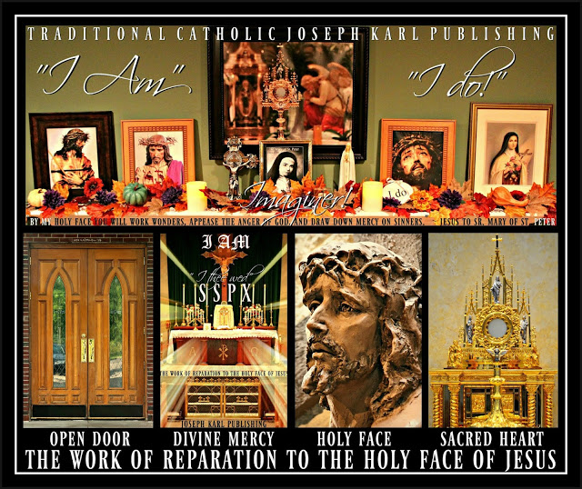
And now the controllers tell us a second bioweapon assault wave is coming (and they have the respirators - few have come off of - at the ready) as one of the inverted "treatments" enforced by those who are anti-God and anti-human is a masked assault against the ability to breathe among the masses (while watching everything; locking down the world; rolling out the 5G control and kill grid and weaponizing the schools, hospitals, and our homes; closing churches; spraying the skies with they-know-what; poisoning the food, water, and air; weaponizing the airwaves; blocking mankind's ability to help himself/herself; inflicting ever more trauma based mind control; promoting paganism, the occult, idolatry, lust, materialism, violence, a love for money which is the root of all evil, and civil unrest but never the One True Faith; keeping people perilously distracted and ever more needy; and destroying the economy and the earth God created for us, among other things). Imaginer.

40. Earth's Sewer and Our Heavenly Host
Apostolic Mission. Go, Team! "By My Holy Face you will work wonders, appease the anger of God, and draw down mercy on sinners." ~ Jesus to Sr. Mary of St. Peter
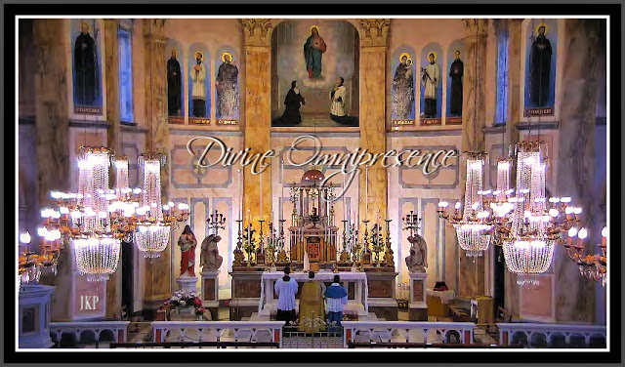

THE DREAM OVERNIGHT
I suddenly found myself inside a house that was mine and it appeared unfamiliar, and yet familiar.
The Holy Sacrifice of the Mass was about to be celebrated within it, in the living room.
This dream happened before but the house was 183, the house that was sold last year.
Inside the living room church were many young people, school children.
The living room had expanded and while it was larger it was not massive. It also had an unusual shape to it, this room with many sides.
At the altar there were a row of chairs and there were people seated at them, facing the people.
The occupants of those chairs were made known to me.
Then, I found myself sitting among them, on the far right from the perspective of the people.
I was seated next to the Slovak pastor.

I am an apostle of I AM's Work of Reparation to the Holy Face of Jesus and everyone has a vital, irreplaceable, indispensable, and God-given Holy Apostolate of Reparation. Most don't know it.
Modernism keeps this information from them; so evil.
Next to him was a liberal nun who was the modernist principal at the modernist desecrated Catholic school my children attended, but only for so long (until things got so bad there our Lord said, "Get them out").
Next to her were seated some priests from Christ's SSPX. I did not recognize them.
All of a sudden, some sort of awards ceremony began when the people had gathered for the Holy Sacrifice of the Mass.
God help us!
While taking everything in with such awe and with wonder, my family was seen seated in the front row including my mother, not front row kinds of people.
You would not be seated before the altar, being a woman but I AM put you (representing His Work of Reparation to the Holy Face of Jesus for the sake of the future of the human race) there. The liberal nun not wearing a habit and dressed like a man was happy to be front and center, happy to occupy the place of Christ her Divine Bridegroom at His Altar where heaven meets earth on Mount Calvary inside His House.
A family member, my late father Joseph's sister, who has been very sick and suffering profoundly, was among them and it surprised me to see her here because she lives far away and is so frail. Then again, I said to myself, she has a great deal of inner strength. Here by sheer willpower, hopefully serving the right Master, and by the grace of God without Whom nothing good is possible and with Whom all things are possible.
Then, all of a sudden, my aunt left her place in the front and approached the Slovak pastor seated before the altar and to my right. She leaned in close to him and began whispering something into his left ear.
She spoke to him for a little while, and then returned to her place without having addressed me.
This is a metaphor and represents this Apostolic Mission that began in Modern Times in 2012 when I AM re-introduced His Work of Reparation to the Holy Face of Jesus at the business minded, money loving, yet Traditional leaning Slovak parish in Catholic Detroit, through Christ's Traditional Catholic Sacred Priesthood, for a world in very serious grave peril.

Our Lord described such churches (well intended or not) that seek to be all things to all people as "SEWERS."
No wonder.
The church home represents Christ's Traditional Catholic Institute of Christ the King Sovereign Priest having been drawn by the Sovereign Divine Hand of Almighty God into the Apostolic Mission of I AM's Work of Reparation to the Holy Face of Jesus for the sake of the future of humanity.
Imaginer.
THE EXQUISITELY MAGNIFICENT TRADITIONAL TRIDENTINE HOLY SACRIFICE OF THE MASS AT 2 P.M. DETROIT TIME IN LIMERICK, IRELAND AT SACRED HEART CHURCH ON JUNE FIRST, 2020, AT THE START OF THE MONTH OF THE SACRED HEART OF JESUS
Such wonders. So grateful!
WHAT LIFE IS LIKE FOR I AM'S WORK OF REPARATION TO THE HOLY FACE OF JESUS IN 2020 FOLLOWING THE LUCIFERIANDEMIC, LOCKDOWN, ONGOING MANIFESTATION BY THE BEAST SYSTEM OF FUTURE THREATS TO HUMANITY, AND EASING OF SOME RESTRICTIONS AS NATIONS ARE DESTROYED BY LUCIFERIAN DESIGN
Two Traditional Tridentine Holy Sacrifices of the Mass a day, Eucharistic Adoration, The Holy Rosary, and Benediction live streamed - at this Traditional Catholic Domestic Church Chapel home - from Sacred Heart Church in Limerick, Ireland while making all the precious and priceless reparative atonement the Lord sends through His Immaculate Mother for Christ's Sacred Priesthood as needed, for the sake of the whole world in our time.
BEAUTIFUL BEAUTIFUL BEAUTIFUL BEAUTIFUL.
So grateful.
Content content content content.
Dear Triune God please lead us all out of the self serving, power hungry, money loving, anti-God and anti-human Beast System 2020 under the banner of I AM's Work of Reparation to the Holy Face of Jesus through the intercession of Your Immaculate Mother and Saint Joseph.
Holy Family.
Oorah!
EARTH'S SEWER AND OUR HEAVENLY HOST
I AM manifested, during the Traditional Tridentine Holy Sacrifice of the Mass, Christ's Catholic priests in the much larger modernist branch of the Catholic family tree who, well intended and also as trapped as they may be, are helping keep His House a filthy sewer by speaking with forked tongues to protect themselves and their interests.
"Even if Catholics faithful to Tradition are reduced to a handful, they are the ones who are the true Church of Jesus Christ." ~ Saint Athanasius
AS LEADERS SPEAKING WITH FORKED TONGUES CLAIM THEY SEEK TO "DRAIN THE SWAMP," ALMIGHTY GOD WANTS HIS CHURCHES THAT HAVE BEEN TRANSFORMED BY THE MODERNISTS INTO SEWERS CLEANED UP AND THIS CANNOT BE ACCOMPLISHED WITH FUNDRAISERS THAT PROMOTE THE LUSTING AFTER EVER MORE MONEY INSTEAD OF DOING WHAT GOD WANTS AND RELYING ON HIS DIVINE PROVIDENCE TO PROVIDE; IT IS TO BE ACCOMPLISHED IN THE MANNER WHICH I AM HAS CHOSEN, THROUGH HIS WORK OF REPARATION TO THE HOLY FACE OF JESUS MEANING THE SPENDING OF ONE'S SELF AS HE WILLS FOR EACH PARTICULAR ONE, IN IMITATION OF AND IN UNION WITH CHRIST CRUCIFIED, WITH PURITY OF INTENTION AND DEVOID OF SELF INTEREST AND WHILE HAVING NO IDOLS OF ANY KIND BEFORE HIM AND WITHOUT COUNTING THE PERSONAL COST
Imaginer. +
This is how it works so well:

AN APOSTOLIC MISSION "FROM WAY IN THE BACK," IN LAST PLACE
Remember, last place is Christ's place which is first place and last place which is first place is always the holiest place.
How important it is to set a proper example.
"My children all we are is what we are in the eyes of God, and nothing more." ~ Saint John Vianney
From the very beginning of the live streamed Traditional Tridentine Holy Sacrifice of the Mass, which was followed by Eucharistic Adoration, the Holy Rosary of Our Lady, and Benediction, the view seemed SO MUCH FARTHER BACK THAN USUAL.
You keep looking and discerning the perspective, but it seems the camera is in the same place it always is with the same things within the frame.
Yet this perspective persists and finally after repeatedly asking our Lord what it means, he responds toward the end of the Holy Sacrifice of the Mass that I AM'S WORK OF REPARATION TO THE HOLY FACE OF JESUS HAS ALWAYS BEEN IN LAST PLACE, ALWAYS IN THE BACK, AND THAT IS BECAUSE THAT IS WHERE THE WORLD CAN FIND JESUS CHRIST OUR DIVINE REDEEMER, DIVINE RESTORER, DIVINE REMEDY FOR ALL, AND THE DIVINE BRIDEGROOM OF EVERY SOUL.
Those who are last shall be first, and those who put themselves first shall be last.
Imaginer.

41. The Tiny House in the Dream Overnight
Guess what it looked like and then guess what happened there. Just guess.
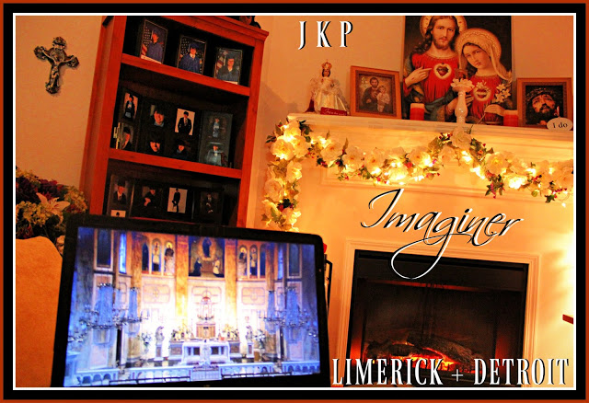
THE TINY HOUSE IN THE DREAM OVERNIGHT
Overnight I found myself the sudden owner of a small house on a small property that appeared unfamiliar.
It was spring or summer.
I was inside it first and then saw it from above and found myself wondering if it has two bedrooms or three.
This is symbolic for something, I do not know what.
WHAT HAPPENED WHILE INSIDE THE HOUSE, BEFORE BEING SHOWN IT FROM ABOVE, ON THE OUTSIDE
People were coming and coming, people I don't know and have never seen before.
They came into the house and went down into the basement. The basement represents Christ's Traditional Catholic Church which in our time is quite small.
The people were all greeted and were allowed to come; each one was there to do something different. One woman walked laps around the outside of the inside of the basement which was small and nothing fancy.
All was peaceful and serene.
WHAT THE HOUSE LOOKED LIKE ON THE OUTSIDE, AS SEEN FROM ABOVE
The small, humble and light earth tone colored brick house had a sweet little yard, very lovely and manageable and of good use you thought so happily to yourself.
Then, after having returned to the ground, you discovered that in the side yard between the house and the road there was an incredible pond.

What wonders!
The small pond was separated from the road by some trees and bushes and was unlike any I have ever seen before, and while taking it in with such delight and of course with such incredible awe and with wonder, the little pond kept getting larger.
The water in the pond in the ground was crystal clear, completely clean and its foundation was white, clearly not made of stone or the earth/dirt.
It appeared like some sort of cement that had shallow smooth mounds as its texture and this is what contained the pond's water, but what it consisted of I can only guess.
Imaginer.

42. Investiture of the Brown Scapular, In Latin and in English

“WHOSOEVER DIES IN THIS GARMENT SHALL NOT SUFFER

ETERNAL FIRE.”
- promise of Our Lady to St. Simon Stock on July 16, 1251.

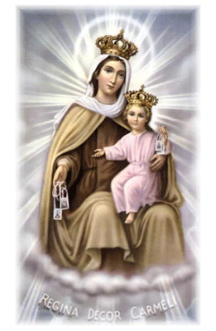
Blessing and Investiture of the Brown Scapular,
in Latin:
click here.
LATIN
Priest – Ostende nobis Domine misericordiam tuam.
Respondent – Et salutare tuum da nobis.
P – Domine exaudi orationem meum.
R – Et clamor meus ad te veniat.
P – Dominus vobiscum.
R – Et cum spiritu tuo.
P – Oremus. Domine Jesu Christe, humani generis Salvator, hunc habitum, quem propter tuum tuaeque Genitricis Virginis Mariae de Monte Carmelo, Amorem servus tuus devote est delaturus, dextera tua sancti+fica, tu eadem Genitrice tua intercedente, ab hoste maligno defensus in tua gratia usque ad mortem perseveret: Qui vivis et regnas in saecula saeculorum. Amen.
THE PRIEST SPRINKLES WITH HOLY WATER THE SCAPULAR AND THE PERSON(S) BEING ENROLLED. HE THEN INVESTS HIM (THEM), SAYING:
P – Accipite hunc, habitum benedictum precantes sanctissima Virginem, ut ejus meritis illum perferatis sine macula, et vos ab omni adversitate defendat, atque advitam perducat aeternam. Amen.
AFTER INVESTITURE THE PRIEST CONTINUES WITH THE PRAYERS:
P – Ego, ex potestate mihi concessa, recipio vos ad participationem, omnium bonorum spiritualium, qua, cooperante misericordia Jesu Christi, a Religiosa de Monte Carmelo peraguntur. In Nomine Patris + et Filii + et Spiritus Sancti. + Amen
Benedicat + vos Conditor caeli at terrae, Deus omnipotens, qui vos cooptare dignatus est in Confraternitatem Beatae Mariae Virginis de Monte: quam exoramus, ut in hore obitus vestri conterat caput serpentis antiqui, atque palmam et coronam sempiternae hereditatis tandem consequamini. Per Christum Dominum nostrum.
R – Amen.

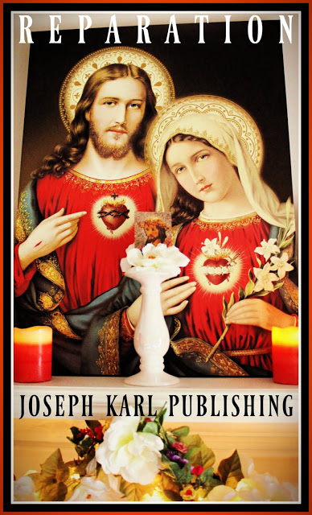

IN ENGLISH

Priest – Show us, O Lord, Thy mercy.
Respondent – And grant us Thy salvation.
P – Lord, hear my prayer.
R – And let my cry come unto Thee.
P – The Lord be with you.
R – And with your Spirit.
P – Lord Jesus Christ, Savior of the human race, sanctify + by Thy power these scapulars, which for love of Thee and for love of Our Lady of Mount Carmel, Thy servants will wear devoutly, so that through the intercession of the same Virgin Mary, Mother of God, and protected against the evil spirit, they persevere until death in Thy grace. Thou who livest and reignest world without end. Amen.
THE PRIEST SPRINKLES WITH HOLY WATER THE SCAPULAR AND THE PERSON(S) BEING ENROLLED. HE THEN INVESTS HIM (THEM), SAYING:
P – Receive this blessed scapular and beseech the Blessed Virgin that through Her merits, you may wear it without stain. May it defend you against all adversity and accompany you to eternal life. Amen.
AFTER INVESTITURE THE PRIEST CONTINUES WITH THE PRAYERS:
P – I, by the power vested in me, admit you to participate in all the spiritual benefits obtained through the mercy of Jesus Christ by the Religious Order of Mount Carmel. In the name of the Father + and of the Son + and of the Holy Ghost. + Amen.
May God Almighty, the Creator of Heaven and earth, bless + you, He who has deigned to join you to the Confraternity of the Blessed Virgin of Mount Carmel; we beseech Her to crush the head of the ancient serpent so that you may enter into possession of your eternal heritage through Christ our Lord.
R – Amen.
THE PRIEST THEN SPRINKLES AGAIN WITH HOLY WATER THE PERSON(S) ENROLLED.

43. A Sacred Conversation with Perfection and the Voice Heard in Heaven
What the Traditional Tridentine Holy Sacrifice of the Mass is. What else can YOU add to this list?
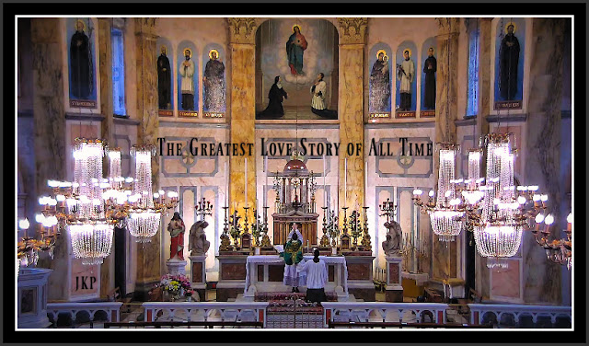
The live stream celebration of the Traditional Tridentine Holy Sacrifice of the Mass, Eucharistic Adoration, The Holy Rosary of the Blessed Virgin Mary, Devotions, Benediction, and Vespers at Sacred Heart Church, Institute of Christ the King Sovereign Priest (ICKSP in English), Limerick, Ireland: click here.
THE TRADITIONAL TRIDENTINE HOLY SACRIFICE OF THE MASS CELEBRATED IN LATIN IS:
The language of God.
It is hell's downfall.
It is a Holy Sacrifice and a Sacred Celebration.
It is a Wedding, the Royal Wedding of each properly disposed soul to Jesus Christ the Divine Bridegroom and our Divine Redeemer, Divine Restorer, and Divine Remedy for All.
It is a sharing in Christ's sacrifice of His very self on Mount Calvary for the Redemption of the entire human race, including you and me.
It is a magnificent love story.
It is the greatest love story of all time (Archbishop Fulton J. Sheen).
It is a petition, with purity of intention, to Almighty God inseparably unified with the holy obedience of Christ completely humbled, immolated, and crucified for our sake, presented through His Immaculate Mother the "Virgin of the Globe and the Miraculous Medal," Our Protectress, and the Mediatrix of all God's lavish superabundant graces.
It is the mystical re-presentation of our Redemption on Mount Calvary.
It is a Divine Gift of immeasurable and eternal worth.
It is a journey through humanity's past, present, and future.
It is the pouring forth mystically of His Divine Mercy, the Blood and Water from the lance strike right into the Sacred Heart of Jesus nailed to and immobilized upon the Cross on Mount Calvary, for the sake of every single one of us.
It is what, and Who, we all need.
It is where evil is not welcome.
It is a means of obtaining the lavishly loving and superabundant Divine supernatural graces of God, which we all need, through the maternally caring intercession of His Immaculate Mother.
It is an exalted means of communicating with the Divine, with the Most Holy Trinity.
It unifies us with the Real Presence of Jesus in the Blessed Sacrament, the Compendium of All Miracles (Saint Thomas) which leaves nothing wanting to content the heart of man (Saint John Vianney).
It is an appeal for all souls, including all of one's brothers and sisters in Christ (meaning all people past, present, and future) and also one's own poor soul.
It is to abandon one's self in God's service in the manner in which He wills for each one.
It is to pledge one's self, with God's help, to a holier future.
It is unspeakably beautiful beautiful beautiful beautiful.
It is incredibly peaceful and so joyful.
It is the Most Holy Trinity's embrace.
It is to see what is unseen, to have become visible what is invisible.
It is to die to one's self unified with Christ crucified to obtain eternal life through Him.
Imaginer.
It is enlightening.
It is sanctifying.
It is love, peace, harmony, security, and true joy.
It is severely penitential.
It is healing.
It is unifying.
It is so unfathomably helpful.
It is genuine, and honest, and packed with wonder.
It costs one one's life, in imitation of and in union with Christ.
It is celebrated in last place, as One with Christ there, for the greater honor and glory of the Most Holy Trinity and then for the sake of all others.
It is a privilege, our duty, and an honor.
It is a foretaste of heaven.
It is the manner in which God wills to be worshiped.
It is the defeat of the forces of darkness.
It is a celebration of life, and of everlasting life, and of true love which spends itself and lasts forever.
It is magnificent, sacred, and holy.
It is packed with the occupants of heaven.
It absorbs and shares in our burdens and returns them to Almighty God through Christ - unified as One with His Sacrifice for us all - who provides and/or allows them to help each one grow in sanctity as He wills.
It is both pledge and a promise and its sacred vows are proclaimed to our Triune God where heaven meets earth before the Throne of God, at His Inner Circle on Mount Calvary.
It is wondrous and unfathomable and incomprehensible.
It is the True Church of Jesus Christ Militant, Suffering, and Triumphant.
"Even if Catholics faithful to Traditional are reduced to a handful, they are the one who are the True Church of Jesus Christ." ~ Saint Athanasius
It is both Royal and Divine and its Host, the Almighty Father of Jesus Christ the King of All Kings, is our Sovereign Authority and He is loving, trustworthy, the One on whom we are to rely to accomplish His will as He wills it, in imitation of Christ and His Holy Family (His Immaculate Mother and Saint Joseph), devoid of self interest and without counting the personal cost.
It spends itself which is the very best gift there is.
It is to be present at multiple locations at once.
It takes place in both the natural and in the supernatural.
Jesus Christ nurtures and teaches us through it.
It is to keep wholesome company with the Holy Angels, Holy Saints, and Holy Martyrs including the Holy Innocents.
It is to exchange the gift of self with God and in the manner in which He wishes. Oorah!
It brings our Angel Guardians great joy as God's creation and as our personal helpers.
It is a gift.
It is thanksgiving.
It is the Devotion to the Sacred Heart of Jesus.
It is a betrothal, a wedding, and a reception all in one.
It is a wedding, the honeymoon, Divine Union, and creation inside of God's House.
It is the highest form of union possible for the human race in this life because one weds one's self to God through Jesus whose love is true for it is sacrificial as Almighty God wills meaning it spends itself.
It is a Divine Royal Wedding Banquet.
It is the Divine Remedy against corruption.
It is the Devotion to Christ's Divine Mercy.
It is both popular and unpopular.
This list can very easily go on forever for it glorifies our Triune God.
It is the highest form of Eucharistic Adoration.
It is the Devotion to the Precious Blood of Jesus.
It is the Stations of the Cross and the Three-In-One Devotion to the Holy Face of Jesus.
It is Almighty God's Work of Reparation to the Holy Face of Jesus which is A VOICE HEARD IN HEAVEN.
It is the language of the Saints, for it is the language of God and of real love.
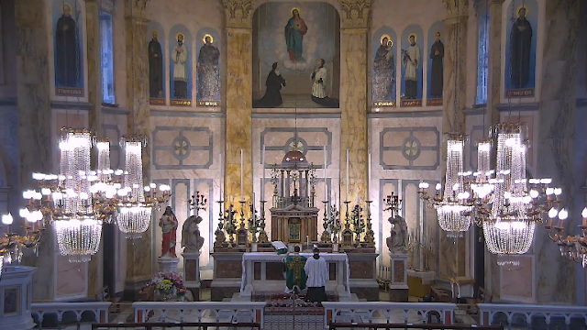
Truly no banquet hall could be finer, no structure more indestructible, no royal reception more lavish, no gold put to better use. No candles could burn brighter, no linens could be more sacred, no Father more generous, no Groom more loving, no Mother more caring, and no wedding guests more grateful to be there. No celebration could be more pure, no attendants more genuine, no sacred vows longer lasting, no mission of more importance, no garments more regal, no singing more beautiful, no silence more expressive, no humble and properly prepared leaders better suited to lead. No children could be more blessed, no expressions could be more royal, no gifts more valuable, no event more meaningful, no gratitude more overflowing, no memories more cherished.

44. Another Encounter with a Certain Pastor in the Dream Overnight and the Two Kneelers
What a wonder that was following the live stream of the Traditional Tridentine Holy Sacrifice of the Mass at 3 a.m. Detroit time at Sacred Heart Church in Limerick, Ireland. "Remember that true religion does not simply mean saying things, but doing them. If you read something that you admire, don't content yourself with saying, 'This is great.' Say rather, 'I am going to do the same.'" ~ Saint John Bosco
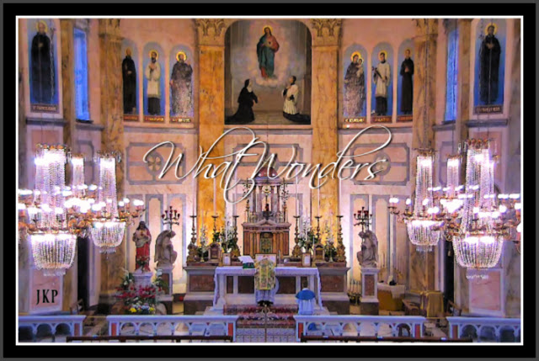
The young lad did such a wonderful job assisting
at Christ's High Altar
which included reciting prayers in Latin.
Beautiful beautiful beautiful beautiful.
So grateful.
The live streaming of
The Traditional Tridentine Holy Sacrifice of the Mass,
Eucharistic Adoration,
The Holy Rosary of Our Lady,
Devotions,
and Benediction
at Sacred Heart Church,
Institute of Christ the King Sovereign Priest,
Limerick, Ireland: click here.
THE DREAM OVERNIGHT ON MONDAY, JUNE 15, 2020

All of a sudden you find yourself inside of a small church that appears more like a chapel in size and the Holy Sacrifice of the Mass is being celebrated.
The church appears unfamiliar and yet familiar, meaning you had never seen it before but it reminds you for some reason of the church's chapel where you attended the daily Holy Sacrifice of the Mass (Novus Ordo) fifteen years or so ago, before I AM summoned you and your family to the Slovak parish which was Traditional Catholic leaning but almost entirely Novus Ordo.
It was at the Slovak parish that I AM had re-introduced His Work of Reparation to the Holy Face of Jesus in Modern Times, in 2012 and during the Great Seven Year War for Souls there (2010 - 2017), for the sake of a world in very serious grave peril.
Yet the one celebrating the Holy Sacrifice of the Mass inside this unfamiliar and yet familiar small church chapel in the dream overnight is the Slovak pastor with an Apostolic Mission.
The dream, like many dreams in the most recent past, centers around what happened during Holy Communion.
This time, you found yourself in the middle of the line, with some people before you and some people behind you.
There was only one line.
WHAT TOOK PLACE DURING HOLY COMMUNION, WHAT WONDERS
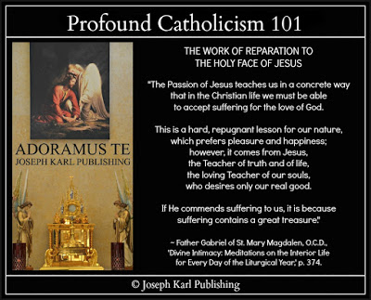
Once you see and realize from your place in the back that the Slovak pastor is celebrating the Holy Sacrifice, you think two things to yourself: you are not welcome by him here in God's House AND you would not be here inside God's House because you are unwelcomed by him here under God's Own Roof . In other words, you would not go where he is because you would not be welcome there, inside God's own House.
Nevertheless, as in so many dreams of the past you find yourself following along with such incredible awe and with wonder, so happy to be in God's House for the celebration of the Holy Sacrifice of the Mass.
Keep in mind also that this Traditional and also Modernist leaning priest stuck in the Modernist desecrated branch of Christ's Catholic Vine in our time knew how to celebrate both the Modernist desecrated Novus Ordo Holy Sacrifice of the Mass and the Traditional, Classical Tridentine Holy Sacrifice of the Mass. It is because he learned the latter and began offering it at the Slovak parish once permitted to do so, before this student teacher's family was sent there by I AM, because of him that this family along with many others here in Modernist desecrated Catholic Detroit learned of It and experienced It for the very first time and absolutely fell in love with It.
Your two beautiful sons honorably served at Christ's High Altar there at the Slovak parish, for years.
Everyone inside the Slovak Catholic Church he led as a Pastor and as a Father for our Lord in suburban Detroit received Holy Communion kneeling and on one's tongue.
The enemies of God within Christ's Catholic Church did not like that, to be sure.
So while walking in single file in one line to the altar in the dream overnight, inside this small church appearing more like a chapel, you note that there are people both before you and people coming after you.
What wonders; all things considered yet you find yourself approaching the altar.
WHAT HAPPENED AFTER HAVING ARRIVED BEFORE THE CELEBRANT IN THE DREAM
In more than one sense, it was a case of déjà vou.
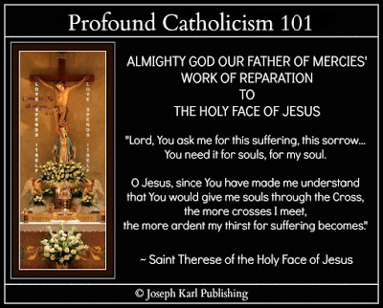
When it was your turn to receive the Real Presence of Jesus in the Blessed Sacrament in the dream overnight, keeping in mind that everything was very peaceful and joyful, you found yourself before the Slovak pastor whom you have not seen since he threw you out of God's House forever with the help of his associate pastor sidekick and two clueless policemen in 2017 on the Holy Thursday of Easter, just prior to the Feast of God's Divine Mercy, here in the communist United States of America.
You also found yourself before two different kneelers.
Keep in mind that now in 2020 the while world, not just the United States, appears more and more like Communist North Korea.
Our Lord warned us that humanity was at a vital crossroads, and said to establish His Work of Reparation to the Holy Face of Jesus at the Slovak parish for the sake of a world in very serious grave peril.
His Work spends itself as I AM wills, in imitation of and in union with Christ crucified on Mount Calvary, it is very important work, and it is very unpopular among Christ's Catholic Priests who know of it.
Everywhere He sent it, it has been rejected in imitation of Christ at His first Christmas coming.
No room for God in the world He created.
Unwelcome, even inside His Own House in our time.
Imaginer.
THE TWO DIFFERENT KNEELERS AND THE INCREDIBLE CONVERSATION WITH THE SLOVAK PASTOR WHILE HE WAS DOING GUESS WHAT
So you arrive before the Slovak pastor in the dream overnight during Holy Communion knowing that he doesn't want you there and that you don't want to be where he is, what wonders, and find yourself just to the left of two wedding kneelers where the Traditional Catholic Communion Rail would be.
The two prie-dieus are very different in appearance; one is directly in front of him and the other is between where you are standing and where HE IS SITTING.
The Slovak pastor who had been standing while distributing the Blessed Sacrament during Holy Communion is upon your arrival and the next one in line suddenly SITTING DOWN, NOT STANDING.
He is sitting down and facing perpendicular to the two different wedding kneelers AS IF HE WAS INSIDE THE CONFESSIONAL.
Before kneeling down to receive our Lord, you find yourself telling him with Almighty God's Divine Supernatural Authority that YOU ARE GOING TO KNEEL ON THE WEDDING KNEELER THAT IS BETWEEN YOU AND HIM, ON THE WEDDING KNEELER TO THE LEFT OF THE ONE RIGHT BEFORE WHERE HE IS SITTING PERPENDICULAR TO IT.
This puts you farther away from him in proximity at the moment that is manifested as receiving both of THE TWO INSEPARABLE SACRAMENTS OF DIVINE INTIMACY: THE SACRAMENT OF RECONCILIATION (THE SACRAMENT OF CHRIST'S PEACE) AND THE BLESSED SACRAMENT.
What wonders.
WHAT THE KNEELERS LOOK LIKE AND WHAT THEY REPRESENT
While staring at them with such awe and with wonder, you notice that the kneeler closer to you is older and more worn while the kneeler before him is newer and more modern.
They represent both branches of Christ's Catholic Church in our time, His much smaller Traditional Catholic Church and the very large Luciferian desecrated Modernist branch.
One is an abomination; the other is not.
The Slovak pastor is manifested as being closer to the abomination than you who represent true Catholic Teaching and I AM's Work of Reparation to the Holy Face of Jesus.
To embrace both branches is to speak with the forked tongue of the devil.
"Even if Catholics faithful to Tradition are reduced to a handful, they are the ones who are the True Church of Jesus Christ." ~ Saint Athanasius
One cannot commit evil hoping that good comes of it.
THE INCREDIBLE CONVERSATION
Keep in mind that this took place during Holy Communion and that there were people still waiting in line after you.
You knelt down on the Traditional Catholic wedding kneeler and began having a conversation with the Slovak pastor and despite the fact that there were people waiting in line behind you, HE ALLOWED IT.
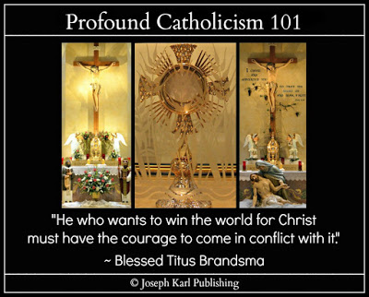
It was wondrous indeed, and he was suffering.
Keep in mind also that this dream is also a METAPHOR that is to be applied to the situation in our time.
His Modernist desecrated side was suffering as a result of having to humble one's self, which the misdirected free will doesn't like because Modernism is self interested, teaches and encourages corruption including a love for acquiring ever more money which is the root of all evil, and as a result serves Lucifer the wrong master.
The Traditional Catholic side of him was sincerely sorry for what he had done and told you that from now on you are welcome inside of God's House.
I AM's Work of Reparation to the Holy Face of Jesus accepted his sincerity and with one hand, embraced one of his consecrated hands through which Christ comes to us.
What a Wedding.
Whose confession was it?
APOSTOLIC MISSION.
"The demons maintain that the sins of men give them power over men. They say that God permits the demons to keep what they have won through the misdirected will of man, and only the free will of man can take from them what the free will of man has given them. Through the willful suffering of victim souls, the demons are deprived of that which men have given them from sin." ~ Mary Crushes the Serpent

45. "Tell Him that You Have Sold Your Soul to Jesus"
From ‘The Life of Dominic Savio’ by Saint John Bosco.
Dominic’s health was steadily deteriorating but he did not want to go home: he wanted at all costs to try to keep up his studies and his life for God at the school. A few months previously I had sent him home, but a few days afterwards he turned up at the Oratory again.
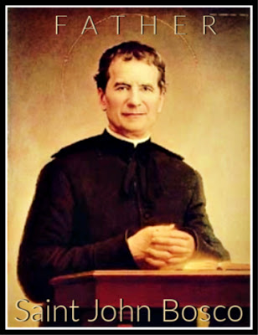I have to confess that the unwillingness was on both sides. I wanted to keep Dominic with me at all costs. My affection and esteem for him were those of a father for his special favorite son. But I felt that the doctor’s recommendation should be carried out and this especially so as he had recently developed a bad cough.
I wrote to Mr. Savio and Dominic’s departure was fixed for March 1st, 1857.
He accepted this decision and offered it as a sacrifice to God.
“Why are you so unwilling to go home?” I asked him.
You should be glad to be going to your parents.
“I want to end my days here at the Oratory.”
“All right; when you get better at home then you can come back.”
“That is all very well … but I know that if I go home, I shall never come back.”
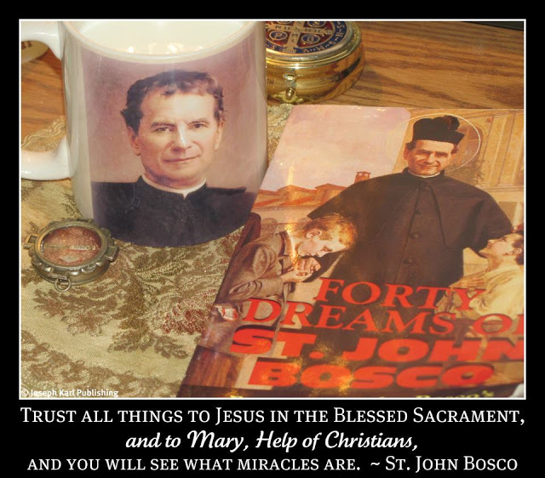

A SACRED QUESTION AND ANSWER SESSION
The evening before his departure, he could hardly be persuaded to leave my side – there was always a new question to be answered or another assurance to be given. The following is some of the dialogue which took place between us:
“What is the best thing a sick person can do to gain merit before God?”
“Frequently to renew the offering of his sufferings to God.”
“What else can he do?”
“Offer his life to Jesus.”
“Can I be certain of being saved?”
“Yes, through the mercy of God which shall never be lacking for you, you can be certain of being saved.”
“If the devil comes to tempt me what shall I say to him?”
“Tell him that you have sold your soul to Jesus and he has paid for it with His Precious Blood. If the devil continues to worry you, ask him what he has ever done for your soul, and remind him that Jesus shed His Blood so that you might be free from his power.”
“When I am in heaven, shall I be able to see my companions here at the Oratory and my family at home?”
“Yes, you will see everything from heaven – what is happening here, at home and lots of other things besides.”
“Shall I be able to visit you here?
“Yes, if it is according to God’s will and for His greater glory.”
~ From 'The Life of Dominic Savio,' by Saint John Bosco
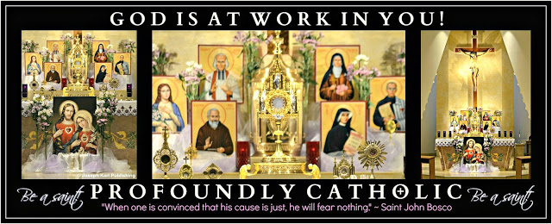
After having entered into eternal life at the age of 15, having previously spent three years at Saint John Bosco's Oratory in Turin, Italy, Saint Dominic Savio did return to visit Saint John Bosco, in a dream.

46. The Two Rabbits Inside the High Rise Building in the Dream Overnight
"Let us carry our crosses with love; let us see that they do not become a burden to others, but let us help others carry theirs." ~ Saint John Bosco +
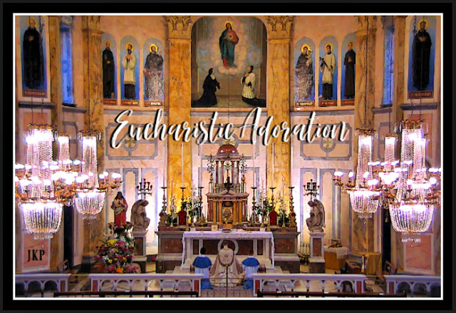
Extraordinarily beautiful, all of it.
So grateful.

THE TWO RABBITS INSIDE THE HIGH RISE BUILDING IN THE DREAM OVERNIGHT

Overnight there was another dream following the 3 a.m. Detroit time Traditional Tridentine Holy Sacrifice of the Mass live streamed from Sacred Heart Church, ICKSP, in Limerick, Ireland.
As in dreams of the recent past, you find yourself at a new home and this one is inside a high rise building.
The high rise building appeared in a dream prior to I AM sending His Work of Reparation to the Holy Face of Jesus to Sacred Heart Church, ICKSP, in Limerick Ireland in 2020 during the Luciferiandemic, lock downs, and controlled demolition of nations.
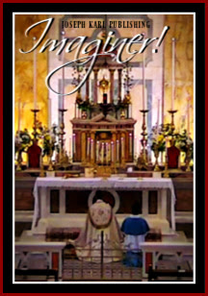
The skyscraper in the dream was in a city, in the City of Detroit, in Catholic Detroit, and then it appeared at in church, at the High Altar in Limerick, Ireland in the
natural as I AM drew His Traditional Catholic Institute of Christ the King Sovereign Priest into His Work of Reparation to the Holy Face of Jesus in Modern Times for the sake of a world in very serious grave peril.
Remember, the SSPX Traditional Catholic Church was first manifested in dreams prior to this student teacher crash landing there in 2017 after having been kicked out of the Slovak parish by two irate priests protecting their own hides and their two clueless policemen, for teaching correctly and for having defended God's Honor inside His Own House.
Imaginer.
It was there at the small SSPX Traditional Catholic Church in Metropolitan Detroit where I AM Divinely and Supernaturally wed His Work of Reparation to the Holy Face of Jesus to Christ's Traditional Catholic SSPX for the sake of the whole world during the Traditional Tridentine Holy Sacrifice of the Mass of His choosing, and then He had it photographed with permission of the new pastor during Eucharistic Adoration.
Yet, no one whom our Lord has asked to establish this Work, meaning the Catholic priests He has asked in particular, has done this and He has been asking since 2012 for the sake of a world in very serious grave peril.
Imaginer.
THE TWO BUNNY RABBITS
While taking everything in the dream in with such awe and with wonder, two people bring you two gifts.
They are little rabbits, and both of them appear different, meaning they are both rabbits but they are distinct from one another.
Everything is very peaceful and joyful, but you don't want the rabbits.
You don't want to care for them, you don't want specifically to have to CLEAN UP AFTER THEM, and you state that they need to be able to move around and not be CONTAINED.
Yet you accept the rabbits and really love them.
The rabbits represent TWO SETS OF TWO THINGS.
2/2.
Who can guess what they are.
THE TWO RABBITS REPRESENT BOTH BRANCHES OF CHRIST'S CATHOLIC CHURCH IN MODERN TIMES: THE LARGE MODERNIST DESECRATED BRANCH AND THE VERY SMALL TRADITIONAL CATHOLIC BRANCH THAT WORSHIPS, SERVES, AND ADORES OUR TRIUNE GOD ALONE WITH PURITY OF INTENTION, DEVOID OF SELF INTEREST, AND WITHOUT COUNTING THE PERSONAL COST IN IMITATION OF AND IN UNION WITH CHRIST CRUCIFIED AND HIS IMMACULATE MOTHER THE MEDIATRIX OF ALL HIS LAVISH, SUPERABUNDANT DIVINE SUPERNATURAL GRACES
True story.
THE TWO RABBITS ALSO REPRESENT BOTH SACRED SPECIES OF THE BLESSED SACRAMENT
We are to properly care for the Real Presence of Jesus in the Blessed Sacrament.
WHAT HAPPENED NEXT: A TRIP THROUGH THE BUILDING
Next you find yourself leaving the rabbits inside your dwelling inside this high rise building and walking through one of its floors and you see crowds of people of all races.
All is peaceful and you find yourself going with people you don't recognize into a small store inside the building and it sells food.
People of all races were working within it and you walk about it taking everything in with such awe and with wonder because it is unlike anything you have ever seen.
Some things are on displays and some things are behind glass counters with helpers standing behind them, helping provide food.
People you do not recognize take you though this small food store where you have been taken to obtain a meal and they instruct you how to go about it as you ask them questions.
It is a metaphor. Imaginer.

PART VIII

THE EIGHTH STATION OF THE CROSS

JESUS MEETS THE WOMEN OF JERUSALEM

47. The Catholic Priests' Descendants and the Crosses inside Sacred Heart Church, ICKSP, in Limerick, Ireland

48. Two Days Later, I AM Divinely Weds His Work of Reparation to the Holy Face of Jesus a Second Time, to Traditional Catholic Institute of Christ the King Sovereign Priest, on the Feast of the Nativity of Saint John the Baptist

49. A Living Will of Eternal Value

50. Into the Jaws of Hell and a Visit from the Devil

51. The Very First Dream I Remember

52. The Divine Royal Wedding Under Water in the Dream Overnight

53. More Water Inside Another Church in the Dream Overnight

47. The Catholic Priests' Descendants and the Crosses inside Sacred Heart Church, ICKSP, in Limerick, Ireland
What a wonder that was during the live stream of the Traditional Tridentine Holy Sacrifice of the Mass at 2 o'clock in the afternoon Detroit time on June 22, 2020 from Limerick, Ireland, the second Holy Sacrifice of the Mass of the day (U.S. time). Guess what was manifested first, and then guess what was manifested second. Just guess. +
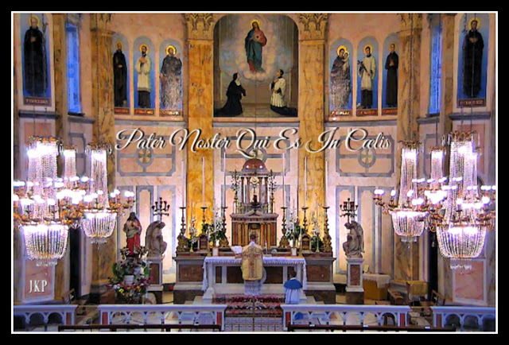

THE TRADITIONAL TRIDENTINE HOLY SACRIFICE OF THE MASS ON JUNE 22, 2020 AT 2 O'CLOCK DETROIT TIME (NOTE THE NUMBERS 2/2 AND 2/2) AT SACRED HEART CHURCH, INSTITUTE OF CHRIST THE KING SOVEREIGN PRIEST (TRADITIONAL CATHOLIC) IN LIMERICK, IRELAND AND THE SUDDEN MANIFESTATION OF CROSSES AS HAD HAPPENED TO THE GOOD FRIDAY JACKET ONE DECADE AGO, TWO YEARS BEFORE I AM RE-INTRODUCED HIS WORK OF REPARATION TO THE HOLY FACE OF JESUS FOR THE SAKE OF A WORLD IN VERY SERIOUS GRAVE PERIL
Something's coming. Something good as Jesus just keeps coming and coming and coming and coming.
At the start of the Holy Sacrifice, a cross was manifested inside the church, in a chandelier on the right.
A cross in the light.
You have been to many live streamed Holy Masses in Limerick, Ireland and never noticed this before.
Right away, it is manifested as a cross as they appeared on the Good Friday pink jacket on the first Good Friday at the Slovak parish where I AM had sent your family in 2010, two years before He re-introduced His Work of Reparation to the Holy Face of Jesus for the sake of a world in very serious grave peril.
He said many times during the Great Seven Year War for Souls at that parish in Catholic Detroit from 2010 - 2017 that humanity was at a crossroads and that He had come to help us in an especial way as Jesus just keeps coming and coming and coming and coming.
I AM asked that His Work of Reparation to the Holy Face of Jesus be established there and promoted worldwide, and that a religious order be founded pertaining to it, but it wasn't. It was very publicly kicked out of that Traditional leaning Catholic Church forever by two angry priests interested in protecting themselves and their two policemen.
Then, as happened with the pink jacket on that Good Friday a decade ago, THE CROSSES INSIDE THE CHURCH DURING TODAY'S HOLY SACRIFICE OF THE MASS BEGAN MULTIPLYING.
One...one, two, three...one, two, three, four, five, six...one, two, three, four, five, six, seven as the celebration of the Holy Sacrifice of the Mass continued.
Can you see them in the picture, in both sets of chandeliers to the left and to the right of Mount Calvary where heaven meets earth before the Throne of Almighty God?
What wonders.
THE CELEBRANT PRIEST'S DESCENDANTS/THE MANIFESTATION OF THE DESCENDANTS OF THE SACRED PRIESTHOOD OF JESUS CHRIST DURING THE TRADITIONAL TRIDENTINE HOLY SACRIFICE OF THE MASS
While taking everything in both in the natural and in the supernatural in with such awe and with wonder, the celebrant priest's descendants were manifested from On High as many, as all souls saved through his sacred priestly ministry and this is to be applied to all the members of Christ's Sacred Priesthood in general who are serving the right Master.
Just imagine those long family lines.
Beautiful beautiful beautiful beautiful.
So grateful.
THE MULTIPLICATION OF THE CROSSES INSIDE THE CHURCH AS THE CELEBRATION OF THE HOLY SACRIFICE OF THE MASS CONTINUES
As usual everything was incredibly stunning from start to finish.
A MESSAGE FOR THOSE SEEKING TO MAKE TROUBLE FOR CHRIST'S FOLLOWERS WHILE SELF IDENTIFYING AS HIS DISCIPLES
Instead of harassing good people and calling them crazy, both publicly and privately, inside and outside of Christ's Catholic Churches, such individuals must look within and address their personal lack of faith and why they are not properly maturing spiritually.
God help them.
I AM manifests His wonders to the humble and the lowly, in imitation of and in union with the Immaculate Mother of God.
ALSO THERE WAS ANOTHER DREAM OVERNIGHT
Once again, it was a metaphor.
WHAT HAPPENED RIGHT BEFORE THE DREAM LAST NIGHT
You woke up and looked up through the dark and saw what looked like something sticking out of the wall.
What wonders, so you turned on the light and see that the image of the Station of the Cross where Veronica wipes the Sacred Face of Jesus along the Way of the Cross just to your right is hanging perpendicular to the wall, half off and half on.
What wonders...
So you remove it and place it on a shelf next to your head.
ANOTHER SAINT BENEDICT CRUCIFIX BROKE THE DAY BEFORE
Very telling.
TODAY'S INCREDIBLE EVENTS ARE EXPLAINED
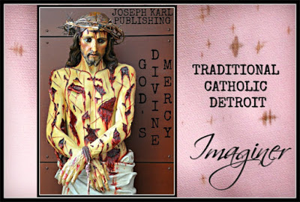Just as I AM provided the miracle of the crosses on the pink jacket prior to re-introducing His Work of Reparation to the Holy Face of Jesus in Modern Times through Christ's Traditional Catholic Sacred Priesthood in 2012 for the sake of a world in very serious grave peril, on this day during the Month of the Sacred Hear of Jesus I AM manifested crosses inside the Sacred Heart Church, Institute of Christ the King Sovereign Priest, during the celebration of the Traditional Tridentine Holy Sacrifice of the Mass on June 22, 2020.
Note the numbers and their having been manifested in a dream during the Great Seven Year War for Souls at the Slovak parish during which the numbers 2/2 (also the Feast of the Presentation of Christ in the Temple and this student teacher's birthday) were manifested very large and in the air while in the vestibule of the Slovak church as the Slovak pastor worked hard in that dream preparing the inside of the church for "A WEDDING").
Is today THAT VERY DAY?
June 22, 2020.
SOMETHING IS COMING. SOMETHING GOOD.
Apostolic mission.
Thanks be to God for everything.
Go, Team.

48. Two Days Later, I AM Divinely Weds His Work of Reparation to the Holy Face of Jesus a Second Time, to Traditional Catholic Institute of Christ the King Sovereign Priest, on the Feast of the Nativity of Saint John the Baptist
In 2020, during the second Traditional Tridentine Holy Sacrifice of the Mass of the day live streamed from Sacred Heart Church in Limerick, Ireland, the ICKSP joins Christ's Traditional Catholic SSPX in having this incredible distinction for the greater honor and glory of our Triune God and then for the sake of a world in very serious grave peril. The presentation of eternal fidelity and the manifestation of the broken crosses, as well as unfathomable immersion in and Divine Union with God as Three Distinct Divine Persons in One: Father, Son, and Holy Spirit, and the unspeakable beauty clearly manifested every moment: what an unfathomable, quiet, and stunningly majestic sacred celebration of the Holy Sacrifice on this incredible day. So grateful to God for everything. What wonders!

49. A Living Will of Eternal Value
Two wills were manifested in the holy silence and in the holy reverence during the second Traditional Tridentine Holy Sacrifice of the Mass of the day, at two o'clock p.m. Detroit time, live streamed from Limerick, Ireland. Imaginer. "By My Holy Face you will work wonders, appease the anger of God, and draw down mercy on sinners." ~ Jesus to Sr. Mary of St. Peter +
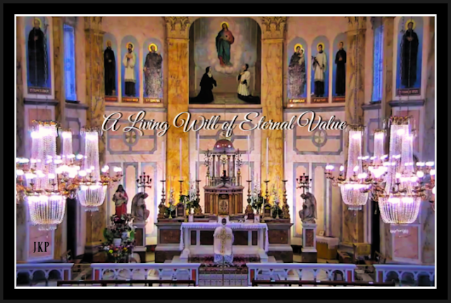
Give God your will and live for Him alone,
for His greater honor and glory first and foremost
and then for the sake of all others, including one's own poor soul.
Beautiful beautiful beautiful beautiful.
So grateful.

THERE WERE MORE INCREDIBLE DREAMS OVERNIGHT
No surprise there.

WHAT HAPPENED DURING THE TRADITIONAL TRIDENTINE HOLY SACRIFICE OF THE MASS ON THIS THURSDAY OF REPARATIVE ATONEMENT ON JUNE 25, 2020
As always, every moment is extraordinarily wondrous and unfathomably beautiful beautiful beautiful beautiful.
Then, there was this.
A LIVING WILL OF ETERNAL VALUE
Your last will and testament suddenly came to mind:
"I leave my earthly possessions, acquired during this life for their proper upbringing, to my children along with the task of helping their Oma - my mother and their surviving maternal grandparent - acquire those things from among them that her heart desires." *
Then what followed as the celebration of the Traditional Tridentine Holy Sacrifice of the Mass continued in the natural was the offering of A LIVING WILL OF ETERNAL VALUE to our Triune God through the Immaculate Mother of God at Christ's High Altar where heaven meets earth on Mount Calvary:
"I give my life to God to be spent in His service as He wills, in imitation of and in union with Christ crucified; may His Immaculate Mother acquire from it all that her Immaculate Heart desires."
Imaginer.
HONORING GOD'S GREATEST TWO COMMANDMENTS THROUGH THE PROPER AND HOLY EXECUTION OF THE SELF WILL
The real value to be acquired during one's mortal life is through a life lived properly, and sacrificially lovingly, as Almighty God wills guided by the Holy Spirit, in imitation of and in union with Christ for the greater honor and glory of our Triune God first and foremost and then for the sake of one's fellow man; the precious value obtained from it lasts forever, into eternity.
"Even half an eternity is a long time." ~ Gene X. Kortsha
Through God's Sacraments we obtain the graces each one needs that enable us to worship, serve, and adore God alone, with purity of intention and devoid of self interest, worshiping, adoring, and serving no idols of any kind, and while loving one's neighbor as one's self.
Through The Sacraments Divinely provided to us, for us, we are unified with our Triune God through Christ our Divine Redeemer, Divine Restorer, Divine Remedy for All, and the Divine Bridegroom of every soul.
The Real Presence of Jesus in the Blessed Sacrament is the greatest Source of Divine Supernatural Graces we have on earth.
Live well, die well, and then go to God forever.
"The price of heaven is carrying the Cross." ~ Servant of God, Father John A. Hardon, S.J.
What wonders. +
* In 2017, Almighty God willed Joseph Karl Publishing's Traditional Catholic Intellectual Material to Christ's SSPX through the Armada (Ray Township) Chapel here in Metropolitan Catholic Detroit.

50.. Into the Jaws of Hell and a Visit from the Devil
Guess what went into the jaws of hell, prior to the ordination of new Traditional Catholic Priests in Italy on July 2, 2020. Just guess.
INTO THE JAWS OF HELL IN JUNE 2020 DURING THE MONTH DEDICATED TO THE SACRED HEART OF JESUS, PRIOR TO THE JULY 2nd ORDINATION OF NEW TRADITIONAL CATHOLIC PRIESTS DURING THE MONTH OF THE PRECIOUS BLOOD OF JESUS OUR DIVINE REDEEMER, DIVINE RESTORER, DIVINE REMEDY FOR ALL, AND THE DIVINE BRIDEGROOM OF EVERY SOUL
While contentedly working in the kitchen cooking, there was suddenly an incredible offering and it was incredible because of the unusual way it was offered.
There was an offering of self, a lifetime of reparative atonement made through the years as Almighty God willed, in imitation of and in union with Christ crucified on Mount Calvary, and THIS OFFERING WAS MADE BY TAKING ALL THE REPARATION MADE BECAUSE OF THE WICKEDNESS OF THE DEMONS AND THEN IT WAS FED RIGHT INTO THE GATES OF HELL.
Imaginer!
The demons have confessed during exorcisms that sacrificial love is more powerful than evil.
There is no way we can lose with God on our side. He is so in love with us all!
There is no room for sin in one's life when one's heart is occupied by Christ the Divine Bridegroom.
A heart occupied by Christ is a very happy heart indeed.
A SURPRISING OTHER OCCURRENCE DURING THE LUCIFERIANDEMIC OF 2020

Once the Luciferiandemic lockdowns and mental torture including social distancing, social isolation, and speaking with forked tongues began in earnest against the populations of the world in 2020, there was an unprecedented term of peace for this student teacher representative of I AM's Work of Reparation to the Holy Face of Jesus in Modern Times, through Christ's Traditional Catholic Sacred Priesthood, for the sake of a world in very serious grave peril.
The forces of darkness have been kept at bay at this pivotal time in human history following a lifetime of severe punishment and harassment.
The demons know full well what I AM's Work of Reparation to the Three-in-One Devotion to the Holy Face of Jesus (Sacred Heart, Divine Mercy, and Holy Face) is and what it means to precious, priceless, and immortal souls.
From the powerful booklet, 'Mary Crushes the Serpent': "The demons maintain that the sins of men give them power over men. They say that God permits demons to keep what they have won through the misdirected will of man and only the free will of man can take from them what the free will of man has given them. Through the willful suffering of victim souls, the demons are deprived of that which men have given them through sin."
This work takes on the mission also, through unyielding alliance with the Most Perfect Will of God at all times, of exorcisms that should take place but don't because of the lack of attention this vital priestly ministry receives in Modern Times.
The demons take exception to this because it works, and their revenge is physical, mental, and spiritual torture directed at the victim souls being led by Our Lady.
The battle between the forces of good and evil is more than a chess match; it is for chosen souls a lifetime of hand-to-hand combat on a battlefield very few see.
AN UNWELCOME VISIT FROM THE DEVIL AND WHAT HAPPENED DURING IT

This used to be a regular occurrence before I AM re-introduced His Work of Reparation to the Holy Face of Jesus in 2012, at the Traditional leaning Slovak parish during the Great Seven Year War for Souls there (2010 - 2017).
The Traditional Catholics accomplishing God's will while worshiping, serving, and adoring God alone inside and outside of this Catholic Churches resisted with all of God's might the destructive-by-design Communist self interest, money loving, false teaching, and funtertaining distractions relentlessly being self promoted by Modernist Luciferians self identifying as Catholic who worship themselves and ultimately the devil.
The physical assaults at night have lessened in the past decade and became even more rare since worshiping God in exclusively Traditional Catholic Churches (SSPX and ICKSP).
Modernism is the demons' way in to Christ's Catholic Churches and also their way into the hearts and homes of God's people.
I AM's Work of Reparation to the Holy Face of Jesus drives them out.
It had been a while since there had been one of the devil's very painful physical assaults overnight but one took place recently, disturbing the peace, after the incredible OFFERING OF REPARATION TO THE HOLY FACE OF JESUS RIGHT INTO THE JAWS OF HELL was made.
That stunning truly charitable return of the spending of the self unified as One with Christ crucified as I AM willed following a lifetime of being assaulted by unfathomable evil came shortly before the Ordination of new Traditional Catholic priests in 2020 during this incredible year of accelerated diabolical assaults against the human person worldwide.
As in the past the devil himself appeared as someone very close to this student teacher, this time as
her young adult daughter, and then the assault took place in the manner in which only the devil can accomplish.
After hating your happiness at seeing your daughter in the vision, he went right for that long suffering right side and inflicted unfathomably agonizing pain that came from the hand of the fallen angel of light.
Using his hand as a weapon, he entered into that right side which has made so much reparation for Christ's Catholic priests as needed in Modern Times, thanks be to God, for the sake of a world in very serious grave peril, and he did so as if it was some sort of knife.
This was with his own unholy and disobedient hand a spiting of the Sacred Lance Wound in Christ's Side through which His Precious Blood and Water flowed during our Redemption on Mount Calvary for the sake of the whole world.
In this manner he also spites the consecrated hands of Christ's Traditional Catholic priests through which so much good is accomplished because Christ comes to us through them.
Imaginer.
The pain he inflicts is experienced in the natural and supernatural, and it is physical suffering in a way that nothing can compare in the natural. This is a manifestation of Christ's physical suffering during His Sacred Passion and execution by crucifixion for our Redemption while taking on the sins of the whole world and making reparation to Almighty God for them.
Imagine how much punishment the forces of darkness inflicted on Him on that first Good Friday, keeping in mind that this punishment continues by those working for the wrong master right inside of Christ's Catholic Churches, at His inverted modernist desecrated altars.
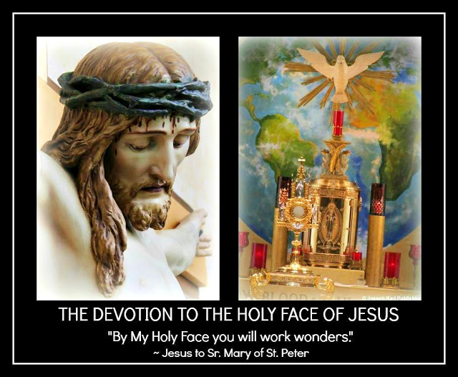

NOW WHAT
In our Triune God we totally trust, through the maternal intercession of the Immaculate Mother of God and the paternal intercession of holy husband and foster father Saint Joseph.
Saint Francis de Sales, Saint John Bosco, Saint Therese of the Infant Jesus and Holy Face, ora pro nobis.
Saint Michael the Archangel, defend us in battle. Go, Team! +

51. The Very First Dream I Remember
It happened when I was very little and it came to pass, just like so many dreams that came later.

THE VERY FIRST DREAM I REMEMBER
I was very, very young.
In the dream I found myself inside a room with several adult men I did not recognize.
They were standing before a stainless steel machine that appeared like a box and before this box was a conveyor belt, which when turned on fed things into the machine.
The machine was a shredder and it was very large.
At the time of the dream my sister and I were both very little girls; she came into the world in 1963, 17 mere months before me.
The men then turned on the machine, put my sister on the conveyor belt, and fed her right into the shredder.
IT CAME TO PASS, THAT VERY FIRST DREAM
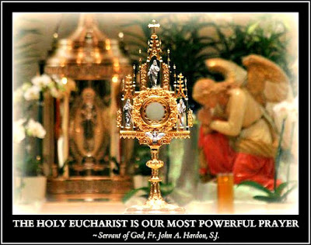
The men in the dream represent the allopathic medical system in Modern Times educated in the image and likeness of the snake that profits from the pushing of Luciferian eugenics pharmacological poisonous drugs, sterilization agents, deadly "treatments", and toxic injections under the guise of caring after having taken an oath to "do no harm" not "line your pockets while destroying your fellow man created by God in His Divine Image and likeness."
The shredder represents their highly profitable eugenics "cures."
In 2011, my sister who wanted to live was martyred, her life was taken from her after death had been very quickly - with no time to lose - sold as her cure, by the allopathic medical self interested mafia working for Lucifer the liar, deceiver, divider, destroyer, and killer after many had financially profited from her and my family's and also all of mankind's brutal suffering in Modern Times.

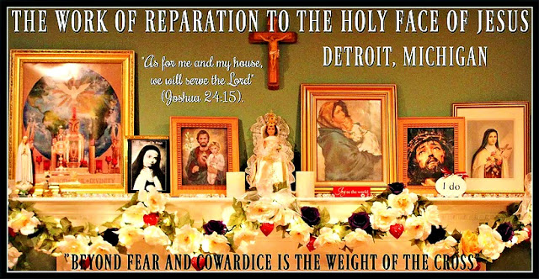
IN 2012 I AM RE-INTRODUCED HIS WORK OF REPARATION TO THE HOLY FACE OF JESUS FOR THE SAKE OF A WORLD BEING LED TO THE SLAUGHTER
He asked His Traditional Catholic leadership to take up this Work and promote it by word and by deed, costing no money while costing one's self everything in imitation of and in union with Christ (meaning one spends one's self and falls in love with God instead of with money) and to date this has not been accomplished for His greater honor and glory first and foremost and then for the sake of the whole world in Modern Times.
Yet the fundraising needs no 4th miracle to prove its worth. It doesn't even require one.
God wouldn't give fundraising a miracle and that is why no one asks for one before proceeding.
GO MIRACLE ME
Fundraising comes from hell and the devil and it originates in the self will of those with a fallen human nature.
Accomplishing God's will is paramount and so is trusting in Him to provide and for this one must leave one's self will and one's whole self behind.
Who sees the difference.
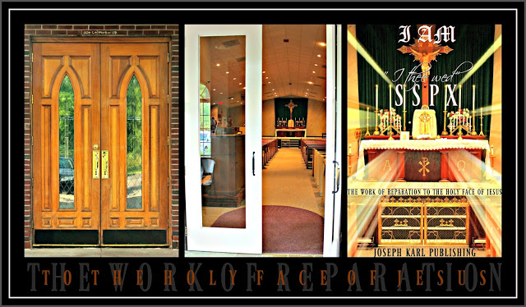

2020
And so here we are in 2020 as Our Lady's prophesies in Fatima play out before our very eyes.
Yet most don't see through the eyes of Our Lord.
Most see what they want to see, which produces a very different vision that distorts both sense and reason.
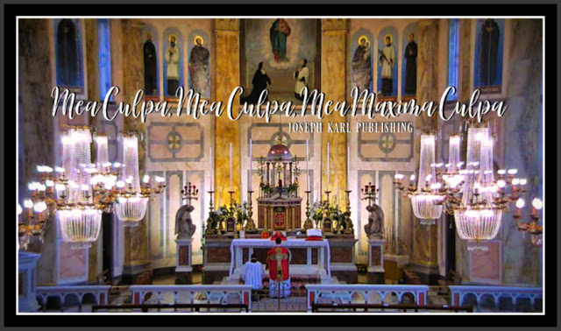
THERE IS NO BEST VERSION OF ONE'S SELF; ONE CHOOSES EITHER TO SERVE GOD AT ALL TIMES OR ONE'S SELF AND THE DEVIL
True story.
Most often the acquisition of ever more money or funds is behind the misguided and perilous service to so many wrong masters, both inside and outside of Christ's Catholic Churches.
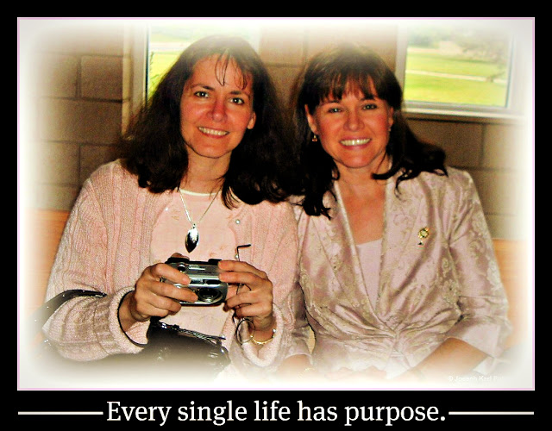
Belinda (holding the camera) and me in church
during the Holy Mass for my oldest son Andre's 8th grade graduation.
We were both about to get catastrophically sick
and only one of us would survive.
One trusted with good intentions in the highly profitable
and for most people unaffordable allopathic snake system while trusting in God,
suffered brutally for two years and then lost her mortal life;
the other one trusted in God and His ways, which work as He wills, and then lived.

God help us all. +
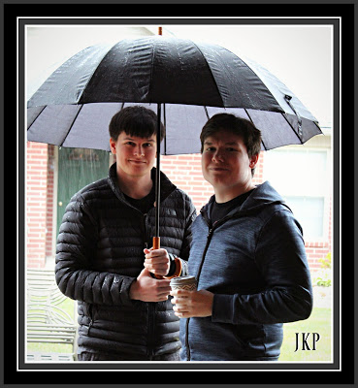

52. The Divine Royal Wedding Under Water in the Dream Overnight
Imaginer. + "By My Holy Face you will work wonders, appease the anger of God, and draw down mercy on sinners." ~ Jesus to Sr. Mary of St. Peter
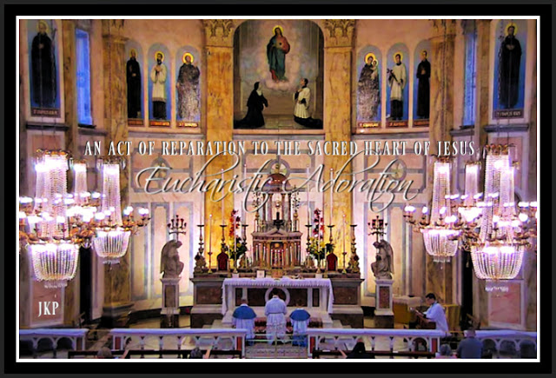
Eucharistic Adoration
following the Traditional Tridentine Holy Sacrifice of the Mass
live streamed on Friday, July 10, 2020
at Sacred Heart Church,
Institute of Christ the King Sovereign Priest,
Limerick, Ireland.
JUST PRIOR TO 3 A.M. DETROIT TIME ON FRIDAY, JULY 10, 2020
This student teacher asks our Lord for a Divine Royal Wedding Present, through Christ's Traditional Catholic Sacred Priesthood, for the sake of a world in very serious trouble.
What is requested from Christ the Divine Royal Bridegroom of every soul is the Divine supernatural conversion of a high ranking priest that will open the door through the intercession of Saint Francis de Sales for the establishment of the teaching order associated with I AM's Work of Reparation to the Holy Face of Jesus which our Divine Sovereign Authority requested after having re-introduced it in Modern Times in 2012 for the sake of a world in very serious grave peril.
In a dream overnight during the Great Seven Year War for Souls at the Slovak parish (2010 - 2017) the return of a prelate's Baptismal innocence had been manifested. Perhaps he is the one for whom the Divine Royal Wedding request early this morning had been made.
God knows.
There was no live stream of the 3 a.m. Traditional Tridentine Holy Sacrifice of the Mass and so there had been more happy cooking and baking instead.

THE DREAM OVERNIGHT INSIDE A CHURCH UNDER WATER
I found myself inside a church that appeared unfamiliar, among people that appeared unfamiliar, and all had gathered for the celebration of the Holy Sacrifice of the Mass.
The church was under water.
The water was several feet high, so people were sitting in the pews in it, and during Holy Communion they were kneeling in it also.
All was very peaceful and serene and wondrous.
At one point, the people left the pews a second time and once again approached the altar single file to the left.
It was as if there was a second Holy Communion of some sort.
Once again the people approached the altar and then knelt at the front of the church, this time right in the area before the altar (between the altar and the Communion Rail usually reserved for the priests and altar boys). However, this time people knelt in small groups, on individual pieces of furniture that were moved and arranged as needed.
There were several priests at the altar for this purpose.
THE PRIESTS IN THE PEWS
The priests in the dream overnight who were ministering during Holy Mass inside the church under water appeared unfamiliar and yet familiar.
It was as if I knew some of them.
Yet not all of the priests served up at the altar.
Some of them were seated next to me in the pew which had been replaced by chairs that could be moved.
A CATHOLIC CHURCH IN MODERN TIMES UNDER WATER
Water is a sign of divine life, purity, and cleansing from sin.
I AM's Work of Reparation to the Holy Face of Jesus in 2020 is the Divine Supernatural means we have been given, through the spending of the self as He wills for each one in imitation of and in union with Christ crucified, to clean things up and restore Christ's Catholic Church in Modern Times, from the inside out and for the sake of the entire human race, through Our Lady the Virgin of the Globe and Miraculous Medal.
Imaginer.

53. More Water Inside Another Church in the Dream Overnight
This time the church was not unfamiliar. Guess which one it was. Just guess.

OVERNIGHT ON SATURDAY, JULY 11, 2020 FOLLOWING THE 3 A.M. LIVE STREAM OF THE EXQUISITELY BEAUTIFUL TRADITIONAL TRIDENTINE HOLY SACRIFICE OF THE MASS AT SACRED HEART CHURCH, ICKSP, IN LIMERICK, IRELAND
There was a second dream having to do with a church filled with water.
A RETURN TO THE SLOVAK PARISH IN THE DREAM OVERNIGHT

All of a sudden you found yourself inside a church where many people were gathering for the Holy Sacrifice of the Mass.
The church appeared unfamiliar and yet familiar.
While it appeared rectangular in shape and large, longer than it was wide, it was made manifest that the church is the Slovak parish where I AM had sent your family around 2009 for the sake of a world in very serious grave peril.
It was at that church in 2012 that I AM re-introduced His Work of Reparation to the Holy Face of Jesus in Modern Times for the sake of the whole world, during the Great Seven Year War for Souls there (2010 - 2017) between those serving God and those very clearly serving the devil.
In 2017 the Traditional leaning Slovak pastor, who had been on the chopping bloc for a while by the communist forces of darkness operating from within Christ's Modernist desecrated branch of His Catholic Church in Modern Times for behaving in a manner that was too Traditional and God-fearing, kicked this Apostolic Work of I AM's out of that Catholic Church and also Christ right along with it after he had been given the axe first; one cannot serve two masters and expect to be protected from one's enemies. The Slovak pastor was then publicly humiliated by more than one prelate, thanks be to God, for one never wants to be celebrated by people cooperating with the devil.
Then his entire parish was significantly emotionally and spiritually traumatized by the wolves in shepherds' clothing, in his absence.
Then the wolves went on to target the next Traditional Catholic priest on their hit list, an older one they have disliked for even longer, and then they very publicly gave him the axe, too.
Many good priests of all ages here as elsewhere continue to face persecution from within for worshiping, serving, and adoring God alone; this is the same ongoing diabolical mission of destruction that will continue to oppose God until the end of time.
Who is YOUR master?
SACRIFICIAL LOVE IS MORE POWERFUL THAN HATRED
"The demons maintain that the sins of men give them power over men. They say that God permits demons to keep what they have won through the misdirected free will of man, and only the free will of man can take from them what the free will of man has given them. Through the willful suffering of victim souls, the demons are deprived of that which men have given them through sin." ~ 'Mary Crushes the Serpent'
In 2017 I AM Divinely supernaturally wed His Work of Reparation to the Holy Face of Jesus to the Traditional Catholic Society of Saint Pius X here in Metropolitan Detroit and then in 2020 did so to Traditional Catholic Institute of Christ the King Sovereign Priest in Limerick, Ireland.
God and His Work and His people are always welcome inside of Christ's Traditional Catholic Churches because our Triune God alone is worshiped, served, and adored there.
Thanks be to God, self interested and self serving and money-loving evil is unwelcome there.

WHAT HAPPENED IN THE DREAM OVERNIGHT BEFORE ENTERING INTO THE CHURCH AS MANY PEOPLE ENTERED INTO IT ALSO
You found yourself entering the bathroom to the right of the vestibule entryway, which appeared unfamiliar meaning not exactly the same in layout as at the actual Slovak parish in the natural.
What was to the right in the Slovak parish in the natural? THE LITTLE CHAPEL CONTAINING THE CONFESSIONALS.
Who sees the metaphor.
It was absolutely filthy and unfathomably wretched inside that bathroom in the dream overnight which is a metaphor as in so many dreams of the past.
Many astounding things were manifested, meaning brought to your attention, in the supernatural pertaining to the filth there in the natural in the dream, things that are not visible in the natural.
What a wonder that was.
WHAT HAPPENED AFTER ENTERING INTO THE CHURCH
You found yourself up at the front, to the very right and right by the wall.
The building in the dream and the atmosphere within it were Traditional (the Slovak church was modern in design but the atmosphere was Traditional leaning).
To your left was the congregation in Modern Times and the entire church was full.
ALL OF THE PEOPLE WERE STANDING
There were no seats. There were no kneelers.
None.
The Catholic world has in our time been almost completely stripped of the Sacred, including the proper Catholic education of God's people, by Modernists working for the forces of darkness to eternally ruin every single precious, priceless, and immortal soul.
WHAT YOU WERE THINKING WHILE INSIDE OF THAT CHURCH
You were thinking that you are not welcome inside God's House there by the leadership working for the wrong master at the Slovak parish and you waited for the Slovak pastor who kicked you out twice, once with the help of two communist policemen, to come and kick you out of God's House again, to insist you never return to the place where He alone is to be worshiped, served, and adored.

HOWEVER, THERE WERE NO PRIESTS AT THE ALTAR IN THE DREAM OVERNIGHT
The church was completely full but the altar area was entirely empty.
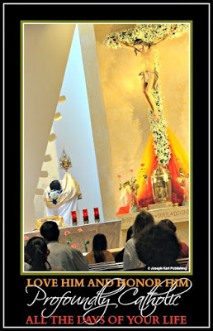
What wonders.
IS THIS A MODERN DAY SIGN OF WHAT IS, OR OF WHAT IS TO COME? OR BOTH?
The absence of proper male leadership inside God's House was very clearly manifested in the dream overnight, and all of God's people are in need of Christ's shepherds.
THE POOL OF WATER INSIDE THE CHURCH

Then, you found yourself turning and facing toward the back.
The entire inside of the church behind you had transformed into a beautiful pool of clear water.
You found yourself entering into it, and traveling toward the back, away from the people while following along with such awe and with wonder.
The water was so refreshing, so peaceful, so calming, so healthy, and so serene.
It represents the Traditional Catholic restoration of Christ's One, Holy, Catholic, Apostolic, and Pro-Life Church through I AM's Christocentric-Marian Work of Reparation to the Holy Face of Jesus, the manner in which Almighty God wills, for the sake of the whole world in our time.

PART IX
THE NINTH STATION OF THE CROSS
JESUS FALLS A THIRD TIME

54. July 12, 2020: Another Encounter with a Traitor in the Dream Overnight
55. The Incredible Explosion, the Line of Fire, the Voice of Almighty God, and Catholic Detroit's Family of Reparation's Procession
56. Half a Suit of Armor
57. The Dilapidated Structure in the Dream Overnight and the Search for Something for the Treasonous Priest
58. Ownership of the Sacred Heart of Jesus
59. The Criminal and the Candle

54. Another Encounter with a Traitor in the Dream Overnight
Ever more metaphor continues to pour out of Traditional Catholic Detroit, home of I AM's Work of Reparation to the Holy Face of Jesus in Modern Times for the sake of a world in very serious grave peril. Where else does this Apostolic Mission want to call home? Yours. Imaginer. +

THE DREAM OVERNIGHT ON SUNDAY, JULY 12, 2020 FOLLOWING THE 3 A.M. DETROIT TIME TRADITIONAL TRIDENTINE HOLY SACRIFICE OF THE MASS LIVE STREAMED FROM SACRED HEART CHURCH, INSTITUTE OF CHRIST THE KING SOVEREIGN PRIEST, IN LIMERICK, IRELAND
A dream from the past decade was repeated but inside its details is a clue as to what may be coming.
Once again you found yourself in the company of a traitor.
This man who was sacramentally wed before God at Christ's Altar on Mount Calvary had in 1989 vowed before God to remain faithful to the promise he willingly made.
He broke that promise within ten years, and 13 years after having made his promise was granted the civil divorce that he wanted.

Thus he abandoned his wife and three children, having fallen in love with the almighty dollar - which is the root of all evil - and being so effortlessly duped into believing the terrible lies of the snake.
The day after he had brought Divine Justice and condemnation upon his own soul, he entered into a treacherous civil union with another wicked traitor in a deep state of self interested and money loving soul decay.
Imaginer.
WHAT HAPPENED WHILE IN THE COMPANY OF THE TRAITOR
This traitor had come in the dream to see you, and wanted to be unified with you after having unified himself as one with Lucifer the father of lies.
UNTIL DEATH DO US PART
It was in the dream as if you were still husband and wife, because you still are in the eyes of God.
"My children all we are is what we are in the eyes of God, and nothing more." ~ Saint John Vianney
While following along with such awe and with wonder, you thought to yourself while finding yourself suddenly in the company of this man that he had sought the company of another.

It seemed in the dream though as if he had separated himself from that disastrous, self-inflicted, and very short-sighted situation based on deception, for every moment he chooses to remain in the state of adultery he obtains for himself a one-way ticket to hell, where the punishment for the unrepentant misdirected and self interested misuse of the free will in the total absence of God, and His sacrificial love, lasts forever.
Imagine what punishments await in hell not only for the treasonous but for those guilty of double treason, meaning for having been a traitor one's self and also for having encouraged another or others to insult Almighty God in that very same manner, over and over, moment by moment, day by day, month by month, and year by year.
WHAT WAS MANIFESTED WHILE IN THE COMPANY OF THE TRAITOR
It was manifested then in the dream overnight that YOU ALREADY HAD TWO CHILDREN WITH THIS TRAITOR.
Note that in the natural you share three very wonderful children, who thanks be to our Triune God had been exposed during their youth to the Three Divine Persons-in-One through Christ's Traditional Catholic Church in Modern Times.
The two children manifested in the dream overnight indicate the great good that our Triune God has accomplished, despite the presence of grave and sinister evil, through those who are willing to accomplish His Most Perfect Will in imitation of and in union with Christ crucified on Mount Calvary through I AM's Work of Reparation to the Holy Face of Jesus in Modern Times for the sake of a world in very serious grave peril.
WHAT HAPPENED NEXT
All of a sudden, you found yourself thinking that you wanted to have A THIRD CHILD.
What wonders.
What this means is that The Great I AM draws great good from even the worst of human disasters and treachery in imitation of Judas through those who are willing to listen to Him and do as He says.
Dear God please grant that the precious, priceless, and immortal souls of those in a persistent state of mortal sin be saved from the fires of hell, for they are worth far more than mere money.
Amen.

55. The Incredible Explosion, the Line of Fire, the Voice of Almighty God, and Catholic Detroit's Family of Reparation's Procession
What a wonder that was overnight and it was followed by a stunning Traditional Tridentine Holy Sacrifice of the Mass live streamed at 2 p.m. Detroit time from Sacred Heart Church, ICKSP, in Limerick, Ireland in which everything was of gold. Imaginer. Guess what happened just prior to the Consecration of Christ's Precious Blood during the Month of the Precious Blood in 2020. Just guess. "Trust all things to Jesus in the Blessed Sacrament and to Mary, Help of Christians, and you will see what miracles are." ~ Saint John Bosco +
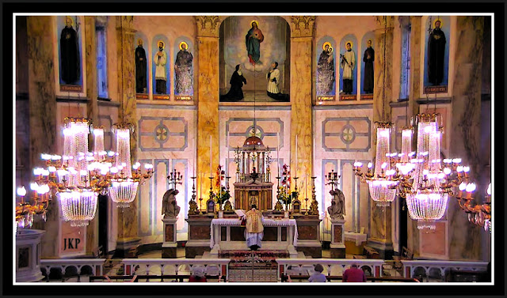

THE MONUMENTAL DREAM OVERNIGHT ON JULY 14, 2020 (THIS STUDENT TEACHER'S PARENT'S WEDDING ANNIVERSARY) AND THE FEAST OF SAINT BONAVENTURE

What a wonder that was.

THE SETTING

You found yourself at a place that appeared unfamiliar and yet familiar.
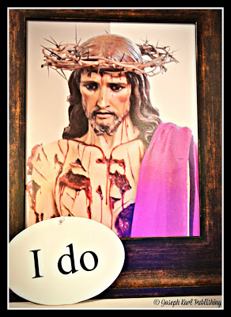
You were at a small apartment complex, the one where I AM suddenly put you almost one year ago. It appeared different and yet the same.
Although you live on the first floor, in an apartment with cathedral ceilings, you found yourself at this complex standing on a second floor balcony, looking south into the distance.
THE STUNNING EXPLOSION OVER THE CITY OF DETROIT
Suddenly, you saw an airplane flying over the city of Detroit which is not a surprise as a major international airport is nearby.
Another airplane was manifested, a second one that was in close proximity to the first, and then the first one which was flying south over the city suddenly exploded.
Then there was a massive fireball over the city of Detroit.
THIS EXPLOSION HAD BEEN FORETOLD IN THE PAST AND HAS BEEN EXPECTED
It is a metaphor and has been manifested to you many times in the past, within the the intellect not in any dreams.
And so this event was foretold and has been expected.
THE PRE-SET FIRE THAT SPREAD FROM IT

The explosion in the sky was astonishing and massive in size, but then a fire erupted on the ground which had come come from it.
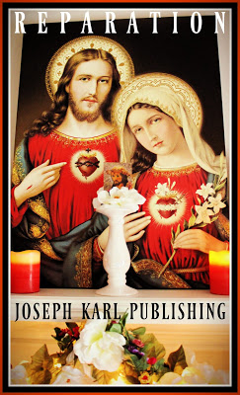
The fire had been very clearly arranged in advance for it rapidly spread out from the explosion, in a straight line.
It moved quickly, this pre-arranged fire.
THE QUICK MOVING FIRE AND THE PEOPLE AND THEIR DWELLINGS
Many people were then manifested at the apartment complex, which now hosts I AM's Devotion to the Holy Face of Jesus in one of its dwellings in the back, for their attention had been captured by the fire as it began spreading out in both directions.
WHO WAS THERE
You found yourself rushing to the front line of the line of fire, which was right in front of the apartment complex, in order to help stop it from spreading.
There were several priests among the people who had gathered at the front of the small complex.
You began providing vital instruction to the lay people who were talking among themselves despite being right next to the fire.
THE THREE GROUPS OF PEOPLE WHO WERE THERE
There were three groups of people manifested in the dream overnight by the destructive fire that had spread outwards from the city of Detroit.
One group was made up of United States citizens, one group was made up of foreign born laborers, and the smallest group was made up of Catholic priests in long garments.
WHAT THE PEOPLE WERE DOING TO STOP THIS FIRE
“In all your deeds and words you should look upon this Jesus as your model. Do so whether you area walking or keeping silence, or speaking, whether you are alone or with others. He is perfect, and thus you will be not only irreprehensible, but praiseworthy.”
~ St. Bonaventure
The priests manifested in the dream overnight spoke among themselves but did nothing.
The U.S. citizens spoke among themselves and waited for someone else to either put out the fire or tell them what to do.
The foreign born laborers were not under a state of hypnosis for they had had to labor their whole lives to survive and they were working hard to properly put out the fire.
THE METAPHOR
Most people, particularly in the United States, are in a deep state of mind control in Modern Times and this was accomplished over time by Luciferian design.
That goes for priests, religious, and lay people.
"We are a hypnotized nation." ~ Servant of God, Father John A. Hardon, S.J.
CATHOLIC DETROIT'S FAMILY OF REPARATION'S PROCESSION

After providing the people with vital instruction to stop the fire's spread, you turned around preparing to take up this work also and saw your three children standing there.
They are now all in their 20s and living on their own but in the dream your two oldest, both boys, were about high school age.
The oldest was the same height as his mother and his brother was shorter, and their little sister was about 6th grade age.
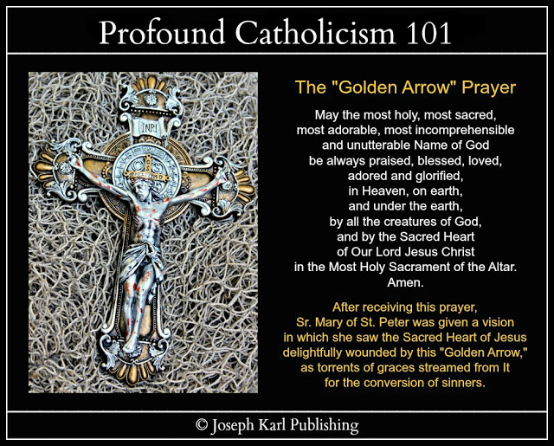
WHAT HAPPENED NEXT
You were stunned to see that your oldest son was outfitted in a religious habit made of poor man's sackcloth.
Over that garment was a white cloth that was long and rectangular in shape and it was draped over the front and the back.
On the white cloth was a crudely fashioned cross in red.
Imaginer.
THE VOICE OF ALMIGHTY GOD OUR DIVINE SOVEREIGN AUTHORITY
While taking all this in with such awe and with wonder, Andre suddenly began speaking.
The Voice of Almighty God was coming through him and in this manner He was speaking to His people.
WHAT IS HE SAYING?
You were so happy, for God remains with us always, and were so eager to know what it was that I AM was saying.
However, you found yourself turning around and leading him among the people, moving east on the west side of the line of fire, as Catholic Detroit's Family of Reparation's Procession for the sake of the whole world in our time.
God works through those who are willing to listen to Him and to do as He says, in imitation of and in union with Christ crucified, with purity of intention and devoid of self interest and without counting the personal cost through the maternal intercession of the Immaculate Mother of God.
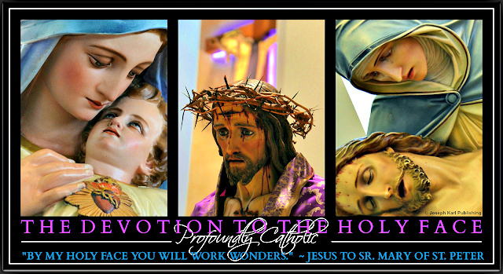

HOW THE DREAM SUDDENLY ENDED
So you led the little four-person family procession among the people who were standing around conversing.
Andre came next, in second place, followed by Nick and then Alyssa.
At one point, still so eager to know what I AM was saying through your firstborn son, you turned around after realizing that the people were not listening. Instead, they continued to communicate among themselves.
Andre, who had been communicating the Voice of God, had stopped speaking.
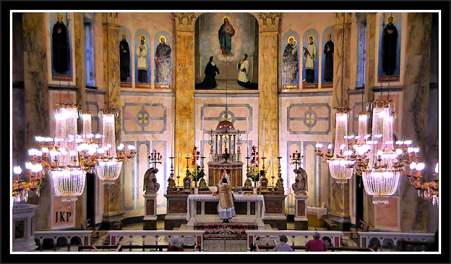

THE TRADITIONAL TRIDENTINE HOLY SACRIFICE OF THE MASS AT 2 P.M. LIVE STREAMED FROM SACRED HEART CHURCH, INSTITUTE OF CHRIST THE KING SOVEREIGN PRIEST, IN LIMERICK, IRELAND: EVERYTHING VISIBLE IN THE CHURCH IS MANIFESTED AS IF OF GOLD
This occurred in both the natural and in the supernatural.
The celebration was unfathomably BEAUTIFUL BEAUTIFUL BEAUTIFUL BEAUTIFUL.
So grateful.
It was as if everything was absolutely PERFECT from start to finish.
Everything was manifested during the live stream as being OF GOLD.
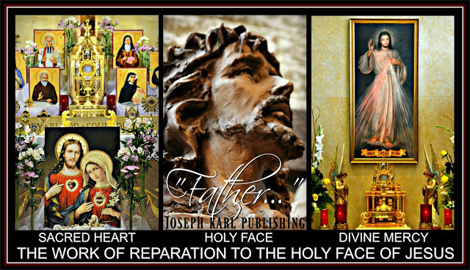

THE MAGNIFICENT MANIFESTATION AND EXPLANATION JUST PRIOR TO THE CONSECRATION OF THE PRECIOUS BLOOD OF JESUS AT CHRIST'S HIGH ALTAR DURING THIS MONTH OF THE PRECIOUS BLOOD OF JESUS IN 2020
"He who desires to go on advancing from virtue to virtue, from grace to grace, should meditate continually on the Passion of Jesus." ~ Saint Bonaventure
Just after the Consecration of the Sacred Body of Our Lord and Savior Jesus Christ, right before the Consecration of His Precious Blood, the following was manifested in the supernatural.
I AM'S WORK OF REPARATION TO THE HOLY FACE OF JESUS: IN PERSONA CHRISTI FOR THE MEN AND IN PERSONA HIS IMMACULATE MOTHER FOR THE WOMEN
“Incline thine ear, O Lady, to hear my prayers: and turn not away from me the beauty of thy face. Turn our mourning into rejoicing: and our tribulation into joy.” ~ Saint Bonaventure
Just as all that is from our Triune God comes to us through His Immaculate Mother, the Virgin Mother of Christ our Divine High Priest and Divine Redeemer, Divine Restorer, and Divine Remedy for All, I AM's Work of Reparation to the Holy Face of Jesus in Modern Times comes to humanity through a mother and it is the Apostolic Mission of Christ's Traditional Catholic priests as our leaders to take action and establish it as I AM wishes, in imitation of and in union with Christ crucified, for the sake of the whole world.
"By My Holy Face you will work wonders, appease the anger of God, and draw down mercy on sinners." ~ Jesus to Sr. Mary of St. Peter +

56. Half a Suit of Armor
Half a suit of armor equals no suit of armor at all to the part exposed to danger during battle. "By My Holy Face you will work wonders, appease the anger of God, and draw down mercy on sinners." ~ Jesus to Sr. Mary of St. Peter +
THE HOMILY FROM ON HIGH THAT CAME AT THE VERY START OF THE CELEBRATION OF THE TRADITIONAL TRIDENTINE HOLY SACRIFICE OF THE MASS ON MONDAY, JULY 20, 2020
I AM said that Christ's priests not taking up His Work of Reparation to the Holy Face of Jesus in Modern Times are wearing only half a suit of armor.
Just imagine the ramifications of this as the enemies of God conspire against us.

57. The Dilapidated Structure in the Dream Overnight and the Search for Something for the Treasonous Priest
Just imagine what THAT funeral was like.
THE DREAM OVERNIGHT ON JULY 24, 2020 WHILE MAKING REPARATION FOR TWO DAYS
I found myself inside a home that appeared unfamiliar and yet familiar.
THE HOME IS A METAPHOR, AND PERHAPS MORE THAN JUST ONE
What wonders; I was in the company of some people I know including the man I married and some people from his side including his friends.
All of a sudden, everything in the incredible house started transforming and becoming dilapidated, one by one.
THEN YOU FOUND YOURSELF INSIDE OF THE GARAGE
There was a large garage attached to the incredible house, very spacious, and it was transforming into a wreck as well.
THE FUNERAL IS ALSO A METAPHOR
Then the man left to attend a funeral with those from his side, including his mother, who had gathered inside the large garage because someone/something had died.
Perhaps it was his soul they were all mourning.
Remember, it is every Christian's duty to help one another GET TO HEAVEN.
This is not easy with Christ's Catholic Church such a Modernist desecrated wreck in our time.
THE HOME BEGINS DECAYING WHILE THE MAN IS AWAY ATTENDING THE FUNERAL FOR HIS OWN SOUL
What wonders that was, to be shown one thing after another inside the home transforming into a complete wreck, including the bathroom which we know from past dreams is a metaphor for THE CONFESSIONAL and THE SACRAMENT OF CONFESSION.
The demons teach people to seek their own personal happiness while not holding themselves accountable for their sins.
When the husband returned from the funeral for his own soul he returned to the garage and was there, along with his mother and a priest in clerical garments who appeared unfamiliar.
By then the place was such an incredible wreck and I asked him as the man and the head of the household to fix some things before he left, as it was very clear that he was about to depart for good.
He was too self interested to remain and in his self induced prideful and arrogant blindness he was blissfully and so short-sightedly being led astray by self interested idolatrous deceivers also in love with money which is the root of all evil.
This request was made of him knowing that he would not want to be helpful despite having the resources to very easily do so.
"Why be helpful and share what God has provided?", says the devil.
SELF INTEREST LEADS TO SPITE AND THE DEMISE OF ONE'S SOUL
The place had become a wreck because of self interested treachery at a time when Christ's Catholic Church has been so badly disfigured and corrupted from within by design in Modern Times after those seeking to destroy Her had "joined" Her.
The treasonous priest telling people what they want to hear, to each soul's demise, represented the battle taking place in our time within Christ's Catholic Church to completely destroy Her, but God had ordained that this is impossible. The forces of darkness know of this impossibility, so they seek to ruin as many souls as possible using deception that appeals to mankind's fallen human nature so they
will have company in hell forever.
Lead people from God, His Commandments starting with the Greatest Two, and Christ's Traditional Catholic Sacraments and let the funerals for souls begin.
Then I found myself searching in the garage for something to give to the priest prior to the departure of the traitors.
I was searching among boxes for a certain book to give to the priest who was a self interested traitor also, the book "Meditating on Christ's Passion," but I could not find it among the ruins inside the garage caused by the misdirected use of the free will of man.
The search for that book indicates in particular the lack of cooperation from within the ranks of Christ's Sacred Priesthood meaning the lack of cooperation with God by those Catholic priests He has asked since 2012 to take up and promote His Work of Reparation to the Holy Face of Jesus for the sake of the whole world in our time, which is precious.

WHO IS A TRAITOR?
Anyone seeking to accomplish one's own will instead of the Most Perfect Will of I AM, as He wills it.
THE WORK OF REPARATION TO THE HOLY FACE OF JESUS
To be without It is to be wearing only half a suit of armor, said the Lord.
To be without It is to fight the forces of darkness and lose.

58. OWNERSHIP OF THE SACRED HEART OF JESUS
To be given the Sacred Heart of the Divine King of All Kings is to be given also the Immaculate Heart of His Mother. Imaginer. +
OWNERSHIP OF THE SACRED HEART OF JESUS
Imagine being given such a Royal Wedding Gift from the transpierced Sacred Hands of Christ the Divine Bridegroom of every soul, before the Three-In-One Devotion to His Holy Face (Sacred Heart, Divine Mercy, and Holy Face) prior to the next celebration of the Traditional Tridentine Holy Sacrifice of the Mass, in Latin.
JUST IMAGINE LOVE THAT LAVISH
"Sweet Jesus, I do and I always will."

59. The Criminal and the Candle
The battle rages on. Oorah! "By My Holy Face you will work wonders, appease the anger of God, and draw down mercy on sinners." ~ Jesus to Sr. Mary of St. Peter +
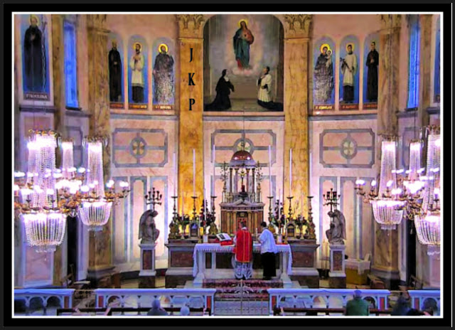
The exquisitely beautiful celebration
of the Traditional Tridentine Holy Sacrifice of the Mass
live streamed from Sacred Heart Church,
Institute of Christ the King Sovereign Priest,
in Limerick, Ireland.

LAST THURSDAY NIGHT

A spinal adjustment is needed very badly; the plan is to call right away in the morning hoping that the good chiropractor is not on vacation.

A VISIT WITH THE ANGEL AND THEN WITH OUR LORD
On Friday morning you learn that the good chiropractor is on vacation this week.
What suffering; there will be no spinal adjustment until at least Monday and the back and neck are very much in need of being properly re-aligned.
It will be a weekend of reparation.
So be it.
That night, your suffering system settles in for what won’t be a good night’s rest, not that there is ever a good night’s rest anyway as the dreams just keep coming, every night.
So be it.
Before some slumber sets in and the dreams begin, two things happen.

First there is a manifestation of your Angel Guardian holding a certain candle and then there is a special visit from Our Lord.
Visit is used but it is really a manifestation of His Divine Presence, His promise, and His Apostolic Mission in Modern Times for He remains with us always until the end of time.
"Jesus makes heaven, wherever He is." ~ Father Frederick William Faber
THE ANGEL GUARDIAN AND THE CANDLE
Suddenly your Angel Guardian appears by your bedside in the dark and he is holding a lit candle.
"What is this candle?" you ask him.
His reply: "It is the candle that is lit and then placed upon Christ's High Altar during the Traditional Tridentine Holy Sacrifice of the Mass, prior to the Consecrations of both Sacred Species."
THEN THERE WAS A SPECIAL VISIT FROM THE DIVINE BRIDEGROOM WHO IS SEPARATE AND YET INSEPARABLE FROM US
Jesus Christ is separate from us and yet is inseparable from us, our Divine Redeemer, Divine Restorer, Divine Remedy for All, the One Who Paid for It All for our sake and with His Very Life, the Divine Bridegroom of Every Soul, and the Lamb of God Who takes away the sins of the world.
Jesus is so near, Divinely separate and yet inseparable from you while sharing As One in His reparative suffering as Almighty God wills for the sake of the whole world in our time.
His love is so pure and so real, authentic, genuine, and self-sacrificing.
Such love is so incredibly beautiful.
Christ came to express His caring for His people at this moment in human history, in Modern Times, in 2020.
A VISIT OVERNIGHT FROM OUR ADVERSARY THE CRIMINAL WHO DOES NOT LIKE I AM'S WORK OF REPARATION TO THE HOLY FACE OF JESUS, NO WONDER
That is because Lucifer is self interested and self serving.
Overnight while trying to get some rest with a system out of alignment and thus under duress our adversary appears as your good chiropractor (note not all are), for Lucifer knows of your reparative suffering and he also doesn't like the good doctor who truly cares about people (not money) while serving the right Master.
The great masquerader charges you $700.00 for an adjustment, insists on having the money, and then refuses to give you one.
Sore loser. +
WHILE ON THE WAY TO GET AN ADJUSTMENT MONDAY MORNING, ASAP, TO OBTAIN RELIEF FROM THE SYSTEM'S SUFFERING WHILE OUT OF ALIGNMENT, BOTH THE BACK AND THE NECK

While on the road to the chiropractor's office during the Luciferiandemic of 2020, your Angel Guardian is manifested inside your vehicle and he is holding the lit candle that is placed upon Christ's High Altar during the Traditional Tridentine Holy Sacrifice of the Mass, prior to the Consecrations of both Sacred Species.
God remains with His people.
Just imagine love that lavish!
THE TRULY COMPASSIONATE CHIROPRACTOR SAID HE WILL NOT BE CHARGING YOU SEVEN HUNDRED DOLLARS FOR AN ADJUSTMENT
You remind him that 7 is a Biblical number.
Go, Team!

PART X

THE TENTH STATION OF THE CROSS

JESUS IS STRIPPED OF HIS GARMENTS

60. “IAN” (God is Gracious)

61. The Incredible Dream a Few Nights Back

62. An Encounter with Myself in the Dream Overnight

63. Pruning

64. The Church Bell in the Morning

65. The Incredible Tower in the Dream Overnight

60. IAN ("God is Gracious")
Wow was there an incredible dream overnight.
Traditional Catholic Bridal Theology flowers
that formed the night's Divine Royal Wedding bouquet.
Later it will make a fine tea that boosts the immune system.
Imaginer.
THE INCREDIBLE DREAM OVERNIGHT FOLLOWING THE 3 A.M. TRADITIONAL TRIDENTINE HOLY SACRIFICE OF THE MASS IN LATIN LIVE STREAMED HERE IN DETROIT FROM SACRED HEART CHURCH, INSTITUTE OF CHRIST THE KING SOVEREIGN PRIEST, IN LIMERICK, IRELAND
You find yourself about to deliver a second baby, in addition to the three now young adult children you have in the natural.
The first child in the second, spiritual set is a boy.
That boy represents I AM's Work of Reparation to the Holy Face of Jesus in Modern Times.

Your first three children were delivered while still legally married; these next two came while legally divorced although still married until death in the eyes of God.
You have remained faithful to your marriage vows; your spouse continues to live in a state of adultery.
THE SECOND CHILD IS DELIVERED, INSIDE A HOSPITAL
Despite the fact that the child was delivered in a hospital, by a foreign born allopathic medical traitor who sought to harm the child for profit, the child is unharmed.
What wonders.
THE DELIVERY WAS WITHOUT PAIN WHILE THE APOSTOLIC MISSION HAS EQUALED AN ONGOING CRUCIFIXION
More about that later.
THIS EVENT WAS AN INCREDIBLE MARVEL
Many things were manifested as you followed along as in so many dreams in the past with such awe and with wonder.
One of the marvels, as in dreams of the past, is that your treasonous husband is present and manifested as the father of this second child who is a metaphor and perhaps more than one.
You think to yourself that he does not want to be there nor does he want the responsibilities of having more children, both in the work meaning sacrificial love it takes to raise them properly but particularly he doesn't want to have to part with the money it takes to have to share one's resources with one's own child.
YOU TAKE POSSESSION OF YOUR UNHARMED CHILD FROM THE DIABOLICAL ALLOPATHIC MEDICAL SYSTEM IN THE HOSPITAL TOGETHER WITH YOUR TREASONOUS SPOUSE WHO IS A SELF INTERESTED, SELF SERVING ALLOPATHIC MEDICAL DOCTOR IN LOVE WITH MONEY WHICH IS THE ROOT OF ALL EVIL
As you take possession of the beautiful baby that had been delivered of you, as he is manifested as unharmed (Divinely protected by God) and as perfect, the man you sacramentally married and who currently lives in an adulterous civil union that leads to eternal punishment in hell NAMES THE CHILD.
Note the man represents himself and he is also a metaphor for the many people whose precious, priceless, and immortal souls hang in the balance at this moment in time (or at any time) due to their lack of remorse for having broken God's Commandments.
With the breaking of one Commandment comes the breaking of the others.
WHAT THE TREASONOUS DOCTOR PATIENT NAMES HIS PERFECT CHILD

He named this perfect child IAN.
IAN MEANS GOD IS GRACIOUS
Imaginer.
What that means for the purposes of this Traditional Catholic Mystical Theology Lesson for Every Soul is that God forgives the humble and contrite wise heart and also that He works through the stubborn and hard-hearted for His greater honor and glory first and foremost and then for the sake of His people.
ETERNAL VICTORY THROUGH JESUS CHRIST IS ASSURED FOR GOD'S PEOPLE
Each one shall reap what each one has sown.
WHAT HAPPENED NEXT
You find yourself going with the man and the beautiful new baby to a home that appeared unfamiliar.
THE INCREDIBLE HOME PREPARED FOR IAN
The home was new and it had many rooms and it was filled with people from your past and from the present.
WHO WAS THERE INSIDE THE HOME FOR IAN'S HOMECOMING
Your family was there, including your late sister, to welcome the new baby.
So was the man's family and also his friends whom you haven't seen in twenty years once the treasonous spouse was granted the civil divorce he wanted so he could enter into a wicked civil union with another one day later.
As you follow along with such awe and with wonder, you are led through the rooms of the house while encountering the people you know from both sides, yours and his.
All is peaceful and serene, for you worship, serve, and adore the right Master.
The man had prepared this home for Ian.
The attention to detail was astounding.
Each room had been professionally designed and you have never seen anything like it in the natural.
The man chose the pictures on the wall also along with the accessories; nothing was lacking when it came to the incredible decor.
You wondered if the man's intentions were good, but suspected that his heart had not changed.
YOUR LATE SISTER TAKES OVER AS TOUR GUIDE
All of a sudden your late sister begins leading you through another part of the house.
That tour took you to different places within the United States of America in the three rooms you were shown at this time in human history, before the dream ended.
Imaginer. +

61. The Incredible Dream a Few Nights Back
What wonders. This dream came just days before the dream about IAN. Imaginer. +
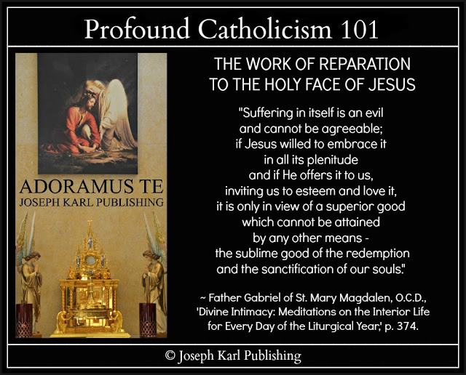

THE DREAM OVERNIGHT JUST A FEW NIGHT AGO IN EARLY AUGUST, 2020 FOLLOWING THE 3 A.M. DETROIT TIME LIVE STREAM OF THE TRADITIONAL TRIDENTINE HOLY SACRIFICE OF THE MASS AT SACRED HEART CHURCH, INSTITUTE OF CHRIST THE KING SOVEREIGN PRIEST, IN LIMERICK, IRELAND
Your three children, two boys and a girl who are now young adults, were manifested as present and then three other children were manifested, as yours although you did not recognize them.
There were two boys and a girl; the boys were young, about grade school age and the girl appeared slightly older than the boys, but more specifically she appeared LARGER than them in size.

You found yourself speaking to the girl while following along as in so many dreams of the past with such awe and with wonder, and asked her for her name.
"What is your name?"
She replied, "Susie."
Then she slowly spelled out her name, letter by letter.
Imaginer.
THAT SAME DAY
While contemplating the dream overnight and its meaning, the focus returned to the girl and her name and this Apostolic Mission in Modern Times for the sake of a world in very serious grave peril.
S - U - S - I - E.
Susie is Susan.
So this dreamer looked up Saint Susan and discovered that she is a martyr; before 1969 she was listed on the Church Calendar.
Saint Susan's Feast Day is AUGUST 11, the very day (in 1989) Jesus Christ had you Sacramentally Wed a traitor for the greater honor and glory of our Triune God and then for the sake of the whole world in Modern Times.

62. An Encounter with Myself in the Dream Overnight
What a wonder that was here in Metropolitan Detroit, modern times home to old fashioned I AM's Work of Reparation to the Holy Face of Jesus, for the sake of a world in very serious grave peril. +
THE DREAM OVERNIGHT ON WEDNESDAY, AUGUST 26, 2020 AND THE INCREDIBLE ENCOUNTER WITH MYSELF, IMAGINER
Overnight there was another dream, and you found yourself inside a modern day supermarket.
People you do not recognize are inside shopping, and as you walk around while taking everything in with such awe and with wonder, you come upon a young woman with slightly longer than shoulder length brown hair.
She appears unfamiliar, and yet somehow familiar.
You are both friendly and begin speaking to one another.
THERE IS SOMETHING VERY SPECIAL ABOUT THIS YOUNG LADY
You are at this time in human history her mentor, meaning as it should be with older people looking after younger people. She is a metaphor, but as you will learn later, after the dream had ended, she is also something else.
The young lady is actually you; she is your younger self.
Before knowing who she is, you speak to her about her work and then tell her that you also used to work in a grocery store when her age, about 18 or so.
She is full of zeal and is so eager to contribute, and while speaking with her remark to her, "You are so beautiful."
Then a supervisor at the store appears on the scene and he is young, because everything is backwards today; the great inversion of God's ways has become very advanced and most people are concerned with merely their own interests.
THE STORE APPEARS UNFAMILIAR AND YET FAMILIAR
It seems as if you are in a modern, modern day supermarket filled with modern day technological advances and while knowing that modern day supermarkets are full of things sold as food that have no nutritional value and/or are downright toxic and unfit for human consumption, it seems as if this store is attempting to sell healthier foods.
WHY DOES IT SEEM AS IF THIS MARKET SELLS HEALTHIER FOOD THAN IS GENERALLY MADE AVAILABLE TO THE POPULATION IN OUR TIME
Jesus Christ makes an appearance inside this place and that is because YOU WORK FOR HIM AS ALMIGHTY GOD WILLS.
WHAT HAPPENED NEXT IN THE DREAM
You, who are a modern day representative of I AM's Work of Reparation to the Holy Face of Jesus for the sake of a world in very serious grave peril, left the young woman to do her work and while walking around, BEGAN CLEANING UP THE PLACE.
So much has happened in the world and to the population in your lifetime.
What a mess.

63. Pruning
What a beautiful little lesson with huge ramifications for us all while merrily working in the Lord's patio garden on this final Saturday in August 2020 following a very beautiful 3 a.m. Detroit time Royal Wedding to Christ the Divine Bridegroom of every soul, live streamed from Sacred Heart Church, Institute of Christ the King Sovereign Priest, in Limerick, Ireland and the incredibly beautiful reception for two that followed. Imaginer.
EVER MORE DREAMS OVERNIGHT
After eight years of thousands of Traditional Catholic Mystical Wedding Theology for Every Soul lessons that came one after another, day after day, they suddenly stopped at the end of 2019 as suddenly as they had begun after I AM had re-introduced His Work of Reparation to the Holy Face of Jesus in 2012 for the sake of a modern world in very serious grave peril.
The lessons have come much less frequently in 2020 following the sudden forced institution of a new and more abnormal abnormal, as the world mostly accepts the various degrees of gravely evil communist lock down and the denial of basic human rights as nations are being systematically destroyed based on one deception after another.
Notice that those working on Lucifer's side and who speak with forked tongues never favor help that actually helps people, while claiming their concern.
Self interested concern is coercion.
Almost every church in the diabolical face masking, social distancing, and lock down affected areas have been complicit in this grave and sinister anti-God and anti-human activity, having surrendered completely to Lucifer's Operation Genocide without even making an effort to resist it, more afraid of what the beast system will do to them while having forgotten that "all we are is what we are in the eyes of God and nothing more" (Saint John Vianney), that is if they had even known God at all.
Yes, that goes for the majority of His leaders.
The love for money and the deep desire to socially conform, for personal gain, to the opinions of others in deep states of diabolical and self interested mind control makes the work of our adversary the devil very simple, as integrity takes a back seat at a level that is unfathomable among those meaning most who are used to getting what each one's will wants at the expense of all others on a daily basis prior to 2020 in Modern Times.
Those who weren't resisting evil before, inside and/or outside of God's House, continue to behave as they have in the past. Included in that group are most people.
OUT OF THE BEAST SYSTEM 2020 AS IT COLLAPSES
Most of the Traditional Catholic Mystical Theology Lessons this year, in 2020, have been private and are applied like the rest throughout each day and night, meaning they are lived as they all are meant to be; Christ's teaching is willingly integrated into one's daily life and the spending of one's self as Almighty God wills for each one, in imitation of and in union with Christ each soul's Savior and Teacher and the Divine Bridegroom of every soul.
THE DREAMS OVERNIGHT
In 2020, I AM speaks mostly to His student teacher representative of His Work of Reparation to the Holy Face of Jesus in Modern Times, His apostle of the Holy Face of Jesus, through dreams overnight for the sake of a world in very serious grave peril.
THE DREAM LAST NIGHT
Once again you found yourself taking leave of one property to go to another.
What wonders.
PRUNING
While working this evening in the magnificently beautiful patio garden belonging to our Lord, there was a very lovely little lesson that has unfathomable ramifications.
Pruning one very lovely pot of flowers after another brought with it such unspeakable joy and was truly a foretaste of heaven.
Any gardener will eagerly admit that working among God's diverse and very colorful creation brings with it a joy that is unlike any other.
You work with wonder at how the pruning reveals the next generation of flowers waiting for their chance to flourish, so many flowers on the same plant and they just keep coming and coming and coming and coming, just like Jesus Himself does, as He promised, for our sake.
So is it with us also; when God prunes us in His lavishly loving perfect wisdom He reveals so many more beautiful layers underneath, enabling each one of us to continue growing and maturing, healthy and hearty and happy and holy .
THERE IS MORE
Just like His flower pruners do in their gardens, God delights in this work of His with each one of us.
Imaginer.

Aug. 30, 2020

64. The Church Bell in the Morning
The bell signaling the start of the Traditional Tridentine Holy Sacrifice of the Mass was heard while still in bed here in Metropolitan Detroit all the way from Sacred Heart Church, Institute of Christ the King Sovereign Priest, in Limerick, Ireland to start this last Monday in August in the year 2020 (note without any live streaming equipment on). Imaginer. +
WHAT HAPPENED LAST NIGHT DURING THE MAGNIFICENT 3 A.M. DETROIT TIME LIVE STREAM OF THE TRADITIONAL TRIDENTINE HOLY SACRIFICE OF THE MASS AT SACRED HEART CHURCH, INSTITUTE OF CHRIST THE KING SOVEREIGN PRIEST, IN LIMERICK, IRELAND
While following along using a Traditional Catholic Holy Mass missal in both Latin and in English, obtained from the Slovak parish during the Great Seven Year War for souls there (2010 - 2017) where in 2012 I AM had re-introduced His Work of Reparation to the Holy Face of Jesus in Modern Times for the sake of a world in very serious trouble, there was a break to meet our Lord within during Holy Communion.
Then He manifested Himself exteriorly, between the Three-in-One Devotion to the Holy Face of Jesus and the wooden double wedding kneeler, and provided Holy Communion Personally in the holy silence and in the holy reverence, in the holy solitude in the middle of the night.
DIVINE UNION WITH BOTH SACRED SPECIES OF THE BLESSED SACRAMENT, THE REAL PRESENCE OF JESUS OUR DIVINE REDEEMER, DIVINE RESTORER, DIVINE REMEDY FOR ALL, AND THE DIVINE BRIDEGROOM OF EVERY SOUL
Note that during the Traditional Tridentine Holy Sacrifice of the Mass, the congregation does not receive the Precious Blood in addition to the Sacred Host although the Sacred Host contains Jesus Christ in His entirety: Sacred Body, Precious Blood, Soul, and Divinity.
One also is unified with His Three-in-One Holy Face Devotion (Sacred Heart, Divine Mercy, and the adoring of His Most Holy Face).
TWO BECOME ONE IN CHRIST THE GREATEST GIVER DURING THE MAGNIFICENTLY BEAUTIFUL CELEBRATION OF THE MAJESTIC TRADITIONAL TRIDENTINE HOLY SACRIFICE OF THE MASS IN LATIN
However, on this night He brought both Sacred Species for you and while His Precious Blood had been received but not consumed, you recalled with Him the times in the past while receiving His Precious Blood when you had wanted to hold Him in this manner for as long as possible as He longed to be completely consumed by you, in order to be completely unified with you in this incredible and unfathomable and miraculous sacrificially loving manner. What One-ders.

65. The Incredible Tower in the Dream Overnight
What a great big wonder that was while making reparation on a Sunday of Reparative Atonement in September 2020 after having started a very effective new health regimen that includes diluted food grade hydrogen peroxide. "By My Holy Face you will work wonders, appease the anger of God, and draw down mercy on sinners." ~ Jesus to Sr. Mary of St. Peter +

The very deeply moving Traditional Tridentine Holy Sacrifice of the Mass
celebrated on the First Saturday of September, 2020,
as Christ's Precious Blood was adored in a very special way here in Metro Detroit,
through Christ's Sacred Passion for our sake.
Out of tissue at the double wedding kneeler.
BEAUTIFUL BEAUTIFUL BEAUTIFUL BEAUTIFUL.
THE DREAM OVERNIGHT ON SUNDAY, SEPTEMBER 6, 2020 FOLLOWING THE 3 A.M. DETROIT TIME TRADITIONAL TRIDENTINE HOLY SACRIFICE OF THE MASS CELEBRATED IN LATIN AND LIVE STREAMED, BEFORE THE DEVOTION TO THE HOLY FACE OF JESUS, FROM SACRED HEART CHURCH, INSTITUTE OF CHRIST THE KING SOVEREIGN PRIEST, IN LIMERICK, IRELAND
This dream was unfathomably epic while making reparation overnight, as the properly diluted food grade hydrogen peroxide could be felt working inside the liver. +
I suddenly discovered (without looking for it) a massive tower and it was revealed that had been built by a small, devout, and faithful family in years past. I found myself holding an incredible replica of this wondrous structure in my hand. The replica was longer than an adult human hand and could be grasped by the hand and held around it.
Other replicas of other historic things were manifested at the same time but this one stood out as being of exceptional and of superior quality to all the rest. It was superior in its construction and it was also coated with a substance that made it stand out both in appearance and in its quality. It had a finish that was supernatural and shiny, not of this world.

THE INCREDIBLE VISIT TO A REPLICA OF THIS TOWER
The computer isn't working right again. Nevertheless, let us proceed.
All of a sudden I found myself inside a replica of this tower which was constructed not far from here meaning this apartment where I AM suddenly put me one year ago on September 14, 2020.
I found myself in the exceptionally wondrous dream going to see it and despite not enjoying extreme heights, went in and after talking to a young woman on the first floor who worked there, took the elevator to the very top which was something like 80 stories high. An actual number of stores was given; it was 80 or 180 and being a rational creature I assume it was 80 stories high.
I rested comfortably at the top for a while and it was quiet and peaceful; I was alone and I marveled at what I had been shown, still holding the replica of it in my hand. All was incredibly peaceful and wondrous.

COMPANY AT THE TOP OF THIS TOWER
All of a sudden my youngest child (of three), my now young adult only daughter, joined me at the top of the tower.
Then, while following along as in dreams of the past with such awe and with wonder, I left her there for a little while to return to the base and see what had been recreated for people who came to visit, meaning the details of this structure and its purpose which had been revealed to me at the top of the tower.
MANY PEOPLE HAVE COME TO THE TOWER NOT JUST TO VISIT BUT TO USE IT AS GOD INTENDED, ALTHOUGH NOT ALL ARE
The tower was no longer empty; many people had come to it to not only see it but also to use it for the purpose for which it had been intended.
I spoke to the same woman at the base of the tower and asked her some questions, and there was also a second woman working there. The women stood at an information desk.
I walked around and took everything in with such awe and with wonder, and wondered why I had not brought my daughter with me on this quick little tour; I did not want to keep her waiting way up there at the top of that tall and exceptional, very unusual structure.
I had been shown things about this tower while alone at the top of it and had return to the base to seek them out.
The family who built it had placed religious statues throughout it; they had been made known to me while at the top level. One of them was a statue of Our Lady of the Miraculous Medal.
A magnificent internal feature of this tower were its stairs.
The stairs were unlike anything seen in the natural and had supernatural qualities to them.
I cannot explain their design but an understanding of them as a metaphor will make sense once the dream is explained.
As time passed while taking everything in with such awe and with wonder, while following along as if in a movie with its powerful and apostolic script, I kept wanting to get back to my daughter in case she didn't want to remain way up there and by herself and for so long.
It seemed I was gone only a short time, but when I could finally take the elevator back up, after having seen what I was being shown and this time among other people, my daughter, one of Traditional Catholic Detroit's Children of Reparation in Modern Times, said the tower was about to close for the day because it was nine o'clock at night!
It was nevertheless still light outside.
At least four hours had gone by while I was gone at the base.
She said she had not minded at all being up there and for so long.
Before the structure closed, before heading back down, we found ourselves being shown something else on the top floor.
It had been manifested as outside before and now there was a part of it that was indoors, and this indoor part had three bedrooms. We quickly went through them and marveled at them and then took the elevator back to the ground floor. Two of the bedrooms looked like those seen in the natural but the largest, what appeared to be a master type bedroom, was supernatural and it opened up to a basement type second floor beneath it. We were only in there for a very short time and could not explore it fully.
Then following a wondrous elevator ride to the base of the tower, I tried to find the place where this tower is located on a map so we could return home, and the map appeared unfamiliar to me.
I wondered how we had gotten there, and then wondered how we were to get back home.
THE DREAM EXPLAINED
Still working...computer still not cooperating.
Never did get to finish this one.

PART XI

THE ELEVENTH STATION OF THE CROSS

JESUS IS NAILED TO THE CROSS

66. "Look After My Mama"

67. A Trip to the Past, Present, and Future in the Dream Overnight

68. Our Lady’s Black Eye

69. The Handful of People Inside the Small Room in the Dream Overnight

70. "Supply Them with Holy Water"

71. The Incredible Prayer in the Dream Overnight

66. "LOOK AFTER MY MAMA"
This stunning dream two nights ago was a stark reminder that I AM's Work of Reparation to the Holy Face of Jesus is meant for everyone, and of how this Traditional Catholic Apostolic Work in Modern Times benefits everyone meaning those who don't know of it, and those who don't care, through those who do in imitation of and in union with Christ. Imaginer. +
THE INCREDIBLE DREAM OVERNIGHT
You found yourself in the company of a woman whom you had not seen in several decades.
Recently, she filed for divorce, ended her Sacramental Union of more than 30 years, and now has a drinking problem.
This woman has worked in the allopathic modern medical eugenics nightmare.
She is beyond 50 and has two children who are now grown.
WHAT HAPPENED AFTER FINDING YOURSELF IN THE COMPANY OF THIS TROUBLED WOMAN
Suddenly, there was an infant between where she was and where you were before her.
You looked at this child and it was absolutely beautiful, and you think to yourself that the child is the most beautiful child you have ever seen.
The child before you appears PERFECT.
WHAT CHILD IS THIS?
Then it is made known to you that the child is hers.
THE CHILD IS HUNGRY
You then find yourself, also over 50, taking the child and nursing it, feeding and caring for it with your own body, because she is not taking care of this particular child and it needs her.
THE INFANT SUDDENLY BEGINS SPEAKING
All of a sudden the baby stopped nursing, looked right at you,
and began speaking.
WHAT THE BEAUTIFUL, PERFECT BABY SAID TO YOU
The baby said, "LOOK AFTER MY MAMA."
WHAT THE CHILD MEANS, WHO THE CHILD REPRESENTS, AND WHAT THE DREAM MEANS

The baby represents each person's vital, irreplaceable, indispensable, and God-given Holy Apostolate of Reparation.
The baby, each one's purpose and obligations in life, is to be nurtured by each one of us with all of God's might and in turn the "child" helps us to grow and become better people, similar to the roles of parents and their children.
Since the child's mother knows not, never knew, or has forgotten her mission and her responsibilities both as God's creation and as His child, the baby needs to be cared for by another.
That means the woman receives Divine Supernatural Assistance from God on High through Christ our Divine Redeemer, guided by the Divine Holy Spirit, which she needs and as needed, through the holy obedience of those who listen to God and who do as He says, particularly those who take up and educate others about I AM's Work of Reparation to the Holy Face of Jesus for the sake of a world in very serious grave peril.
TO FEED THE "CHILD" IS TO CARE FOR ITS MOTHER
The feeding of the child for the mother's sake with one's own life by nursing the child and providing mother's milk with one's own body (a symbol and a metaphor presented in Traditional Catholic Mystical Wedding Theology Lessons for Every Soul in the past) represents Christ's providing for and feeding us with His Own Sacred Flesh and Precious Blood through His Real Presence in the Blessed Sacrament: Body, Blood, Soul, Divinity, Sacred Heart, Divine Mercy, and Sacred Countenance.
What wonders.
"Mary, Mother of our Redeemer, obtain for us something of the generous surrender of will which you made as you stood under the Cross on Calvary. Help us to put into practice the words you spoke at Nazareth when you conceived your Divine Son. Let the motto of our lives be, 'Be it done to me according to Your word. Amen.'" ~ Servant of God, Father John A. Hardon, S.J.

67. A Trip to the Past, Present, and Future in the Dream Overnight
Two things were sought out during this incredible dream while following along with such awe and with wonder. Guess what they are. Just guess. +
A TRIP IN THE PAST, PRESENT, AND FUTURE IN THE DREAM TWO NIGHTS AGO
All of a sudden you found yourself inside what appeared to be a large church hall that appeared unfamiliar, and it was attached to the church where you took your children when they were little.
Their Modernist desecrated Catholic elementary school was right next door.
That parish used to be the largest one in the Archdiocese of Detroit until it was destroyed by Modernism and became a Modernist wasteland. Still, a small devout group of authentic Catholics remained, daily Holy Mass attendees in the chapel, people who remembered a very different Traditional Catholic Church as children, a church that Lucifer himself sought to annihilate in Modern Times, from within.
However, God promised that the very gates of hell shall not prevail against Her, the One True Holy Catholic and Apostolic, Pro-Life Church.
Most people attending church once a week or less have no idea what has happened and what is going on; they stand on the battlefield totally unaware of what is happening and of the very real danger to themselves and to others. Most of them have no idea how to defend God and His Territory. Most of them don't care.
Anyone trying to teach them will pay dearly by the enemies of God proclaiming to be Catholic and to be there for God.
Lucifer's servants are very self centered.
WHAT HAPPENED WHILE INSIDE THE LARGE BUILDING ATTACHED TO THAT CHURCH
You find yourself being led into this building among people who appear unfamiliar.
It appears like a warehouse, and inside it organized into categories you see Traditional Catholic items that have been stripped from Christ's Catholic Churches in our time as one after one was left in ruins while their congregations were encouraged to celebrate anything other than the Traditional Holy Sacrifice of the Mass.
The sacred was replaced by self interest, by the love for self instead of the love for God first and foremost and then a love for one's neighbor.
You walked through this building, guided through it, while taking everything in with such awe and with wonder.
The pastor at this Modernist desecrated parish has been collecting these things and preserving them! What wonders...how could that be?
How you love walking through and seeing these magnificent items that give honor and glory to our Triune God in His House: statues, candle holders, pews, you name it.
WHAT HAPPENED NEXT
It appeared like a warehouse museum preserving the rich and meaningful history of Christ's Catholic Church, and then you notice that the many items have price tags on them.
They are for sale!
Welcome to the present, in the past.
So while following along with such awe and with wonder surrounded by the history of the One True Faith, you find yourself deciding to purchase some items, TWO IN PARTICULAR.
THE QUEST TO FIND TWO STATUES IN PARTICULAR
You desire to find and purchase two statues: A STATUE OF OUR LADY OF THE MIRACULOUS MEDAL AND A STATUE OF THE INFANT OF PRAGUE
HOW THE DREAM ENDED
The dream ended in the future: you walked around the warehouse looking structure attached to the church from which this Apostolic Mission in Modern Times was summoned by I AM to go to the Slovak parish in Metropolitan Detroit by name - where He would then re-introduce His Work of Reparation to the Holy Face of Jesus for the sake of a modern world in very serious grave peril in the year 2012 - looking for the statues but suddenly you could not find them for the were not there.
Imaginer.
WHAT WILL HAPPEN IF WE REFUSE TO LISTEN TO ALMIGHTY GOD AND DO AS HE SAYS
Just guess.

68. Our Lady's Black Eye
What a surprise that was during the incredibly beautiful Traditional Tridentine Holy Sacrifice of the Mass here before the Devotion to the Holy Face of Jesus, at Her side altar. +
SUNDAY, SEPTEMBER 13, 2020 IN METROPOLITAN DETROIT
The day was so beautiful here in isolation; once again this student teacher had the entire swimming pool and hot tub to herself for ever more rest and restoration following a very eventful entire life.
Then our Lord allowed that the beautiful fall decorating continue inside of the humble and happy dwelling, where He placed this Work of His in Modern Times suddenly, one year ago tomorrow.
As the very happy decorating continued for the greater honor and glory of our Triune God here where I AM's Work of Reparation to the Holy Face of Jesus is hosted, there was a sense of I AM's tremendous power in the supernatural here in the natural, and a sense of victory over evil through Christ our Divine Redeemer, Divine Restorer, Divine Remedy for All, and the Divine Bridegroom of every soul.
OUR LADY'S BLACK EYE
Then there was the eagerly anticipated live stream at 3 a.m. Detroit time on this Sunday morning of the Traditional Tridentine Holy Sacrifice of the Mass celebrated in Latin and it was beautiful beautiful beautiful beautiful.
The homily was beautiful and all was so joyous and celebratory and then suddenly, just prior to the Consecrations of both Sacred Species, Our Lady appeared at her side altar with a black eye.
She had a black right eye.
Imaginer.
Hoping and praying that victory is coming from On High over something that has greatly harmed our Lady.

69. The Handful of People Inside the Small Room in the Dream Overnight
What a wonder that was. +
THE DREAM OVERNIGHT ON SUNDAY, SEPTEMBER 20, 2020 INTO SEPTEMBER 21, 2020 (WRITTEN ON SEPTEMBER 22, 2020 AT 2:20 A.M.)
All of a sudden you found yourself inside a small room that appeared unfamiliar and yet familiar, with a handful of people whom you did not recognize.
Something had taken place first, before you had been gathered there, and it had to do with the handful of people.
All that can be remembered about what happened first is that it was incredibly wondrous.
In the dream the natural was as one with the supernatural, for you but not for the people that you were with.
WHAT HAPPENED INSIDE THE ROOM WITH THE HANDFUL OF PEOPLE
You found yourself on one side of the room across from the door, in the middle of it against a wall, and next to you there was a man with light hair who was not a young person, he was older than young people and also a little younger than you.
There were several people just to your right but they were slightly away from the wall where you found yourself.
You were closest to the man on your left and he held a certain higher rank pertaining to his mission than the others there.
Perhaps his rank is to be more of a leader.
There were also two young people in their very late teens or early twenties who were on the other side of the room, against the far wall to the right.
They were sitting down, and you and the man to your left were standing.
The people in the room had been put there by I AM.
Just because you did not recognize them in the dream does not mean that you don't know who they are.
I AM had gathered these people in this room that was both unfamiliar and yet familiar, and He did so for a reason.
ALL OF A SUDDEN, YOU BEGIN SPEAKING
You begin telling the small group of people in the room words which I AM has provided to you and you do so with His Authority and while delivering His address flawlessly, are quite stunned at the incredible event taking place.
You speak to the small group of people in the room while taking everything in with such awe and with wonder as in so many dreams of the past.
WHAT YOU TOLD THE PEOPLE IN THAT ROOM
You began instructing them in language that cannot be restated by this student teacher alone from memory (meaning without Divine assistance) that they all had been summed by I AM for a special purpose.
THE REACTION OF THE PEOPLE INSIDE THE ROOM
It was so incredible, so supernatural, so peaceful, and so profound this experience in the dream overnight.
The man to your left listened as you spoke, but he seemed humble and surprised to learn this while taking the message in; he seemed to not have anticipated this turn of events and being humble did not seem to believe it.
However, he kept listening and remained discerning.
Then while still speaking and while still in awe and profound wonder at the words that were coming out of your mouth and with the Authority of I AM, you noticed (it was brought to your attention) that two young people on the opposite side of the room were not listening at all.
The young man and the young woman seated right next to each other were not paying attention because they were lost inside their cell phones.
Nevertheless, I AM had summoned everyone inside this room for an especial purpose and let them know of it through His messenger.
Imaginer. +
"Here the will of God is done, as God wills, and as long as God wills."
~ Saint Gerard Majella

70. "Supply Them with Holy Water"
That is what I AM said to His chosen shepherd prior to 2020. He requested the full rite be used meaning both salt and water are exorcised before the water is blessed. Was His most perfect will accomplished? No, it wasn't. Imaginer. +
Wise are the very small number of Christ's leaders of the soul who saw the writing on the wall and properly prepared their flocks prior to the diabolical fallout of 2020.
They are the ones not cowering in fear; they are not promoting as are most of their brethren - inside and/or outside of Christ's Catholic Churches - the worldwide diabolical eugenics agenda that FALSELY TEACHES God-detesting and people-hating propaganda promoting an unhealthy fear of getting sick while seeking to destroy God's creation in our time and increasingly control everyone they have not killed off already.
2020
Those working for the wrong master seek to and are killing us or are making us sick, often by poisoning (in the air, food, through drugs sold as prevention or the cure, and in the water) and often by abortion, and then blame us for all this carnage by falsely accusing us of spreading some virus.
Evil always blames its victim and it has no mercy for anyone.
Wise are those who don't believe wicked people claiming to care.
WHAT HAS HAPPENED TO THE HUMAN BODY
We have been conditioned (mind controlled) from birth - through the use of toxic injections and potions and procedures manipulated into us from the moment we are born (by people in whom our trust has been misplaced) to fearfully prevent suffering that hasn't even afflicted us (the very opposite of healthy and holy prevention) and then to repeatedly purchase toxins and buy procedures to end any suffering, and to even defend the ones very actively seeking to harm us while claiming to care - by Lucifer's mighty pharma drug cartel and their accomplices.
These willing accomplices who are first students and then become business partners are those in white coats or are outfitted in the garments of those self identifying as health care professionals and heroes.
"My children, all we are is what we are in the eyes of God and nothing more." ~ Saint John Vianney
Their defense for their crimes against humanity so that they can live an extravagant lifestyle is that they are special and highly educated, when in actuality what they have been taught by the wrong master they have chosen to serve is to be self interested order followers who are hyper entitled after having fallen in love with money ( which is the root of all evil) as they financially profit again and again from humanity's suffering and its ever increasing suffering under this diabolical and unfathomably prideful eugenics allopathic medical regime that has proclaimed itself god and refuses to hold itself accountable, instead of serving God alone and using one's God-given brain to address the root cause of problems and use the means He has provided to all naturally assist the body which He designed to heal itself.
Almost everyone else in the health care professions that are honest and promote proper prevention, proper healing, and wellness throughout the lifespan (find and eat real food and accept no poisons) and who have not sold out to this monster will still not risk their own interests to fight and defeat it. They do what they are told to stay open and make money.
WHAT HAS HAPPENED TO THE MIND WORLDWIDE IN OUR TIME
The same thing because most claiming to care for the human mind see themselves as the god and the healer and make it a point to keep God out of their care plans.
A care plan without God is no care plan at all; such a care plan is a recipe for disaster.
WHAT HAS HAPPENED TO THE SOUL WORLDWIDE IN OUR TIME
The same thing.
Most priests care most about their popularity and bringing in ever more money, not necessarily in that order.
That means they love themselves and money more than God and other people.
Modernism teaches and encourages it. OR ELSE.
Imaginer. +
IT IS NOT TRUE THAT NO ONE CARES OR THAT NO ONE IS LISTENING; GOD IS WITH US AND SO IS HIS IMMACULATE MOTHER AND SO ARE HIS PEOPLE AND SO ARE HIS HOLY ANGELS, HIS HOLY MARTYRS, HIS HOLY SAINTS, AND HIS HOLY SOULS IN PURGATORY WHO CAN PRAY FOR US AND WHO NEED OUR PRAYERS (DON'T FORGET THEM)
Remember that a remnant exists, Christ's Remnant, the very small minority of people who properly worship, adore, and serve GOD ALONE and who strive with all of His Might to accomplish His will as He wills it, through the spending of ONE'S SELF IN IMITATION OF AND IN UNION WITH CHRIST, GUIDED BY THE DIVINE HOLY SPIRIT.
They are people who truly care, in imitation of and in union with Christ and His Holy Family (Blessed Mother and Saint Joseph), people who can be truly trusted.
Find them, and then become one of them.
Join them in serving the One True (Triune) God - with purity of intention, devoid of self interest - His way, which is always the right way.
Each one shall reap what each one has sown.
I DO NOT CONSENT TO GRAVE AND SINISTER EVIL.
"Here the will of God is done, as God wills, and as long as God wills."
~ Saint Gerard Majella

Oct. 8, 2020

71. The Incredible Prayer in the Dream Overnight
What a wonder that was here in Traditional Catholic Detroit. Oorah!! + "By My Holy Face you will work wonders, appease the anger of God, and draw down mercy on sinners." ~ Jesus to Sr. Mary of St. Peter
THE POWERFUL DREAM OVERNIGHT A FEW DAYS AGO
This was actually the last dream of the night and it was very short and very memorable.
THE INCREDIBLE PRAYER
All of a sudden a prayer is manifested before you in the supernatural there in the natural in the dream overnight as you found yourself as in so many dreams of the past following along with such awe and with wonder.
You find yourself saying the prayer and then all of a sudden a man you do not recognize appears and he said with deep feeling,
"I WISH I had a prayer like that in my religion!"
The prayer is this:
"Glory be to the Father, and to the Son, and to the Holy Spirit, as it was in the beginning, is now, and ever shall be, world without end. Amen."
Imaginer.
Working on a new video from the book, "Meditating on Christ's Passion" while creating some new images for it.
God is so good.
"Here the will of God is done, as God wills, and as long as God wills."
~ Saint Gerard Majella

PART XII
THE TWELVTH STATION OF THE CROSS
JESUS DIES UPON THE CROSS

72. I AM's Omega Trident of Gold in the Dream Overnight
73. The Incredible Little Restaurant in the Dream Overnight
74. Requiescet in Pace, Brandy Vaughan
75. Lucifer Appears Overnight as Saint (Padre) Pio
76. On Having Given Up One's Blood as I AM Willed, Twice, as One with Christ
77. The Priest Giving Out Holy Communion in the Dream Overnight
78. The Journey from the Traditional Catholic Church through the Roadblock
Rubble at an Intersection
79. The Arrogant Man Doing the Speaking in the Front and the Silent Child Sent by God in the Back

Nov. 6, 2020
72. I AM's Omega Trident of Gold in the Dream Overnight

A trident is used as a fishing spear and this one is Traditional Catholic, made entirely of gold, and has been provided to us by Almighty God Himself in heaven, through Jesus Christ our Divine Redeemer, Divine Restorer, Divine Remedy for All, and the Divine Bridegroom of every soul. Imaginer! "By offering My Face to My Eternal Father nothing will be refused, and the conversion of many sinners will be obtained." ~ Jesus to Sr. Mary of St. Peter

SOMETHING OF CONSEQUENCE WORTH NOTING FIRST

Following a lifetime (55 years) of brutal persecution by the forces of darkness, that suddenly stopped as soon as the Luciferiandemic that had been pre-planned in advance was rolled out worldwide to begin 2020, there has been a time of great peace and liberation from the assaults of Lucifer and his adorers, both in the supernatural and in the natural.

That peace while working for our Lord, for the greater honor and glory of our Triune God first and foremost and then for the sake of His people in Modern Times, in happy isolation away from the world and the worldly, had lasted almost a year.

That peace came as Lucifer let loose on the rest of the world through his people in the form of diabolical lockdowns, forced masking, social distancing, plexi-glassing, toxic hand sanitizing, forced isolation, created shortages to induce fear and unholy compliance, elite and catastrophically detrimental mental traumatizing and torture and mind control, the brutal suppression of the truth, and the mass marketing of so many lies.

The grave and sinister evil came also in the form of first having forced good people out of God's House and then forcing the masses out of work and into ever greater financial hardship - by design - while
rolling out the 5G spy, control, and kill grid while blaming all the problems he and his followers created on God's people.

The evil also comes in the form of poisons and toxins sprayed on people worldwide, tainting the food supply and the water, so much mental poisoning through media and social media and educational programs and by people self proclaiming to be experts.

There are also unrelenting assurances from those seeking our harm while profiting from this man-made Luciferian inspired problem called a pandemic, that is not what it is, that eugenic toxins forced on the people through needles will cure those who have been systematically made sick on purpose and for generations through the modern Luciferian arrogant allopathic unholy drug pusher medical system, which will be punished by God for its crimes against Him and the human race He created in His Image and Likeness.

The irony is that most of the the places Lucifer has been shutting down weren't serving God anyway, and so in that sense he has been cutting off his nose to spite his own unholy face. People are better off not going to such places and such places are diverse and also great in number.

THE REVELATION OF WHO SERVES GOD AND WHO DOESN'T

The great tragedy is that very few people within the very few places that are serving God alone in our time are resisting this grave and sinister evil.

Remaining silent and cooperating with corruption, while hoping it goes away real soon, still makes one complicit in it even if one disagrees with it.

Placing Xs six feet apart on the floor clearly indicates the cowardice of the leaders at whatever level who issued that order.

So many cowards so early. Imaginer. +

Cowards comply with evil hoping that good comes of it eventually, and use that rationale in an attempt to hide their glaring lack of courage and lack of true faith.

That is not how God's Divine Economy of Salvation works.

God's people behave with great courage in imitation of Christ and understand to their core that despite the personal cost, God will make great good come out of their sacrifices in His service.

NO GUTS, NO GLORY

The evil will only get worse when people consent to it through their actions; adamantly verbally and/or mentally (quietly) disagreeing to it is not enough.

Those claiming to serve God alone must trust in Him, not in money or any other false security, and they also must fear the devil a lot less.

OH SO MANY BAD "MARRIAGES" IN MODERN TIMES

Going along with this grave and sinister evil in order to remain open is like being in a bad marriage where one mortally sinful partner mentally tortures his or her good partner and tries to wear the other one down until he or she joins the sinner in sinning.

IF AND WHEN ONE DOES, THE TRAITOR WILL ABANDON ANYWAY THE ONE WHO WAS COERCED TO DO WRONG, AND WILL CONTINUE TO BLAME HIS OR HER VICTIM FOR THE SINNER'S UNSURPRISING UNHAPPINESS RATHER THAN EVER (LUCIFER FORBID) ACCEPTING PERSONAL RESPONSIBILITY, MAKING PROPER RESTITUTION AND REPARATION, AND VOWING TO AMEND HIS OR HER WICKED AND SELF DESTRUCTIVE WAYS.

Each one shall reap what each one has sown; who was it who said that the road to hell is paved with good intentions?

The Way to the Cross on Mount Calvary is paved with the spending of one's self, in imitation of and in union with Christ our Divine Redeemer, Divine Restorer, and Divine Remedy for All.

God is the only One who can get us out of this diabolical deceptive anti-God and anti-human mess, and He will when we listen to Him and when we do as He says.

Still, so few remain willing.

No guts, no glory. +

In November 2020, Lucifer's assaults against this student teacher were allowed by God to begin again in earnest in the supernatural in the form of very ugly and very personalized direct mental assaults and in the form of a lot of things breaking.

Great good must be coming from our Divine Three-In-One God Who is and Who are always the Highest Power there is.

THE INCREDIBLE DREAM OVERNIGHT ON SATURDAY, NOVEMBER 14, 2020

You suddenly find yourself sitting toward the back of a full church that appears on the inside to be very modern. There are individual seats and no kneelers, and it appears more like a performance hall because that is what it had become.

THE SMALL AGILE SPIDER IN THE BACK OF THE FULL CHURCH

All of a sudden a spider that is very small but capable of a whole lot of trouble descends right beside you from the ceiling, on a thread.

You try to knock it down but the spider representing Lucifer the liar, deceiver, and destroyer is incredibly agile.

The tiny spider that most people who are unaware would consider harmless (and who would eagerly belittle you for your justifiable holy concern and willingness to take proper action as God wills) represents Modernist Luciferianism that seeks to destroy Christ's One, Holy, Catholic, Apostolic, and Pro-Life Church through the love of money which is the root of all evil, false teaching based on the self interested pleasure principle, and the worship of the self and one's own will in imitation of and in union with Lucifer, their leader while self identifying as whatever they like.

You then turn and find yourself appealing to your mother who is almost 80 (and who prays the Holy Rosary of Our Lady every day and who taught her children about Our Lady of Fatima) to take care of the spider and she does right away.

In the dream, your mother easily killed it with her reparative suffering as a mother and as a grandmother through the maternal intercession of the Immaculate Mother of God, our Lady of Sorrows.

THE TWO WOMEN WITH EUROPEAN ACCENTS (ONE OF THEM WAS FRENCH) AND THE CHILD THEY HAD ADOPTED

Then you encountered two women inside the church who have something to do with the eradicating of the spider from God's House and also from the hearts, minds, and souls of God's people.

OUTSIDE OF THE CHURCH

You then find yourself talking to these two women outside of the church in the parking lot.

They are so happy and so eager to speak to you and they have European accents.

They represent Sr. Mary of St. Peter of Tours, France and Sr. Maria Pierina de Micheli of the Work of Reparation to the Holy Face of Jesus. The child they had adopted is you who represent all apostles of Almighty God's Work of Reparation to the Holy Face of Jesus through time and in our time.

THE SMALLER CHURCH HIGH ON A HILL, THE ELDERLY PRIEST IN THE ELEGANT VESTMENTS, THE MAN SITTING NEXT TO YOU IN THE BACK, AND THE UNLIMITED SUPPLY OF FREE FOOD BEHIND YOU IN THE BACK OF THE CHURCH

Suddenly you find yourself leaving the parking lot and traveling by yourself from the Modernist desecrated Catholic Church toward a small Traditional Catholic Church up a hill that few travel in our time.

On top of the hill representing Mount Calvary you find yourself entering into a small, Traditional Catholic Church.

All is very peaceful and joyful.

You see an elderly priest with white hair standing up at the altar and he represents Christ's Traditional Catholic Church.

He is welcoming and he worships, serves, and adores God alone.

The priest is outfitted in vestments and he exudes truth, honor, and great dignity.

He is very humble and simple and yet seems to be high ranking.

He represents The Flawless One and celebrates the Holy Sacrifice of the Mass of the Ages.

The priest begins celebrating the Holy Sacrifice of the Mass but what is manifested in the dream is that at one point he faces the people and begins speaking to the small group of people present.

A holy man is sitting next to you, to your right. He appears unfamiliar and yet familiar and it is as if you know him and he knows you.

He represents Ven. Leo Dupont, Apostle of the Holy Face Devotion.

WHAT THE CELEBRANT PRIEST SAYS TO THE PEOPLE, WHAT WONDERS

The Father priest celebrant is holding something in his hand.

It appears like a small bag of popcorn that contains fluffy white popped corn, without any of the crunchy kernels.

Then he points to the back of the small church which isn't far from him and which is behind you in the back, just to the right.

There is some sort of small stand back there that offers more of what he is holding and the celebrant encourages everyone to go back there and help themselves to as much as they would like.

What he is holding in his consecrated hands represents the Real Presence of Christ the Divine Second Person of the Most Holy Trinity, our Divine High Priest and our Divine Redeemer, Divine Restorer, Divine Remedy for All, and the Divine Bridegroom of every soul who can be found in His Catholic Churches in LAST PLACE.

His followers do not place themselves in a higher place than His.

Lucifer's followers do, like he did and as he continues to do.

The Real Presence of Jesus in the Blessed Sacrament remains mystically available to His people during this time of locked doors, desecrated sanctuaries taped up and occupied by the forces of darkness with the help of church leadership, and of cowardice by the masses, inside and outside of Christ's Catholic Churches.

Notice that their requests for donations continue, unabated.

God's people don't ask suffering and traumatized people for money they need more than ever for their very survival and God's people certainly don't help the devil.

God's people spend themselves, as Almighty God wills for each one, in imitation of and in union with Christ, His Immaculate Mother, and Saint Joseph.

THE OMEGA TRIDENT MADE OF GOLD SENT OUT INTO THE WORLD

All of a sudden you find yourself leaving the small Traditional Catholic Church on the hilltop and returning into the world, and you see that you are carrying something in your left (writing) hand.

It is made of gold and is almost as tall as you are (5'7 1/2 "), and it looks like a trident.

However, this trident came from On High and it has some very unique features to it.

Keep in mind that this is a fisherman's spear.

It is a Three-Pronged Fisherman's Spear: God the Father, God the Son, and God the Holy Spirit.

WHAT THE SOLID GOLD OMEGA TRIDENT LOOKS LIKE AND WHAT IT DOES

As you take everything in with such awe and with wonder, and with such tremendous gladness and serenity that comes from God alone, your attention is drawn to the top of the trident for instead of the tines facing toward the sky, they face SIDEWAYS.

So the tines appear somewhat like the shape of an epsilon, and that is what you see in the dream with your natural sense of sight, but the tip of this incredible spear is manifested to you in the supernatural there in the natural as AN OMEGA.

An Almighty Omega Spear; what wonders!

Keep in mind that while I AM is the Alpha and the Omega, the past, present, and future Who WAS and Who ALWAYS IS and WILL BE, omega also means in human terms a separation of one's self from the world for we are in the world and yet not of the world.

This incredibly powerful Divinely provided peaceful weapon of mass sanctification and eternal salvation (and of inestimable value) is I AM's Work of Reparation to the Holy Face of Jesus.

Imaginer. +

GET ONE, AND USE IT.

73. The Incredible Little Restaurant in the Dream Overnight

What a wonder that was on December 3rd, 2020 while trying to rest an injured finger and while waiting for I AM to provide inspiration for the Advent outfitting of the Devotion to the Holy Face of Jesus inside a small domestic Traditional Catholic chapel in suburban Detroit. +

“Have a great love for Jesus in His Divine Sacrament of Love; that is the Divine Oasis of the desert. It is the heavenly manna of the traveler. It is the Holy Ark. It is the Life and Paradise of love on earth.” ~ Saint Peter Julian Eymard

A VERY PAINFUL CASE OF TRIGGER FINGER ON THE THUMB OF THIS STUDENT TEACHER'S LEFT (WRITING AND ALSO TYPING) HAND

The fine naturopath recommended painful stretches but the one ultimately in charge of one's own health determined that rest for the thumb that locks in place and is painful and sometimes impossible to bend is what is needed. It seems that the motion of that particular thumb while producing videos on the computer as two books are being recorded in video format has led to the condition.

Splinting it is impossible for then there can be no typing. So while resting it from producing videos, a special project is in the works but first for it, new material must be learned and in Latin.

Happy smile. +

THE INCREDIBLE RESTAURANT IN THE DREAM OVERNIGHT ON DECEMBER 3, 2020

Following the Traditional Tridentine Holy Sacrifice of the Mass celebrated on the First Thursday of December, 2020 at 3 a.m. Detroit time at the Sacred Heart Church, ICKSP, in Limerick, Ireland, after having fallen asleep, you found yourself inside a small restaurant.

You also found yourself in charge of it.

People filled the restaurant and they kept coming.

It was as it had been before, meaning no one was masked and no one kept apart from one's fellow man.

WHAT WAS ON THE MENU

There were many people in the dream overnight, including the people who came to the small restaurant to eat and the people who were working at the restaurant, and all of it was overseen by you.

You helped prepare the tables and serve the food.

You led those who were working at the small restaurant.

You also helped by taking out the trash.

You welcomed people as they entered and brought them to carefully readied tables to dine.

While taking everything in with such awe and with wonder, you noticed that everyone was eating the same thing.

You also noticed that there was only one thing on the menu.

You wondered while existing in both the natural and in the supernatural in the dream why nothing else was served with the single item meal.

Very clearly, the small restaurant only served one thing: a simple sandwich containing the same few ingredients inside of a round white bread roll.

THE SMALL RESTAURANT WAS VERY POPULAR AMONG THE PEOPLE

The people just kept coming, so happy to be there and so happy to be eating what the restaurant was serving.

All was so peaceful and very joyful.

Properly caring for the people did not seem like work; rather, it caused tremendous gladness.

WHAT COVERED THE TABLES

At one point while working, while serving food meaning the only item on the menu and while welcoming people and cleaning off the tables and then carefully setting them once again, you noticed that the tables were covered with not one tablecloth but two tablecloths of two different colors.

You marveled at this, that each table was covered with two tablecloths. The longer tablecloth underneath was of a different color than the shorter one on top, so that both were visible to the restaurant's guests as they entered and as they were served and then dined on the one thing being served there.

WHAT THE DREAM OVERNIGHT MEANS

"Even if Catholics faithful to Tradition are reduced to a handful, they are the ones who are the true Church of Jesus Christ." ~ Saint Athanasius

The little restaurant represents Christ's Traditional Catholic Church in our time which is small and yet

serves many.

The only food served there is the Holy Eucharist.

Contained within the round consecrated piece of bread served at the little restaurant in the appearance of a round roll, which makes up a simple but satisfying "sandwich of self giving" are other "ingredients" that represent works of reparation offered to I AM in union with Christ crucified.

This food that spends itself as I AM wills supernaturally helps "feed" other people.

The two tablecloths represent both Sacred Species of the Blessed Sacrament: the Sacred Host (Body of Christ) and His Precious Blood.

You represent I AM's Work of Reparation to the Holy Face of Jesus in Modern Times and His Work of Restoration that comes from reparation offered to Almighty God - as He wills - through the three-in-one Devotion (Holy Face, Divine Mercy, and Sacred Heart) to the Holy Face of our Divine Redeemer, Divine Restorer, Divine Remedy for All, and the Divine Bridegroom of every soul.

Imaginer.

74. Requiescet in Pace, Brandy Vaughan
This courageous, truth-telling human life and right-to-good health advocate was recently found dead by her young son following multiple threatening home invasions, by those in love with money which is the root of all evil, warning her what was coming if she dared do the right thing and properly inform people.
THE DARK SIDE OF PHARMA

After having once again warned my very own mother who won't listen
of the adverse health effects that come with
accepting toxic flu vaccines,
pharmacological drugs for highly lucrative chronic conditions,
and antibiotic after antibiotic that solves nothing and further harms the body,
instead of looking at the root cause of the problems
which clearly include the toxins aggressively marketed to us
and even forced upon us throughout life,
even before birth
"for our own good"
injuring us on purpose for the financial profit of so many self professed experts
that profit from the trust of the unsuspecting needing their care,
another human being who is also a senior citizen was encouraged
to get the flu shot and then got very sick
while blindly once again saying "I'm fine" and defending the enemy,
instead of admitting what really happened.
+
THIS IS NOT HOW PEOPLE ARE TO BE TREATED
AND THIS IS CERTAINLY NOT HOW WE ARE TO BE TREATING
OUR VULNERABLE ELDERLY, WHO NEED US.
+
Now one who is vulnerable and who was made ever sicker on purpose
must, like so many others, navigate the corrupted to the core allopathic medical system,
and during the chastisement Luciferiandemic making things even more of a mess,
that again generated the need for ever more doctor and specialist appointments
for ever more health problems they created on purpose,
as the willing victim has to endure the unfathomable suffering
that was not there until those serving Lucifer provided their "remedy."
+
THIS IS NOT NORMAL; THIS IS NOT HOLY.
+
THIS IS FROM HELL,
THAT SO MANY PEOPLE IN OUR TIME
HAVE BEEN MANIPULATED INTO EAGERLY BECOMING SUICIDAL,
DEATH (SOMETIMES FAST, SOMETIMES SLOW)
BY HIGHLY LUCRATIVE TOXIC
PROFESSED MODERN MEDICAL INTERVENTION
CLAIMING TO CARE.
+
ONE'S DESTRUCTION MAY EVEN BE COVERED BY INSURANCE COMPANIES,
ALSO WORKING FOR LUCIFER THE LIAR, DECEIVER, AND KILLER,
WHO WILL NOT MUCH MORE COST EFFECTIVELY COVER
PREVENTION, PROPER EDUCATION,
AND MAINTAINING WELLNESS THE WAY GOD INTENDED.
+
As the very well calculated human suffering in our time increases,
imaginer,
and as those created by God in His image and likeness have been injured
for generations and by design,
must during the chaotic mess
from the manufactured CV Luciferiandemic controlled demolition
of the human population in Modern Times
seek health care while suffering after having been poisoned on purpose
through the lucrative and toxic shots and drugs among other things,
what a catastrophe,
one telling the truth about the real dangers
AND PROVIDING TRUE AND HONEST CARING
while spending the self and not looking to cash in on anyone else's suffering
is called crazy and mentally unstable.
+
JESUS CHRIST WAS CALLED THE VERY SAME THINGS.
+
So was Brandy Vaughan.
+
So are others with the God-given mission
of telling the truth about what is really going on.
+
People,
be grateful to have encountered anyone willing to tell the truth in our time
with purity of intention and as God Wills,
people who don't seek to be personally compensated for it, either.
+
GO AHEAD AND CALL ME WHAT YOU LIKE
BUT I WILL FIGHT FOR YOUR LIFE TO THE BITTER END
IN IMITATION OF AND IN UNION WITH JESUS CHRIST
BRUTALLY CRUCIFIED ON MOUNT CALVARY
FOR THE SAKE OF THE WHOLE WORLD THROUGH ALL TIME.
+
THAT IS TRUE LOVE AND IT IS HEALTHY AND NORMAL.
+
TAKE A GOOD LOOK AT WHAT
TRADITIONAL CATHOLIC COURAGE AND PROPER CARING
LOOKS LIKE.
+
Treat your unholy and/or unhealthy enablers well
but I refuse to be one of them.
+
Many, many good people have lost their lives
trying to save you and all others,
in imitation of and in union with Jesus Christ.
+
BE GRATEFUL.
+
Those under the mind control of the forces of darkness,
either through the love for money which is the root of all evil
and/or via human pride
and/or the mind controlling effects of the shots and drugs,
people who defend those aggressively seeking their physical, mental, and spiritual ruin,
never from the very beginning liked any of the work done here as Almighty God wills,
through His Apostolic Mission in Modern Times,
once Jesus Christ Himself came,
having been sent to Detroit by I AM in 2012
to re-introduce His Work of Reparation to the Holy Face of Jesus
for the sake of a world being led to the slaughter.
+
Some things never change.
+
Where is your courage?
+
As for me and my household,
we serve the only Divine Supernatural Authority there is,
our Triune God,
through the Immaculate Mother of God
who never abandons Her children (every one of us)
and like Her, neither do God's people.
+
Anyone who doesn't like it,
call me whatever you like
as you irresponsibly do whatever you please,
but all I am is what I am in the eyes of God
and nothing more (Saint John Vianney).
+
Using one's pride as a weapon to harm good people
only harms one's self,
and calling someone crazy to defend one's own unethical behavior
leads to this reminder:
PEOPLE,
ONE CANNOT HAVE THINGS BOTH WAYS.
Choose wisely.
Remember what happened to Lucifer, your leader.
+
NOT WANTING TO KNOW WHAT IS IN THE TOXINS
ONE IS WILLINGLY TAKING
IS BOTH COWARDLY AND UNETHICAL.
+
SEEK TO ACCOMPLISH GOD'S WILL
AND ASK HIM FOR THE COURAGE YOU LACK.
+
The Luciferian poison and eugenic agenda we valiantly fight
in God's Most Holy Name, as He wills,
for the sake of the whole world in our time,
WHICH HATES THE TRUTH AND DOESN'T WANT TO HEAR IT,
is for the physical health,
the mind,
and the precious, priceless, and immortal soul
of everyone else.
+
THIS MISSION COMES TO US FROM GOD HIMSELF
and He does not need your permission.
COME JOIN US.
+

75. LUCIFER APPEARS OVERNIGHT AS SAINT (PADRE) PIO

What a wonder that was. Guess what he had with him, and then guess what he said. Just guess!

OVERNIGHT ON FRIDAY, FEBRUARY 12, 2021

Lucifer made an appearance pretending to be Saint Padre Pio.

You find yourself talking to whom you think is Saint Padre Pio and he is holding something in his hands.

He is speaking to you as if he is a priest advisor and you find yourself answering his questions and looking to him for guidance.

He is holding the Good Friday pink jacket circa 2010 which was on Good Friday suddenly covered on the front with brown crosses. The jacket had been pressed in anticipation for Holy Mass on Easter Sunday.

It was the first Good Friday and Easter Sunday for you and your three children at the Slovak parish where I AM had sent you, by name, prior to re-introducing His Work of Reparation to the Holy Face of Jesus in Modern Times here in Traditional Catholic Detroit for the sake of a world in very serous grave peril.

WHAT "SAINT PIO" SAID

All was very peaceful and joyful. "Saint Pio" presented you with the Good Friday pink jacket (which was given to Christ's SSPX here in Traditional Catholic Detroit after the Slovak pastor had refused to take it) and then questioned its authenticity.

He asked two questions pertaining to its validity.

The first question was, "Did Our Lady talk to you?" (that Good Friday on which the miracle took place).

You replied, "No."

He then asked, "Did you smell anything?" (of supernatural origin).

You replied, "No."

Then he indicated that as a result, no miracle could have taken place.

MASQUERADE!

All remained very peaceful and joyful within you and you accepted the priest's judgement with humility.

Then it was revealed that it was Lucifer the liar, deceiver, manipulator, and destroyer and not Saint Pio who had come for a visit.

He doesn't like I AM's Traditional Catholic Work of Reparation to the Holy Face of Jesus, and he was defeated by humble obedience to holy authority.

Imaginer. +

76. ON HAVING GIVEN UP ONE’S BLOOD AS I AM WILLED, TWICE,
AS ONE WITH CHRIST

What a stunning revelation that was in a very recent dream overnight from Traditional Catholic Detroit for the sake of the whole world in our time. + Imaginer.

A RECENT DREAM OVERNIGHT

You find yourself moving from place to place with your 2nd son who is now a young adult, but in the dream he is younger.

First you find yourselves at a Modernist desecrated Catholic school in modern times and then you find yourself at a modernist Catholic Church that perhaps was Traditional leaning.

Then you find yourself going with your son who is younger in the dream to an exclusively Traditional Catholic Church that appears unfamiliar and yet familiar.

It is as if recent history is being re-presented in the dream overnight.

The Traditional Catholic Church where you found yourselves in the dream overnight has both a church and a school and you encounter the people and the goings-on there, both in the church where people are gathered for the celebration of the Holy Sacrifice of the Mass and as people (children, young people, and their parents accompanying them both taking them and also picking them up) come and go to attend the school.

All of a sudden, you find yourself addressing them all meaning all the people both inside the church and at the school.

THE INCREDIBLE WORDS THAT CAME OUT OF YOUR MOUTH

All was very peaceful and you found yourself following along with such awe and with wonder.

You began speaking loudly to address all the people and spoke with such incredible authority.

You told them that your family had given up its BLOOD - for the sake of the whole world in our time - and as you said the world BLOOD once, the world BLOOD was stated A SECOND TIME and not by you but in the supernatural.

What wonders.

77. THE PRIEST GIVING OUT HOLY COMMUNION

IN THE DREAM OVERNIGHT

This dream was short (unlike so many others) and it took place very recently, in early 2021.

A RECENT DREAM OVERNIGHT

You found yourself in church during Holy Communion.

When it was your turn to receive our Lord's Real Presence in the Blessed Sacrament at the Communion Rail, the priest standing before you held out a mesh bag attached to a handle which he was holding.

The mesh bag contained multiple Consecrated Sacred Hosts.

Kneeling, you looked at all those Consecrated Sacred Hosts there in the see-through mesh bag and you looked at them with such awe and with wonder.

The celebrant expected you to reach into the fine mesh bag with your unconsecrated hands and help yourself to a Consecrated Sacred Host.

He wouldn't even touch them.

Imaginer.

78. THE JOURNEY FROM THE TRADITIONAL CATHOLIC CHURCH

THROUGH THE ROADBLOCK RUBBLE AT AN INTERSECTION

You were holding two things, one in each hand. Guess who came to help you get past the the huge pile of rubble in the middle of the intersection of the town. A little boy. Guess who He is. Just guess. +

A RECENT DREAM OVERNIGHT

You found yourself at a Traditional Catholic Church that appeared unfamiliar and yet familiar.

You were very happy to be there and hoped to remain there.

However, after a short while, the people all began appearing wearing masks.

They were happy to engage in this Luciferian ritual, both inside of the church where you were and also on the outside.

So you found yourself leaving that place.

All was peaceful and calm and you maintained your joy.

You found yourself walking away from that church and the people happy to be enslaved to the wrong master there.

WHAT TOOK PLACE IN TOWN

You found yourself approaching an intersection in a town that appeared unfamiliar.

You were holding two things in your hands.

In one hand you held a crucifix, and in the other an image of the Holy Face of Jesus suffering during His Sacred Passion (that is the image of the Holy Face that I AM has asked us to use in Modern Times).

You found yourself trying to pass through the intersection but there was a huge pile of rubble there.

As you got closer to it and tried to make your way around it, the pile of destruction got bigger and it kept blocking your path as you tried to go around and beyond it.

You found yourself climbing some of the rubble, carefully trying to climb up and over and then down it while holding those two things, one in each hand.

There was rubble including piles of concrete, among other things. What a mess.

You have never seen anything like it. What ruin.

THE THREE LITTLE BOYS SITTING ON THE PILE OF RUBBLE

While stepping onto a pile of the rubble and navigating on it and then down it to the left, while trying not to fall, it seems like there will be no getting around this blockage that keeps growing and getting in the way.

Then on the left you see before you three little boys sitting on a smaller pile of the rubble facing forward, watching the situation unfolding before all four of you.

One of them then comes over to you and takes your left hand which is holding the crucifix and easily guides you right through the rubble.

It is the Divine Child Jesus.

Imaginer. +

79. THE ARROGANT MAN DOING THE SPEAKING IN THE FRONT

AND THE SILENT CHILD SENT BY GOD IN THE BACK

This is dream from the first quarter of 2021.

A RECENT DREAM OVERNIGHT

You found yourself in a place that appeared unfamiliar, inside a room that looked like a classroom or a smaller conference room.

There was a white projector type screen in the front, where the speakers or educators were standing.

You stood in the back, very happily holding a beautiful infant in your arms.

This dream has repeated many times through recent years, always slightly different yet the same.

The child is a metaphor for I AM's Work of Reparation to the Holy Face of Jesus in Modern
Times, which had been re-introduced by Almighty God in 2012 here in Traditional Catholic Detroit for the sake of a world in very serious grave peril.

WHO IS DOING THE TEACHING

What a gift of immeasurable worth this child is, and you are filled with such joy to have the child.

All of a sudden, you see the man you Sacramentally wed before our Triune God in Church standing before the white screen flanked by two other people who appear unfamiliar.
You are so happy to present to him this beautiful child that is such a gift from God.

However, this man left his wife and three small children in 2001 to enter into an adulterous union that persists to this day, an unholy wicked union that is repaying him in kind for his treachery as the vile woman interested in only money who helped him commit treason against his own family now has a significant and destructive drinking problem.

The man went out of his way to punish those who truly loved him, first and foremost his own wife and three children throughout their entire childhoods. He used the stupid alcoholic woman to help him abuse his own family while she used him to acquire money, and they both enjoyed bitterly hating people who serve God and are good, unlike them.

The two of them are possessed by grave and sinister evil, and by stupidity, and have taken pleasure in harming good and innocent people including children for more than twenty years.
God help them.

Jesus said that whatsoever we do to others, we do to Him.

FALSE TEACHING BY THE ARROGANT ADULT IN LOVE WITH MONEY AND HIS OWN SELF DESTRUCTIVE WILL WHO STANDS IN THE FRONT BEFORE ALL, AND THE CORRECT TEACHING COMING FROM THE SILENT CHILD IN THE BACK

The scandalous man destroying himself through pride, who has proclaimed in the natural (while trying to force his way through the locked front door of a home not belonging to him) that he is "in the top 5 %!" (and was asked from the other side of the door, "Of what?"), begins speaking at the front of the room in the dream.

The two adults on either side of him are eager to hear what he has to say, but you are eager to show him the baby.

The precious child is the beautiful fruit of the brutal reparative suffering that he inflicted upon his own family in imitation of Judas because of his own lack of self esteem and tragic self loathing.

The three worldly people at the front who are doing the teaching, the self proclaimed experts so celebrated by the Luciferian mass media today and who are working for the devil, are smiling.

They are so in love with themselves and their skills in Lucifer's service. Their pride (self love) has blinded them to the realities of what hell is like and who goes there.

Lucifer rewards them very well in this life with false promises and with things that quickly lead to an insatiable desire for ever more of what is of no eternal worth and of what destroys people, as they place their precious, priceless, and immortal souls in grave peril of being lost to the punishing fires of hell forever. If such people are not willing to change, they will reap what they have sown in the fires of hell for all eternity. Arrogance is very, very short-sighted.

You, however, are in love with God and the baby.

WHAT THE MAN SAID IN FRONT OF EVERYONE

The arrogant self-destructive man had no interest in seeing the beautiful baby representing I AM's Work of Reparation to the Holy Face of Jesus for the sake of a modern world in very serious grave peril.

Smiling, he spoke to everyone in the room of the importance of serving one's self.

He had no interest in those serving God alone in the back.

"My children all we are is what we are in the eyes of God, and nothing more." ~ Saint John Vianney

PART XIII
THE THIRTEENTH STATION OF THE CROSS
THE SACRED BODY OF JESUS IS TAKEN DOWN FROM THE CROSS

80. That Look on Saint Jacinta Marto's Face and what it Means
81. The Two Adopted Boys in the Dream Overnight
82. The Little Boy in Church in the Dream Overnight
83. Divine Wisdom Comes from the Unsuspected Quarters
84. God's Means and the Two Pathways to Eternity
85. The Divine King Seated at the Right Hand of His Father in Heaven
86. The Encounter with a Traditional Catholic Priest, the Angel of Death, and Jesus Christ Our Divine Supernatural Remedy for All

80. THAT LOOK ON SAINT JACINTA MARTO’S FACE

AND WHAT IT MEANS

What a wonder that revelation was, all of a sudden in early 2021. Imaginer. +

When this student teacher was a child, she shared a room with her sister who was 16 months older.

One day, a pilgrimage was headed to Fatima and her aunt (close friend of the family) who was an active
Catholic arranged for a poster of Jacinta Marto to be brought back for them, a poster that was first touched to her grave.

That poster was put up on their bedroom wall.

However, soon the girls noticed that the image of Jacinta seemed very lifelike, and not only that, she appeared angry.

They found the image of the future saint to be surprisingly frightening.

Then one day, her mouth disappeared.

The rest of her face still appeared on the poster, but her mouth disappeared.

It looked like her mouth was replaced entirely by smooth skin.

Shortly after that, the image was taken down and put into a closet because the girls were frightened by it.

WHAT HAPPENED YEARS LATER

The youngest sister grew up and had three children, and after the leader of the family abdicated to go off and live in adultery, Saint Joseph found the young family a house.

It was in the living room of that house that Our Lord appeared one day, in front of and just to the right of the fireplace (to this student teacher's left).

He had come to re-introduce I AM's Work of Reparation to the Holy Face of Jesus around 2012 for the sake of a world in very serious trouble.

The fireplace became the humble home of the three-in-one Devotion to the Holy Face of Jesus (Sacred Heart, Divine Mercy, and Holy Face) inseparably united to I AM's Work of Reparation.
Several years after that, the same poster of Jacinta found its way on the wall of our home.

Her image appeared so lifelike, and she appeared so angry, that her image frightened the entire family of four.
The image which had seen some wear by that time was taken down and put away inside a protective piece of plastic.

WHO ENDED UP WITH THE PICTURE OF SAINT JACINTA MARTO

The Traditional Catholic leaning Slovak pastor of I AM's choosing at the Slovak parish through which I AM had re-introduced His Work of Reparation to the Holy Face of Jesus (the family had been sent to that parish by I AM circa 2010 for that very purpose) had been given the picture and was told that it was I AM's will that His Work be established at that church and promoted worldwide for the sake of a world in very serious trouble.

It was not.

In 2017, I AM's Work of Reparation to the Holy Face of Jesus was kicked out of the Slovak parish forever on the Holy Thursday of Easter during Eucharistic Adoration (for a second time and this time for good, although there would be a third time) by two angry priests (the Slovak pastor and the associate pastor) and two communist policemen for having taught people correctly while setting a good example.

Imaginer.

WHAT HAPPENED IN THE PICTURE ALL THOSE YEARS AGO (CIRCA THE 1970s) IS SUDDENLY EXPLAINED DECADES LATER, IN EARLY 2021

Jacinta was declared a saint around the time that I AM's Work of Reparation to the Holy Face of Jesus was kicked out of God's House, by His chosen shepherd no less. I AM then sent His Work of Reparation to the Holy Face of Jesus to an exclusively Traditional Catholic Church in suburban Detroit, but the pastor there did not do what I AM wanted, either.

What wonders.

Instead, the pastor denied I AM's messenger absolution while making a Sacramental Confession, for not being sorry while making brutal reparation as One with Christ on Mount Calvary for the sake of His Sacred Priesthood which is a modern mess, after I AM had sent His messenger right into that confessional at the foot of Christ's Cross.

Working for I AM on His terms isn't easy.

Remember what Almighty God's Will cost Jesus, for His greater honor and glory first and foremost and then for the sake of the entire human race.

REPARATION VERSUS ETERNAL PUNISHMENT

In February 2021, it was privately revealed from On High that the look on Jacinta's holy face had to do with what was coming in our time, and the muzzle mask mandate very few are resisting as the world faces unthinkable chastisement for having turned its back on God, and on His Immaculate Mother.

All of a sudden worldwide, people's mouths have disappeared, "for their own protection" says those working for the devil.

When we don't listen to God, He removes His Divine protection, which we need, from His enemies who are ours also.

Imagine the punishment that exists in hell, forever, for those who do not repent of having persecuted and/or attempted to silence those granted the grace and courage from God to tell and to teach the truth.

81. THE TWO ADOPTED BOYS IN THE DREAM OVERNIGHT

The spiritual assaults from the forces of darkness have ramped up and the dreams, like Jesus, just keep coming and coming and coming and coming. The boys in the dream are metaphors. Guess what they stand for in early 2021. Just guess. +

A RECENT DREAM OVERNIGHT

All of a sudden you find yourself among family members, and the dream takes place in two different times at once.

What a wonder; time bi-location.

The family's five in the next generation are small in the dream, even though they are now all young adults in their 20s.

All is very peaceful and serene.

FIVE PLUS TWO MAKES SEVEN

At the same time, you find yourself in the present, in 2021 and there are two young boys in the dream that appear unfamiliar.

They appear unfamiliar and yet you find while watching along with such awe and with wonder that you have adopted these young boys. They are yours!

What a joy that is to have young people around again!

THE TWO BOYS ARE METAPHORS

One represents Christ's crucifixion and the other represents I AM's Work of Reparation to the Holy Face of Jesus in Modern Times.

WHAT HAPPENED TODAY ON FRIDAY, FEBRUARY 19, 2021

You spent five brutal hours unified with Christ on Mount Calvary, from 10 - 3, with a relocation coming in the near future.

I AM is moving His Work very soon.

As in all things may God's will be done, His way which is always the right way. +

82. THE LITTLE BOY IN CHURCH IN THE DREAM OVERNIGHT

There he was again, and he brought with him the past, the present, and the future. Just imagine. +
THE DREAM OVERNIGHT AND THE RECURRING THEME

You suddenly find yourself inside a church that appears unfamiliar and yet familiar, for the celebration of the Holy Sacrifice of the Mass.

Your late sister, who was brutally martyred for financial gain by the Luciferian allopathic medical eugenics cartel at the age of 46, and who died on the Feast of Saint John of the Cross in 2011, is beside you on your left in the pew toward the back.

You find yourself holding an infant boy in your arms.

All is so peaceful and joyful.

The little boy is so beautiful, and he is manifested as being yours.

How happy you are to have this child!

How grateful you are to be caring for him, with three wonderful children now grown and off on their own.

WHAT ELSE WAS MANIFESTED IN THE DREAM OVERNIGHT

Suddenly it was manifested that the celebrant is the Traditional leaning Slovak pastor from the Slovak parish in Catholic Detroit where I AM had in 2012 re-introduced His Work of Reparation to the Holy Face of Jesus for the sake of a modern world in very serious grave peril.

Two things crossed your mind in an instant.

One is that you hope that the priest notices the child, who by the way is manifested in this dream like so many dreams in the recent past that have had the same theme with different details.

The beautiful child represents I AM's Work of Reparation to the Holy Face of Jesus in Modern Times, which is "A Voice Heard in Heaven" and also "God's Way Out of the Darkness."

Then you think to yourself that the priest with a God-given Apostolic Mission does not want you there and is going to kick you out, again, this time while holding the beautiful baby boy in your arms.

However, that is not what happened.

WHAT HAPPENED INSTEAD
Instead, people who come to Jesus Christ's Roman Catholic Church to worship, serve, and adore our Triune God alone were welcome at the foot of Christ's Cross on Mount Calvary.

Imaginer. +

83. DIVINE WISDOM COMES FROM THE UNSUSPECTED QUARTERS

From “Life of Christ” by Archbishop Fulton J. Sheen.

“The big cities are sometimes thought to contain all the wisdom, while the little towns are looked upon as backward and unprogressive. Christ chose the insignificant Bethlehem for the glory of His birth; the ridiculed Nazareth for His youth; but the glorious, cosmopolitan Jerusalem for the ignominy of His death. 'Can anything good come out of Nazareth?' is but the prelude to 'Can anything redemptive come from a man who dies on a cross?'

“Nazareth would be a place of humiliation for Him, a training ground for Golgotha. Nazareth was in Galilee, and the whole of Galilee was a despised region in the eyes of the more cultured people of Judea.

"Galilean speech was supposed to be crude and rude, so much so that when Peter denied Our Lord, the maidservant reminded him that his speech betrayed him; he had been with the Galilean. No one would ever look to Galilee, therefore, for a teacher; and yet the Light of the World was the Galilean.

“God chooses the foolish things of the world to confound the selfwise and proud.

“Nathanael merely gave expression to an evil prejudice probably as old as humanity itself; people and their power to teach are judged by the places whence they come.

“Worldly wisdom comes from where we expect it, in the best-sellers, the “standard brands” and the universities.

“Divine Wisdom comes from the unsuspected quarters, which the world hold in derision.

“The ignominy of Nazareth would hang about Him later on.

"His hearers would taunt: 'How is it, they said, that this untrained man has such learning?' (John 7:15)

“While this was a reluctant tribute to His learning, it was also a sneer at His “backwoods” village

"How did He know? They did not suspect the true answer; namely, that in addition to the knowledge of His human intellect, He had a Wisdom that was not school taught, nor self-taught, nor even God-taught, in the sense in which the prophets were God-taught.

"He learned from His mother and the village synagogue; but the secrets of His knowledge must be found in His oneness with the Heavenly Father.”

Pp. 47-48.

84. GOD’S MEANS AND THE TWO PATHWAYS TO ETERNITY

Having been asked by people who really should know better, "Why is I AM's Work of Reparation to the Holy Face of Jesus necessary?" one wonders what it is that people see when they take even a superficial look around at the state of the world in our time but also at the state of the minds of most people. This Traditional Catholic Mystical Theology Lesson for Every Soul takes a look as these lessons have in the past at where we are as History keeps repeating Himself and as Jesus just keeps coming and coming and coming and coming, even during a Luciferiandemic, even when people are kept out of His Catholic Churches, even when one can only find such a Catholic Church worshiping, serving, and adoring Him alone online, even when one is surrounded by muzzled people who are under a terrible spell, no longer able to comprehend reason while insisting they do things the wrong way. Imaginer. +

Reflecting back to I AM’s lessons through Joseph Karl Publishing from the recent past, prior to the events of 2020, we recall that He was teaching a new generation of people of all ages in Modern Times about why we are here and why He created us out of love alone: to know Him, to love Him, and to serve Him His way, which is always the right way.
This teaching of His never changes.

He taught us about Divine Union and Creation through our true union, not a symbolic union, with Jesus Christ our Divine Redeemer, Divine Restorer, Divine Remedy for All, and the Divine Bridegroom of every soul through the Sacraments He instituted for our sake; through the Traditional Catholic Church Jesus Christ came to found Himself with His very own Sacred Flesh, Precious Blood, Soul, and Divinity through His total obedience to Almighty God; through His sinless life, lessons, condemnation, Sacred Passion, execution by Crucifixion between two thieves (one repentant and one not) on a Cross on Mount Calvary, Resurrection, and ongoing mission until the end of time (of which each of us has a part, or a vital, irreplaceable, indispensable, and God-given Holy Apostolate of Reparation).

Wise are those who listen to Him and who do as He says.
Wise are those who seek Him still, three Divine Persons in One (Father, Son, and Holy Spirit).
Wise are those who trust themselves not, and who find themselves completely unworthy of such a noble calling.

Wise are those who look to God to provide through His Divine Providence, and who strive at all times to mirror the Three-in-One Truine God Who loves and value each one of us beyond human comprehension.

Wise are those who desire to be His students, and who strive to be among His best pupils by presenting themselves before Him at all times, for that is when He is always ready, in order to accomplish Almighty God’s will, led by the Holy Spirit, with purity of intention and devoid of self interest and while having no idols before Him, at all personal cost and without counting the personal cost, in imitation of and in union with Christ, His Immaculate Mother, and the caring intercession of Saint Joseph.

WHEN THE DEVIL SPEAKS THROUGH HIS CHANNELS ON EARTH, THROUGH THOSE WHO ARE IN LOVE WITH MONEY WHICH IS THE ROOT OF ALL EVIL, AND PRESTIGE AMONG THE BLIND EYES OF THE WORLD, AND POWER, AND MAINTAINING TOTAL CONTROL

Such people know full well that evil is A MONEY MAGNET.

It is also their poison, for no amount of money will ever satisfy them.
God alone satisfies.

They always want to know what others have, and what they spend, and always offer to help those in need who stir up what remains of their conscience but that is where their willing help ends, with offers to help. To prevent themselves from actually helping, they blame the victims and will even go as far as to say to a victim's face that they enjoy being victims.
Such darkness lurks in many minds.

The devil likes to tell Christ’s real followers, whom one can spot because they avoid the money trail like the black soul death that it is, that they should live within their means as God's people spend themselves and their precious resources - which belong to God in - I AM’s service right there on Mount Calvary.

What God's people have the most of to give to others is themselves in God's service, and they do so as I AM wills, led by the Holy Spirit, in imitation of and as One with Jesus Christ.

Holiness is not a money magnet.

Not all those in love with money spend lavishly on themselves; some live very frugally so they can keep what they adore but either way, their work for the wrong master directs incredible fervor at not parting with their precious resources which they don’t even need, so they can control people in imitation of and in union with Lucifer their master.
They call themselves whatever they like, often Christian, even better Catholic says the devil.
What a crime against God to misrepresent one’s self in this manner, and as if He doesn't see and know everything. So short-sighted!

"My children all we are is what we are in the eyes of God, and nothing more." ~ Saint John Vianney

THOSE POSSESSED BY THE DEVIL FOLLOW BLINDLY AS LONG AS THEY CAN THINK AND ACT AS THEY LIKE

Such people despise truly generous people who spend themselves as I AM wills in imitation of and in union with Christ, with purity of intention, devoid of self interest, and while having no idols before Him.

They know that they cannot control them in the same manner in which they themselves are willingly enslaved and for so little.
First and foremost they hate God, knowing that they cannot control Him.

THE TWO PATHWAYS TO ETERNITY

There are two pathways to eternity: the Way of the Cross, the Way of Sacrificial Love that spends itself as I AM wills for each one, led by the Holy Spirit, in imitation of and in union with Christ our Role Model and Divine Teacher.
The other pathway to eternity is the way of self love, the way of self interest, and the way that leads souls to hell forever.

One cannot serve both God and mammon.

Servant of God, Father John A. Hardon, S.J. taught that hell is a place where one gets what one wants forever; it is a place where the perpetual hymn prior to perpetual adoration of one's self is I did it my way.

THERE IS NO PLEASING THESE PEOPLE

It isn’t possible to please those under Lucifer's spell because they work for the wrong master.
We were created by God out of love alone to know, love, and serve Him and since He is the Divine Source of real love (love that spends itself and with purity of intention) and of life, true happiness can be found in Him alone.

Without Him, no matter how one self identifies - and to be sure those serving the wrong master fool themselves into believing they are and can call themselves Christians and worse yet Catholics without it costing themselves in both this life and in eternity - one cannot be truly happy in this life, and most importantly one cannot be truly joyful in the next life, without Him for all eternity.

THERE IS NO WINNING WITH THESE PEOPLE

Their actions are always justified in their own minds, and their will is their god which means they have elevated themselves to God status in their own minds. That is the ultimate self defeating illusion that comes right from Lucifer and his legions of demons.

One third of the angels rebelled against God and were condemned to hell for all eternity. It is their numbers who conspire against people in our time and through time.

The rebellious angels were given no second chance. They had a loving Creator but no Savior, no Sacraments, no confessional, no Mount Calvary, no Holy Communion, no Holy Hours, no Eucharistic Adoration.

Holy, humble contrition among humans is one of their biggest enemies.
They don’t like it that we were and are given a second chance, and a third, and so on until God decides each one’s mission in this life is done.
We were given a Savior, a Divine Teacher who fell three times on the way to His execution by Crucifixion.

The only-begotten Son of Almighty God and Source of all Strength allowed Himself to be publicly humiliated by the weak, for our sake, and as He carried the Cross and made loving and forgiving reparation to God our Father for our sins. All the while He nobly taught us, having become one of us, to get up and keep going after having fallen because when God wills anything, He will provide the strength and the graces and the means to accomplish it.

IT IS BEST TO STAY AWAY FROM PEOPLE EAGERLY SERVING THE WRONG MASTER

A wise priest once stated during a homily that those working for the wrong master will say and do bad things to God’s people, and then he said, “LET THEM.”

Let them, but it is best to stay away from them, such highly toxic and destructive people who enjoy harming other people. Remember, they are willingly possessed by the devil and they include many well intended (and also not well intended) people.

These troubled people willingly destroy their own lives and their own precious, priceless, and immortal souls as the world celebrates their accomplishments in Lucifer’s service.
Ultimately those on Lucifer's self interested side, like him, want as much company in hell forever as possible.

It is true that misery in the service of the wrong master loves company, both in this life and in the life ever after.

These people are dangerous; they are by their willing service to the forces of darkness Lucifer's sociopaths and are real and present dangers to society. Make no mistake, their numbers are many.

“For whosoever will save his life shall lose it; but whosoever shall lose his life for my sake and the gospel's, the same shall save it. For what shall it profit a man, if he shall gain the whole world, and lose his own soul?” ~ Mark 8:34-38

THOSE SERVING THE WRONG MASTER ARE EXPERT PROJECTIONISTS

They love to reach out to those striving to live in God’s peace in order to call them all the things that these serving the wrong master actually are.

In other words, they make it a point to cause trouble.

They are channels of the forces of darkness and they are expert self-interested accusers.
Such people at first refuse and ultimately are incapable of listening to and comprehending holy reason.

At first they refuse to listen, and then ultimately they no longer can.

One should never take God's graces for granted, for ultimately He may decide to stop sending them to the arrogant and hard-hearted.

What a very sad way of spending one’s life on earth.

Such people are experts at disturbing holy peace.

They don't value quiet, either.

They really detest those who spend their lives as Almighty God wills, led by the Holy Spirit, in imitation of and in union with Christ and with purity of intention.

They absolutely despise holy generosity.

They say to people who are generous in imitation of the Holy Family with all that they have and all that they are, "YOU need to live within your means!" as they hoard as much as they can for themselves.

In this manner, they cause a premeditated distraction so their bad behavior isn't the topic of discussion.

What can one expect of those who only give when it gains them a tax deduction, favors, or some worldly public recognition.

God's people live within God's means without being misers and it is a very happy and well-balanced life, as long as one isn't in the unpleasant company of those who are willingly possessed by the lies of the devil.

THOSE SERVING THE WRONG MASTER FAVOR LUCIFER’S PROPAGANDA, PARTICULARLY FROM THE WORLD’S MIND-CONTROLLED AND WELL FUNDED LEADERS AND MASS MEDIA

The propaganda comes in so many forms in our time, outside and inside of Christ’s Catholic Churches.

The more vulgar the mind-control presentation, the more they love it.

Think Luciferian Olympic opening ceremonies, televised award ceremonies, and the Luciferian Super Bowl halftime show.

They ask, and they scoff, quite mystified when properly warned not to watch, “How can the Olympics and/or football (and/or abortion, and/or eugenics, and/or extortion…) be bad?”

How can evil be bad? they wonder.

"Lighten up!" they protest while God observes everything. "It doesn't mean anything." "Don't be so rigid! That might get you to heaven."

God's people pray that they do no harm, while Lucifer's followers see harm as their mission.
They love to explain evil away by saying things like “But it’s for charity!” or “My main concern is for the children” as they focus exclusively on themselves and their wants at the moment.

WILLING CHANNELS OF THE DIABOLICAL LOVE WORLDLY ACCLAIM AS MUCH AS BEING ENTERTAINED, AND LUCIFER THEIR LEADER IS THE HOST OF THE WORLD'S AWARD CEREMONIES AND SHOWS

Those serving God alone do not love acclaim, they avoid it for they know that without God one is nothing. They also know that God alone deserves credit for everything good and that everything one does should reflect attention on Him and never on one's self.

Father John A. Hardon, S.J. taught that as soon as a glorifying thought about one's self enters one's mind one is to resist it immediately.

God’s people also know that anything done out of self interest is the soul’s black plague, as is accomplishing God’s will without wanting to do it.

“We are a hypnotized nation.” ~ Servant of God, Father John A. Hardon, S.J.

THOSE WORSHIPING AND ADORING GOD ALONE REJECT THE DEVIL, HIS WORKS, HIS FALSEHOODS, AND HIS LIES

The devil, his works, his falsehoods, and his lies come in the form of self love, a love for money which is the root of all evil, a preference for false teaching, people pleasing, television watching, higher status coveting, poisonous food eating, and news media trusting by people being willingly drugged by their allopathic doctors working for the Luciferian pharmaceutical drug eugenics cartel who import many of these toxins from Communist China.

Luciferians (the self interested who ultimately, out of love and preference for self, serve the devil) choose to believe that their opinions and the opinions of those like them are fact and after a while they begin to truly believe lies. Without the Divine supernatural grace of God, such people are not reachable by righteous and God-fearing human logic alone.

In other words, self love distances one's self from God and His/the truth.

They are in fact possessed by the devil and they allow this for personal gain, often for something so little as insisting they have the right to think and do whatever they want.
Their favorite word is "I."

God’s people do what God wants while leaving themselves behind in imitation of and in union with Jesus Christ, and they are the enemies of Lucifer and the demons and those who are willingly possessed by them in this life.

God’s people will to be possessed by Him alone, now, always, and then forever.
“Cruel people are very unchaste people.” ~ Servant of God, Father John A. Hardon, S.J.

ONE EITHER ALLOWS ONE'S SELF TO BE POSSESSED BY GOD OR ONE ALLOWS ONE'S SELF TO BE POSSESSED BY THE DEVIL

God's people surrender their wills to I AM and seek with all of His Almighty Might to accomplish His will at all times His way, which is always the right way.

Lucifer's people do as they like and always hold themselves above proper reproach. Ultimately this leads them to do what he likes, which is as he dislikes because he is proud, hateful, spiteful, and unfathomably cruel.

Such people also seek to control, meaning have their way, with other people (i.e. they use people) while God's people spend their lives teaching others correctly which always leads to their persecution by the worldly.

THOSE SERVING THE WRONG MASTER ARE UNDER A STATE OF DIABOLICAL MIND CONTROL

They believe they can eat the corrupted food sold in stores and be healthy. They believe that they can be cowards and be courageous. They believe that they can do what they want, when they want, and that it won't have both temporary, long-term, and eternal consequences.

They believe a lot of falsehoods, such people.

They believe they can take drugs prescribed by doctors who profit from their suffering, drugs that are obtained cheaply by insurance companies who profit from them as their victims are denied informed consent as to what is in the toxins sold to them as cures. Lucifer's people are far too trusting of the wrong people and are wary of the truth coming from those who are trustworthy.

They seek total control of themselves and others while handing over their control on a regular basis to those who lie to them for profit and for personal gain.

They insist on not paying out of pocket for natural health care that works, and which isn't covered by insurance company eugenics cartels, and refuse to believe it when they see proper care working. If their denials would be too blatantly absurd, they insist that natural healing takes too long. It sure can, depending on the damage accrued while in the care of expert self interested racketeers calling themselves doctors while claiming to care.

They believe that the drugs they have been put on for their medical condition are helping them and do not question their diagnosis, and also have no interest in learning why their symptoms exist and what they need to do to actually restore their health, as much as is possible depending on the accrued damage, by discovering the root cause of their symptoms.

They just don't want to work that hard. Remember, they prefer to and will do whatever they want.

We have a worldwide pandemic of people who choose to believe whatever they want instead of what they should. This is a humanitarian catastrophe of Biblical proportions.
SUCH PEOPLE ARE LUCIFER'S PERFECT VICTIMS AND IN OUR TIME THEIR NUMBERS ARE LEGION

Lucifer is the king of quick fixes and of empty promises.

He was a liar, deceiver, manipulator, and killer from the very beginning.

Those who insist on doing as they like are Lucifer's fools who cannot fathom why anyone would want to give up one's life as God wills in His service.

Jesus Christ the King of All Kings and the King of All Victims told us to take up our crosses, crosses sent to us and crosses allowed by Almighty God, and follow Him.

Those who have fallen victim to Lucifer's spell find vulgar television programs ahead of their time when what they actually are and have been is CIA led mind control programming to socially engineer the population to want what they want when they want it, to refuse to listen to reason, to worship themselves, to do what they want at all costs to self and to others, to commit grave and sinister evil, as their viewers praise the MK Ultra mind controlled and enslaved actors for being such visionaries when they were forced to be slaves.

Those under Lucifer's spell believe what they hear on the mainstream news, funded by bad people including the pharmaceutical drug cartel working for Lucifer, and also what they hear on mainstream radio, and become the same mind controlled victims like the actors they adore on the television, the mind control box that watches them in return.

Those under Lucifer's spell find people to be useless consumers and insist people don't have the right to use natural resources created for our sake by God.

God's people become "wasters" as Lucifer's people can do as they like.

Yet take just a glance and see that such people who feel others don't have the right to need anything or to do anything - including teaching others correctly - love hoarding things for themselves. What a horrible prison on earth these people are in and each one shall reap what each one has sown.

Just imagine the eternal prison that eagerly and impatiently awaits them.
CHRIST’S PEOPLE ARE EXECUTED IN IMITATION OF AND IN UNION OF HIM, GIVING UP THEIR LIVES AS ALMIGHTY GOD WILLS FOR EACH ONE, FOR THE SAKE OF THE WHOLE WORLD IN OUR TIME AND THROUGH ALL TIME

That is how we can possibly help those possessed by grave and sinister evil whose numbers through time and in our time are legion.

That is our mission, that is why we are here. This is a Traditional Catholic Search and Rescue Operation.

The devil tries to corrupt even that, by insisting that our efforts to pray for people is only good at the present moment, in the here and now.

God is not limited by time and by place.
Lucifer loves to insist that God's means aren't working.

He wishes.

We were created by God through an act of His Most Holy Will out of His love alone to know, love, and serve Him and to glorify Him into eternity in His most wonderful sacrificially loving Presence forever, among His willing creatures.

“We don’t go to heaven alone; we must bring others with us.” ~ Servant of God, Father John A. Hardon, S.J.

OUR GOD-GIVEN DIVINE SUPERNATURAL REMEDY FOR THE REAL PANDEMIC IN OUR TIME: POVERTY OF SPIRIT

What is the remedy for the unfathomable enslavement of the masses in Modern Times, mentally, physically, and spiritually?

What can be done for so many people who will not listen to reason, for those who no longer can, adrift in spiritual darkness, and for the many well-intended people who are imprisoned under and being destroyed by Lucifer's spell cast so often in our time and in so many diverse and entertaining ways?

WHO is our Remedy is the question with the all-important right answer in our time and also until the end of time.

Our Divine Redeemer, Divine Restorer, Divine Remedy for All, and the Divine Bridegroom of Every Soul is Jesus Christ and it is no wonder that I AM provided for us in our time His Work of Reparation to the Holy Face of Jesus.

We need Him. +

85. THE DIVINE KING SEATED AT THE RIGHT HAND OF HIS FATHER
IN HEAVEN

Once there was a woman who left one horrible job in 2019 because of the corruption in the anti-God and anti-human, money-loving corporate environment managed by unqualified people to take a job caring for the sick and the suffering.
THE NEW JOB AT THE CLINIC CLAIMING TO CARE
Caring for the patients there was a beautiful experience for the woman who was no stranger to suffering and hopefully also for the patients in need of proper care, who she could see were really responding to receiving God's love and compassion.
However, internal problems were evident from day one at the clinic which was run by a family of three chiropractors including a father and his young son and daughter.
The father had two clinics but had scaled back to the one, and the three doctors were not honest with the woman beforehand about the catastrophic internal problems at their clinic, because they were the cause of most of them.
However, youngest among them, the son, showed some promise although he had and continued to learn some very bad behavior from his dictator type father.
THE UNFATHOMABLY MANY RED FLAGS AT THE CLINIC
The woman who began working there was of the same age group as the father doctor, and his doctor children were the same age as the woman's children (who by the way would never treat people the way the young doctors did because they serve the right Master and don't love power and money).
Right away an incredible number of red flags began flapping:
The entire office staff which rotated all the rest of the jobs at the clinic was comprised of all young people, except for the woman. Two of these young people were an incredible joy to work with and so normal, kind and caring.
The father doctor ran two clinics and had been practicing for something like thirty years in the same location, and yet no one on the staff had been there longer than three years.
The girl they had pseudo running the place was from a foreign country, young, inexperienced, rude, self interested, and at times downright hostile.
Every day there was exceptional tension in the air.
The doctors could do no wrong, and the staff could do no right.
There were meetings once a week which right away transitioned into sessions where the doctors complained about their staff, to their staff. Signs of appreciation were fewer and more far between, really just a means to an end for the doctors (they had to be encouraging once in a while for their own sake or they would have lost everyone).
These meetings that destroyed trust and unity soon became training sessions during which the doctors threatened to write people up, but they were nowhere near properly educating, caring, and intelligent training sessions. They became role playing sessions (same as the last lousy job) meant to make the staff feel inferior to the those doing the training who were very poor role models and teachers, although the young inexperienced son did his best at first in that hellish environment to try.
The doctors had a chip on their shoulders, and as it turned out they were in love with money which is the root of all evil.
The staff was to treat patients as fast as possible and get them in and out, maximizing profits but also so that no one had the opportunity to treat the suffering like the human beings in need of proper caring and compassion that they are. That wasn't a billable service, or they may have considered trying it.
Everything was run on timers, so that no one got anything for nothing, and the timers were constantly going off all throughout the day. When they went off, one had better be there to shut them off and get the patient on to the next treatment or to the billing area and then out the correct door. This is called a "fast paced environment."
There was an in door and an out door to maintain proper flow and God help everyone if a patient went out the in door.
Patients had to be greeted by name, even if one didn’t have the chance to learn their names yet, checked in, and sent to a room before having the chance to sit down. And yet there were chairs in a waiting area. In fact, there were various waiting areas around the medium sized clinic with about five rooms for patients. Three of those rooms had no doors for privacy.
The training was terrible and one was not made to feel welcome.
One was there to generate income because, as the head father doctor said at one meeting, the young doctors had school bills to pay. Someone among the unfortunate staff had the guts to respond that the staff had bills to pay, too.That was the only sign of courage manifested among the staff in the three months the woman was there.
The father doctor caused the staff to be very nervous and fearful when he was around, and one young woman on the staff who was expecting a baby responded to his presence by casting off her anxiety on the new person. How sad.
The fear generated by the doctors, particularly the father who was improperly teaching his children with his very poor example, was a disaster to everyone’s physical, mental, and spiritual welfare including the pregnant staff member's unborn child and also the doctors who should have been behaving properly and leading with dignity.
The father doctor became increasingly hostile to all acts of kindness and generosity, a clear sign of diabolical narcissism, and became impatient with staff members even when they gave him the right answers during "meetings." He was perpetually unhappy while at work, and the problem was not his staff, it was him.
DOCTOR ENVY
The patients were responding well to receiving proper care but the doctors didn’t like it because it wasn’t coming from them.
They had, after all, gone to school for so long.
Apparently it is not only allopathic doctors who are taught to be conceited and spiteful. What a terrible waste of one's educational funds.
There was a mandatory one hour lunch but no other breaks through each long day, and the shifts often went over 8 hours. There was no break for dinner, not even for the pregnant woman who was under severe duress there which was not good for her or her unborn child. Yet one was expected to be at the top of one's performance while tired and hungry at the end of the day because potential new patients were coming in after work. The days were long and dinner at home was regularly later.
The doctors became angry when anything helpful was pointed out to them, most likely more so when when they were held accountable for having acquired this knowledge because they studied health care (and for so long).
Once a patient was being helped by the woman on their staff and the youngest doctor got angry and held the woman responsible for having helping his patients properly. He said, angrily, “I went to school for 8 years!” or whatever the number was, but so had the woman. Only one of them was behaving properly, which shows that being educated doesn't have to ruin a person.
So no one working full time, which is everyone, could have a break in the morning or in the evenings which were long. It used to be two breaks and a lunch for each eight hour shift, back when human beings were not as blatantly treated worse than cattle.
Now, people are expected to behave like sheep.
The woman was selling her home and was not allowed to check her messages during a well deserved break, for such things are anathema to employers working for the wrong master.
The doctors were allowed to tend to their business.
The young staff was allowed somehow to check their cell phones throughout the day because they can't be without them, in other words they are addicted to them, and without proper leadership some of the young people were very disrespectful on a regular basis. BUT they got to/had to touch their cell phones throughout the day and that was totally acceptable.
It is highly unlikely in our time that one can even hire a staff devoid of a cell phone addiction.
The list goes on and on and on.
What a toxic environment that was, and unfortunately such workplaces are common today and have been throughout human history.
Not everyone works for the right Master.
THE QUEST FOR ANOTHER JOB BEGAN RIGHT AWAY
Right away after having started working there, the woman began looking for another job.
The young son doctor who was encouraged by his mean spirited and angry father to think that he knew everything knew during the interview process of the work environment the woman had been in and why she was looking for another job, a job in a place where people behave properly.
It was so obvious there was no way to hide it. The elderly assistant manager at the woman's previous job, who was allowed to steal from her co-workers, was the senior ranking member of the team after the manager quit due to internal problems and the thief refused to allow the woman to go on an interview, despite the fact that she wanted the woman out so she could keep all the sales to herself! So short-sighted.
There was no time at the clinic for proper training because there was ever more money to be made!
The doctors would not allow the woman to teach anyone else properly, either, as she sought to help the young people so they wouldn't get fired.
Once the unpredictable lead young woman staff member without the formal position who also lacked proper empathy, the one who had let the woman have it right after she hired in for having replaced a few paper clips by the desk (and who subsequently took them out and put them back in the box on the supply shelf even though they were needed - imagine her power struggle), took the woman back to learn x-rays and all seemed fine but then the young daughter doctor approached the in the hallway on their way to the room and sabotaged the effort.
Be quick she demanded, and don't let the patient know anyone is there to learn! The staff member then insisted on doing it herself, and fast, without providing any instruction, so none of the doctors got angry at her.
And so how are people expected to learn?
No wonder they paid slightly higher than others. More deception.
That hostile environment made learning even more stressful and it seemed that even though one was hired, one was not wanted there except for the suffering patients in need of proper care and compassion. It seemed no one but the doctors wanted to be there, either. No one in his or her right mind would want to be part of that daily mistreatment.
The woman used to work at a major teaching hospital in a big city and so she knew full well what proper education in a health care setting is. Actually all it takes is common sense.
The only way for doctors to get away with such really shameful employee abuse is to own one's own clinic, or to work for one's angry father.
The doctors at the clinic, particularly the young doctors being formed so poorly by their arrogant father, badly needed an experienced, qualified, and compassionate office manager but they didn’t want that.
They wanted to make ever more money, fast, and they wanted to do it their way which is the wrong way.
The doctor father, who included in his clinic's literature that he was once awarded as "best chiropractor of the year," what wonders, was furious at any negative reviews online.
He began a program for everyone at the clinic to solicit good reviews from the patients being rushed through their visits like cattle. He offered his hired help a small reward for succeeding in obtaining glowing reviews. Not long after, the daughter doctor praised herself at a meeting for having gotten one, meaning the staff had to compete with the doctors if they hoped for any such reward.
High turnover costs companies money but arrogant, money- loving people cannot recognize and come to terms with that. A clear characteristic of such people behaving badly is that their self interested behavior makes no sense.
During the staff meeting at the beginning of the summer, the father doctor complained that the patient visits had gone down, as if it was the staff’s fault, when what it was was the beginning of summer.
How hard it is for such people to part with money they have not even earned yet.
The list goes on and on.
THE PLIGHT OF HONEST, HARD-WORKING PEOPLE IN OUR DAY
Anyone working for Modern Day corporate corporation run America knows this environment especially well, as did people of the past, and now in our time things have gotten far worse since the Luciferiandemic. Now, employers insist their employees be muzzled because it is all about keeping the money flowing into their pockets.Such people would never stand up against injustice. They help perpetuate it.
Workers in our time are ever more blatantly denied their human dignity, respect, and now their fresh air.
Soon, they will no longer be welcome at work unless they submit themselves to being poisoned through a needle.
THE PERPETUAL EUCHARISTIC ADORATION CHAPEL DOWN THE ROAD
Thanks be to God there was a Perpetual Eucharistic Adoration Chapel just down the road and that is where the woman spent her lunch hour.
The state of the world, outside and also inside of Christ’s Catholic Churches had become so deplorable, and intolerable, that she went there and cried tears of sorrow before our Eucharistic Lord.
Once, an adorer in the back came forward and kindly offered her some tissue.
How much the woman enjoyed properly serving the sick and the suffering, but it was clear that working for those three doctors at the clinic was making her sick.
Our Lord then spoke and said, “How many times are you going to keep asking Me to get you out of the situations I put you in?”
Yes, I know Lord. You have me there for a reason. Perhaps even more than one.
May Thy most perfect will be done.
Then, before she knew it, she was out of that foretaste of hell called a clinic.
THINGS REALLY WENT SOUTH AFTER THE WOMAN BROUGHT A CAMERA TO WORK
She used it to take a picture of the clinic's sign out front was destroyed by a car that veered off the main road.
The image of the sign was to be used for a story about the car crash at that clinic, but the woman later learned from inside the local chiropractic world that the owner of the clinic, the senior doctor, had committed insurance fraud in the past, and so perhaps he was up to no good and feared being discovered and turned in.
God knows.
His behavior towards his hard working employees certainly was outlandish, that is for certain.
KICKED OUT ONCE AGAIN BY THE HARD HEARTED SERVING THE WRONG MASTER
The woman had not found another job yet, had just sold her house, was in the process of buying another dwelling, and would not quit without giving her employer two weeks notice on moral grounds.
However, the father Judas doctor had hired someone to replace her while she was still working there, properly caring for the patients, and then did right by himself after having threatened to fire everyone else.
One day just before having worked three months at the clinic, at the start of the lunch hour, he called the woman into one of the rooms where new patients are encouraged to keep coming and coming and it was there that he suddenly said goodbye.
Just like that.
Get out and don’t come back.
There was never any rational discussion, for the man knew in his dark heart that his staff wasn't the problem.
This sure was a recurring event in the woman’s life.
Get out of this marriage, I no longer want you helping me get to heaven. I as your dictator husband want to do as I please (after having fallen in love with money which is the root of all evil).
Get out of this church, I no longer want you teaching people correctly and setting a good example. I as your dictator pastor want to do as I please (after having fallen in love with money which is the root of all evil).
Get out of this confessional, you are not really sorry as you take the sins of the world upon yourself as I AM willed in imitation of and in union with Christ crucified on Mount Calvary. I as your dictator confessor prefer not to forgive you. Which begs the question, was she welcome at the next fundraiser, and the next one?
Get out of this clinic, I no longer want you treating my patients the way that I should be treating them (after having fallen in love with money which is the root of all evil).
"I HAVE MY OWN PROBLEMS," SAID THE ONE WITH NO CONSCIENCE
The woman mentioned to the doctor that if she had no job she also could not purchase the dwelling she was about to move in to very soon.
"I have my own problems," he callously said (self inflicted problems, no doubt).
THE SERVANT IS NOT GREATER THAN HIS MASTER
Jesus gets treated like this over and over by His very own creation, by the people He suffered and died for as He just keeps coming and coming and coming and coming.
So do His people.
Once one of the doctors had self identified to the woman as a Christian.
How many Christians will end up in hell forever for having served the wrong master while turning the cold shoulder (or worse) to Jesus and then to His people?
God knows.
Now comes the most fascinating part of this incredible Traditional Catholic Mystical Wedding Theology Lesson for every soul.
BUT FIRST, WHAT HAPPENED WHEN THE WOMAN WAS TOLD TO LEAVE THE CLINIC FOR HAVING WORSHIPED, ADORED, AND SERVED GOD ALONE THERE
The owner of the clinic told the woman she wasn't learning how to take x-rays fast enough and that is why she was being terminated, while he was the one who interrupted that training to start a gift bag program for his patients and was having her call local businesses and encourage them to give him free stuff to put in the bags (also a means to encourage those on the other end of the phone call to come and get adjusted at his clinic).
The one thing the father doctor DID teach the woman about taking x-rays was this: if one messes up, tell the patient that he/she moved and then take some more.
He did offer to be used as a reference, good PR move while behaving so incredibly badly without shame, and invited the woman to continue coming (and paying) for their very harsh meaning rough adjustments what wonders.
The woman then told the father Judas doctor that he had not disclosed the internal problems that had existed, before her arrival, at his clinic.
One of his eyes twitched at such incredible honesty, and integrity.
No one talks to HIM that way!
Shortly after you no longer worked there, thanks be to God, there was another notice in the paper looking for another employee at the clinic. One wonders if someone else was sent packing or if someone had the courage to quit.
THE DIVINE PHYSICIAN SEATED AT THE RIGHT HAND OF HIS FATHER
Not long before being shown the exit door (be sure to go out EXIT door and not the ENTRANCE door, or else), something very remarkable took place inside the office shared by the three doctors.
Keep in mind that new employees should be properly made to feel welcome and deserve time and a reasonably stress-free along with a hostile-free environment in which to properly train, and in which to carry out one's responsibilities.
The woman was the newest hire and came in as the staff was being regularly threatened, meaning all of them.
What unnatural wonders.
If the doctors do the hiring, why don't they like the ones they selected?
Things were going so well between the woman and the patients, although some of them began complaining to the woman that the staff was so hurried and they were clearly picking up on the stunning psychopathology of the place.
WHERE DOES ONE'S FATHER SIT?
One day the young son called the woman into his shared office. He had the middle spot in the winder than it was deep office and his father's desk was on the left. His doctor father sat in the fanciest chair.
It was tufted and had a high back.
So the woman sat down in her scrubs in one of the two seats available in the office, the one closed to her, which happened to be the father king's chair.
Despite the mess that she had hired in to, she could not believe it when the son began speaking.
He said that his father and sister didn't want her, but he did and he was the one good enough to have given her the job.
The woman noticed that she was sitting in the king's chair LIKE A MAN.
She then found herself speaking words of Divine wisdom to the foolish young doctor.
He then backed down a little and told her that others were being written up also, as if that made her feel better about working in that terrible and toxic environment his family had created at their clinic.
Then the woman spoke again, and told the young man with a lot to learn that this was not about what is right and just; had to do with acquiring ever more POWER AND CONTROL.
When did the young man begin acting more hostile, like his father? After he gave a tour of the place, and introduced the mistreated and suffering staff, to his new girlfriend who was a very immodestly dressed young lady.
WHAT FOLLOWED THAT MEETING IN THE THREE DOCTORS' OFFICE AND WHO WAS THERE TO WITNESS EVERYTHING - THE THREE DIVINE PERSONS OF THE MOST HOLY TRINITY
Later, Jesus explained that you were sitting like a man in the king's chair because you were ONE WITH HIM IN THAT HORRIBLE CLINIC'S OFFICE SITTING ON HIS THRONE IN HEAVEN AT THE RIGHT HAND OF ALMIGHTY GOD HIS FATHER (AND DIVINE SOVEREIGN AUTHORITY).
Imaginer. +

86. THE ENCOUNTER WITH A TRADITIONAL CATHOLIC PRIEST, THE ANGEL OF DEATH, AND JESUS CHRIST OUR DIVINE SUPERNATURAL REMEDY FOR ALL

THE INCREDIBLE DREAMS OVERNIGHT ON THURSDAY, MARCH 25, 2021

In the dream overnight, you suddenly find yourself inside a Catholic Church’s Chapel and it appears unfamiliar and yet familiar.

The people appear unfamiliar and yet familiar, also.

Although the place and its people appear unfamiliar, they also appear familiar, as if you are back for the daily Holy Sacrifice of the Mass (Novus Ordo, or the New Mass) at Saint Andrew’s in suburban Catholic Detroit where a single mother brought her three children to worship, serve, and adore God alone for ten years (and which also had a Modernist Catholic elementary school next door) before learning what had happened to Christ’s Catholic Church in our time, as it battled the forces of darkness within and without since Christ’s coming, as God promised that the very gates of hell would not prevail against Her, Christ’s Bride, His Church, which He founded Himself, with Himself, for our sake throughout our lives and for the sake of our eternal salvation.

It was from some of the small group of regulars that filled the small chapel, people one generation older than you, that you learned of the Traditional Catholic Church which Lucifer was working hard to eradicate, from within.

“Even if Catholics faithful to Tradition are reduced to a handful, they are the ones who are the true Church of Jesus Christ.” ~ St. Athanasius

You always knew in your heart, mind, and soul that something was missing.

It was from there circa 2009 that I AM commanded you leave that Modernist stronghold of a parish which was once the largest in the Archdiocese before people started leaving en masse and go to a certain Slovak parish named after two Saints and to take your children with you.

That parish mentioned by I AM by name was Traditional leaning, but not only did you have no intention of leaving the parish where your family belonged and knew so many people, many of which sent their children to its school, but you were heartbroken to leave and would not have if I AM had not said to do it.

Broken hearted, you left and took your children with you.

It was there at the Slovak parish during the Great Seven Year War for Souls from 2010 to 2017 that I AM suddenly re-introduced His Work of Reparation to the Holy Face of Jesus for the sake of a world in very serious grave peril.

He said, more than once, that humanity was “at a crossroads.”

This crossroads appeared before the two-in-one altar: the Novus Ordo altar that was transformed back into a Traditional Catholic High Altar once a week on Saturday evenings.

Remember what took place when the Immaculate Mother of God appeared to three shepherd children at Fatima early in the 20th Century.

Our Lady warned the world to turn from its sinful and self interested ways and return to God, to follow His Commandments including His Greatest Two, and to make reparation for one’s sins and for the sake of the whole world, for the greater honor and glory of God.

I AM had asked at that parish that His Work of Reparation to the Holy Face of Jesus, the Holy Face of
Jesus - meaning through the three-in-one Devotion to the Holy Face of Jesus (Sacred Heart, Divine Mercy, and Holy Face) - be established and promoted (meaning taught) for the sake of a world being led to the slaughter.

His will was not accomplished as He willed it.

Instead, His Divine Supernatural Remedy was kicked out of that parish by two angry Modernist priests with the help of their two young Communist policemen for having taught correctly while setting a proper example.

I AM then allowed His Work to be taken to an SSPX exclusively Traditional Catholic Church named after Saint Joseph located in metropolitan Detroit but His will was not accomplished there, either.

BACK TO THE DREAM OVERNIGHT

So you find yourself in church in the dream overnight.

It is time for Holy Communion, and Holy Communion is being distributed at the altar by lay women.

You watch from your place in the back of the small chapel that was longer than it was deep as those there for the Holy Sacrifice of the Mass at the Modernist desecrated Catholic Church Chapel that appears unfamiliar and yet familiar, as people arise one after one from their individual chairs, not pews, and join the lines to the altar to receive Holy Communion from one of the handful of women who are not supposed to be distributing the Real Presence of Jesus in the Blessed Sacrament.

Something happens as in dreams of the past: as eager as you are to receive our Lord, you do not make it to the altar in time for Holy Communion.

By the time you made it there, the women had already begun walking away from the edge of the altar.

Now what, you wondered.

Then as in dreams of the past while following along with such awe and with wonder, you found yourself kneeling down before the Altar (everyone else had received while standing) and waited, hoping one of the women holding the Blessed Sacrament would notice and bring you the Real Presence of Jesus.

What wonders.
THE STUNNING CONCLUSION TO THE DREAM OVERNIGHT

All of a sudden you looked up and saw that behind the altar, to the right, a Catholic priest emerged dressed in Traditional Catholic vestments, a chasuble.

He wore a biretta on his head and held in his consecrated hands the paten and chalice covered with a cloth that he would be using to celebrate the Traditional Tridentine Holy Sacrifice of the Mass.

Suddenly you got up, left the altar, and went right to him.

When you got there, he stopped walking and stood there at the back of the altar on the right.

You knelt down on the ground, on both knees, before him to receive our Lord's Real Presence in the Blessed Sacrament.

Then, he listened to what you had to say.

The father priest celebrant appeared unfamiliar.

You told him what had just happened and asked him if he would provide you with the Blessed Sacrament, with Holy Communion.

He then spoke.

Apparently he wasn't going to honor your request.

You repeated your request a second time.

Then he spoke again; apparently he wasn't going to honor your request.

You repeated your request a third time.

Then he spoke a third time, and this is what he had to say:
“There will be another offering of the Holy Sacrifice of the Mass” meaning you should go to that one and receive Holy Communion then and there.

You found yourself telling him, while following along with such awe and with wonder, “THIS ONE IS NOT FINISHED YET.”

That time he listened and he understood.

WHAT THE DREAM MEANS

I AM wants His shepherd to listen to Him and to do what He says and take up His Traditional Catholic Work of Reparation to the Holy Face of Jesus and promote it world wide for the sake of a world in very serious grave peril.

We must use the means He has provided to us to fight this battle against grave and sinister evil.

We must listen to Him and we must do as He says.

We must strive at all times to accomplish His most perfect Will His way, which is always the right way.

Better late than never to listen to our Divine Sovereign Master.

THEN THERE WAS A SECOND PART TO THIS DREAM

You, born in 1965, found yourself alone in the company of someone who appeared very familiar.

It is the man that you Sacramentally wed in 1989, before our Triune God and all the occupants of heaven in a Modernist desecrated Catholic Church because you didn’t even know Christ’s Traditional Catholic Church and the Mass of the Ages existed.

Imaginer.

That man had filed for divorce on his wife’s birthday on 2/2 (the Feast of the Presentation of our Lord
in the Temple) in 2001, without warning, and the day after he was granted the request for his treason, he entered into an adulterous civil union with a woman who was also married and who divorced her husband.

They, the woman and the man, are infected with Luciferian narcissism and so you keep your distance because they work for the wrong master and they love to destroy that which is of God, including His people.

There he is in the dream and you are still married because in the eyes of God you still are, having vowed to Him until death do us part.

So there you are, the two of you; one remains hard hearted and the other one thanks be to God remains generous with her whole God-given life and with all of God's Almighty Might in God’s service, in imitation of and in union with Jesus.

Jesus is always faithful, first to Almighty God and then to us, and we are to imitate Him at all times.

We must not be faithful to treachery for to do so would make one a follower of Lucifer, and everyone knows where he is spending forever.

You have three very wonderful now grown children in the natural, but in the dream it is as if you don’t have any, and you are both younger in the dream than you are now.

You, in the natural as in the supernatural, are thanks be to God open to life and desire many children in the dream which represents good works accomplished by God alone, through those who are willing.

The man, however, doesn’t want any.

Nevertheless, I AM continues to work through the man's ongoing treason that had by His Divine providence crossed paths with the obedient woman on Mount Calvary and He does so in imitation of Jesus Christ and Judas.

This example is an ongoing lesson for us all.

Despite the circumstances, you find yourself caring for a new baby boy.

He represents I AM's Work of Reparation to the Holy Face of Jesus in Modern Times, the precious, priceless fruit of holy obedience to God when confronted with grave and unfathomably sinister evil.

I AM'S WORK OF REPARATION TO THE HOLY FACE OF JESUS IN MODERN TIMES

It is not just for the sake of Christ’s Traditional Catholic Church in Modern Times but also for the sake of God's people that I AM wills that His Work of Reparation to the Holy Face of Jesus be established and promoted WORLD WIDE, costing no money.

The Will of God in this matter does not require acquiring money, the love of which is the root of all evil, nor does it give out money and that is
why worldly Catholic leaders have no interest in it.

Worldly priests and prelates value acclaim and acquiring ever more money and that is why they follow the wrong master.

Evil is a money magnet.

Holiness is not a money magnet.

First and foremost, accomplishing Almighty God our Sovereign Authority's will as He wills it glorifies Him, the One we are to be worshiping, adoring, and serving, never to be parted, not in this life or in the next one which lasts forever.

While still at the Slovak parish, where I AM's Traditional Catholic Mystical Wedding Theology Lessons for every soul came in earnest just about on a daily basis for seven years prior to 2020, I AM said that the angel of death would pass over in our time as it had occurred in the time of Moses.

In Moses' time God's people were instructed to place lamb's blood on their door frames for protection after hard hearted Pharaoh himself had chosen the chastisement.

In our time, after Christ offered Himself on the Cross as the Sacrificial Lamb to Redeem us all from eternal damnation in hell, the Remedy we are to use in our dwellings as the angel of death passes over is the Holy Face of Jesus Christ - our Divine Redeemer, Divine Restorer, Divine Remedy for All, and Divine Bridegroom of every soul - suffering during His Sacred Passion.

CONCLUSION

PART XIV

THE FOURTEENTH STATION OF THE CROSS

JESUS IS PLACED INTO THE TOMB

87. The Incredible Traditional Catholic Church and Its People in the Palm Sunday

2021 Dream Overnight

87. THE INCREDIBLE TRADITIONAL CATHOLIC CHURCH

AND ITS PEOPLE IN THE PALM SUNDAY 2021 DREAM OVERNIGHT

This one is coming, and will be written by the water at the new location after icing a very sore back, neck, and right shoulder.
At six o’clock in the morning you got up to get some ice and put it on a very sore back, neck, and right shoulder.
Then you fell back to sleep for a little while knowing that a dream was coming.
And it did.
In the dream you found yourself inside a large church that had many rooms and it appeared unfamiliar.
It was unlike any church you have ever seen and it had many levels, and the floor plan was open.
THE SEARCH FOR PROPER BRIDAL ATTIRE
Suddenly you found yourself in search for BRIDAL ATTIRE.
While looking for a suitable garment of pure white, you were tempted with clothing that was quite inappropriate, including garments of striking bold colors and shoes with incredibly high heels.
As they were manifested to you, all remained peaceful and joyful as you requested out loud items that were more practical, and more suitable for the incredible wedding that was coming during the celebration of the Traditional Tridentine Holy Sacrifice of the Mass on Mount Calvary and each person’s wedding to Jesus Christ the Divine Royal Bridegroom of every soul.
THE ENCOUNTER WITH A TRADITIONAL CATHOLIC SSPX PRIEST WHO APPEARED UNFAMILIAR AND YET WAS FAMILIAR
Then you found yourself in the company of a Traditional Catholic priest who appeared unfamiliar.
He was one of three manifested to you as being in the building, in the area in which you found yourself, and although you had never seen him before, it was manifested in the supernatural there in the natural during the dream that these priests were members of the Society of Saint Pius X (SSPX).
The priest you found yourself in close proximity to had left the other two priests who were in another room and very easily visible because this incredible church had an open, transparent floor plan.
It seemed as if there was a lot of glass serving as walls within the building which made it appear even more open to all within it.
IT APPEARED THAT THIS PRIEST REPLACED THE PRIEST WHO HAD REFUSED TO ABSOLVE YOU INSIDE THE CONFESSIONAL AFTER I AM SEND YOU IN TO MAKE A SACRAMENTAL CONFESSION IN 2017
That was what was manifested, although replaced does not necessarily mean replaced as it does in the natural.
Perhaps he represented those willing to accomplish God’s will as He wills it pertaining to I AM’s Work of Reparation to the Holy Face of Jesus in our time as the entire human race is being led by Lucifer and his followers to the slaughter.
WHAT HAPPENED BETWEEN THE TWO OF YOU IN A PUBLIC ROOM INSIDE THE CHURCH WHILE IN THE COMPANY OF OTHER PEOPLE THERE AFTER HE SAT ON A COUCH TO LISTEN TO YOU, AS YOU KNELT BEFORE HIM, HELD HIS CONSECRATED HAND, AND SPOKE TO HIM
You found yourself going with that priest into a public room that was large and had a sofa and chairs in it, a sort of large living room.
There were several other people in the room and they were standing and talking among themselves.
The priest sat down on the couch and he was going to listen to you.
You found yourself kneeling before him, just to his right and taking his right consecrated hand in yours and then you began speaking to him as he listened.
He was listening as one does who seeks to accomplish the most perfect will of I AM.
This encounter represented a meeting with Almighty God’s Work of Reparation to the Holy Face of Jesus in Modern Times with Christ’s Traditional Catholic SSPX shepherd who appeared unfamiliar yet was the leader of the others.
Humanity finds itself now in a time of chastisement.
Christ’s leadership during times of chastisement has certain responsibilities to God’s people including teaching them by word and by example IN PERSONA CHRISTI how to handle it, and what to do with the precious, priceless reparation for the greater honor and glory of our Triune God first and foremost and then for the sanctification and eternal salvation of all others including one’s own poor soul.
We are here to know, love, and serve God His way, which is the right way, come what may.
God is always the highest power and it is very important for each person to follow the right Master whose love is Divine and Whose ways are just.
WHAT HAPPENED JUST PRIOR TO THE CELEBRATION OF THE TRADITIONAL CATHOLIC TRIDENTINE HOLY SACRIFICE OF THE MASS AT THIS WONDROUS CHURCH THE LIKES OF WHICH YOU HAVE NEVER ENCOUNTERED AND THE SMALL NUMBER OF LAY PEOPLE WHO TRIED TO HELP REPAIR WHAT WAS BROKEN
Then, you found yourself in the sort of atrium of this large Traditional Catholic Church with many levels and an open floor plan.
You found yourself in the company of about three other people and you were trying to get to the lowest level one floor down, in the basement.
The basement appeared like the other levels even though it was the lowest one.
However, the way the basement was obstructed by many means to get down there that were broken.
All remained very peaceful and joyful, completely without worry and you and the others began trying to fix what was broken.
While following along as in so many dreams of the recent past, the past decade after I AM had re-introduced His Work of Reparation to the Holy Face of Jesus for the sake of a world in very serious grave peril, it was manifested that you were going to the basement, the lowest level of the church, because the celebration of the Traditional Tridentine Holy Sacrifice of the Mass was about to start. .
THE INCREDIBLE EVENTS THAT TOOK PLACE THERE ON THE LOWEST BASEMENT LEVEL AS THE CELEBRATION OF THE TRADITIONAL TRIDENTINE HOLY SACRIFICE OF THE MASS GOT STARTED ON A HIGHER LEVEL, THE NEXT HIGHEST ONE AND GROUND FLOOR
You found yourself suddenly looking up and to your right, up to the next level within the church with the open floor plan and you could see the same three priests as before and they were being led by the one who had listened to you.
There were many altar boys around where they were and all were dressed in Traditional Catholic garments.
The procession began toward the church inside this incredible structure but you never saw it, the inside of the church.
Instead, the following took place.
It must have been a special Feast Day because the priests did not approach the High Altar from the side; instead they were starting to process from outside of the church, down a corridor inside the incredible structure that lead to the church.
Everyone in the procession meaning the properly, elegantly attired celebrant priests and the altar boys who all appeared to be young men in their late teens and early twenties looked so majestic, so regal, so Traditional as the celebration began in honor of the Divine King of All Kings and Lord Over All.
AN ENCOUNTER WITH INFINITY IN THE LOWEST LEVEL OF THE CHURCH
What happened next is that the altar boys began processing to where you were, only they remained on the first, higher floor while you remained in the lower basement/underground level.
The young man altar boy with dark hair who led them stopped there one floor above where you were on the lowest level. Behind him were other altar boys in the procession, dressed in black cassocks and white surplices.
Behind them and last in line, way to your right and up one level were the three celebrant priests. Soon after moving toward the church when the procession had started, they had stopped moving when the altar boy leading the procession stopped one level up from where you were standing.
It then appeared as if the altar boy leading the procession into the church was face to face with you, on your left, even though he remained one level up.
He was that close.
He was singing and was looking right at you, and all was so incredibly beautiful beautiful beautiful beautiful.
You could see him very clearly; he was a very attractive young man and someone you had never seen before.
Everything in the dream seemed so real, so incredibly realistic as if it was happening in the natural.
THE STUNNING CONCLUSION TO THE PALM SUNDAY 2021 DREAM OVERNIGHT
Then the next thing you knew, you turned to your right and standing right beside you ON THE LOWEST LEVEL was your 26-year-old first born son, who had served at Christ’s High Altar during the once a week Saturday evening Traditional Tridentine Holy Sacrifice of the Mass at the Slovak parish during the Great Seven Year War For Souls there from 2010 – 2017.
Then, he began speaking as the three celebrant priests to your right and one floor up, who had stopped walking when the procession stopped right by you, one floor up, stood there watching.
When your son began speaking, everyone else stopped singing and was silent.
Stunned, you listened to him with such awe and with wonder, this beautiful young Catholic man
outfitted in a black cassock and white surplice WHO WAS HOLDING A RED SWING TORCH CANDLE atop the pole in his hands.
Then when he stopped speaking, the altar boy on your left started singing again and he was singing before you in particular.
So you turned your head once again to the left and looked right at the young man's face visible right before yours even though he was one level higher up.
Then, he stopped singing again when your son standing to your right once again began talking.
This happened three times in succession.
It was absolutely incredible.
The young man altar boy on your left was leading the procession and sang as a man honoring our Triune God through Christ's Traditional Catholic Church.
However, when your son spoke it was Almighty God speaking through him.
The lead altar boy then became silent a third time when your son began speaking for a third time and when he spoke, everything else stopped (the procession remained halted and the singing stopped) and all listened as he spoke with the authority of Infinity, of I AM.
Looking up one level to his and your right, you saw that the three Traditional Catholic celebrant priest Fathers knew this, and understood it.
"Even if Catholics faithful to Tradition are reduced to a handful, they are ones who are the true Church of Jesus Christ." ~ Saint Athanasius

WHAT SON NUMBER ONE (OF TWO FINE SONS AND A FINE DAUGHTER) HAD TO SAY AFTER HEARING ABOUT THE DREAM LATER, REGARDING THE ALTAR BOY WHO CARRIES THE SWING TORCH
He said the one holding the swing torch is the altar boy in the lowest position.
"Seems fitting that the person with the swing torch has something extra to do (meaning speak) because usually the swing torch is the lowest position. ... The swing torch is the lowest because it's the simplest task. That's why the young kids always have it," he humbly explained.
Imaginer. +
"Amen I say to you, unless you be converted and become as little children, you shall not enter into the kingdom of heaven" (Matthew 18:3).
Like mother, like son, like Jesus Christ, like His selfless shepherds, and like His people who listen to Him and who do as He says, with purity of intention and devoid of self interest, and also without counting the personal cost in imitation of and in union with the Divine Bridegroom of every soul.
Thanks be to our Triune God, the Immaculate Mother of God, and Saint Joseph for the sake of the whole world in our time.
Oorah! Go, Team.

