THESACRAMENT OF
CHRIST’S PEACE
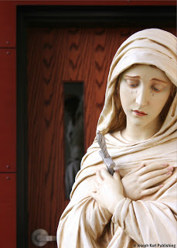

Michele Bondi Bottesi
CONTENTS
PRIEST SEARCH AND RESCUE SERIES
Lesson 1
The Demons in the Confessional, the Filth, the Rope, the Monstrance Sword,
and a Search and Rescue Operation for Treasonous Priests

Lesson 2
An Independence Day Rescue Mission and the Vital Work of Reparation

Lesson 3
Savior, Servant, Beast and Treasonous Priests

Lesson 4
A Catholic Priest Search & Rescue Operation at the Vatican

Lesson 5
Blessed Mother: The Mediatrix of all Graces & the Sword We Must Use

Lesson 6

Liberating the Wounded from Two Different Ships: Today's Double Catch, with a Twist

Lesson 7
The Homeless, Penniless, Useless, Worthless, and Helpless Fisherman
and Another Massive Catch of Priceless Fish

Lesson 8
A Holy Mass of Adoration, Reparation, the Miraculous Devotion
and Another Massive Catch of Treasonous Fish

Lesson 9
The Children, the Ransom, the Rescue and Our Little Redeemer

Lesson 10
The Perpetual (24/7) Fishing Wharf Inside the Church

Lesson 11
Adoration, Reparation, Devotion, Quadlocution,

Lesson 12
A Holy Rosary of Adoration for Christ’s Treasonous Priests
Lesson 13
Sacrificial Prayer, Sacrificing, and Praying for Priests
Lesson 14
Lesson 15
Lesson 16
Lesson 17
Lesson 18

The Diamond Encrusted Monstrance Sword

& A Rescue Operation of Epic Proportions

Lesson 19
The Battle at Two Wharfs and the Way of the Cross

SCRIPT 120

A Tuesday Holy Hour of Reparation

While Unified with Christ During His Sacred Passion

A very special and unifying journey along the Way of Sacrificial Love with Jesus our Redeemer and His most holy Mother. They are so in love with us all.
"REMAIN after Holy Mass and have a conversation with paradise.
As you begin praying the Sorrowful Mysteries of the Holy Rosary, Jesus suddenly unites you very powerfully with Himself during His Sacred Passion, in particular to show you how He prayed to God our Father for strength while suffering and making reparation for all of humanity.
We are to live in imitation of Christ and go to God our Father often to ask Him for the Divine assistance we need to fulfill the mission He has prepared for each one of us from all eternity.
"All Jesus Christ did, He did for us. His prayers, His tears, His watchings, His fasting, His preaching, His journeys, His conversations, His miracles-all those were for us." ~ Saint John Vianney, Sermon on Love for God
HIS AGONY IN THE GARDEN FOR US
Jesus has you pray to God our Father while unified with Him in the Garden of Gethsemane, as He prays and suffers reparation for the entire human race.
You pray also in particular to God our Father for the ransom, restoration, and eternal salvation of treasonous priests, because this is part of your God-given mission.
HIS SCOURGING AT THE PILLAR FOR US
Jesus continues to unify you with Himself as you pray. He is bound to a pillar, and the forces of evil are brutally scourging His Sacred Body to shreds.
Through it all, Jesus prays to God our Father for strength to accomplish His will and, while making reparation for our sins, He prays for the entire human race.
The witnessing of Christ's unfathomable love and mercy is so deeply touching that you shed mystical tears of blood.
Together with Jesus, you pray to God our Father in particular for the ransom, restoration, sanctification, and eternal salvation of His treasonous Catholic priests who desecrate His Sacred Body and Precious Blood and/or keep His Real Presence in the Blessed Sacrament from His people and/or teach badly or not at all about the greatest Source of grace we have on earth.
HIS CROWNING WITH THORNS FOR US
You are unified with Jesus as He is crowned with thorns. Our battered beggar King constantly appeals to God our Father for the strength to fulfill His mission while suffering to a degree we cannot comprehend in atonement for our sins as He prays for the eternal salvation of the entire human race.
Suddenly, Jesus begins praying differently. He prays for each one of us individually.
This is so incredibly moving that you shed mystical tears of blood. God's love for each one of us is very personal.
HIS CARRYING OF THE CROSS FOR US
Jesus continues to appeal to God our Father for strength as He carries the Cross to Calvary while unified with you on this Tuesday dedicated to making reparation, and suddenly you are mystically unified with everyone else through time who accepted or will accept God's invitation to become crucified souls, willing victims of love who closely imitate Christ and Blessed Mother.
Suddenly you see Blessed Mother following her Divine Son, our Redeemer, as He carries the Cross among the hostile mob, His Sacred Body so incredibly defiled.
She appeals to God for the strength to accomplish her mission as the Mother of our Redeemer and as our Mother also, she prays as well for all of humanity. She, too, prays for each one of us individually.
"Greater love has no man than this, that a man lay down his life for his friends" (John 15:13).
HIS CRUCIFIXION FOR US
As Blessed Mother stands close to her Son Who now hangs crucified completely desecrated before all on a Cross on Calvary, she prays to God our Father in union with Jesus and with all victim souls for the strength to fulfill each of their missions, and also prays for the sanctification and salvation of every single precious, priceless, and immortal soul.
Imagine what happens when we choose to remain unified with Christ crucified, His mission, and His suffering for the sanctification and eternal salvation of all.
YOUR APOSTOLATE OF REPARATION
When we remain after Holy Mass concludes while still unified with the Real Presence of Jesus in the Blessed Sacrament during the sacred fifteen minutes of divine union with God, we are present during the mystical taking down of our Lord's Sacred Body from the Cross after His execution by crucifixion for us.
Remaining in church even a little longer while still unified with Jesus in the Blessed Sacrament to adore God, offer Him a proper thanksgiving, and accept all the graces He lavishes upon souls who are willing to accept them are all wonderful ways to begin one's Apostolate of Reparation.
Everyone has an Apostolate of Reparation.
As Blessed Mother holds Jesus' desecrated and completely annihilated Sacred Body in her arms, she also holds all her children who are unified with Her Son and His Mission to save precious, priceless, and immortal souls.
As our Blessed Mother holds each one of us, we also hold her, always present with her Divine Son Who remains with us in the Blessed Sacrament, their inseparable and immolated Sacred and Immaculate Hearts cradled reverently and with great tenderness and devotion on our tongues.
"Trust all things to Jesus in the Blessed Sacrament and to Mary, Help of Christians, and you will see what miracles are." ~ Saint John Bosco
To learn more about the vital Work of Reparation to the Holy Face of Jesus and begin your powerful apostolate (if you haven't already), visit:
Jesus said to Sr. Mary of St. Peter, "By My Holy Face you will work WONDERS," and He still means it.

THE PATHWAYS TO HELL, PARTS 1 - 5

Part 1: How to Block the Gateway to Hell.

Part 2: More Ways to Block the Many Pathways to Hell.

The Pathways to Hell, Part 3.

Part 4. The Eucharist is the glory of the Church

Part 5: A Massive Rescue Operation Through Time and Space.
MORE
A Massive Moment of Mercy(click here).
Suffering, Sacrificial Prayer, and Praying for Priests(click here).
The Vestments, the Victims, and the Virtue! (click here).

Reparation, Wedding Theology & The Sacred Priesthood(click here).
LESSONS FROM THE LORD DURING ADVENT JUST FOR YOU
Lesson 1: "Ascend Higher!"
Lesson 2: The Light of the World
Lesson 3: A Present for You from Jesus.
Lesson 4: A Mother/Son Rescue and the Powerful Weapon in Your Hand.
Lesson 5: Living Entirely for Jesus as He Guides Your Soul to Perfection.
Lesson 6: On Determination: The Only Spiritual Defeats are the Ones We are Willing to Accept.
Lesson 7: Another Revealing Assault from the Devil

BACK COVER ~ THE SACRAMENT OF CHRIST’S PEACE

First paragraph. The Sacrament of Christ’s Peace

See a pillar transformed into a pedestal, Communion into creation, chaos into restoration, the Cross into a bridge, an impaled Heart into a refuge, a drop of Blood into salvation, silence into intimate conversation, and the daily Holy Sacrifice of the Mass into every soul's wedding.

See deep into eternity as words come to life. See adults transformed into children, people into tabernacles, wounds into reparation, holy faces into God’s mirrors, a valley of tears into heavenly joy, a prie-dieu into a place of mercy on Calvary, and the gates of heaven open wide as the guilty are granted pardon by an innocent Man nailed to a Cross.

See a church transformed into a hospital, candles into promises, a fallen race into ___________, human hearts into sanctuaries where the Son of God takes shelter, disgrace into honor/integrity, into self mastery, self centeredness into service, cowards into heroes, a perpetual adoration chapel into the soul’s refuge, struggles into opportunities, temptations into victories, failures into triumphs, Golden Arrows into graces, and the Work of Reparation to the Holy Face of Jesus into the most critical task of our time.

See a chapel transformed into the Garden, bread into God, Christ’s Precious Blood into the seeds of faith, the faithless into farmers and fishermen, profoundly Catholic teaching into nets, and petitions into keys which hands joined in prayer use to free captive souls bound and chained by the devil.

See sinners transformed into saints, the forgotten into the remembered, and those considered by the world to be the most worthless, powerless, useless, and penniless into phenomenal channels of grace for the massive conversion of sinners.

Saint quote on the Holy Sacrifice of the Mass here.

COPYRIGHT PAGE ~ THE SACRAMENT OF CHRIST’S PEACE

copyright © 2014 Michele Bondi Bottesi

First edition

All rights reserved.

Michele’s photograph copyright © Kathy Rizzo

Cover design by Joseph Karl Publishing

Book design and layout by Erin Howarth, www.wildernessbooks.org

Front cover image taken at Ss. Cyril & Methodius Slovak Catholic
Church, Sterling Heights, Michigan, U.S.A. www.saintcyrils.org

To order additional copies, please contact:
Joseph Karl Publishing
www.josephkarlpublishing.com

The Scripture quotations contained herein are from The Holy Bible:
Revised Standard Version, Catholic Edition, copyright 2004, by Oxford
University Press, Inc., New York, NY.

Manufactured in the United States of America

"Restore My House, Which Has Fallen Into Ruin"
A summons for every soul from the Master Gardener, the Owner of the manor, the Good Shepherd, our Creator, Savior, Teacher, Restorer, and the Love of our eternal lives.

IT'S TIME TO GET THE RIGHT KIND OF BUSY
"Francis, go and build up My house, which as thou seest, is falling into ruin." ~ Our Lord
During this lesson, you suddenly find yourself on the property of a very large and elegant house. The grounds are extensive and beautiful.
The house and grounds are very stately, appealing to the senses, and seem timeless.

A few people you are very close to are with you, but other than that, there are no other people until the end of the lesson.

THE CARETAKER OF THE HOUSE

It is with great surprise that you find yourself the owner of the house.
“The time best spent is that which is spent for the glory of God and the salvation of souls.” ~ Saint Pio of Pietrelcina

The first thing you think while scanning the grounds, which are expansive: I cannot afford to own this house.

And then you think: I physically cannot take care of something this big.

Such a large house, so much property, so much to care for, such a huge responsibility.

Nevertheless, you find yourself totally at peace, without worry, and you do not resist taking ownership of the house.

So curious this scenario, that the care of something so large and so beautiful would be given to one who has nothing and is nothing.
"With God, nothing is impossible" (Luke 1:37).

A few people closest to you (family, or perhaps friends) enter the house with you. It has many rooms. Some of the rooms are absolutely enormous and some of them are very small. The house as seen from the outside cannot contain all the rooms that are in the house, especially not one of the rooms, which is bigger than any room in any house.

The first room you enter is the room in your previous house where you offered the most to God. What room would that be? That room in this house is just huge, the size of a warehouse! What comes to your mind (and is actually quite funny): Furniture would be really dwarfed in here. It would look microscopic! Why is this room in this house so massively large? An area rug covers the carpeted floor, and it much larger than the size of the room. You take this in with great wonder. That is the largest area rug you have ever seen!

Your people accompany you into another room, and it is the dining room. That room is very large, but not as crazy big as the previous room. The room is furnished. There is a dining room table with chairs in it, and the table is very, very long. You remark to your people right away, "Look how long this table is!" (There is a place reserved for everyone at the Lord's head table).

You are surprised to find furniture in some of the rooms, a great many things had been left in the house.
You remark that you should have had an agreement before taking ownership of the house that everything in it be removed, not entirely realizing that this "transaction" is supernatural.
You never took ownership of anything. The responsibility to care for this house has been given to you.
While continuing to look around, you think that you now have a lot of work cut out for you. But not once do you feel worried.

You are surprised to find the dining room table in the wrong place in the room. It is obviously off center, and so the people closest to you begin restoring it to its proper place in the room.
You then see an area to the left and are drawn to it. That area is next to a lovely garden, and it contains many tables and chairs. They are piled there in disarray, abandoned and not being used. You immediately begin going through them and remark how beautiful they are, and begin planning to remove them and restore them somewhere where they will get proper use. A table made of marble catches your eye, and that is the first one chosen to be restored to the house.

RESTORE MY HOUSE, WHICH HAS FALLEN INTO RUIN

Are you catching the metaphors?

The enormous rug in the largest room is a fishing net, and it extends beyond the boundaries of the room. The furniture that is to go in it would be dwarfed but the good works offered to God for the salvation and sanctification of the human race are mighty, and symbolized by the enormity of the size of the room.

The tables are altars, and they symbolize things that are not being done correctly in God’s house, and the rampant abandonment of what is useful, good, and beautiful. They represent a misplacement of things, and of Him, and show the catastrophic lack of proper Catechesis that has existed in most Catholic parishes and for generations. Since so few Catholics really know their faith, errors and outrages have spread far and wide. Billions of graces have been lost and so many more are being lost to ignorance by the hour.
Local Catholic parishes that get just the basics right are very, very hard (if not impossible) to find. Many people don't realize this because so many people are the wrong kind of busy. It's easy to find programs, but very hard to find the core basics that are the foundations of parishes that supernaturally explode each day with superabundant graces. Such rare parishes are tremendous channels of massive amounts of grace for the conversion of sinners through all time and space.
RAMPANT ERRORS WITHIN THE MANOR
Tabernacles containing the King of all kings not placed front and center. Caste systems created by people that exclude others in the Lord's house. Altar girls. Women distributing Holy Communion in church. Holy Communion received while standing (when able to kneel) and in the hand. People walking out of church while still unified with Jesus in the Blessed Sacrament after Holy Mass has concluded. The ongoing and colossal lack of proper Catechesis, especially for children. The lack of spiritual direction the devout faithful desperately need, the lack of silence, reverence, kindness, and compassion.
The willingness to serve oneself at all costs to self and to others. The absence of Eucharistic Adoration. Limited Holy Mass times at many parishes, and severely restricted times for making sacramental confessions. Idolatry, excessive and unrestricted soliciting and fundraising, an unwillingness of leaders to change for the better, and people in the congregation who have never been taught how to behave in God's house (or outside God's house), the many well meaning people who seek to be entertained instead of recognizing and developing the desire to follow Jesus at the side of Blessed Mother on the road to Calvary, where we are to spend our lives serving (not taking from) our fellow man.
What can you add to the list.
Where to find the perfect parish.
"The Church is a ship, and even if the ship is in difficulty,
it is necessary that we at least be in it."
~ Saint Augustine
You find yourself surprised that whoever left the house would leave such nice things behind in it, and so many things, including things with great historical significance which you discover later.

A HOUSE CONTAINING MANY MYSTERIES

You find yourself in other rooms alone. One is like a closet, but not like a conventional closet. It is more like a room one would find in a museum. It is full of things of historical significance. It would take hours for you to go through everything. Why would these things of great significance have been left behind?

The house also contains many mysteries, mysteries that are kept in certain rooms. There are so many details, so many rooms, so much in disarray, other things in other rooms had been kept with great care.

So much is left for you to care for, and there is so much beauty to restore. So much work to be done. You continue to feel completely at peace, and never feel worried or anxious. Nor do you resist taking ownership of the house, which has somehow been entrusted to you.

THE LORD OF THE MANOR RETURNS

While you are in a room containing many intriguing mysteries, a man and a woman suddenly enter the very small room that seems more like a special and unique closet. They enter behind a younger man with dark hair and a beard. You do not recognize Him by sight but immediately know Who He is.

The Man is the King of all kings and the owner of the house. Jesus has come to claim ownership of His house, of His Catholic Church, and is the One Who will help you and others restore it. Behind Him stand His parents, God the Father and His most holy Mother.
What has our Lord entrusted you to do to restore His house to its proper glory?
"By My Holy Face you will work wonders." ~ Jesus to Sr. Mary of St. Peter
KNOW YOUR FAITH CORRECTLY BY FIRST LEARNING IT CORRECTLY
Then, teach the Faith correctly to others.
Phenomenal material for you in print, audio, and video by one of the greatest Catholic educators in the history of the Catholic Church, Father John A. Hardon, S.J.: Archives.
God is at work in you! Go, Team!!

Fishing at an Almighty Pier
Another lesson from our Master Fisherman, Who invites us all to become fishers of men and "launch out into the deep" (Luke 5:4).
On this day, while still at home before leaving for the church, Jesus shows you the inside of the church as a mighty fishing pier, and all around it and also underneath this pier is the ocean of almighty God's mercy.
Our Savior redeemed every one of us, and He keeps coming for every one of us, offering His Sacred Body and Precious Blood to us all, and for us all. There is a place reserved just for you at His head table!
The unfathomable love and mercy of God are available to all without exception.
To begin, we must be willing to accept them. There are no limits to His extravagant love for us.
Accept His love and His graces. Accept them for others. Love Him in return, and love Him for others.
"Unless souls are saved, nothing is saved; there can be no world peace unless there is soul peace. World wars are only projections of the conflicts waged inside the souls of men and women, for nothing happens in the external world that has not first happened within a soul." ~ Archbishop Fulton J. Sheen
THE CLOSET
Jesus also shows you an image of your clothes closet and tells you that everything in it is an opportunity to help someone else.
On the day and at the time when He calls each one of us into eternity, all the precious opportunities given to us by God to care for others in His place which were not taken, precious opportunities to serve which merit grace for ourselves and for precious souls through all time, will be lost forever.
Make the most of these important opportunities now, while you have the opportunity.
Look for them, watch for them, recognize them, and realize them.
Always thank God for them.
SACRIFICIAL LOVE
Sacrificial love is the strongest force in the universe.
Sacrificial love is so strong that the bonds formed by it cannot ever be broken, and the gates of hell cannot prevail against it.
Sacrificial love transforms hearts, and lives, and saves souls for all eternity.
Allow sacrificial love to bind your soul to God, forever.
Allow sacrificial love to transform you into a tremendous channel of superabundant grace for the massive conversion of sinners.
God is so in love with us all!
DAILY WEDDINGS TO THE KING OF ALL KINGS
Jesus tells you one more thing before you leave for the church. He recalls your personal suffering and says little did you know back then that you would be wedding your life to His daily during the Holy Sacrifice of the Mass. Wed on Calvary. Wed in His grand mystical Cathedral.
Wed, paid, fed, loved, and valued beyond measure.
Loved extravagantly, and lavishly.
Our Lord loves you so much that He invites you personally to wed your life to His every single day during the Holy Sacrifice of the Mass, during the mystical re-presentation of His Passion, Crucifixion, Death, your Redemption, and His Resurrection. What great dignity!
What a delightful moment, Jesus. Thank You. You are so charming, and so very adorable.
HOLY MASS AND THE REST OF THE LESSON
Today you remember to offer almighty God the Holy Sacrifice of the Mass to the Holy Face of Jesus from the very beginning. Very good!!
Right after doing so, you experience very profoundly, personally, and also realistically, the Precious Blood of our Savior coming from the wound in His Sacred Heart on the Cross.
Today's lesson comes straight from the heart, from our Lord's Sacred Heart and from our hearts also.
The experience is deeply moving, very beautiful, and so incredibly loving.
OFFERTORY

During the Offertory, arrows project from the Sacred Heart of Jesus, and also from the hearts of the people, and they land in the mystical hole in the ground before the altar leading to the ocean of God’s mercy. Those arrows are powered by the Love of God, and today they are going to catch some fish!
The fish represent precious, priceless, and immortal souls who have distanced themselves from God and are being held in spiritual captivity by the devil.

THE CONSECRATION
Blessed Mother comes to you and collects your tears with her mantle. Then, she takes a large and very powerful golden arrow, a precision weapon of mass salvation which she acquired from the Sacred Heart of her Son on the Cross, and wraps It in her mantle.
This golden arrow represents the Sacred Body of Christ, which was given up for each one of us.
She then places this precious bundle into the large mystical hole in the floor in front of the altar in the center isle that leads to the ocean of God's mercy.
You wonder if this powerful "Bait" is going to catch a certain fish in particular.
HOLY COMMUNION
While walking up the isle to receive Jesus, arrows project from the bodies of all the people as they approach the communion rail to kneel and receive our Savior in the Blessed Sacrament, the greatest source of grace we have on earth.
The arrows are also projecting from Jesus, Who is distributing Holy Communion and is superimposed over the celebrant.
All the arrows projecting in so many directions land inside of the mystical holes in the floor.
A MASSIVE CATCH
After you return to your place in church, while unified with Jesus in the Sacrament of love, you see that many nets are being raised, not only from yesterday's new holes around the altar but also from the newest ones that have burst forth today.
So many nets are being raised, and they are full of fish!

Then you see that the nets being drawn out of a great many holes leading to the ocean of God's mercy extend as far as the eye can see.
The many nets can be seen way, way off in the distance.
The powerful golden arrow Blessed Mother had placed into the hole not only represents Christ’s Sacred Body as a weapon of mass salvation, but because she came to you and added your tears to it, the golden arrow represents the mission involving your personal apostolate in particular.
God and His most holy Mother, the Mediatrix of All Graces, are at work in you!
The fish were and will be caught in the distance, meaning the work of your personal mission extends outwards, and its fruits are not limited to time and space.
"REMAIN"
Jesus acquires arrows from the heart of each person that has remained after Holy Mass has concluded.
These precious arrows acquired from hearts unified with the Sacred Heart of Jesus during the sacred time of Divine Union with our Lord are precision weapons of mass salvation that our Lord gathers personally.
Make it a point to remain in church after Holy Communion, during the sacred fifteen minutes of Divine union with our Creator, Master, Savior, humble Carpenter, Fisherman, Good Shepherd, Teacher, and Love of our eternal lives.
He is so in love with us all!
Love Him and honor Him, all the moments of your life. Remain, be still, and know that He is God.
So many graces are lost forever when we leave God's house while unified with Jesus in the Blessed Sacrament.
So many opportunities to offer God reparation are also lost when we fail to remain while unified with Christ in the Sacrament of Love.
"When you have received Him, stir up your heart to do Him homage; speak to Him about your spiritual life, gazing upon Him in your soul where He is present for your happiness; welcome Him as warmly as possible, and behave outwardly in such a way that your actions may give proof to all of His Presence." ~ Saint Francis of Sales

A Holy Mass of Reparation
Redemptive suffering in union with Christ, baskets, mystical holes in the floor leading to an ocean of God's mercy, a massive search and rescue operation not limited to time and space, and the efforts of the devout faithful who fish from a mighty pier.

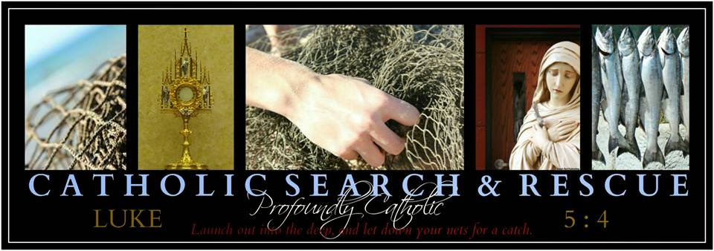

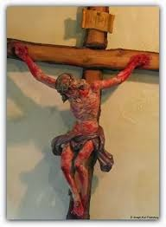Another provoking lesson from the One Who loves and values us all more than we can ever imagine.
Today's lesson begins just prior to the start of the Holy Sacrifice of the Mass and concludes later that evening, before the miraculous Devotion to the Holy Face of Jesus.
JUST PRIOR TO HOLY MASS

As you pray to prepare your heart before Holy Mass begins, Jesus tells you that as soon as It does, His Sacred Body is going to be mystically raised on the Cross on this Friday, in front of the altar, and will remain there throughout.
That's exactly what happens.
You see Jesus as He is raised on the Cross in front of the altar at the start of Holy Mass, and witness what happened to His Sacred Body as the Cross stopped abruptly when It came to rest in the hole prepared for It in the ground.
It is so incredibly moving that you have to place yourself at the back of the crowd on Calvary, even farther back mentally than physically, in order to refrain from weeping.
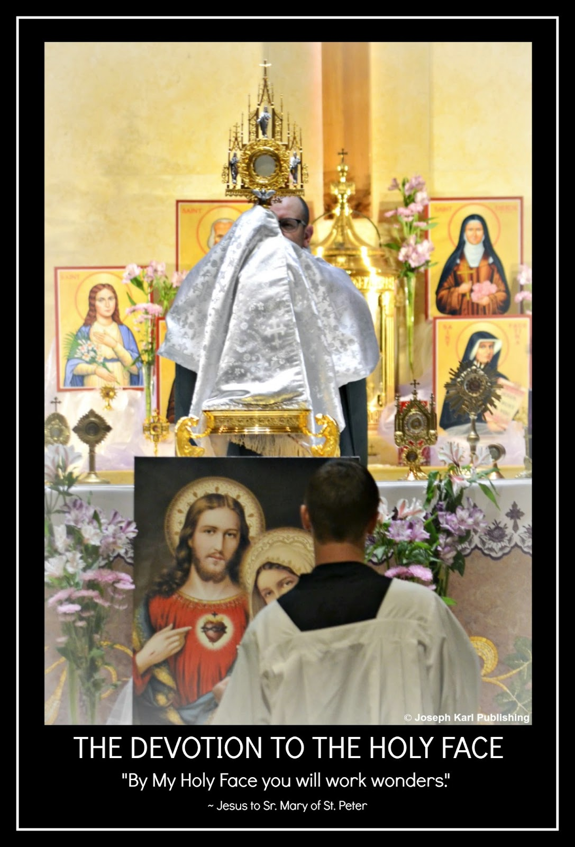
A HOLY MASS OF REPARATION
Jesus tells you that this will be a Holy Mass of Reparation.

The greatest offering of reparation IS the Holy Sacrifice of the Mass.

Jesus continues to suffer mystically on the Cross throughout Holy Mass, which is being celebrated between the hours of noon and three on a First Friday.

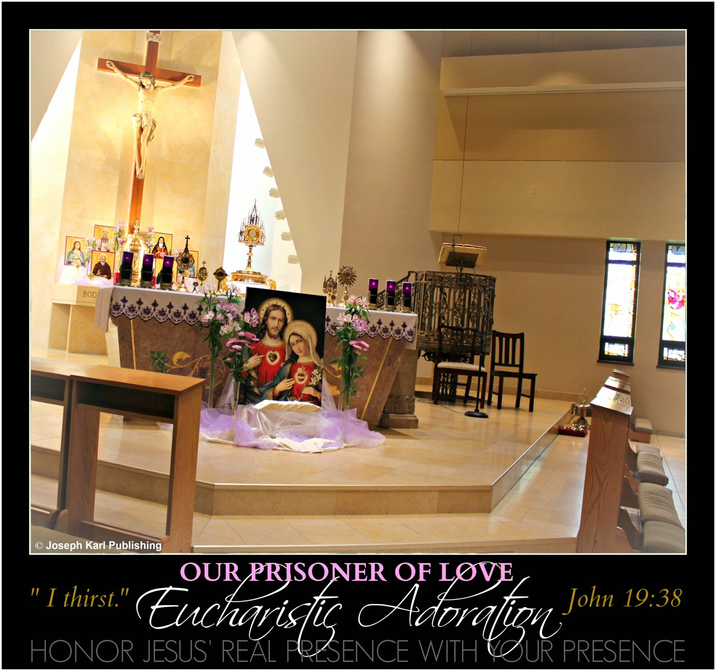

EUCHARISTIC ADORATION

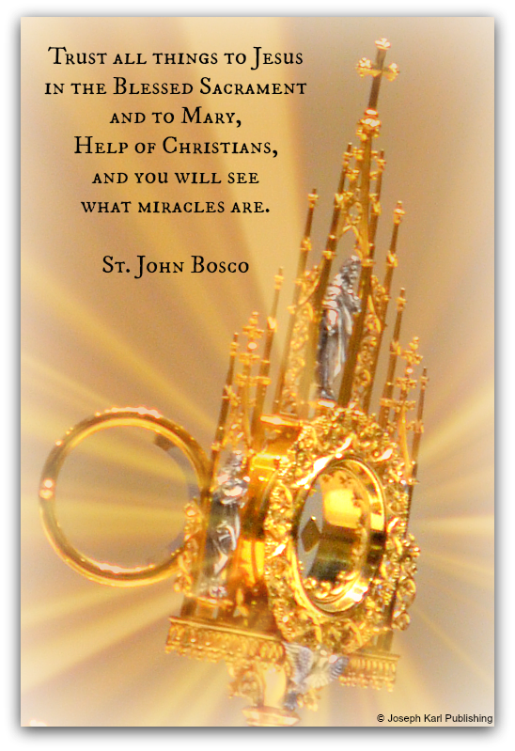
Just prior to Holy Mass there was Eucharistic Adoration.
During the entrance hymn, after Father removes the Sacred Host from the monstrance and as he places the Blessed Sacrament inside the tabernacle, Jesus draws your attention to the empty monstrance on the altar.
You find the sight striking for some reason, and all of a sudden, superimposed over the empty monstrance are all the parishes that do not make Jesus available in the Blessed Sacrament to the people for Adoration and consolation.
That would be most parishes.
The monstrance was empty, and the churches were empty.
What an incredibly sorrowful sight, shared with our Savior who has presented Himself mystically, crucified on the Cross!

Reparation must be made for this humanitarian catastrophe. Reparation will avoid an even greater humanitarian catastrophe, and save precious, priceless, and immortal souls who would otherwise be lost for all eternity.

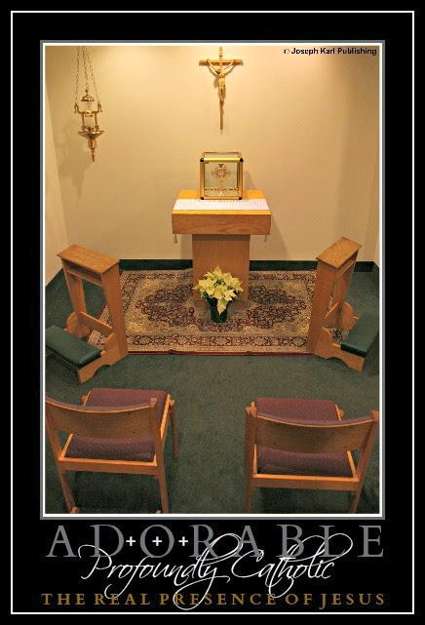HOLY COMMUNION

As people in the center isle approach the altar to receive Jesus in the Blessed Sacrament, they pass our Lord who is mystically crucified on the Cross in front of the altar.

As they go by, each person was to place their works of reparation into a basket that was on the ground below the Cross. Since they did not know this was happening, their good works were drawn from them. If they were taught about the Work of Reparation, which our Lord Jesus Christ Himself called, "the most beautiful work under the sun," then they would have even more to offer.

This happens with you as well. When everyone had passed by, Blessed Mother and Saint Joseph, who were standing on either side of the Cross and the mystical hole in the floor, raised the basket and together, poured out the contents into the ocean of God’s mercy.

All that was offered and collected will be used to catch and liberate precious, priceless, and immortal fish lost and being held captive in spiritual bondage.

“REMAIN”

Those who remain in church during the sacred 15 minutes of Divine Union with Jesus receive a personal blessing from Jesus who is still mystically crucified and suffering, for us, on the Cross. Just imagine what that is like.
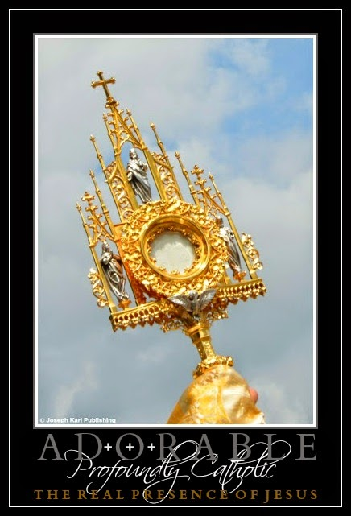
"When you have received Him, stir up your heart to do Him homage; speak to Him about your spiritual life, gazing upon Him in your soul where He is present for your happiness; welcome Him as warmly as possible, and behave outwardly in such a way that your actions may give proof to all of His Presence." ~ Saint Francis of Sales

EUCHARISTIC ADORATION THAT NIGHT
"By My Holy Face you will work wonders." ~ Jesus to Sr. Mary of St. Peter

That evening, you plan on traveling a great distance to the closest Perpetual Adoration Chapel so you can pray and offer reparation to Jesus, but our Lord has you remain home and suffer before the Devotion to His Holy Face.

As you do what the Lord requested, and while offering up your suffering, you suddenly see that there is a basket on the ground before the Devotion, by the mystical hole in the floor leading to the ocean of God's mercy.
The basket is there to collect reparation, very similar to the basket our Lord showed you during Holy Mass earlier today.
Sweet Jesus, Your wish is my command.

Sacred Union, Service, and Surrender
Another provoking lesson from our Savior and Teacher during Operation Profoundly Catholic Search and Rescue. God is at work in you!
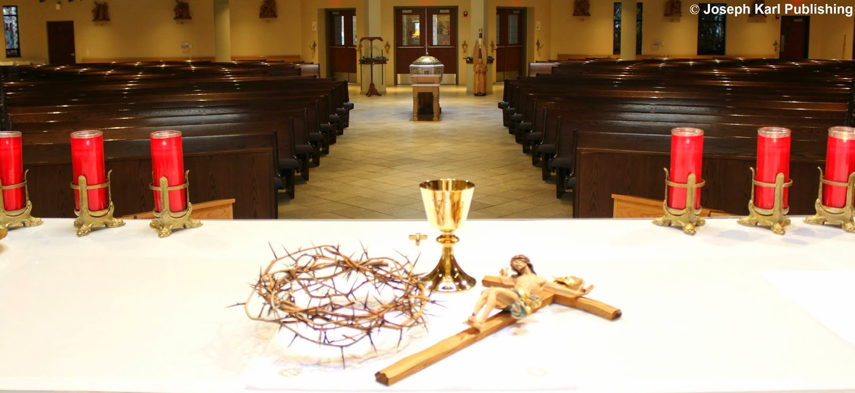
THE HOLY SACRIFICE OF THE MASS AND TODAY'S LESSON
Our Teacher reveals nothing to you in the beginning, and so you ask Jesus if He is going to teach you anything new today.
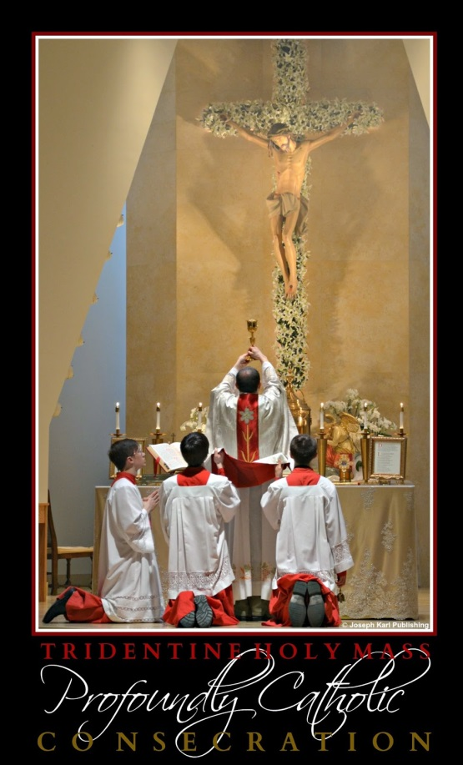When the student soul is ready, our Teacher always appears.

He reminds you that you had forgotten to offer the Holy Sacrifice of the Mass to God along with His Holy Face.
So you do that right away.

Not long after that, you see that each one of your hands is mystically transpierced with a golden arrow.
THE OFFERTORY AND THE CONSECRATION

During the Offertory and the Consecration, you see Jesus at the altar concelebrating the Holy Mass.
You are shown that the devout faithful are individually (and also collectively, as the Mystical Body of Christ) unified with Him, mystically. The union of Jesus and each individual, two having become one, is stressed more than the collective union which includes everyone.
Jesus reminds you of the earlier sight of your hands transpierced with golden arrows, and instructs you that the hands of all people are to be His Sacred Hands, which carry on the work of mankind’s salvation and sanctification which is being accomplished in our time and for all souls through all time.
Our hands are His Sacred Hands, two having become one at every soul's wedding to Christ during the Holy Sacrifice of the Mass.
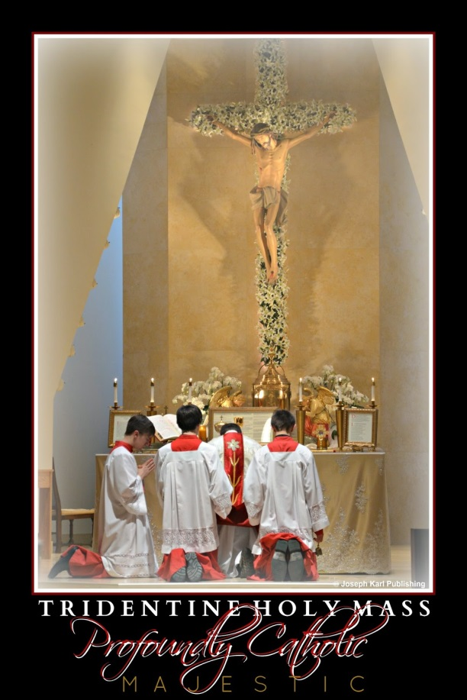How important it is for us to go to Holy Mass daily, if at all possible.
How important it is for us to be unified with Jesus in the Blessed Sacrament, as reverently as possible and while in the state of grace.
How important it is for us to remain with Him during the fifteen sacred minutes of Divine union.
How important it is for us when we leave the church to invite Him to accompany us, to remain in His presence always, and to "Bring Him everywhere" (Father Benjamin Kosnac).

As Jesus speaks at the altar, looks around at His people, and performs the various sacred actions as the Last Supper is mystically concelebrated during the Holy Sacrifice, each individual unified with Him does so in like manner. How is that possible? He and we are unified, having already become one and the same at all the Holy Masses we have assisted at in the past, celebrations where we have wed our lives to Christ.
In other words, you see yourself and others fulfilling each one of our missions in union with our Savior, our defiled (by other people in imitation of Christ) and purified bodies (purified through sacramental confessions, submission to God's will, loving sacrificially, and patient suffering) unified with His defiled and pure Sacred Body.
The lesson on our sacred union with the defiled and pure Sacred Body of Christ: Divine Mercy, the Golden Arrows, and a Massive Rescue Operation.

Clearly, the faithful are not unified with Christ at the altar as priests, because the people in the congregation are not priests. The celebrant is unified with Jesus as a priest. Everyone else is unified with Him as His servants, and as the servants of others.

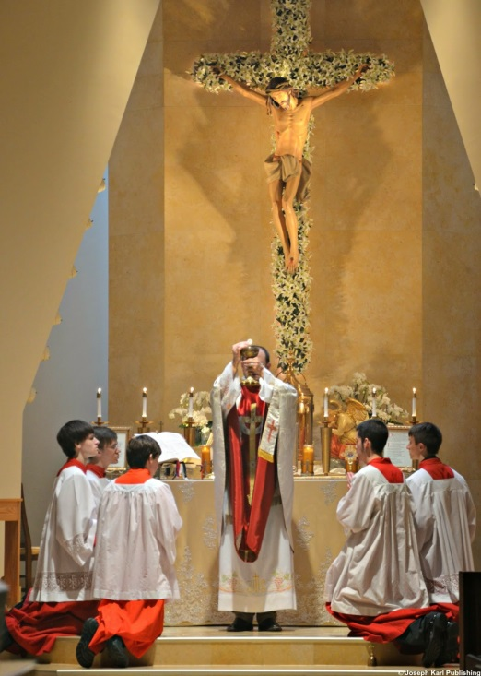HOLY COMMUNION

Similar to what had just been revealed, you see that the faithful are unified with Jesus as individuals when He distributes His Sacred Body to the faithful, again two having become one.
As Jesus distributes Holy Communion, the persons you see unified with Him serve others through his or her apostolate, which is shown symbolically as distributing His Sacred Body.
As that is accomplished, grace projects out from Christ's Sacred Body to the communicants and also out into time and space, showing that so much more good happens than what we see. Countless people are affected by choices and our efforts to serve and care for others in union with Christ and in imitation of Him and His most Holy Mother.

MASSIVE FLOODGATES OF MERCY
You walk up the isle to be unified with Jesus in the Sacrament of Love and are almost to the front, when it is suddenly revealed that mystical holes are blowing open at points before the altar where people walk up to receive Holy Communion.
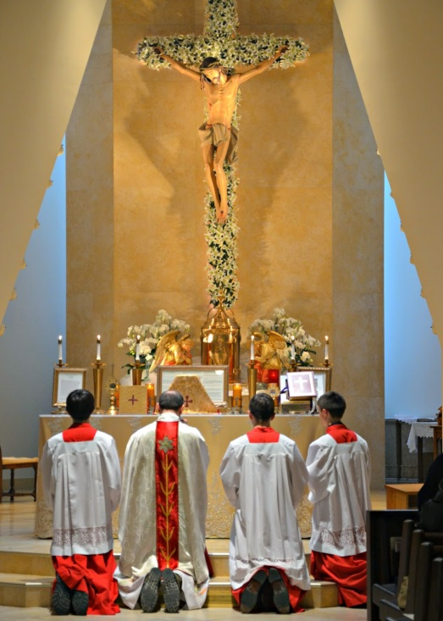
The mystical holes leading to the ocean of God’s mercy are blowing open with tremendous force, and the almighty presence and power of God is very evident. The holes are smaller than the very large one in the center isle, but bigger than the individual holes by every person (which you are not shown during today's lesson).

You also are shown this metaphor another way, to your sight as an image and to your mind as an understanding. You see a horizontal representation, on the floor, of a great dam breaking open, one circular hole after another is forced open wider from the tremendous force of the flood of water breaking through. Then, the entire structure begins to crumble.

First the holes blow through the floor from the ocean of God's mercy upwards, and then the floor begins crumbling all around the faithful, exposing the very large ocean of God’s mercy.
You see that there is no stopping the almighty and unfathomably loving power of God.
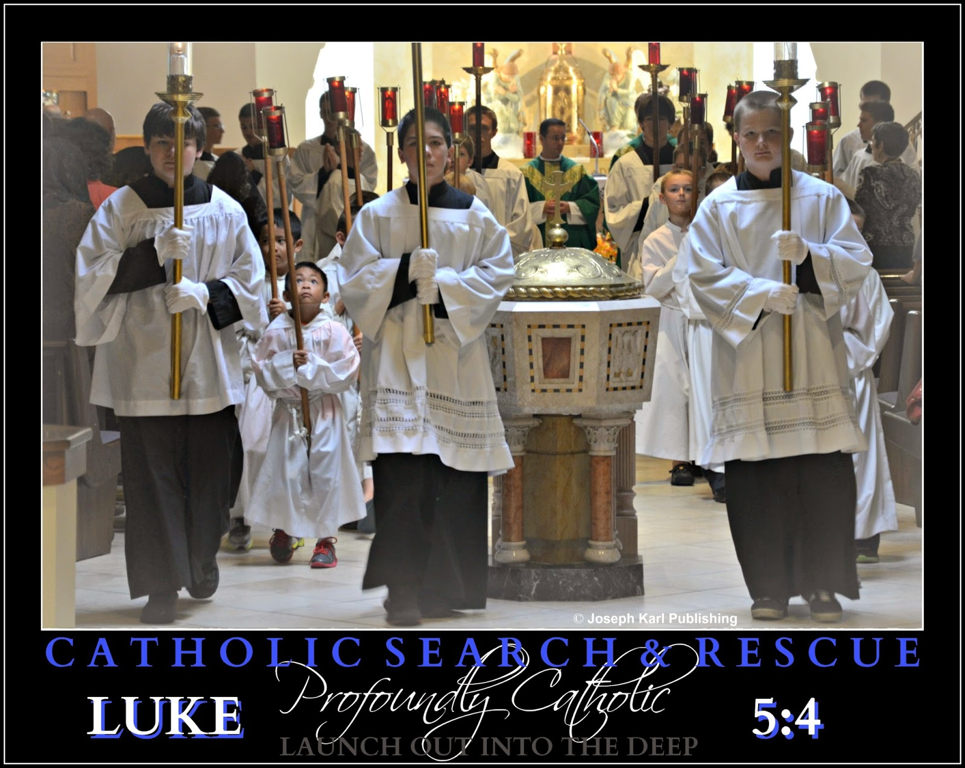

“REMAIN”

After Holy Mass concludes, you try to remain silent interiorly while unified with Jesus during this sacred time of Divine union. This pleases Jesus, our Teacher and our Savior, very much. He then appears in front of you dressed as our High Priest, in black clerical garb and a roman collar. Jesus has a blessing for each person who remains, as He has requested, during this sacred time of union with the wonderful Bridegroom of our souls.

This is so delightful! You wait for Jesus to bless you, but nothing happens.
Jesus is waiting.

You ask our Lord why He is waiting, and Jesus says that He is waiting for you to ask Him for a blessing (smile).

So you ask Jesus to give you His blessing, and then Jesus' attire suddenly changes. He is now wearing vestments, and He gives you His blessing.

Thank You, Jesus; that was so very beautiful. Your wish is my command!
"When you have received Him, stir up your heart to do Him homage; speak to Him about your spiritual life, gazing upon Him in your soul where He is present for your happiness; welcome Him as warmly as possible, and behave outwardly in such a way that your actions may give proof to all of His Presence." ~ Saint Francis of Sales

Incredibly Powerful Precision Weapons of Mass Salvation
The very next lesson from our King, Who reminds us that with God all things are possible. And probable.
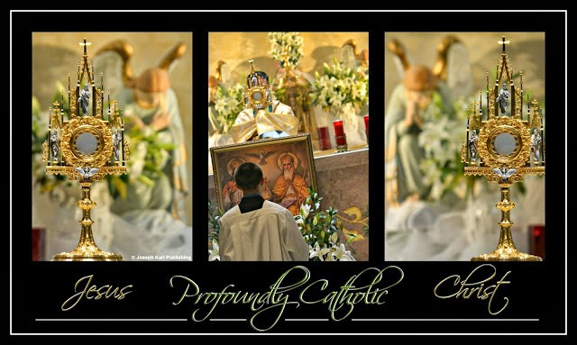
NEVER PUT LIMITS ON ALMIGHTY GOD'S POWER
While on your way to Holy Mass, Jesus begins instructing you in your vehicle. He says that the devil convinces people directly and/or through others to say and think that we can't change things, that we can't change the world, and that change isn't even possible.
Jesus tells you this is not true because with God, all things are possible (Matthew 19:26) and we can do all things through Him who strengthens us (Philippians 4:13).
How many have heard all their lives what isn't possible, instead of what is.
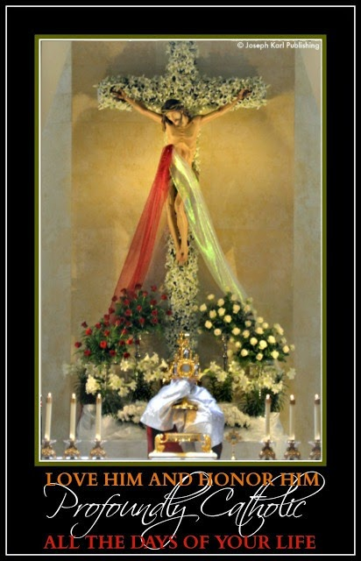
The devil works hard to condition us to think we can't, but Jesus says that with Him, we can. And we will.
HOLY MASS
During previous lessons, Jesus presented His Sacred Body on the Cross as an arrow, the golden arrow, and also as a very powerful arrow that crushes the demons defiling humanity in so many different ways.
Today, from the beginning of Holy Mass, our Savior presents His Crucified Sacred Body to you as a precision arrow.
This arrow is razor sharp, and one hundred percent accurate.
What an incredibly powerful sight!
Jesus makes it clear that His Sacred Body is an incredibly powerful weapon of mass salvation.
Recently, Jesus taught that we take on His likeness in two distinct ways (Divine Mercy, the Golden Arrows, and a Massive Rescue Operation) when we are unified with Him in the Blessed Sacrament, and our union then makes us very powerful weapons of mass salvation also.
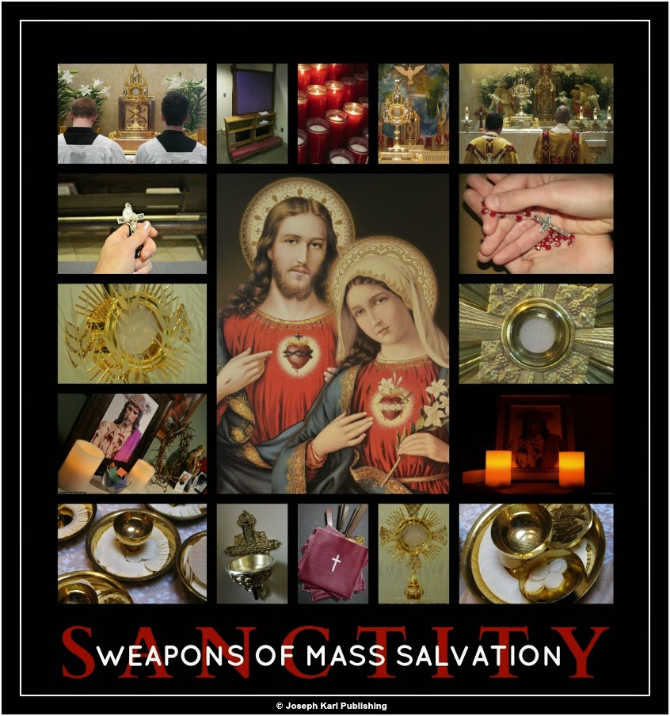
OFFERTORY
As Father and Jesus mystically concelebrate Holy Mass and prepare the altar for the consecration, the air around them and also around the altar fills with small arrows.
The appearance of all those little arrows flying in every possible direction is similar to what snow flurries look like.
They were of various colors, the little arrows, all soft pastels.
What a sight!
Jesus, where did those arrows come from? you ask our Lord.
He replies that they come from the angels, who are always helping us.

Divine Mercy, the Golden Arrows, and a Massive Rescue Operation
Another lesson from our lavishly loving Teacher that spans two days, two Holy Masses, and one spectacular Feast of His Mercy.
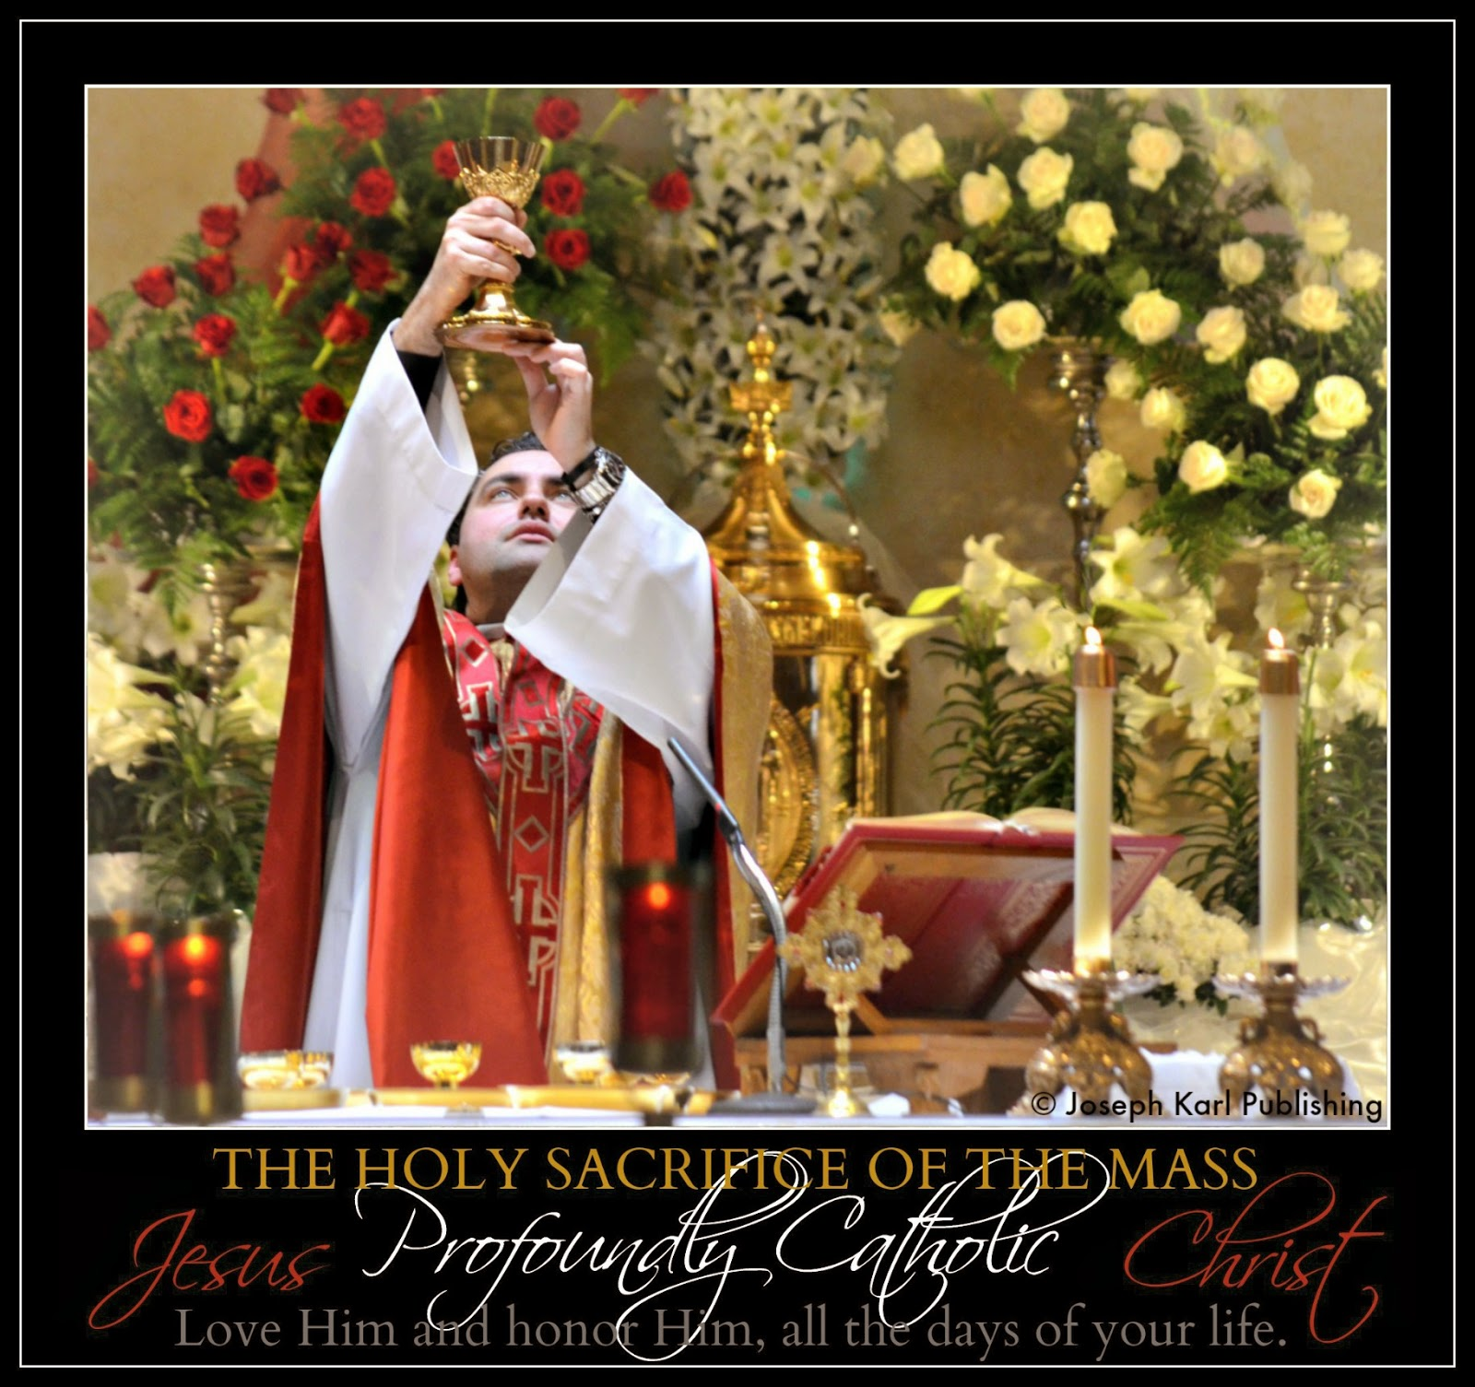

"By My Holy Face you will work wonders." ~ Jesus to Sr. Mary of St. Peter

EMBARKING UPON A NEW ROAD

Right after you begin praying before the celebration of Holy Mass on the eve of the great Feast of
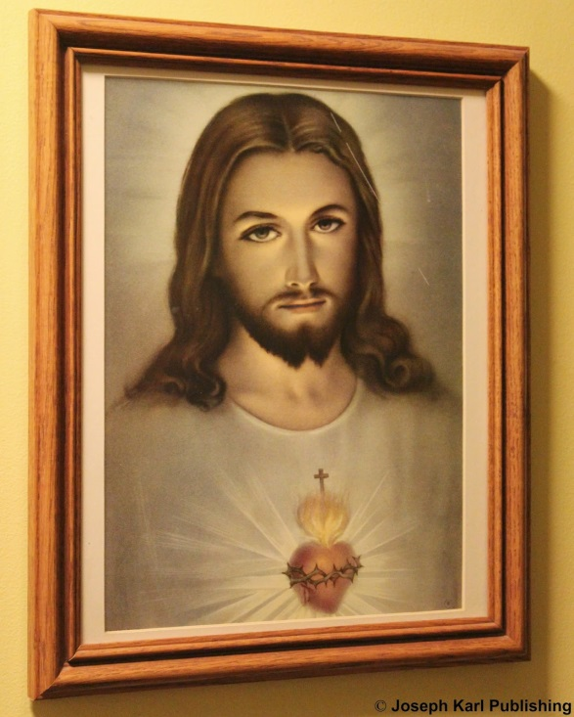
Divine Mercy, you are shown the mystical hole in the floor leading to the ocean of God’s mercy, it is huge, and flames are shooting from it.

Arrows begin projecting out from the flames and they land on the floor of the church. Shortly after that, more arrows project out, and they have caught the fish! They are coming out of the ocean of God’s mercy and land on the floor in the center isle before Holy Mass has even started.

Next, our Lord shows you that the blood and water streaming from the wound in His side contain arrows. So many arrows are streaming forth from the wound, from the Sacred Body of Christ which has been presented to you during the lessons of the past week as an arrow.

THE TIME OF MERCY AND THE TIME OF REPARATION

Humanity has arrived at the end of one road and is embarking upon a new one, as one era leads into the next. The time of mercy is transitioning into the time of reparation.

GOD ALONE

At one point during Holy Mass, Our Teacher draws you to Himself so profoundly that it is just you and Him, alone.

“I HAVE A GOLDEN ARROW FOR YOU”
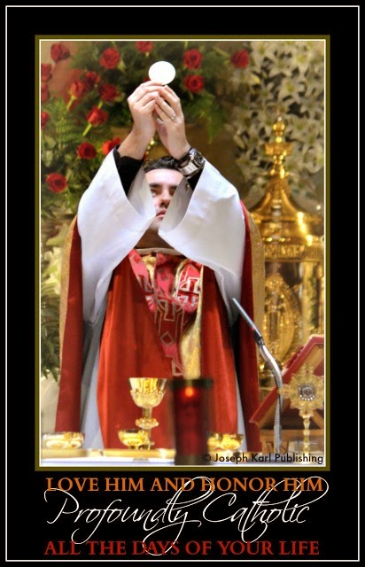
As the time for Holy Communion draws near, Jesus tells you that He has a golden arrow for you.
More about the Golden Arrow.

So you ask our Savior when He is going to give it to you, and He tells you it will be in the Sacred Host you receive during Holy Communion.
Jesus had made another reference to His Sacred Body as an arrow, this time as the golden arrow.

ARROWS, ARROWS EVERYWHERE

During Holy Mass, the words being spoken and prayed, as well as the words of the songs being sung become visible in the air. The air is completely filled with translucent words, and you see that they all contain arrows.
It also begins snowing, signifying more grace being showered upon humanity so gently and so beautifully, and the snowflakes contain arrows, too.
Some land in the ocean of God’s mercy where they will catch fish (precious, priceless, and immortal souls in spiritual peril), but most land all over the floor of the church.

Jesus, what is going to happen to the arrows on the floor. How can they catch fish if they are on the floor?

All of a sudden, children who lost their lives to abortion appear in the center isle, and they begin picking up the arrows and throwing them into the mystical hole in the ground by the altar.

What an incredibly delightful sight!

NO NET

No net was raised, and no more fish came out of the hole as they had before Holy Mass.

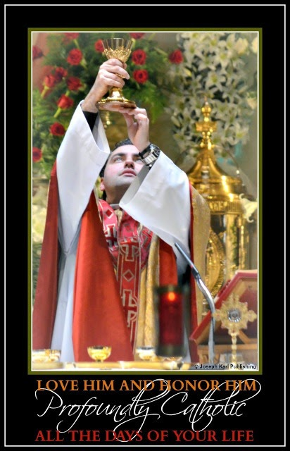Why not, Jesus? What is going to happen?

Jesus tells you that the arrows will catch the fish tomorrow, on the great Feast of His Divine Mercy.
DAY TWO, LESSON TWO: THE FEAST OF DIVINE MERCY
While praying before Holy Mass begins, in the church which tragically lacks silence, Jesus shows that each one of your hands is transpierced with a golden arrow. This symbolizes the ongoing work of the salvation of men through the work of our hands.

DIVINE UNION: DEFILED BODIES AND GLORIFIED BODIES

At one point during the Holy Sacrifice of the Mass, Jesus tells you that the faithful are unified with Him in the Blessed Sacrament in two distinct ways.
The first way is defiled: the defiled bodies of the people (meaning mistreated, not self inflicted) are unified with His defiled Sacred Body (defiled during His lifetime, Sacred Passion, and Crucifixion).
The second way God and His beloved servants are united is in purity: the purified bodies of the faithful (purified by His Precious Blood through the sacraments He instituted for us) are unified with His pure Sacred Body during Holy Communion.

THE MYSTICAL RE-PRESENTATION OF CHRIST’S PASSION AND THE ARROWS

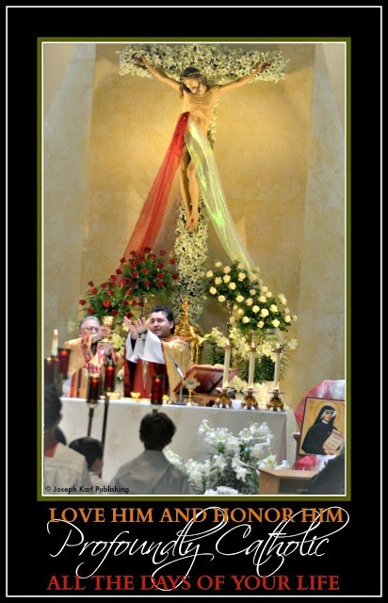As Holy Mass progresses, all the people present in the church, and also all the souls they have brought mystically to the church through intercessory prayer, proceed through the mystical re-presentation of the events of Christ’s Passion and Crucifixion, and mankind's Redemption.
Jesus' Precious Blood, tears of Blood, and drops of Bloody sweat project out into time and space throughout Holy Mass, and contain grace that is represented in the lesson as arrows.
Jesus is shooting arrows from His own Sacred Body for the salvation and sanctification of men, and projecting grace out into time and space, for us.
Thank You for Your great love, mercy, and compassion, Jesus.

Yesterday during Holy Communion, you suddenly experienced our Lord’s Sacred Body, the Sacred Host He presented to you that had the arrow inside, in pieces.
Jesus then took you to the pillar and you saw His Sacred Flesh scattered all over the ground. Those pieces of His Flesh all contained arrows, and He had you gather them up and collect them for souls.

SNOW, WORDS, AND MORE TYPES OF KEYS

It began snowing in the church from the beginning on this day two of His lesson; the snow contains more arrows, and the words in the air contain them also. Jesus tells you that the arrows are very powerful because they catch fish AND can also set fish free from their spiritual bondage, because the tips of the arrows work like keys.

COMPASSION AND MERCY

As the congregation stands during the Gospel reading, the following takes place.
Arrows begin projecting from the people assisting at Holy Mass, for two reasons.
First, the mercy people had shown to others caused arrows to project from them into the mystical hole in the ground by the altar leading to the ocean of God’s mercy, to catch fish.
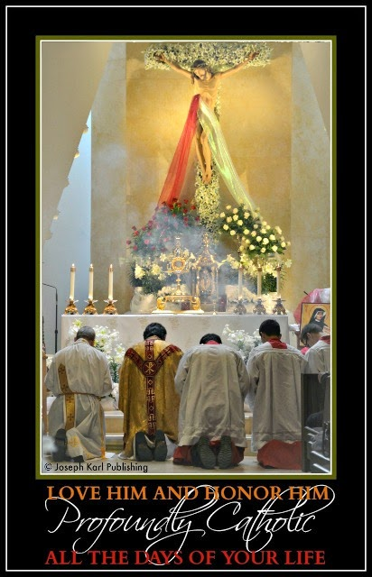Remember, Jesus told you yesterday that the big catch was coming today, on the Feast of Divine Mercy.

How is that going to happen, Lord? And when? During Holy Communion?

Then second, and most strikingly, Jesus stresses compassion in even greater measure to you, although mercy and compassion remain inseparable. Very large golden arrows begin projecting out from the bodies of those who showed compassion to others in imitation of Christ and Blessed Mother. Those arrows also landed in the ocean of God's mercy.

Now this is very interesting, this individual and collective phenomenon of arrows projecting from everyone into the mystical hole in the ground by the altar, because of what the Lord will show you very soon. You anticipate that a very large net is going to be raised from that hole as has happened during prior lessons, but that is not what is going to happen. Not at first.

THE LITTLE CHILDREN AGAIN COLLECT THE KEYS

Once again small children who had lost their lives to abortion appear as they have in the past, and begin collecting the arrows scattered all over the floor. They happily place them in the mystical hole in the ground leading to the ocean of God’s mercy.

During the consecration they stop, and bow down very low.
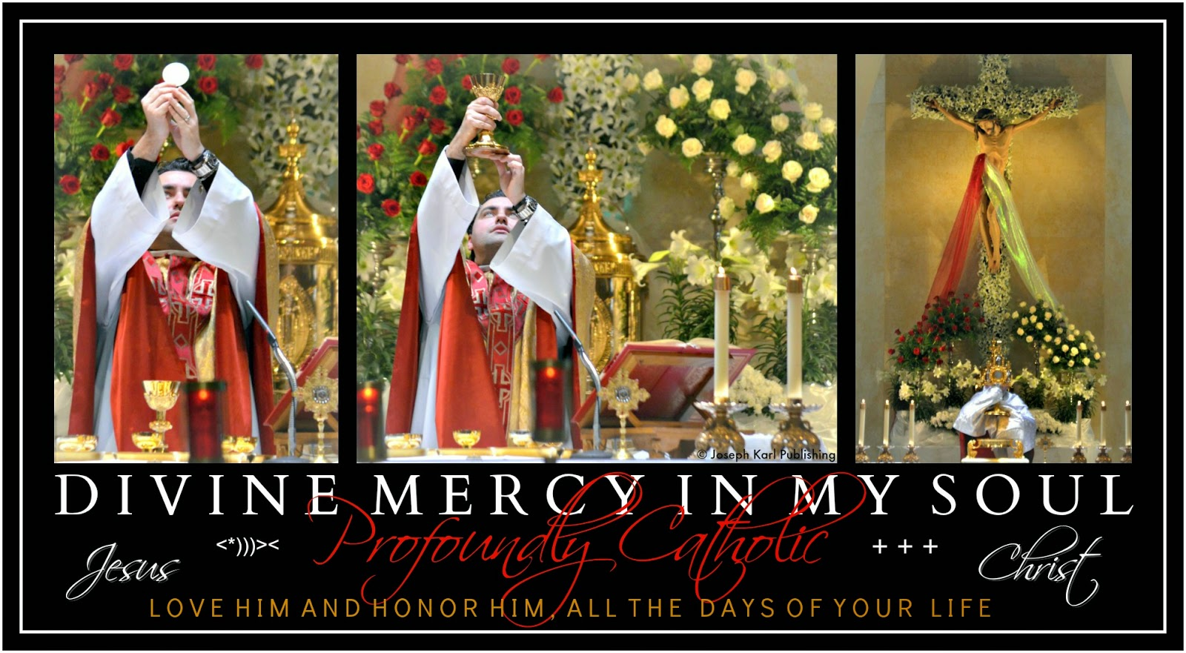

CONSECRATION

Just prior to the consecration, Jesus has you place all the demons who are working tirelessly to defile the bodies of humanity into the mystical hole in the floor before the altar. You had already been shown at the start of Holy Mass Jesus' Sacred Body on the Cross as an arrow, and as that image continued to be presented as the consecration drew near, you got the very strong sense that the justice of God, which is mighty, was going to absolutely CRUSH those demons today. You understood that when the Cross was going to be mystically raised and placed into the hole on this great Feast Day, it was going to fall with tremendous force, with great power.

HOLY COMMUNION

As people begin approaching the altar to be unified with Jesus, you see that as each one passes the mystical hole in the floor, God raises net after net after net, individual sized, and they are full of fish, fish caught with golden arrows that had projected from each individual (resulting from the individual efforts of that particular person).
This revelation is incredibly moving; one net after another is raised as each person walks by, and souls are saved for all eternity as the faithful are unified with God on this great Feast of Divine Mercy, also everyone's wedding day.

This does not happen with you, however. As you walk by the mystical hole in the ground, nothing happens.
Why not?

THE FIRST BIG CATCH

After you arrive back at your place in church while unified with Jesus in the Blessed Sacrament, you are suddenly shown a huge net is being raised by the Hand of almighty God from the mystical hole by the altar, and it is full of fish.
The net then opens and the fish spill out all over the floor. You see that they all had been caught with golden arrows, which not only caught them but also freed them from their locks (spiritual enslavement).

A mighty and powerful army from heaven begins gathering next to and behind you and around Jesus Who is next to you on your right, and together as a team you watch as the many fish are released from the net.

Why is this catch so much bigger than the others today, Jesus?

Jesus explains that it is bigger because it symbolizes a larger mission to catch many fish, a mission that is not limited to time and space, a rescue mission that has all of heaven on its side.
God is at work in you!
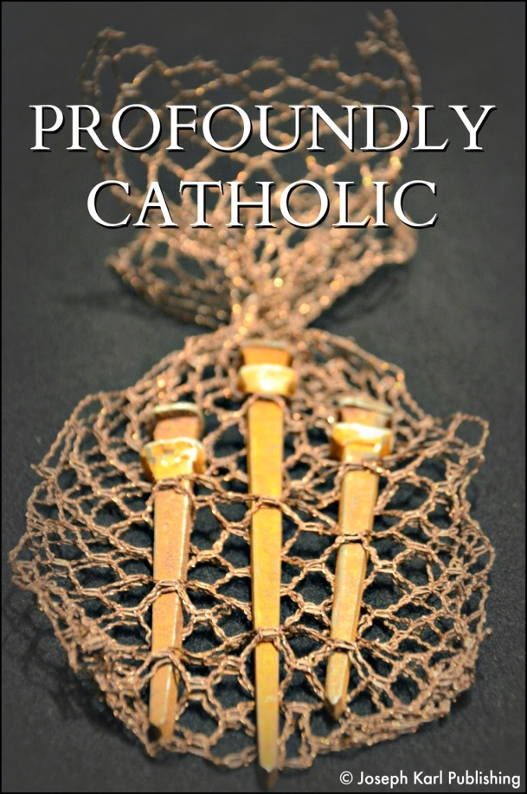

THE SECOND CATCH OF FISH

After that, you are told that another big catch is coming!
And so as everyone prays the Divine Mercy Chaplet and other lovely prayers, as everyone sings and prays to honor and adore our Eucharistic Lord, and then through Benediction, you wonder when the next big catch will happen.

"REMAIN"

When all was concluded and as most people walk out, another huge net is raised from the ocean of God’s mercy.
It opens, and fish caught with golden arrows spill out onto the floor and on the heels of the people as they leave.
This catch is the fruit of the people's prayers on the Lord's Feast of Divine Mercy. Jesus waited until all was said and done (knowing most people leave right away) so that all the graces that could possibly be gathered would be gathered.

As someone kept talking at the podium even though most people were no longer in the church, they had left, so much noise, so much to say, so little silence, Jesus comes to you dressed as our high priest in black clerical attire and a roman collar, and in each pierced Sacred Hand He is holding a golden arrow. Who are they for?

Those who remain as Jesus has requested save even more fish. Little nets are raised from the smaller mystical holes next to them that lead to the ocean of God's mercy, and they are full of fish.

Our Jesus is so caring, and so charming. And so adorable.

The Preservation of the Desecrated Human Race
A great chastisement is already upon us.
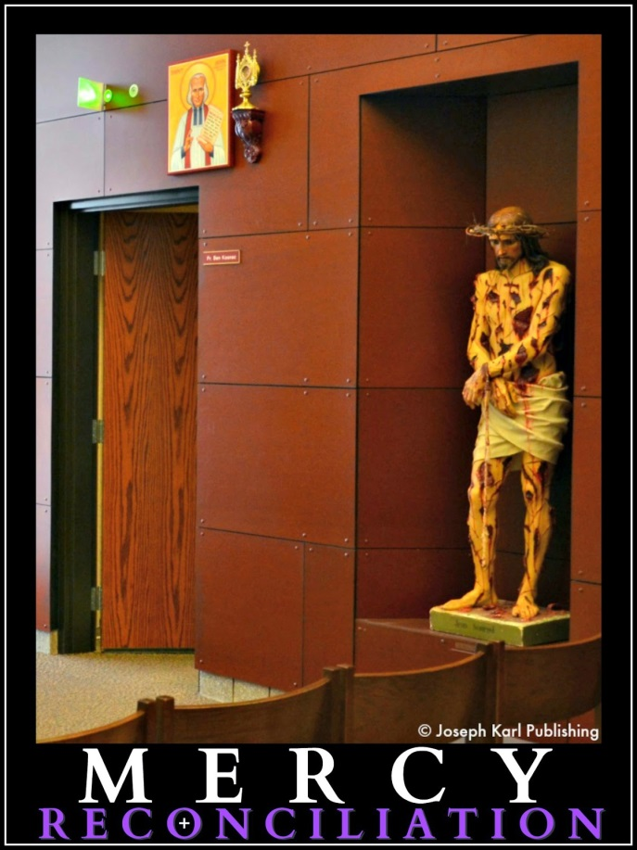A LESSON FROM THE CROSS

This lesson began before you even got out of bed.

Continuing with His prior lesson on the defiled Sacred Body of Christ, adoration, and the Work of Reparation, Silence, Jesus' Defiled Sacred Body, and Reparation, Jesus pointed out the many ways people are defiling their own bodies in our time, in imitation of how they defile Christ’s Sacred Body. Our bodies and His Sacred Body, He said, are distinct and yet one in the same.

Jesus also told you that many people are defiling not only their own bodies but also the bodies of others.

Our Savior atoned for these sins by offering up and allowing His Sacred Body to be wounded, and we are to do the same, to be unified with Him in His suffering while making reparation to God.

But before even delving into the lesson, Jesus speaks to you about the necessity of humility. He teaches us to be humble, when we are willing to learn.

CHANNELS OF GRACE

As you drove to church, you saw that keys were mystically projecting from your body to the other drivers on the road as you passed each other. They then absorbed these keys. You were also shown this the other day while out in public. Keys were streaming from your body and they were absorbed by all those around you.

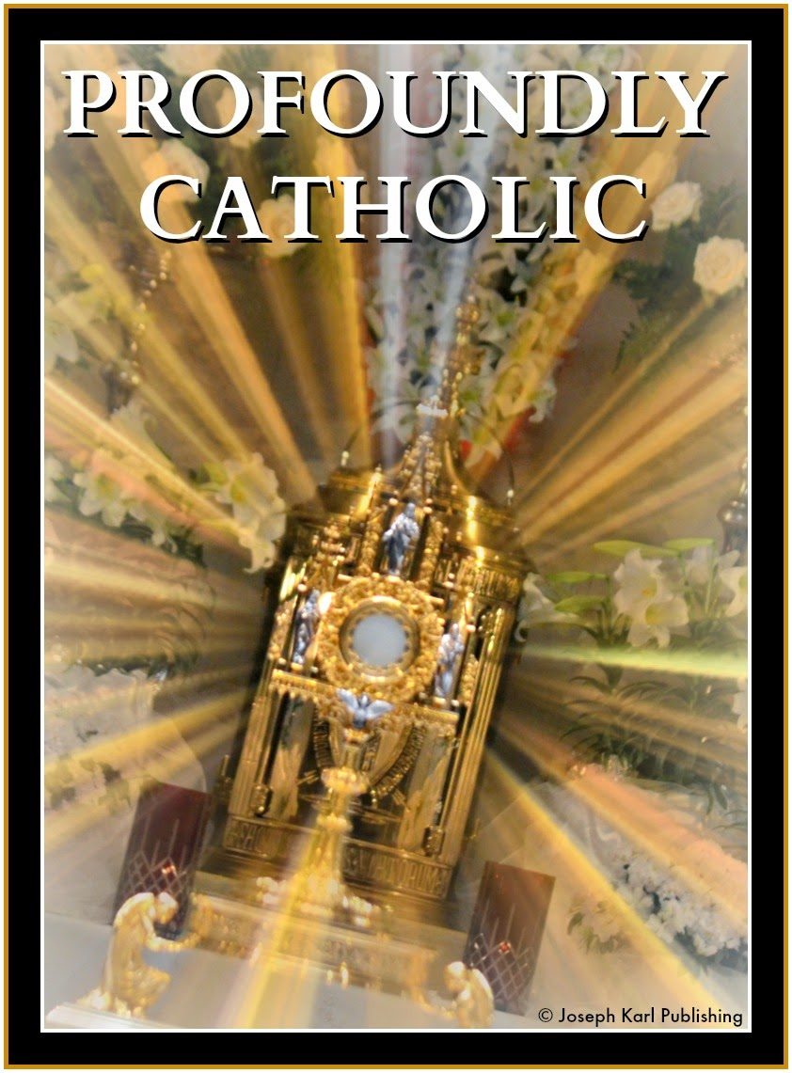How important it is for others that we keep our bodies undefiled.

The Lord has demonstrated to you how He works through the devout faithful as channels of grace for others.

ADORATION PRIOR TO HOLY MASS

While meditating on the Lord’s lesson from the past two days, the mystical hole in the floor by the
altar that leads to an ocean of God’s mercy opened to your right. You were kneeling right next to it.

Jesus began showing you the parallels of His suffering throughout His life, Passion, Crucifixion, and death and our suffering. Everything He did that was good (which was everything) fell into the hole, and everything we offer Him, the good and the bad (since we are imperfect) fell into the hole also. All His and our tears, blood, and sweat fell into the hole, and all that went in transformed into hooks to catch fish (precious, priceless, and immortal souls). This was just incredible as it was presented.

And then you saw Blessed Mother and Saint Joseph at the rim of the mystical hole, and they began lowering a very big net into it. As the work of Salvation continues, they continue to lower this net into the ocean of God’s mercy. Jesus was on the Cross before you. You saw the net going deeper and deeper to reach the most remote fish, and then you saw it spreading far and wide.

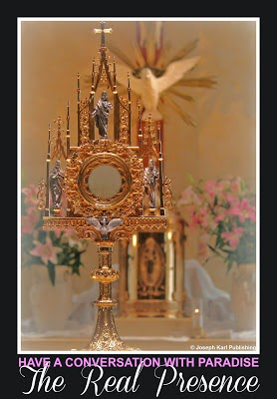You were also shown this net extending out across all time.

JUST PRIOR TO HOLY MASS
You returned to the church after making a sacramental confession and it was completely silent, and the experience of adoring our Eucharistic Lord was so beautiful.

Instead of saying “PAID!” or “WED!” or “WOUNDED” as He had in the past, Jesus said, “SILENCE!”

But He said this very gently and quietly (it made you smile) because the people were so reverent inside the church. Jesus revealed that He said it that way to indicate He was pleased, not only because He deserves respect but because He wants to shower us with massive amounts of grace.

In order for that to happen to the fullest extent, things must be done His Way.

HOLY MASS

You wondered what would happen that day, and were surprised that the large net was not raised during the Holy Sacrifice. Instead, Blessed Mother and Saint Joseph continued to put more of the net into the ocean of God’s mercy.

Jesus said that no fish were hauled in to signify the ongoing work of the salvation of men in our time.

LESSON TWO: THE DESECRATION OF THE BODY

You returned to church that Friday afternoon to be with our Lord on the Cross and pray the Holy Rosary, and that's exactly what happened.
You got to be with our Lord on the Cross.
While praying, the Lord drew you in to His suffering on the Cross in a new way.
You could never adequately describe it in words, it was deep, and our Lord's most holy Mother was there also. Their collective suffering was unimaginable.
This mystical pain affected your breathing, and so you had to stop during the third mystery because you couldn't take it.
All the while, Jesus had you adore His defiled Sacred Body. He had you do this through each mystery. It was very deeply moving.
Imagine how much our Lord loves us, and now imagine what is happening to us. Imagine what we are doing to Him, to ourselves, and to one another.
After a while you finished praying the Rosary and experienced the same phenomenon, but to a lesser degree.

HIS RECURRING THEME
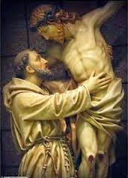During Holy Communion earlier that day, you had only received the Precious Blood of our Lord and not a Sacred Host. Something happened at that moment, but you didn't know what it was. You experienced such deep emotion.
Jesus, what is going on now?
While on your way home from church later that afternoon, you asked Jesus why He did not have you receive His Sacred Body that morning, given the subject matter of the newest lessons.
Now keep in mind that you had just gone to confession before Holy Mass and were in the state of grace, completely without sin.
Jesus responded that He wanted to make a point as part of this important lesson: you only received His Precious Blood because His Sacred Body and yours are the same, two having become one.
It is very important that we not defile the Sacred Body of Christ, our bodies, or the bodies of other people.
THE VITAL SAINT PIO HEALTH MINISTRY
The Holy Family has established the Saint Pio Health Ministry, which exists to properly train people in self mastery and healthy eating and lifestyle choices that must be made so people get/remain healthy and learn how to respect and not desecrate the Lord, themselves, and others.
More information will be added to this new teaching page dedicated to proper health maintenance as the Lord inspires it.
Additional material will be added that teaches about the catastrophic effects sugar consumption has to our bodies. Much more attention must be paid to the very common consumption of and addiction to sugar. It's deadly. History of Sugar
Untold numbers of people in the U.S. alone are addicted to sugary, fat laden, and salty foods.
BE INFORMED AND PRESERVE YOUR HEALTH
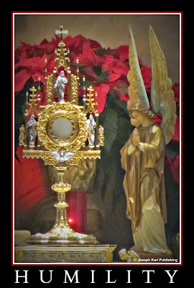Examine the research and the similarities between high-sugar, energy-dense, fatty and salty processed junk food and cocaine, heroin, and nicotine. Food Addiction: Could It Explain Why 70 Percent of America Is Fat?
Several hundred million people are infected with candida, and most don't know and could care less. The withdrawal symptoms one must face when trying to kill candida are similar to those from drug withdrawal. And the candida fights back hard; it desperately wants to live and needs sugar to survive, so it gets the body to crave its food supply, which totally lacks any nutrients for the human consumer.
As people get sicker and sicker unaware of what is happening, since most physicians don't look for candida infections, they more desperately seek to self medicate and find relief from the relentless suffering, most often choosing things that harm and/or poison the body.
Does this sound like the battle between good and evil also? This is what humanity is facing.
We have arrived at the point in human history where we face another humanitarian disaster, a catastrophic health disaster, and most people have no idea and could care less.
This is a chastisement for human abortion. In choosing to seek our own wills at all costs, even to the point of killing others, we are also choosing our own self destruction through the seeking of our own wills at all costs.
Why are so many people placing themselves on the Way of Self Destruction, the Way to Perdition? Because doing something about it involves personal responsibility and self mastery, it means stepping onto the Way of the Cross instead, the Way of Sacrificial Love, and most people have been conditioned, even hypnotized, to want what they want right when they want it.
We have become conditioned to desperately crave and seek our own self destruction.
Many are addicted to sugar, but most deadly in both the physical and supernatural senses, many are addicted to their own will, to various degrees.
SUGAR: THE DEVIL'S POISON
Sugar is poisoning us, and affecting the thinking of many people who have been hypnotized to live with symptoms and/or mask them with toxic pain relievers. As the medical profession and pharmaceutical companies get rich off of this catastrophe (not as much money can be made among well people, there is money to be made, but the devil convinces the ignorant to be exceptionally greedy), people are getting so sick, earlier and earlier in life.
To say the consequences of our unrestricted actions will kill people is too nice; first, many will get so sick and suffer so badly they will wish they were dead. This is already happening, and many people can't see it for what it is.
One of the devil's lies: You can keep eating sugar and remain healthy, or even better yet, Keep doing whatever you want to your body; God will heal you.
Here's his favorite, and he has convinced many people to say it straight out of his mouth: I'd rather die early (than acquire self mastery).
That's exactly what he wants to do to each one of us, take us out as early as possible.
SEEKING TRUTH
Look around and see all the distended abdomens on both men and women, the morbid obesity which has become common, various degrees of open hostility which has become common also, and listen to the complaints of people during conversations, serious symptoms that they are either ignoring and/or masking with drugs because they listen to their physicians, or living with because they cannot find a doctor that concentrates on wellness and health maintenance (it's not as lucrative) who will provide them with the correct diagnosis, the actual reason why their bodies aren't working right.
The answers are there, in plain sight. But one must find health care professionals who are willing to see. That includes doctors of the body as well as doctors of the soul.
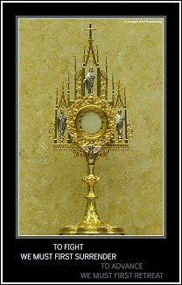Without a proper diagnosis, things can't be fixed and most will get worse. The medical profession has been well compensated for drugging the population, having them pay for expensive drugs they don't need that depletes their much needed resources as the undiagnosed problems get worse, and ordering expensive tests most can't afford and most don't need.
Insurance will pay for it, the doctors proclaim, and their consciences become more cloudy and their wallets fatter.
Medical professionals are without a doubt being drugged by pharmaceutical companies, their morality is being bought out as they sell out, as both parties are literally adulterated by kickbacks including money, material goods, trips. Meanwhile, people desperately needing care and compassion are drugged with toxic chemicals that make them even sicker and go for tests they don't need.
The very best diagnostic tool is the brain.
This behavior, the giving and the taking for personal gain at the expense of people's health, is diabolical.
It is celebrated by minds that have surrendered to the devil, and succumbed to by an increasingly weakened population that still believes that as long as insurance pays for the expensive drugs and tests they are ordered to receive by the self centered and wealthy, they are receiving proper care.
THE COLOSSAL INABILITY TO THINK CLEARLY
The best outcomes for the patient are when both the patient and the doctor use their brains.
That's not what is happening on a colossal scale.
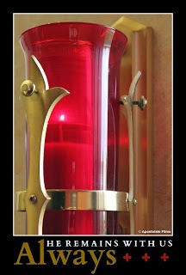The devil's goal is to destroy humanity. Take a good look around; he has been and continues to be wildly successful. So successful, that most people are helping him destroy themselves and others, totally unaware.

Grace, grace, and more grace is absolutely necessary because many people can no longer see, and can no longer even help themselves out of the holes that have been created.

However, Jesus provides us with a mystical hole in the ground in every one of His Catholic Churches, in front of every altar, and also a smaller one next to each person, that lead to an ocean of God's mercy.

Every single Holy Mass is mystically concelebrated by Jesus, and so each one is made absolutely perfect, which means that the devout faithful who lead sacramental lives of heroic virtue are used by God as extraordinary channels of His grace for others.

Their undefiled bodies are united with Jesus' undefiled Body in the Blessed Sacrament, and miracles happen. We have no concept of how much God loves and values us, and what He is capable of doing on our behalf. He comes again each and every single day to save us through His sacraments, which He instituted for our sake, and He remains with us always.

People who are willing to lead by example and teach others are so desperately needed. These people have no interest in money. Instead, they truly care about others in imitation of Christ and Blessed Mother. Be one of those people. Perhaps you already are. THANK YOU!

WHY ALL THE SELF DESTRUCTIVE BEHAVIOR?

Take a very good look around and ask yourself, why are so many people behaving in ways that are so self destructive? Why is sin so rampant, so accepted, so coveted, and so celebrated in our time?

Why are things that are so destructive for lives and eternal lives pursued by most people with such tremendous fervor?

Why are the majority of people deciding to spend their free will choices to harm themselves and other people.

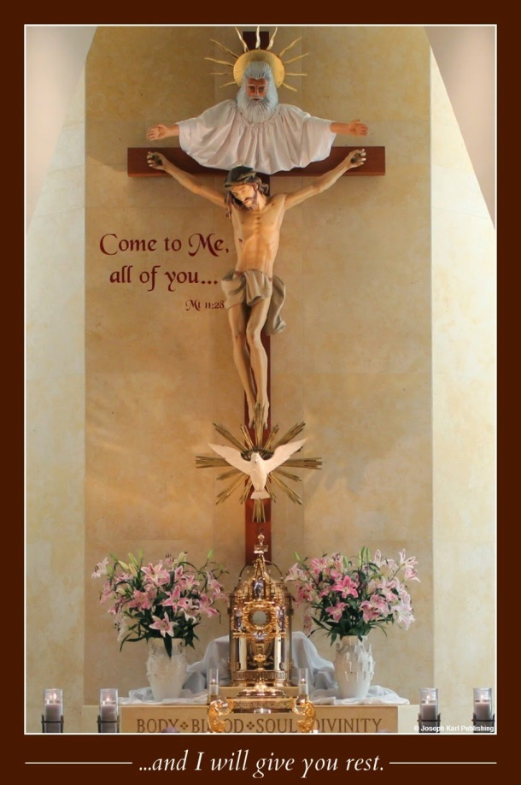
This is happening because bodies are no longer functioning normally and won't unless they are taken care of properly, and this won't happen unless they are reverenced in imitation of Christ's Sacred Body, unless people are willing to change.

Just try to get people who can't process information properly any more to listen. Try to get people addicted to toxic substances/food and their own wills to change.

Many won't, because they no longer can.

That is why the Lord is sending massive floods of grace to humanity through humble and obedient people around the world, who at great personal cost, live sacramental lives of heroic virtue in imitation of Christ and Blessed Mother.

Those who pursue, encourage, and promote miracle healings without teaching the necessity of taking personal responsibility for the proper care of God's body, their bodies, and the bodies of other people are not only fooling themselves, they are fooling a lot of other people. Keeping people from the truth, even if they don't want to hear it, is delusional and unethical. It's also diabolical.

Many, many people lacking self mastery are looking anywhere for quick fixes without having to take personal responsibility, and even churches eager to bring in crowds are willing to promise quick fixes. This is not holy when proper reverence for the Sacred Body of Christ, for our bodies, and for the bodies of others are missing in the message.

Many people omit the truth because people don't want to hear it. And so what such things become are self-serving ventures that further desecrate the bodies of others.

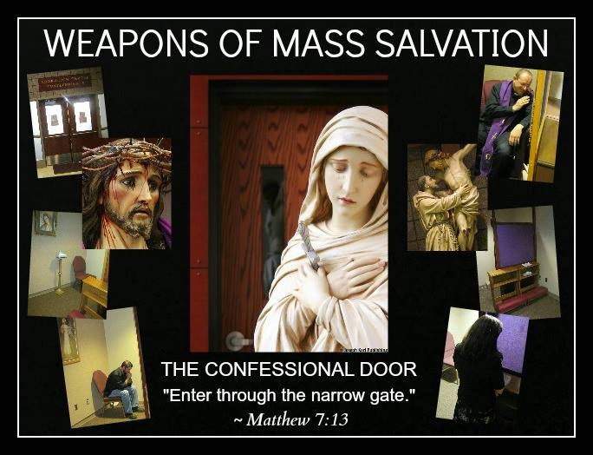

THE PRESERVATION OF THE DESECRATED HUMAN RACE
How vital it is to have perpetual adoration chapels in every single community where people can be silent in the illuminating and healing presence of God. How vital it is for people in every community to have access to the sacraments and receive them often.
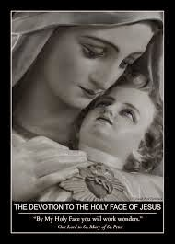The devil is taking a lot of people out in our time, hundreds of millions in the U.S. alone, and they aremore than eager to help him do it, largely unaware. How are they helping the devil destroy mankind? By desecrating our Lord's Sacred Body, their bodies, and the bodies of other people.
This happens in so many ways in our time. So many. How many ways can you think of that humanity is defiling itself and its God? How many are you guilty of.
Abortion, artificial contraception, sterilization, using other people in any way for personal gain, unchastity, uncharity, medical malpractice, improper educating, marketing, stubbornness, gluttony, impurity, many fundraising practices, abuse, addictions, lying, hatred, pride, idolatry, worshiping anything or any one instead of God (including one's self), remaining ignorant and/or keeping others ignorant, purposefully misleading people, pornography, homosexuality (yes, homosexual relationships and unions defile the body and are contrary to the will of God), human trafficking, financial enslavement of oneself or others, insistence on one's own will, refusing to listen or change for the better...
The more self mastery we acquire, the more the Lord can and will use us as tremendous channels of massive amounts of grace so necessary for other people in our time.
"Trust all things to Jesus in the Blessed Sacrament and to Mary, Help of Christians, and you will see what miracles are." ~St. John Bosco

Silence, Jesus' Defiled Sacred Body, and Reparation
Today's very powerful lesson, from the One Who loves and values us more than we can ever imagine, which emphasizes the importance of how we treat people, first and foremost our Creator, Savior, and God.
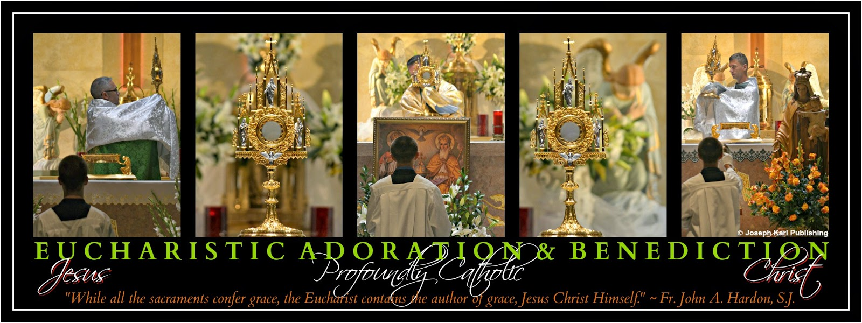

THE HOLY SACRIFICE OF THE MASS: EVERY SOUL'S WEDDING TO CHRIST
"By My Holy Face you will work wonders." ~ Jesus to Sr. Mary of St. Peter
Immediately as Holy Mass begins, you find yourself also in the Lord’s (mystical) grand cathedral,
and this time it is ornately decorated with the most favorite flowers of everyone present.
Whatever anyone's favorite flowers are, that's how the cathedral is decorated, by God, for each person.

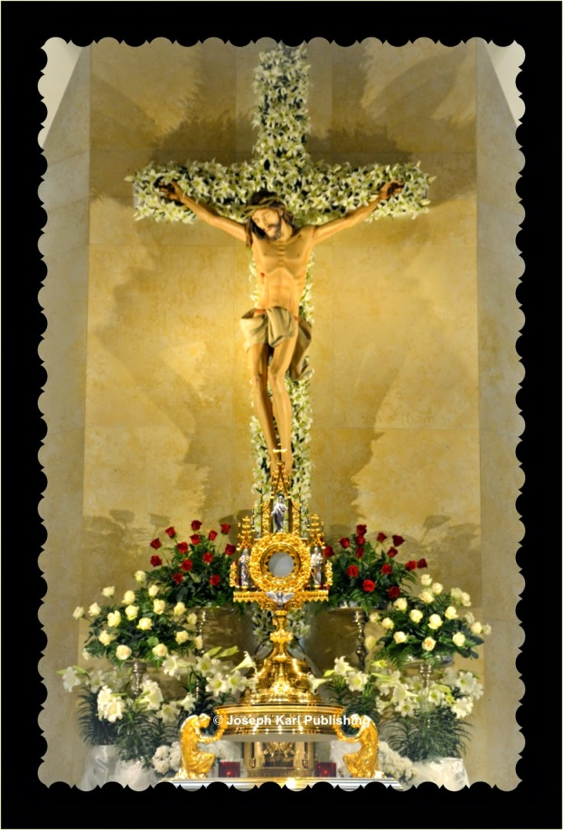Can you just imagine that everyone (if physically able), though so completely unworthy, can come and be wed to Christ each day, receive His Sacred Body into our own, and be unified with almighty God, and He decorates His mystical grand cathedral to our tastes.

We have no concept of how much we are loved and valued by God.
We have no concept of how humble God is.

Also right away (you cannot even describe how incredibly moving this is), Jesus shows you that there are already fish on the floor of the church.
The floor is not covered with them as before. Today, there are a certain number, and these fish are very big, two to three feet long.

These fish had already been saved, before Holy Mass even began. How was God at work in you before you even got to the church?

The fish are your wedding presents from Jesus.

JESUS' SACRED BODY AS AN ARROW

Jesus continues to present His Sacred Body crucified on the Cross to you as an arrow.
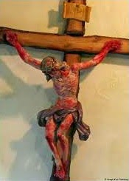
His Body, the Blessed Sacrament, is the most potent source of grace we have on earth.

JESUS' DEFILED SACRED BODY

Jesus also reveals His desecrated Sacred Body on the Cross throughout the Holy Sacrifice. Later on, you discover why.

Similar to how Jesus presented His Passion to your soul so profoundly in the past, He allows you to very personally experience His Sacred Body's degradation.

You feel as if you could cry forever.

OFFERTORY

As the gifts are brought up, Jesus prepares the altar.
There He is, our Savior Whose Sacred Body has been so defiled by mankind throughout time, preparing the altar again mystically for the Last Supper. He is doing this for us.
Jesus' humility defies description; you hope to absorb all the humility you can from Him, as we all can and must.

Jesus, transform us into Your likeness.

During yesterday's lesson, Jesus revealed to your soul the beginnings of this defilement and humility lesson by bringing to your attention during Holy Mass what it was like for Him, the most pure, modest and humble person, to be exposed before the crowds of people let alone anyone.
Yet He allowed it and continues to allow it in representations of His stripped Sacred Body crucified on the Cross, and even in the Resurrection images and statues where His Sacred Body is exposed to various degrees.
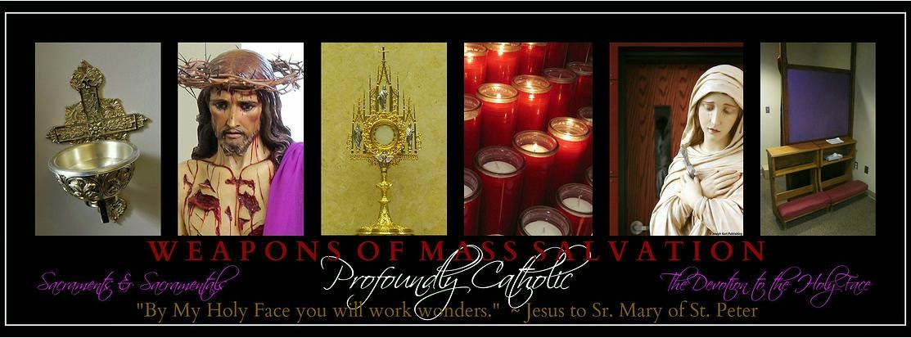
THE POWERFUL NETS OF THOSE WOUNDED IN IMITATION OF CHRIST

During the Gospel Reading, Jesus has you place the powerful nets with so many holes in them into the ocean of mercy through the mystical hole in the floor in front of the altar. You are told that when you go up to receive Jesus in the Blessed Sacrament, the Lord wants you to be the one to pull the net out of the hole.

This is very deeply moving also, our Lord demonstrating how He uses us as tremendous channels of grace for others.

Instead of waiting for Jesus to say something loud and clear, this time with tremendous gratitude you say to Him in a similar way, several times during Holy Mass, “YOUR WISH IS MY COMMAND.”

HOLY COMMUNION

As you walk past the mystical hole in the floor and raise that net in an action of thought similar to a prayer as Jesus instructed, very large fish, bigger than any caught during Lent spill from the net onto the floor. You notice that it isn't snowing, there are no words in the air, and as a result there are no keys.

Why aren't there any keys today, Jesus?

Jesus replies that these large fish were caught by that special net provided to those wounded in imitation of Christ. That particular net with so many holes in it is so powerful that the most remote rescued fish need no more rescuing (they are caught and saved; the chains holding them in spiritual bondage have already been broken and need no keys to unlock them).

A BEAUTIFUL BOUQUET FROM JESUS
Jesus once again returns to thoughts of your favorite flowers, and hands you a beautiful bouquet He had prepared just for you on your wedding day today.
He then had you throw it as brides do, backwards even, into the ocean of God's mercy through mystical hole in the floor by the altar (let us ask Him what He has the men do).
Why did Jesus have you do that?
The bouquet Jesus made for you transforms into a net as soon as it lands in the ocean of mercy.
Guess what happened to it.
When you walk up to receive Jesus and He has you draw out the very powerful net that has the big fish in it, He tells you the net from the bouquet of flowers must remain in the ocean of His mercy, at least for now.
Who it is meant to catch?
DIVINE UNION

These moments are so incredible and affect you very deeply. You kneel to receive Jesus reverently, and on your tongue. Just after you rise to return to your place in church you see that you are walking down the isle of the mystical cathedral, unified with the Bridegroom of your soul.
You are also shown that the Lord has outfitted you in a beautiful white garment, and on your head is an exquisite diamond studded tiara (for the ladies) or crown (for the men). The tiara or crown represents your work as the Lord's instrument, as a channel of grace for the massive conversion of sinners. The diamonds represent souls that have been saved for all eternity by the Lord's work through you.

This revelation of being outfitted by our humble Jesus in such an elaborate way is just incredible, not only because of the symbolism of what He wants to accomplish through every single person, but also because all are there to worship, praise, serve, and thank Him and as we do so, Jesus loves us more extravagantly than we could ever imagine or love Him back.

While kneeling after returning to your place in church, you remain in awe of God, Who continues to very profoundly manifest the diamond studded tiara or crown on your head.
Jesus, the Divine Bridegroom of your soul, is so proud of you.

“REMAIN”

During the final hymn, Jesus appears next to each person dressed as our High Priest, in black clerical clothing and a roman collar.
He has a very loving supernatural, mystical embrace for each person, but most people walk right out, not knowing this is taking place, and without thanking Him. Without loving Him. Without even saying goodbye, or asking Him to go with them.
Love Him for everyone. Accept the graces that so many people miss in their places.

“OFFER THEM SILENCE”

After the final hymn, you kneel and are silent for a time while unified with Jesus, as our Lord has requested.

Suddenly, He says very clearly, “OFFER THEM SILENCE.”

Then, Jesus tells you of His desire that Perpetual Adoration Chapels be established in every community, specifically promoting the Work of Reparation to His Holy Face, where people are offered silence and where God is adored as reparation is made for the defilement of Jesus' Sacred Body through all time and in our time.

Holy Faces, God's Graces, and Exceptionally Powerful Nets
"Launch out into the deep!" (Luke 5:4).
More profoundly Catholic instructions and revelations from our Teacher, presented once again during the Holy Sacrifice of the Mass.
A GRAND CELEBRATION
Once again, the congregation is present for a spectacular wedding.
It is so grand, and you see it somewhat differently today than has been shown to you in the past.
Today, it is as if God is holding back because the sight of the grandeur as it really is would completely overwhelm your senses.
Everything is so majestic, so beautiful, so grand.
Continuing on with what happened yesterday, the small box with one person's name in particular in it is placed once again into the mystical hole in the floor by the altar.
Then, you see before you the names of every person being prayed for by the people in church, and those names are being put into their own small boxes, and then are placed into the ocean of God's mercy through the mystical hole in the floor in front of the altar.
HOLY FACES
Once again, Jesus has you offer the Holy Sacrifice of the Mass to God the Father through the merits of His Holy Face. He asks that all things done in His service be offered to God in this way.

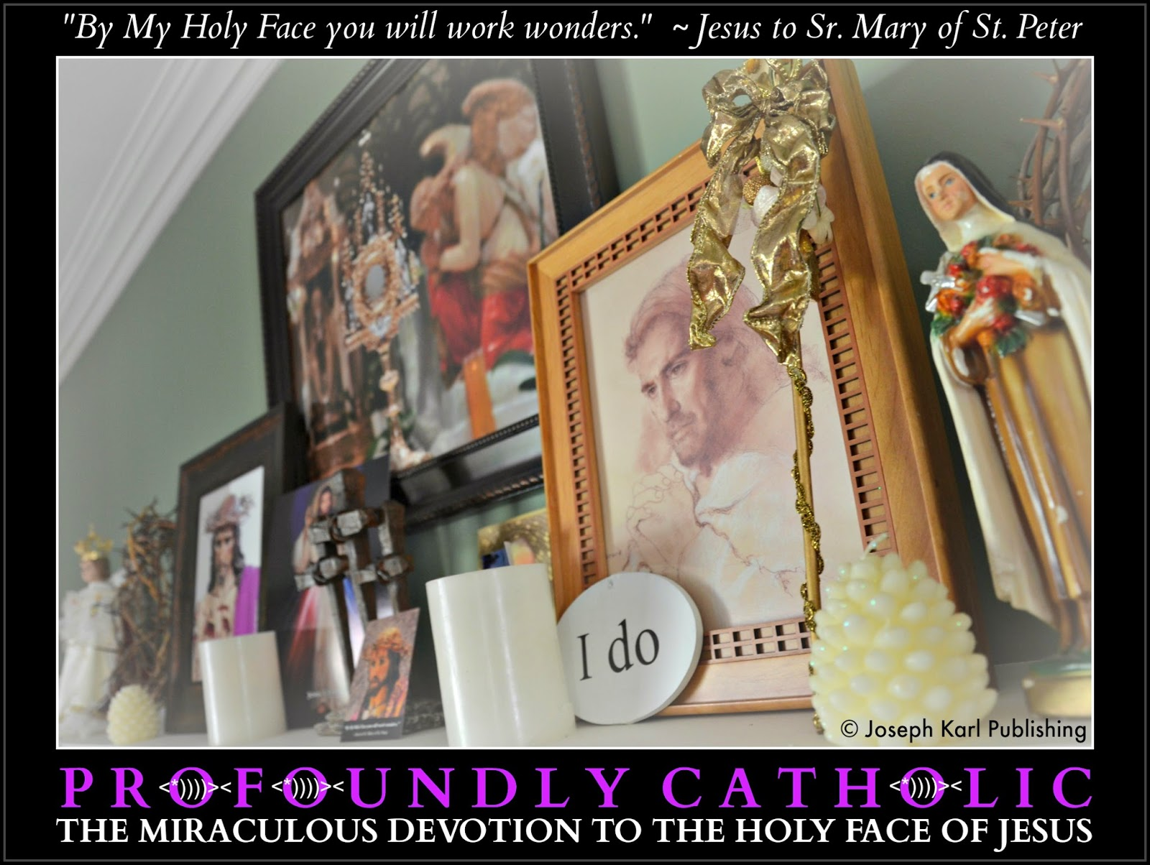
You see Jesus at the altar, and in particular you see His Holy Face facing the congregation and the holy faces of the congregation facing Jesus. This is very powerful, the sight of the congregation face to Face with Jesus. Yours mirror His, your holy faces reflect His back to Him, and also reflect His love to others, especially to God as all worship and praise the Divine Bridegroom of their souls.
SO MANY FISHING NETS
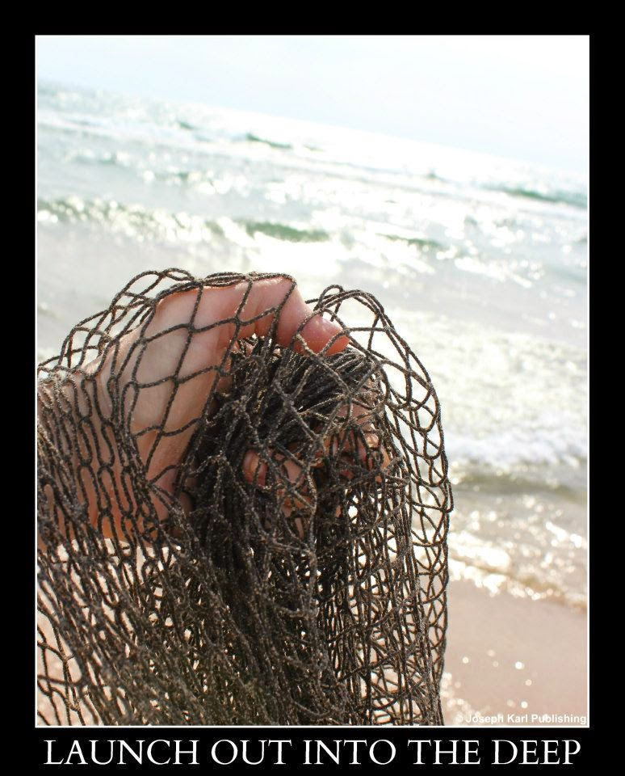
You are then shown that the mystical action taking place is producing nets. It happens in the following way.
God's grace comes to you through His Son's Holy Face and then exits through your holy faces. As it does, the graces transform into nets.
Those nets then travel from the faces where they are generated into the ocean of God's mercy through the mystical hole in the floor by the altar.
Later, the mystical wedding attendants pull up the nets and they are full of fish. So many fish are being caught! The fish represent precious, priceless, and immortal souls who are bound and chained by sin and are being held captive in spiritual bondage.
You see see this taking place in time but over the course of time, meaning in God's perfect timing and with the understanding that you are to trust in Him always because He loves us all, knows what is best for us, and always desires our eternal salvation.
You are to trust that your prayers for these people will be answered by our Lord, in time. Don't give up; persevere with great love and abandonment to the will of God, and keep praying.
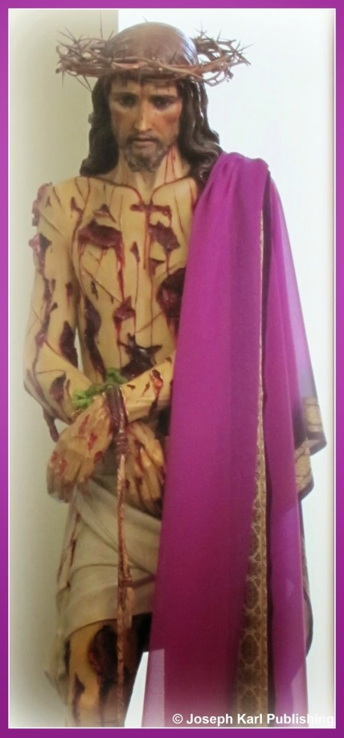As you approach the altar to receive Jesus in the Blessed Sacrament, the fish are once again all over the floor. Snow is falling so beautifully in the church all around you, and the snowflakes gently release keys onto the ground throughout the church.
These keys are used by hands folded in prayer to liberate the precious fish from their spiritual bondage.
"WOUNDED!"
During two prior Holy Masses, Jesus had said two specific words to you loud and clear. The first time He said, "PAID!" and the second time He said, "WED!"

Today, Jesus says to you loudly and resolutely, "WOUNDED!"

It is actually very delightful, that moment. It makes you smile.
After returning to your place in church while unified with Jesus in the Sacrament of Love, Jesus inspires your thoughts to turn to the most remote fish, and Jesus tells you that when we allow ourselves to be wounded by Him, and thus are transformed into His likeness, very special nets are generated that are capable of catching the most remote fish.
Jesus even shows you what those nets look like.
This moment with Jesus while unified with the One Who loves and values each one of us beyond measure, every single person without exception, is so moving it brings you to tears.
God is so good.
Guess what they look like, these highly effective nets that are able to catch the most remote, and unrepentant fish.

The nets are full of holes.
"By My Holy Face you will work wonders." ~ Jesus to Sr. Mary of St. Peter
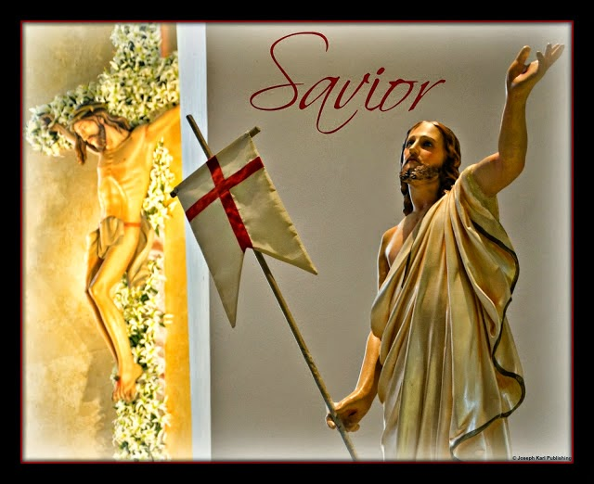
"REMAIN"
Once again, Jesus does not have you hold His crucified Sacred Body after Holy Mass has concluded.
Instead, our Resurrected Lord has an embrace for the few who remain during the fifteen sacred minutes of union with Jesus in the Blessed Sacrament, with His Sacred Body, Precious Blood, Soul, and Divinity.
While holding you close, Jesus has you to place God's will for you into His Sacred Heart, through the wound in His side.

More Bridal Theology: There is a Place Reserved Just for You at His Head Table
Take your place of honor at the celebration of the coronation of our King, at the mystical re-presentation of Christ's Passion, Death, Resurrection, and our Redemption, and at every soul's wedding. God is so in love with you!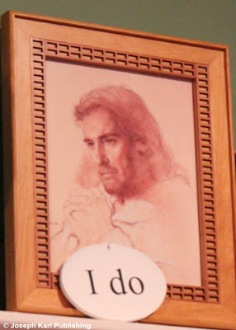

Today's lessons, revelations, restoration, and reparation.
HOLY MASS
During the Holy Sacrifice of the Mass, Jesus presents Himself crucified on the Cross at the altar, and He has you feel His physical presence very strongly even from across the length of the church.
It is as if He is very close. This is very deeply moving, to feel so close to our Lord crucified on the Cross.

After that, Jesus appears next to you on the Cross, and He remains there throughout the Holy Sacrifice.
Grace streams from His Sacred Body throughout Holy Mass, grace that He wants His servant to absorb.

Later, you see that Jesus is present this way next to each person in church also, just as He had been in the chapel that day He showed you the same things as people were preparing and waiting to make their sacramental confessions.
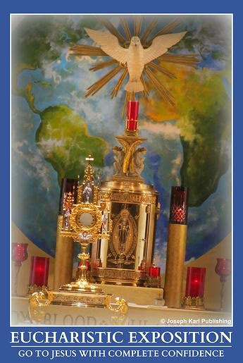

DIVINE REASSURANCE

Jesus also assures you several times that everything is going to work out according to His plans, and that all will be okay. You have absolutely no desire to doubt Him because there is no room left for anything but confidence in Him.
Thank You for Your great mercy, Jesus.

ANOTHER SPIRITUAL OPPOSITE

Jesus also explains that there is a spiritual opposite to submitting our wills to God so He can work best through us, sometimes in ways that we do not understand (which can include His speaking through us) as we remain close to Him through the Sacraments.
People who prefer their own wills and distance themselves from God allow the devil to work through (even speak through) them, perhaps without their even knowing that this is taking place.
We can be instruments of God or instruments of the devil; the free will choice is ours to make.

MORE BRIDAL THEOLOGY

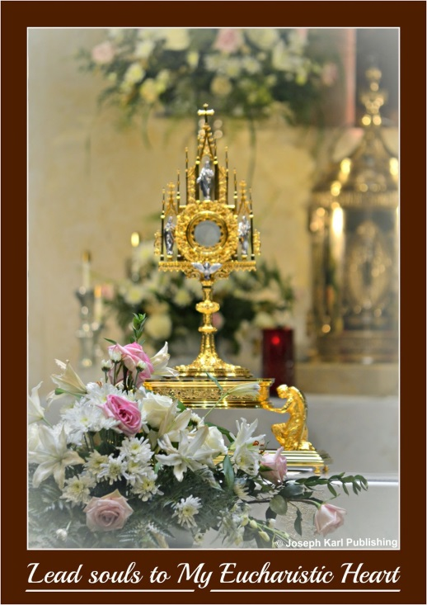

Once again there are references to our souls’ wedding to Christ, and Jesus addresses the hierarchies people have established in His churches, in His parishes.
Jesus speaks in particular to those who are or have been marginalized by others in His very own house, and says very clearly that everyone has a place at the head table during His celebration of the Holy Sacrifice of the Mass.
Every single person has a place at the most distinguished table, at the table of honor, as we wed our souls to Christ.
Jesus loves us so lavishly, so extravagantly, and points out the great dignity and equality of everyone in His eyes.
AN OCEAN OF GOD'S MERCY

You wonder if the large mystical hole in the floor is still there and still open now that Lent and Holy Week are over, although the Easter celebration is not.
Today you are shown that the hole is still there, as are the personal mystical holes next to each person present in church because Jesus is present on the Cross next to each person.

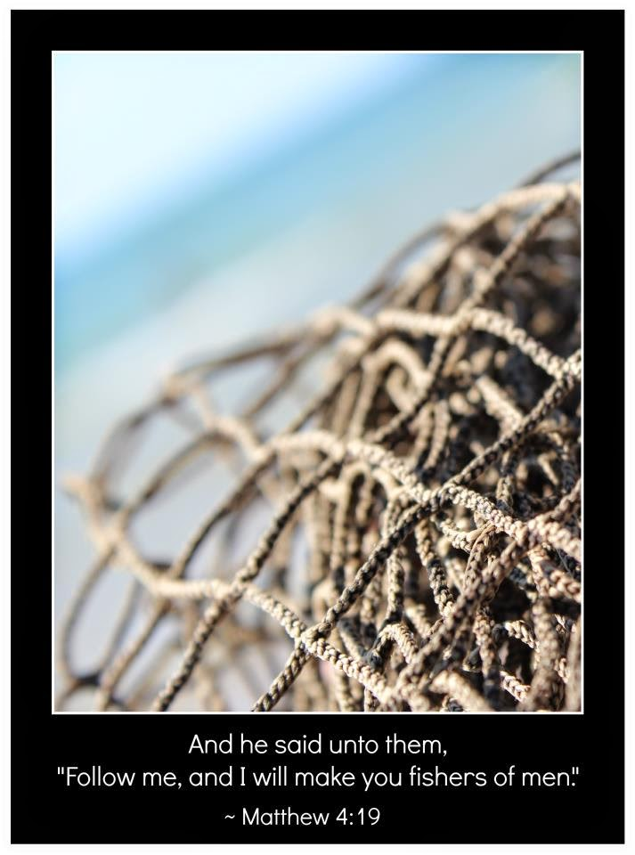
WEDDING PRESENTS!
You are inspired to place the wedding gifts you brought for the Bridegroom of our souls into the collective hole in the front along with those of everyone else, and also place some personal ones into your own mystical hole which leads to an ocean of His mercy.

ANOTHER SPECTACULAR DRAUGHT OF FISH

At one point, the arm of Almighty God pulls a net out of the ocean of His mercy in the center isle, and you are told that the wedding presents placed in there had transformed into nets that caught the fish.
We can present Jesus with so many gifts during our weddings to Him each day, gifts which He uses to save people for all eternity.

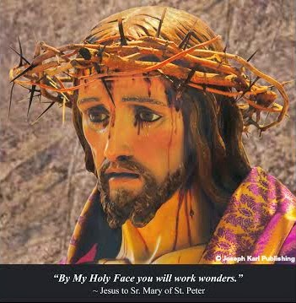As the faithful walk up the aisles to receive and be unified with their Divine Bridegroom, they walk among the many fish that are scattered all over the floor.
WHAT A CELEBRATION!
Toward the end of Holy Mass, it begins snowing as if confetti is falling down during this incredible celebration that means so much to so many, and the snow transforms into keys that gently fall among the fish.
PRAYER TO SAINT MICHAEL
All of a sudden at the conclusion of Holy Mass, as the congregation says the Prayer to the Michael the Archangel, the Lord tells you to say this prayer while offering the Holy Face of Jesus to God the Father.
REMAIN
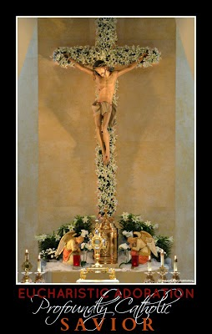After Holy Mass has concluded you remain as our Lord has requested to spend priceless time with Him during the sacred fifteen minutes when you are unified with Him; with His Sacred Body, His Precious Blood, His Soul, and His Divinity.
Jesus once again does not have you hold His crucified Sacred Body as usual, but instead our Resurrected Lord has a very loving embrace for you.
Then, He gives you a present in a small box.
Jesus has a wedding present for you!
You open the box. Inside is a loose diamond.
The diamond represents a precious, priceless, and immortal soul that has been saved for all eternity.
EVEN MORE MERCY
Jesus has you remove the diamond, He wants you to have it forever, and requests that you place the name of someone in particular in the empty box.
You then place the box into the ocean of God’s mercy through the mystical hole in the floor by the altar.

A Spectacular Easter Wedding, Another Miraculous Draught, & Love that Never Ends
The location of your wedding, the attendants, the guests, the color scheme, and the presents may surprise you but they are very real. God loves you this lavishly, this extravagantly, every day if you like; love Him and honor Him, all the moments of your life.
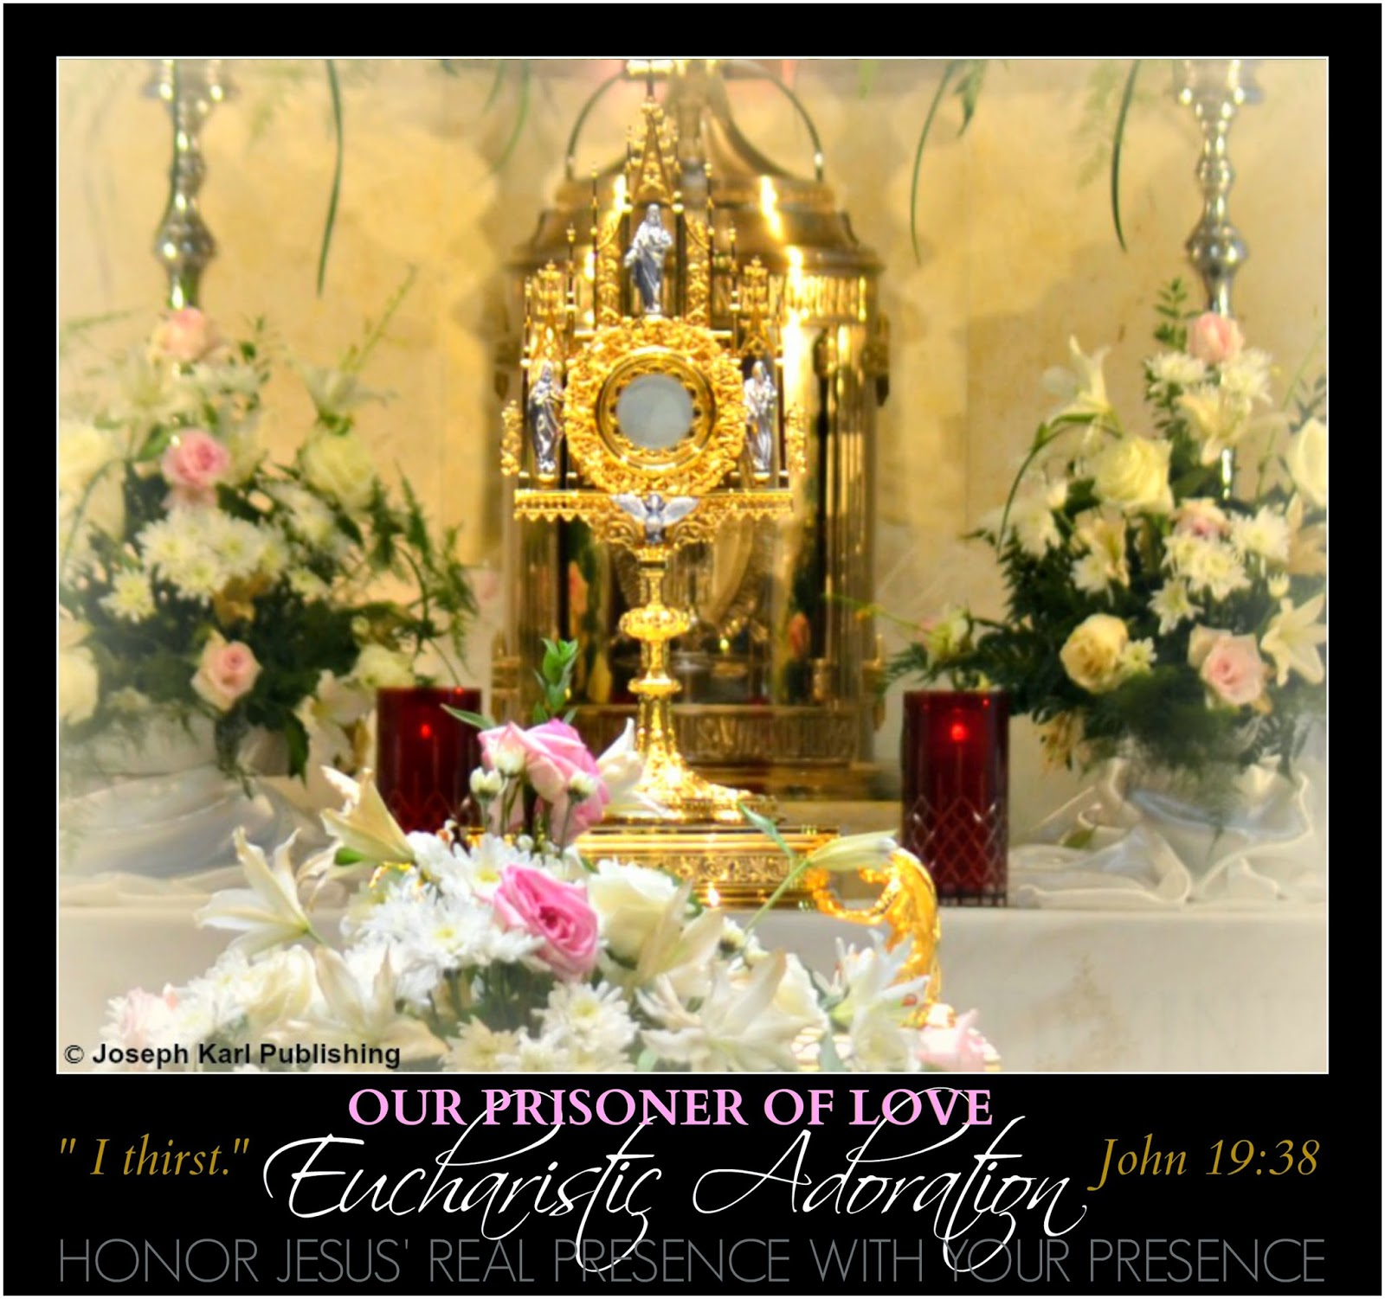
AN EASTER SUNDAY WEDDING

Jesus draws you into the mystery right away, even before Holy Mass begins, as you pray and prepare your heart for another very special encounter with the Love of your eternal life.
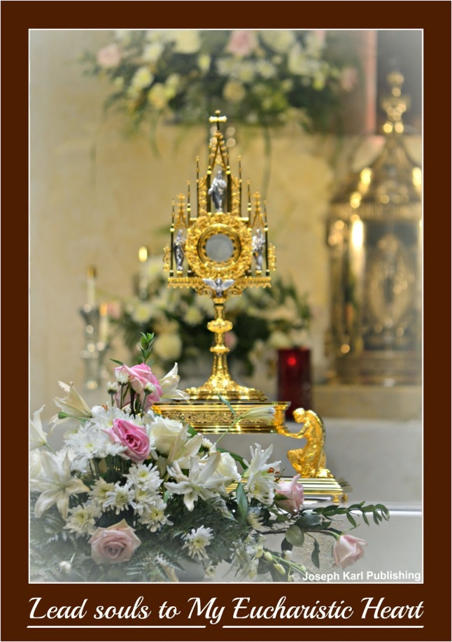

What an incredible event.

You immediately feel as if you are marrying another person. However, this Person is also divine.

As family members would be ushered in during a wedding, Blessed Mother and Saint Joseph are escorted up the isle where they take places where the family normally would be when a couple marries.

Any living relatives not physically present for this spectacular occasion, as the congregation celebrates their individual and collective weddings to Christ, are brought there mystically by the power of intercessory prayer.

LOVING LITTLE WEDDING ATTENDANTS

The Divine Bridegroom of your soul reveals that there are many small children in the church, children who lost their lives to abortion.

They are there to serve as little wedding attendants, as the bearers of the rings.

The children line both sides of every isle in church, and each one holds a pillow.

On top of the pillows rest mystical wedding rings, one for every person present and one for Jesus.

WE ARE LOVED AND VALUED BEYOND MEASURE

How incredibly moving to see your family in heaven present for you, and taking their places in the front of the church. How much they care for you and for us all!

As the events occur they are so profoundly meaningful, and very deeply felt.

Love never ends.
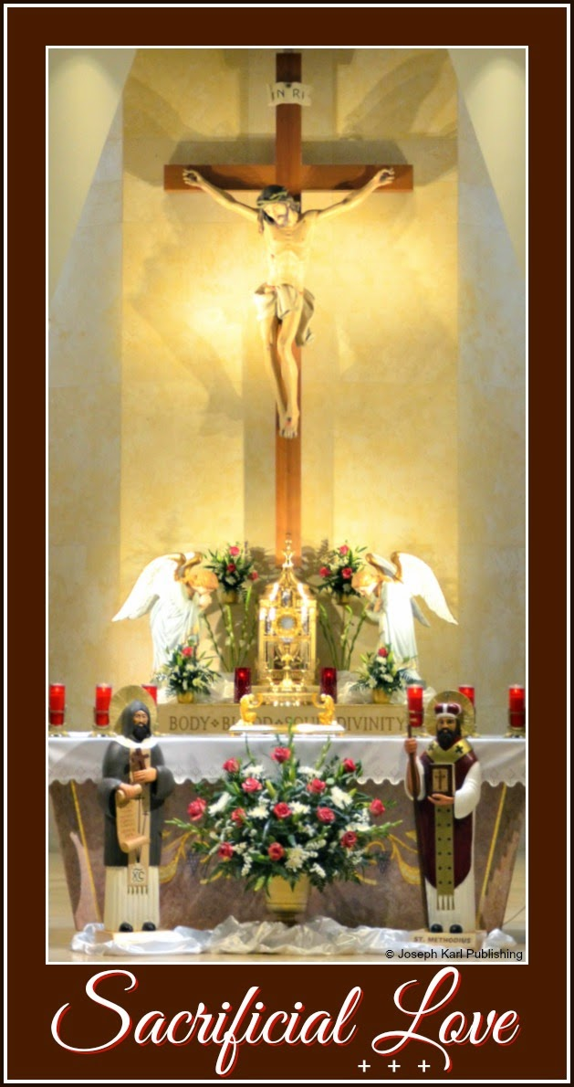

Next, you see your Divine Bridegroom at the front of the church, at the altar, waiting for you and also for each person personally, to wed our souls to Him at His coronation.
Just imagine His incredible humility.

How beautiful, the expression from Jesus to your heart of how much each one of us is loved and valued on this occasion the faithful have come together to crown our resurrected King.

THE CATHEDRAL

Jesus shows you that you are in an exquisite, mystical Cathedral for your soul's wedding to Him. Christ's Church, the Catholic Church, in its majestic glory and fullest expression is superimposed over the celebration in progress at that very moment.

This parish shown to you, His Parish, is the one so many in our time desperately seek and need, the one we should be aspiring to because it most resembles His Way, and the one many know in their hearts exist but they don't know where.

This mystical parish can be found in every Catholic Church from the least obedient to the most obedient one can find. And Jesus has brought you here for your soul's wedding to Him, a union that will last forever.

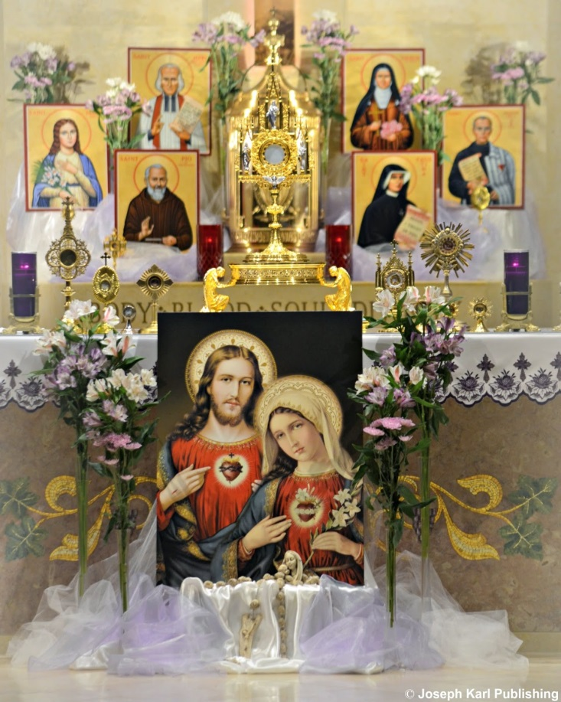

"JESUS MAKES HEAVEN WHEREVER HE IS"(FATHER FREDERICK WILLIAM FABER)

Our Divine Bridegroom weds us where heaven meets earth.

Jesus loves us so lavishly, so extravagantly.

You see the gates of heaven open wide, its occupants present to celebrate such a grand occasion.

God the Father oversees all, our Creator and Author of Love giving us so much and loving and valuing us beyond measure, we who deserve nothing and owe Him everything.

This mystical celebration is so exceptional; it even begins snowing inside the church. The snowflakes release keys, which fall gently to the ground. The keys are used by hands joined in prayer to free captive souls that are bound and chained and held captive in spiritual bondage by the devil.

You see the words of the prayers being spoken and the songs being sung are present before all, in the air, and they are releasing more keys.

Most striking is the sight before you of the words that make up the formula of how God works miracles through us: obedience, humility, forgiveness, mercy…

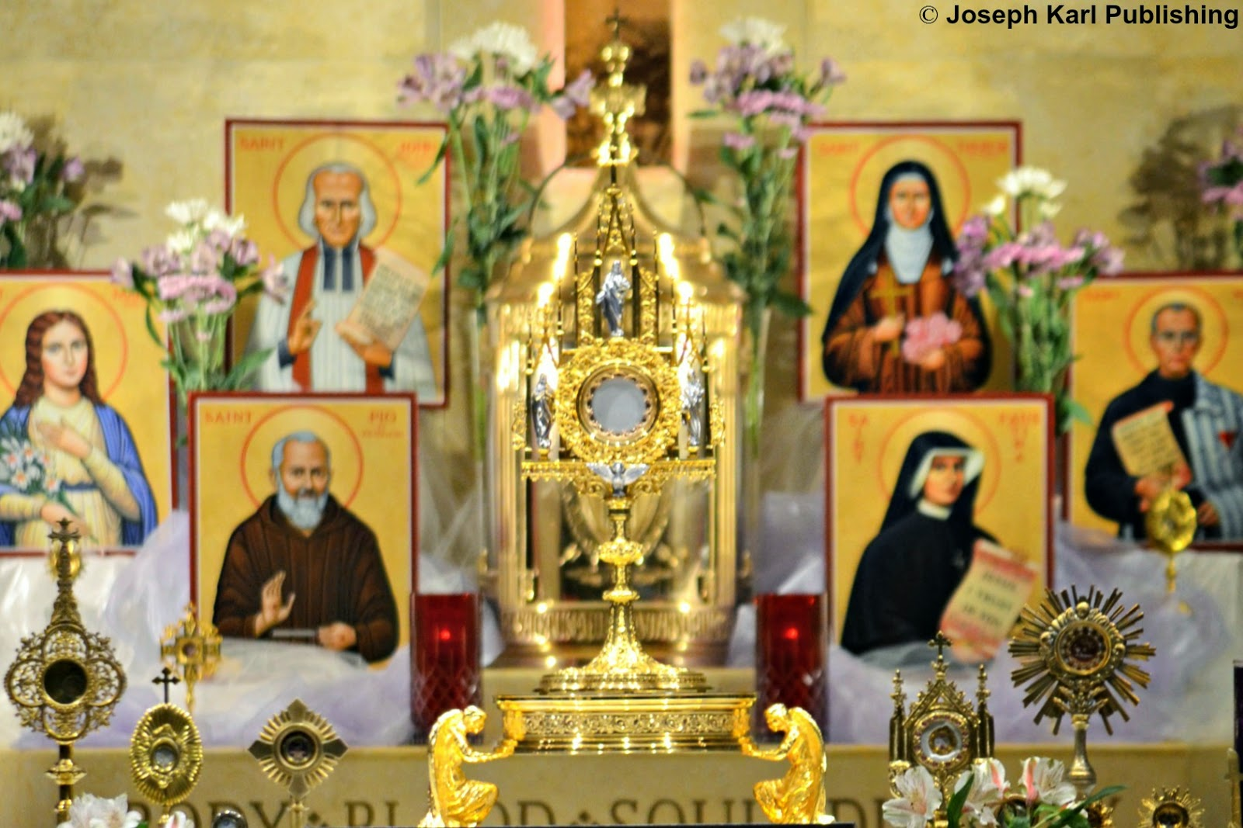

GOLDEN ATTIRE

During the Offertory, Jesus draws your attention to the color of the vestments, and you see that they are gold. How beautiful, Jesus, you say to Him. How fitting to honor You, our King. Jesus explains that gold is the color scheme He has chosen for your wedding today, and He then shows you that He has outfitted the little wedding attendants in gold also.

What a majestic sight!

Jesus even has wedding music playing for you throughout the Holy Sacrifice of the Mass.

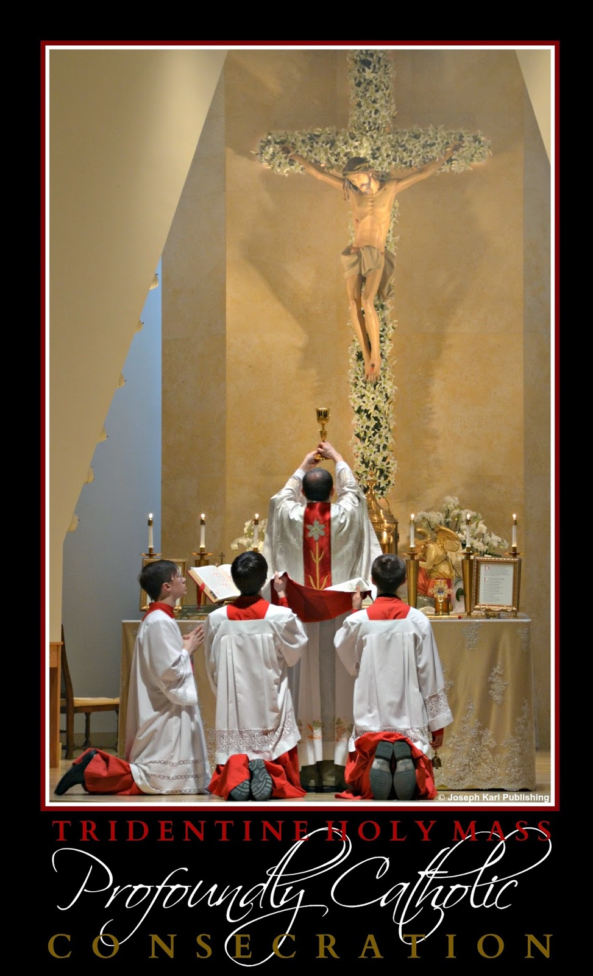

CONSECRATION

As Jesus is mystically raised on the Cross, the sudden jolt as It comes to rest in the mystical hole prepared for it in front of the altar causes His Precious Blood to project out just as the holy water had when Father sprinkled and blessed the people with it a short while earlier. This comparison presented by our merciful Lord is so deeply meaningful that you shed tears of gratitude and love.

WEDDING PRESENTS! ANOTHER MIRACULOUS DRAUGHT OF FISH

Suddenly, your family from heaven gathers around the mystical hole in the ground, and begins pulling the huge net out of the ocean of Christ's mercy. The little wedding attendants help also, and the fish fall all over the floor, among the keys.

While walking up the isle during Holy Communion to wed your soul to Christ and be unified with Him in the Sacrament of Love, you ask Jesus why you don't see any fishing hooks today.

Jesus replies as you draw near, "The fish are caught by love. Even the most remote fish."

We were created to be loved and to love in return.

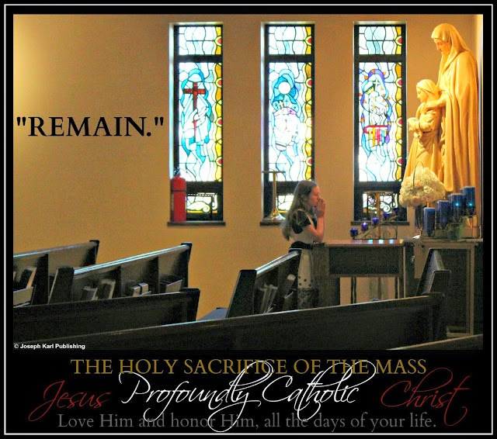

"REMAIN"

At the conclusion of Holy Mass, instead of saying "PAID!" as Jesus had done recently once before, He joyfully and resolutely says, "WED!"
The children then present each person with a basket, and in each basket there are fish and keys.

The fish represent precious, priceless, and immortal souls that are being entrusted into each person’s care.

Jesus does not have you hold His crucified Sacred Body today during the fifteen precious and priceless minutes when you are unified with His Body, Blood, Soul, and Divinity.

Instead, our Resurrected Lord has a very loving embrace for each person who remains during this sacred time of divine union, which is hardly anyone.
"Be still, and know that I am God" (Psalm 46:10).
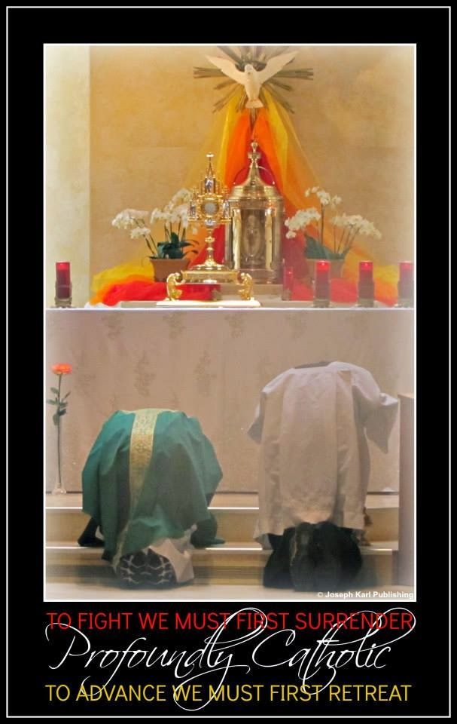

SPIRITUAL OPPOSITES

Jesus reveals one more thing to you on this very special day.
The devil has his fishing hooks, too. He has lots and lots of them, and he uses them to catch many fish.

"Trust all things to Jesus in the Blessed Sacrament and to Mary, Help of Christians, and you will see what miracles are." ~ Saint John Bosco

A Holy Saturday Bridal Theology Lesson: Divine Union, Creation, Labor, Delivery, and Eternal Joy
Be unified with and transformed into the extravagantly loving Bridegroom of your soul. Together, through the miraculous power of God's sacrificial love, create and deliver many beautiful things.

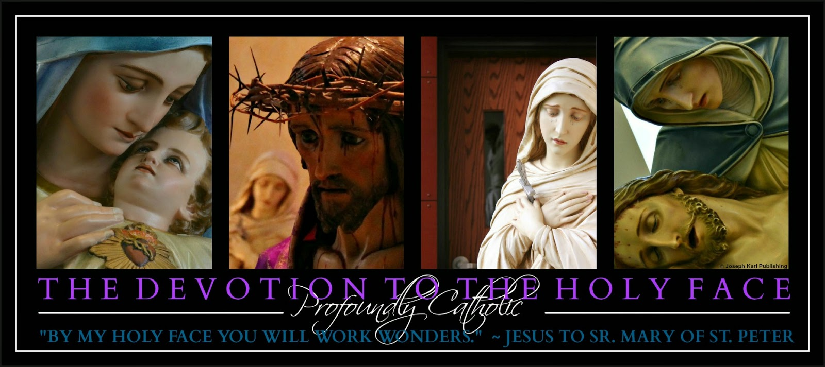
As the Precious Blood of Christ continues to be shed for us mystically every single day during the Holy Sacrifice of the Mass, on Calvary when we make sacramental confessions, as we adore our Eucharistic Lord when the Blessed Sacrament is exposed for the people, while meditating on our Lord's Passion, when we visit the Blessed Sacrament, and when we pray, our Savior labors and obtains our salvation and sanctification through His own Sacred Body.
In order to receive the graces God wants to flood humanity with during this time of His mercy, all we have to do is be willing, willing to accept them for ourselves and for others, willing to accomplish God's will in imitation of Christ and Blessed Mother.
SWEET JESUS, I DO!
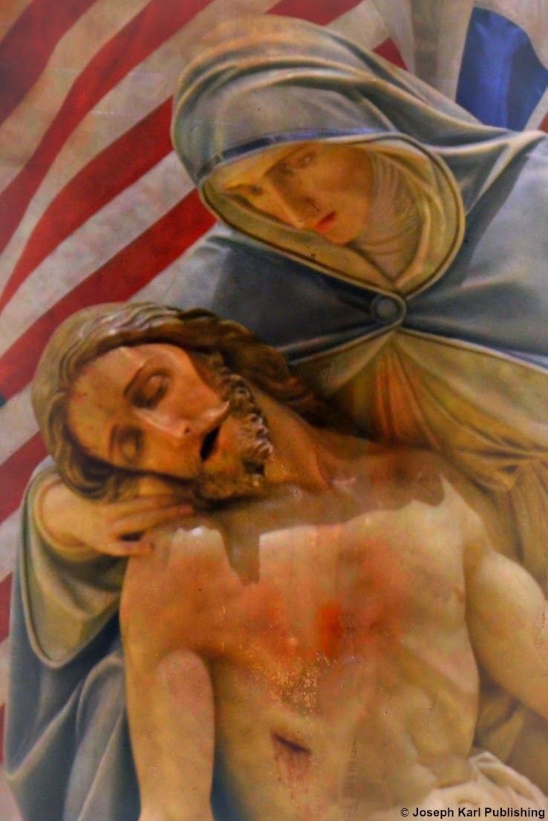
Lord, I accept Your magnificent offers of salvation and sanctification, and promise to love You and honor You all the days of my life. Sweet and gentle Jesus, I love You in return and for everyone.
BRIDAL THEOLOGY FOR EVERY SOUL
May we wed our souls to Christ every single day during the Holy Sacrifice of the Mass (which He instituted for our sake), be united with Him in the Blessed Sacrament, and eagerly allow God to create the most beautiful things from our union, including many opportunities to save precious, priceless, and immortal souls.
May we be nurtured by Jesus' own Sacred Body in the Blessed Sacrament and be strengthened by His Precious Blood, while obediently laboring in the Master's vineyard. Then, when the time comes, let us deliver His will with great courage.
While looking into the holy face of the newborn "baby," or "babies," may we celebrate with great happiness and look forward to what God will create through us next, the next "births," and to the eternal joy we will share with many in heaven while unified with our Creator and Savior, forever and ever and ever.
LIVE, LOVE, SERVE, AND PATIENTLY SUFFER IN UNION WITH CHRIST
Most generous, loving, compassionate, and merciful Lord, so too do I, along with Your most obedient devout faithful, offer You my shed blood and unite it with Your Own, while laboring to obtain the salvation and sanctification of all our brothers and sisters, through the offering to God and sacrificing of my body also, in imitation of the One who gave and continues to give us everything and loves us all more than we can ever imagine.
MORE BRIDAL THEOLOGY, FOR YOU
Bridal Theology as referenced in the material on Joseph Karl Publishing's Bridal Theology Page, created just for you, refers to the wedding of the soul to Jesus, its Divine Bridegroom.
In other words, it explains and explores the mystery of our union with God through Jesus.

The vows you and Jesus make to one another as you wed your soul to Christ do not surrender themselves to death. Vows exchanged with Jesus last forever.
Congratulations!
May you both live happily forever after, and may your sacred union guide many precious, immortal souls to God and to heaven.
God is so in love with us all!

Good Friday: The Ocean of Mercy on Calvary, the Massive Net, Fishing Hooks, Keys, and a Rescue Operation
There is a place for everyone at the foot of the Cross and at Christ's Table, and an ocean of His mercy available to all without exception.

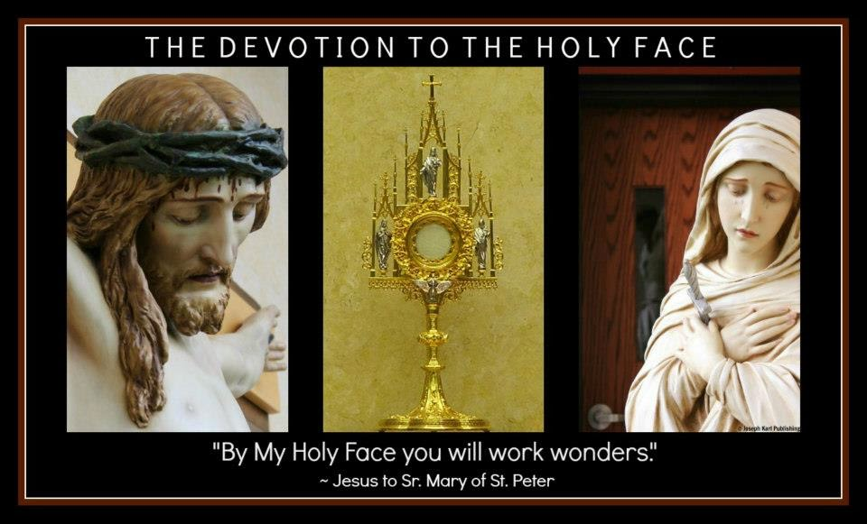
God is so in love with us all. And "with God, nothing is impossible" (Luke 1:37).

The following events took place on Good Friday. In lieu of another formal lesson, there was a massive search and rescue operation.

Were you there?

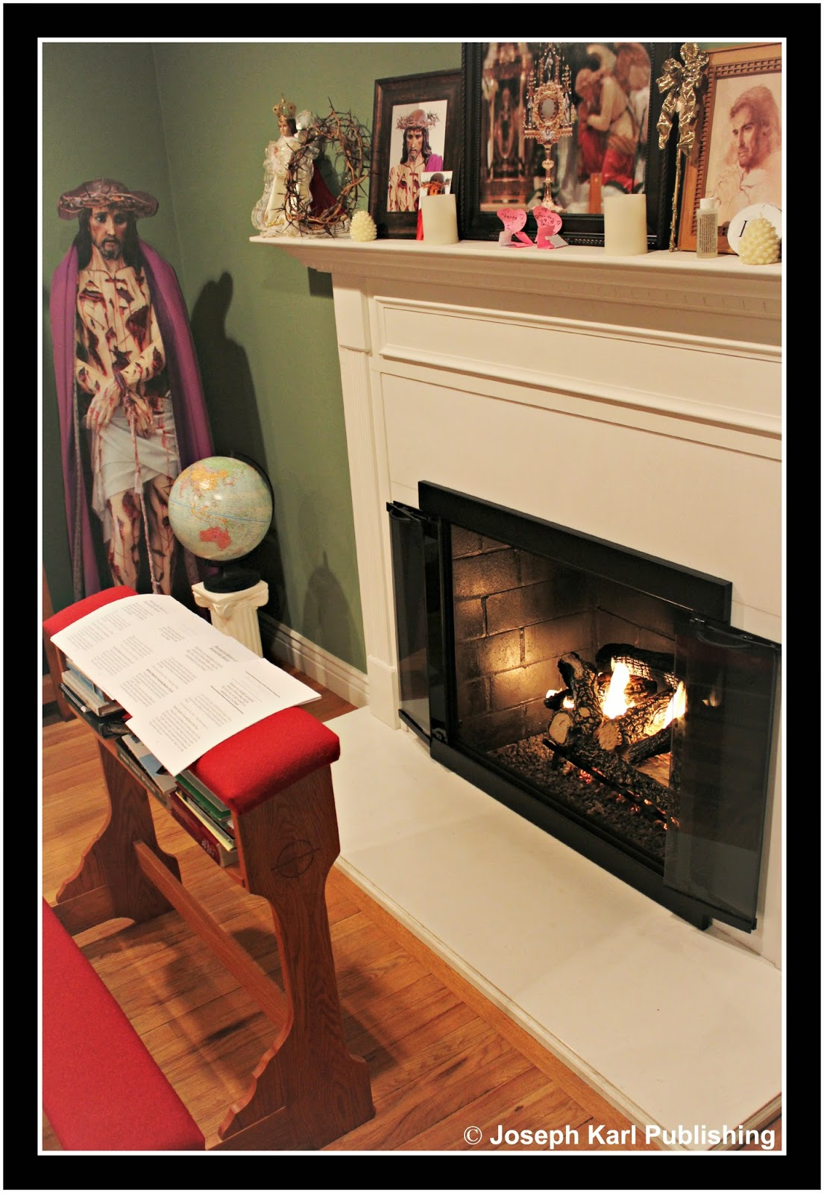

REMAIN

At 10:30 you got up and prayed before the Devotion the Holy Face which you have obediently established in your home. Then you prayed the Chaplet of Divine Mercy while offering God the Holy Face of Jesus. While doing so, the Lord once again granted relief from your suffering, and consoled you as God's will is accomplished through you.

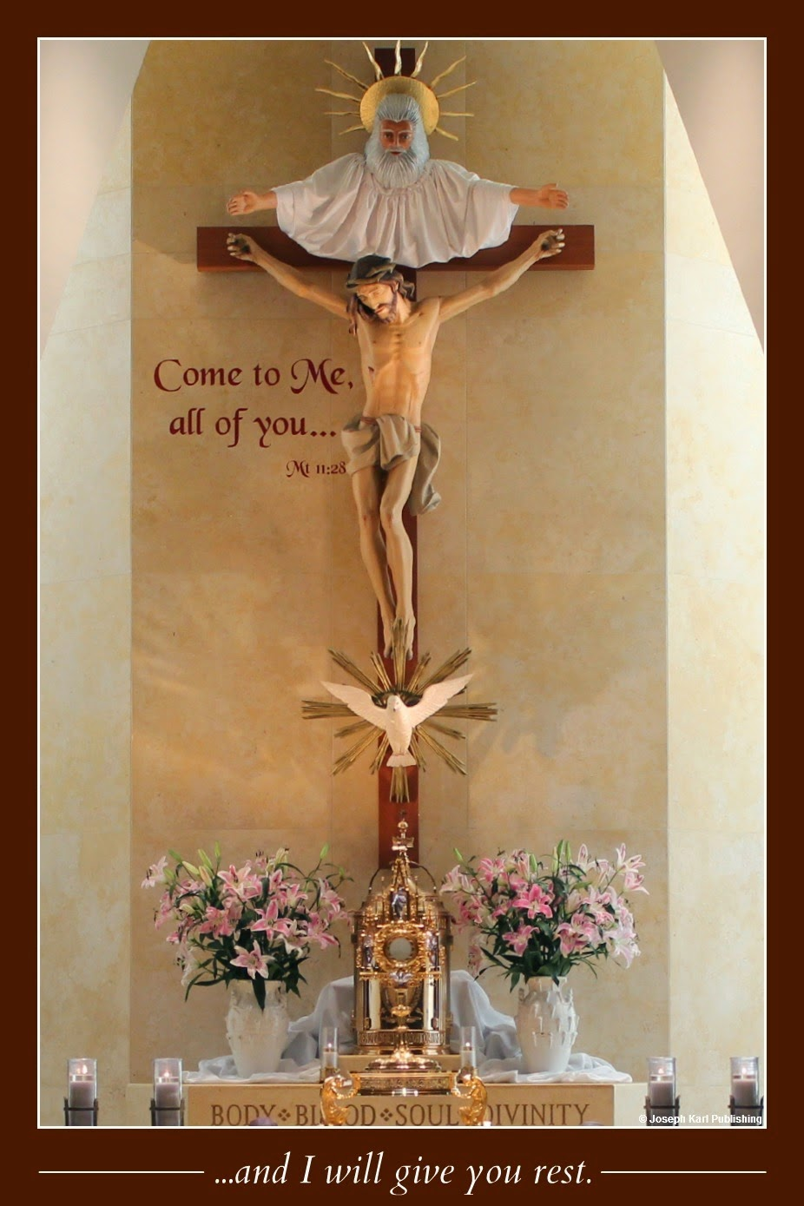
NOON

At noon, you were summoned to the prie-dieu, removed your shoes, began saying personal prayers, and also launched some golden arrows (said the Golden Arrow Prayer, which obtains many graces from the Sacred Heart of Jesus for the conversion of sinners).

Blessed Mother appeared on your left, and Saint Joseph on your right. Jesus was crucified on the Cross before the three of you, between the prie-dieu and His Devotion.
Once again, the Lord presented the largest net that would be accepted by His people, and because the Devotion to His Holy Face has been established somewhere per His request, not where He wants requested it be (in His house) but at least somewhere, a larger net was being given to you before the
Devotion instead of to the parishes where this Devotion and Work of Reparation are not being established, for whatever reason.

Blessed Mother and Saint Joseph began lowering the massive net into the mystical hole before the Cross, into the ocean of God's mercy.

When Jesus was raised upon the Cross, the sudden jolt as it came to rest in the hole caused His Precious Blood to project from His Sacred Body; It fell into the mystical hole and transformed into fishing hooks.

Jesus had you pray by Him with your hands open and very generously filled them with fishing hooks, which were placed into the ocean of God's mercy before you. Blessed Mother and Saint Joseph continued to lower the massive fishing net into the hole.

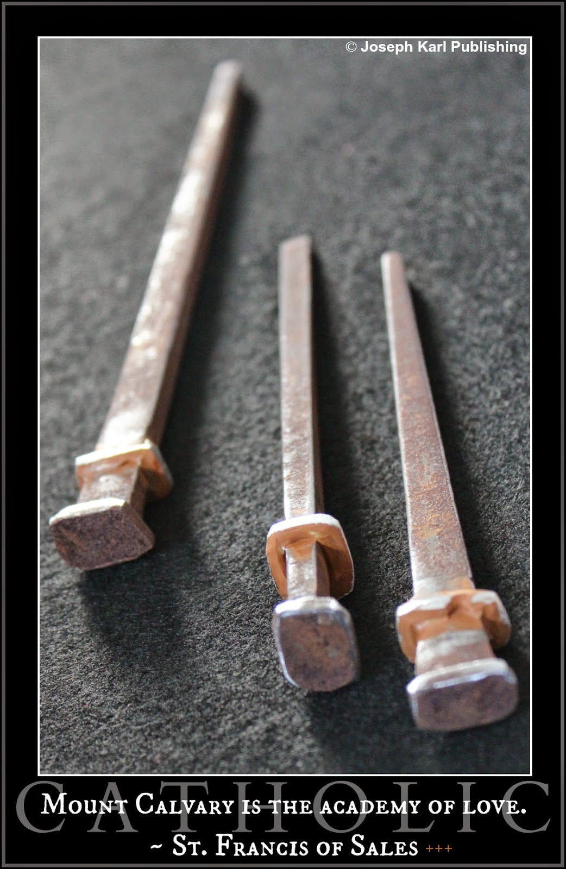

AROUND 1:00: MORE FISHING HOOKS

At about 1:00 it became clear that Jesus was mystically still present on the Cross before the Devotion, and so you remained by the Devotion to the Holy Face of Jesus and maintained a vigil by our Crucified Lord.

The tears you shed for our loving Lord transformed into more hooks for the precious fish.

God loves us all so lavishly, so extravagantly, that is, if we let Him.

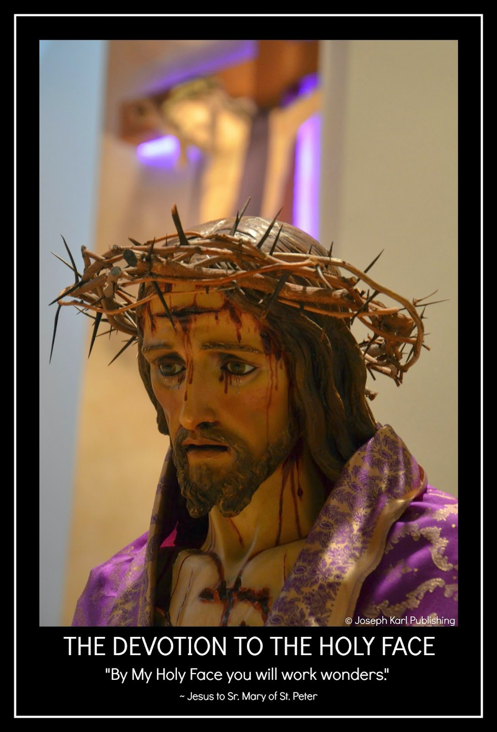

2:30: THE NET, THE HOOKS, AND A GREAT MANY KEYS

At 2:30 you knelt before the Cross at the Devotion to the Holy Face of Jesus and began praying the Holy Rosary. During the final Sorrowful Mystery, Blessed Mother and Saint Joseph knelt and bowed their heads and prayed very solemnly.

The words of the prayers floated in the air and transformed into keys which fell onto the ground around you. During the time of your vigil, it began snowing in the room and the snow transformed into keys which gently fell to the ground around you.

Jesus’ Sacred Blood continued to fall into the ocean of mercy beneath the Cross, and graces streamed from His Sacred Body as it was adored and sacrificed for us all; the graces transformed into keys that landed gently all over the floor.

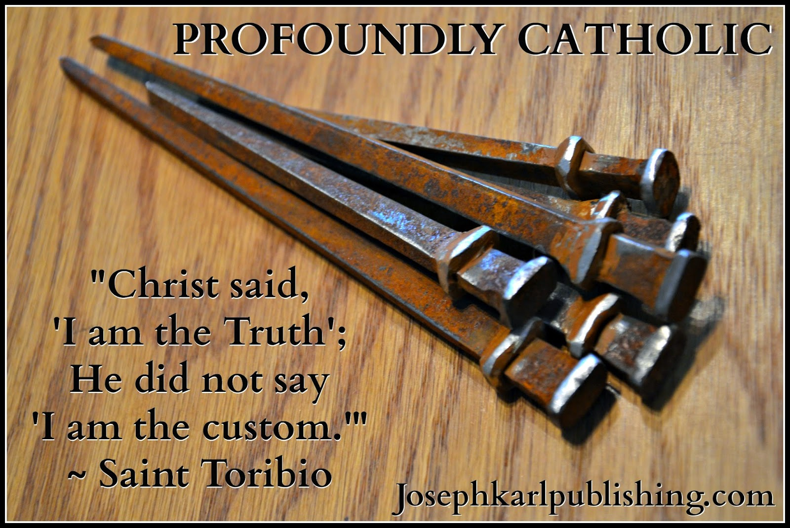

3:00: SALVATION, SANCTIFICATION, AND MORE SURPRISES

Around the Divine Mercy hour, the lance was thrust into Jesus’ side and the Blood and Water flowed out of His Sacred Heart and into the hole, and transformed into many more hooks.
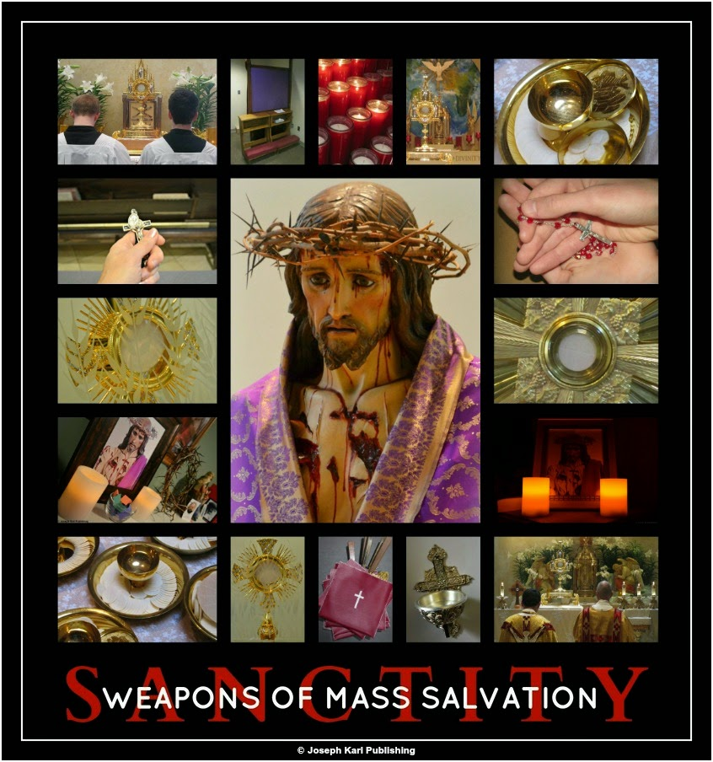

"IT IS FINISHED" (JOHN 19:30)
Blessed Mother and Saint Joseph then began pulling the net out of the water.
Suddenly, the occupants of heaven began appearing, the saints and the holy innocents, there were so many people, the devout faithful also, and they began helping pull this massive fishing net out of the ocean of God's mercy before the Cross.

Fish were pouring out of the net onto the floor as all the helpers from heaven and earth continued pulling it out of the hole, so many people, so many angels all around you, and the fish were flopping all over the ground among the keys.

You asked Jesus, "Why are the fish flopping around?"

"They want to live," He replied.

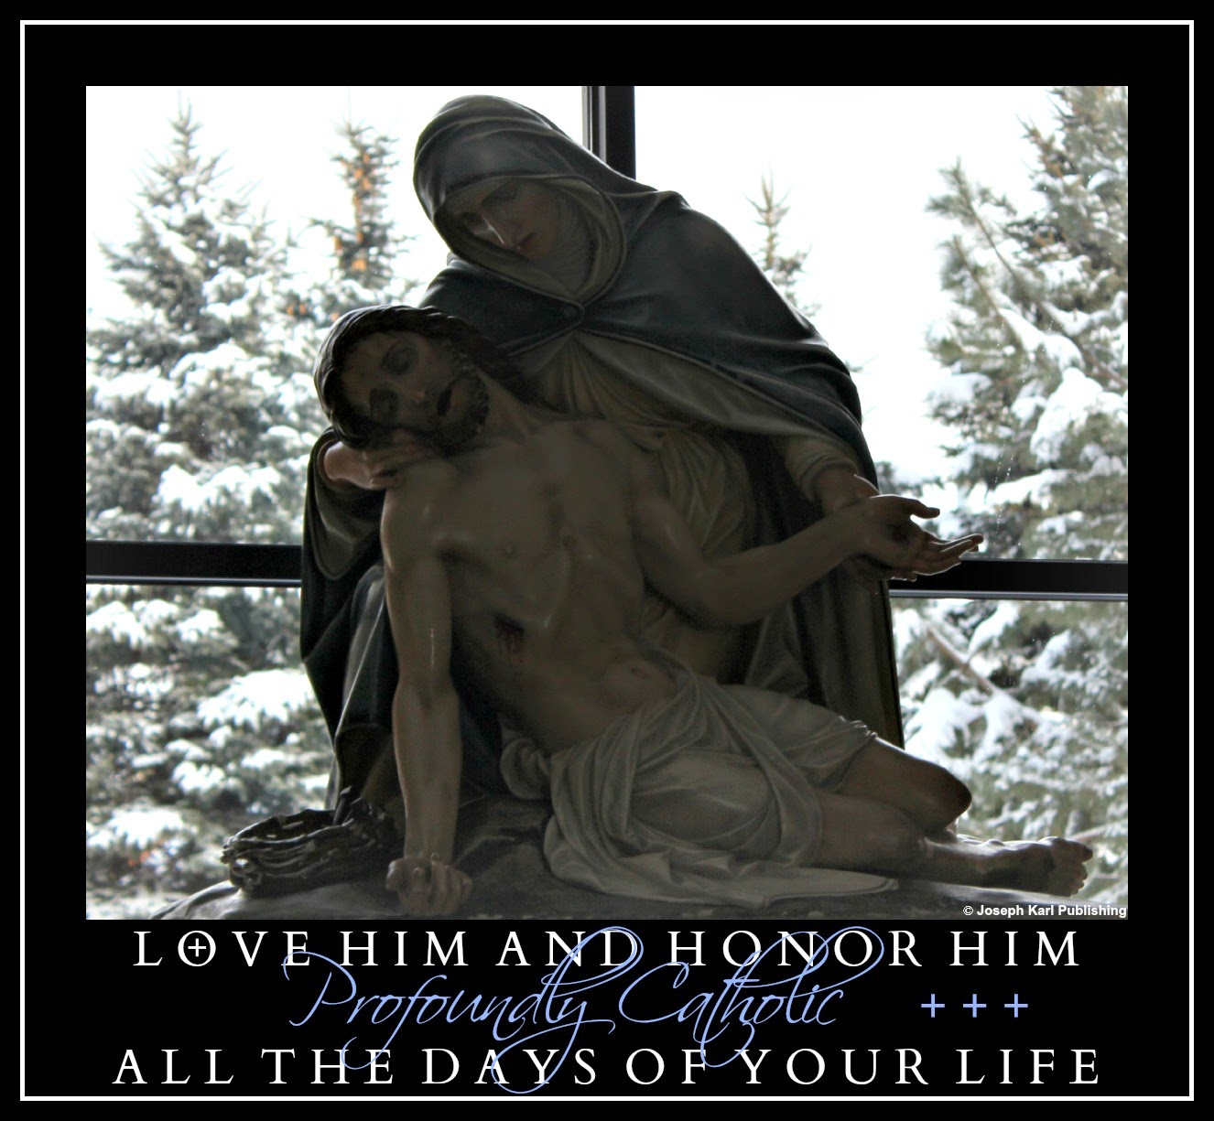

REMAIN

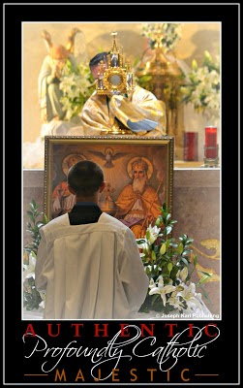People began taking Jesus’ Sacred Body down from the Cross and while doing so, handed the instruments of torture to Blessed Mother who after venerating them then passed them to you (and anyone else who was interested) for veneration.

All of a sudden, the fish who were flopping around and eager to be set free were granted liberation by the keys (through the power of God’s grace) and they began transforming into people, people who began worshiping Jesus right there on Calvary. They were handed the instruments of Christ’s torture which continued to be passed from person to person (the crown of thorns and the nails) and began venerating them, too.

After Blessed Mother held and adored the crucified Body of her Son she gave Him to you (and to anyone who was interested and had remained).

You held Him in your arms and adored Him in imitation of our Mother, and was inspired to place in His Sacred Heart, through the wound in His side, a letter in which was written an expression of your gratitude, the promise to love and honor Him all the days of your life, and the words, Your wish is my command.

SOMETHING FROM OUR CRUCIFIED LORD

Just before you returned Jesus to His Mother, He revealed that there was something in His pierced Sacred Hand that He wanted you to take.

You looked into His Hand and while removing it, was instructed that it isn’t for you. It is for someone else, for one of His shepherds.

It’s a key.

Holy Thursday: "With God, Nothing is Impossible" (Luke 1:37)
A very beautiful story that shows what happens when we listen to God.
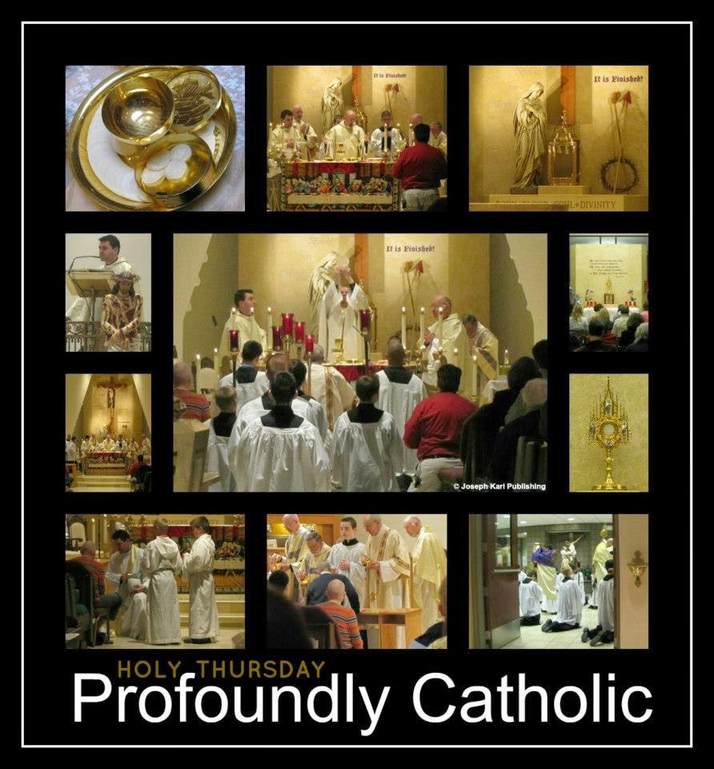
So many precious, priceless, and immortal souls through all time depend on our obedience.
"By My Holy Face you will work wonders." ~ Jesus to Sr. Mary of St. Peter
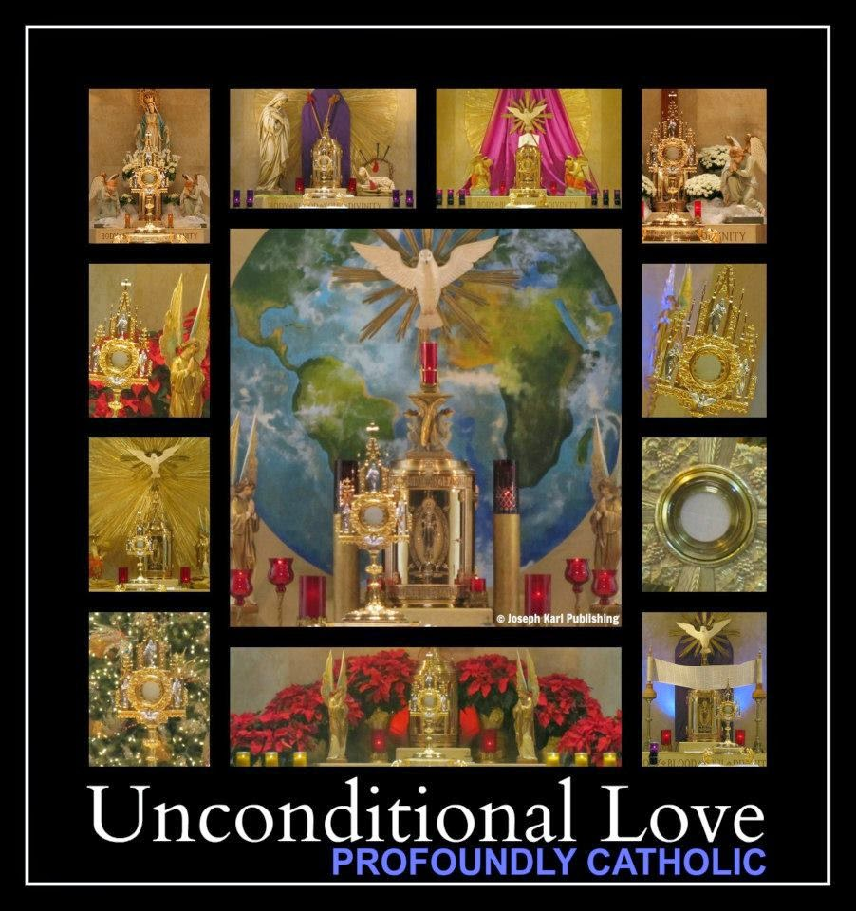

On this Holy Thursday evening, you kneel on the prie-dieu before the Lord's Devotion to His Holy Face and say some prayers to God while offering Him the Holy Face of Jesus as He has requested.
After a while, Jesus reveals to you that it is snowing in the room, there before the Devotion to His Holy Face.
The snow releases keys, and while this is occurring, the image of the Holy Eucharist in the monstrance taken during Eucharist Adoration at the Lord's Parish projects keys into the room also.
Then you see the words of the prayers you had spoken, including those in the Golden Arrow prayer, are floating in the air (since words have great meaning and purpose).
All those words begin releasing keys also, and they land on the floor all around you.
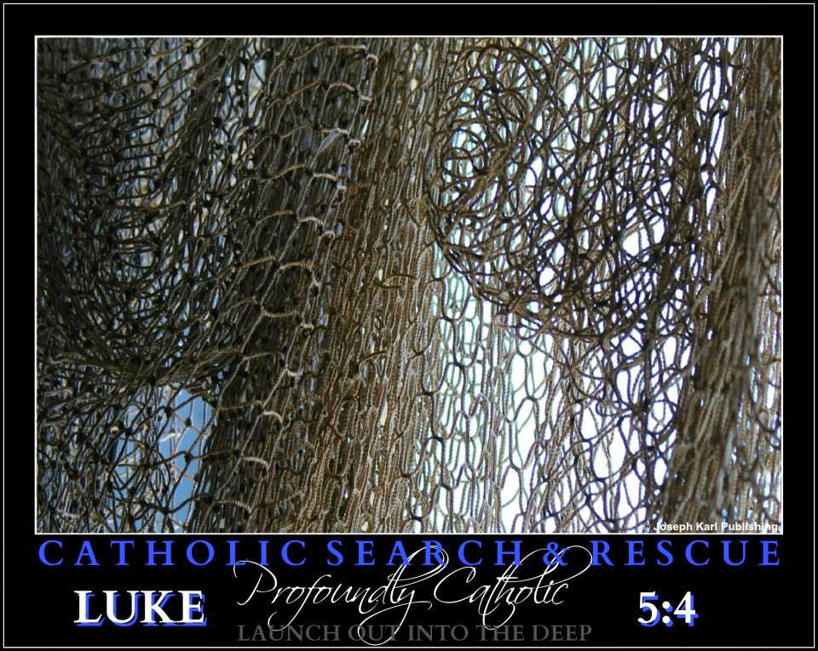
How absolutely delightful, Jesus.
Then all of a sudden, a large net is raised from the mystical hole in the floor before the Devotion, and it is full of fish.
Another miraculous draught!

Thank You, Jesus!
Your wish is my command (smile).
Then, the fish are released from the net and scatter all over the floor, among the keys.
God is so in love with us all.

Holy Thursday: Where to Find the Perfect Parish
In a time when the Catholic Church has been disfigured to the point that it is virtually unrecognizable, our Good Shepherd tells His Flock where to go to find the Church instituted by Jesus Christ.
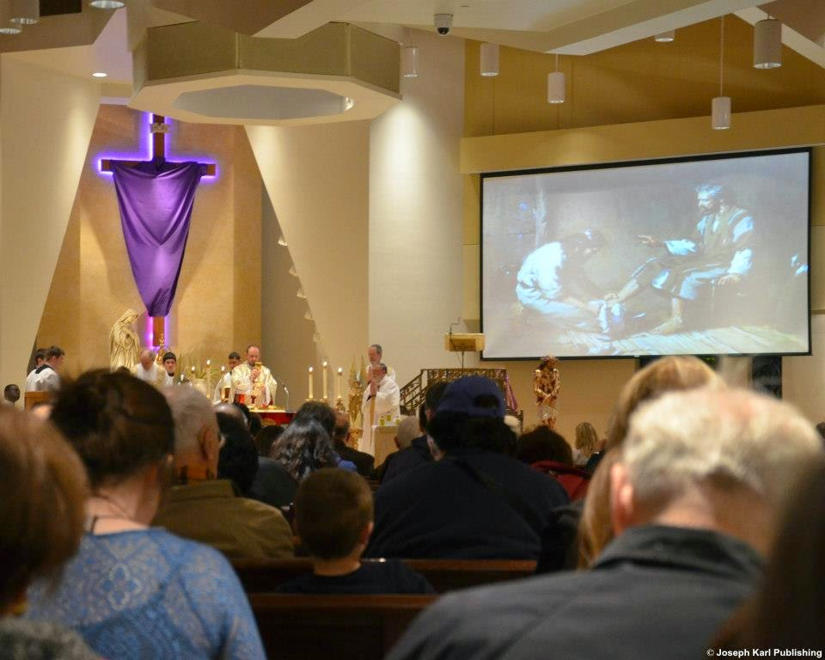
Today's lesson is actually a rescue mission and many things are revealed to the devout faithful by the Master Fisherman and Love of our Eternal Lives.
Holy Week, Holy Thursday, the Eucharist, the Sacred Priesthood, Adoration, Christ's Passion, intercessory prayer, obedience, reparation, education, restoration, a massive army of love in heaven and on earth, a very big truck, and tremendous amounts of Divine Mercy.
Jesus, Your wish is our command!
JESUS, PLEASE GIVE US ONE CHURCH WHERE WE FEEL AT HOME. JUST ONE.
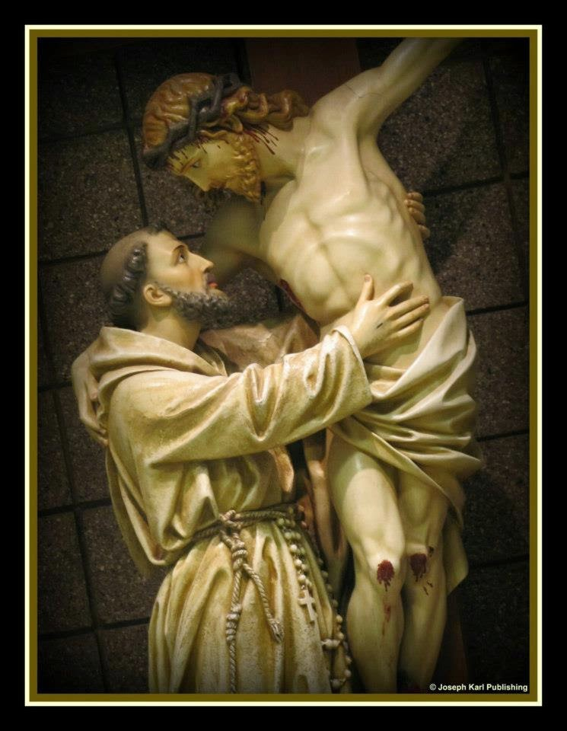During Holy Week, the student asked the Teacher if during his/her lifetime there will be just one parish where the devout faithful who most resemble Him can find a place they feel welcome and at home.
Jesus will we ever find one parish that gets the fundamental basics right? Will we ever find one parish that genuinely cares about us.
Just one where people can receive the Sacraments frequently and obediently, and provides even a somewhat respectable catechism program for its children.
Just one parish that properly catechizes the faithful and teaches them the basics for heaven's sake, such as how to behave in church (perhaps even outside of church), and how to make a good confession.
Just one that has a perpetual adoration chapel so necessary in our time, just one that encourages its most devout members (not just the most superficial, powerful, and wealthy), one that promotes the vital Work of Reparation to the Holy Face of Jesus (why are they not doing this, Lord?), discourages caste systems, worships God and not the constant acquisition of money for every cause under the sun, on the most basic human level cares about and is friendly to everyone including those who most resemble Jesus (the poor, outcast, sick, rejected, invisible, despised), doesn't encourage idolatry, and doesn't see people as a means to an end (i.e. acquiring money, soliciting, and seeking to filling buses, airplanes, seats, and programs) but instead recognizes and respects the eternal and inestimable value of every single person.
So many parishes, so many busy people, so many programs, so much money changing hands, so many smiling people, so much pride, so much ignorance, so little obedience.
Jesus, how would something so wonderful as just one obedient parish anywhere in this area even be possible in our times, when so few people see things as they truly are and so many frightfully resist the Truth, preferring to accomplish their own wills instead of Yours, even when this means treating other people like human garbage.
Many people behave as if they believe that Jesus founded a bank. Lord, have mercy on us all.
JESUS REVEALS WHERE THE DEVOUT FAITHFUL ARE TO GO
When student souls are ready, the Teacher always appears.
Our Lord in His great mercy responds to your plea and shows you during the Holy Sacrifice of the Mass, just prior to Holy Week, where you, your family, and all people can always find the full expression of Christianity as established by its very Founder, Jesus Christ.
You are to go to His parish. Jesus reveals to you His celebration of the Mass, the first consecration and presentation of the Eucharist at the Last Supper, superimposed over the Holy Mass being celebrated before you, and it was indescribably beautiful.
Jesus tells you that His people are to go there and be present for this awesome celebration which most people do not even know is taking place simultaneously.
His parish is mystical, and it is present in every one of His Catholic Churches from the most disobedient to the most obedient one can find.
Jesus wants us to know this at a time where disobedience by many shepherds and their flock has disfigured His Church to the point that it is virtually unrecognizable, just as He allowed Himself to be disfigured beyond recognition during His Passion. All are allowed to exercise their free will, for better or for worse. Living in imitation of Christ, who accomplished the will of our Father in all things, is best for everyone.
It was because His garment was replaced upon His Sacred Body that people were able to recognize Him along the Way of the Cross, and it is by the Eucharist that His People can recognize His Real Presence in His Catholic Churches, most of which have been corrupted to various degrees by people preferring things their way instead of God's Way.
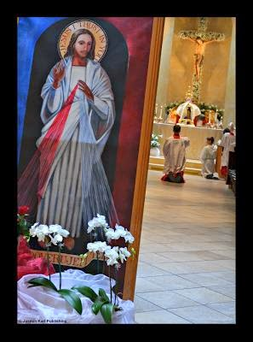
"COME, COME!"
Jesus encourages us to come to His mystical Church, where the devout faithful that have remained are consoled and can serve God on His terms amid the colossal destruction in His physical churches caused by pride, idolatry, greed, colossal ignorance due to the lack (for decades) of proper catechism/faith formation, a tremendous lack of fraternal charity (while so many claim to work for God), fearful leaders, virtually nonexistent battle training, the lack of encouragement (to do the right thing), and disobedience.
We are fighting like we want to lose, and we are losing, even though we fight for the winning side! This is because for many people, the devil has been their only teacher.
The Devil's Greatest Weapon Against Humanity.
By tapping into the infinite value of Christ's Sacrifice and the graces granted during His Holy Mass, which occurs simultaneously with all of those on earth, Jesus makes up for all humanity is lacking. In addition, the devout faithful are present at the very best parish, Christ's Parish, where they are then able to serve to the extent that they are willing as channels of massive amounts of His grace for all souls through all time and all parishes through all time.
This particular issue is not one of debating whether we should accept the fact that we all have a fallen human nature, and as a result we should all be allowed to do whatever we want, even if it means disfiguring Christ's Church, harming other people, and losing significant amounts of grace by the hour.
The issue being addressed here is one of decay, improper faith formation, and ongoing corruption due to self will and the tremendous lack of self mastery (since hardly anyone teaches about or encourages it) that disfigures (and has disfigured) so many parishes, leaving the devout faithful without a parish to call home (that is if they remain Catholic).
The worst of all cases are parishes that have been corrupted by disobedience by both leaders and the flock who are content with getting their own way (or insist upon it) as massive amounts of grace are lost for them and for all of mankind through all time, by the hour.
When the Lord showed you where to find the perfect parish, the parish His devout faithful have available to them always, you saw that it was snowing during the celebration of His Holy Mass. A great many keys to liberate souls bound and chained by the devil were being released through the snow along with many graces, and oh so many words fill the air and they released a great many keys also.
What a magnificent sight; God loves us so lavishly, so extravagantly!

NO PLACE TO ADORE OUR EUCHARISTIC LORD ON HOLY THURSDAY
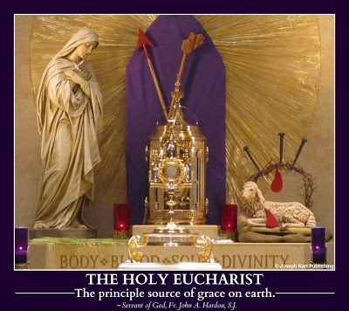
The Lord asks you to offer up all of your suffering that morning to Him, but He does not tell you why.
He will.
Our Teacher always knows the conditions of our soul so intimately and always seeks our greater good by encouraging us to trust in Him with greater measure.
Lord, what was all that suffering for?
Unable to find a place to adore our Lord in the Blessed Sacrament, and really needing to be with our Lord on the day He instituted the Blessed Sacrament and the Priesthood (Holy Orders), you ask Him where to go and He sends you to the most devout parish that can be found. Fortunately, you find it open.
By the way, the Sacrament of Confession (inseparable from the Blessed Sacrament) was instituted by our Lord on Easter Sunday night.
THE POWER OF INTERCESSORY PRAYER
Jesus has you begin praying the Chaplet of Divine Mercy, always offering to God the Father the Holy Face of His beloved Son, with your hands open. Once again, His Sacred Hands are superimposed over your hands, and all four are transpierced with nails. God has much to give humanity right now, individually and also collectively.
He tells you that it is we who place obstructions in the way of massive floods of grace He wants to bestow upon all people through all time. We do this by our disobedience and by our partial obedience. Our Creator and Savior wants to absolutely let loose. If only we would not block Him.
God is so merciful; He wants us to have these graces. We need them. A very big truck is coming right at humanity standing oblivious in the middle of the road, most likely texting, certainly distracted, careless, and uneducated.
THE POWER OF THE HOLY ROSARY: "BE IT DONE TO ME ACCORDING TO THEY WORD" (LUKE 1:38).
While praying the Sorrowful Mysteries of the Holy Rosary, you are shown all of heaven mobilizing to come to humanity's aid, and not only that, you see them mobilizing the Lord's obedient devout faithful on the ground. They are serving as massive channels of grace as humanity consents and aggressively contributes to its self destruction.
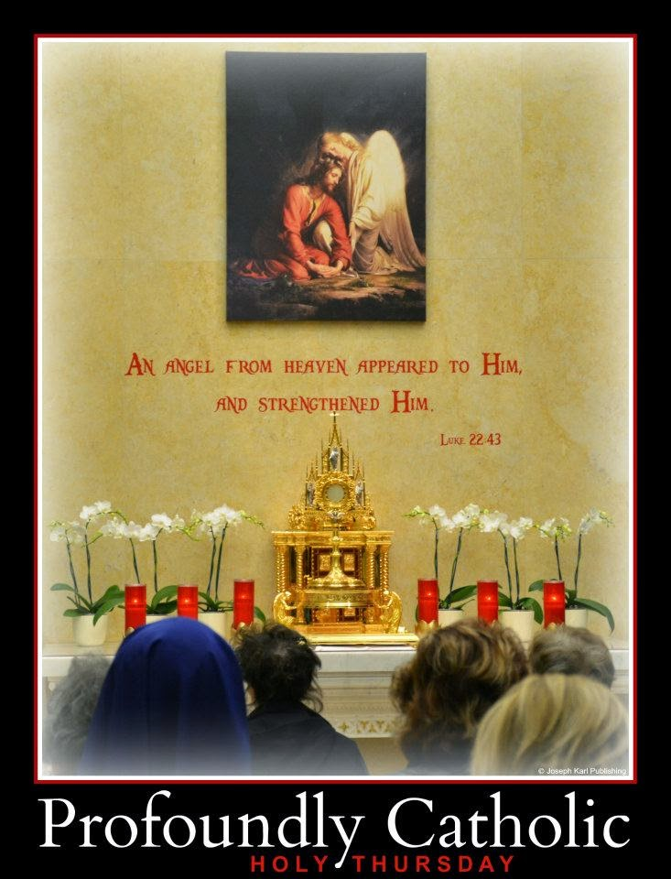
THE AGONY IN THE GARDEN
You join Jesus in the Garden, and see that He is wearing black clericals and a roman collar. The Holy Family joins you in its entirety; Blessed Mother kneels to your left, and Saint Joseph keels to your right.

Jesus reveals to you that your suffering today was for the devout and obedient members of His Sacred Priesthood. The Mother of all Priests and the Father of all Priests are here to help us.
You then see so many loving and courageous shepherds kneeling and praying in the Garden with you.

What a sight!'
THE SCOURGING AT THE PILLAR

During the Second Sorrowful Mystery, as Jesus is scourged at the pillar, He brings you the parish's monstrance with His Sacred Body inside, and sets it and His Real Presence right next to you.
That is profoundly Catholic mercy.
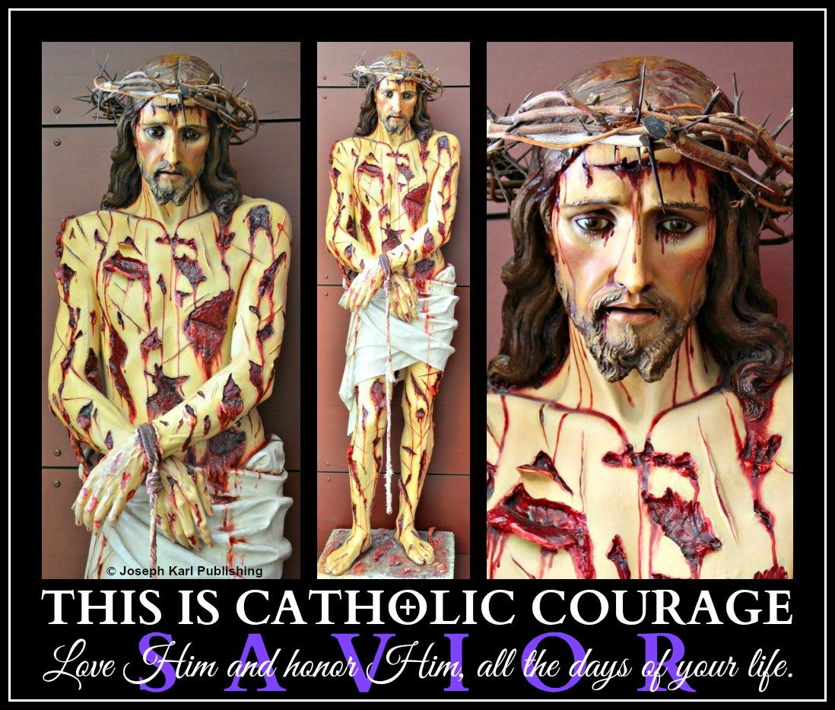
JESUS IS CROWNED WITH THORNS

During the Third Sorrowful Mystery, as Jesus is crowned with thorns, stellar Catholic educator Father John A. Hardon, S.J. visits and prays next to you, and he is smiling. He is very happy to help us. He certainly did a tremendous amount of work for us already.
Thank you, Father Hardon. Servant of God, Father John A. Hardon, S. J. archives.
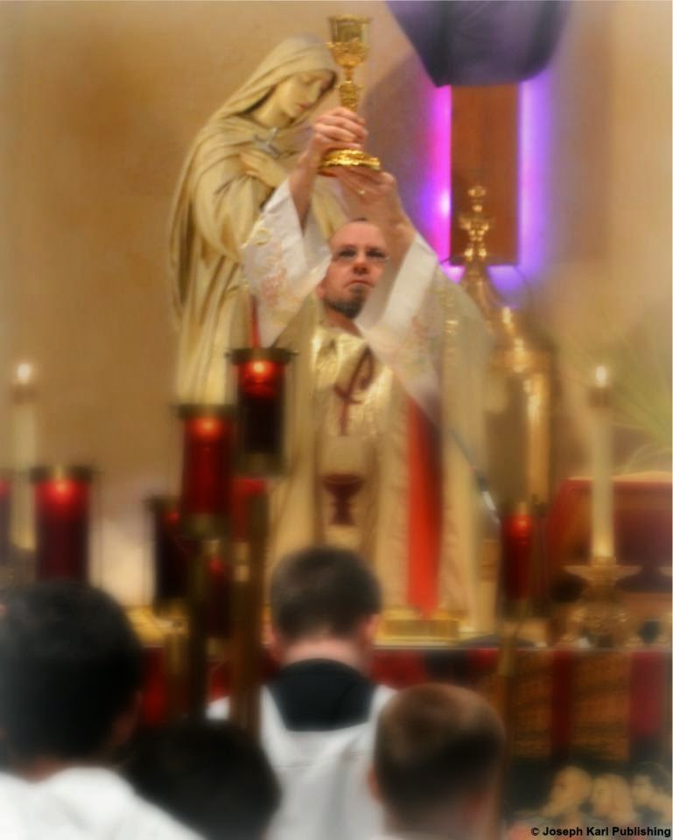
JESUS CARRIES THE CROSS

The Forth Sorrowful Mystery is prayed before Jesus' Real Presence for the liberation of sinners held captive in spiritual bondage. You accompany Jesus as He carries the Cross to Calvary and present along the Way are all these people, carrying the very heavy burden of their sins, most of them unaware as their crosses carve wide trenches into the ground as they travel.

THE POWER OF THE HOLY EUCHARIST

At the conclusion of the Fifth Sorrowful Mystery, The Crucifixion, Jesus takes a chalice of His Precious Blood from His Sacred Heart through the wound in His side and holds above It the Sacred Host removed from the monstrance. Then, having already given you absolution, Jesus gives you Himself.
"REMAIN"

As you hold Jesus' Sacred Body in your arms, having received Him from the loving arms of His most holy Mother after He was mystically taken down from the Cross, Jesus has you place your heart transpierced by a nail into His Sacred Heart, through the wound in His side.
He already had you place your heart on the altar during the mystical Holy Mass at His Parish, and drive a nail through it to crucify it upon the altar.
There, it remains.
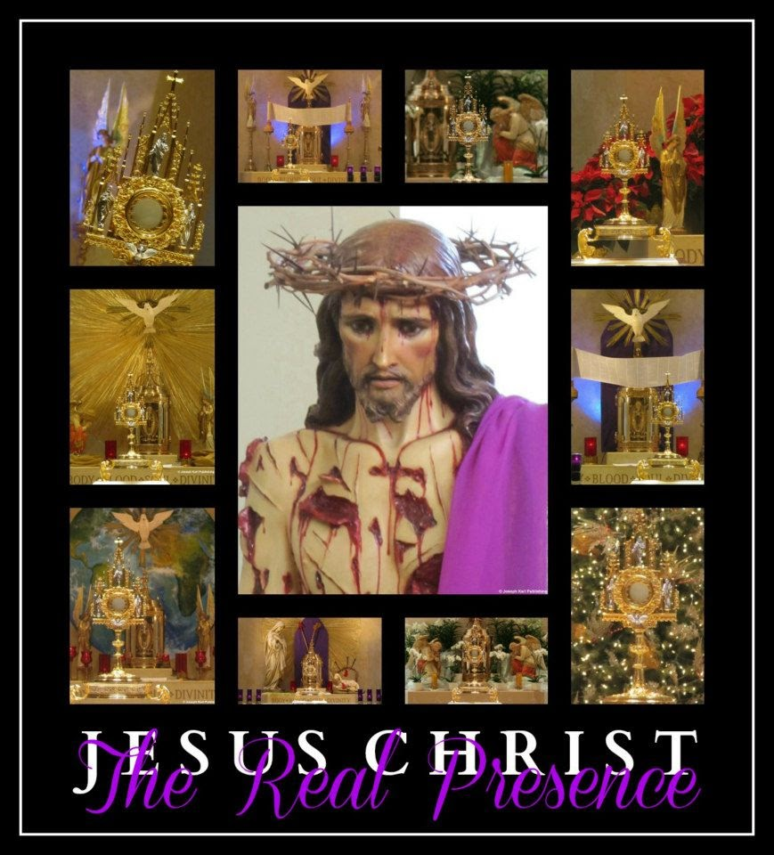

THE POWER OF SACRIFICIAL LOVE AND OBEDIENCE
Before you return the mutilated Sacred Body of the Son to His Mother, our Mother, Jesus has you look in His pierced Sacred Hand, and in His right Hand, He is holding a net.
That net is to be used to catch massive amounts of fish.
That is the net the celebrant is to cast into the mystical hole before the altar during the Mass of the Lord's Supper, the extent of his cooperation unified with yours and the complete cooperation of Jesus and Blessed Mother; that will determine the size of the net.
Jesus has placed no limits on what He is willing to accomplish through each parish, and through you.
THE VITAL WORK OF REPARATION AND RESTORATION
What was necessary for our Lord to save and sanctify us must be our response also.
We MUST give our lives and our wills to God completely, and unconditionally, for the salvation of souls.
We MUST do what He says, and not what we want.

THE PENITENTS, THEIR CROSSES, AND THE CONFESSIONALS
A lesson from our compassionate Teacher, Whose love and mercy are available to every single person, without exception.

This short but powerful lesson takes place while you pray in church with the Real Presence of Jesus in the Blessed Sacrament.
SALVATION AND SANCTIFICATION
In previous lessons, Jesus showed you an image of Hmself crucified on the Cross next to the prie-dieu (kneeler) inside of every confessional.
Christ also showed you this image of Himself on the Cross right next to every penitent praying and preparing to be reconciled with God, prior to going in.
Our Crucified Lord is already mystically covering us with His redeeming and sanctifying Precious Blood as we wait for our turn to be liberated from sin and be healed of its consequences.
Did you know that you are loved and valued that much?
Jesus is also waiting for us inside the confessional, waiting for us to come to Him often.
If only the devout faithful were encouraged by their shepherds to do this, and if only the opportunities to go often were available to most of the flock that lack them.
"Come to Me, " Jesus beckons us all, waving us to Him with arms open wide. "Come, come."

Sweet and merciful Jesus, please help us all to get to You!
SO MANY MEANINGFUL LESSONS
Our Savior had also previously showed you an image of penitents entering confessional doors, and each person was carrying his or her cross.
Jesus understands the human condition. He created us, and has tremendous compassion for us. Hasn't He proven this to us during His entire life, and through His Passion, Crucifixion, Death, and Resurrection. Hasn't He proven this to us by instituting the Sacraments, by calling men to His Sacred Priesthood, and by remaining with us always in the two inseparable Sacraments of Divine Intimacy, the Blessed Sacrament and the Sacrament of Confession.
TODAY'S LESSON
During this brief lesson, our Savior shows you penitents entering the confessional and once again they are carrying their crosses. This time, however, He shows you the marks they make on the floor. Some of the crosses are very heavy, and their marks are carved deeply and starkly into the ground. Others are less heavy, and leave less of a trail.
All are headed to the right place, the foot of the Cross, to be covered in the Blood of the Innocent

Lamb Who takes away the sins of the world.
Be loved; be forgiven!
Accept God's magnificent offers of salvation and sanctification.
Allow our Lord to use you as a tremendous channel of grace for the massive conversion of sinners.
Allow Him to transform you into His likeness.
To begin, all we have to do is be willing.
God is so in love with us all.

BEING BEACONS OF HIS LIGHT
Immense suffering is required of the devout faithful, especially now during Holy Week. It is a time of tremendous grace for mankind and also a time of fierce resistance from the devil, who doesn't like to lose his fish.
Today's lesson takes place during Eucharistic Adoration. As you are gazing affectionately upon our Lord really present in the Sacrament of Love, you see the monstrance and Sacred Host inside are rotating from side to side, just like a light in a lighthouse does.
OPERATION PROFOUNDLY CATHOLIC SEARCH AND RESCUE
You see and understand this as being similar to the time Jesus unified you with Himself on the Cross when you were praying before the Blessed Sacrament in church. At that time, Jesus was moving His Sacred Head from side to side as He hung nailed to and crucified on the Cross.
At first you understood that Jesus looks for us on Calvary but then He clarified, saying that He does not have to look for anyone because He always knows where we are.
Jesus looks at us, because He loves us. He knows where we are, because He cares where we are. He wants us to be with Him, the Author of Love, both now and forever.
Our Savior explains to you during today's lesson that if we are with Him and among others, He looks directly at each one of us individually (as if we are there alone). If we are not with Jesus on Calvary during the Holy Sacrifice of the Mass and/or don't make sacramental confessions, if we don't pray before the Blessed Sacrament, and don't honor His Real Presence with our presence during Eucharistic Adoration (if it is even available for the people), the Light of the World seeks us out with His light and draws us near to Himself.
Our Savior looks at us. That's because He loves us.
But we must be willing to accept His love and prefer His Way. Christ's Way is the Way of the Cross, the Way of Sacrificial Love.
SACRIFICIAL LOVE
Sacrificial love is the most powerful force in the universe. Sacrificial love is so strong that the bonds formed by it cannot ever be broken, and the gates of hell cannot prevail against it.
Sacrificial love robs the devil of many precious, priceless, and immortal souls (fish). Allow sacrificial love to bind your soul to God, forever. Allow God to use you as a tremendous channel of grace for the massive conversion of sinners. This requires abandonment to the will of God.
THE CATECHISM CRISIS AND AN ARMY WILLING TO SURRENDER
When the Lord summons His devout faithful and asks them to agree to do His will unconditionally, and then reveals to them what that entails, that we must be His messengers, He may neglect to reveal that so few people will be willing to listen.
The Lord's servants quickly find out that this is indeed the case.
Why are so few people willing to listen?
There are various reasons for this, a big one is that most people consume toxic food and aren't receiving proper health care. So bodies and brains don't function as they were designed to, and as they should. Most people are unaware of this, and could care less.
Mostly there are few people willing to listen because everyone in our era has been well conditioned, very well trained, to want and get their own way at all costs.
The devil rewards us lavishly for this destructive reasoning, while at the same time the devout faithful are taught little to nothing about abandonment to the will of God and self mastery.
So many know not that they are in spiritual bondage and that liberation can be found in God alone.
Father John A. Hardon, S.J.'s favorite description of hell is a place where souls get to have their own way forever.
When the devout faithful are not properly catechized, then the devil gains serious advantage over us.
He and his battalions are highly intelligent, highly organized, highly trained, and are willing to cooperate very efficiently with one another for the sake of humanity's destruction.
The devout faithful find churches closed, leaders' ears closed, confessional doors closed, very few perpetual adoration chapels, little if any spiritual direction, and shoddy catechism programs for their children.
Fundraisers, however, are epidemic. Get them to focus on perpetually acquiring money instead of on perpetual Adoration, kindness, and compassion, teaches the devil. Only reach out to those starving for human decency to ask them for more money to fund your compassion. Love is expensive! Don't use your own money, save it, and don't ever look close enough to see what the needs of those around you are. They exist to admire you! See how much you love people.
Hence the tremendous, very necessary, and extraordinarily valuable suffering required of the devout faithful in our time, for souls through all time, which obtains grace from our lavishly loving Lord that illuminates minds that are closed and warms hearts.
OBTAINING UNCONDITIONAL SURRENDER OBTAINS ETERNAL VICTORY
God is the only one who can reach those so rewarded by the devil for preferring their own way that they can no longer see things as they really are. Their minds can no longer be penetrated by reason. Such people prefer their own way even when it means that they and others will suffer.
Even through the devout faithful are part of a massive untrained and uncatechized army of love, our efforts to live, love, serve, surrender to God, and patiently suffer in imitation of Christ and Blessed Mother are catching and saving many precious souls as part of our merciful Lord's Operation Profoundly Catholic Search and Rescue.
"With God, nothing is impossible" (Luke 1:37).
This of course makes the devil very angry because then he loses fish. His resistance is as fierce and as brutal as the Lord will allow, and indicates that our efforts to further glorify God and serve as tremendous channels of His grace for precious, priceless, and immortal souls are bearing great fruit.
Praise be to Jesus Christ, now and forever! Go, Team. God is at work in you!
"By My Holy Face you will work wonders." ~ Jesus to Sr. Mary of St. Peter

THE SACRAMENT OF
C H R I S T ‘ S P E A C E
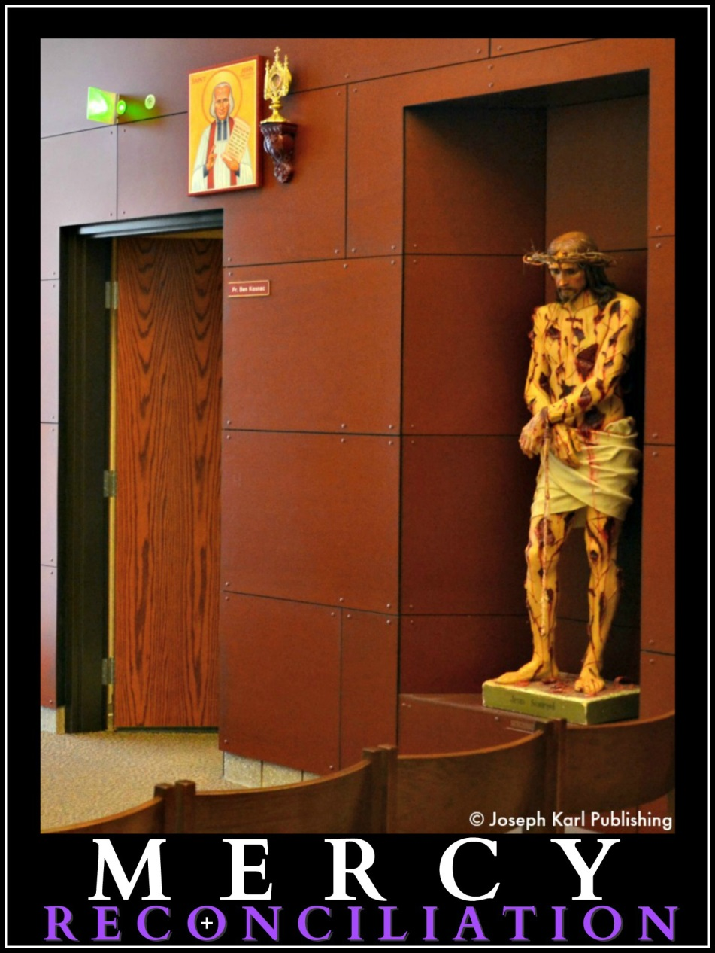

Michele Bondi Bottesi

IF WE ONLY KNEW AND UNDERSTOOD, WE WOULD REMAIN
During today's lesson, our Teacher and Savior once again shows us what takes place during the wedding and union of our souls to Christ during the re-presentation of His Passion, Crucifixion, and Resurrection, and instructs His uncatechized people to "remain."
So many important graces for all people through all time are lost every single day because generations of the faithful have never been taught even the basics of the One True Faith.
This is despite generations of (terrible) catechism programs, so many programs and so little authentic Catholic teaching that sets the world ablaze for Christ.
Properly catechized teachers are so desperately needed, now.
The devout faithful must go directly to our Savior for instruction in order to get it. Then, we must be the ones to teach our families and others. We can't wait for our parishes to be willing to do this; most are not. Most like things the way they are: a disaster.
Most love themselves and their way of doing things far too much (pride) instead of loving God as they should and responding to HIS call as they should. They have not been taught that one day, everyone will be held accountable for the choices they have made, for the souls that were meant to benefit from their obedience, and for the souls that suffered because of their disobedience.
For so many, the devil has been their only teacher, and he is an exceptionally skilled educator. The Devil's Greatest Weapon Against Humanity. He teaches pride, and a great many people fall for the deception with starry eyes, and become his best students who love learning more about coveting power and control, and getting their own way. This deception leads them to see with the devil's spiritual vision, and they see the destruction within their parishes as something very, very beautiful.
Father John A. Hardon, S.J.'s favorite way to describe hell was as as the place where souls get to have their way, forever.

When the student soul is ready, the Teacher appears. Be open to learning from the One who gave up His life for your education.
Some inspiration to encourage the faithful to be humble and open to learning: Meditating on Christ's Passion.
We gain so much when we are open to the Truth, when we make the choice to be reachable and teachable.
"By My Holy Face you will work wonders." ~ Jesus to Sr. Mary of St. Peter

Today's lesson takes place during the Holy Sacrifice of the Mass.
HOLY MASS
Jesus once again requests that the Holy Sacrifice be celebrated by first offering His Holy Face to God our Father. Once again He tells you there is great power in doing this and all things through His devotion.
The Work of Reparation to the Holy Face of Jesus.
Jesus also requests that you present one black fishing hook to Him on your heart, the soul's wedding pillow during its wedding to Christ.
WATERFALLS
Jesus reveals waterfalls in the most beautiful forms during Holy Mass, unique forms, in the forms of the people He created. You see these waterfalls, a metaphor for His lavish grace, in the women’s and girls’ long hair, and then in the veils (wimples) worn on the heads of the nuns. The Lord's grace comes to us and goes through us during the Holy Sacrifice, and finds its expression in the most beautiful ways because God's creation is very beautiful.
OUR HIGH PRIEST ON THE CROSS

For a very brief time, Jesus shows Himself crucified on the Cross wearing black clerical clothes and a roman collar.
This is one of the most deeply moving things you have ever seen, just as the Lord intended, our High Priest showing you what He did for every single person. So much more could be said and written about this image of our Savior on the Cross dressed as a member of His Sacred Priesthood.
PRIESTS CRUCIFIED ON THE CROSS
A short while later, you are shown members of the Sacred Priesthood superimposed over Jesus on the Cross and they, too, are wearing clerical clothes and roman collars. So much more could be said and written about that as well.
THE OUTFITTING OF THE FAITHFUL
Jesus points out to you that the nuns’ outfits match our Teacher's clothes when He presents Himself to His student dressed in clerical clothing. He explains that just as couples like to sometimes match their clothes, so too does this matching of the clothes please the Spouse of our souls. And when people see souls consecrated to Jesus matching the High Priest, they naturally think of Him and receive blessings.

MORE WATERFALLS
You are also shown waterfalls of grace and light come from the five wounds of Jesus on the Cross, and then God's extravagant love and mercy are revealed in greater measure as grace and light pour from every single wound on His Sacred Body!
They pass through everyone present in church and join with everyone's work and offerings in union with Christ, and then exit through everyone's wounds sustained in imitation of Christ.
God's grace then travels in the form of waterfalls to all those through all time who are being praying for.
You also see the Lord’s light and graces pouring through everyone and traveling to other parishes, where they line the floor and fill the air. This image is a metaphor for the Lord's proper way of behaving, leading, administrating, and teaching spreading from the few obedient parishes to all the rest. The people in those other well meaning but uncatechized parishes who are losing colossal amounts of grace then absorb the graces coming to them, merely by being present, because God is that generous as minds are illuminated by the Lord’s light.
THE FUNERAL
This happens to be a Funeral Holy Mass, and at one point, you see Jesus of the Passion approach the casket and place His Sacred Hand upon it, leaving a hand print of His Precious Blood on the cloth (pall) covering it. Jesus kisses the casket as well. Every single one of us is loved and valued by God beyond measure.
When the Cross is mystically placed upright into the hole prepared for it during the Consecration and stops abruptly, drops of His Precious Blood project from His Sacred Body and land on the casket. His Blood combines with that person’s good works during life, and transform into black fishing hooks that are baited with grace and catch and save precious, priceless, and immortal souls held in spiritual bondage by the devil.
THE CONSECRATION
The Lord has you once again place demons seeking humanity's destruction into the hole in the ground before the Cross is mystically raised, and also Has you place certain people into the hole.
Who were you inspired to place into it? The outcomes are the same as during previous lessons. God is so good!

HOLY COMMUNION

During Holy Communion, after returning to your place in church, Jesus again unifies you with Himself on the Cross.

"The holy sufferings of Jesus is a sea of sorrows, but it is also a sea of love. Ask the Lord to teach you to fish in this sea. Immerse yourself in it, and, no matter how deeply you go, you will never reach the bottom. Allow yourself to be penetrated with love and sorrow. In this way you will make the sufferings of the gentle Jesus your own. Fish for the pearls of the virtues of Jesus. This holy fishing is done without words." ~ Saint Paul of the Cross, Spiritual Diary, 8th April, 1758
“REMAIN”
During the final hymn, as everyone stands up while still unified with Jesus in the Sacrament of Love, you are shown that they are also unified with Jesus on the Cross!
What an astounding sight, to see everyone who had received the Real Presence of Jesus mystically unified with Him on the Cross of our salvation!
But what you see next is even more shocking. Almost everyone walks right out after the final hymn has ended, never knowing this is taking place, never knowing the basic truth that they are unified with God for 15 precious, priceless, and SACRED minutes and that it is HIS WILL that we remain with Him, be still, and know that He is God.
What are we doing. What are we not doing. Merciful Lord, rescue us from our incredible ignorance!
How do you put up with us.
AN ONGOING TRAGEDY OF COLOSSAL PROPORTIONS
How little the faithful are taught; how little the faithful have been taught. Generations of people have never received even basic instruction despite so many ongoing programs. So many programs, so many pilgrimages, so many mission trips, so many functions, so many organizations, so many fundraisers, so many bake sales at the foot of the Cross (Blessed Mother your only Son just gave up His life for us, would you like to buy a cupcake for your Rosary society?), so many fish frys, parish festivals, so much toxic food, and so many requests for money for everything under the sun, so many ignorant and over fed Catholics starved of the truth in need of being entertained, so many bored children, so many blind and fearful leaders, so few with courage, so few loving and serving in imitation of Christ and Blessed Mother.
The effects of this nonsense on not only generations of people but on all people through all time is absolutely CATASTROPHIC.
The people are unified with Jesus on the Cross, and they are leaving!
They leave to go do anything else.

As you pray with Jesus in the mostly empty church, you anticipate that you will be holding the Sacred Body of Jesus after it is mystically taken down from the Cross as usually happens when you remain, but that is not what happens today.
PRAYING WITH JESUS
Jesus shows you your hands, which are clasped together in a particular way in prayer (they are holding a prayer intention for the Lord's one particular fish) as being His Sacred Hands also. You see that His Sacred Hands are superimposed upon yours, and all four are transpierced with the nails of crucifixion.
OPERATION PROFOUNDLY CATHOLIC SEARCH AND RESCUE
Suddenly, your hands began to fill with black fishing hooks! Absolutely delighted, you put them into the hole before the altar (in an action of thought similar to a prayer) which the large nets were previously drawn out of by the Divine Hand, and then guess what happens?
Your and Jesus' hands filled with even more hooks! This process repeats itself several times. Jesus explains that when His people are obedient and remain as He has requested so many times now, He grants many more hooks to catch and save precious, priceless, and immortal fish.
THE HEART AND THE HOOK

Jesus then has you place one hook for one particular fish inside your heart, and then you are inspired to place both into the wound in His shoulder.
NO PLACE TO REST HIS HEAD
At one point while praying with Jesus while still unified with Him in the Sacrament of Love, your
head once again feels like it is twisted in an odd position and facing the left as has happened once before.
It feels horrible, so uncomfortable, and you ask Jesus what is going on. He explains that while Crucified on the Cross, He was unable to even rest His Sacred Head against It because of the crown of thorns. Can you just imagine that.

Thank You for sharing that with me, Jesus.
You shed more mystical tears of blood, which release even more black fishing hooks.
THE LORD AND HIS PEOPLE SEEK A PLACE WHERE THEY ARE WELCOME
Most of the Lord's devout faithful have no place to rest their heads, either, unable to find even one parish within reasonable distance that gets just the basics right, no home because so many don't know the basics or don't care.
What will it take to get people to see that things that are not done God's way don't work.
"By My Holy Face you will work wonders." ~ Jesus to Sr. Mary of St. Peter
A LOOK TO THE LEFT

Jesus, why are You looking to the left? you ask Him.

Jesus said that He is looking at all those people who are “on the left,” people who have placed themselves on Calvary, meaning that they truly believe that they are doing good, but they are not serving in imitation of Christ and Blessed Mother. They serve themselves instead.
Jesus is singling them out to receive much needed grace, which is pouring from His Sacred Body and also pours through the few people who remained while unified with our Savior on the Cross.

THE EVE OF SPIRITUAL VICTORY

The next lesson from the One Who created us, knows us best, and loves us beyond our comprehension.

The following lesson from the Teacher Who gave His very Life for your education is presented to you over the course of two days, through two Holy Hours, two Holy Masses, one Eucharistic Adoration, two Divine Mercy Chaplets, two Holy Rosaries while meditating on the Sacred Passion of Jesus, and one Sacramental Confession.
Don't ever just be Catholic; be PROFOUNDLY Catholic! There is so much more of God's love to discover and then keep rediscovering. He is SO in love with you!!

A PROFOUNDLY CATHOLIC, PROFOUNDLY MEANINGFUL LENT AND BEYOND

"God wants us to think about him. We should ask ourselves everyday: How much is God on my mind? I honestly believe the single most important question we can ask ourselves in the spiritual life is the one I have just made: how often is God on my mind." ~ Father John A. Hardon, S.J., The Divine Attributes Retreat The Attributes of God The Worship of God With Our Minds

HOW IT ALL BEGAN

This lesson actually began with a video.
Father John A. Hardon, S.J. said "Nothing happens by chance or coincidence."

THE VIDEO

The day before yesterday, the Lord set a short video in your path. In it, a young woman had her face videotaped while she was having an abortion to demonstrate to others that abortion is not harmful. The baby’s father was never mentioned. At the end, the abortionist doctor the woman paid to execute her child complemented her for doing so well.
"Behind every abortion is the devil." ~ Father John A. Hardon, S.J.

WHILE ON YOUR WAY TO CHURCH THE NEXT MORNING

You are told that the circumstances of your life at times mirror the miraculous draught of fish story; in a similar way to what took place back then after fishing all night yielded nothing, so God also ordains that your suffering at times precedes His work in our time catching many fish.

This metaphor can be generalized to everyone; in fact, it is the very life of Christ.

“The reason moments of catastrophe may be the eves of spiritual victory is because it is in those moments of defeat that man’s pride is most humbled and his soul thus prepared for the help of God…It is only when Peter had labored all the night and taken nothing that he was given the miraculous draught of fishes” (Fulton J. Sheen, Our Grounds For Hope).

OFFERTORY

As Father prepares the altar, and as Jesus simultaneously prepares for the mystical re-presentation of the Consecration at the Last Supper, you are shown very clearly and profoundly how our Savior allows
Himself to be handled by men, which includes permitting His Sacred Body to be mishandled by men.

That can be generalized to His being mishandled by anyone, but more so indicates the mishandling of Jesus by some of the members of His Sacred Priesthood, the physicians of souls.

Misguided and self serving physicians of the soul and of the body are causing many people to suffer in our time.

As Jesus continues preparing for the Last Supper, He tells you that He is suffering this way in union with us, in union with the suffering inflicted upon man by so many physicians who are not helping people as they should be. For a great many people, sin has become so obscured to the point where sin isn't even considered sin, and things such as money, status, material goods, and power are worshiped instead of God, the Creator of Life and our Savior.
Jesus continues the lesson from the altar by comparing His having surrendered His life for us after atoning for every one of our sins, while so many in our time are being harmed and even killed by those within these helping professions.
CONSECRATION

At the time of the Consecration, Jesus suddenly asks you to thank Him for creating the child that was killed in the abortion video. That deeply intimate moment shared with Jesus during the mystical re-presentation of His Crucifixion is so strikingly powerful that you are moved to tears.

Then, Jesus asks you to thank Him in place of the aborted child's mother. He also asks you to thank Him in the father’s place.

We have no concept of how much God loves and values us, nor do we understand the incomprehensible dignity and value of every single human being. Nor do we adequately comprehend the value of sacrificial love.

After that, you understand that this formal expression of gratitude is even more than God asking for what He has coming to Him, our immense, humble, and eternal gratitude. Our Savior wanted to bestow upon the parents of that aborted child much needed grace, and in order for that to happen, someone needed to be grateful and thank Him in their places. Someone had to be willing to accept His love.

SACRIFICIAL LOVE

Sacrificial love is the most powerful force in the universe.
Sacrificial love is so strong that the bonds formed by it cannot ever be broken, and the gates of hell cannot prevail against it.
Allow sacrificial love to bind your soul to God forever.
Allow sacrificial love to transform you into a tremendous channel of grace for the massive conversion of sinners.

HOLY COMMUNION

During Holy Communion, you are inspired to love Jesus for everyone, and to ask for grace so that mother who has no remorse for having an abortion experiences a change of heart.

Then He tells you to place your entire life into the large mystical hole in the ground before the altar, and He compares doing this to making a general examination of conscience over one’s entire life.
In presenting the information to you in this way, Jesus shows a connection to and the inseparability of the two Sacraments of Divine Intimacy.
This is also a precursor to what is coming, a large catch and perhaps some lessons on the Sacrament of Reconciliation.

"REMAIN"

As you hold the crucified Sacred Body of Jesus in your arms after Holy Mass has ended, Jesus has you place your entire life within His Sacred Heart through the wound in His side.

THAT AFTERNOON DURING EUCHARISTIC ADORATION JESUS SUMMONS YOU TO CONFESSION

While adoring our Lord in the Holy Eucharist, you insightfully ask Him to teach you more about making powerful confessions, and are inspired to petition God for this through the beaten Holy Face of Jesus and also through the Holy Face of the Child Jesus.

Then, Jesus summons you to confession in the morning, and inspires you to ask St. Joseph to help you make a good confession.

I bet you would have made really good confessions, you tell St. Joseph.

EXPRESSING MORE GRATITUDE
Jesus has you thank Him for creating all the children whose lives were terminated by abortion, people who live on in eternity, our powerful allies who are with us to help us fight this daily battle against tremendous evil with eternal consequences.

JUST BEFORE LEAVING THE CHURCH

Jesus reveals that what He and St. Joseph will inspire you to say in the confessional in the morning is being done for more than just your sake; you are being summoned to obtain graces for those through all time who are in a state of mortal sin because of their involvement in destroying human life.

PRAYING BEFORE THE HOLY FACE OF JESUS THAT EVENING

That evening, you pray before an image of Jesus' Holy Face and ask the Lord what it is He wants you to say as you make your confession in the morning.
"By My Holy Face you will work wonders." ~ Jesus to Sr. Mary of St. Peter
Jesus reminds you of previous lessons about catching fish during Holy Mass, and He explains further that this also takes place when sacramental confessions are made.
Jesus tells you that the two Sacraments of Divine Intimacy, the Blessed Sacrament and the Sacrament of Reconciliation, are inseparable.
ANOTHER HOLE IN THE GROUND
Right after that, our Savior shows you a confessional, it is as if you are actually in the small room, and you see a mystical reinforced hole in the ground in the empty space next to the penitent. It holds the Cross upright, with Jesus crucified on It as during Holy Mass, but you are only shown the hole at this time. That hole awaits you in the morning, when you will kneel at the foot of the Cross and accomplish the Lord's will.
What's up with all the references to fishing? Launch Out Into the Deep.
Jesus tells you that a very large net will be placed into that hole, and you have been informed that your next sacramental confession will specifically target the evil of abortion.

You ask our merciful Teacher, Jesus, what do You want me to say?
Jesus keeps things simple and asks you to thank Him for creating all the people killed by abortion, to thank Him in place of their parents and also others, and to accept His love, mercy, compassion, and healing in place of everyone ever wounded by the demonic deception of abortion.

PREPARING FOR SACRAMENTAL CONFESSION THE NEXT MORNING

Immediately after arriving in church and praying in the chapel outside the confessional doors, you are suddenly shown through your spiritual vision that individuals are walking into each confessional, and as they do so, each one is carrying his or her personal cross.

You also see fishing nets hanging on some of the chairs in the chapel. So many souls are being caught and saved by Jesus' Divine Mercy, through the power of this great sacrament of courage , honesty, and humility.

As you pray, you hold the heart of St. Joseph in your hands and appeal to God to help you accomplish His most perfect will, through the very heart and person of the incredibly humble and holy man created to be the father of the Son of God and husband to His most Holy Mother.

At one point, Saint Joseph appears next to you and places a cloak around your shoulders. The chapel begins filling with little children, those whose lives ended by abortion. They have come to help you accomplish God's will!

IN THE CONFESSIONAL

As you make your sacramental confession, you see St. Joseph beside you on your left. He is lowering a large net into the mystical hole in the floor. With so many helpers, and confident that God's grace is sufficient to accomplish anything He requests, you are able to accomplish the Lord's will and leave the confessional to begin praying in church prior to the start of Holy Mass.
Perhaps you said something like this:
Dear Lord, How much you love every single one of us. I love You back, and I love you in place of everyone. Jesus, I ask Your forgiveness for the many ways I have sinned against You, and am also here as You requested to apologize in place of everyone not in the state of grace, to accept your love, mercy, and grace in their places, and to thank You for everyone….

...Jesus, I give myself entirely to You and promise to love and honor You all the days of my life.

Through the power of your Sacraments of Divine Intimacy, please convert all those who are pro-abortion and help us find a way to end it everywhere.

HOLY MASS ~ CONSECRATION OF THE SACRED HOST

During the Consecration of the unleavened bread into the Sacred Body of Christ, you are suddenly shown Saint Joseph and he is still in the confessional. He is pulling up the large net from the mystical hole in the ground, and it is loaded with keys!

Saint Joseph is our very powerful ally in the search and rescue effort for precious, immortal souls.

CONSECRATION OF THE PRECIOUS BLOOD

As the wine was Consecrated into the Precious Blood of our Lord, Jesus is mystically raised on the Cross which is then placed into the mystical hole prepared for it in the floor by the altar. The power of the Cross crushed the demons of abortion, unchastity, uncharity, and the demons keeping people in spiritual bondage through regret, sorrow, and shame.

Then Christ’s Precious Blood flowed down into the hole and onto all the souls through all time harmed by abortion, who along with the devils had been placed into the hole during the Holy Sacrifice of the Mass in an action of thought, of the will, similar to a prayer.

REMAIN
As you hold the crucified Sacred Body of Jesus in your arms following the conclusion of Holy Mass, you are inspired to place something within His Sacred Heart through the wound in His side. What is it?

WANT WHAT GOD WANTS

"Never question God's dealings with you. Respect God's work in your soul with silence." ~ Father John A. Hardon, S.J., On the Holy Eucharist as Prayer

It is impossible for a person to have an appreciation for the Passion and Death of Christ, and of his or her own Redemption, unless he or she has unconditional respect for the life and great dignity of every single person
created by God. That means not only professing to be pro-life, but behaving charitably towards everyone (instead of asking everyone to fund one's charity). "Help that kills the body or soul isn't help at all." ~ True Love Leads to Life

YOUR WISH IS MY COMMAND

Lamb of God, Who takes away the sins of the world, grant us peace.

This powerful second confession lesson from our Lord takes place throughout the course of a day and is revealed from morning to evening, providing us with not only an eternally valuable lesson but also an important reminder that our Lord can teach is at any moment and so we must remain open, willing to learn, and ready.

God is so in love with us all!

THE LESSON BEGINS IN THE MORNING

While preparing to start the day you reach for your crucifix but before putting it back on, hold it in your hand and kneel down very reverently as if you are right in front of Christ on His Cross on Calvary.

Then, you kiss your crucifix very reverently and say with tremendous love and gratitude, “Jesus, I love You.” As you do this, the following happens:

Jesus suddenly appears crucified on the Cross before you.

Immediately after He appears, your individual sins come to light before you, because nothing is hidden from God. This does not take long, because you had recently made a sacramental confession.

The experience is incredibly beautiful.

DIVINE FAVOR

From what you understand, our Lord was drawing your sins from you into His light with great mercy and compassion because you strive to live a sacramental life of heroic virtue and receive His two Sacraments of Divine Intimacy, the Blessed Sacrament and the Sacrament of Reconciliation, often. This experience is reserved for those who cooperate with His grace and strive to accomplish God’s will on His terms and not on one’s own.

THE REDEEMING AND RESTORATIVE POWER OF CHRIST’S PRECIOUS BLOOD

Immediately after that, a drop of Jesus' Precious Blood, one for each one of your sins which had been drawn from you and brought to light, exited the wounds on His Sacred Body which He sustained and suffered because of those sins.

The priceless drops of His Precious Blood from each of those wounds land right on you, and cleanse you from those sins (note: this is a lesson and not a substitute for making Sacramental Confessions).

Remember, just one drop of Christ’s Precious Blood was enough to redeem the entire human race, to redeem every single person ever created.
Our Savior surrendered every drop for us.
Jesus gave Himself up willingly, was beaten beyond recognition, His Sacred Flesh shredded at the pillar, His Sacred Head crowned, wounded, and then shredded with thorns, He was mocked, belittled, humiliated, endured our punishment stripped of His clothing, the most modest, loving, compassionate, pure, forgiving, and compassionate of men, all in front of His most holy Mother, dear friends, followers, strangers, the curious, and enemies.
Jesus willingly carried His Cross along the Way of Sacrificial Love, falling with great pain on His knees underneath the weight of the world, and then surrendered His battered and belittled Sacred Body to be nailed to and then raised upon a Cross where He suffered indescribable agony for three hours in His catastrophically injured state.

As His Sacred Body was tortured to Its very limit, He surrendered His will and His life to God, for us, while praying for us constantly as He also prayed for the strength to endure all to the end, for us.

Love Him and honor Him, all the days of your life.

WANT WHAT GOD WANTS

In an era where truth has become so obscure and sin so prevalent, prefer God's truth to any other version of it. Where sin abounds, grace abounds even more!

Our fallen human nature has the propensity to be very intelligent and yet at the same time incredibly ignorant. Want what God wants. He is so in love with us all!

To conclude that part of the lesson, Jesus shows you yourself kneeling at the foot of His Cross on Calvary in the confessional while receiving the Sacrament of Reconciliation and at the same time kneeling at the foot of His Cross on Calvary during the Holy Sacrifice of the Mass while receiving the Blessed Sacrament. In this way, He shows you that these two Sacraments of divine Intimacy are inseparable.

Jesus, how incredible loving and humbling. Thank You for Your great love and mercy. I love You back!

Your wish is my command.

Have you ever said this to our Lord? Say it, and say if often. Jesus, Your wish is my command! It delights the One Who remains with us always and gives us everything.

THE SECOND PART OF THE SECOND LESSON

The second part of this lesson is presented to you during the Holy Sacrifice of the Mass in the evening that same day.

Just minutes before Holy Mass is to begin, Jesus suddenly draws you back to the moment at the foot of His Cross from this morning.

Once again, you experience this very profoundly and feel it very deeply.

Why has our Lord presented this lesson to you again, during the Holy Sacrifice of the Mass?

INSEPARABILITY

Jesus is teaching you that while the two Sacraments of Divine Intimacy are not interchangeable because they are not the same, they are inseparable.
We kneel in the mystical Real Presence of Jesus crucified on the Cross as we receive His real mercy during sacramental confession, and His Real Presence during Holy Mass.

VALUE AND RESPECT GOD’S TRUTH

Make your life a testimony to God's truth.
His truth, THE TRUTH, is always worth telling and He wants us all to hear it and understand it. The devil doesn't.

The consequences of whose truth we embrace are eternal, both for ourselves and for so many other people.

Make sure you know the difference, and do not what you want but what you should.

“Trust all things to Jesus in the Blessed Sacrament and to Mary, Help of Christians,
and you will see what miracles are."
~ Saint John Bosco

© Joseph Karl Publishing/Michele Bondi Bottesi

Meditate on Christ's Passion every day.

He is so in love with you!

It is impossible for a person to have an appreciation
for the Passion and Death of Christ,
and of his or her own Redemption,
unless he or she has unconditional respect
for the life and great dignity of every single person
created by God.

Lesson #3 Before the Devotion to the Holy Face of Jesus
Another unexpected lesson that reminds us that our Teacher may appear at any time, and anything can happen.

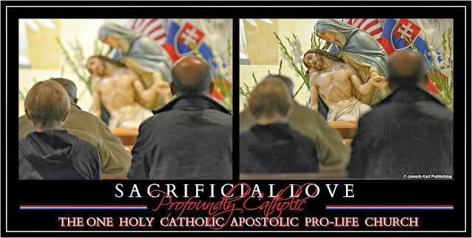

"With God, nothing is impossible" (Luke 1:37).
NOW WHAT?

This lesson takes place late in the evening right when you are about to retire for the night.

The Lord calls you to pray before the Devotion to His Holy Face in your home.

Every home and parish home must have this powerful Devotion, especially in our times.

So you take your tired self and happily relocate, feeling profoundly grateful that the One Who knows all things wants to meet with you.
The prospect of this unexpected encounter fills you with wonder. Immediately you kneel down before images of our Lord's most Holy Face during His Sacred Passion.

DO WHAT?
What comes to your mind right away is to lay on your back in the empty space on the floor in the room.

As that imagery floats around in your conscienciousness, you say to Jesus, I should be on the floor face down in the shape of a Cross instead.
But then Jesus tells you that is what He wants you to do. Our Lord wants you to lay on the floor on your back, and so that is what you do.

Guess what happens next. Our Savior's lessons are always so unforgettable.

MORE UNION WITH JESUS AT THE PILLAR

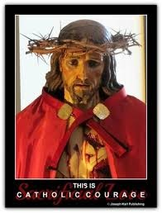You find yourself suddenly unified with Jesus, and He is on the ground after having been scourged at the pillar.

What a moment.

The tears were dripping down, His Sacred Blood dripping down, sweat dripping down…

Why are we here on the ground at the pillar, Jesus?

Our Savior tells you that He had to trust in His Father to help Him fulfill His mission.

Jesus wants you to know that you must do the same.

Jesus, you reply, I… (concerns presented here).

Jesus responds by telling you that He was catastrophically injured and still had a mission to fulfill.

I was laying in My own Flesh and Blood, He says.

I was stripped of My clothing.

Jesus had to fulfill His mission stripped of His clothing.

He wants us to strip ourselves of everything so that God can work freely in us and through us. We must ask God to help us, and we must rely totally on Him in order to do it or it won’t be possible, and we must strip ourselves of everything.
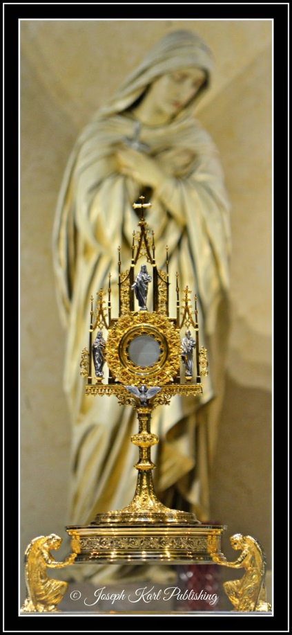

That is what I will do, Jesus. Thank You for the reminders, especially right now you say to Him in reply.

And so you continue to lay on the floor unified with our Savior and Teacher, so peaceful and comfortable there on the ground, and launch a bunch of Golden Arrows (the Golden Arrow Prayer).

A SURPRISE CONCLUSION

You linger a few more moments on the ground, and all of a sudden a mystical person comes up to you by your feet and kicks you with tremendous malice. You don't feel this physically but do feel it mentally and also see it happen.

That is a totally surprise ending to an unexpected lesson.

What just happened, Jesus. Why did that person just come up and kick me?

Referring to the way some people have been treating you, Jesus replies, That is also what was done to me.

Praise be to our sweet Jesus, now and forever!

"By My Holy Face you will work wonders." ~ Jesus to Sr. Mary of St. Peter

A Lesson in Trust
How the disclosure of one soul in the confessional to the Lord, from Whom nothing is hidden, was rewarded with a powerful lesson in trust.
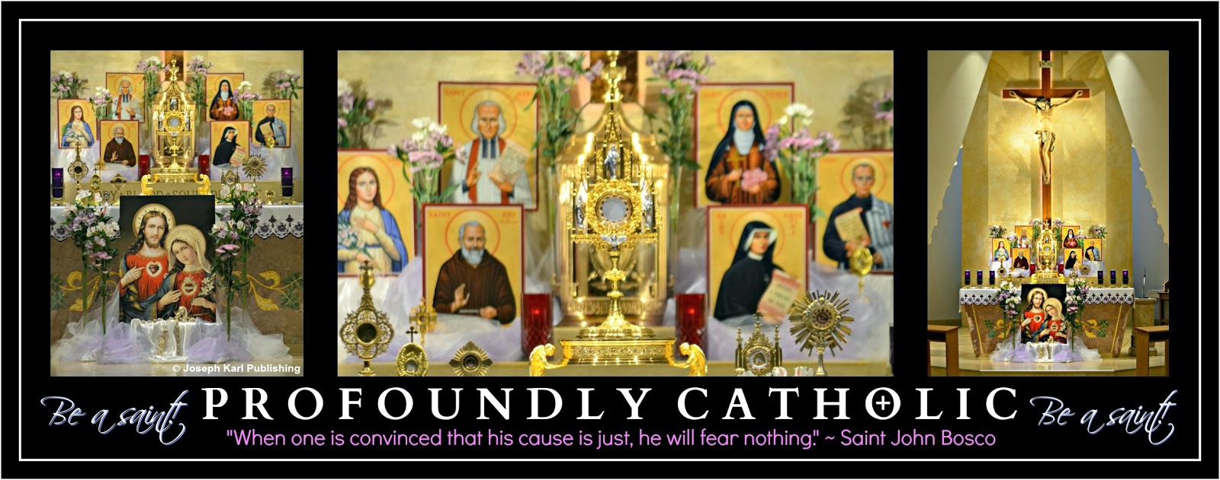
Don't ever just be Catholic; be PROFOUNDLY Catholic! There is SO MUCH MORE of God's love to discover and then keep rediscovering. God is so in love with us all!
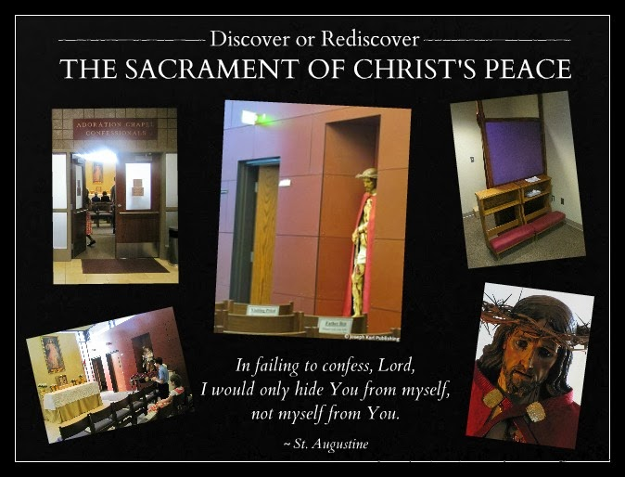
AMAZING GRACES
"If God is for us, who can be against us?" ( Romans 8:31).
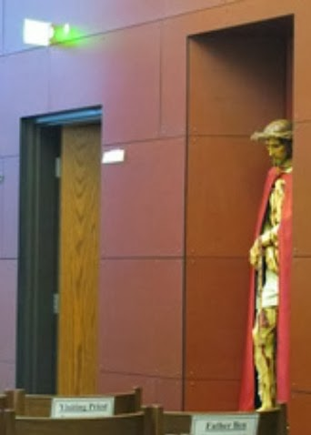Never underestimate the incredible power of the "other" Sacrament of Divine Intimacy, the Sacrament of Christ's Peace.
Take advantage of the opportunity in the confessional to ask the Lord and Blessed Mother to protect your purity and the purity of your entire family.
Ask the Holy Spirit to reveal to you what else you need grace for and then ask for Divine intervention tailored to the specific needs of your soul so you can continue growing in holiness.
YOU WILL!
Saturday, after confessing this soul's lack of faith, apologizing to the Lord for not trusting Him, and being absolved of this offense against God, this soul asked Jesus to increase her faith.
"No prayer is ever lost." ~ Saint John Vianney
And so this morning this particular soul left the house for the long drive to church in the Midwest's latest snowstorm, having forgotten her purse (and ID and money) and also having forgotten to fill the empty gas tank the day before.
After arriving at the church, realizing the importance in the rapidly accumulating snow of holding on to the only precious set of keys to the vehicle (as the other set rested comfortably at home in the purse), this small soul began a Holy Hour before Holy Mass.
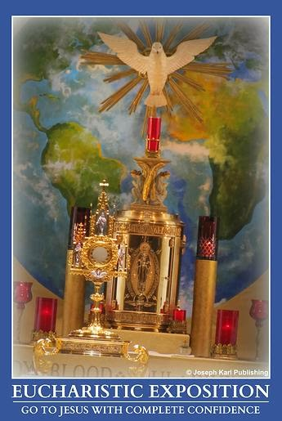Being so happy to have made it to church, and almost giddy from the power of His sustaining grace, the tired soul began the precious, and priceless, quiet time alone with the Lord in His Real Presence.
As we began conversing, Jesus began delighting and teaching, always loving so lavishly during His lessons.
"Jesus, why didn't You remind me to grab my purse before I left the house?"
He replied, "You're going to have to trust Me."
Sweet Jesus, how much You love every single one of us. Your wish is my command!
How is God at work in YOU? + + +

Two Inseparable Sacraments of Divine Intimacy, Jesus, Blessed Mother, Unrepentant Sinners, and You

A stunning new lesson that begins in a chapel and ends by the Sacred Heart and at the Feet of our very loving and merciful Teacher.
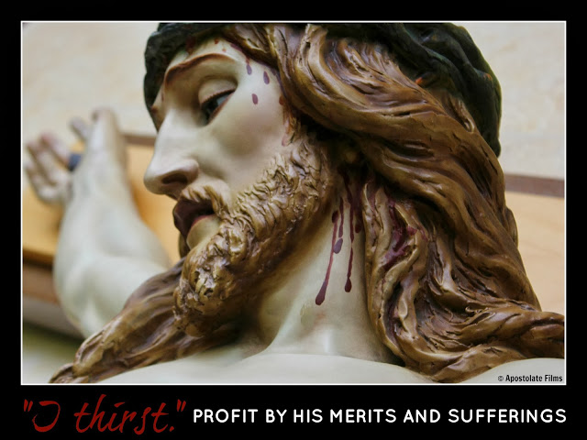

Don’t ever just be Catholic; be PROFOUNDLY Catholic! There is so much more of God’s love to discover and then keep rediscovering. He is so in love with you!

The Lord and Blessed Mother want to use you as a tremendous channel of love, mercy, and grace for precious, priceless, and immortal souls through all time. Let Them!

How is that best accomplished? By living sacramental lives of heroic virtue. Does that sound unattainable, impossible, unlikely?

It’s not; it is your calling. Holiness is your destiny.

A NEW LESSON

When the student soul is ready, the Teacher appears, and He is very, very nice.

Today’s lesson involves two sacraments of Divine Intimacy, the Sacrament of Reconciliation (Confession) and the Sacrament of Love (the Blessed Sacrament). This lesson is so powerful that for a few moments it renders you speechless in the confessional.

God loves us so lavishly, so extravagantly! Spend time with Him, and ask Him to show you by granting you spiritual vision so you can see things through His eyes. What a beautiful, wondrous world! Everything is so much more beautiful, and positive, and clear when seen through God's eyes.

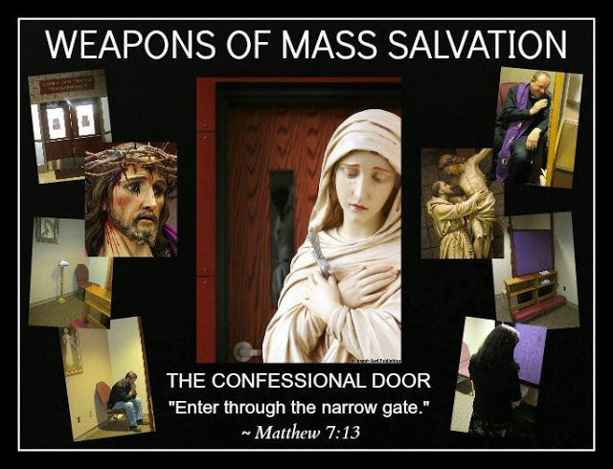

TODAY’S LESSON BEGINS IN A CHAPEL

Today as part of the lesson, the Lord summons you to go to confession. Sometimes He summons us and for various reasons, and sometimes He waits for us to come to Him on our own for various reasons.

Time spent remaining still (mentally and physically) in prayer conversing with the Lord is necessary for proper discernment.

You respond to the Lord's summons by first conducting an examination of conscience, and then write out your confession. A short while later, you travel to church and enter the chapel.

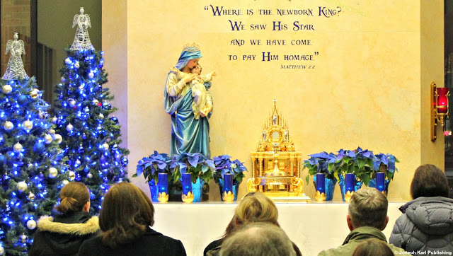

PREPARATION

You humbly, happily, and lovingly greet our Lord, kneel next to the confessionals, and begin praying while waiting for confessions to begin. You pray to God asking for help making a good confession, and also pray for your confessor, for all confessors, and also for all the people who are also there to receive the Sacrament of Christ's Peace.

The devout faithful must always remember to pray, and to pray for one another. Praying beforehand helps you and others make good confessions and helps the physicians of our souls care for us well.

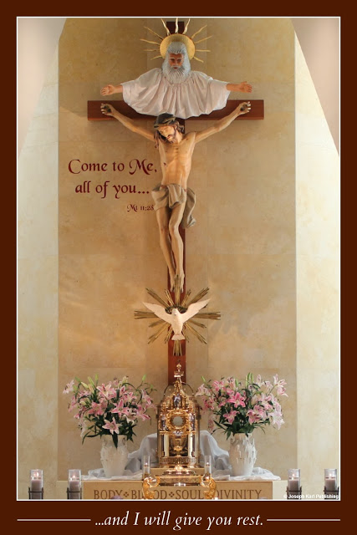

A STUNNING SIGHT

Suddenly, the Lord reveals Himself to you in an incredibly striking way: you see Him in each one of the confessionals to your right. Jesus is present in each room and He is hanging crucified on the Cross.

Meditate for a moment on what our Lord is showing you.

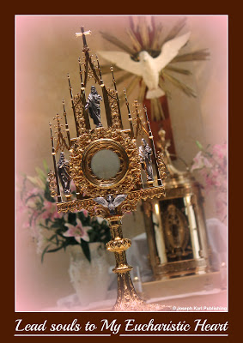Jesus has suffered through His Passion, is beaten beyond recognition, His Sacred Flesh absolutely shredded everywhere by the merciless scourging at the pillar, He has been stripped of His clothing, crowned with thorns, and is covered with dirt, His own Precious Blood, sweat, and tears shed for us, and also covered with spit, malice, rejection, unbridled hatred, and hair which has maliciously been pulled from His Sacred Head and His Holy Face.
Jesus is just covered with our judgment and is enduring our punishment in our places.

Jesus presents Himself to you in this powerful way as you prepare to present your heart to Him at the foot of His Cross.
Our Savior is barbarically stretched out in His catastrophically injured condition and nailed to a Cross. As immobilized as Jesus is, He exerts every effort to lean His Sacred Body forward despite His agony to get as close to everyone as He possibly can. As He does so, love and mercy absolutely pour from Him everywhere and cover all those who are willing to accept them.
The unfathomable love and mercy of our Creator also pour forth for all those who will not accept them, and we must be there to accept the graces for them, in their place.

What our Lord reveals is absolutely stunning, because you are not merely seeing an image but being granted a profound understanding of unfathomable mercy pouring from His extravagantly loving Sacred Heart and His catastrophically wounded Sacred Body.

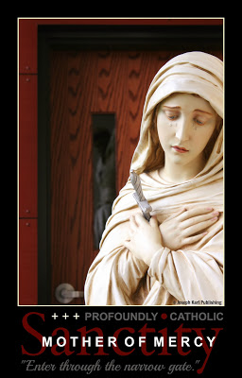Our crucified Lord is there in every room simultaneously, even in the confessionals that are not being used for confession that evening.

MORE REVELATIONSFOR THE STUDENT SOUL
Jesus has more to show you because you are so eager to learn and then teach others.
Our Savior further reveals Himself Crucified on the Cross next to everyone waiting in the chapel for his/her turn to confess. You see so many Crosses with Christ crucified on them, and His love and mercy pours forth upon everyone, extravagantly.

We are loved and valued more than we can ever imagine.

YOUR CONFESSION

As you kneel before our Crucified Savior and make your confession, you are absolutely overwhelmed by the limitless love and generosity of God, and for a time are rendered speechless.
The faithful waiting outside must wait just a little longer, but the Lord rewards them with His Presence on the Cross right by their sides.
After being absolved of your sins, you gratefully and joyfully thank God and also your confessor, because our priests are the filters of humanity's filth, and we owe them our eternal gratitude for their sacrificial, loving, and vital ministries.

Still profoundly moved, you exit the wound in Christ’s Sacred Heart through the confessional doorway and enter the church to thank the Lord and to prepare your soul for the Holy Sacrifice of the Mass and union with Jesus in the Blessed Sacrament. God is so good!

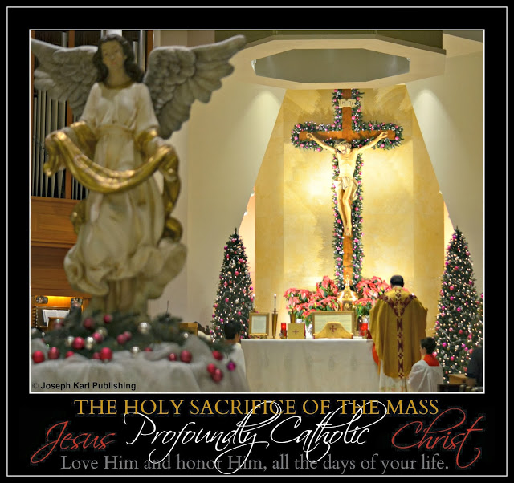
A VISIT FROM BLESSED MOTHER

As you begin saying the prayers of your penance, Blessed Mother presents herself by your side. She has come to collect your tears, the product of your immense gratitude, love, and submission to the will of God.

God’s most holy Mother presents a cloth for this purpose, and when you see it, you tell her that it is too bad that you had not thought of pressing a cloth against our Lord’s Sacred Body in the chapel to collect His Precious Blood as you have been taught to do in the past. Blessed Mother smiles, and responds that she had done just that while you were in there, and is using that very cloth to collect your tears!

OUR LORD AND HIS MOTHER SET THEIR SIGHTS ON UNREPENTANT SINNERS

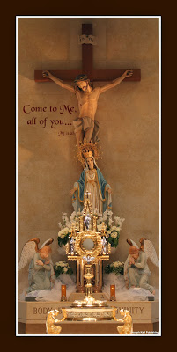Then, she places her hand on your shoulder and has the souls of all unrepentant sinners placed on the cloth, then wraps them inside of it, and then places this precious and priceless bundle in the manger on the tiny Sacred Body of her newborn Son, right by His little Sacred Heart.

You shed more tears of gratitude because God and His most holy Mother care for us all so lavishly, so kindly, and with great compassion and mercy.

Then, Blessed Mother presents another cloth which she also pressed against the wounded Sacred Body of her Son on the Cross in the chapel and also in the confessionals.

She collects more of your tears with it, and has you place the souls of all the members of the Sacred Priesthood of her Son inside of it.

Then Our Lady of the Blessed Sacrament places the cloth on the Sacred Body of Jesus in the manger next to the other one, close to His infant Sacred Heart.

And then it happens a third time as the tears continue to flow down your cheeks, precious waterfalls of sacrificial love and thanksgiving. Blessed Mother has you place the souls the members of your family in this third cloth, and then she places this precious bundle among the others, which resemble soft cloth dolls given to a child, to be loved and nurtured by our little Master.
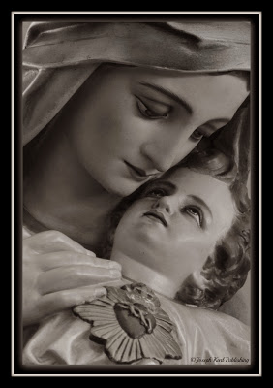
.
THANKSGIVING

While praying and remaining still after Holy Mass with the One Who remains with us always because this pleases Him a great deal, Jesus shows you that His little Sacred Body in the manger is holding those three precious bundles by His little Sacred Heart as He rests underneath the Cross on which He is also Crucified in the church.

Then, Jesus shows you the same image and this time, the Divine Infant and His precious bundles are positioned underneath all the Crosses in the chapel and confessionals on which our Savior is crucified. His Precious Blood is cascading into the manger and onto the bundles, covering all the immortal souls contained within them with His unfathomable love and mercy.

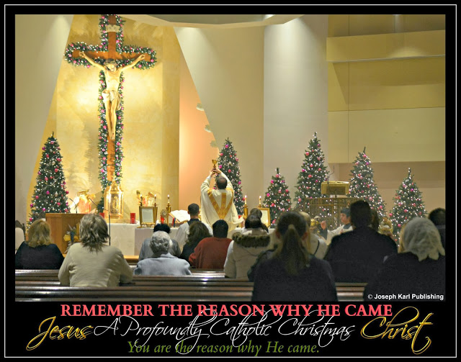

ALWAYS STRIVE TO LOVE GOD IN GREATER MEASURE

On your way home that night, Jesus tells you that you can satisfy His longing by loving Him in greater measure to make up for those who love Him less.

Praise be to Jesus Christ, now and forever!

PART X
FORGIVENESS

Forgiveness

A Profoundly Catholic Christmas: We Must Forgive Constantly and Unconditionally in Imitation of Christ
If we really, truly understood the importance of forgiving in imitation of Christ and Blessed Mother, we would always immediately forgive everyone of everything.
”If a man finds it very hard to forgive injuries, let him look at a Crucifix, and think that Christ shed all His Blood for him, and not only forgave His enemies, but even prayed His Heavenly Father to forgive them also. Let him remember that when he says the Our Father, every day, instead of asking pardon for his sins, he is calling down vengeance on himself.” ~ Saint Philip Neri
The following very important lesson is presented to you today in two parts, part one during the Holy Sacrifice of the Mass, and part two while praying a Holy Hour before the Blessed Sacrament.
When the student soul is ready, the Teacher appears. The Lord knows everything and He is very, very nice. Listen to Jesus, learn from Him, and do what He says! Our Savior wants what is best for you. He also wants to use you as a tremendous channel of love, mercy, and grace for other people.
LET HIM.
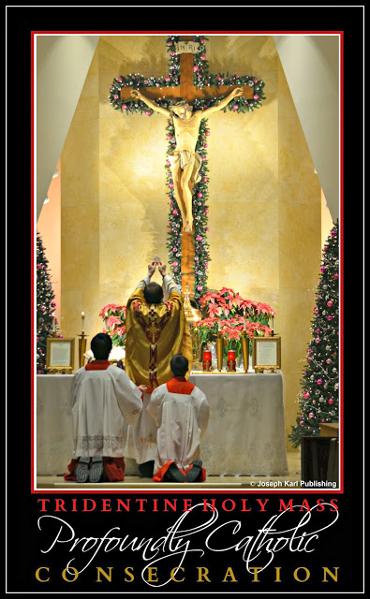
PART I: A VERY LARGE VEIL IS LIFTED IN CHURCH
"He who knows how to forgive prepares for himself many graces from God. As often as I look upon the cross, so often will I forgive with all my heart." (390) ~ Saint Faustina
Profound Catholicism is so very interesting! The first part of the lesson is rather short.
While you are listening to the homily during the Holy Sacrifice of the Mass, a veil appears before you in the church, about halfway between you and the altar. It is sheer enough that you can see through it but the veil is not thin. It extends all the way from the ceiling to the floor and to both sides of the church.
Right after you begin seeing this veil, it begins lifting. The veil is not parting vertically like curtains do. Instead, it is rising horizontally from the bottom up.
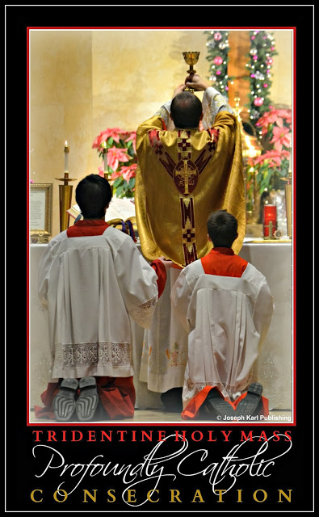
ONE WORD FROM THE VOICE THAT MAKES NO SOUND

"For there are three ways of performing an act of mercy: the merciful word, by forgiving and by comforting; secondly, if you can offer no word, then pray - that too is mercy; and thirdly, deeds of mercy. And when the Last Day comes, we shall be judged from this, and on this basis we shall receive the eternal verdict." ~ Saint Faustina
As the veil is being drawn up, you hear your name said one time by a voice that makes no sound. Your name was pronounced very gently, and also softly.
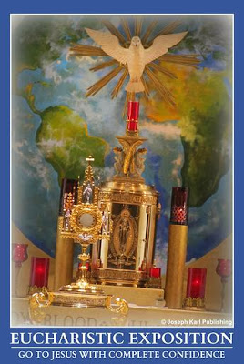
Next, you see your name before you, in the air by the veil that is being lifted. Your name is written in script that is presented to you as being soft and gentle.
Your name is very large (as is the veil), and it is presented to you at an angle, as if it is moving forward toward the altar.
The rest of the Holy Mass is celebrated as usual and the Lord shows you nothing else. He awaits your visit to the Blessed Sacrament, and then He continues and concludes the lesson.
PART II PRESENTED DURING A HOLY HOUR
Visits with Jesus in the Blessed Sacrament are very important, very necessary, very loving, and very surprising! He is so in love with us all!
Be sure to love Jesus with all your heart as He loves you with all His.
A REVELATION DURING THE CHAPLET OF DIVINE MERCY
"This Blood that but one drop of has the power to win all the world forgiveness of its world of sin." ~ Saint Thomas Aquinas
You begin a Holy Hour by praying the Divine Mercy Chaplet.
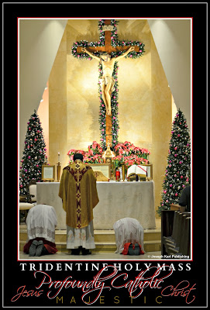As you pray, the Lord launches into quite a powerful explanation. Jesus tells you that all the trials that occurred in your lifetime took place by Divine Providence so that He could use you as His instrument of love, mercy, and grace at this time, and so that your mission could come to fruition and ultimately be completed.
Our Lord has important plans for you!

Jesus presents some of the most difficult trials of your life to you, trials involving great injustice. You are shown moments where you were treated very, very badly.
Jesus says that all those events had to occur so that God could use you as His instrument at this time and place, an instrument who had to endure those trials so that you could forgive everyone of everything.
Jesus tells you that this complete and unconditional forgiveness is a condition that must be met in order for the Lord to be able to use you optimally, and once met, will lead to some very beautiful things.
Our Savior tells you that is just what He did and had to do when He willingly become the Victim for us all. In order for God's will to be completed through Him, Jesus had to completely forgive everyone of everything.
Remember how He was treated, most notably during His Passion and Crucifixion.
ALWAYS FIGHT EVIL WITH GOOD
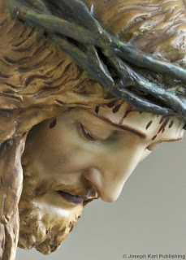
What the Lord presents to you, this incredible turn of events that takes evil and transforms it into great good, is so incredibly moving, and beautiful and loving, that you are inspired to recite a very beautiful canticle of gratitude to God.
As you recite it to Him with all your heart, tears of gratitude and joy stream down your face and soak your neck.

While praying the Chaplet you go through the Sorrowful Mysteries at the same time as a method of meditating on Christ’s Passion.
As you do so, it becomes clear that the Lord wants you to do something specific with all those injustices that He has mentioned to you.
Little Jesus comes over and stands by your side as you pray. He is so happy to be with you, and is wearing a crown of thorns.

LITTLE JESUS HAS VERY SPECIFIC PLANS FOR YOU

In between the prayers, you ask little Jesus to take everything that has by Divine Providence happened to you into His small Sacred Hands and present everything to God the Father at the altar, for the accomplishment of His will.
But little Jesus, as glad as He is by your beautiful gesture, will not do it that way.

So you ask the Divine Child how He wants you to go about accomplishing the Lord's will. Little Jesus doesn't tell you!
Not yet.

THE SORROWFUL MYSTERIES

After concluding the Chaplet of Divine Mercy you begin praying the Sorrowful Mysteries, having no idea what will happen next. As you pray the Mysteries in order, the Lord reveals some things to you out of order to prepare you to do what He wants as He wants it done.

JESUS' AGONY IN THE GARDEN

While praying in the Garden with our Lord, He tells you that you are going to present all the injustices from your entire life to God the Father, but not in the Hands of the Christ Child. Jesus tells you that instead, you are going to place something within the wound in His Sacred Heart during the final Sorrowful Mystery.

Curious, you wonder if all those experiences are going to be placed within the wound in Christ's side as He is Crucified on the Cross. The Lord tells you no, that is not what is going to happen.
So you wonder if you are going to place your FIAT into His side instead.
The Lord reveals to you exactly what He wants and does so in the most beautiful way.
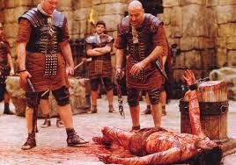

THE SCOURGING AT THE PILLAR

As Jesus is scourged at the pillar, He has you take all the individual experiences where you had been harmed or mistreated, all the ones that you can remember especially the biggest ones, and place them within His wounds as He is scourged at the pillar.
As you do so, you see the word FORGIVENESS exiting each one of those wounds and you collect them all.
Jesus is so incredibly kind and merciful. Our Savior offers you compassion and a purpose for each one of those injustices there at the pillar, as both you and He submit to God's will and offer everything to Him so great good can be accomplished through you.
AN INQUIRY FOR JESUS
At one point, you wonder why Jesus is not requiring that you place any of your sins and faults within the wounds on His Sacred Body. You ask our Savior why not, but He disregards your inquiry and continues on with the lesson.
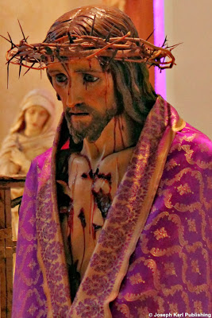THE CROWNING WITH THORNS

While Jesus stands bound and crowned with thorns, you place whatever smaller injustices and injuries you can think of in the wounds on His Sacred Head caused by the thorns.

THE POWER OF WORDS

Jesus then shows you your name as you saw it earlier in church as the veil was lifted. Your name is not as big this time. The word fits within your two hands, and it is made of wood.

THE CARRYING OF THE CROSS

As Christ carries the Cross to Calvary, you are shown that your name, as it was presented to you, is the Cross you are to carry throughout your mission in this life.
Next, you see that the Cross Jesus is carrying is made of your name, too, along with the names of everyone else. It appears similar to a piece of wood that many people had carved their names into.

You also see that you can help our Savior carry the Cross made up of all of our names while at the same time He helps you carry yours.

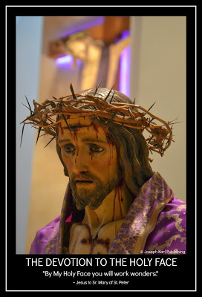The Lord also shows you the manger He rested in as an Infant was made of wood, and constructed of all our names in the same way as the Cross.

THE CRUCIFIXION

Next, you find yourself standing at the foot of the Cross with Blessed Mother and the Child Jesus, Who had accompanied you through the Sorrowful Mysteries once you began praying the Chaplet of Divine Mercy.
As you hold the Child Jesus in your arms, He, Blessed Mother, and you take your name and together, place it into the wound in Christ’s side on the Cross.
Each one of you is wearing a crown of thorns.
Little Jesus and Blessed Mother are very pleased that this is being accomplished, and as you are placing your name into the Sacred Heart of Jesus on the Cross, the three of you say out loud, all at the same time and very resolutely, “FIAT!”

There was the fiat. It was part of the plan all along. +
The Lord provides the most interesting endings. Even though this is just the beginning.
"Christian revenge consists in forgiving those who offend us and praying for them. Always conduct yourself in this way and your life will be a very happy one." ~ Saint John Bosco

ADDRESSING JESUS ON THE CROSS

"The patient man goes through a great and salutary purgatory when he grieves more over the malice of one who harms him than for his own injury; when he prays readily for his enemies and forgives offenses from his heart; when he does not hesitate to ask pardon of others; when he is more easily moved to pity than to anger; when he does frequent violence to himself and tries to bring the body into complete subjection to the spirit." ~ Thomas A. Kempis, The Imitation of Christ
In conclusion, you position yourself even closer to Jesus on the Cross and the moment is so moving your neck is once again soaked with tears.
You look up at Jesus and perhaps say something like this: Jesus, thank You for dying for me. I love You back! I give myself entirely to You, and promise to love and honor You all the days of my life.

Then you offer yourself to God the Father completely, in imitation of Christ and Blessed Mother.
SACRIFICIAL LOVE IS THE MOST POWERFUL FORCE IN THE UNIVERSE
The Lord wants to use you as a very powerful instrument, a tremendous channel of love, mercy, and grace for precious, priceless, immortal souls through all time. LET HIM.
The beginning.

Forgiveness

"Ecce Homo!" Remember the Reason for His Coming

Jesus just keeps coming and coming and coming and coming. How familiar are you with the Reason for the season?
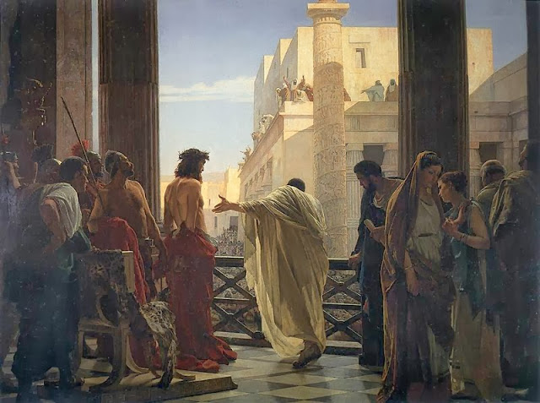
"Ecce homo!" Behold the Man.
How familiar are you with the Reason for the seasons of Advent and Christmas? How familiar are you with Jesus the Reason, your Savior, and the Love of your eternal life.
He is so in love with you.
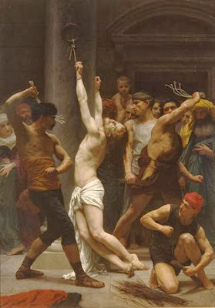LESSON EIGHT
During this very powerful lesson as Advent concludes and Christmas draws near, Jesus brings you to the pillar where He is scourged.
First, our Lord unifies you with Himself and shares that moment with you physically and very personally.
Kind and gentle Jesus! Your poor Sacred Body, that same tortured and suffering Sacred Body that we receive in the Eucharist. May we always receive You with great reverence, gentleness, love, compassion, and awe.
Next, the Lord has you watch the scourging from very close proximity.
Suddenly, you see words begin exiting the wounds in Christ's Sacred Body as His Precious Blood projects in all directions, sowing the seeds of faith out into time and space.
The first word you see exiting His wounds is LOVE. The next word you also see begin exiting His wounds: MERCY.
Then, one more word begins exiting the wounds as His savage scourging continues: GRACE.
You are there with Jesus as these three words stream from the wounds in His Sacred Body during the scouring at the pillar.
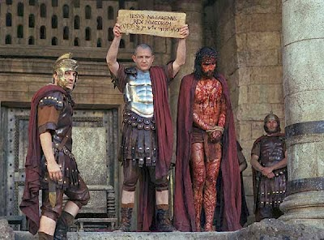
ECCE HOMO: BEHOLD THE MAN!

Immediately after that, the Lord takes you to another moment during His Passion. You find yourself standing behind Jesus and Pilate and can see past them, out into the crowd before them.
Two things are presented to you, very vividly to your eyes and very profoundly to your intellect: Christ's Precious Blood coming from His wounds and the crown of thorns on His Sacred Head.
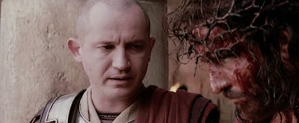
SUBMISSION AND SACRIFICE
Pilate says to the crowd, "Ecce homo!"
Behold the Man.

And then guess what happens. Do you know what happens?

Our innocent Jesus was rejected and shown no mercy in His catastrophically injured condition.

"My Jesus..."

What words do you express to Him at that defining moment for every soul.

OUR LORD'S RESPONSE

Just guess what happens next during this very powerful lesson presented to your soul by our Savior and the Love of your eternal life.

As Jesus stands before the crowd, having been so mistreated and rejected by so many, you see one word starts exiting the wounds all over His Body.
That word begins streaming from Him everywhere, since He was wounded everywhere.

The one word you see streaming from the wounds all over His Sacred Body as He stands before Pilate and the crowd during that very horrible moment: FORGIVENESS.

ECCE HOMO AND THE HOLY SACRIFICE OF THE MASS
Jesus takes you to the celebration of the Holy Sacrifice of the Mass for the next part of the lesson. At the start of Holy Mass, Jesus presents Himself above the altar. The scene unfolding before your eyes as Holy Mass continues is very dramatic and also very large, filling the entire space above the altar.
You see Jesus standing next to Pilate, and He has been brutally scourged and crowned with thorns.
Both men stand before everyone in the church, all the people in the congregation celebrating Holy Mass.
The Man with great courage was silent and spoke volumes; the man without courage spoke and said to you and to everyone present, "Ecce Homo!"
"Behold the Man!"
That moment is a very personal and very significant one for each one of us. Every one of us stands with Jesus at that very moment.
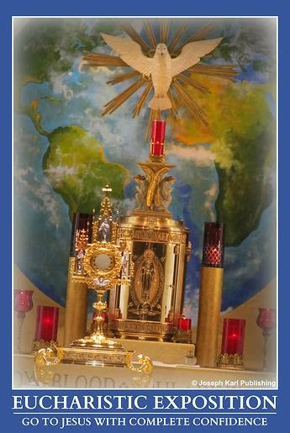

ANOTHER VERY PERSONAL PUBLIC AND PRIVATE MOMENT
Not only do you join those who were present at that very moment in time, you are present along with your congregation, and also along with all the congregations who were present for each Holy Sacrifice of the Mass offered through all time.
You are there collectively with a great many people, but also you are there alone, individually and very personally, to participate in that very significant event with Jesus.
BRING EVERYONE WITH YOU
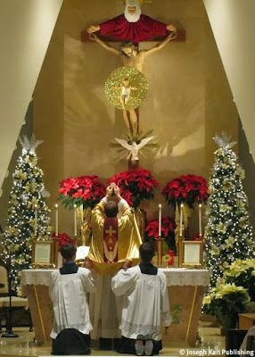Next, you are shown the people physically present in the church during that Holy Mass, and then are shown many more people present among them.
They are your loved ones who do not go to Holy Mass. Jesus tells you that you bring them with you when you pray for them. So many more people are there to hear Pilate declare, "Behold the Man!" because people in church are praying for them.
ECCE HOMO AND THE CONSECRATION
The lesson continues with your being shown Jesus at the Last Supper presenting His own Sacred Flesh and Blood in the Blessed Sacrament so He would remain with us always. In an instant you see and understand His knowledge as He did so that the Ecce Homo moment was coming.

So much could be said about those two moments that have been presented to you together at the time of the consecration.

At the Last Supper, already knowing He was going to be so mistreated and rejected and in particular at that one moment, Jesus gave us Everything we need and Everything worth having anyway. He gave us Himself anyway, and He keeps coming and coming and coming and coming.
MERRY CHRISTMAS!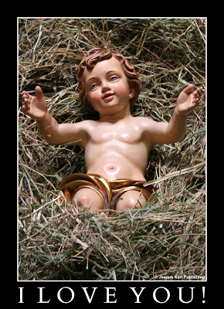
Behold the Man.
Spend time getting to know Jesus and avail yourself of the Sacraments He instituted for every single one of us, knowing that we need the love, mercy, graces, and forgiveness provided to us by God through them.
Accept Jesus into your life.
Receive Him from the hands of Pilate and show Him compassion, love, reverence, and awe. Treat Him well, the King of kings.
Love Him lavishly, and extravagantly.
Accept His magnificent offers of salvation and sanctification.
Live a sacramental life of heroic virtue. Obtain much needed grace for yourself and for others.
Work hard at remaining in a state of grace and enjoy the most incredible moments of Divine intimacy with Jesus when receiving Him in the Blessed Sacrament, the Sacrament of Love.
Give yourself to Him completely as He gives Himself to you completely. Promise to love Him and honor Him, all the days of your life. Our Lord longs to create the most beautiful things from your union.
Jesus is so in love with you!

Part:
Purity, Christ’s Passion, and Your Protection
Another divine lesson from the Sacred Heart of the Teacher who loves and values us more than we can ever imagine.
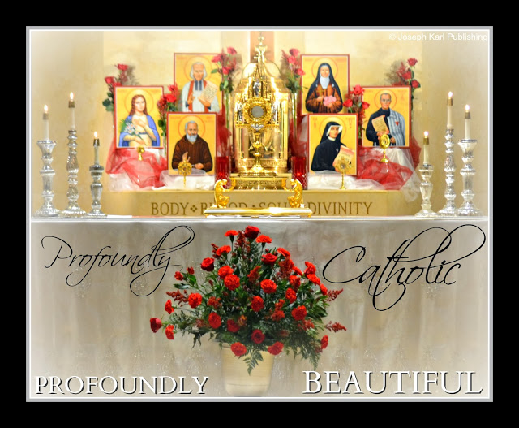
Don't ever just be Catholic; be PROFOUNDLY Catholic! Especially during Advent, the time of year
when we prepare our hearts to celebrate the coming of our Lord and also during Christmas, when we welcome the One who just keeps coming and coming and coming and coming.
There is always so much more of His love to discover and then keep rediscovering.
Our Savior longs for our love in return; accept His love! He loves us all so lavishly. Love Jesus lavishly in return.+++++++
Find yourself blissfully lost in His Divine embrace; be enveloped within love so great we just cannot even fathom It. Christ's waiting, welcoming, loving, compassionate, and merciful arms are open wide, for you!
Go to Him, discover Him, then discover Him ever more intimately, and as you do so guide other precious, immortal souls to Christ.
Bring Him everywhere. +
LESSONS FROM THE LORD DURING ADVENT JUST FOR YOU
Lesson 1: "Ascend Higher!"
Lesson 2: The Light of the World
Lesson 3: A Present for You from Jesus.
Lesson 4: A Mother/Son Rescue and the Powerful Weapon in Your Hand.
Lesson 5: Living Entirely for Jesus as He Guides Your Soul to Perfection.
Lesson 6: On Determination: The Only Spiritual Defeats are the Ones We are Willing to Accept.
More than thirty meditations on Christ's Passion to help guide you during Advent and Christmas into some serious Divine intimacy with the Love of your eternal life: Meditating on Christ's Passion.
LESSON SEVEN: ANOTHER REVEALING ASSAULT FROM THE DEVIL

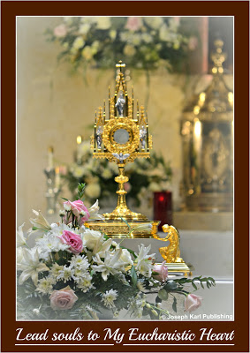For today's lesson, the Lord allows the devil to present himself and openly attack your family's purity.
"We must be pure. I do not speak merely of the purity of the senses. We must observe great purity in our will, in our intentions, in all our actions"' ~ St. Peter Julian Eymard
You may be surprised that it took this long for this lesson to be presented, because anyone's purity makes the devil absolutely furious but an entire family's purity makes him crazy with fury.
"God desires from you the least degree of purity of conscience more than all the works you can perform." ~St. John of the Cross
Our adversary knows the eternal value of purity and that is why he works unceasingly to destroy it. Just look around you; the evidence is everywhere.
The devil shouts vulgarities at us and tempts us in so many not-so-subtle ways and also subtle ways, while at the same time very few people are openly promoting and encouraging purity by word and by example.
You must be one of the people who openly promotes and defends purity. It is every Catholic's obligation, and we need you.
THE DEVIL'S POWERFUL WEAPON
Do you know what one of the most effective weapons satan has in his modern arsenal is, one which he is aggressively using to destroy humanity by attacking our dignity assaulting our purity?
It may surprise you. Perhaps you may not even believe it at first, but take a closer look through a very powerful, profoundly Catholic lens and you will see it very clearly.
Many, many well intended people have been enticed to help him accomplish his goal to destroy humanity, attack our dignity, and assault our purity and they have been lured into doing so by their insatiable pride and greed.
"In temptations against chastity, the spiritual masters advise us, not so much to contend with the bad thought, as to turn the mind to some spiritual, or, at least, indifferent object. It is useful to combat other bad thoughts face to face, but not thoughts of impurity." ~St. Alphonsus Liguori
SOMETHING WORTH NOTING

Are you aware that when you return to your place in church while unified with Jesus in the Blessed Sacrament during Holy Communion, Jesus is not only within you, He is also next to you, and kneels by your side.
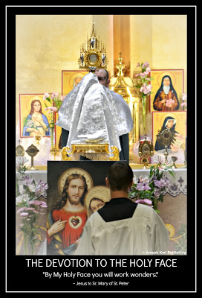
Next time you receive the Blessed Sacrament take a closer look through that spiritual lens and see that both He and you are wearing robes. They are mock robes but nevertheless they are quite elaborate, and you are both crowned with thorns.
Each time you receive our Lord in the state of grace, He places His arm around your shoulders, holds you close, and protects you. He is there to protect your purity because you have asked Him to.
"[God] has assigned as a duty to every man the dignity of every woman." ~Pope John Paul II
Jesus personally protects your purity through the power of two inseparable Sacraments of Divine Intimacy: The Blessed Sacrament and the Sacrament of Reconciliation.
Avail yourself of His help, often.
BACK TO TODAY'S LESSON
To continue the lesson, you are shown the devil coming to your family and it is made very clear to you that he is very successfully using the medical profession, MODERN MEDICINE (as opposed to HEALTH CARE in imitation of Christ) as a means to accomplish his plan to destroy humanity by assaulting our dignity and attacking our purity.
Pride blinds us, while humility reveals things to us very clearly.
GREAT PEACE

Even though you see the devil attempting to assault the members of your family one by precious one, knowing clearly that is his plan, the Lord floods your soul with great peace and you are surprised to find that at that moment, you are not at all disturbed by this grave evil.
"Don't say, 'That's the way I am—its my character.' It's your lack of character. Esto vir!—Be a man!"
--St. Josemaria Escriva
Even though you have the very natural and holy desire to protect them, the Lord has you watch the events as they unfold.
THE DOCTOR
You are shown that the doctor the devil wants to use as his instrument of destruction is not harming them, but is properly caring for and protecting them instead! The doctor has dark curly hair and at first, you do recognize who he is.
"When you decide firmly to lead a clean life, chastity will not be a burden on you: it will be a crown of triumph." ~ St. Josemaria Escriva
MORE ROBES
The next thing you know, the very peaceful doctor who had taken command of the situation calls you over to his desk where you see him speaking to several of your family members. He has looked after them well and has outfitted them, robed them, with long doctor coats which you see offer them protection from the assaults of the devil. The members of your family and the doctor are so comfortable together, it seems as if everyone knows the doctor intimately, and everyone is so incredibly happy.
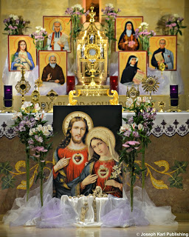"To be pure, to remain pure, can only come at a price, the price of knowing God and loving him enough to do his will. He will always give us the strength we need to keep purity as something as beautiful for him." ~Blessed Mother Teresa
THE DIVINE PHYSICIAN
You find yourself so attracted to the doctor's incredible peacefulness, the fact that his holy face radiates such joy, conviction, and protection, and are intrigued that He is capable of filling all of you with so much peace and joy.
You find yourself asking the doctor with great curiosity and also delight, "What is your name?"

He looks into your eyes and says with such great kindness, "My name is Dr. Cross."
As He tells you His name you look on his lab coat and see the name "Dr. Cross" embroidered on it, and then your eyes travel to the lab coats your family members are wearing and see that the caring doctor has outfitted them with his own personal lab coats which also have his name embroidered on them.
Our Divine Physician values our human dignity and protects our purity by clothing us with the power of His Cross.
EVERY SINGLE CHRISTIAN'S OBLIGATION
"To defend his purity, Saint Francis of Assisi rolled in the snow, Saint Benedict threw himself into a thornbush, Saint Bernard plunged into an icy pond . . . You . . . what have you done?" ~St. Josemaria Escriva
What have you done and what are you doing to protect the purity of others. Doing so in imitation of Christ is every single Christian's duty.
Oh, so much more could be written about today's lesson. What can you add to it?
The beginning.

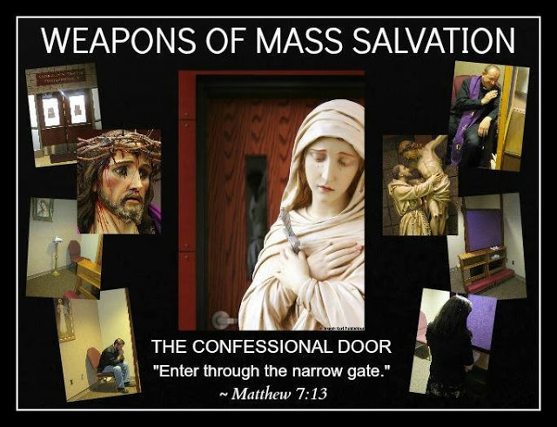
Go for everyone in your family (don't confess for them, go for them)
and ask the Lord in the confessional to protect your family's purity.

Part: Perseverance?

The Sixth Lesson of Advent, on Determination: The Only Spiritual Defeats are the Ones We are Willing to Accept
Encouragement for the devout faithful to remain strong and not feel defeated, because as Jesus reminds us, "I am with you always" (Matthew 28:20) and "with God, all things are possible" (Matthew 19:26).
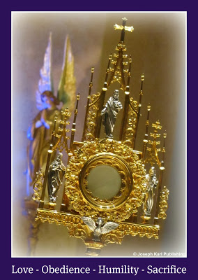
Don't ever just be Catholic; be PROFOUNDLY Catholic! Especially during Advent, the time of year when we prepare our hearts to celebrate the coming of our Lord.
There is always so much more of His love to discover and then keep rediscovering.
Our Savior longs for our love in return; accept His love! He loves us all so lavishly. Love Jesus lavishly in return.
Find yourself blissfully lost in His Divine embrace; be enveloped within love so great we just cannot even fathom It. Christ's waiting, welcoming, loving, compassionate, and merciful arms are open wide, for you!
Go to Him, discover Him, then discover Him ever more intimately, and as you do so guide other precious, immortal souls to Christ.
Bring Him everywhere. +
LESSONS FROM THE LORD FOR YOU DURING ADVENT
Lesson 1: "Ascend Higher!"
Lesson 2: The Light of the World
Lesson 3: A Present for You from Jesus.
Lesson 4: A Mother/Son Rescue and the Powerful Weapon in Your Hand.
Lesson 5: Living Entirely for Jesus as He Guides Your Soul to Perfection.
More than thirty meditations on Christ's Passion to help guide you during Advent and Christmas into some serious Divine intimacy with the Love of your eternal life: Meditating on Christ's Passion.
LESSON SIX
A very big weapon the devil uses to assault Christ's followers in our time is discouragement, and it is 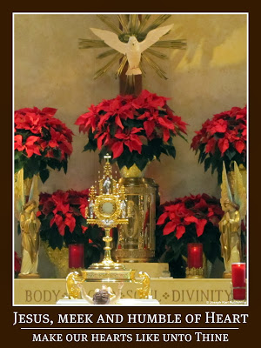quite plain to see it pouring forth from the hearts of the devout faithful as soon as Advent begins.
Many had already long been dreading the arrival of the modern day assault against humanity that occurs during Advent and Christmas in full force.
So much attention is focused on spending, shopping, creating marketplaces, selling, advertising, and God spare us from the aggressive marketing and manipulative fundraising. It seems we cannot even escape from these things because they have infiltrated our society like a rapidly spreading cancer.
The cure? The Sacred Body and Precious Blood of Christ.
The counterstrike: Offer up all temptations to feel discouraged for the conversion of sinners. This turns the devil's assaults against him and ransoms many precious, immortal souls held captive in the black abyss.
Businesses and fundraising are meant to be good and holy things, but far too often in our times what was intended by God to serve people, care for them and help them, has become the devil's way to get people to batter other people just to acquire money and power, and far too often this is being done in God's Holy Name.
We must remain mindful of this trick of the devil to make us feel discouraged and defeated, all this excessive spending, shopping, collecting, and focusing on things very contrary to the simple and holy life of poverty and service chosen by our Lord, the King of all kings, and His most holy Mother.
Certainly it is going to take an act of God to stop it.
Nevertheless, every assault from the devil can be turned against him and into an opportunity to grow in virtue, educate others, save precious, immortal souls, and be powerful living representations of the Holy Face of Jesus. Jesus is not absent from anywhere, and we can bring Him everywhere we go!
Be Christ's living, traveling tabernacle.
Do not allow yourself to be overcome by the lack of self mastery that absolutely surrounds us, because great good can be accomplished during Advent, and in so many very simple ways while not falling prey to another one of the devil's tricks of encouraging us to be excessively busy.
Avoid excessive busyness and excessive business like the plague, especially if it keeps you from spending time with our Lord in prayer and especially if it leads you to disregard the needs of others.
Take time each day to be with our Lord by going to Holy Mass. Go, and be unified with Him in the Blessed Sacrament for everyone in your family who does not go and do not despair: "Go For Everyone in Your Family."
Go to the Lord with complete confidence and persevere. Spend lots of time with Jesus in the Blessed Sacrament.
Make sacramental confessions of devotion regularly. Saint John Bosco referred to confession as "the devil's bankruptcy."
"Do you want to become saints? Here is the secret: confession is the lock; confidence in your confessor is the key. This is how you open heaven’s gates." ~ Saint John Bosco
Serve in imitation of Christ and Blessed Mother, and defend the rights of God, particularly in His own house, in your house, and everywhere else.
Wish everyone a very joyous "Merry Christmas!"
Smile, a lot. This is a very powerful way to defeat the devil as he tries to discourage us.
He strikes at the heart of our human dignity and he has many well intended people working very hard for him, but our Lord knows the condition of everything and He reminds us, "Behold, I make all things new" (Revelation 21:5).
To encourage you in your efforts to live a sacramental life of heroic virtue, Jesus provides you with the following very personal lesson.
Go, Team!! God is at work in you.
MORE DIVINE UNION ALONG THE WAY OF SACRIFICIAL LOVE
While meditating on Christ's Passion today, look at the Holy Face of Jesus which He presents to you bleeding so profusely as Christmas draws near. Jesus very briefly yet very powerfully has you unified with Him during a particular moment along the Way of the Cross.

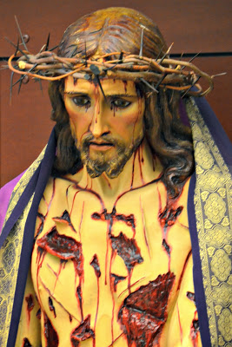
You realize that Jesus still has a way to go before making it to Calvary, and are shown the determination on His Sacred Face, the determination to suffer as much as possible before surrendering His life on the Cross for our Redemption.

He allows you to not only see this, but you can also feel it.

PROFOUNDLY CATHOLIC DETERMINATION

Jesus, Your Face, your Most Holy Face! Look into His eyes as you share this moment so deeply with our Savior.

Meditate on that one moment along the Way.

The wicked and barbaric disfiguring of Christ's Holy Face was unable to stop His inner beauty from pouring forth from It.

See it pouring forth like His Precious Blood is, as both beauty and Blood are pumped out completely by the unfathomable and uncontainable love within His Sacred Heart.

Look upon His Holy Face and see It radiantly projecting that look of determination, which so powerfully bears the expression of sacrificial love.

Jesus, our First Priest, our High Priest! Our Father, and Brother. Teacher. Counselor. Friend! The Love of our eternal lives.

This determination of His, Jesus wants us to share in it, because His followers must possess it.

We are to ask our Lord for great determination to save souls, because He is going to give us lots of it.

"By My Holy Face you will work wonders." ~ Jesus to Sr. Mary of St. Peter

THE EMOTIONAL SHREDDING OF CHRIST DURING HIS PASSION AND CRUCIFIXION
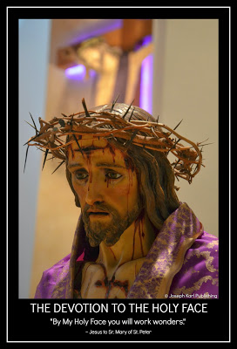The Lord presents you with an additional lesson today.

This second lesson has to do with the mental, emotional shredding that occurred simultaneous to His physical agony while He suffered as God Who became Man. By taking on our humanity He subjected Himself to a horrific mental agony, so much could be written about it, so many different types of mental suffering, such an unfathomably large amount.

What a striking lesson, to have Jesus present this mental anguish to you as an emotional shredding that paralleled the shredding of His Sacred Flesh at the pillar.
Jesus allows you to experience this in small measure, and it takes you several hours to recover from the experience. The mental suffering is so overpowering you are astonished that our Savior was even able to walk, let alone carry the Cross and then offer Himself to be crucified upon it, let alone keep forgiving while remaining patient, gentle, and humble.
We must go to Him for what we need to accomplish God's holy will, and He will provide everything.
Sweet Jesus, please provide us with great determination.
DIVINE INTIMACY AND SPIRITUAL VICTORIES
This part of the human condition He took on for our sake is something we must always share in union with Him, for we all experience mental suffering, sometimes even extreme anguish, to varying degrees and throughout life.
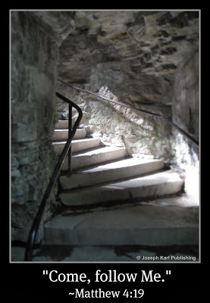All of it is important and provided to us by God for a reason. So much of it we don't even recognize and these are very important moments of Divine intimacy through which we draw closer to Christ.
Let us profit from the Lord's providence for our souls.
"Do whatever He tells you" (John 2:5).
THROUGH THE VICTIM WE ATTAIN VICTORY
It is through these mysteries, through sacrificial love which includes patient suffering, complete surrender, and a very generous, forgiving, and courageous heart graced with fortitude that grave, widespread, and deeply rooted evil is defeated.
Truly, the only spiritual defeats are the ones we are willing to accept.
Often, we do this because the devil has been our only teacher.
The beginning.

Spiritual Warfare

What Every Soul Must Choose: To Battle the Lord or Battle the Devil
The soul that resigns itself to accomplishing the most holy will of the Lord stops wrestling God and starts wrestling the devil.
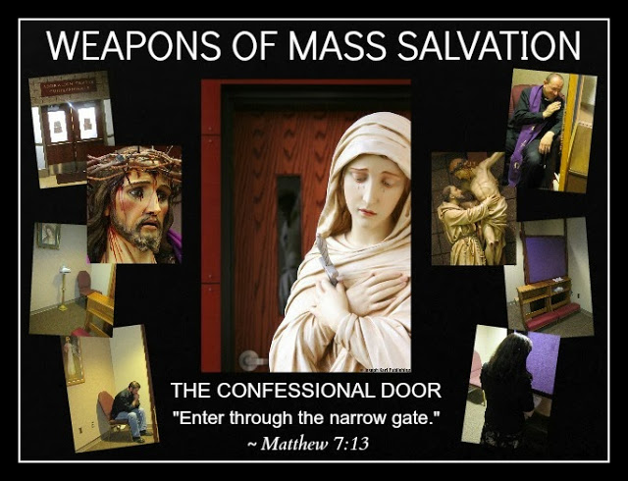

"What I recommend most earnestly is not to lose heart when you are tempted.
Do you wish to succeed?
The best way is to reveal the temptations to your spiritual director immediately.
The devil loves darkness.
He always operates in the dark
because he knows that if he is discovered he is beaten."

~ Saint John Bosco

"The Sacrament of Christ's Peace"
(video)

Starving for meaningful material?
More PROFOUNDLY Catholic material on spiritual warfare (click here).

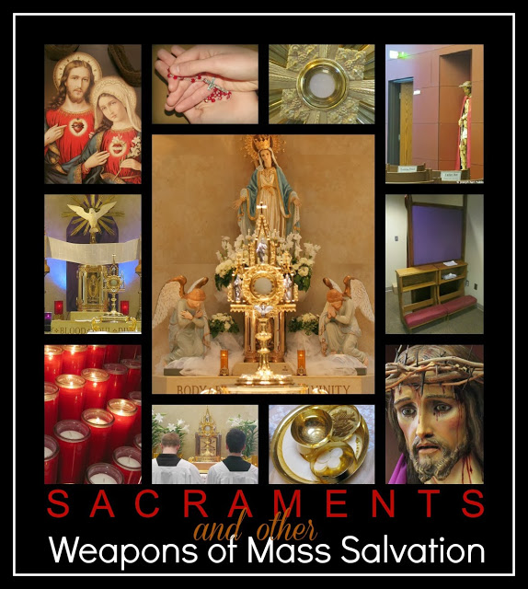

POWERFUL and PROFOUNDLY CATHOLIC audio meditations
to help you recognize the battlefield,
know your enemy, discern whose side you are fighting on,
fight the spiritual battles, and win:

Apostolate Films on Mixcloud (click here)

Go, Team!!

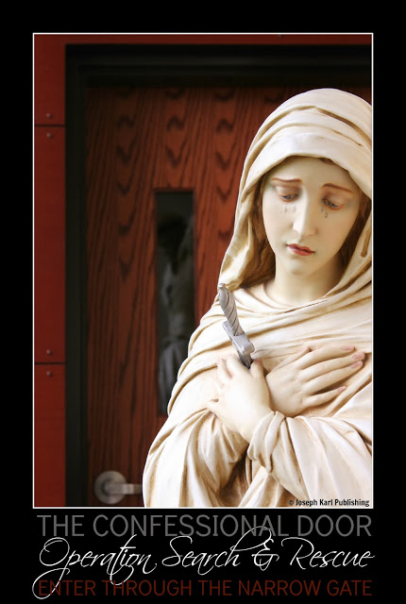

"The Devil's Great Weapon Against Humanity" (click here to read the article)
We live in the time of the greatest assault against the human person in the history of mankind. The devil uses a very powerful weapon against us. Do you know what it is? Does he use it on you.
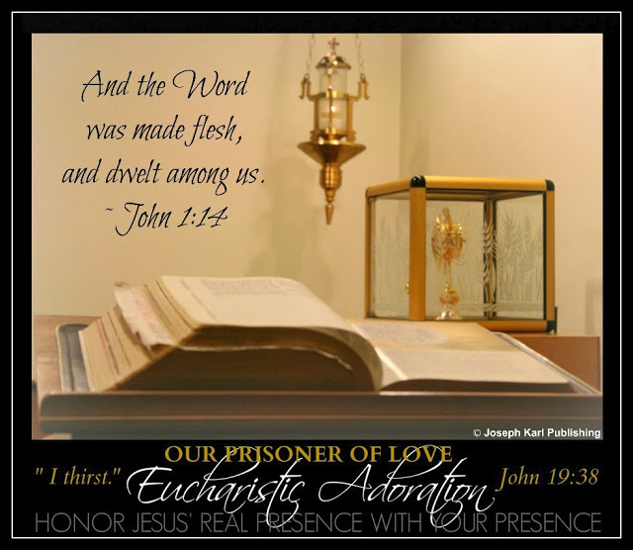

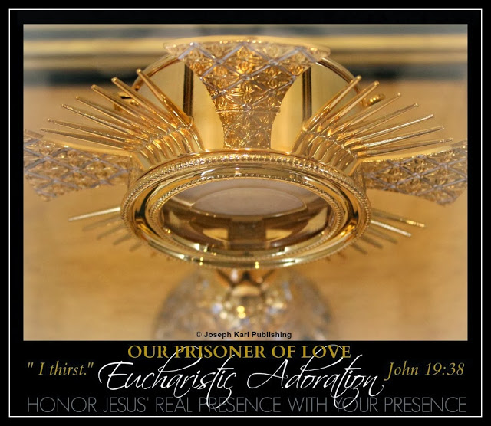

"Trust all things to Jesus in the Blessed Sacrament and to Mary, Help of Christians,
and you will see what miracles are."

~ Saint John Bosco
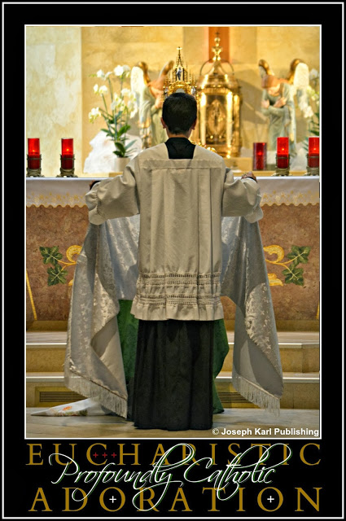
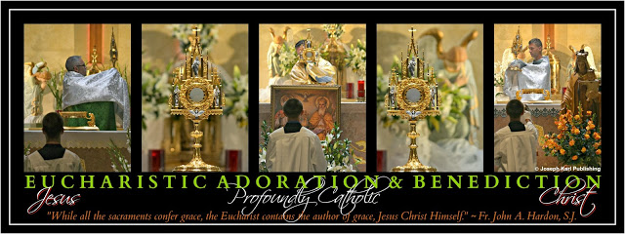

© Joseph Karl Publishing /Michele Bondi Bottesi
Images taken at Ss. Cyril and Methodius Slovak Catholic Church,

Sterling Heights, Michigan, U.S.A. Parish Website

Starving for meaning material?
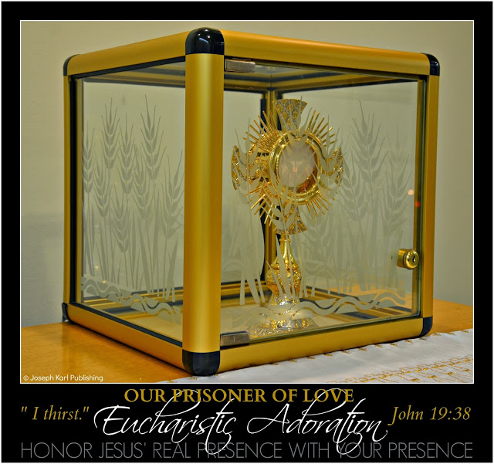

Take a VERY POWERFUL and PROFOUNDLY CATHOLIC mini-retreat
from wherever you are!
To access a fishing boatload full of PROFOUNDLY Catholic material
including award-winning books, pictures, articles, audio, and video,
immeasurably and eternally valuable and FREE, just like God's love,
visit: www.josephkarlpublishing.com
God is so in love with you!!

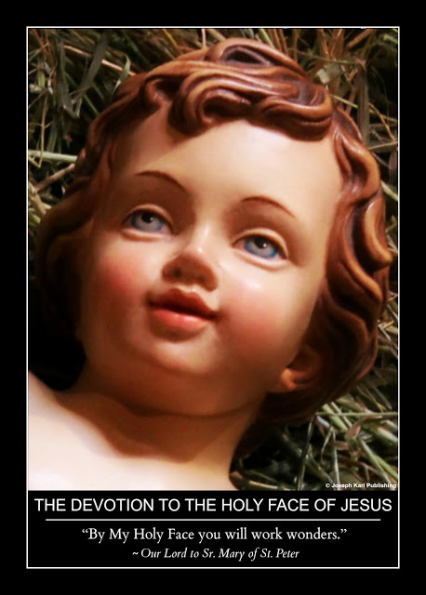

Spiritual Warfare

Two House Tours in Seven Minutes that Will Benefit Your Soul Forever
Take two very different house tours with two very different owners and ask yourself, "Whose house have I chosen?"
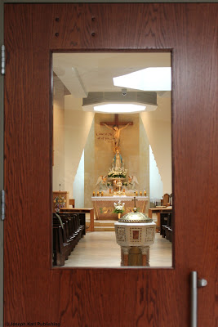
New, just for you! Seven minutes of PROFOUNDLY CATHOLIC audio from Apostolate Films.
Here's what happens:
"It's all yours," the devil says to you.
"NO, you were NOT meant for this," says the Lord...
You must choose one of two houses.
They are both really beautiful.
Which house do YOU choose?
Choose wisely, because the battles for precious, immortal souls are fought and won in only one of the houses.
Do you know which one? Which house has your soul chosen.

The Devil's House versus God's House
Which one do YOU prefer? Choose wisely.
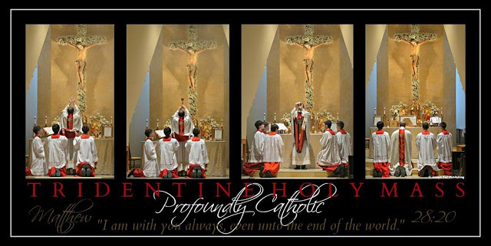
Imagine that one night, the devil pays you a visit and he takes you to a very beautiful house.
The minute you step foot in the house you find the decor appealing. Very quickly you realize that everything in the house including the rooms, the staircase, the pictures on the walls, the furniture, and even the carpeting are very much to your liking.
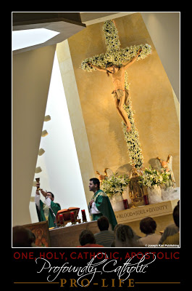You find yourself very allured by the house and everything in it. How is that even possible; it's the perfect house!
Next, the devil, who is masquerading as someone who cares for you a great deal, tells you that you can have the house.
"It's all yours," he so touchingly whispers in your ear as he leads your soul from one room into another. He is so proud of the house, you deserve it, and he wants you to have it! He is going to give it to you.
How wonderful it is to be in that house, built with such beautiful materials...the decorating in each room is so masterfully done, everything is so pleasing to the eye... everything is so clean, so orderly, so tidy...the colors in every room appeal to you, you love the layout, the furniture, the smell...everything in that house is so incredibly w a r m a n d i n v i t i n g .
Your benefactor is happy beyond measure to see that you love the house. He has been hard at work getting you to like it.
YOU ARE NOT MEANT FOR THIS
All of a sudden the illusion is shattered when you hear a loud, commanding, and eternal Voice say, “NO! You are not meant for this.”
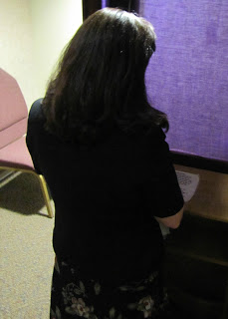The voice of God brings you to your senses, and you find that you are no longer in that house.
THE DEVIL'S HOUSE VERSUS GOD'S HOUSE

Later that day, you write out an examination of conscience, travel to church, then pray in the chapel while waiting your turn to make a sacramental confession.
When it is your turn, you go into the confessional and are forgiven and healed by Jesus.
Then you leave that room, pass through the chapel, and enter into the church for the Holy Sacrifice of the Mass.
While praying before Holy Mass, you stare out into the church while speaking to the Lord, and the sight of the beautiful church and everything in it makes you smile. It is always so beautiful there.
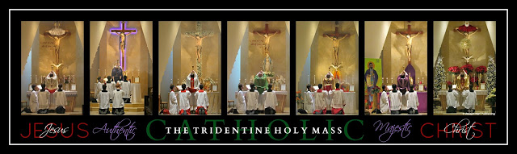
GOD'S HOUSE ALSO HAS VERY BEAUTIFUL ROOMS
The next thing you know, the Lord says to you that overnight, He had allowed the devil to take you through his house and tempt you to accept it.
Why would the devil tempt you to accept that house? Because the devil knows that you spend a great deal of time in God's house, and he doesn't like it.
The Lord further explains to you that His house has rooms just like the devil’s does, and you realize that you had just been in several of those rooms: the chapel, then the confessional, then the church.
There is also a beautiful mystical stairway to heaven in God's house! It was built with the most loving material, sacrifice love, and is held together with the Precious Blood of the Homeowner.
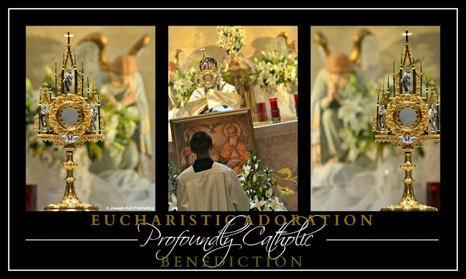
WHY IT MATTERS WHICH HOUSE YOU PREFER
The battles for precious, immortal souls are fought, and they are won, in God's house.
WHAT A BEAUTIFUL HOUSE!
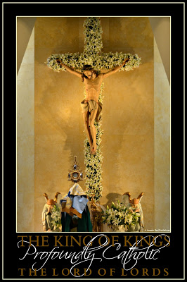Though out the Holy Mass, you look at God’s house and contrast it with the house tour you were given by the devil over night, and are shown how that house had nothing holy in it, no religious pictures, no Crucifixes…it was sterile. Who would want such a house?
You are shown that God's house has the Real Presence of Jesus Christ in the Eucharist.
God's house also has a beautiful altar, a Crucifix, the Stations of the Cross, beautiful statues, candles, holy water fonts, plain wood pews, and delightful kneelers...
JUST FOR YOU FROM THE LOVE OF YOUR ETERNAL LIFE
In contrast to the devil’s tempting you with beautiful decorating in your favorite colors, the Lord shows you an exquisitely beautiful crucifix made of roses that He made and placed in His house just for you. Even His Body, His Corpus, is made of roses. God is so in love with you!
"How lovely, Jesus," you tell Him. "Thank You." +
WHOSE HOUSE DO YOU PREFER?
That incredible day, you found yourself in two very different houses.
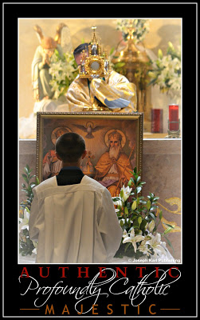As soon as the devil brought you into his house, under false pretenses, he began appealing to your fallen human nature. He studies every one of us very well, and he's very clever. He appeals to us through our weaknesses.
The devil's goal on the surface appeared to be to attract you to the house and give it to you because he's generous, but his actual goal is to steal your soul and trap you inside the house, with him, for eternity.
GOD IS LOVE AND THE DEVIL IS A LIAR
As soon as you chose to reconcile yourself to God and then honor the Lord and receive Him in His house, He began restoring your fallen human nature. He knows each one of us better than we know ourselves, because He knows everything. God appeals to us through the Cross.
On the surface, the Lord's goal seems to be to make your life harder and take things from you, but the truth is God gave us everything He had, and He also gave us everything we have. God's goal is to save your soul and guide you to paradise, where you will spend eternity unified with Him in love that we just cannot imagine.

Part

"This Makes No Sense!"
To God, everything makes sense. Another PROFOUNDLY Catholic confession story that reminds us once again to trust in the Lord always, and do what He says! (smile)
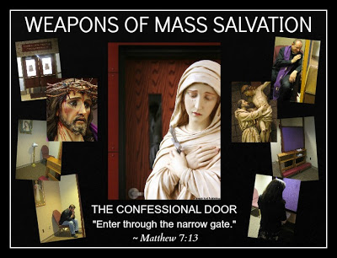How many times things happen and we respond by saying to God, "Lord, this makes no sense!"
Then He reminds us that what we think and feel aren't always relevant to the equation because we don't always know the full extent of the math problem, nor do we always know what the solution is going to be.
Things don't always add up to us, but God always has the right "numbers" to make everything work out the way He determines is best.
As I ended up saying this morning to my confessor, "If only I would do what God tells me, things would go a lot smoother!" (smile)
GOD ALWAYS KNOWS BEST
Remember always that when the Lord tells us to do something, imperatively keeping in mind that God never asks us to anything that will cause harm to anyone, what we think and feel is of no consequence when it is precious, immortal souls we are serving. Why? Because we don't always understand everything, nor do we always know how things are going to work out in the end.
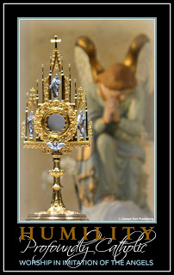And so it happened that two days ago I went to confession, 3 1/2 weeks after my last one. In between those incredible encounters with Christ at the foot of His Cross so many things happened, including very personal moments of Divine union with the Lord, and also with the forces of evil, the challenges of daily living, and a two week spiritual honeymoon that took my family through beautiful Pennsylvania, the lower Finger Lakes Region of New York, and Boston.
Once again, the suffering before going to confession Wednesday was tremendous. I had actually hoped to go on Saturday, five days prior, but once again the cat was out of the bag, the devil heard I was preparing to go, and going suddenly got very complicated.
Praise God my confessor Father Raymond, a visiting priest, was incredibly wonderful and together with our Triune God, Blessed Mother, the Holy Angels, Martyrs and Saints in heaven, the Holy Souls in Purgatory, and tens of millions of Holy Innocents, that sacramental confession was very beautiful. They all are, despite what we happen to perceive, think, or feel. Go, Team!! + + +
EVERY SINGLE SACRAMENTAL CONFESSION HAS GREAT PURPOSE
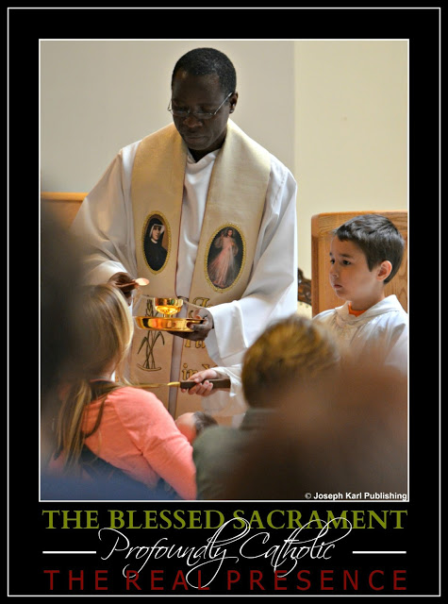
Father Raymond Saba distributing the Eucharist,
as a devout altar boy holds a paten
during the Holy Sacrifice of the Mass.
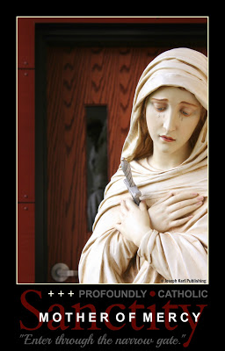Early that afternoon, I felt physically and mentally terrible and had to lay down for about an hour. Late that evening I still felt rather terrible, and while doing some work before the Devotion to the Holy Face, the Lord summoned me quite powerfully to join Him in prayer.
I made the mistake of elevating how I was feeling above the wishes of Jesus, and did not meet Him in prayer that night as He had asked.
That defiant choice displeased Jesus and I tried to make it up to Him the next night, but because of my disobedience He summoned me back to the confessional this morning.
At least the devil was given no advanced warning, and had very little time to tempt me to defy the Lord and not go.
WE MUST NEVER ASSUME WE WILL BE GRANTED ANOTHER DAY
When the Lord clearly asks us to do something we must do it. I was blessed to have another day to do what the Lord said, but we must never assume that we will be granted another day in this life.
So this morning the Lord told me to return to the confessional and in order to get there in time, my children and I had to get ready in a hurry, eat our first meal of the day, and get to church before the noon Holy Mass.
I quickly wrote out some things that had been inspired by the Lord and added my own examination of conscience. We ate brunch in the car while on our way to the church.
A BIG SURPRISE
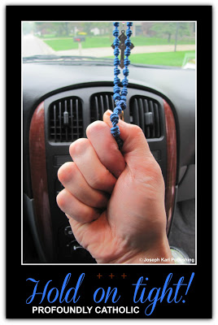
After arriving at the church, my two altar boy sons went to put on their black cassocks and my daughter and I rushed through the doors of the chapel. Holy Mass was going to begin in twenty minutes.
"Please let this go well," I asked Jesus as we opened the doors.
We entered the chapel and found it was quite full. More people entered right after we did.
And so what did this faithless creature do? I said to Jesus, "Jesus, why would You have me rush here this morning knowing it was going to be so full?"
The devil immediately told me to forget it. "It's not meant to be," he said. "You can go next week. Let all these other people go instead." I was very tempted and almost gave up right away (head shaking as I write this, such a feeble soul). But there would be no confessions for the next two days because of the parish festival.
PROFOUNDLY CATHOLIC TRUST
I knew it would not be a good thing to go against the will of the Lord a second time, and so I very quickly assessed the situation. All this happened in a matter of seconds.
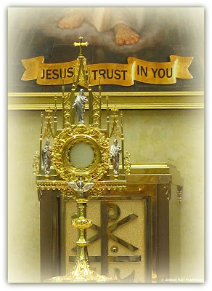I looked to the right and saw that there were three priests hearing confessions. Praise the Lord! There are three priests! Then I quickly counted the number of people waiting. At least twelve people, three priests, four rotations and it would be my turn. There would be enough time to go before Holy Mass.
The Lord summoned me here; I'm going!
WHO THE HECK IS NEXT??
Keep in mind it was a challenge to accomplish the will of God on such short notice. My daughter and I remained standing in the back of the chapel (where we had stopped in disbelief) because we saw that there was no way of determining the order of who was next.
"This makes no sense!" I said out loud.
We didn't know what to do.
Then I said it again: "This makes no sense!" I may have said it a third time, my disbelief was so great.
However, I was there because of my disobedience to the Lord, and accept full responsibility for the error of my ways including the consequence of not knowing who was to go next.
Alyssa suggested we kneel down somewhere in the crowd and so as we began moving forward, I surrendered and having done all I could to fulfill God's will, handed the entire situation over to Him.
Guess what happened next.
DIVINE INTERVENTION
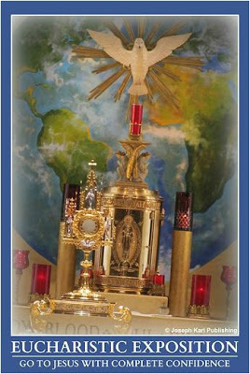I hadn't even taken a step forward when a fourth priest entered the chapel. He walked past us and into the confessional. As Alyssa and I knelt down somewhere in the middle of the chapel, the newest priest to arrive turned on the green light above his confessional door, and guess what happened next?
Just guess.
Nobody moved.
It was surreal. I could see the incredible events unfolding before my eyes and, knowing what was going to happen, was absolutely delighted by Jesus once again. My soul was filled with such incredible joy.
I looked around and everyone remained kneeling, so I asked the people in every direction, "Are you going?"
No one moved. I almost laughed out loud and actually did laugh when I wrote this. What an incredible journey.
Almost as soon as I had knelt down in that crowd I got up and went into the confessional!
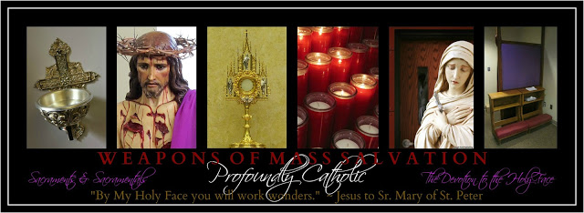
I thanked the Lord immediately for His tremendous goodness, knelt down beneath the Cross of my Crucified Lord, and reverently began.
In the Name of the Father, and of the Son, and of the Holy Spirit, Amen. Please bless me, Father, for I have sinned. My last confession was two days ago.
Your Majesty, I apologize to You for not coming to You two nights ago as You had requested. I know that this displeases You enough to warrant the necessity of kneeling here at the foot of Your Cross and apologizing to my Crucified Lord. Jesus, I love You and am sorry. Help me submit to You and all You have requested, Spouse of my soul.
Forgive me for my impatience and lack of fraternal charity, and for eating a few things I am not supposed to have (by doctor's orders), knowing that by doing this I will still suffer but by this choice suffer less, because I choose against self mastery and against your will, and that is not what You want.
Please continue helping me overcome my worldly, self-serving, pleasure seeking, defiant nature, and continue helping us part with everything we don't need.
Thank you for that magnificent experience of kissing a warm Crucifix this morning following Your inspiration to keep You close to my heart throughout the night. How much You love every one of us! I love You in return, give myself entirely to You as You have given Yourself to us, and promise to love and honor You all the days of my life.
Father's wise words about the importance of doing what God asks of us were followed by my saying an Act of Contrition, and then I was covered by the beautiful words of Absolution and the loving, merciful Precious Blood of my Lord and Savior, Jesus Christ. He is so in love with us all!!
With immense gratitude, I also thanked Father Craig for coming to the parish to hear confessions that morning. + + +
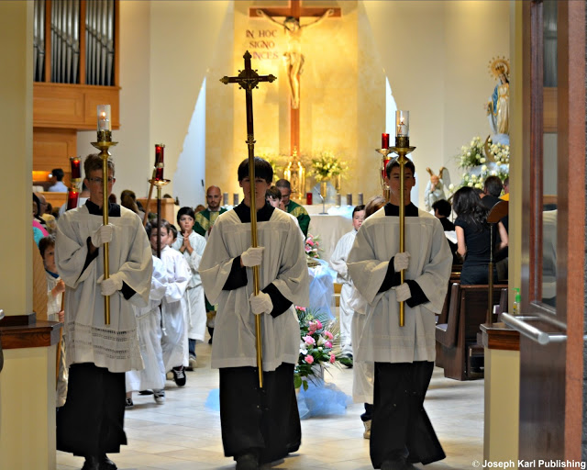
This afternoon's concelebrant Father Craig Giera on the left
and newest associate pastor Father John Simoneau on the right,
surrounded by so many devout altar boys.
"DO WHATEVER HE TELLS YOU" (John 2:5)
Sometimes things do not make any sense to us, and we must recognize that this is also part of God's plan. It is not always necessary for things to make sense, and sometimes, it is important that they don't! We must rise above our perceptions, thoughts, and feelings and always do as the Lord tells us because He knows best. When we trust in the Lord, He makes things work out, even when it seems to us that such things are impossible. With God, all things are possible, and He is so in love with us!!
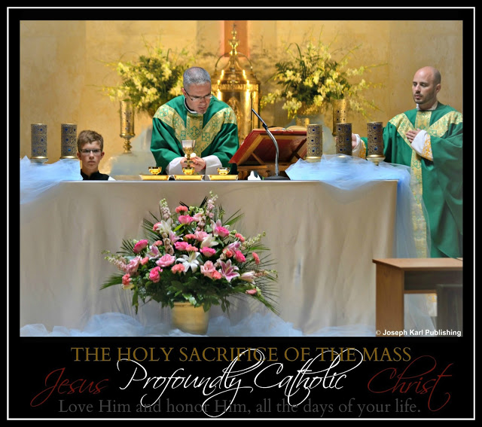

Perhaps my reward:
the Lord suggested I photograph at the Holy Sacrifice of the Mass today,
and my heart is still smiling! He is so in love with us all.
Concelebrants Father John Simoneau, left; Father Craig Giera, right;
and a devout altar boy during the Consecration.

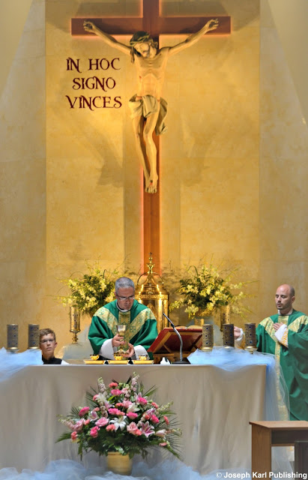
Frequent Sacramental Confessions and frequent reception of the Eucharist
are inseparable.
SACRAMENTAL CONFESSION: FORGIVE YOURSELF AND OTHERS CONSTANTLY AND BE FREQUENTLY FORGIVEN BY THE LORD
Enjoy more PROFOUNDLY Catholic material focusing on the Sacrament of Christ's Peace, all created to help you make your sacramental confessions meaningful, deeply intimate, and incredibly powerful: The Sacrament of Divine Intimacy

Part

A Confession, a Confrontation, Defiance, and a Request from Our Crucified Lord

One incredibly compassionate sentence that came from an innocent Man in agony on a Cross, the precious fruit of making frequent and meaningful sacramental confessions at a profoundly Catholic parish.
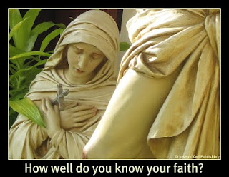
Don't ever just be Catholic. Be profoundly Catholic. There is always so much more of God's love to discover and keep rediscovering.
He is so in love with us!!
A SACRAMENTAL CONFESSION
Saturday it was time once again to make a sacramental confession. The soul determines this with the help of God, not on its own. That is why so many people do not go at all, or do not go often. They make the decision on their own and leave God out of it.
God wants us to make sacramental confessions; that is why He instituted Sacramental Confessions on Easter Sunday night.
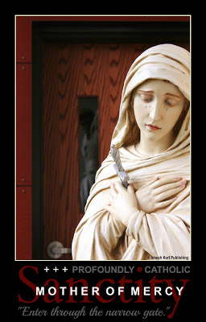
So little is known by many Catholics about this sacrament, this is a great tragedy, and not enough is said and taught about it in church, in catechism classes, in homes, and so many places where it should be the topic of conversation.
Receiving this powerful and vital sacrament is inseparable from receiving the Blessed Sacrament!
So many people say little or nothing about it because they know little or nothing about it.
And so the devil is our only educator, and he appeals to our fallen human natures in so many clever ways and insists that we not go, and/or that we can just apologize to God directly instead, as if that is the same thing as doing what God said we should do!
How tragic that any of us would ever settle for so little.
One of the things we must always confess is pride. The devil appeals to us through our pride. He appeals to us as if he loves us like God does, pretending he has our best interests mind. But never forget that he is a liar, a manipulator, a stingy thief, and a killer. The devil is full of empty promises and his goal is to keep each one of us company in hell, forever.
How often he tries to trick us through our intellect. The devil tells us we do not need to go to Holy Mass, it is no different than any other service being offered by any other denomination, he whispers into our ears that nothing special happens, that it is boring, and we should find our faith in things that are really fun. "Don't go to confession," he says to each one of us. "It doesn't matter. You don't really have to go. Nothing special happens. Why should you have to confess to a priest?" How quickly and easily we can be convinced to disregard the teaching of Christ's Church, perhaps we never even made a point to know it, and in so doing we disregard Christ Himself.
The devil's great weapon against humanity.
The easier road is never the Way of the Cross, and that is the Way we must travel to get to heaven.
Remember where pride got Lucifer, that majestic and beautiful, highly intelligent angel. Think about what our pride does to us.
This is how we conquer it, pride, a hard-fought battle worth fighting and winning. We step on to the
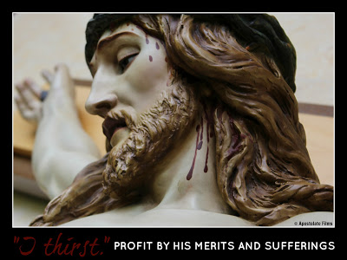
front lines on the battlefield and kneel right there on Calvary, at the foot of the Cross of an Innocent Man named Jesus.
There, in the presence of our angel guardian, Blessed Mother, our crucified Lord, the entire Blessed Trinity, and perhaps some saints, we admit our faults, our faults and not others' faults, sincerely and with sorrow. We conquer our pride by choosing to be humble and to submit to God's authority, when we acknowledge our place, which must always be lower than last place, for that is the place Jesus gave to Himself.
There can be no precious fruit without labor, without great effort, without bending, without suffering.
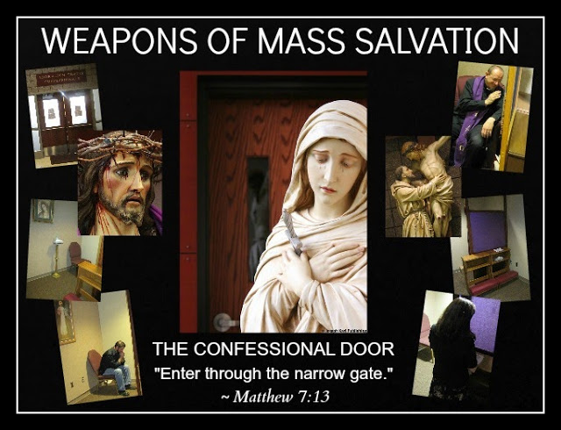
THE CONFESSION
Note the highlighted text of the examination of conscience, which was conducted with the aid of the Holy Spirit, and the fact that it has to do with the soul's petition that it not block the Lord's action within and through it. This is a very important detail and its purpose will be clear to you by the end of the story.
The sign of the Cross. Please bless me, Father, for I have sinned. My last confession was about a week and a half ago.

Glory be to the Father, and to the Son, and to the Holy Spirit!

Most loving Lord, I have come today because I love you in return, and kneel at the foot of the Cross to plead for your mercy and pardon, so grateful to you for Your patience with me, and for Your love and generosity. I apologize for the times my failures have hurt You, have hurt others, and have blocked Your most perfect plans from coming to fruition through me.

Please help me so that this never happens, Lord.

I apologize for my worldly, prideful, self serving, and pleasure seeking nature, my lack of self mastery, and the times I lacked fraternal charity and became frustrated with the behavior of others; truly, mankind has become disfigured by its own hand, but You are the answer to everything, Lord, have given us what we need in the Devotion to Your holy and disfigured Face which reflects what we have become, and I trust in You!

I apologize for the several times that I have spoken to my children harshly, eaten food I am not supposed to have, for turning impatiently yesterday which may have scared another driver, and even though that was not my intention it was the result of impatience, and even worse I was on my way to see You. These recurring weaknesses of mine are always fueled by great physical and mental fatigue, but knowing that You have a plan, I ask not for more energy but ask for greater patience, the patience of a saint!

I apologize for the bitterness I was holding in my heart yesterday toward a very difficult person and for speaking to him with a hard heart. In truth he is an incredible instrument in Your hands and great good is being accomplished through Him because that’s the way You are, and so I please ask you Lord to forgive me for my hardness of heart and please let me always be kind and forgiving, especially to this person. Please free us all from the demons that grip us; so often because we have invited them to join us...

Jesus please heal the hearts of all those whom I have harmed throughout the course of my entire life, in so many various ways, sometimes intentionally, and sometimes out of ignorance. Please heal the wounds of all of humanity so that we may be able to better serve you and one another as whole people, with You always present in our restored hearts.

I apologize to You for the times I have set a bad example for anyone. Please help me to love everyone as You love them, and always see You in them. Please make of me Your mirror, a living representation of the Devotion to Your Holy Face.

Please grant me the strength to be very careful when eating, and speaking, and help me to always be kind and generous like You. Thank You for your great love and mercy, Lord! I give myself entirely to You, and promise to love and honor You, all the days of my life.

An act of contrition, absolution, and then liberation!

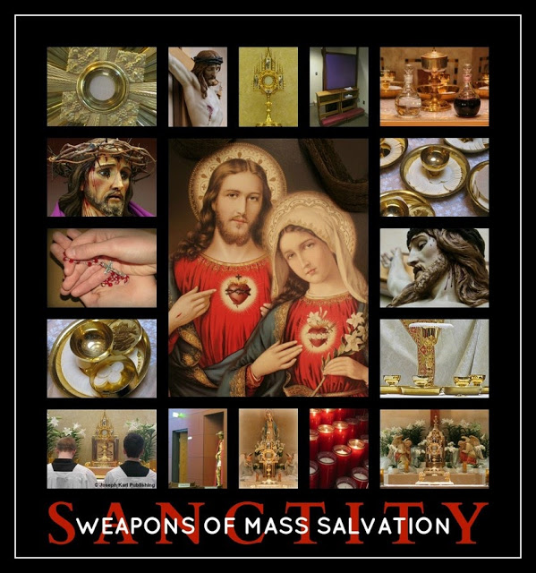

THE CONFRONTATION
After confession, I moved from the chapel to the church to pray before the Holy Sacrifice of the Mass. Right after kneeling in church to pray, I was confronted in a major and quite unexpected way by my defiant nature. The experience was unprecedented; the presentation before me of my defiant nature came to me from Jesus on the Cross above the altar, and it was enormous. The expression of this defiance seemed to fill the entire space between Jesus above the altar and me in the back.
THE DEFIANCE
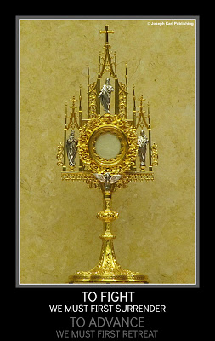
The experience did not make me feel bad, because it was clear the Lord was doing me a great favor.
He was giving me information that I needed, and also the means to fix it.
At first it was surprising, since this has never happened to me before, and because at the time I was expecting to feel more a sense of relief after having been forgiven of my sins. This is a reminder not to allow our feelings to deter us from accomplishing God's will.
The Lord granted a tremendous grace, the precious fruit of having received the Sacrament of Reconciliation, the Sacrament of Divine Intimacy.
But that was not all.
A REQUEST FROM OUR CRUCIFIED LORD
From the beginning of the Holy Sacrifice of the Mass, it was clear that everyone present was standing in the presence of our Crucified Lord on Calvary. The Lord inspired me to SHOUT to Him there on the Cross, to shout above the crowd (an action of thought) and beg Him to rid me of this defiance. Beg probably isn’t the best word but it makes the point; I was to purposefully petition our Lord and insist He change this defiance, and it seemed crucial that it be done right away.
When we don't ask the Lord then we are left to wonder how many things we do and are block God from acting within us, when He wants not only to have us ascend to greater heights of sanctity but to use us as tremendous channels of grace for the massive conversion of sinners.
I was shown this as an action similar to the moment when the Good Thief accepted Christ’s magnificent offer of salvation and sanctification. The Lord wants us to do this, to petition Him on Calvary as He hangs crucified on the Cross, for the things we are in need of, specifically the things
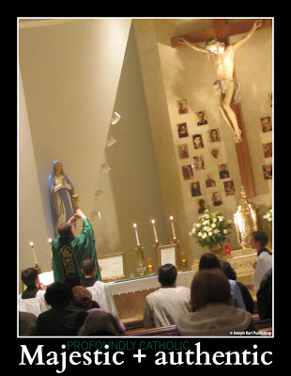
we need to change in ourselves so that He can work through us more perfectly.
The Lord wants each one of us to benefit from His Sacrifice, and so many people are not benefiting.
How is it possible, for us to benefit in this way? When we assist at the Holy Sacrifice of the Mass, we are there for the re-presentation of Christ's passion, crucifixion, and our redemption. These moments are of tremendous value to us, and also to others through us.
To fight we must first surrender; to advance we must first retreat.
So there on Calvary during the Holy Sacrifice of the Mass, I shouted toward Jesus on the Cross (silently, in a deliberate action of thought), and begged Him with serious purpose to change my defiant nature and transform me into His likeness.
I asked Him to fix this and also anything within me that is blocking His will from being accomplished within me and through me.
The power of His Sacrifice, of His Sacred Blood, can do this. Just one drop of Christ's Precious Blood was enough to redeem the entire human race! And during the Holy Sacrifice of the Mass we receive Christ's Body and Blood in such abundant measure, and we are mystically covered with His Precious Blood during the Sacrifice of the Mass, during our Sacramental Confessions, when we pray with Jesus in the Garden of Sorrows, and when we accompany Him along the Way of Sacrificial Love when praying the Stations/Way of the Cross, meditating on His Passion, praying the Holy Rosary or the Chaplet of Divine Mercy...
The Lord wants every person to petition Him in this way.
He wants us to ask ourselves while standing among the crowd on Calvary, “What do I shout out to our Crucified Lord?” Are we saying anything. Do we want to know anything.
CHRIST APPEARS AGAIN IN A SIMILAR WAY
The next afternoon, I returned to the chapel before Holy Mass to pray a Holy Hour before the Blessed Sacrament, by the confessionals and next to a replica of our gentle and humble Lord after He had been beaten, scourged, and crowned with thorns.
While praying the final Sorrowful Mystery, the Crucifixion, Christ presented Himself once again. He was crucified on the Cross, and He was much, much closer to me than the day before. He was so battered, and His suffering was indescribable, but my attention was immediately directed to the fact that Jesus' thoughts were not on Himself, they were on us.
He said, "Come to Me with what you need."
Really think about that for a moment. Our Lord is suspended on the Cross in absolute agony, He is battered beyond recognition, surrounded by His executioners, still being mocked, scorned, and rejected, and He says to us, "Come to Me with what you need."
What is your reaction to that.
I cried, and with gratitude and humility inspired by an immeasurably loving Heart torn open by a spear, the great instrument of Divine Providence which opened for us the gateway to God, said to Jesus, "I should be asking what it is I can do for You."
Accept God's magnificent offers of salvation and sanctification, and then love Him and honor Him, all the days of your life.
"Trust all things to Jesus in the Blessed Sacrament and to Mary, Help of Christians,
and you will see what miracles are."

~ Saint John Bosco
ASK AND YOU SHALL RECEIVE...
Discover and then keep rediscovering the One, Holy, Catholic, Apostolic, and Pro-Life Church, and the majestic full expression of Christianity as established by its very Founder, Jesus Christ.
How is God at work in you?

Part

Penitents, Confessors, "Unloading," and Powerful Channels of Grace for the Massive Conversion of Sinners
A confession story that reminds us to allow the Lord to lead us by listening for His voice, trusting in Him, and submitting our wills to His.
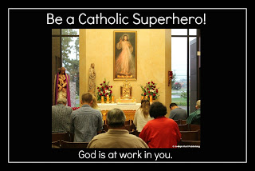
The following story is shared to highlight the importance of receiving the Sacrament of Reconciliation not only for ourselves but also to obtain graces for others. It also serves as a reminder of how important it is that we cooperate with the Lord and work together with our confessors and be tremendous channels of grace for the massive conversion of sinners.
A SUMMONS TO THE CONFESSIONAL AND REQUEST TO “UNLOAD”
It had been two weeks since my last confession when Jesus summoned me to return. He also said very clearly and specifically that while making my next sacramental confession, I was to "unload my burdens.”
Several times Jesus repeated it because He can read my mind (smile): He wanted me to “unload” in the confessional.
How sweet of Jesus to care for us so personally, always knowing what we need. If it was just the two of us, He and I, communicating during prayer, then I would have eagerly endorsed His plan and it would have been accomplished rather easily. But I was hesitant to "unload" during my next confession and with good reason. God's will remained very clear.
I knew I had to do what He requested, and immediately felt sorry for whoever Divine providence had determined the confessor would be. I didn’t want to do it at all if it was to be my regular confessor, not wanting to hurt him. I also knew that the devil had already entered into the arena, another battle was underway, and once the devil had appealed to my emotions I felt very afflicted by the situation.
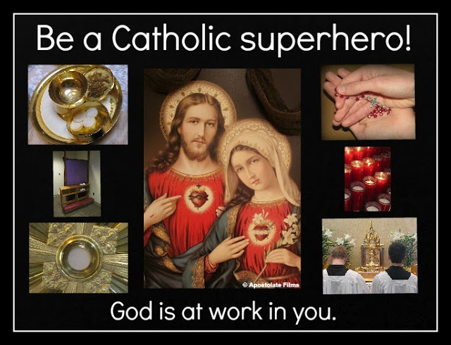
Certainly, I was being drawn into a mystery.
Every time each one of us makes a sacramental confession, we go because we have responded to the Lord’s invitation to participate in a great mystery of God’s unfathomable love and mercy. And what a phenomenal mystery this often misunderstood sacrament is.
DETERMINING WHAT TO SAY WHEN UNLOADING
Having accepted the will of God, I stayed up that night after my three children went to bed until 1:00 a.m. praying, discerning, and writing. I had wanted to go to confession for the past several days before that particular summons but could not think of anything to say; my mind was a complete blank, because the Lord had already determined what day He wanted me to go, what was to happen, and who the confessor would be.
So after praying to Jesus for inspiration before the Devotion to the Holy Face at the kneeler in our home, I typed the following out. While some of what was written are feelings I have had in the past and some are feelings I still have as Divine Justice and the devil wage a battle for souls within my soul, I also very much felt and still feel that what was written was quite harsh. That is because the “unloading” includes generalizing, statements of things as all good or all bad, and that did not accurately represent the way I felt personally at the time.
But that was how the Lord wanted it, so it was printed out and tucked inside my purse so I would not forget it.
I struggled with the situation through the night and all the way to church that morning.
I’m going to leave out the unloading and just state my sins. Or, if the Lord has chosen my regular confessor I will say everything and he will understand. But then again, this may hurt him. I'll leave most of it out. Things really aren’t that bad. Lord, I am in no shape for this. Is the confessional the appropriate place to do this? Yes; it is after all the Sacrament of Healing. No, it’s really not the place. Not every confessor will understand this. It seems that Father X prefers nice confessions and this one isn't very nice. If he is the confessor, I will leave most of it out. But it would feel good to unload to God in such an intimate setting, especially since He requested it… You are such a tormented soul. (laugh)
And then there was the voice of reason: God has been very clear. You must do what He said.
Nevertheless, I would have preferred to not include the unloading, and continued to feel bad for my confessor, whoever he would be.
LORD, YOU GET ME INTO SO MUCH TROUBLE
Have you ever said that to the Lord? I did.
I arrived at the church a little early to pray to God in the chapel for strength before confessions began. Not long after, the confessor walked into the chapel, bowed reverently before the Blessed Sacrament, and then went into the confessional.
He is not my regular confessor. He is a Bishop.
When the green light above the door went on, I entered. It was very dark in the confessional and so I had to turn to the left in order to read what had been written. The entire situation was very uncomfortable, but I proceeded against my will with resignation.
WHAT THE LORD HAD ME SAY
“My Lord, My God, Father, Son, and Holy Spirit,
You have protected me for so long, and then left me to my own devices in order to fail and sin against You, as You said, in order to summon me right back here.
So here I am, Lord, holding nothing against You for that, for You order all things for my greater good and I thank You, and know that you are going to do something really wonderful through this.
You have summoned me here for this precious opportunity for Divine intimacy, and I am here because I love You in return and as a sinner, ask for your pardon for all of my faults. Let there be no distance between us, Jesus.
Lord, You have summoned me here and requested that I unload the burdens that I have carried for so long, but that is not so easy. Coming here should be about you, not me. But you love us so much that you want me to unload, and so because this is what you want, I will.
You share the moments of Your Passion with me so intimately, and then the devil lets me have it so severely, two complete opposites, extreme love and extreme hatred hoping for an intimate relationship with my soul, and sometimes I can’t even find myself lost in the battle somewhere, not always knowing where I begin and end, not always knowing whose thoughts are whose.
I almost didn’t come today because I don’t want to unload for the devil, and he has had plenty of horrible suggestions regarding what I should say.
Jesus, I do trust in You, but it causes me a great deal of grief that You do not always defend my honor and sometimes allow me to sin against you. But I cannot complain about that, for as You just showed me, it leads to Your summons to come here and enjoy these precious intimate moments with You and you reward us with so many graces.
You have shown me Yourself so cruelly treated, so catastrophically injured, so rejected, and it hurts me when I hurt You.
I have given myself entirely to You and consented to allow You to accomplish Your will within me, and so I have no right to complain about anything. But You said to unload, so here it is. Because of You, I see things so differently. So often I feel like a dog chasing its tail, and it is always the behavior of other people who lead me to feel this way. As You said, You are keeping me very close to you, and I am so grateful and happy about that, but the thorns are sharp, Lord, and I am not as patient and humble as You. The devil has let me have it though so many people close to me, and I am in no physical condition to handle anything well. Oh so much anguish because of this, Jesus. And so much battering by the devil directly... It seems like so many people are either not listening or resisting Your will for me, and when their complaints are justified that causes me so much more suffering.
So many things are going on at the same time, Lord.. The world places so many meaningless demands on us and it only distracts us from focusing on You and on others.
I don’t always understand what is happening, no one explains anything, and I am bombarded so often with temptations to feel that no one cares, as so many people focus on parties and shows and trips and taking instead of on quiet and prayer and true service in imitation of You and Blessed Mother... the devil is constantly trying to get me to leave... So many of your ambassadors seem unhappy, and it seems like people aren’t even treated kindly on a basic human level. I feel like nothing we do is ever good enough, because we aren’t wealthy and worldly...
It seems like we don’t matter here, we have never felt like we fit in, except when I am alone with You in church, and still no one is properly caring for the Cristeros who are quietly and patiently bleeding out in the pews as they heroically carry humanity on their shoulders. Once in a while there is a homily that may or may not be for their benefit, but that remains speculation.
It is as You said, Lord, that your followers will be like you, with nowhere to lay their heads, and no place to call home. I feel like the people who resemble You most are considered to be worthless, even garbage, even in Your house, and worse than invisible because we become seen when so many want something or can use us in some way, or want us out of their way.
So there it is because You requested it, Lord; I prefer to remain silent but was obedient. Most certainly what I have said has no merit to it whatsoever, and I am willing to continue to do as You wish, no matter the cost... I know that Your plans are good, and that what You are going to accomplish is going to be as helpful for people as You said it is to be. I trust in You, and I need You. Thank You for allowing me to make to Holy Mass so often.
Please forgive me for...
On my own I am absolutely nothing, and so after honoring Your request hope that this means I may appeal to You for whatever it is that I and my family need. But we already have what we need. We have You.”
THINGS GO FROM BAD TO GOOD TO EVEN WORSE
After I was finished, and what a relief that was, I was stunned by what my confessor said. He asked if that was my confession. I held my ground (I'm smiling while writing this although at the time it wasn't funny), and told him that was what the Lord told me to say.
He persisted. “Do you know what you just said?” he asked. Lord, now what. I did what you wanted, and things are getting even worse. I repeated my initial response; I said what God wanted me to say.
Then he asked me yet again if that was my confession. I stated my reply a third time, covering the entire Trinity. I said what the Lord wanted me to say.
WHO CAN BLAME THE GOOD MAN; HE SHOULD HAVE BEEN GIVEN A WARNING FIRST
My confessor, who by the way is a good and holy man, then told me I was not to read anything and I should have said those things to the Lord outside of the confessional, as there were other people waiting.
There was one, maybe two other people waiting in the chapel, and one of them was waiting for a specific confessor to arrive. I hadn’t taken long at all, I was quick about it, and hadn’t wanted to do it in the first place.
I felt completely rejected and humiliated.
The good Bishop repeated over and over and over that I was to say these things to Jesus outside the confessional and that I had kept other people waiting. But I had done what God requested. Shouldn't we be glad that people are still willing to go to confession, I thought to myself while trying very hard to remain humble. And how can penitents be criticized when we are taught virtually nothing about how to conduct ourselves in the confessional. More thoughts of remaining humble followed. Why? Because I assumed that this was going to be a wonderful exercise in self-mastery, something I had prayed for in the past while making sacramental confessions. But my assumption was incorrect.
I kept my thoughts to myself and replied, “Yes, Father.”
As soon as the words came out of my mouth I thought, Great, now I have not only insulted my confessor but demoted him as well, right here at the foot of Christ's Cross! What is happening?
But the Lord had me call Him “Father.” Why would He do that? Read on.
MORE HEARTACHE
It was so horrible to be on the receiving end of the confessor’s words, especially after what I had just said (unloaded), and while receiving his unpleasant instruction I looked from the image of the Holy Face of Jesus I had brought with me to the Divine Mercy images hanging on the walls.
Oh how I have longed for feedback in the confessional, instruction I felt was so desperately needed, and instead I was getting a reprimand for doing as the Lord had requested.
I didn't like it.
When the Bishop was finished speaking, he instructed me to say the Act of Contrition. I was so glad that it was finally over, but it wasn’t over. I was surprised to find myself crying the moment I began saying it. So much sorrow poured forth from my being as I prayed. It was surreal and so incredibly horrible, feeling so much pain and confusion so deeply.
Although I felt confused, at the same time I understood that God already knew how everything would play out and that He had not had me do that for nothing.
If that event had been orchestrated just for me so I could unload, the experience made me feel even more unloved, rejected, and disrespected. Thoughts of leaving the parish while not having any better place to go repeated in my head. But there had to be more to this. Why would Jesus ask me to unload my sorrows in the confessional only to have my confessor say those things, over and over and over again?
While being absolved of the sins that served as my summons to this important moment of Divine intimacy at the foot of Christ’s Cross, I found myself shaking my head in disbelief. I exerted great effort to restrain my tongue while shaking my head instead, and remained as humble as I could under the circumstances.
God had me say those things, and feel those things, for a reason.
TORRENTS OF SORROW
When the Bishop was finished absolving me, I got up and left so incredibly sad, in tears as the few people sitting in the chapel looked up when I exited, and with surprised and sympathetic expressions studied my face.
If I were them, certainly I would have been at least a little apprehensive to go in after seeing my very sorrowful exit.
Thoughts ran through my head: Perhaps what I said was right, things are that bad, and that experience while kneeling at the foot of Christ’s Cross confirmed it. Didn't he hear a thing Jesus had me say.
I cried through the Holy Sacrifice of the Mass, through Benediction, and during a short time praying with Jesus before leaving the church.
A SECOND PUPIL
My son Andre had fallen asleep in the car after we arrived at the church (early), and woke up and came into the church just after Holy Mass had begun. It is very rare for us to sit together because he serves as an altar boy, but the Lord had him there next to me during that particular lesson. He, too studied my sorrowful face.
I felt the supernatural effects of that experience throughout the day, very intensely in the morning and then it tapered off through the afternoon. I felt such intense sorrow at the church, and after that terrible feelings of unresolved anger, hurt, and disappointment.
That perplexed me. I had to explain to my children what happened so they would not worry, because I also didn’t feel well physically and they were worried to see me in such a state. I reminded them that without a doubt God’s will was being accomplished, even though we could not understand it and even though I felt so hurt and so angry. I knew for sure that God was working through us, and we were to trust in Him.
The Lord had many people be very kind and compassionate to me through the afternoon and evening, and He was loving me so carefully in that way. I suffered quite a lot physically through the afternoon and passed out for a while on the sofa.
A REVELATION THE NEXT MORNING
The next morning, the Lord explained what had actually taken place the day before in the confessional.
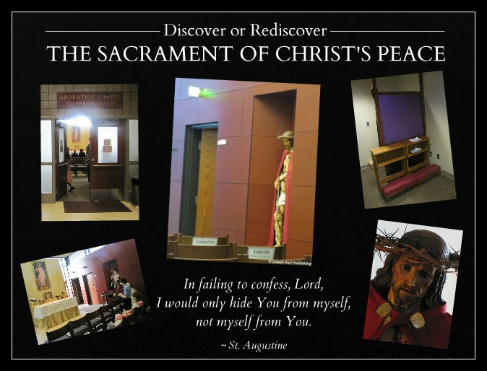
SACRAMENTAL CONFESSION THROUGH THREE AND FOR MANY
The Lord said that our Shepherd has come in search of His beloved sheep whose faith had been targeted for execution by the devil. Our adversary had orchestrated that these people be harmed by others he (the devil) had incited within their parishes so the victims would run for their lives and as a result, run from the very Sacraments they needed to help them survive, heal, become stronger, and strengthen the Church.
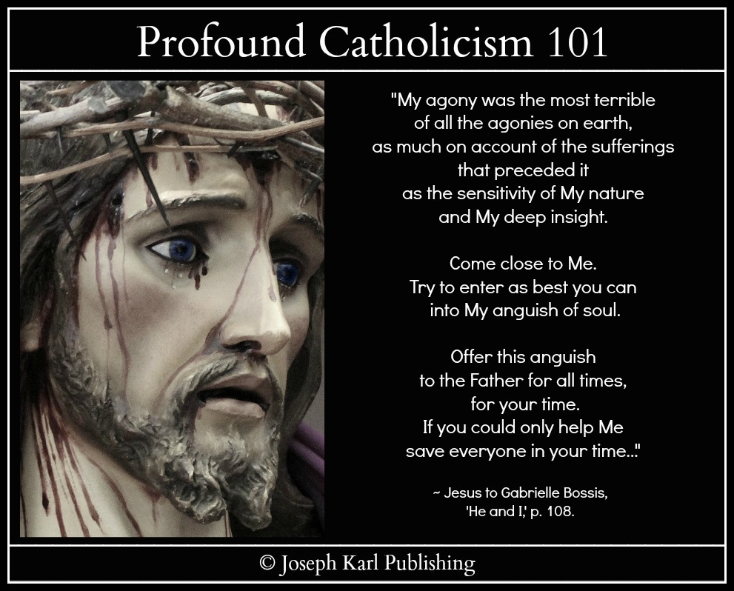
Our Lord said that He experienced the sorrow of each one of these victimized and injured souls during His Passion and Crucifixion. Can you just imagine His collective sorrow. If His heart had not been opened by the lance, surely It would have exploded instead to release in torrents all the graces humanity would need.
Jesus loves us that much, and our need for healing only the Divine Physician can provide is so great.
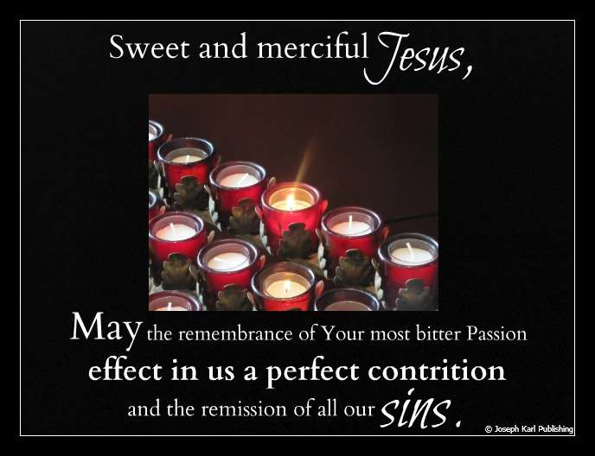
TORRENTS OF GRACE
When I made that sacramental confession, the Lord had me kneel in place of all those rejected and injured souls and unload in the confessional for them. That’s why the language was so generalized, why my sorrow was so great, why my heart felt so broken.
The Lord works through willing souls to bestow graces upon humanity, in this case upon those through all time who were hurt by people within the Church and left the sacraments, people whose hearts remain injured and have separated themselves from the graces that they need.
During the Holy Sacrifice of the Mass the next day, I held all those souls carefully in my hand.
I subsequently wrote out the story and sent it to my regular confessor, thanking him and also the Bishop the Lord had used as a powerful channel of grace, for the healing of so many souls who no longer go to confession and to lead them back to the Sacrament of Divine Intimacy.
God is so in love with us all! + + +
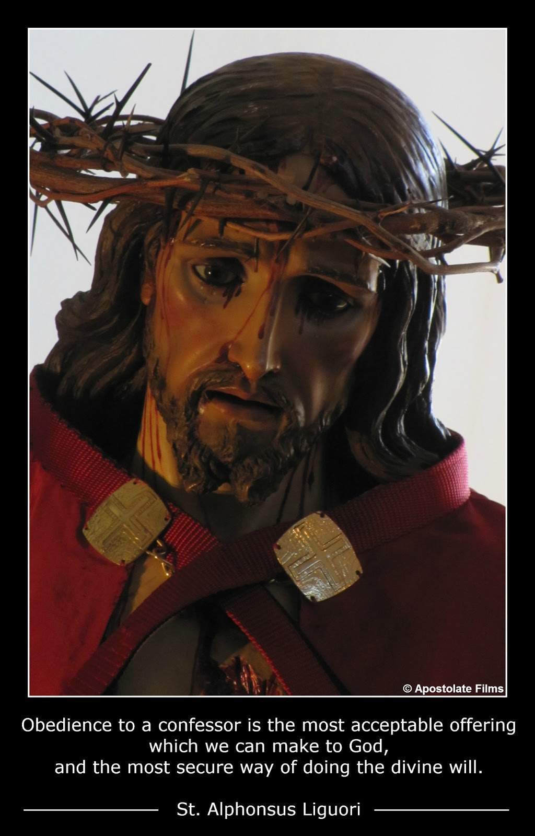
Discover or rediscover the Sacrament of Christ's Peace. Don't stay away from the confessional and if you have been injured by others within Christ's Church, please return. God is so in love with you!
And don't ever forget that you, Jesus, and your confessor are a team. Go, Team!! + + +
For more PROFOUNDLY Catholic information on making your Sacramental Confessions incredibly meaningful, deeply personal, and tremendously powerful, visit Joseph Karl Publishing's page The Sacrament of Reconciliation , which was created just for you!
"Trust all things to Jesus in the Blessed Sacrament and to Mary, Help of Christians, and you will see what miracles are." ~ Saint John Bosco

Spiritual Warfare

Profoundly Catholic Spiritual Warfare: Know God, Know Your Enemy & Know How to Fight for the Right Side
The battle between good and evil is very real, and the outcome has eternal consequences for each one of us. Some basic information to help you fight the many and various battles, and win.
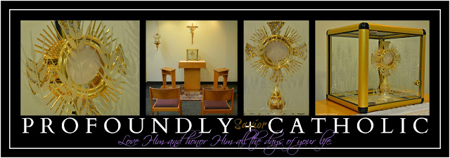

All holy people get assaulted by the devil, and the holier we become, the more we get assaulted.
Sinful people get assaulted by the devil, too, but once the devil has them under his influence, he rewards them well to entice them to remain in self-induced spiritual comas. "See how successful you are, how wealthy, how "happy," how beautiful, how respected by others you are!" he whispers so convincingly into their ears, stroking their pride while telling them all the things they long to hear.
The devil's goal is to have us spend eternity with him in hell.

When we live sacramental lives, the power of God that comes to us through His sacraments improves our spiritual vision, makes the devil and his assaults more clearly visible to us, and equips us with God's grace so we can fight him and defeat him.
We more clearly see that hell is not a pleasant place for us to spend forever. There's no love there. In fact, there is absolutely nothing good there, only evil.

We are better equipped to fight the enemy when we first know there is one, when we know who he is, and when we can recognize him.
Once we know these truths and understand them, we become willing to fight hard not only for our own eternal souls but for the souls of other people, even people we do not even know, even people through all time and space.

Know who you are fighting for.
It is crucial that you know who you are fighting for. First, make sure you are fighting on God's side. Are you? Are you sure? If you fight to defend the rights of God, then you fight for the winning side.

One of the devil's favorite tricks, especially in our incredibly self-absorbed era, is to present evil as good.
"We are a hypnotized nation." ~ Servant of God, Father John A. Hardon, S.J.
One of the best examples of this tactic the devil uses of presenting evil as good and a clear illustration of how destructive this tactic is for humans is the legalized murder of children worldwide by abortion. How many well intended people fight for the devil by working to keep abortion available and legal, by encouraging anyone to kill their child(ren), and by promoting, supporting, and voting for abortion.The devil works very successfully through many people using misguided compassion as his weapon and has destroyed many, many countless millions of lives through us.

The devil hates God, even though he alone is responsible for his choice to reject all that is good. In his senseless quest for revenge, the devil seeks the destruction of all mankind. He wants to stop us from being conceived and if he can't do that, then he wants us aborted, and if he is unsuccessful, then he targets us throughout our lives in a variety of ways seeking our destruction.
Why? Because God loves us so much. As a result of this love, the devil does all he can to convince us to stay away from the Sacraments. He knows their value, while many people do not.
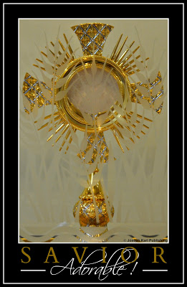
The devil combats humanity as a masquerader, and frequent reception of the Eucharist while in the state of grace reveals him, his assaults, and his schemes.
Perhaps you may see him reaching out to assault you in one way or another for the good you have done. He does this directly and also right through people whether they are well intended or not.
Most people would be surprised to learn how often he is able to assault us through individuals who are closest to us, and to also learn how often he uses us to assault other people.
The devil uses us frequently to clobber one another, and the less we avail ourselves of the graces we need in the Blessed Sacrament and Sacrament of Reconciliation, the less we recognize this and the more we are at risk of being used by the devil.
Most people would be quite surprised to see this as it happens. We can't see it at all if we are not humble.
But always the Lord uses the scoundrel to further humanity's cause, and the even better news is that as we draw closer to God, the Lord speaks to us in the deepest recesses of our hearts in ways we could never have imagined.
Do whatever the Lord tells you, and He will always provide.
Discern your influences (those who influence you) very carefully; the devil is a liar and a manipulator and has tricked many good people into becoming his best helpers. Just look at how Christ's Church has been disfigured by so many people who call themselves Catholic and claim to love God so much.
The devil allows us to call ourselves whatever we like. His favorite collaborators are individuals who are prideful, disobedient, selfish, pro-abortion, AND call themselves Catholic, because he is able to accomplish much destruction through them.
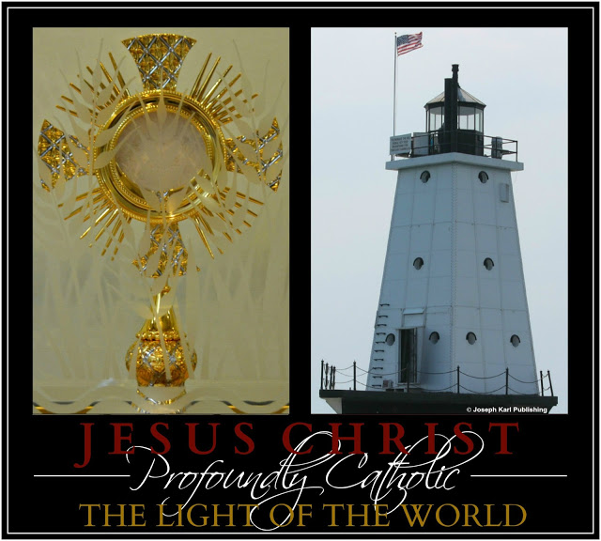
How can you be sure if you are being influenced by good or by evil?
The Lord will never ask or influence us to cause anyone harm or to break His Commandments, and God always encourages us to be gentle, humble, charitable, loving, kind, and obedient in imitation of Christ and Blessed Mother.
Sometimes the devil's assaults can be extremely oppressive and isolating, especially when we understand little about spiritual warfare.
Just like an airplane rises high enough to clear the storm clouds and then flies in clear weather, souls who experience intense assaults from the devil eventually reach a breakthrough point and find themselves viewing the spiritual battle much differently. They arrive in a much calmer place.
Such souls find themselves no longer on the constant defensive. They take an offensive approach, are able to see victories on the battlefield, work hard at growing in holiness, and realize they are supported in battle by the Lord, Blessed Mother, the Martyrs, the Saints, the Holy Innocents, the Holy Souls in Purgatory, and fellow devout souls around the world. They consecrate themselves and their families to Jesus through Blessed Mother, and strive to fulfill the will of God in all things.
Never forget that the devils are intelligent and highly organized, they are loyal and work as a team.
Men must constantly battle our fallen human natures which can hinder our working together for the good of other people.
So first, team up with the Lord and our intercessors in heaven, then connect with other devout souls near and also far. Together, we are stronger, and we fight for the winning side! The devils can and are being defeated, and precious, immortal souls are being saved from eternal damnation.
Learn more about profoundly Catholic spiritual warfare.
Information is power, and when we understand things as they really are, when we seek to know Truth, when we fight for the Lord and for precious, immortal souls, then the battle doesn't seem so oppressive, we go on the offensive, we don't feel constantly defeated, and we see through the devil's "house of mirrors."
When we are accomplishing great good for others, the devil tries very hard to make it look like we are losing.How often the devil says to us, "What you are doing doesn't matter. Why work so hard? Do something else! Do anything else. Do what everyone else does! No one cares. You're crazy!"
Don't listen to the liar; always listen to God instead, because He is the One who truly cares about us.
When under attack, take action.
First, identify the devil's presence (the Eucharist helps us do this).
Second, remain calm, humble, loving, and charitable. This takes practice.
Third, pray! So often we don't think to pray. The powerful prayer to St. Michael and the Hail Mary are powerful defenses.
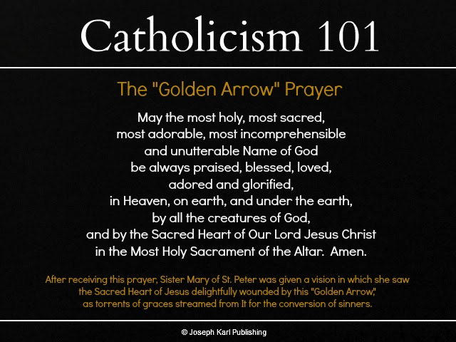
Another POWERFUL thing you can do when under spiritual attack is to pray the Golden Arrow Prayer. Memorize it and pray it often, even when not under attack. Every time it is said, massive amounts of grace pour forth from the Sacred Heart of Jesus. Stay on the spiritual offensive, by reciting this prayer throughout the day, not only when under spiritual attack.
Yet another powerful means to defeat the devil when he strikes is to look outside of ourselves and focus on other people, especially when the assaults are relentless, and intensify. Do something good for others. Focus the attention of everything you do on others. The devil uses this tactic often on people who serve others in imitation of Christ. Selflessness is the sister of humility and they are very, very powerful weapons we must use.
When the devil assaults us we tend to retreat within and focus on ourselves and the battle. This is a natural human tendency, the devil knows it, and he uses it against us as often as he can. Many people fall for this without realizing it, and because we are not trained to fight we are not becoming the best profoundly Catholic warriors that are needed to wage the colossal battle through time and space for precious, immortal souls.
The Lord wants to use us to change this. Please share this information with others and keep growing in sanctity! Expect things to get hotter, but better.
Fight with great faith! Remember that with God, all things are possible. And don't think that you must be strong to be a good soldier for Christ. We are powerful channels of grace for the massive conversion of sinners when we are weak, insignificant, broken, mystically covered with the Precious Blood of Christ, and holy.
"Trust all things to Jesus in the Blessed Sacrament and to Mary, Help of Christians,
and you will see what miracles are."
~ Saint John Bosco

Part

A Very Special Sacramental Confession Request from the Lord

Sacramental Confessions apply to our souls all the merits of the Passion of Jesus.
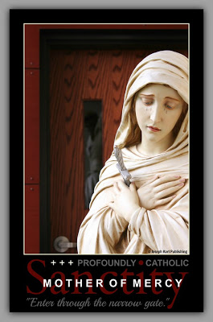
“The most difficult sacrifice we are called to make is to surrender that most precious creature that happens to have your name.” ~ Father John A. Hardon, S.J.
WE ARE LOVED AND VALUED BEYOND MEASURE

What if right now, the Lord summoned you to the Confessional and asked you to make a Sacramental Confession of Devotion for the benefit of others?

Would you do as He asked?

Are you prepared for Him to ask you.

BECOMING CHANNELS OF GRACE FOR THE MASSIVE CONVERSION OF SINNERS
Why would the Lord ask you to do such a thing?

He longs to pour forth graces upon humanity, and so many people are not accepting them.

He wants to bless such souls through the people who are willing to accept them.

Would honoring the Lord's request make any difference?

You bet. Being channels of the Lord's graces for the sake of other precious, immortal souls makes a huge difference, eternally, in ways we cannot always imagine or fathom in the present moment.

We have a very loving Triune God, and He looks after each one of us very, very well.
May we trust Him always, because His plans for us are good.
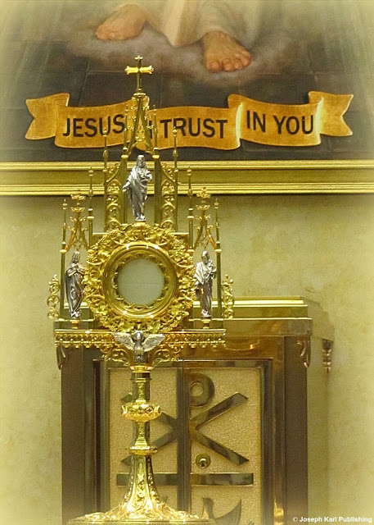

“In failing to Confess, Lord, I would only hide You from myself, not hide myself from You.” ~ Saint Augustine

KNOW YOUR FAITH AND SHARE IT WITH OTHERS
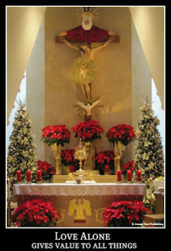How well do you know your Catholic Faith? Are you making an effort to grow closer to God by learning more about Him, and not only for your own benefit, but also for the benefit of others?

How often do you share the Faith.

What if God wanted to use you in a particular way as a channel of grace for a specific group of people.
Say in this case He wanted to use you as a channel of grace for all the people who do not make Sacramental Confessions and do not obtain for themselves and others the beneficial graces He wishes to generously shower upon them.

Do you ever make Confessions of Devotion? All of us should, and we must! They are potent sources of grace for the massive conversion of sinners.

WHY WOULD ANYONE CHOSE TO NOT GO?

There are so many reasons why people do not go to confession, and while some are perfectly justifiable to the human mind, in the spiritual realm it is a great tragedy, in fact it is a tremendous catastrophe when anyone chooses not to accept all our merciful Lord offers us through this great means of reconciling ourselves to Him, to His Church, and to others.

Do not let any reason stop you from going and making sacramental confessions, and go often.

God wants to work in a very powerful way, through YOU!

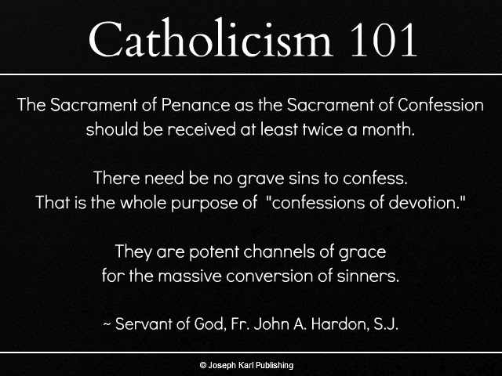

“O Jesus, if just one drop of Your Precious Blood has the power to wipe out all the crimes of the world, what will it not do in me when You pour it so abundantly over my poor soul at the moment of absolution! O Jesus, revive my faith and give me a complete understanding of the immense value of the sacrament of Your Blood. Only Your Blood can wash away my sins, purify the stains on my soul, and heal and vivify it. Oh! Grant that this salutary bath may cleanse my whole being and restore it entirely to Your grace and love!” ~ Father Gabriel of St. Mary Magdalen, O.C.D. , Divine Intimacy, p. 308

WHY GO TO CONFESSION AT ALL?

Jesus instituted the Sacrament of Penance to heal the wounds of sin, to restore sinners to grace, and to provide strength for our weaknesses. Christ conferred on the Apostles and successors (priests) the power to forgive sins in His Name when He said, “Whose sins you shall forgive, they are forgiven them; and whose sins you shall retain, they are retained: (John 20: 23).

Be reminded what Jesus said to Saint Faustina: “I desire trust from My creatures. Encourage souls to place great trust in My fathomless mercy. Let the weak, sinful soul have no fear to approach Me, for even if it had more sins than there are grains of sand in the world, all would be drowned in the unmeasurable depths of My mercy.” (Diary, Divine Mercy in My Soul, p.p. 399-400).

If the Lord asked you to make a sacramental confession in place of everyone through all time, past, present, and future who did not go, are not going, or will not go, are you prepared to do it?

What would you say.

DISPENSE HIS MERCY

“Pray for souls that they be not afraid to approach the tribunal of My mercy. Do not grow weary of praying for sinners. You know what a burden their souls are to My Heart. Relieve My deathly sorrow; dispense My mercy.” Diary, p. 377.

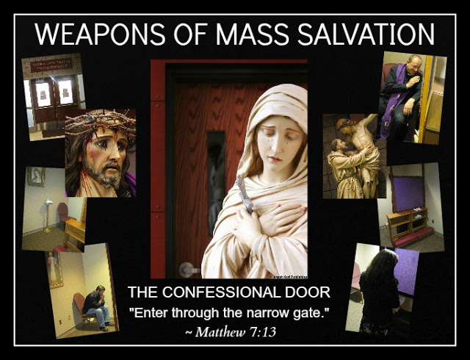
ASK THE LORD WHAT YOU SHOULD SAY AND THEN SAY IT

After praying to our Triune God for insight, perhaps He would have you say something like this (He comes up with the most beautiful things):

The Sign of the Cross. Please bless me, Father, for I have sinned. My last confession was about two weeks ago.

Most Loving, Compassionate Triune Lord,

I am here because I love You, to thank You for loving me, to renew my promise to love and honor You all the days of my life, to thank You for so much goodness so freely given, and to apologize to You for the times that my actions have hurt You and distanced myself from You.

How can that ever be a consideration for any of us, Lord, to distance ourselves from the Author of Love when You constantly seek to draw us into closer union with You.

It is only possible when we love ourselves more than You, and while it seems that is self serving, it is really self defeating. On our own we are powerless, defenseless, and loveless. And yet You even use these things to our ultimate advantage when You see us merely shoot You a glance.

Lord, I thank You for everything realizing that You want what is best for every single person. I apologize to You for my many transgressions, determined to go forth trusting in You always, needing You always, seeking You always, and thus always having You by my side.

Lord, I apologize to you for...

Jesus, You summoned me here today not only to be reconciled with You following my own offenses, but also to obtain graces for all those through all time who would not and will not make sacramental confessions for whatever reason.

And so Lord I am here to represent them all, and humbly apologize to You on everyone’s behalf for every offense. I love You in return and thank You on behalf of all these precious, immortal souls, and ask Blessed Mother to present to You the particulars of every single human heart in great need of Your mercy. Blessed Mother, please place each one of these souls within the Sacred Wounds of Jesus which best applies to them as I kneel here at the foot of the Cross in all of their places, and ask you dear Mother which one best applies to me? Place me well, Blessed Mother, so that through the Passion and Death of Your Son my faults can be overcome, so that my life, and the lives of all those I represent, may become living testimonies to God’s greatness.

O Bleeding Face, O Face Divine, be every adoration Thine!

THE BEAUTIFUL, MEANINGFUL WORDS OF ABSOLUTION
"God, the Father of mercies, through the death and resurrection of His Son has reconciled the world to Himself and sent the Holy Spirit among us for the forgiveness of sins; through the ministry of the Church may God give you pardon and peace, and I absolve you from your sins in the name of the Father, and of the Son, and of the Holy Spirit. Amen."
"Lord Jesus has forgiven you everything; go in peace."

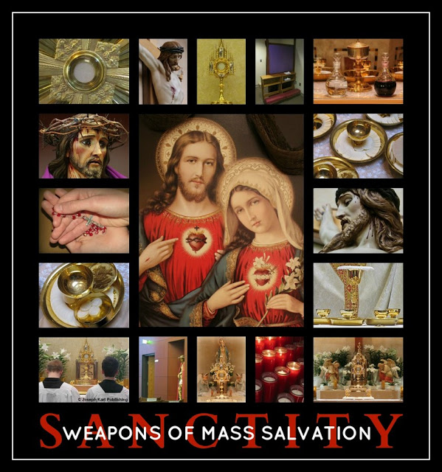

CONFESSION APPLIES TO OUR SOULS ALL THE MERITS OF THE PASSION OF JESUS

“Confession applies to our soul all the merits of the Passion of Jesus, all the infinite value of His Blood; we shall always return from this Sacrament renewed, sanctified, and strengthened in good in the measure in which we have approached it with a contrite and humble heart.”~ Father Gabriel of St. Mary Magdalen, O.C.D., Divine Intimacy, p. 214.
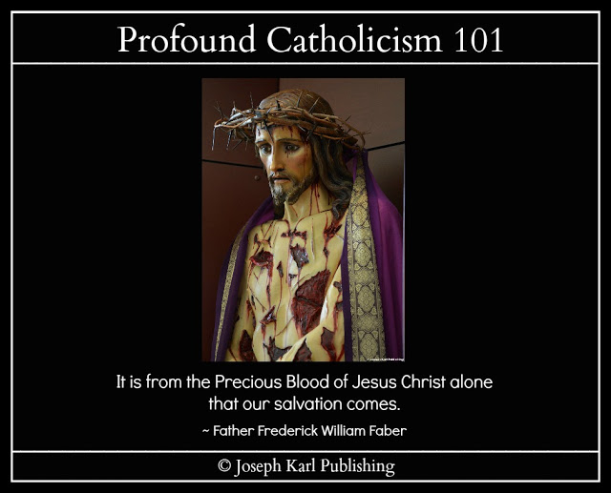
"The Precious Blood, then, is the greatest, the most undeniable of our necessities. There is no true life without It" (Father Frederick William Faber).

FINAL THOUGHTS

Our Lord said to Saint Faustina, “Daughter, when you go to confession, to this fountain of My mercy, the Blood and Water which came forth from My Heart always flows down upon your soul and ennobles it. Every time you go to confession, immerse yourself entirely in My mercy, with great trust, so that I may pour the bounty of My grace upon your soul. When you approach the confessional, now this, that I Myself am waiting there for you. I am only hidden by the priest, but I myself act in your soul. Here the misery of the soul meets the God of mercy. Tell souls that from this fount of mercy souls draw graces soley with the vessel of trust. If their trust is great, there is no limit to My generosity. The torrents of grace inundate humble souls. The proud remain always in poverty and misery, because My grace turns away from them to humble souls.” Diary, pp. 568-569.

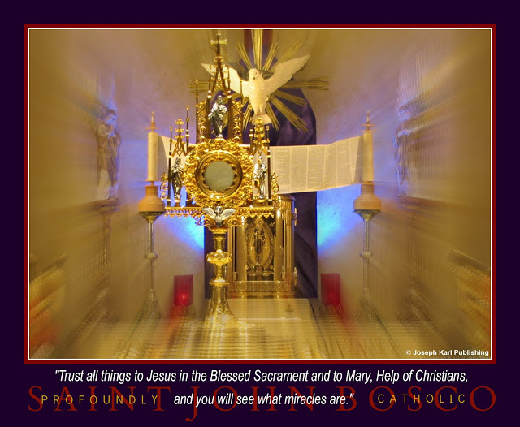
DAILY CONVERSION AND PENANCE FIND THEIR SOURCE AND NOURISHMENT IN THE EUCHARIST

So much more could be said about the Sacrament of Reconciliation! One final thought, from the Catechism of the Catholic Church: Daily conversion and penance find their source and nourishment in the Eucharist, for in it is made present the sacrifice of Christ which has reconciled us with God. Through the Eucharist those who live from the life of Christ are fed and strengthened. “It is a remedy to free us from our daily faults and to preserve us from mortal sins.” ~ Catechism of the Catholic Church, 1436.

A very powerful story from Saint John Bosco that reinforces this (audio):

"These Are the Remedies You Must Use" by Apostolate Films on Mixcloud

"He [the confessor] knows how much greater than your sins is the Mercy of God, this Mercy which grants you pardon through his ministry. He applies to you the infinite merits of the Precious Blood of Jesus Christ with which he can wash away all stains from your soul." ~ Saint John Bosco

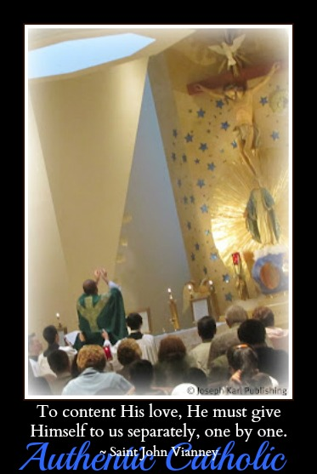

Discover and rediscover the POWER of making Sacramental Confessions of Devotion!

God is so in love with us all.

Examining One’s Conscience

A Confession, A Petition, His Pardon, and the Peace

Discover or rediscover the Sacrament of Christ's Peace. God is so in love with you!
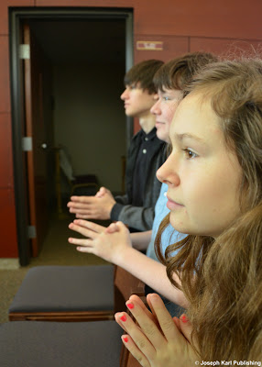
The next time you are tempted to minimize sin and its consequences, ask Jesus to allow you to share in His Passion for even just a brief moment and it will change your outlook forever.
“For what am I to myself without You, but a guide to my own downfall?” ~ Saint Augustine
Sign of the Cross.

Please bless me Father, for I have sinned. My last confession was about a week and a half ago.

God the Father, Son, and Holy Spirit,

How much You love every single one of us. And how imperfectly and inadequately I love You in return.

I have come today to accept Your generous offers of salvation and sanctification. I place my unworthy self at the foot of Your Cross, submitting myself to Your will and to Blessed Mother because I love You, and because I want our relationship to be all that You want it to be. I want You to work through me on Your terms and not my own.

I come to seek Your pardon for my many faults and offenses against You, against heaven, and against humanity.

How greatly I fail in fraternal charity, not only in regards to my fellow man but in regards to You Lord, to so many loving friends and intercessors, the saints, and especially to my angel guardian.
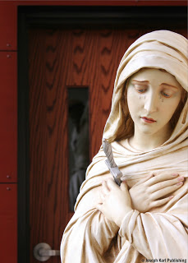How much goodness You show to me directly and through so many, and I am so often thoughtless and self centered. How much I long to know and serve You and Your people more intimately and meaningfully.

Please help me to grow in holiness and do better, Lord, for there is no reason sufficient to warrant treating anyone badly in person or during his/her absence.

How many times I have hurt others by my inconsideration; how many times I have hurt You.

I apologize to you for my selfish, self-centered, prideful, pleasure-seeking, and worldly nature...

Jesus, I trust in You, and I need You.

I trust that all You allow to happen to me is for good reason, and ask You to continue working with me and teaching me, So many beautiful things come to us from the opened wound in Your side, created in malice and allowed by sacrificial love.

Continue wounding my heart, Jesus, and turn my malice into the most beautiful expressions of sacrificial love.
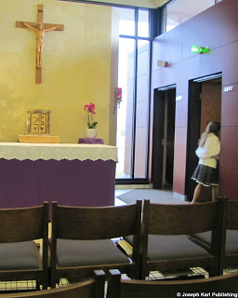
I apologize for my intolerance of other people’s ignorance, and for the tolerance of my own.

Lord, I apologize for the times I have spoken to anyone impatiently, or angrily, or harshly. I apologize for the bitterness in my heart that is harbored against anyone. You love so much while the devil hates so much, and it is my desire not to dislike anyone or hold a grudge against anyone. But the devil tempts me so severely, Lord; please do not allow any bitterness to exist in my heart, not for any reason, and let me profit from Your and Blessed Mother’s example.

Please forgive me for the times I set a bad example for anyone, and also for my impatience. Also for the times I resist doing your will, preferring to accomplish my own instead.

Jesus, please do not let any of the precious suffering be wasted on account of my faults. I am so grateful to You for the opportunity to travel with You and Blessed Mother, the saints, and devout faithful through all time along the Way of the Cross.

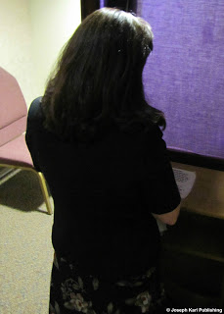You forged this path in Your Precious Blood so that we may know the Way. You help me carry my Cross and cushion my steps with Your Precious Blood, spilled out so liberally for each and every single one of us, and You perfect all my efforts on their journey to our Father’s Throne.

Jesus You have promised us that by Your Holy Face You would work wonders. Please (special intention), liberate the many souls in the black abyss, strengthen Your devout faithful, assist the dying, and free the Holy Souls in Purgatory.

What more could I possibly ask of You, Lord.

Instead, let the question be, “What can I do for You?”

Sweet Jesus, thank You for suffering and dying for me, for continuing to give of Yourself so freely and generously. I give my self entirely to You, and promise to love and honor You, all the days of my life.

Absolution: "God, the Father of mercies, through the death and resurrection of His Son has reconciled the world to Himself and sent the Holy Spirit among us for the forgiveness of sins; through the ministry of the Church may God give you pardon and peace, and I absolve you from your sins in the name of the Father, and of the Son, and of the Holy Spirit. Amen.
"Lord Jesus has forgiven you everything; go in peace."

Part

Sacramental Confession: Tap into the Supernatural Where with God, All Things are Possible
Discover or rediscover the personal, meaningful, and powerful Sacrament of Divine Intimacy.

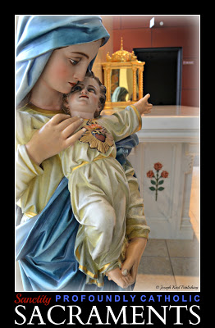
Sacramental Confession is truly a phenomenal supernatural treasure given to humanity by our loving and merciful God. Making a sincere, honest, and thorough confession is truly a group effort between the soul and the three Persons of the Blessed Trinity. That is why I suggest addressing all three Persons individually - Father, Son, and Holy Spirit - when beginning one's confession.
Each distinct Person of the Blessed Trinity offers us something unique for our individual soul's welfare, and every time we go things are slightly different.
Perhaps it is because going to confession is such a personal experience that some people don't explore in greater detail the richness of what is said between the beginning script and the ending words of absolution.
Oh, so much is meant to happen in between! And the contents are meant to be deeply personal, very intimate, and incredibly powerful.
Some suggestions have been offered in precious posts about what to consider saying while making a sacramental confession, with actual examples provided, to encourage you to make your examinations of conscience beforehand very meaningful to you and to God so that your actual confession is so spiritually rich it releases absolute torrents of graces from heaven.
This particular post highlights the role grace plays in the quality of our sacramental confessions.
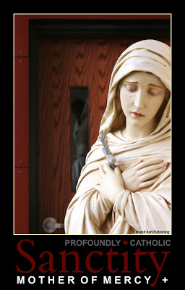
We know our adversary seeks our ruin and absolutely does not want us to go to confession. He battles us because he does not want us to be forgiven of our sins, be reconciled with God and the Church, grow in humility, and have our souls cleansed completely by the Sacred Blood of Christ, nor does he want us to obtain such valuable graces for ourselves and for others.
The quality of our confessions also depends upon what we know and what we have been taught.
Not nearly enough information is shared among Catholics about how to make sacramental confessions more deeply personal, intimate, and incredibly powerful.
Many people go to confession and don't even know how to make what they say to the Lord in between the scripted parts much more meaningful, personal, and powerful.
Such information is very beneficial for souls, and providing it for them is very necessary.
So many people don't even like going, and that is a great tragedy. The Lord does not want this. He did not institute Sacraments so we would hate them!
God wants our relationship with Him to grow deeper and more meaningful through His Sacraments.
The following story is shared to encourage you to change your perception of the Sacrament of Reconciliation if need be, to help you fall in love with the Sacrament of Divine Intimacy, and to encourage you to make your sacramental confessions even more fruitful.
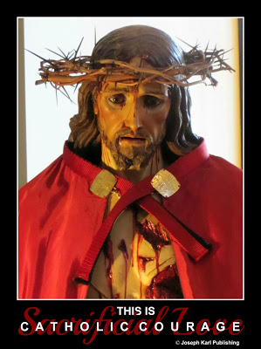
I admit that I knew very little about this Sacrament until more recently, and I'm forty eight years old. I'm a conception Catholic and have been going to Confession throughout my life since making my first one as a young child. I never cared for going but went because that is the right thing to do and because I understand its incredible value and necessity.
Several years ago the Lord summoned my children and me to a parish He mentioned by name. We became members per His request but it was another six months to a year before we began going to confession there. The Lord knew and understood my reasons for waiting and when He wanted us to wait no longer, He gently orchestrated our transition.
The spiritual growth was tremendous and it happened in a hurry.
As a result, the demon's assaults intensified, indicating that great good was being accomplished by our going and by growing in sanctity.
In the beginning I knew something quite supernatural was taking place but still didn't know what I was doing. My confessions were amateurish at best. But the key was that I was obedient to what the Lord wanted, I was trying and actually made tremendous effort to go, and my confessors are holy priests who hear confessions often at the parish and so the graces just stream from the Lord in torrents.
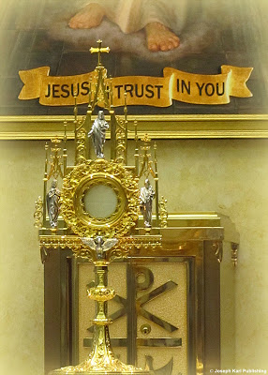
Very soon, I reached a fork in the road. I knew the Lord wanted me to advance and I wanted to advance, too, but for various reasons I was holding back. It was as if I knelt in front of an invisible barrier, could see through to the other side and wanted to go there, but I just could not pass through.
After so many years of personal struggle and trying to survive plenty of trauma, I was not used to being completely open about personal things involving the heart in front of anyone, not even God. It seemed too risky. But this sacrament is the Sacrament of Divine Intimacy, of Divine Union! And being honest and open is what wonderful relationships are all about.
I do believe that any training or suggestions would have been beneficial to me at that time and the Lord agreed because He provided it, and would like this information shared to help you. +
I totally planned on taking my personal issues that kept me on the wrong side of that barrier to the grave with me. It's funny to think about it now after having crossed over to the other side. What seemed so insurmountable from the other side of the barrier seems so insignificant now.
It's hard now to imagine I ever felt that way. I had even resolved that my final confession before death would involve some emotional holding back. God will understand, I convinced myself. After all, He made me! He knows everything already, and His love for me is unconditional.
But as I later learned, these thoughts originated as temptations of the devil. He is happy to provide us with suggestions about confessing and rejoices to be the only one providing them to us. Then, there's no competition! He does not want us going to confession, ever, and if we do go, he tries so hard to manipulate us and get us to hold back during our confessions. He tries to get us to be secretive, embarrassed, put up our defenses because our hearts have been injured, and warps our understanding of this sacrament he knows is of so much value to mankind. One of his favorite strategies is to make us feel too ashamed to confess the very things the Lord is so willing to forgive. The devil is well aware that our honesty and genuine remorse will merit the graces we need to overcome our faults and to defeat sin.
If that doesn't work, he operates in the reverse and tries to get us to be prideful!

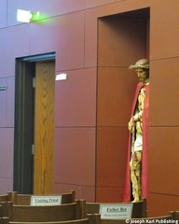Once the devil lost his grip on me and I was able to be totally open and honest with my feelings, he switched strategies. You see, when his stranglehold on me was broken for good and I passed through that barrier, I absolutely fell in love with the Sacrament of Divine Intimacy. He won't ever get me to change my mind about being in love with God.
So now he tries very, very hard to make me proud, tries to get me to hate my confessor, not listen to him, not agree with what he says, feel that he should be saying something else or something more, and even tries to convince me to get up and walk out. Get up and walk out!! He (the confessor) doesn't care about you! He could care less!
The devil went so far once as to tell me not to take a prayer card from my confessor before I had even gone into the confessional. Don't take it! Don't take it!! Tell him you don't want it! Refuse it. Leave it there. Leave it right there on the kneeler and walk out!! What a moment that was when I reached out and took a card from Father's hand after having received absolution. It wasn't a prayer card, but a card on which he had written some important information.
I will tell you that the devil can be very convincing, and that is why we must keep returning to confession to grow in humility and obtain much needed graces. The devil has harassed me on the way to church, well aware that I was on my way to confession, and has harassed me while I awaited my turn in the confessional. The devil even follows me in sometimes and lets me have it while I confess. Once I had to pause during my confession to collect myself because he was battling me so viciously to get me to stop confessing.
Can you identify his various attempts to prevent you from going? You do know that God does want you to go, and His grace is sufficient to accomplish all things.
Going to confession is sacrificial. It is a willful act of surrender, the humble submission of one's will to God. Sacrificial love is the most powerful force in the universe. It is so strong that the bonds formed by it cannot ever be broken. It is so strong that the gates of hell cannot prevail against it.
Make use of it to change lives, including your own.
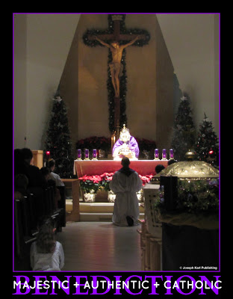
The first time the quality of my confessions changed in a dramatic way, forever, was the direct result of grace. I absolutely knew it. The unfathomable yet very real power of our loving and merciful God made it possible.
This grace was granted to me by the Sacred Heart of Jesus because He knew I was trying. This grace was obtained through the loving and maternal intercession of Blessed Mother, by
my saint friends in heaven, the prayers of my angel guardian, and the efforts of countless good people through all time who prayed and suffered for sinners (me).
I had no intention of making that major spiritual leap on the particular day it happened. All of a sudden, without warning, just before leaving the house for the church, I could feel God's grace in a very profound way. It was made very clear to me what was happening.
All of a sudden I had a tremendous desire to be totally honest and open in the confessional. There were no fears or inhibitions, and I felt immersed in the love and mercy of God. It was a very beautiful experience.
As a result, I very comfortably stated my confession that morning and for the first time ever, was totally genuine. What a moment that was! So loving, and so significant. After being absolved of my sins I asked my confessor, who had guided my soul to that point so well, if I could come around and give him a hug on such a momentous occasion. He said sure, and as we hugged I said with such joy, "We're making progress!"
Finally, I was making progress!
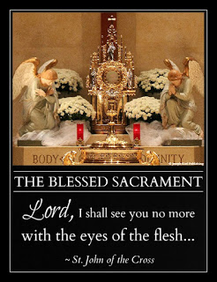
As soon as I walked out of the confessional I knew that the devil had lost a grip he had on me since I began going to confession. It was a huge loss for the devil, because for me there would be no going back to the way things were, and my confessions kept getting better, more intimate, and also more powerful.
Once I had passed through that invisible barrier, my perception changed entirely and I could not believe that I had held back for so long, that it seemed like such a big deal, and that there was ever a time when I had resolved to go to my grave willing to accept so little.
That is what God's grace can accomplish in an instant.
The devil had me fooled for so long, but heaven and good people interceded for me and now there is no going back, not ever.
Once, the Lord even said that the devil's stranglehold on my family is being broken, and this is happening in part because of the power of making deeply personal, intimate, and thus powerful sacramental confessions.
Humility is a very powerful choice of the will and a necessary weapon in the battle to overcome evil.
By valuing the Sacrament of Reconciliation, going often, and striving to make our confessions personal, intimate, and powerful we must embrace humility. Every time we go we have the precious opportunity to grow in humility through the practice of self mastery. Eventually, with the help of God's graces, we grow in sanctity. We get much better at it. It is possible for our spiritual growth to be tremendous.
There have been several more times since when I have experienced the power of grace at work in my soul which was the direct result of just having made a very meaningful, intimate, and thus powerful sacramental confession.
So, so much happens during each sacramental confession. We admit our faults, promise to do better, obtain the grace to make good on our promise, our souls are cleansed from sin, we reconcile with God and with the Church, forgive ourselves, forgive others, and ask for forgiveness for all those we have hurt by our actions or inactions. We grow in sanctity, we become better people. We become more humble, more tolerant, more understanding. We obtain the grace to practice fraternal charity. We obtain grace for ourselves and for others, we spend very meaningful time with the Lord, and we tap into the supernatural where with God, all things are possible.
Discover or rediscover the Sacrament of Christ's Peace. God is so in love with you!!

Part

One of the Best New Year's Resolutions You Can Ever Make (and Keep)
Discover or rediscover the Sacrament of Divine Intimacy (Confession). God is so in love with you!
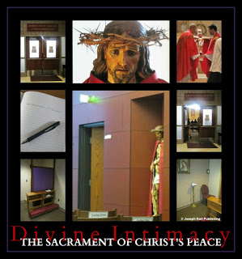
Happy New Year!!
One of the very best things you can do for yourself, for your family, friends, acquaintances, and even strangers is to go to Confession regularly and often.
Never take this vital Sacrament for granted, and don't ever underestimate the benefits you gain from going to confession!
Go, because it is God's will that you go.
Why? It is the will of God that you examine your conscience regularly, ask the Lord to forgive your sins, accept His forgiveness, be reconciled with God, His Church, and His people, grow in sanctity, achieve greater Divine Intimacy (closer union with God), grow in humility and love, receive His graces which are necessary for you to fulfill your mission, see yourself and others through God's eyes, become more forgiving, and vow to live, love, serve, and suffer in imitation of Jesus and Blessed Mother.
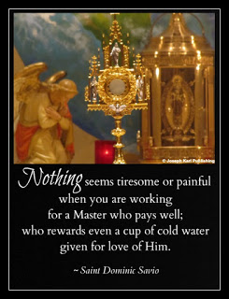
Go, and not only for yourself, but for other people as well.
Go, because God wants you to go. Don't keep yourself from so much goodness!
Go, because the devil does not want you to go. He knows full well how much your soul and the souls of others stand to gain by your going. He makes every effort to keep you from the confessional. If you don't go, rest assured, you are allowing yourself to be manipulated by our adversary, either willingly or unwillingly.
So much more could be said about this tremendous gift God has given mankind. So much more!
Remember while you are waiting for your turn in the confessional, or while you are preparing your heart before the Holy Sacrifice of the Mass, to pray for others who are going to confession and for all confessors.

Part

The Penitent, the Courage, the Mercy, the Instruments, and the Golden Arrows
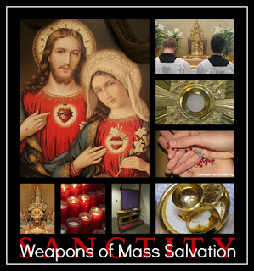
How is God at work in you?
The following story took place early this afternoon. If I hadn't already absolutely fallen in love with Jesus before, I would have without question just a few hours ago.
What happened absolutely charmed me beyond measure.
After making a Holy Hour during Eucharistic Exposition and Adoration early this morning, then assisting at the Holy Sacrifice of the Mass, followed by an appointment and then lunch, I returned to the church to work on a special assignment from the Lord.
Since the noon Holy Mass was still being celebrated in the church, I went to the chapel to work on some writing before the Blessed Sacrament.
There were a few other people in the chapel; several women with small children listened to and participated in the Holy Mass which was being celebrated next door in the church. I sat down in the back row on the left side of the chapel. Also in the back row, way to the right, sat a young man. He stared straight ahead; it looked like he was waiting.
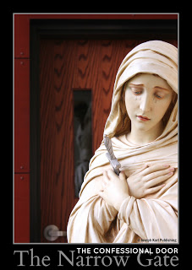While working, I remained mindful of the Sacred Mysteries unfolding next door, and paused during the Consecration and later during the final blessing. When people exchanged the sign of peace, I looked up from my writing and smiled at the people around me. Everyone in the chapel exchanged greetings with the exception of the young man. He remained in the same position, staring straight ahead.
After Holy Mass ended, I became completely engrossed in my work, for there was just a little time left to work on it.
At some point, the Lord pointed out that the young man had gone into the confessional. I hadn't seen that happen because I was typing, so I wasn't quite convinced that's where the man was.
The Lord asked for prayers for that young man, and also for his confessor. So, I prayed to God, and also asked for Blessed Mother's intercession. Then, the Lord had me use a different, and very special weapon.
He had me fire "Golden Arrows" for that man, straight at the Sacred Heart of Jesus!

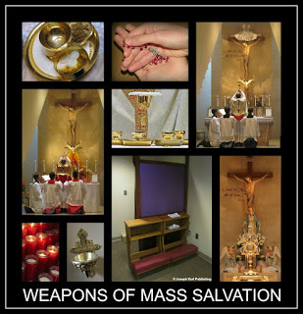What a powerful moment that was, to witness our incomprehensibly loving and merciful Creator make use of His instruments to extend every care to His beloved creation. What courage that man showed by going to confession, and what love! What love and devotion the shepherd, his confessor, showed to this vital member of his flock.
How interconnected we all are! God planned it that way. How phenomenal that the Lord uses us as co-conspirators in the salvation of one another!
I was absolutely delighted to have been summoned by God to be a part of something so very beautiful, and intimate, as that man's reconciling himself with God. At the Lord's request, I launched Golden Arrows, one after another, right into the Sacred Heart of our Savior!
The experience was so meaningful. So, so meaningful. Everything about being profoundly Catholic is extraordinarily meaningful. I was mindful of all the people the Lord summoned to pray for me, and how much their cooperation with grace has meant to my life, my mission, and my eternal welfare.
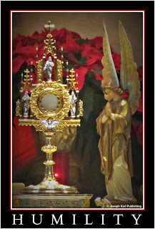I admit that at one point, I took a good look around and wasn't quite convinced that the man had gone into the confessional. There was no way to know for sure just by looking. During regular confession times, there is a green or red light on over the confessional doors to let those waiting know if the confessional is available or occupied. At that time of the day, confessions are not normally heard, so no lights were on over any doors.
I began to doubt that the man was in the confessional. Trusting in the Lord more than myself, I launched more Golden Arrows, and then went back to my work.
Nothing happened.
I must have been mistaken, I thought to myself while working.
How awesome it would be, though, if that was really happening and the Lord was asking other people to pray for the man and his confessor while they were in there!
Time passed, and then after a while more, I heard two male voices in the chapel. Although I didn't look up, the voices came from the confessional and they were heading toward the back exit doors.
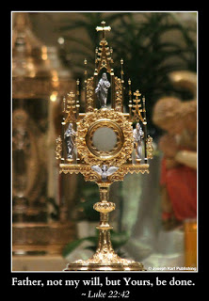How much God loves every single one of us. His love and mercy are available to each person, any time, all the time.
All we have to do is accept them.
Listen for the Lord's summons in your life. They aren't always big, life changing events, at least not always to us. Sometimes we are used as His instruments for brief moments, significant moments, loving moments, charming moments, and life-changing moments.
Sweet and gentle Jesus, if I hadn't already given You my heart, You would have had it for sure today. How compassionate You are, how generous, how caring, how forgiving.
I renew my vow and give myself entirely to You, and promise to love and honor You all the days of my life.

PaRT

The Jeopardized Soul and the Sacred Heart

There’s nothing ordinary about being Catholic. Nothing!

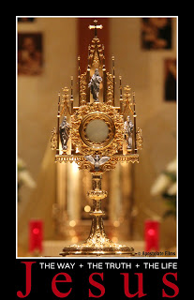Today is Tuesday, and I have missed Holy Mass three days in a row. Sacrificial love had me remaining home with my son who had been sick with a contagious illness that had made its way through the members of our household for over a week.

This afternoon after my children left to visit with their dad, I went to church to pray. It was the Hour of Divine Mercy. First I prayed the Divine Mercy Chaplet. Then, I meditated on Christ’s Passion while preparing my heart to journey through the Sorrowful Mysteries of the Holy Rosary.

Jesus and I shared some precious time exchanging greetings, very mindful of the joy we experience while in the company of one another. Then, as Jesus, Blessed Mother, and I entered the Garden of Gethsemane to pray during the First Sorrowful Mystery, I thought of how sad I was to have missed receiving Jesus in Holy Communion the past three days. So I asked Jesus to bring me His Precious Body and Blood in the Eucharist.

He had not offered and awaited my request. Oh, how much our Savior longs for us, His beloved, to be eager to see Him, be happy to be with Him, and want to receive Him. He so longs for our love in return!
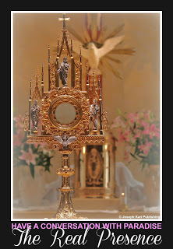
Jesus was so pleased with my request that He immediately brought me the Eucharist. Our Savior stood before me, slightly off to my right.

After I received His Precious Body and Blood, Jesus took His pierced Hand and lovingly stroked my right cheek.

It was an incredibly beautiful and profoundly meaningful moment of such tender love that tears of gratitude and joy began flowing down my face.
Last week I had missed several Holy Masses to remain home with my daughter, who was the first one to get sick. Last Friday morning all my children were well enough to attend school, and I was delighted to be able to pray before the Eucharist during a Holy Hour that morning before Holy Mass.

Jesus requested that I come close to Him on Friday mornings during Eucharistic Adoration and Exposition, and so I knelt down in the front row. Then, something very special happened just for you and me.

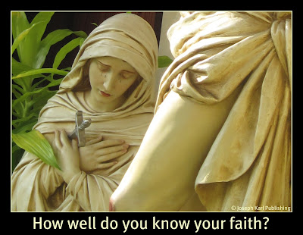

The good Lord knelt next to me on the right, and Blessed Mother knelt next to me on the left; I was in the middle. We began praying together, in the Garden of Gethsemane.

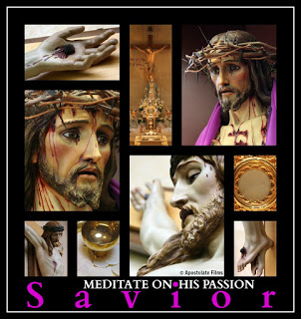The three of us represented our Savior, Blessed Mother, and every person who meditates on Christ's Passion and the same pains willingly endured for us by God's most holy Mother.
They were there to show us how to submit our wills to the will of God the Father. While offering themselves as victims for the redemption of mankind on Holy Thursday, they sweated blood and cried tears of blood. And in our time, it is possible for us to mystically sweat blood and cry tears of blood as we meditate on their suffering, and as we unite our suffering and our wills with theirs and then offer everything to God the Father.
So this afternoon, in the peaceful, dark, and quiet church, Jesus continued to lovingly caress my cheek with His Sacred Hand throughout the Sorrowful Mysteries of the Rosary, as He was scourged at the pillar, crowned with thorns, struggled under the weight of the Cross, and as He fell and then willed Himself up so He could make it for our sake to the absolute horror of the Cross.
Somewhere along the journey, I reached up and took His pierced Hand in mine.

I apologized to Jesus for all my faults and transgressions, and thanked Him for having taken upon Himself the punishments I had earned by willfully sinning, and for satisfying Divine Justice in my place.
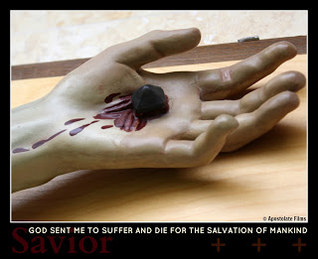
Then, the most incredible thing happened.
Together, we began praying for a soul in grave jeopardy because of mortal sin. Jesus took that person’s soul and placed it between His pierced Hand and mine.

Jesus and I continued praying and traveling along the Way of Sacrificial Love together, all the while holding this soul in our hands.
That precious soul is so loved by our Lord that He not only suffered and gave up His very life for it, He continues to pray for it AND asks others to pray for it as well!

Every single soul is so precious in God’s eyes, and is loved and valued beyond measure.

Your soul is absolutely priceless in God’s eyes, and He loves and values you beyond measure.

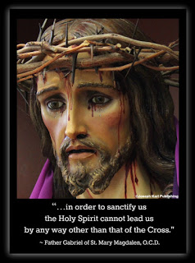Jesus, Blessed Mother, and Ifinished praying the Rosary. What indescribable peace, love, and joy they bring to us! How much they love us.
Another very special Holy Hour had been completed, and I wondered what was to become of the precious, immortal soul so lovingly and carefully held in our hands.

Guess what happened to it.

Jesus took that soul into His hand alone, and after passing it through the beautiful gate of the Wound in His side, placed it within His Sacred Heart.

Sweet and gentle Jesus, most loving and merciful Savior, Your love knows absolutely no bounds!
And You always provide the best endings (smile).

How can one resist shedding more tears (of blood) after that. +
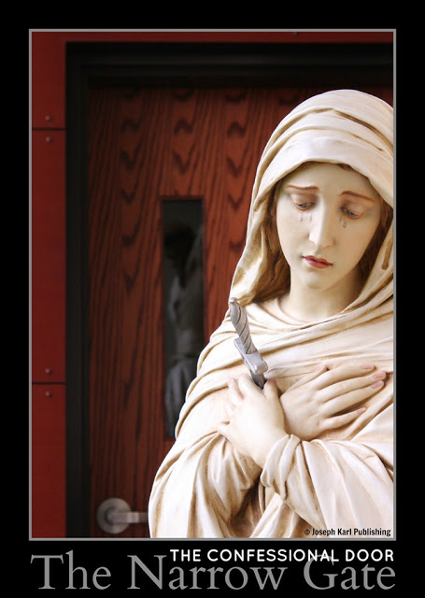
Your prayers help guide precious, immortal souls to Christ, particularly through the confessional door, the narrow gate.

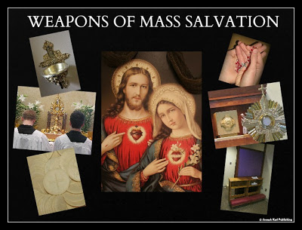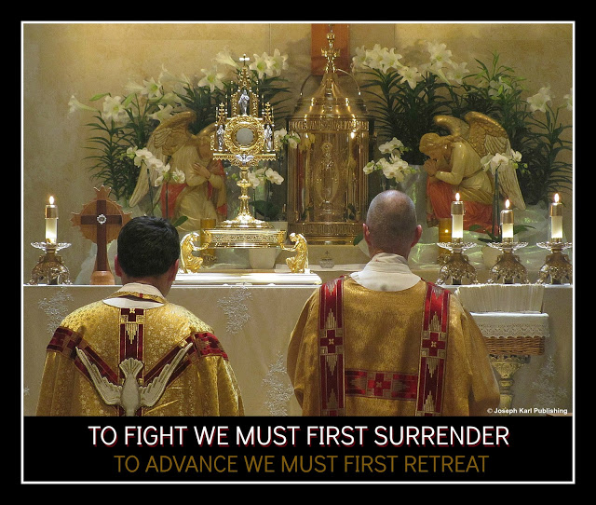

We should never just be Catholic. We must be PROFOUNDLY CATHOLIC living witnesses and dispensers of God’s PROFOUND LOVE.
And for the love of God, keep praying for other people. One moment I will never forget is Father Ben saying during one homily, "We don't give up on ANYONE." God bless our shepherds, every single one of them.
"Trust all things to Jesus in the Blessed Sacrament, and to Mary, Help of Christians, and you will see what miracles are." ~St. John Bosco

Up Next: Mortal Sin and the Self Destructive Soul

© Joseph Karl Publishing
Meditating on Christ's Passion
and the Moment the Crown of Thorns was Removed from His Sacred Head

6 1/2 minutes of profound Catholicism that may change your life forever.

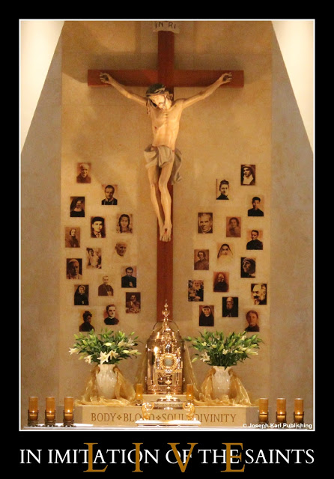

Believe in imitation of the martyrs,
love in imitation of the saints,
and live in imitation of Jesus and Blessed Mother.
God is at work in you!

Part

"Lord, WHAT Are You Trying to Teach Me?"
Discover or rediscover the Sacrament of Christ's Peace. God's love and mercy are available to every person, without exception, at any time. Grow closer to the Love of your eternal life!

It had been three and a half weeks since I had been to confession. This past weekend, the Lord explained that He was having me wait so I could concentrate on finishing the pro-life book He commissioned. Over the past three weeks, the devil has waged an all out war on chastity, patience, poverty, and fraternal charity.
As usual, I knew the Lord was up to something good. + + + But there is so much to learn, and it is sometimes very difficult and painful living in the world and battling it, the flesh, and the devil. With each passing day, I was even more eager to receive the priceless graces God dispenses to humanity through the Sacrament of Reconciliation.
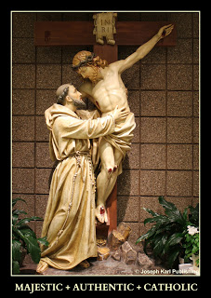One powerful case in point why God's grace is absolutely necessary: it's not even Advent yet, and already the faithful are forced to travel from one battlefield to another throughout each day because the wicked spirit of consumerism has turned every place one goes, and I mean EVERY PLACE one goes, into marketplaces.
Oh how painful to be able to see the carnage everywhere as the greedy are lured into even more emptiness, and the compassionate are lured into the same evil by constant selling for the sake of their service to the Lord.
How easily the devil manipulates us; God have mercy on us all!
What have we become. All of us. What have all of us become.
"Lord," I asked Him from the depths of my assaulted soul yesterday morning, "WHAT are you trying to teach me?"
His lesson was pro-life, and it focused specifically on chastity and charity. Why?
"...unless the practice of charity and chastity is restored not only is there no stopping of abortion, this crime will only increase in intensity, and the number of innocent victims beyond all human calculation." ~ Servant of God, Father John A. Hardon, S.J.
Late that afternoon, during a Holy Hour, Jesus left the Tabernacle and came to the back of the church to console His sorrowful daughter, gave me a hug, and sang a song I had sung for Him just the day before ("When I Look in Your Eyes" from the film Dr. Dolittle). Then, He treated me to a very nurturing hot supper.
Late last night, I asked Jesus if He wanted me to go to Confession in the morning. I was eager to receive the graces needed to fight the ongoing battles. What a beautiful moment that was when He consented, and then He helped me write an examination of conscience.
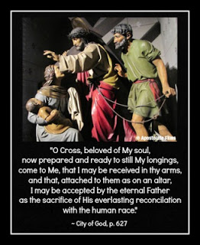This morning, while praying in the chapel before confessions began, Jesus of the Divine Mercy came over, bent down, and comforted me again with a hug. Then, He knelt down next to me and guarded me until it was my turn to "enter through the narrow gate." Sometimes the devil assaults me while I wait for my turn in the confessional, but this morning Jesus made it a point to be by my side following a hard-fought three week battle against the forces of darkness.
If you ever doubt God's tremendous love for you, meditate on Christ's Passion. Mark my words, He loves you and is always with you, ready to help you, guide you, console you, forgive you, and love you. All you have to do is let Him!
Everything God does is with our eternal good in mind, and He wants us to be happy and holy. He wants to love us, and so much of His love is being rejected.
Through all the joys and sorrows of life, through all the victories and defeats, Jesus tells us, "There is no situation in which I am absent."
He wants us to have faith, but not just say "We believe." He wants us to be PROFOUNDLY Catholic. He wants us to be instruments of His love and channels of His grace.
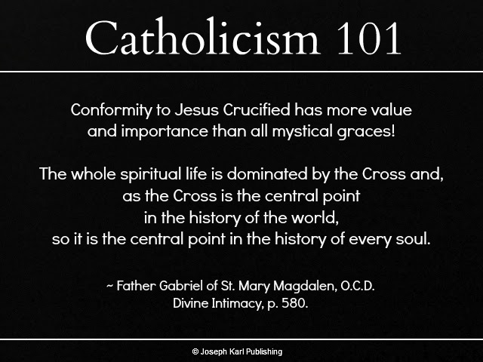
The devil seeks to sabotage all this goodness, and tempts us to think that God doesn't hear us or care about our problems. We are vulnerable to giving in and believing this lie when we focus on accomplishing our own agenda instead of striving to accomplish God's will.
Around my house, things and people constantly break, and it's been one plumbing, appliance repair, or medical bill after another for years. Since I've been too sick to do much of anything, we have had to hire people to do work around the house and yard.
The Lord recently explained why all that has been allowed to occur, lest I be tempted to think He doesn't care. Jesus said that although these things appeared to be hardships, He was having them occur with very good reason. The reason? For greater Divine intimacy!
He granted this insight because of my efforts to grow closer to Him.
Poor health, lots of bills, and a very vigilant Lord have been detaching my soul from so many worldly things that are meaningless for my eternal welfare. God is so incredibly good! In this way, He said, "I am keeping you very close to Me."
These personal details are being shared with you at our Lord's request, because He wants you to believe in Him, know Him, trust in Him, accept His love, love Him in return, and share His love with others. He wants your relationship with Him to be deeply personal and very meaningful. He wants you to live a holy life, guide others to Him, and spend eternity unified with Him in heaven.
Don't ever just be Catholic. Instead, be PROFOUNDLY Catholic. God is so in love with you!!
Which leads us back to the Sacrament of Divine Intimacy. Don't ever be tempted to believe that it doesn't matter whether or not you go to confession. God instituted the Sacrament of Reconciliation, elevated confessing to a priest to a Sacrament, and wants you to go, often.
Some Confession Catholicism 101
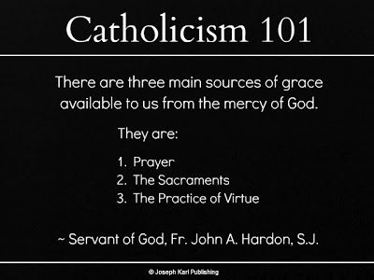
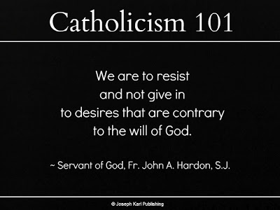
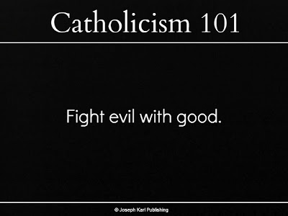
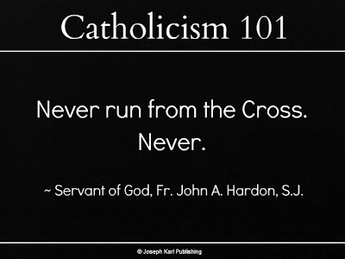
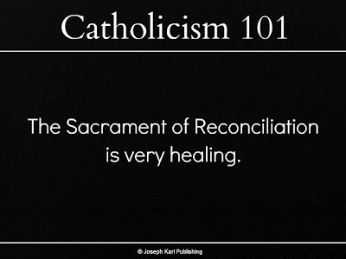
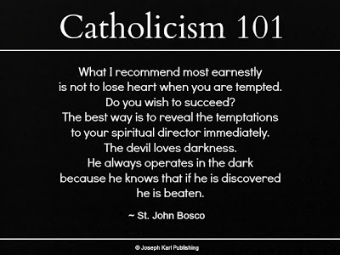
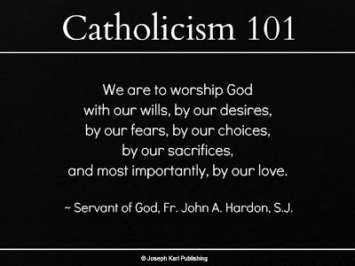
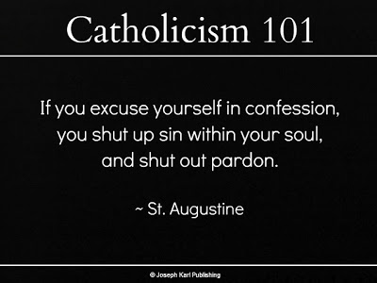
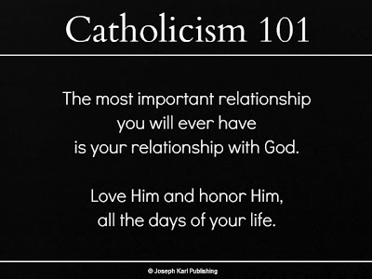
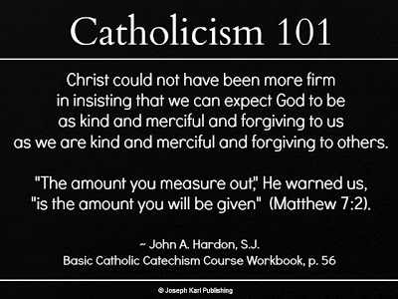
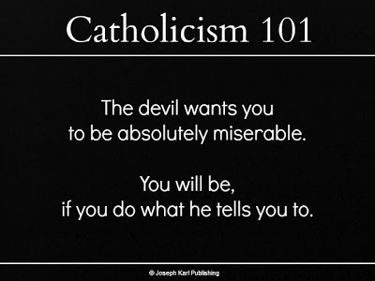
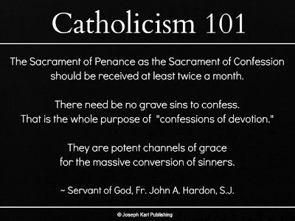
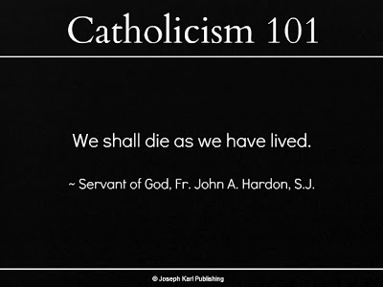

Here's my confession from this morning, shared at the Lord's request, as a guide for those who could use one. It is just an example.
Ask the Holy Spirit, who knows you best, for enlightenment as you examine your conscience. Make your confession personal, meaningful, and powerful. Don't hold anything back. Never, ever take this vital Sacrament for granted, and don't ever give in to the devil's temptation to stay away from confession. You will get as much out of this Sacrament as you put into it. Remember to pray for those whose prayers have helped lead you closer to the Blessed Trinity. Prepare to be absolutely astounded; God is so in love with you!
Today's Confession
Sign of the Cross. Bless me, Father, for I have sinned. My last confession was three and a half weeks ago.
Glory be to the Father, and to the Son, and to the Holy Spirit!

My Father, Spouse of My Soul, and My Guide,

I am so happy to be here! I have wanted to come sooner, especially after the devil threw that horrible spiritual grenade, but once again You have had me wait for another three week interval.

As You explained yesterday, You wanted me to be able to focus on finishing the book first. I thank You for your consideration, Lord! And thank You for explaining how these recent assaults of the devil tie in with the pro-life work. I know You have other assignments in mind and await Your instruction on what to accomplish and when.

The torments of the devil have caused me a great deal of sorrow these last three weeks, more so than usual, because of his wicked and unrelenting temptations against purity, to hate, and to despair as he mocks all things Catholic and holy.
Sometimes You had me fight him, and other times You came to intercede for me right away. As You said, there is no situation in which You are absent, and the devil has not won although he has tried so hard. Without You I can’t fight these battles, especially while so tired and suffering on the Cross at night.
Please help me to mentally manage his inconceivable nightmare of manipulation and vulgarity, and I thank You for the work You are accomplishing in my soul, for me and for the benefit of others as well.
Is my soul so troubled because I don’t trust in You, Jesus? If so, I am very sorry. But I don’t think that is mostly the case. My problem is I remain too attached to my own will. And it is a challenge in my condition and with the circumstances being what they are to process what You are showing me as You continue to detach me from the things of this world.
It’s painful sometimes, Lord, because so many things around me have been stamped by Your almighty Hand with the word “MEANINGLESS,” and because the people around me don’t always understand. I don’t want to harm anyone, realizing that serving You comes first, but sometimes that happens. Please keep working with me, sweet and gentle Jesus! I know Your plans are always best. Thank You for coming to console me in church yesterday. I love You.

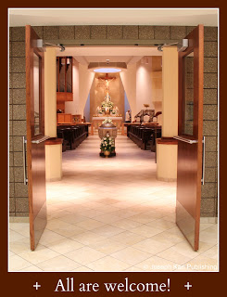I am sorry for having offended You by losing my temper, for the times I have been frustrated with myself or others, for the times I have been unjustifiably angry, impatient, and for the times I have spoken to others harshly, especially my son Nick the other day, who was so gracious and accepted my apology.
I apologize for the times I failed to cooperate with Your grace and for any harm I have caused others by my behavior. I am sorry for the times I have set a bad example for others, or for any time my actions have caused others to sin.

I am sorry for my worldliness, lack of self mastery, for being self centered, and for my terrible pride, and lack of humility and fraternal charity.
Oh how much I need Your grace to listen for and hear Your inspirations, cooperate with Your most perfect will, to grow in holiness, and manage the assaults of the devil along the way.
Thank You for Your boundless compassion and Your mercy, Lord. Please extend any benefits You so generously see fit to grant to my soul to my brothers and sisters also, especially those most in need of Your mercy.

Please convert sinners, assist the dying, and liberate the suffering souls in purgatory, especially Belinda and (name), if they are there.

I give myself entirely to You, and promise to love and honor You, all the days of my life.
Act of Contrition, followed by Absolution, and a joyful "Thank you!" whispered to my confessor. (smile)

More Thoughts on the Importance of Going To Confession
The spiritual battle is very real; how prepared are you to fight, and win?
How to make your confessions meaningful, powerful, and very beautiful.
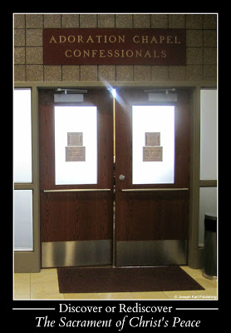
On Friday night, my children and I discussed our plans for the next day, and determined that it was time for everyone to go to confession. So we planned on talking the next day about what to include in an examination of conscience to make our confessions very meaningful and powerful, to write them out, and to help one another if anyone requested assistance.
Because we mentioned our intentions out loud, our adversary knew where we were headed the next day.
The next morning, I woke up my fifteen year old son Nick, and he shared with me the following experience he had overnight. Nick gave his permission to share it with you:
"I had a dream that we were in California, and wanted to go to the beach, but there were sand sharks on the beach. So we had to go into a ten by ten pool, which was by the beach. It was about twelve feet deep, and I jumped in, feet first. There were suction cleaners at the bottom, and my feet got stuck to them. I started to drown. I saw my mom jump into the pool, too, and I waved her over from the bottom of the pool to come help me. She did not.
"Then, I finally got free, after about a minute and thirty seconds. I swam to the top of the pool, and when I was about to break the surface, something pulled me down. I finally broke loose of the strange force pulling me down, and rose to the surface. Then, I woke up and found that for some reason, I had been gasping for air in real life."
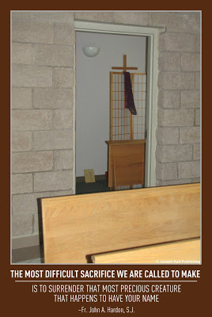Nick's dream is very significant (have you had similar experiences?), and it is shared with you to point out the very real spiritual battle every one of us faces each and every day, and to encourage you to go to confession, often. There, you will obtain the graces for yourself and for others that are needed to fight the battles against the flesh, the world, and the devil, AND WIN.
The sharks on the beach are symbolic of the traps we must avoid as we go about our lives, whether we are working, resting, or at play. Nick avoided the beach when he saw the sharks, and went to swim in the pool instead. But even there, he was pulled down and kept from the air he needed to sustain his life, symbolizing our adversary's attempts to "keep us down" and distance us from God.
Nick tried to signal his mother for help, but the devil wanted him to think that appealing for help to those who can be trusted is futile. He wanted Nick to feel that his efforts were all in vain, and that reaching the surface (growing in sanctity) was not worth the effort because the devil's hold on him was so strong that it was no longer possible. Nick finally broke loose of the force pulling him down, because he kept fighting hard to get away and ascend higher, to reach the source sustaining his life.
We discussed the dream, and I assured Nick, and also assure you, that the spiritual battle for our immortal souls is very real, that our efforts to fight evil and grow in holiness matter a great deal, that the people around you who are trustworthy will in fact come to your aid when you ask for help, and that our most loving and merciful God is always ready and willing to intercede for us.
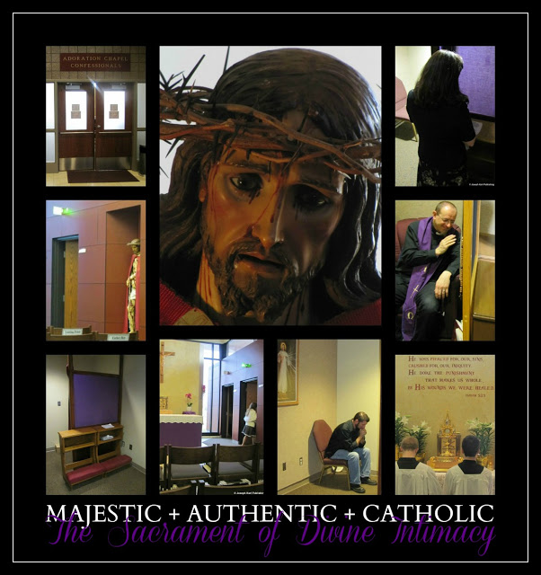
A short while later, my family went out to lunch, and after our meal had a very important discussion. Make sure you have this discussion with your family, friends, classes, or congregation. We had already talked many times before about the importance of going to confession, so this time the focus was on making our confessions personal, deeply meaningful, and very powerful. American Catholics are not encouraged nearly enough to give proper consideration to what we are saying, nor are we properly educated about what to say. Most people have no concept of how necessary and incredibly powerful this sacrament is. As a result, many churches don't have people availing themselves of this vital sacrament regularly and often.
There are several reasons for this disastrous reluctance to discuss the Sacrament of Divine Intimacy. Many American Catholics, even after having made their sacraments and after having attended Catechism classes in their youth, lack an even basic understanding of the Catechism of the Catholic Church. That's why so many leave the Church; anyone who truly knows the one True Faith could never leave it. Other reasons include the very personal and private nature of confessions; no one can, or wants to, tell anyone else what to say. Another reason we know so little is because confessions are usually not shared, and so we don't learn from one another. As a result, when many do go, they sadly just go through the motions.
As a result, so much is never gained. HOW TRAGIC! Every single one of our confessions, no matter how short or long, no matter what style in which they are said or written, should be deeply personal, very meaningful, powerful, and PROFOUND. They should be life-changing. Certainly, the graces available to us are life-changing because they are strengthening, healing, restorative, provide courage, knowledge, unify us with God, and help us overcome our faults and love in greater measure.
Most of the time when confession is discussed we are told to go, be sincere and be sorry, and that's about it. More must be said to enlighten the faithful and teach others how to make this sacrament so much more beneficial to us as we also obtain much needed grace for others.
No two confessions are ever the same. Styles vary from person to person, and for various reasons may even vary from time to time with the same individual. Examinations of conscience will vary depending on individual penitent's age, abilities, and spiritual level. Guidance should be given to others in developmentally appropriate language/ways.
There are many right ways to approach one's confession, and the key is to examine one's conscience with the guidance of the Holy Spirit, be open to God's will, go regularly and often, and be obedient to one's confessor.
Pay particular attention to Who you are speaking to in the confessional (God), what you are saying, and how you are saying it. Make your confessions deeply personal, meaningful, and very powerful! Together with Jesus, make them extraordinarily beautiful.
The devil absolutely doesn't want you to know this, but as you grow more unified to our most loving, compassionate, caring, and merciful God, you will find yourself absolutely loving going to confession. Who wouldn't want more of so much of our Triune God's goodness!
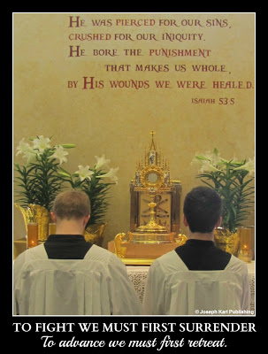Late that afternoon, as we drove to the church, the devil's assaults began anew and he bombarded me with tremendous anxiety. He absolutely did not want us to go to confession!
When this happens, the most important thing to do is to pray to God for the grace to persevere, and KEEP GOING! Do not avoid going to confession when such an assault occurs. Such an assault is an indicator that great good will be accomplished because of your efforts! Pray to Blessed Mother for her help, and proceed to the church.
My confessor, Father Ben, stated something very powerful and very important in his homily last week and encouraged us to share it. In Matthew 7:13 we are told to "Enter through the narrow gate." Father referred to the width of this entrance, and explained that it is as wide as the confessional door. "Go to confession often," he said.
While waiting for your turn in the confessional, especially if you are experiencing the assaults of the devil, pray to the Holy Spirit to help you make a wonderful confession, and repeat as often as necessary, "God, Your grace is sufficient."
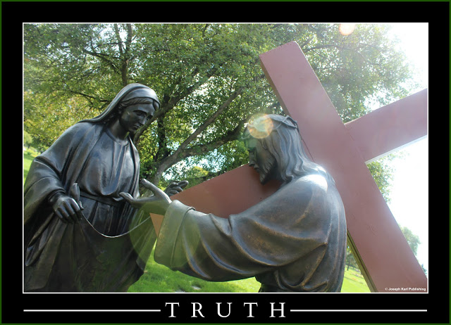
My confession is presented here as an example to help you make your confessional meaningful, personal, and very powerful. Worth noting is what was said at the Lord's recommendation to release our adversary's grip on our souls when he tempts us to hate others. Read on (that text is in bold).
And to learn more about what you need to know to fight the spiritual battles and win, visit:
Parts I - IV: Tired of Being on the Defensive Against the Devil? Launch a Spiritual Offensive Instead (also includes: Do You Know What Weapons You Need to Fight the Spiritual Battles Against Evil and Win? Perhaps Some of Them May Surprise You; Suggestions for Making Your Confessions More Powerful, Intimate, and Meaningful; The Sacrament of Reconciliation, Penance, Conversion, Forgiveness, Divine Intimacy, Christ's Peace, Healing, Humility, and Catholic Courage).
God is at work in you!
Discover or Rediscover the Sacrament of Christ's Peace

Sign of the Cross. Bless Me, Father, for I have sinned. My last confession was two weeks ago.

Lord, this is entirely inadequate, but You know the shape I am in; our adversary is all over me, and I feel like I’m going to throw up. That means it is very important that I am here, and Your grace is sufficient, so let us begin. (God did provide His grace, and I continued in peace).

My most loving, merciful, ever present, and all powerful God,

I am here to love You in return with all my heart, to submit to Your most perfect will, to ask for Your forgiveness for my many transgressions, and to beg for the grace to overcome my faults.

I am very sorry, Lord, for my worldly, self indulgent, self centered, prideful, stubborn and self absorbed nature, my lack of fraternal charity, for the times I still hold back from loving you as much as I should. I apologize for avoiding You in the evening; You have asked why I am doing that, and I don’t know why that is, because I love being in Your presence and am so grateful for all You show me and teach me. May I reserve none of this goodness for myself; help me to clearly know Your will moment by moment , so that I accomplish all that You ask.

Help me to empty myself of my pride and my own will, so that You are able to work within me and through me entirely at Your good pleasure.

I apologize for being judgmental, for allowing negative thoughts to pass from my lips, and for the times that I have spoken to others harshly.

The devil is relentless in his assaults and has focused on tempting me to be impatient, to absolutely hate people, to give up the work You have assigned, and tries so hard to tempt me to impurity. His physical attacks have been severe, as are his attempts to exhaust me, and his temptations can only be overcome by Your grace. You have said that You are present through it all, and allow all this for good reason. I trust in You, Jesus, and thank You for everything.

As I beg for mercy and Your forgiveness for offending You, and for all the times I have hurt others by my actions, I now forgive all those who have ever hurt me, and ask You to forgive them, and shower them with Your divine graces and love. Let there never be any bitterness in my heart, and let me never hold anything against anyone.

Forgive me, sweet and gentle Jesus, and cover my soul and the souls of all my brothers and sisters with Your Precious Blood, and save us from the wickedness and lures of the devil. Please convert all sinners, assist the dying, and release the suffering souls in purgatory, especially Belinda if she is there, and the most forgotten souls, the most wicked, and the souls of those who were most faithful to You.

Thank you, almighty God, for so much goodness that is so freely given, for sending us to this parish, for the gift of life; please convert everyone who is pro-abortion, and I ask You to guide the hand of every person voting so that everyone chooses to defend life and liberty, and votes in imitation of Christ.

May I never stand in Your way, block your action through me, or offend You, most loving and gentle Jesus! May I always accept Your graces and always be grateful. Please do not let any of this precious suffering be wasted because of my imperfections. Again, I give myself entirely to You, and promise to love and honor You, all the days of my life.
Act of Contrition, Absolution, Sign of the Cross, lots of joy. Thank you, Father!

The Sacrament of Reconciliation, Penance, Conversion, Forgiveness, Divine Intimacy, Christ’s Peace, Healing, Humility, and Catholic Courage

Which name do YOU prefer, and how well do you know this sacrament so helpful in achieving Divine intimacy, and so vital in fighting the battles against the flesh, the world, and the devil?

The fourth part of the spiritual warfare series focuses on gaining a better understanding of, and appreciation for, the Sacrament of Reconciliation, a tremendous gift given to us by our most loving and merciful God.
This post presents just a small sense of what this sacrament means to humanity in general and you as an individual. Hopefully it encourages you to learn more about the Sacrament of Christ’s Peace, apply it to your own life, and teach others this important information by word and by your example.
Guaranteed, your life will never be the same!
Rest assured that this sacrament is necessary for every one of us because every one of us has a fallen human nature. Also know that God’s love and mercy are available to every single person, without exception. Go for yourself, and go to obtain graces for others!

The earlier posts in the series:
Part I: Tired of Being on the Defensive Against the Devil? Launch a Spiritual Offensive Instead
Part II: Do You Know What Weapons You Need to Fight the Spiritual Battles Against Evil and Win? Perhaps Some of Them May Surprise You
Part III: Suggestions for Making Your Confessions More Powerful, Intimate, and Meaningful
And now Part IV:

The Sacrament of Penance and Reconciliation

1422 “Those who approach the sacrament of Penance obtain pardon from God’s mercy for the offense committed against Him, and are, at the same time, reconciled with the Church which they have wounded by their sins and which by charity, by example, and by prayer labors for their conversion.” Catechism of the Catholic Church, p. 396

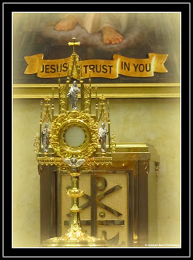Did you know that the Sacrament of Penance goes by many different names? It is called the Sacrament of Conversion, the Sacrament of Penance, the Sacrament of Confession, the Sacrament of Forgiveness, and the Sacrament of Reconciliation.
Servant of God, Father John A. Hardon, S.J. referred to it as the Sacrament of Christ’s Peace.
Other delightful names are the Sacrament of Humility, the Sacrament of Healing, and the Sacrament of Divine Intimacy. St. John Bosco referred to it as the devil’s bankruptcy, and we can also call it the Sacrament of Catholic Courage, Spiritual Warfare, or Spiritual Combat.
Do you have a preferred title among them? Or, do you prefer a title of your own.

According to the Catechism of the Catholic Church, this is what some of the names imply in particular:

Sacrament of Conversion because it makes sacramentally present Jesus’ call to conversion, which is the first step in returning to the Father from whom we stray when we sin.

Sacrament of Penance consecrates the Christian sinner’s personal and ecclesial steps of conversion, penance, and satisfaction.
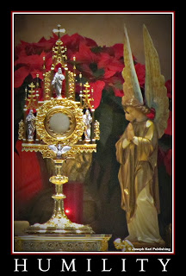Did you know it was this meaningful? Read on!

Sacrament of Confession because the disclosure, or confession, of our sins to a priest is an essential element, our confession or acknowledgement and praise of the holiness of God and of His mercy toward sinful man.

Sacrament of Forgiveness since penitents are granted pardon and peace by the priest’s sacramental absolution.

Sacrament of Reconciliation because it imparts to the sinner the love of God who reconciles by the words “Be reconciled to God.” When we accept God’s love and mercy, we are ready/equipped to respond to the Lord’s call that we be reconciled to one another.
Some other unofficial names and meanings:
Sacrament of Healing; perhaps one of the most under appreciated and least considered benefits of making good Confessions is the healing power of God's graces. Penitents are relieved of the burdens of guilt and shame sinning imposes upon our moral consciences. While this state of spiritual disequilibrium can help us because we then feel remorse and want to reconcile with God, the devil can also use these feelings against us and try to stop us from confessing. After having asked for and received pardon for their sins, penitents have greater mercy for others.

Sacrament of Divine Intimacy; when we willingly are honest, sincere, and humble while seeking pardon and ask to be reconciled with our most loving Creator, our actions show we love Him in return and we grow closer to God. The setting is intimate, the discourse is intimate, the reason we are there is intimate, admitting our sins is intimate, our love is intimate, and our relationship with God is intimate.

Sacrament of Catholic Courage; it takes great courage to be humble, admit one’s faults, be truly sorry, and be committed to amending one’s life. We need God’s grace to accomplish this; and what takes place in the confessional is totally supernatural and transforming. Grace is necessary for us to accomplish good and fight evil. This sacrament is very, very powerful, makes us stronger, and is indispensible in helping us fight temptation AND WIN.

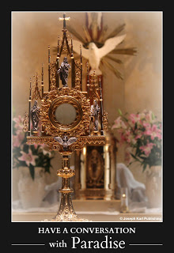The Sacrament of Humility; by this name, we come to better understand that this sacrament is a very powerful way to break the devil’s hold on us. Humility causes the demons to bid a hasty retreat. When we apologize, we are humble. When we submit to our confessor, we are humble. When measuring our unworthiness against the love and mercy of God, we are humbled.

“We cannot content ourselves, as the Pharisees did, with simply not doing harm to our neighbor; we must practice toward him a positive fraternal charity. It is not enough ”not to kill” in order to escape “the Judgment,” the Master teaches, but “whosoever is angry with his brother, shall be in danger of the judgment.

"It is useless to make an exterior display of goodness is this does not proceed from a good conscience, a sincere heart. It does not suffice to avoid giving outward offense to our neighbor; we must avoid, or rather, repress our inner resentment. ... Jesus asks great delicacy of us in all our exterior dealings with our neighbor He demands that we avoid not only offensive acts but even words that might hurt another.
~ Father Gabriel of St. Mary Magdalen, O.C.D., Divine Intimacy, pp. 670-671.

So much more could be said about the Sacrament of Reconciliation! One final thought to end Part IV, from the Catechism of the Catholic Church: Daily conversion and penance find their source and nourishment in the Eucharist, for in it is made present the sacrifice of Christ which has reconciled us with God. Through the Eucharist those who live from the life of Christ are fed and strengthened. “It is a remedy to free us from our daily faults and to preserve us from mortal sins.” ~ Catechism of the Catholic Church, 1436.
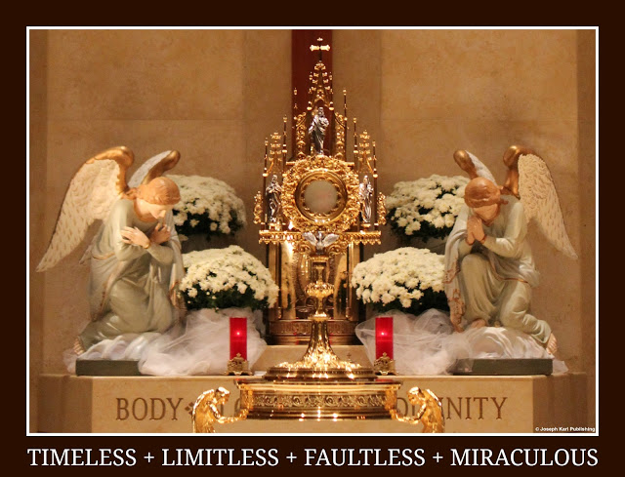
What follows is an actual confession, which is included as an example, to help you make every one of your confessions deeply personal and meaningful.
Part III of this series provides more examples for you to consider as you make your examinations of conscience and, together with the Holy Spirit, determine what you should say to God each time you go. Remember, details differ because they are personal to each individual penitent.
So pray, and then make your examinations of conscience and confessions deeply intimate, personal, meaningful, and loving!

Soon, you will be so astounded by your spiritual progress and by how you have grown closer to God by leaps and bounds, and will find yourself absolutely loving going to confession, if you don’t already!
Don't just be Catholic. Be PROFOUNDLY Catholic!!

Sample of a Confession

The Sign of the Cross. Bless me, Father, for I have sinned. My last confession was two weeks ago.
My most loving and merciful God,

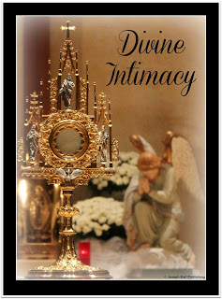I kneel here at the foot of the Cross to ask for Your pardon for having offended You. I remain so incapacitated and in great discomfort, and doing even the simplest things has been incredibly difficult, especially being kind, patient, and positive. But even though it doesn’t always feel like it, my health is improving and I am so grateful to You for allowing me to attend Holy Mass and receive You in the Blessed Sacrament most days. That brings me great joy, my Jesus!

Lord, I freely consented to accept this cross which most recently has me unified with Your suffering body attached to the Cross, so cruelly stretched as to cause you unfathomable torment. You suffered so horribly to atone for my sins because You are so loving, and I thank You for the opportunity to offer You reparation for my many offenses against Your Divine majesty.

I apologize to you for my tremendous pride, my worldliness, lack of fraternal charity, impatience, negative disposition, and for the many times I have spoken to others harshly, including (name), (name), and (name).

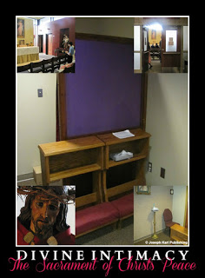
Please help me to accomplish Your will with honor, courage, and dignity. Please help me so that I do not harm others and offend You as I travel along the Way. You show me so many beautiful things that I know are the precious fruit that can only be harvested when a soul is willing to take on Your likeness, take up its cross, and follow You. Please do not allow my imperfections to be the cause of any of this precious suffering to be wasted. Allow everything to be gathered into Your Sacred Heart, immersed in Your Precious Blood, and thereby come to fruition exactly as You intended.

Thank You for Your incredible generosity, for what You have restored in me, for those beautiful moments of Divine intimacy, for teaching me so many things, for being willing to use me as an instrument of Your unfathomable love, and for Your great mercy. May all of my brothers and sisters benefit from the mercy and pardon obtained here at the foot of Your Cross. Please heal those in need, and may we all come to know and love You as we should.

Please help the dying, convert sinners, and liberate the Holy Souls in purgatory.

My sweet, gentle, patient, and innocent Jesus, I trust in You! And now, as You have requested, my poor soul arises to begin again and though unworthy, I submit to Your most perfect will. Do with me as You please. I give myself entirely to You, and promise to love and honor You all the days of my life.

* * *
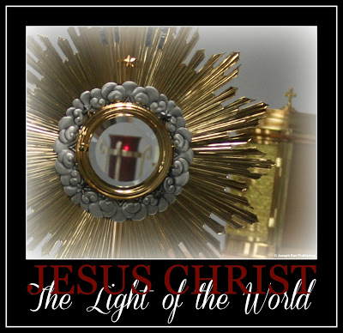

The following reconciliation prayer was written during a moment of Divine intimacy, and was used for years as a prayer before going into the confessional. Then one day when the penitent was very sick, the good Lord requested that it be said that morning during the actual Confession. Feel free to say it as it is, modify it to make it personal, or use it as a guide to create your own.

A Reconciliation Prayer
Oh sweet Author of Life,
Your pardon I seek as I kneel before Your Cross.
Lord, forgive me.
Immerse me in Your compassion,
for I have so little to offer you.
Even my petition for forgiveness comes from You.
You long for my approach, though wounded,
so generously willing to exchange human iniquity
with the Love that annihilates and saves,
when the soul but accepts Your invitation.
I give my nothingness entirely to You.
Divine Justice, have mercy on me,
and may all my brothers and sisters benefit also,
especially those most in need of Your saving grace.
Blood of Christ wash over me,
and transform my self into You.
Make of me the mirror
that reflects Your love to Your beloved.
I thank You for Your sacrifice and invitation,
for Your patience while awaiting my response,
as I seek Your will
while You encourage me to make my own choices.
For lovingly creating, guiding, and consoling me,
for all You have generously given me,
including the grace to recognize
that which on my own I cannot see.
For allowing me to lose, that I may win.
For giving me the opportunity to journey with You
along Your Way of the Cross.
I accept Your love,
and return to You my heart united with Yours
along with my obedience.
Thank You for everything, Thy will be done;
accept my petition to fill this dry well
with Your Divine Presence.
Amen.

© Joseph Karl Publishing
Hopefully this information increases your appreciation for the beautiful Sacrament of Reconciliation, which is so valuable for our souls, as you grow in sanctity and intimacy with God.

God is at work in you!

EXTRA STUFF

What King Leads the Most Powerful, and Untrained, Army on the Planet?
The King of all kings and Lord of all lords.
WELCOME TO THE ERA OF GLOBAL, PROFOUNDLY CATHOLIC
RENEWAL and RESTORATION
What a mighty army humanity has fighting for precious, immortal souls in the humble, obedient members of the One, Holy, Catholic, Apostolic, and Prof-Life Church who know their Faith and continue learning more!
Oh, but what a catastrophically untrained army we are, an army largely unequipped with the information and the armor we need to suit ourselves up for the colossal battle against the highly trained and highly organized forces of evil that constantly seek the ruin of precious, immortal souls.
If Catholics knew their Faith we would behave so very differently, and we would fight so very differently.
Countless graces are lost every single day because we are not being taught even the basics such as how to bow reverently before our King, how to submit our wills to His, how to hold our hands reverently in prayer during Holy Mass, how to dress when in His Real Presence, how to greet and speak to other people, how and when to remain silent, how to receive Jesus in the Eucharist, what His Real Presence really is, what happened during His Passion and Crucifixion, why we are to live in imitation of Christ and Blessed Mother, how we even do that, how to make sacramental confessions that are incredibly meaningful, intimate, and powerful, why we should make sacramental confessions, why making a daily examination of conscience is necessary for our spiritual progression and why doing so is inseparable from making sacramental confessions, how to grow in virtue, what a sacrament even is, why it's important to go to Holy Mass, and why it's important to be obedient to our confessors.
So many soldiers in God's army are not taught why human life must be defended and valued, how to guide souls to Christ, that there are more important things than money, having it and raising it (like praying every day and remaining in church with Jesus after receiving Him in the Eucharist), what a Holy Hour is and why are they important, who the saints are, why we should invoke the help of the Holy Angels, Saints, Martyrs, Holy Innocents, and Holy Souls in purgatory, why we must work together, why intercessory prayer is so powerful, and meaningful, and why we should be very careful about what we think, say, eat, and do in general.
So few are taught to grow in self mastery, that we are channels of grace for countless others, and know little if anything about Cristology, Mariology, and demonology.
But we are encouraged by society to learn a lot about anything else. And so we are being beaten on many battlefields and precious souls we are supposed to be fighting for are being held captive by the devil in a black abyss, some against their will and some willingly.
Other precious souls are LOST, FOREVER, because Catholics do not know their Faith.
The devil does all he can to stop us from living sacramental lives. The more ignorant we are about our Faith, the easier it is for him to manipulate us into believing his lies, and the less we help other people grow in holiness. He is a master manipulator, and has many, many Catholics fooled because they were never taught their Faith!
Those placed by God in positions to teach will be held accountable on judgment day for notteaching! So many souls are at stake! If Catholics don't accept personal responsibility for learning the Faith and teaching It to others, CORRECTLY, then the devil is the only teacher.
The devil is very good at teaching us what he wants us to know, which is not what God wants us to know: The Devil's Great Weapon Against Humanity
There is so much more of God's love to discover and then keep rediscovering, and it's vital for us to do so, to seek Him and crave Him. Our eternal welfare depends upon it, as does the eternal welfare of all the souls we are meant to fight for.
Every single day we stand on the battlefield and the battles rage on wherever we are. Sometimes we even fight multiple battles simultaneously! How prepared are you to fight?
Profoundly Catholic Spiritual Warfare: Know God, Know Your Enemy and Know How to Fight for the Right Side: http://godisatworkinyou.blogspot.com/2013/06/profoundly-catholic-spiritual-warfare.html
POWERFUL, PROFOUNDLY CATHOLIC TEACHING
The powerful Work of Reparation through the Devotion to the Holy Face
It is absolutely essential that every Catholic know and understand what the Work of Reparation is, and offer reparation to God for the salvation of souls.
HOW WELL CAN YOU SEE?
To fight we must first surrender and to advance we must first retreat!
To fight, we must have good vision!! Profoundly Catholic audio to get you inspired to see things differently, as they really are: Spiritual Vision: How Well Can YOU See? Audio
See sinners transformed into saints, the forgotten into the remembered, and those considered by the world to be the most worthless, powerless, useless, and penniless into phenomenal channels of grace for the massive conversion of sinners.
How well can YOU see?
Whose side are you fighting on?

Profoundly Catholic, Profoundly Marian: Where to Go for Unfailing Help
Blessed Mother's Immaculate Heart is open wide to receive our prayer petitions. Go to her!
Place your prayer intentions deep within our Blessed Mother's loving maternal heart, mystically torn open by an act of malice against Her Son on the Cross, an act transformed by God into the means of immersing humanity in His unfathomable love and mercy.
Blessed Mother takes all our petitions to Jesus, and as God's appointed dispenser of His grace, makes sure every soul receives what we need.
PROFOUNDLY CATHOLIC: BLESSED MOTHER'S SYSTEM OF FILING
God's most holy Mother takes each soul and places it within the particular wound on her Son that best applies to it and its needs.
Blessed Mother "files" our precious and immortal souls, not in a wood cabinet but on wood, in her merciful Son as He hangs crucified on the Cross.

Don't ever just be Catholic; be PROFOUNDLY Catholic!

There is SO MUCH MORE of God's love to discover and rediscover.

He, and His most holy Mother, are so in love with us all.

How To Develop a Deeply Personal, Intimate, and Meaningful Relationship with the Love of Your Eternal Life

Some material to help guide you to the Way of Sacrificial Love, the path lined with Christ's Precious Blood that leads to God, our salvation, and our sanctification.

LIVE IN IMITATION OF CHRIST AND BLESSED MOTHER
Jesus offers Himself to us completely in the Holy Sacrifice of the Mass, Body, Blood, Soul, and Divinity. He holds nothing back. Nothing. He remains with us throughout all our days and nights and is constantly loving us. Constantly.Christ comes to us gently and always so humbly, showing us how to live, love, serve, and suffer in imitation of Him. He is our ultimate role model when it comes to exercising fraternal charity and forgiving others.
We become Christ-like by offering ourselves to God the Father completely as Jesus and Blessed Mother did, by always seeking to accomplish God's will, by being kind, by forgiving everyone of everything, by loving much, by not possessing more than is needed, and by trusting God to provide.
STEP INTO HIS LIGHT
MEDITATE ON CHRIST'S PASSION EVERY DAY
Another very powerful way we can become like Christ is to spend time meditating on His Passion and Crucifixion.Every time we meditate on Jesus' Sacred Passion, we join Him and Blessed Mother, the martyrs, the saints, angels, and all the faithful and together, travel along the Way of the Cross. Jesus does not travel alone and we don't, either. Take that journey with our Lord here and imagine the realities.

Begin by joining Jesus in the Garden of Gethsemane that first Holy Thursday. Share in His abandonment and profound sorrow. So much happened for humanity that night; experience it as it happens while praying the Sorrowful Mysteries of the Holy Rosary or while assisting during the Holy Sacrifice of the Mass. Unify yourself with the sacrifice of Jesus and Blessed Mother that night; mystically sweat blood and cry tears of blood right along with them as you thank them for their generosity. Experience our Lord's mental anguish and internal suffering at the moment He took upon Himself the sins of every person ever created. With Jesus on your right and Blessed Mother on your left, pray as one for all mankind. Make sure you never limit your prayers for others to time and space.

Pray for all souls through all time, including all those who have already passed into eternity, those still living, and those who are yet to be created. Jesus and Blessed Mother may also inspire you to pray for specific people or groups of people existing at any time in human history, in the present time, or in the future.Perhaps you will be Divinely inspired to pray for all those who will receive the Sacrament of Christ's Peace (Reconciliation) that day, along with their confessors. The possibilities are endless, and the need for prayer is great.
Be there as Innocence is taken into custody, bound, struck, and thrown in prison. Offer to have your hands bound in imitation of Christ, and request to be bound to Him forever. Gratitude, Union, Sacrifice, and Service Wear a chain or a rope around your wrist as a symbol of your union with Christ.Remain with Jesus during His imprisonment overnight.Offer homage to the Innocent One who is indicted, imprisoned, and mistreated throughout the night in your place. Offer Him gestures of love and consolation as He awaits the completion of His mission to redeem the entire human race.

Remain by His side during the sorrowful journey from the prison the next morning. Shower His Precious and beaten Face with many, many kisses (Kissing the Sacred Face of Jesus) as you accompany Him on the way to His condemnation.Be there as He is struck in the mouth, as His Precious Lips are torn open by the blows. Wipe His Sacred Blood as it runs down the Mouth that speaks such words of eternal love, kindness, forgiveness, and compassion. Will you show Him some compassion?

SEE THINGS DIFFERENTLY
Discover and then keep discovering the One, Holy, Catholic, Apostolic, and Pro-Life Church, where the invisible becomes visible and all things are possible.
THINK OF OUR LORD OFTEN BECAUSE HE IS ALWAYS WITH YOU
Be there as He faces the Scourging at the Pillar in our place, as the most pure and modest of men is cruelly stripped of His garments in front of everyone that cold morning. Feel the cold air against your skin as you await with Him the moment when He is struck for the first time. Experience the indescribable embarrassment and shame that gave way in an act of the Divine Will to the ultimate expression of love, that of giving His body to us to be used for our salvation.Imagine that with every blow, as His Sacred Blood and pieces of His Sacred Body projected in every direction, that His thoughts were not on Himself during and in between each agonizing strike. His thoughts were always on you and on me. How often are your thoughts on Him?
The Most Loving of Men is now unrecognizable. Can you recognize Him still? Can you recognize Him in the Eucharist, in circumstances, in people, in creation, in new life? No matter how disfigured we are because of our sins, He always recognizes us, and He never flees from us. Pay Him homage as the King of kings as He is mocked and the top half of His Sacred Head is crowned with a cap of thorns.

Share the moment when Jesus embraced the Cross with joy, knowing that carrying it, falling underneath it, being nailed to it, suffering on it, and dying on it would satisfy Divine Justice and allow for our Redemption.
Include God in everything that you do (it helps to talk to Him a lot), because He remains with us always. Ask the Lord to help you embrace your crosses willingly, joyfully, patiently, and courageously, just like He did for us.
"Heaven is rich enough to reward you." ~ Saint John Vianney
UNDERSTAND THE VALUE OF HIS CROWN OF THORNS
As our Lord traveled along the Way of the Cross, the Crown of Thorns sometimes moved on His Sacred Head, and the sharp points that impaled His Scalp moved back and forth, widening the wounds as His Sacred Blood flowed down in crimson streams from each point of entry.When considering this particular agony of our Lord's, we must also consider that the individual thorns pierced the entire top of his Head, and when He moved or was struck specifically on the Crown, the combined action of movement and sharp ends cut up the entire top of His scalp.
How the sharp points of the very plant He created to delight us pierce the very Eyes that look with pleasure upon His creation, and scrape against the Skull holding such incredible genius and goodness.Be there as He falls, injuring His Sacred Body further, and as He forces Himself up with all His might for your sake, thank Him for His courage, compassion, sacrifice, honor, heroism, and for showing you how to accept suffering and failure patiently and how to rise again after failing.How many blows He suffers, how many insults He is forced to endure! How many times we fall, Lord, and you are always ready and willing to pick us back up. This time, Jesus, I am here for you: 'Jesus' Crown of Thorns and Living in Imitation of Christ and Blessed Mother.'
MAKE SACRAMENTAL CONFESSIONS, OFTEN; ACCEPT GOD'S FORGIVENESS AND ALSO FORGIVE YOURSELF AND OTHERS CONSTANTLY
Thank Jesus for His mercy, for the Sacrament of Divine Intimacy (Confession), and for the ocean of His mercy present in every single drop of His Sacred Blood.Be there the moment someone who has the privilege of standing so close to God spits directly in His Sacred Face! Sweet Jesus, what an inconceivable insult! What horror in that very moment!! Oh how many times I still do this to You! I am sorry, sweet Jesus, for the times I spit in Your face. Please forgive me, help me to do better, and allow me to wipe Your Sacred and Beautiful Face clean from such wickedness.Share the moment when Jesus meets His Most Holy Mother. Look through your suffering eyes into Their suffering eyes and offer yourself once again to God the Father as a willing victim for mankind. Console them, love them in return, and thank them for Their indescribable generosity and immeasurable love.

CULTIVATE A DEEP DEVOTION TO THE HOLY FACE OF JESUS
Rush through the crowd and bring Jesus a cloth He can use to wipe His assaulted and disfigured Countenance, and be there at the moment when the Devotion to the Holy Face of Jesus began: .Veronica's Compassion and the Beginning of the Devotion to the Holy Face of Jesus.
BE KIND AND MERCIFUL
Experience His difficulty breathing on the Cross, the indescribable pain, all patiently suffered as He forgives everyone of everything and instead of malice, offers more love and Redemption.Stand close by the Cross with Blessed Mother during Jesus' three hour agony, and remain with them until the very end of His suffering. Consider the moment when Jesus' Sacred Heart was struck by the lance:Longinus, Our Lady, Her Love, and the Lance Are you familiar with the details of the story? They are worth knowing, and keeping in your heart forever. Use this moment to make wise decisions and forgive yourself, forgive others, and take your heart for healing to Him in the loving, caring hands of His loving Mother: The Doctor, the Divine Physician, the Pardon, and the Peace
Remember His final words and adopt them as your own until the moment when He calls you into His loving arms for all eternity: The Crucifixion, the Cross, the Disciples, and the Person Closest To Our Lord With His Arms in the Air.
Be there just before His Sacred Body is removed from the Cross, when the Crown of Thorns are removed from His Sacred Head: Meditating on the Moment the Crown of Thorns was Removed from Jesus' Sacred Head. Have you ever spent time sharing these moments with our Lord? Be sure you do, and integrate these meaningful moments into your days and your nights.

ASSIST DAILY AT THE HOLY SACRIFICE OF THE MASS
Don't ever take the Holy Sacrifice of the Mass, and all it means to your soul in particular and the eternal welfare of humanity in general, for granted.
Christ's message to us now is the same as it has always been: He came on Christmas Day to save us, and He keeps coming and coming and coming to save us. Jesus comes to us in the confessional, in the Living Word, in the Eucharist, all throughout the the Holy Sacrifice of the Mass, and also in prayer, through the gift of life, in suffering, in joy, through all the people and circumstances in our lives...He has come again to save us and intends to keep coming, for He has promised to remain with us always. "...lo, I am with you always, even unto the end of the world. Amen." ~ Matthew 28:20
All throughout your day, and especially just before receiving Jesus in the Blessed Sacrament, offer yourself to God the Father in return for Jesus and Blessed Mother having offered themselves to God the Father for you.When you assist at the Holy Sacrifice of the Mass, remember the moments you shared with Jesus and Blessed Mother as you traveled with them along the Way of Man's Redemption.Love Jesus in return during the Last Supper/Consecration, and receive Jesus in the Eucharist as reverently as possible, on your tongue while on your knees. Receive Him gently, for He presents Himself to you personally, and very gently.Leave your heart at the altar with His: The Two Hearts, the Sword, the Altar, and the Divine Exchange
Kneel when you return to your place in church as the Creator of the Universe, the Author of Love, reposes on your tongue. During these very intimate, personal, and meaningful moments of Divine union, give yourself to Jesus completely and without holding anything back, just like He does each time with you! Together, conceive the most beautiful things: Divine Union and Creation
Never, ever take the meaning of the word Sacrament for granted.SACRAMENT: A sensible sign, instituted by Jesus Christ, by which invisible grace and inward sanctification are communicated to the soul. 1 Still not feeling it? Read this: The Foxhole, the Battle, the Souls, and the Devotion
UNDERSTAND WHAT TAKES PLACE DURING HOLY MASS
Understand what takes place during the Holy Sacrifice of the Mass; bow reverently, hold your hands properly in prayer, participate lovingly, be there to worship our Lord, receive Him as reverently as possible, kneeling (if physically able to) and on your tongue from the hands of a priest or deacon (if possible), and remain with our Lord in church even after the Holy Sacrifice of the Mass has ended: 'With How Much Love Can You Do It?'

DEVELOP A STRONG PRAYER LIFE; DISCOVER OR REDISCOVER THE POWER OF HOLY HOUR
Remember to pray, every day, for the conversion of sinners, the dying, and the holy souls in purgatory. Pray that God's will is accomplished through you and through your family. Pray for your needs and also pray for all of humanity's needs. Pray for every single soul through all time.
Be sure to also spend time listening to our Lord. He has your best interests in mind, always. And He is so in love with you!
READ!
Read the Bible every day, read profoundly Catholic books by profoundly Catholic authors, and read biographies and autobiographies of the saints. Read to yourself, read to children, and share what you learn with others.
LIVE A SACRAMENTAL LIFE AND FOLLOW GOD'S RULES
BE COUNTER CULTURAL
Do not focus on money, and that includes having it, acquiring it, or raising it. It does not take money to be nice to people. God's love is absolutely free, and He has an unlimited supply. Treat people with great dignity, and never view them as a means to an end. Serve people instead (without asking others to give you money first). Never, ever use people. Keep your focus on eternity and on God's Economy of Salvation: "How Taking a Vow of Poverty Has Been a Greater Blessing than Winning the Lottery."
Promise to love and honor God, all the days of your life. Renew that promise every single day as you wed your life to His while receiving Jesus' Real Presence in the Eucharist during the Holy Sacrifice of the Mass.
True followers of Christ face rejection, persecution, fierce resistance from the enemies of God, fierce resistance from those they love, even fierce resistance from those they trust, and suffer in imitation of the Holy Family. Following Christ means giving everything we have been given by Him back to the Lord in His service, to accomplish His will and not our own.
"Heaven is rich enough to reward you." ~ Saint John Vianney
The forces of good and evil oppose one another. Be sure you know whose side you are fighting on. To fight for God we must first surrender to Him; to advance we must first retreat to Him. A quick way to test whose side you fight on is to ask yourself: Do I follow God's Commandments? Am I obedient to Church teaching? Am I pro-life? Do I care about acquiring money more than about the people I should be serving? Do I dress with dignity? Whose company am I keeping? Am I willing to listen, and learn? Am I humble.
KNOW YOUR FAITH!

Continue your faith formation throughout your life. There is so much more of God's love to discover and then keep rediscovering! Absolutely phenomenal, PROFOUNDLY Catholic material of inestimable and eternal value can be found in the Servant of God, Father John A. Hardon, S.J. Archives including material in print, audio, and video. Visit the index, select a topic, and grow closer to God by leaps and bounds. Learn more, and teach others. God is so in love with us all.
St. Pio of Pietrelcina provides us with an invaluable first-hand account of the soul's journey with our suffering Lord to Calvary in the book Secrets of a Soul: "When Jesus wants me to understand that He loves me, He allows me to savor the wounds, the thorns, the agonies of His passion...When He wants to delight me, He fills my heart with that spirit which is all fire; He speaks to me of His delights. But when He wants to be delighted, He speaks to me of His sorrows, He invites me -- with a voice full of both supplication and authority -- to affix my body [to the cross] in order to alleviate His suffering. Who can resist Him? I realize how much my miseries have caused Him to suffer, how much I have offended Him. I desire no other than Jesus alone, I want nothing more than His pains (because this is what Jesus wishes). Let me say--since no one can hear me--I am disposed to remain forever deprived of the sweetness Jesus allows me to feel. I am ready to suffer Jesus hiding His beautiful eyes from me, so long as He does not hide His love from me, because then I would die. But I do not feel I can be deprived of suffering--for this I lack strength. [...] Perhaps I have not yet expressed myself clearly with regards to the secret of this suffering. Jesus, the Man of Sorrows, wants all Christians to imitate Him; He has offered this chalice to me yet again, and I have accepted it. That is why He does not spare me. My humble sufferings are worth nothing, but Jesus delights in them because He loved [suffering] on earth...Now shouldn't this alone be enough to humiliate me, to make me seek to be hidden from the eyes of men, since I was made worthy of suffering with Jesus and as Jesus? Ah, my father! I feel too keenly my ingratitude toward God's majesty."

The Love of God in the Sacrament of the Altar is Absolutely Indescribable
How Much Our Lord Desires to Give Himself to the Soul Who Loves Him!
"Consider in how small a space I give you My entire Divinity and My Humanity. Compare the size of this with the size of the human body, and judge then of the greatness of My love. For as the human body surpasses My Body is size - that is to say, the quantity of the species of bread under which My Body is contained - so My mercy and charity in this Sacrament reduce Me to this state, that the soul which loves Me is in some sort above Me, as the human body is greater than My Body."
~ Jesus to Saint Gertrude the Great
The next time you bring up the gifts during the Offeratory, mystically place the globe (in miniature, of course) in the tinction cup and offer the entire world to God the Father, with the intention that when the Precious Blood of Christ is poured in the cup after the Consecration, everyone on the entire planet will be covered with the Precious Blood of Christ.
Adorn your soul with spiritual vestments to receive your Savior in the Blessed Sacrament.
Saint Gertrude once was about to receive Holy Communion and feared that she was not prepared sufficiently, and after reflecting more on her unworthiness, placed her confidence completely in the mercy of God. Saint Gertrude said to herself, "Why defer longer, since, even had I a thousand years, I could not prepare as I ought, having nothing which could serve to promote the right dispositions in me. but I will meet Him with confidence and humility; and when my Lord beholds me from afar, He can fill me with all the grace and the attractions with which His love desires that I should appear before Him." 1
She thought only of her imperfections and negligences, but while advancing, perceived our Lord regarding her with compassion and love; He sent her His innocence, His humility, filler her with hope, presented her with His love of souls, inspired her with joy, and gave her confidence "with which He deigned to rest on the inconstancy of human frailty, and which made Him find His delights with the children of men. And thus she was worthy to be presented to God." 1
_______________
Sources:
Images taken at Ss. Cyril and Methodius Slovak Catholic Church, Sterling Heights, Michigan, U.S.A., in the Archdiocese of Detroit.
1. St. Gertrude the Great and The Religious of Her Monastery, The Life and Revelations of St. Gertrude the Great (Rockford, IL: Tan Books and Publishers, Inc., 2002), pp. 164-165.
2. Father John A. Hardon, S.J., On the Holy Eucharist as Prayer. Copyright © 2000 - 2012 by www.therealpresence.org. All rights reserved worldwide. Used with permission.
3. Devotion to the Sacred Heart (Charlotte, NC: Tan Books, 2010; Originally published at Clyde, MO, under the title True Veneration of the Sacred Heart, 8th Edition, November, 1949), pp. 59-60.
THE MONTH OF THE SACRED PASSION OF JESUS

Spend precious, priceless time with Jesus meditating on His Sacred Passion. God is so in love with you!

Join Jesus in the Garden, as He is taken into custody, bound, imprisoned, beaten, stripped of His clothing, humiliated, as His Sacred Flesh which we receive in the Holy Eucharist is shredded at the pillar and His Holy Face is completely disfigured, as His Sacred Body is covered with Blood and wounds, as His Precious Blood drips from His fingertips, as He offers His Sacred Head to be coronated with thorns, as He carries the Cross along the Way of Sacrificial Love, and on Calvary as Jesus submits to being nailed to a Cross and surrenders His life after forgiving everyone and giving us His most holy Mother at the site of the first confessional and the site of our Redemption.
Jesus did so much for you. Won't you spend some time with Him each day, meditating on His sacrifice? Adore Him.
Clothe Him with your purity and integrity. Show Him some compassion. Kiss His Holy Face. Become His mirror. Be a representation of the Holy Face of Jesus! Love Him in return. Accept His magnificent offers of salvation and sanctification.

Remain in, return to, or be welcomed into His one, holy, Catholic, apostolic Church; help restore It, and strengthen It with the gifts that He gave you.

"Restore My House, Which Has Fallen Into Ruin"
A summons for every soul from the Master Gardener, the Owner of the manor, the Good Shepherd, our Creator, Savior, Teacher, Restorer, and the Love of our eternal lives.
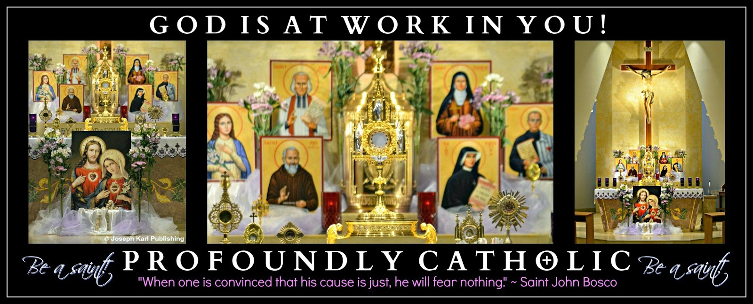
IT'S TIME TO GET THE RIGHT KIND OF BUSY
"Francis, go and build up My house, which as thou seest, is falling into ruin." ~ Our Lord
During this lesson, you suddenly find yourself on the property of a very large and elegant house. The grounds are extensive and beautiful.
The house and grounds are very stately, appealing to the senses, and seem timeless.

A few people you are very close to are with you, but other than that, there are no other people until the end of the lesson.

THE CARETAKER OF THE HOUSE

It is with great surprise that you find yourself the owner of the house.
“The time best spent is that which is spent for the glory of God and the salvation of souls.” ~ Saint Pio of Pietrelcina

The first thing you think while scanning the grounds, which are expansive: I cannot afford to own this house.
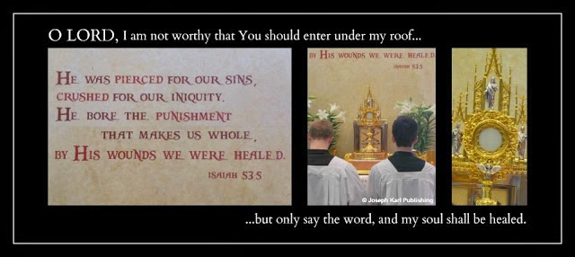
And then you think: I physically cannot take care of something this big.

Such a large house, so much property, so much to care for, such a huge responsibility.

Nevertheless, you find yourself totally at peace, without worry, and you do not resist taking ownership of the house.

So curious this scenario, that the care of something so large and so beautiful would be given to one who has nothing and is nothing.
"With God, nothing is impossible" (Luke 1:37).

A few people closest to you (family, or perhaps friends) enter the house with you. It has many rooms. Some of the rooms are absolutely enormous and some of them are very small. The house as seen from the outside cannot contain all the rooms that are in the house, especially not one of the rooms, which is bigger than any room in any house.

The first room you enter is the room in your previous house where you offered the most to God. What room would that be? That room in this house is just huge, the size of a warehouse! What comes to your mind (and is actually quite funny): Furniture would be really dwarfed in here. It would look microscopic! Why is this room in this house so massively large? An area rug covers the carpeted floor, and it much larger than the size of the room. You take this in with great wonder. That is the largest area rug you have ever seen!
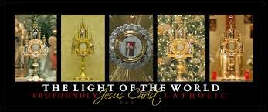
Your people accompany you into another room, and it is the dining room. That room is very large, but not as crazy big as the previous room. The room is furnished. There is a dining room table with chairs in it, and the table is very, very long. You remark to your people right away, "Look how long this table is!" (There is a place reserved for everyone at the Lord's head table).

You are surprised to find furniture in some of the rooms, a great many things had been left in the house.
You remark that you should have had an agreement before taking ownership of the house that everything in it be removed, not entirely realizing that this "transaction" is supernatural.
You never took ownership of anything. The responsibility to care for this house has been given to you.
While continuing to look around, you think that you now have a lot of work cut out for you. But not once do you feel worried.

You are surprised to find the dining room table in the wrong place in the room. It is obviously off center, and so the people closest to you begin restoring it to its proper place in the room.
You then see an area to the left and are drawn to it. That area is next to a lovely garden, and it contains many tables and chairs. They are piled there in disarray, abandoned and not being used. You immediately begin going through them and remark how beautiful they are, and begin planning to remove them and restore them somewhere where they will get proper use. A table made of marble catches your eye, and that is the first one chosen to be restored to the house.
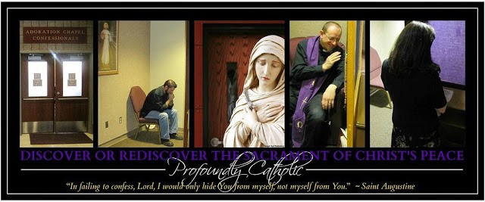
RESTORE MY HOUSE, WHICH HAS FALLEN INTO RUIN

Are you catching the metaphors?

The enormous rug in the largest room is a fishing net, and it extends beyond the boundaries of the room. The furniture that is to go in it would be dwarfed but the good works offered to God for the salvation and sanctification of the human race are mighty, and symbolized by the enormity of the size of the room.

The tables are altars, and they symbolize things that are not being done correctly in God’s house, and the rampant abandonment of what is useful, good, and beautiful. They represent a misplacement of things, and of Him, and show the catastrophic lack of proper Catechesis that has existed in most Catholic parishes and for generations. Since so few Catholics really know their faith, errors and outrages have spread far and wide. Billions of graces have been lost and so many more are being lost to ignorance by the hour.
Local Catholic parishes that get just the basics right are very, very hard (if not impossible) to find. Many people don't realize this because so many people are the wrong kind of busy. It's easy to find programs, but very hard to find the core basics that are the foundations of parishes that supernaturally explode each day with superabundant graces. Such rare parishes are tremendous channels of massive amounts of grace for the conversion of sinners through all time and space.
RAMPANT ERRORS WITHIN THE MANOR
Tabernacles containing the King of all kings not placed front and center. Caste systems created by people that exclude others in the Lord's house. Altar girls. Women distributing Holy Communion in church. Holy Communion received while standing (when able to kneel) and in the hand. People walking out of church while still unified with Jesus in the Blessed Sacrament after Holy Mass has concluded. The ongoing and colossal lack of proper Catechesis, especially for children. The lack of spiritual direction the devout faithful desperately need, the lack of silence, reverence, kindness, and compassion.
The willingness to serve oneself at all costs to self and to others. The absence of Eucharistic Adoration. Limited Holy Mass times at many parishes, and severely restricted times for making sacramental confessions. Idolatry, excessive and unrestricted soliciting and fundraising, an unwillingness of leaders to change for the better, and people in the congregation who have never been taught how to behave in God's house (or outside God's house), the many well meaning people who seek to be entertained instead of recognizing and developing the desire to follow Jesus at the side of Blessed Mother on the road to Calvary, where we are to spend our lives serving (not taking from) our fellow man.
What can you add to the list.
Where to find the perfect parish.
"The Church is a ship, and even if the ship is in difficulty,
it is necessary that we at least be in it."
~ Saint Augustine
You find yourself surprised that whoever left the house would leave such nice things behind in it, and so many things, including things with great historical significance which you discover later.
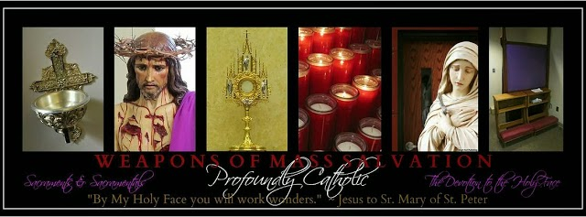

A HOUSE CONTAINING MANY MYSTERIES

You find yourself in other rooms alone. One is like a closet, but not like a conventional closet. It is more like a room one would find in a museum. It is full of things of historical significance. It would take hours for you to go through everything. Why would these things of great significance have been left behind?

The house also contains many mysteries, mysteries that are kept in certain rooms. There are so many details, so many rooms, so much in disarray, other things in other rooms had been kept with great care.

So much is left for you to care for, and there is so much beauty to restore. So much work to be done. You continue to feel completely at peace, and never feel worried or anxious. Nor do you resist taking ownership of the house, which has somehow been entrusted to you.
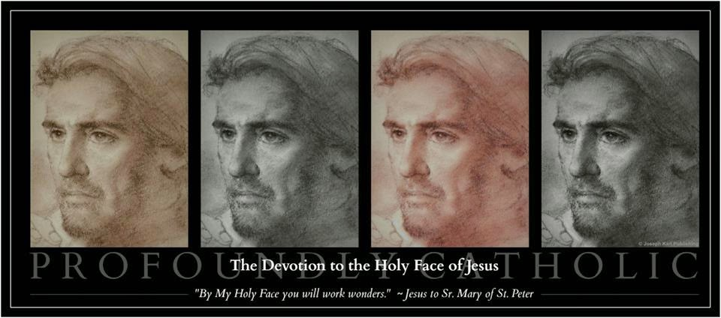

THE LORD OF THE MANOR RETURNS

While you are in a room containing many intriguing mysteries, a man and a woman suddenly enter the very small room that seems more like a special and unique closet. They enter behind a younger man with dark hair and a beard. You do not recognize Him by sight but immediately know Who He is.

The Man is the King of all kings and the owner of the house. Jesus has come to claim ownership of His house, of His Catholic Church, and is the One Who will help you and others restore it. Behind Him stand His parents, God the Father and His most holy Mother.
What has our Lord entrusted you to do to restore His house to its proper glory?
"By My Holy Face you will work wonders." ~ Jesus to Sr. Mary of St. Peter
KNOW YOUR FAITH CORRECTLY BY FIRST LEARNING IT CORRECTLY
Then, teach the Faith correctly to others.
Phenomenal material for you in print, audio, and video by one of the greatest Catholic educators in the history of the Catholic Church, Father John A. Hardon, S.J.: Archives.
God is at work in you! Go, Team!!

Fishing at an Almighty Pier
Another lesson from our Master Fisherman, Who invites us all to become fishers of men and "launch out into the deep" (Luke 5:4).
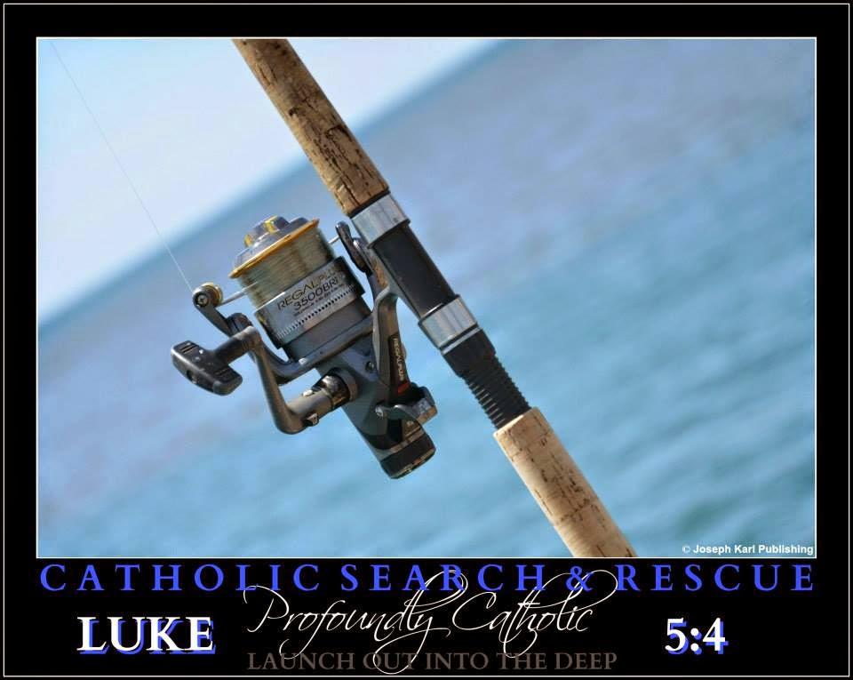

On this day, while still at home before leaving for the church, Jesus shows you the inside of the church as a mighty fishing pier, and all around it and also underneath this pier is the ocean of almighty God's mercy.
Our Savior redeemed every one of us, and He keeps coming for every one of us, offering His Sacred Body and Precious Blood to us all, and for us all. There is a place reserved just for you at His head table!
The unfathomable love and mercy of God are available to all without exception.
To begin, we must be willing to accept them. There are no limits to His extravagant love for us.
Accept His love and His graces. Accept them for others. Love Him in return, and love Him for others.
"Unless souls are saved, nothing is saved; there can be no world peace unless there is soul peace. World wars are only projections of the conflicts waged inside the souls of men and women, for nothing happens in the external world that has not first happened within a soul." ~ Archbishop Fulton J. Sheen
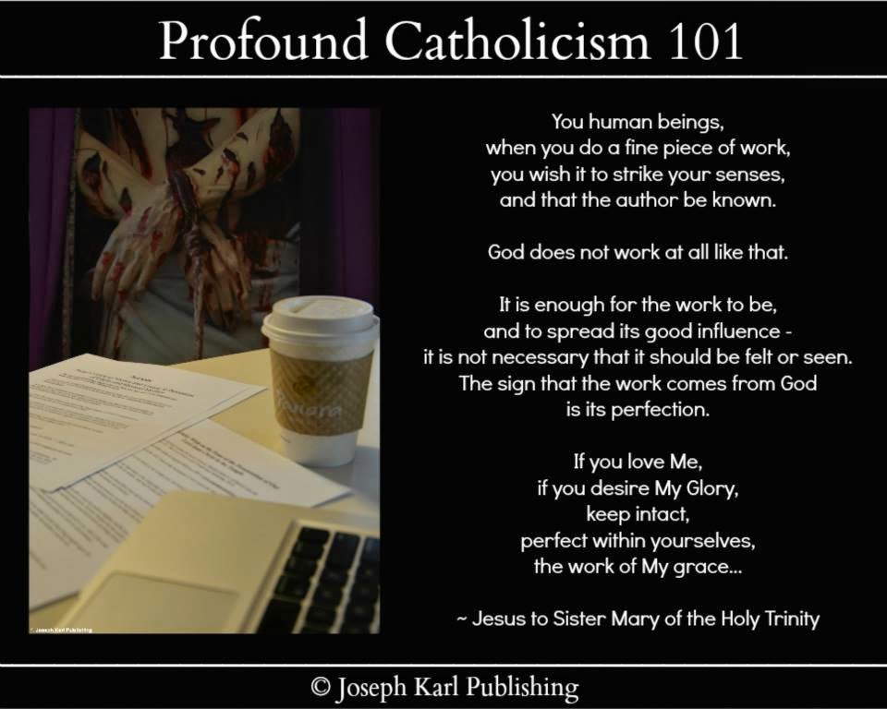

THE CLOSET

Jesus also shows you an image of your clothes closet and tells you that everything in it is an opportunity to help someone else.
On the day and at the time when He calls each one of us into eternity, all the precious opportunities given to us by God to care for others in His place which were not taken, precious opportunities to serve which merit grace for ourselves and for precious souls through all time, will be lost forever.
Make the most of these important opportunities now, while you have the opportunity.
Look for them, watch for them, recognize them, and realize them.
Always thank God for them.
SACRIFICIAL LOVE
Sacrificial love is the strongest force in the universe.
Sacrificial love is so strong that the bonds formed by it cannot ever be broken, and the gates of hell cannot prevail against it.
Sacrificial love transforms hearts, and lives, and saves souls for all eternity.
Allow sacrificial love to bind your soul to God, forever.
Allow sacrificial love to transform you into a tremendous channel of superabundant grace for the massive conversion of sinners.
God is so in love with us all!
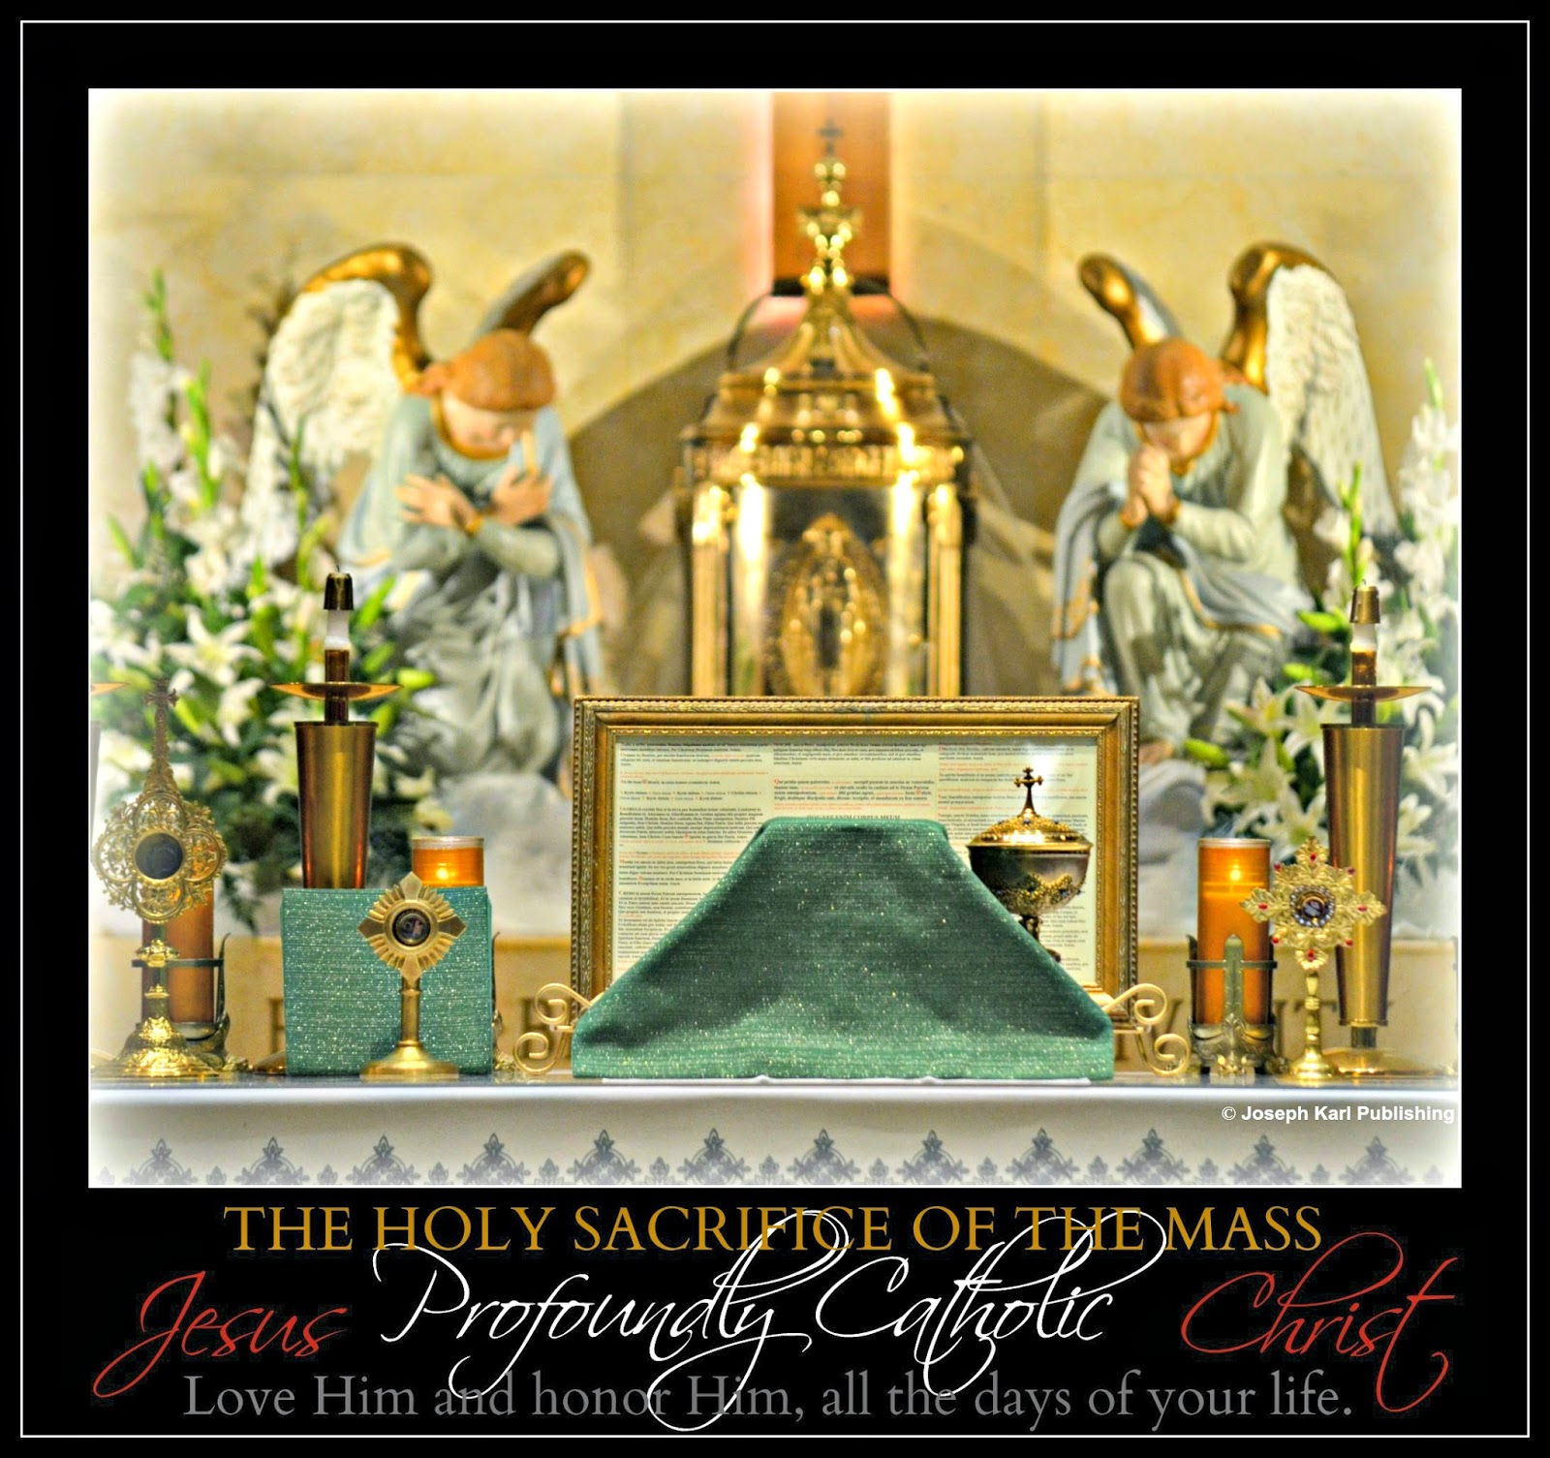

DAILY WEDDINGS TO THE KING OF ALL KINGS

Jesus tells you one more thing before you leave for the church. He recalls your personal suffering and says little did you know back then that you would be wedding your life to His daily during the Holy Sacrifice of the Mass. Wed on Calvary. Wed in His grand mystical Cathedral.
Wed, paid, fed, loved, and valued beyond measure.
Loved extravagantly, and lavishly.
Our Lord loves you so much that He invites you personally to wed your life to His every single day during the Holy Sacrifice of the Mass, during the mystical re-presentation of His Passion, Crucifixion, Death, your Redemption, and His Resurrection. What great dignity!
What a delightful moment, Jesus. Thank You. You are so charming, and so very adorable.
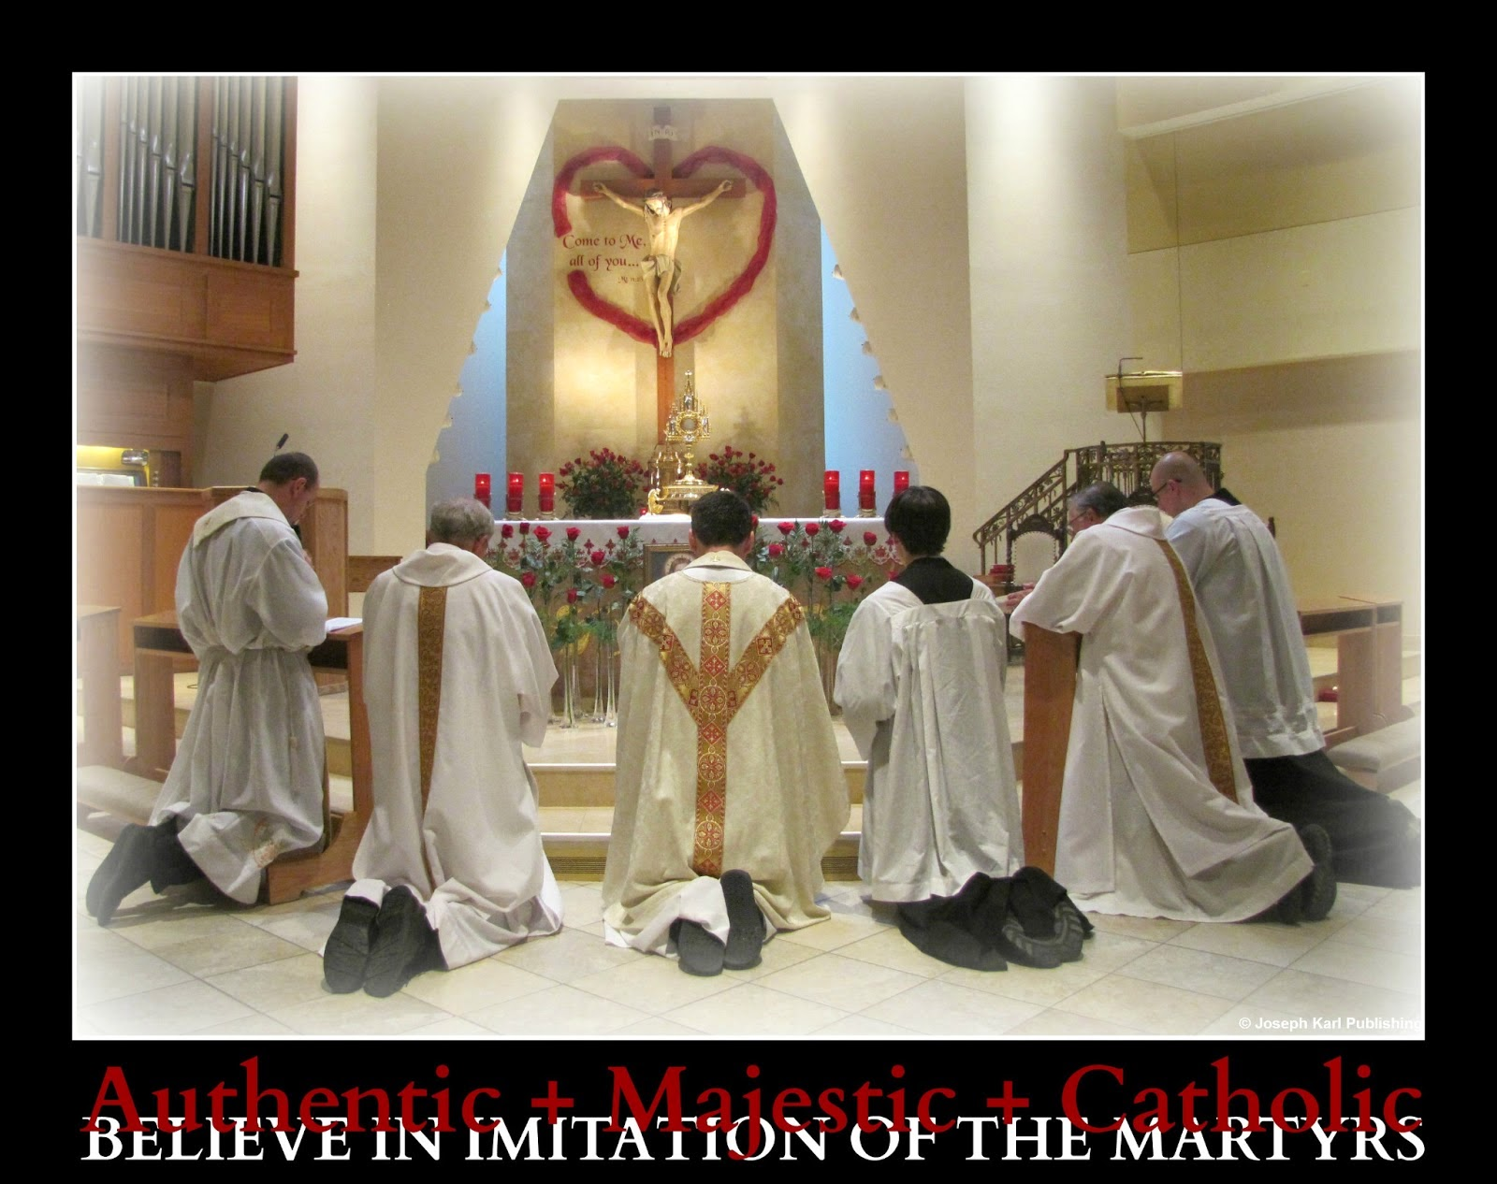
HOLY MASS AND THE REST OF THE LESSON

Today you remember to offer almighty God the Holy Sacrifice of the Mass to the Holy Face of Jesus from the very beginning. Very good!!
Right after doing so, you experience very profoundly, personally, and also realistically, the Precious Blood of our Savior coming from the wound in His Sacred Heart on the Cross.
Today's lesson comes straight from the heart, from our Lord's Sacred Heart and from our hearts also.
The experience is deeply moving, very beautiful, and so incredibly loving.
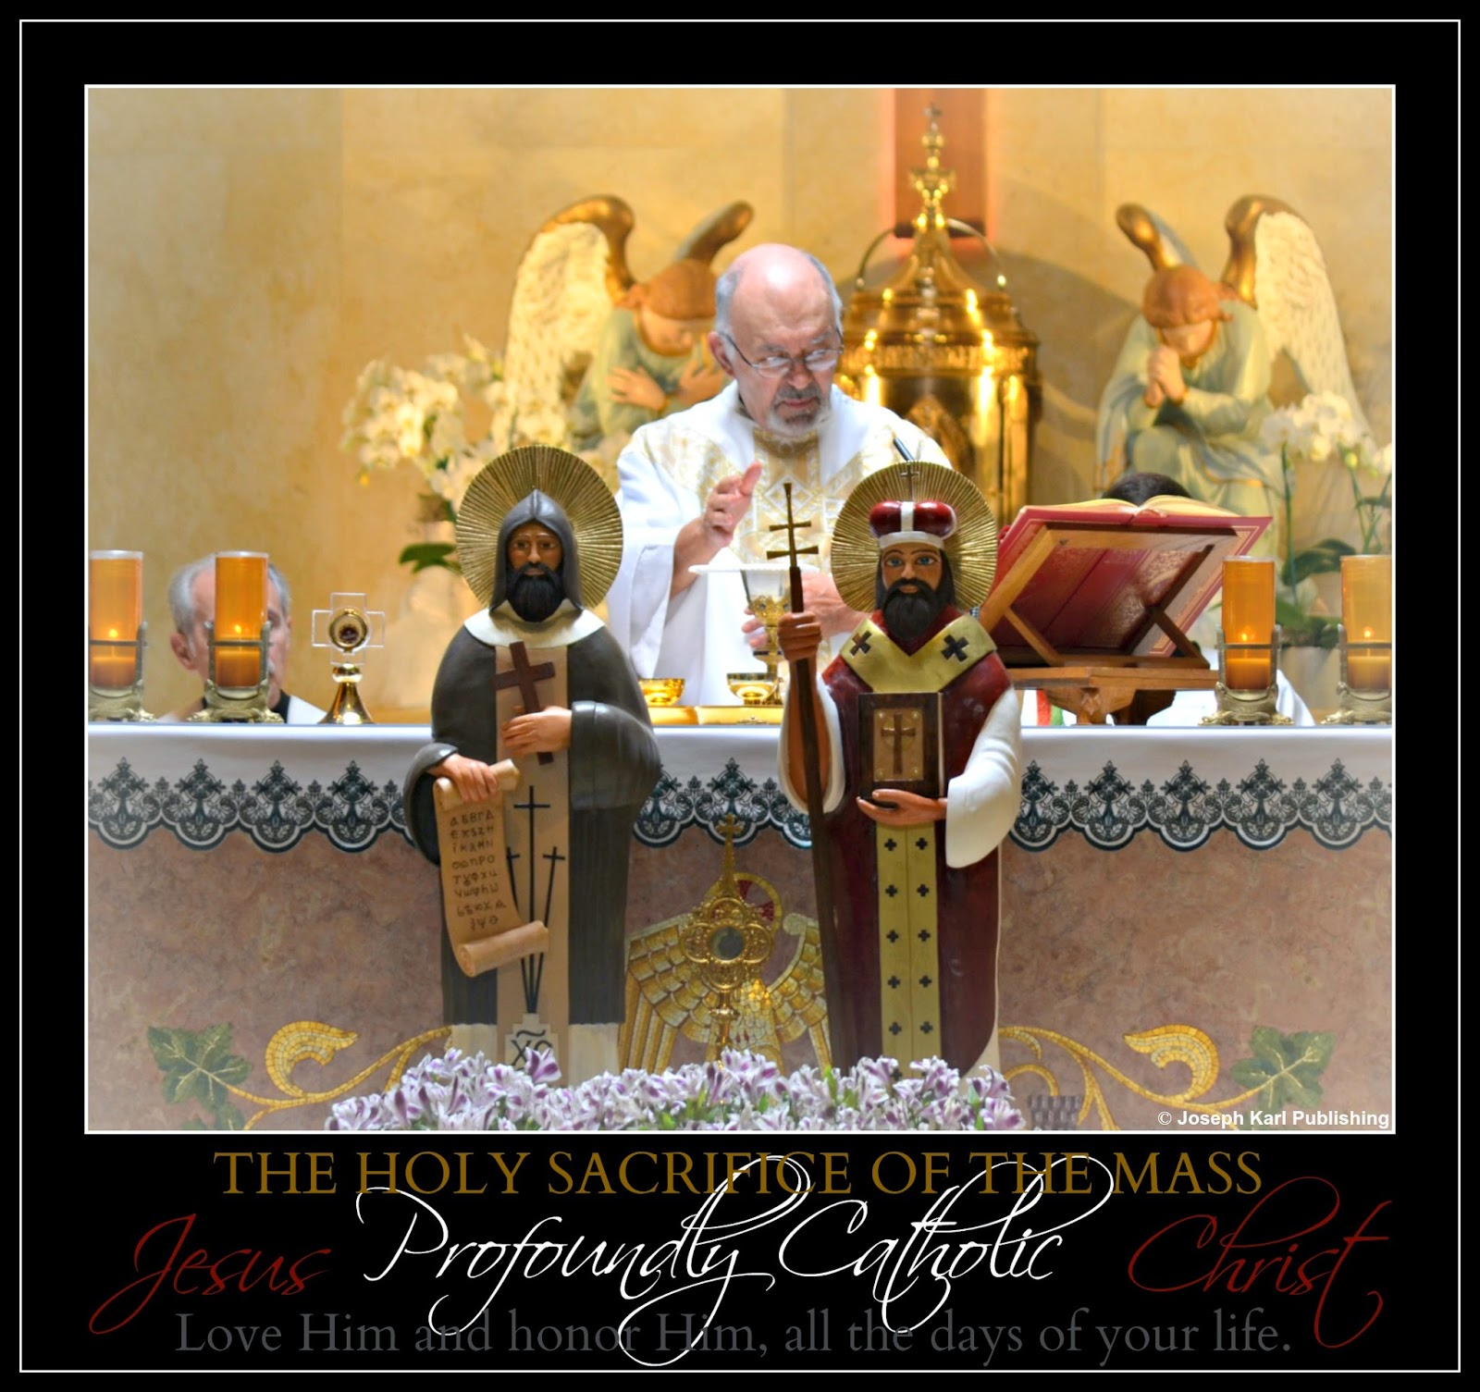

OFFERTORY

During the Offertory, arrows project from the Sacred Heart of Jesus, and also from the hearts of the people, and they land in the mystical hole in the ground before the altar leading to the ocean of God’s mercy. Those arrows are powered by the Love of God, and today they are going to catch some fish!
The fish represent precious, priceless, and immortal souls who have distanced themselves from God and are being held in spiritual captivity by the devil.
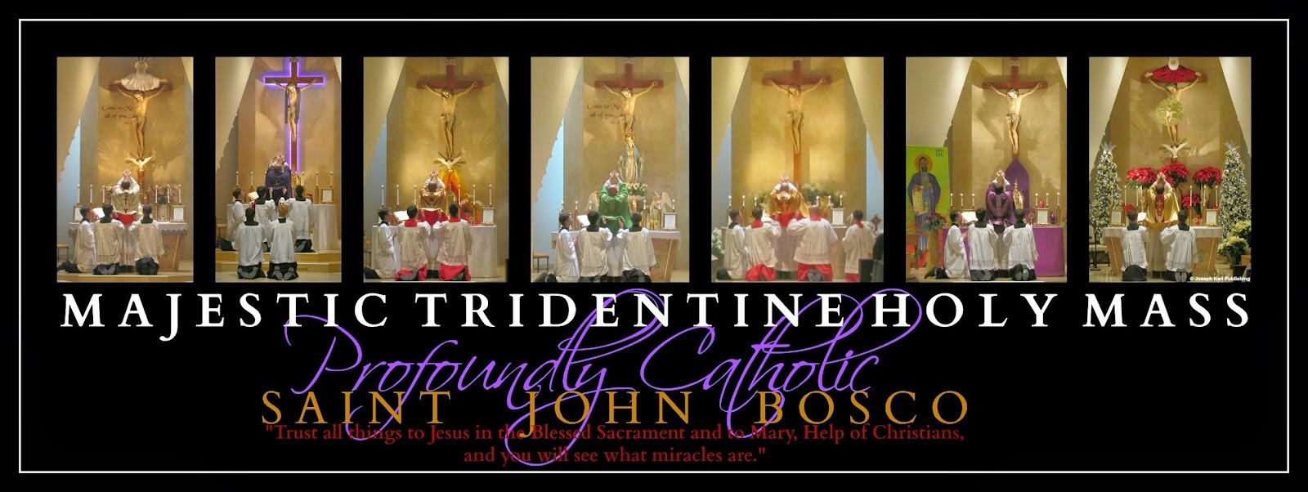

THE CONSECRATION

Blessed Mother comes to you and collects your tears with her mantle. Then, she takes a large and very powerful golden arrow, a precision weapon of mass salvation which she acquired from the Sacred Heart of her Son on the Cross, and wraps It in her mantle.
This golden arrow represents the Sacred Body of Christ, which was given up for each one of us.
She then places this precious bundle into the large mystical hole in the floor in front of the altar in the center isle that leads to the ocean of God's mercy.
You wonder if this powerful "Bait" is going to catch a certain fish in particular.
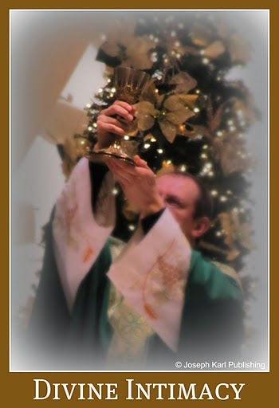
HOLY COMMUNION

While walking up the isle to receive Jesus, arrows project from the bodies of all the people as they approach the communion rail to kneel and receive our Savior in the Blessed Sacrament, the greatest source of grace we have on earth.
The arrows are also projecting from Jesus, Who is distributing Holy Communion and is superimposed over the celebrant.
All the arrows projecting in so many directions land inside of the mystical holes in the floor.

A MASSIVE CATCH

After you return to your place in church, while unified with Jesus in the Sacrament of love, you see that many nets are being raised, not only from yesterday's new holes around the altar but also from the newest ones that have burst forth today.
So many nets are being raised, and they are full of fish!

Then you see that the nets being drawn out of a great many holes leading to the ocean of God's mercy extend as far as the eye can see.
The many nets can be seen way, way off in the distance.
The powerful golden arrow Blessed Mother had placed into the hole not only represents Christ’s Sacred Body as a weapon of mass salvation, but because she came to you and added your tears to it, the golden arrow represents the mission involving your personal apostolate in particular.
God and His most holy Mother, the Mediatrix of All Graces, are at work in you!
The fish were and will be caught in the distance, meaning the work of your personal mission extends outwards, and its fruits are not limited to time and space.
"REMAIN"

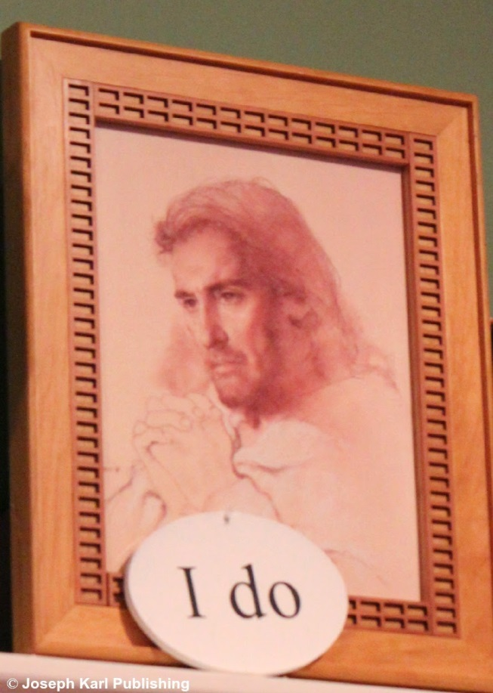Jesus acquires arrows from the heart of each person that has remained after Holy Mass has concluded.
These precious arrows acquired from hearts unified with the Sacred Heart of Jesus during the sacred time of Divine Union with our Lord are precision weapons of mass salvation that our Lord gathers personally.
Make it a point to remain in church after Holy Communion, during the sacred fifteen minutes of Divine union with our Creator, Master, Savior, humble Carpenter, Fisherman, Good Shepherd, Teacher, and Love of our eternal lives.
He is so in love with us all!
Love Him and honor Him, all the moments of your life. Remain, be still, and know that He is God.
So many graces are lost forever when we leave God's house while unified with Jesus in the Blessed Sacrament.
So many opportunities to offer God reparation are also lost when we fail to remain while unified with Christ in the Sacrament of Love.
"When you have received Him, stir up your heart to do Him homage; speak to Him about your spiritual life, gazing upon Him in your soul where He is present for your happiness; welcome Him as warmly as possible, and behave outwardly in such a way that your actions may give proof to all of His Presence." ~ Saint Francis of Sales

A Holy Mass of Reparation
Redemptive suffering in union with Christ, baskets, mystical holes in the floor leading to an ocean of God's mercy, a massive search and rescue operation not limited to time and space, and the efforts of the devout faithful who fish from a mighty pier.

Another provoking lesson from the One Who loves and values us all more than we can ever imagine.
Today's lesson begins just prior to the start of the Holy Sacrifice of the Mass and concludes later that evening, before the miraculous Devotion to the Holy Face of Jesus.
JUST PRIOR TO HOLY MASS

As you pray to prepare your heart before Holy Mass begins, Jesus tells you that as soon as It does, His Sacred Body is going to be mystically raised on the Cross on this Friday, in front of the altar, and will remain there throughout.
That's exactly what happens.
You see Jesus as He is raised on the Cross in front of the altar at the start of Holy Mass, and witness what happened to His Sacred Body as the Cross stopped abruptly when It came to rest in the hole prepared for It in the ground.
It is so incredibly moving that you have to place yourself at the back of the crowd on Calvary, even farther back mentally than physically, in order to refrain from weeping.
A HOLY MASS OF REPARATION
Jesus tells you that this will be a Holy Mass of Reparation.

The greatest offering of reparation IS the Holy Sacrifice of the Mass.

Jesus continues to suffer mystically on the Cross throughout Holy Mass, which is being celebrated between the hours of noon and three on a First Friday.

EUCHARISTIC ADORATION

Just prior to Holy Mass there was Eucharistic Adoration.
During the entrance hymn, after Father removes the Sacred Host from the monstrance and as he places the Blessed Sacrament inside the tabernacle, Jesus draws your attention to the empty monstrance on the altar.
You find the sight striking for some reason, and all of a sudden, superimposed over the empty monstrance are all the parishes that do not make Jesus available in the Blessed Sacrament to the people for Adoration and consolation.
That would be most parishes.
The monstrance was empty, and the churches were empty.
What an incredibly sorrowful sight, shared with our Savior who has presented Himself mystically, crucified on the Cross!

Reparation must be made for this humanitarian catastrophe. Reparation will avoid an even greater humanitarian catastrophe, and save precious, priceless, and immortal souls who would otherwise be lost for all eternity.

HOLY COMMUNION

As people in the center isle approach the altar to receive Jesus in the Blessed Sacrament, they pass our Lord who is mystically crucified on the Cross in front of the altar.

As they go by, each person was to place their works of reparation into a basket that was on the ground below the Cross. Since they did not know this was happening, their good works were drawn from them. If they were taught about the Work of Reparation, which our Lord Jesus Christ Himself called, "the most beautiful work under the sun," then they would have even more to offer.

This happens with you as well. When everyone had passed by, Blessed Mother and Saint Joseph, who were standing on either side of the Cross and the mystical hole in the floor, raised the basket and together, poured out the contents into the ocean of God’s mercy.

All that was offered and collected will be used to catch and liberate precious, priceless, and immortal fish lost and being held captive in spiritual bondage.

“REMAIN”

Those who remain in church during the sacred 15 minutes of Divine Union with Jesus receive a personal blessing from Jesus who is still mystically crucified and suffering, for us, on the Cross. Just imagine what that is like.
"When you have received Him, stir up your heart to do Him homage; speak to Him about your spiritual life, gazing upon Him in your soul where He is present for your happiness; welcome Him as warmly as possible, and behave outwardly in such a way that your actions may give proof to all of His Presence." ~ Saint Francis of Sales

EUCHARISTIC ADORATION THAT NIGHT
"By My Holy Face you will work wonders." ~ Jesus to Sr. Mary of St. Peter

That evening, you plan on traveling a great distance to the closest Perpetual Adoration Chapel so you can pray and offer reparation to Jesus, but our Lord has you remain home and suffer before the Devotion to His Holy Face.

As you do what the Lord requested, and while offering up your suffering, you suddenly see that there is a basket on the ground before the Devotion, by the mystical hole in the floor leading to the ocean of God's mercy.
The basket is there to collect reparation, very similar to the basket our Lord showed you during Holy Mass earlier today.
Sweet Jesus, Your wish is my command.

Sacred Union, Service, and Surrender
Another provoking lesson from our Savior and Teacher during Operation Profoundly Catholic Search and Rescue. God is at work in you!
THE HOLY SACRIFICE OF THE MASS AND TODAY'S LESSON
Our Teacher reveals nothing to you in the beginning, and so you ask Jesus if He is going to teach you anything new today.
When the student soul is ready, our Teacher always appears.

He reminds you that you had forgotten to offer the Holy Sacrifice of the Mass to God along with His Holy Face.
So you do that right away.

Not long after that, you see that each one of your hands is mystically transpierced with a golden arrow.
THE OFFERTORY AND THE CONSECRATION

During the Offertory and the Consecration, you see Jesus at the altar concelebrating the Holy Mass.
You are shown that the devout faithful are individually (and also collectively, as the Mystical Body of Christ) unified with Him, mystically. The union of Jesus and each individual, two having become one, is stressed more than the collective union which includes everyone.
Jesus reminds you of the earlier sight of your hands transpierced with golden arrows, and instructs you that the hands of all people are to be His Sacred Hands, which carry on the work of mankind’s salvation and sanctification which is being accomplished in our time and for all souls through all time.
Our hands are His Sacred Hands, two having become one at every soul's wedding to Christ during the Holy Sacrifice of the Mass.
How important it is for us to go to Holy Mass daily, if at all possible.
How important it is for us to be unified with Jesus in the Blessed Sacrament, as reverently as possible and while in the state of grace.
How important it is for us to remain with Him during the fifteen sacred minutes of Divine union.
How important it is for us when we leave the church to invite Him to accompany us, to remain in His presence always, and to "Bring Him everywhere" (Father Benjamin Kosnac).

As Jesus speaks at the altar, looks around at His people, and performs the various sacred actions as the Last Supper is mystically concelebrated during the Holy Sacrifice, each individual unified with Him does so in like manner. How is that possible? He and we are unified, having already become one and the same at all the Holy Masses we have assisted at in the past, celebrations where we have wed our lives to Christ.
In other words, you see yourself and others fulfilling each one of our missions in union with our Savior, our defiled (by other people in imitation of Christ) and purified bodies (purified through sacramental confessions, submission to God's will, loving sacrificially, and patient suffering) unified with His defiled and pure Sacred Body.
The lesson on our sacred union with the defiled and pure Sacred Body of Christ: Divine Mercy, the Golden Arrows, and a Massive Rescue Operation.

Clearly, the faithful are not unified with Christ at the altar as priests, because the people in the congregation are not priests. The celebrant is unified with Jesus as a priest. Everyone else is unified with Him as His servants, and as the servants of others.

HOLY COMMUNION

Similar to what had just been revealed, you see that the faithful are unified with Jesus as individuals when He distributes His Sacred Body to the faithful, again two having become one.
As Jesus distributes Holy Communion, the persons you see unified with Him serve others through his or her apostolate, which is shown symbolically as distributing His Sacred Body.
As that is accomplished, grace projects out from Christ's Sacred Body to the communicants and also out into time and space, showing that so much more good happens than what we see. Countless people are affected by choices and our efforts to serve and care for others in union with Christ and in imitation of Him and His most Holy Mother.

MASSIVE FLOODGATES OF MERCY
You walk up the isle to be unified with Jesus in the Sacrament of Love and are almost to the front, when it is suddenly revealed that mystical holes are blowing open at points before the altar where people walk up to receive Holy Communion.
The mystical holes leading to the ocean of God’s mercy are blowing open with tremendous force, and the almighty presence and power of God is very evident. The holes are smaller than the very large one in the center isle, but bigger than the individual holes by every person (which you are not shown during today's lesson).

You also are shown this metaphor another way, to your sight as an image and to your mind as an understanding. You see a horizontal representation, on the floor, of a great dam breaking open, one circular hole after another is forced open wider from the tremendous force of the flood of water breaking through. Then, the entire structure begins to crumble.

First the holes blow through the floor from the ocean of God's mercy upwards, and then the floor begins crumbling all around the faithful, exposing the very large ocean of God’s mercy.
You see that there is no stopping the almighty and unfathomably loving power of God.

“REMAIN”

After Holy Mass concludes, you try to remain silent interiorly while unified with Jesus during this sacred time of Divine union. This pleases Jesus, our Teacher and our Savior, very much. He then appears in front of you dressed as our High Priest, in black clerical garb and a roman collar. Jesus has a blessing for each person who remains, as He has requested, during this sacred time of union with the wonderful Bridegroom of our souls.

This is so delightful! You wait for Jesus to bless you, but nothing happens.
Jesus is waiting.

You ask our Lord why He is waiting, and Jesus says that He is waiting for you to ask Him for a blessing (smile).

So you ask Jesus to give you His blessing, and then Jesus' attire suddenly changes. He is now wearing vestments, and He gives you His blessing.

Thank You, Jesus; that was so very beautiful. Your wish is my command!
"When you have received Him, stir up your heart to do Him homage; speak to Him about your spiritual life, gazing upon Him in your soul where He is present for your happiness; welcome Him as warmly as possible, and behave outwardly in such a way that your actions may give proof to all of His Presence." ~ Saint Francis of Sales

Incredibly Powerful Precision Weapons of Mass Salvation
The very next lesson from our King, Who reminds us that with God all things are possible. And probable.
NEVER PUT LIMITS ON ALMIGHTY GOD'S POWER
While on your way to Holy Mass, Jesus begins instructing you in your vehicle. He says that the devil convinces people directly and/or through others to say and think that we can't change things, that we can't change the world, and that change isn't even possible.
Jesus tells you this is not true because with God, all things are possible (Matthew 19:26) and we can do all things through Him who strengthens us (Philippians 4:13).
How many have heard all their lives what isn't possible, instead of what is.
The devil works hard to condition us to think we can't, but Jesus says that with Him, we can. And we will.
HOLY MASS
During previous lessons, Jesus presented His Sacred Body on the Cross as an arrow, the golden arrow, and also as a very powerful arrow that crushes the demons defiling humanity in so many different ways.
Today, from the beginning of Holy Mass, our Savior presents His Crucified Sacred Body to you as a precision arrow.
This arrow is razor sharp, and one hundred percent accurate.
What an incredibly powerful sight!
Jesus makes it clear that His Sacred Body is an incredibly powerful weapon of mass salvation.
Recently, Jesus taught that we take on His likeness in two distinct ways (Divine Mercy, the Golden Arrows, and a Massive Rescue Operation) when we are unified with Him in the Blessed Sacrament, and our union then makes us very powerful weapons of mass salvation also.
OFFERTORY
As Father and Jesus mystically concelebrate Holy Mass and prepare the altar for the consecration, the air around them and also around the altar fills with small arrows.
The appearance of all those little arrows flying in every possible direction is similar to what snow flurries look like.
They were of various colors, the little arrows, all soft pastels.
What a sight!
Jesus, where did those arrows come from? you ask our Lord.
He replies that they come from the angels, who are always helping us.

Divine Mercy, the Golden Arrows, and a Massive Rescue Operation
Another lesson from our lavishly loving Teacher that spans two days, two Holy Masses, and one spectacular Feast of His Mercy.

"By My Holy Face you will work wonders." ~ Jesus to Sr. Mary of St. Peter

EMBARKING UPON A NEW ROAD

Right after you begin praying before the celebration of Holy Mass on the eve of the great Feast of
Divine Mercy, you are shown the mystical hole in the floor leading to the ocean of God’s mercy, it is huge, and flames are shooting from it.

Arrows begin projecting out from the flames and they land on the floor of the church. Shortly after that, more arrows project out, and they have caught the fish! They are coming out of the ocean of God’s mercy and land on the floor in the center isle before Holy Mass has even started.

Next, our Lord shows you that the blood and water streaming from the wound in His side contain arrows. So many arrows are streaming forth from the wound, from the Sacred Body of Christ which has been presented to you during the lessons of the past week as an arrow.

THE TIME OF MERCY AND THE TIME OF REPARATION

Humanity has arrived at the end of one road and is embarking upon a new one, as one era leads into the next. The time of mercy is transitioning into the time of reparation.

GOD ALONE

At one point during Holy Mass, Our Teacher draws you to Himself so profoundly that it is just you and Him, alone.

“I HAVE A GOLDEN ARROW FOR YOU”
As the time for Holy Communion draws near, Jesus tells you that He has a golden arrow for you.
More about the Golden Arrow.

So you ask our Savior when He is going to give it to you, and He tells you it will be in the Sacred Host you receive during Holy Communion.
Jesus had made another reference to His Sacred Body as an arrow, this time as the golden arrow.

ARROWS, ARROWS EVERYWHERE

During Holy Mass, the words being spoken and prayed, as well as the words of the songs being sung become visible in the air. The air is completely filled with translucent words, and you see that they all contain arrows.
It also begins snowing, signifying more grace being showered upon humanity so gently and so beautifully, and the snowflakes contain arrows, too.
Some land in the ocean of God’s mercy where they will catch fish (precious, priceless, and immortal souls in spiritual peril), but most land all over the floor of the church.

Jesus, what is going to happen to the arrows on the floor. How can they catch fish if they are on the floor?

All of a sudden, children who lost their lives to abortion appear in the center isle, and they begin picking up the arrows and throwing them into the mystical hole in the ground by the altar.

What an incredibly delightful sight!

NO NET

No net was raised, and no more fish came out of the hole as they had before Holy Mass.

Why not, Jesus? What is going to happen?

Jesus tells you that the arrows will catch the fish tomorrow, on the great Feast of His Divine Mercy.
DAY TWO, LESSON TWO: THE FEAST OF DIVINE MERCY
While praying before Holy Mass begins, in the church which tragically lacks silence, Jesus shows that each one of your hands is transpierced with a golden arrow. This symbolizes the ongoing work of the salvation of men through the work of our hands.

DIVINE UNION: DEFILED BODIES AND GLORIFIED BODIES

At one point during the Holy Sacrifice of the Mass, Jesus tells you that the faithful are unified with Him in the Blessed Sacrament in two distinct ways.
The first way is defiled: the defiled bodies of the people (meaning mistreated, not self inflicted) are unified with His defiled Sacred Body (defiled during His lifetime, Sacred Passion, and Crucifixion).
The second way God and His beloved servants are united is in purity: the purified bodies of the faithful (purified by His Precious Blood through the sacraments He instituted for us) are unified with His pure Sacred Body during Holy Communion.

THE MYSTICAL RE-PRESENTATION OF CHRIST’S PASSION AND THE ARROWS

As Holy Mass progresses, all the people present in the church, and also all the souls they have brought mystically to the church through intercessory prayer, proceed through the mystical re-presentation of the events of Christ’s Passion and Crucifixion, and mankind's Redemption.
Jesus' Precious Blood, tears of Blood, and drops of Bloody sweat project out into time and space throughout Holy Mass, and contain grace that is represented in the lesson as arrows.
Jesus is shooting arrows from His own Sacred Body for the salvation and sanctification of men, and projecting grace out into time and space, for us.
Thank You for Your great love, mercy, and compassion, Jesus.

Yesterday during Holy Communion, you suddenly experienced our Lord’s Sacred Body, the Sacred Host He presented to you that had the arrow inside, in pieces.
Jesus then took you to the pillar and you saw His Sacred Flesh scattered all over the ground. Those pieces of His Flesh all contained arrows, and He had you gather them up and collect them for souls.

SNOW, WORDS, AND MORE TYPES OF KEYS

It began snowing in the church from the beginning on this day two of His lesson; the snow contains more arrows, and the words in the air contain them also. Jesus tells you that the arrows are very powerful because they catch fish AND can also set fish free from their spiritual bondage, because the tips of the arrows work like keys.

COMPASSION AND MERCY

As the congregation stands during the Gospel reading, the following takes place.
Arrows begin projecting from the people assisting at Holy Mass, for two reasons.
First, the mercy people had shown to others caused arrows to project from them into the mystical hole in the ground by the altar leading to the ocean of God’s mercy, to catch fish.
Remember, Jesus told you yesterday that the big catch was coming today, on the Feast of Divine Mercy.

How is that going to happen, Lord? And when? During Holy Communion?

Then second, and most strikingly, Jesus stresses compassion in even greater measure to you, although mercy and compassion remain inseparable. Very large golden arrows begin projecting out from the bodies of those who showed compassion to others in imitation of Christ and Blessed Mother. Those arrows also landed in the ocean of God's mercy.

Now this is very interesting, this individual and collective phenomenon of arrows projecting from everyone into the mystical hole in the ground by the altar, because of what the Lord will show you very soon. You anticipate that a very large net is going to be raised from that hole as has happened during prior lessons, but that is not what is going to happen. Not at first.

THE LITTLE CHILDREN AGAIN COLLECT THE KEYS

Once again small children who had lost their lives to abortion appear as they have in the past, and begin collecting the arrows scattered all over the floor. They happily place them in the mystical hole in the ground leading to the ocean of God’s mercy.

During the consecration they stop, and bow down very low.

CONSECRATION

Just prior to the consecration, Jesus has you place all the demons who are working tirelessly to defile the bodies of humanity into the mystical hole in the floor before the altar. You had already been shown at the start of Holy Mass Jesus' Sacred Body on the Cross as an arrow, and as that image continued to be presented as the consecration drew near, you got the very strong sense that the justice of God, which is mighty, was going to absolutely CRUSH those demons today. You understood that when the Cross was going to be mystically raised and placed into the hole on this great Feast Day, it was going to fall with tremendous force, with great power.

HOLY COMMUNION

As people begin approaching the altar to be unified with Jesus, you see that as each one passes the mystical hole in the floor, God raises net after net after net, individual sized, and they are full of fish, fish caught with golden arrows that had projected from each individual (resulting from the individual efforts of that particular person).
This revelation is incredibly moving; one net after another is raised as each person walks by, and souls are saved for all eternity as the faithful are unified with God on this great Feast of Divine Mercy, also everyone's wedding day.

This does not happen with you, however. As you walk by the mystical hole in the ground, nothing happens.
Why not?

THE FIRST BIG CATCH

After you arrive back at your place in church while unified with Jesus in the Blessed Sacrament, you are suddenly shown a huge net is being raised by the Hand of almighty God from the mystical hole by the altar, and it is full of fish.
The net then opens and the fish spill out all over the floor. You see that they all had been caught with golden arrows, which not only caught them but also freed them from their locks (spiritual enslavement).

A mighty and powerful army from heaven begins gathering next to and behind you and around Jesus Who is next to you on your right, and together as a team you watch as the many fish are released from the net.

Why is this catch so much bigger than the others today, Jesus?

Jesus explains that it is bigger because it symbolizes a larger mission to catch many fish, a mission that is not limited to time and space, a rescue mission that has all of heaven on its side.
God is at work in you!

THE SECOND CATCH OF FISH

After that, you are told that another big catch is coming!
And so as everyone prays the Divine Mercy Chaplet and other lovely prayers, as everyone sings and prays to honor and adore our Eucharistic Lord, and then through Benediction, you wonder when the next big catch will happen.

"REMAIN"

When all was concluded and as most people walk out, another huge net is raised from the ocean of God’s mercy.
It opens, and fish caught with golden arrows spill out onto the floor and on the heels of the people as they leave.
This catch is the fruit of the people's prayers on the Lord's Feast of Divine Mercy. Jesus waited until all was said and done (knowing most people leave right away) so that all the graces that could possibly be gathered would be gathered.

As someone kept talking at the podium even though most people were no longer in the church, they had left, so much noise, so much to say, so little silence, Jesus comes to you dressed as our high priest in black clerical attire and a roman collar, and in each pierced Sacred Hand He is holding a golden arrow. Who are they for?

Those who remain as Jesus has requested save even more fish. Little nets are raised from the smaller mystical holes next to them that lead to the ocean of God's mercy, and they are full of fish.

Our Jesus is so caring, and so charming. And so adorable.

The Preservation of the Desecrated Human Race
A great chastisement is already upon us.
A LESSON FROM THE CROSS

This lesson began before you even got out of bed.

Continuing with His prior lesson on the defiled Sacred Body of Christ, adoration, and the Work of Reparation, Silence, Jesus' Defiled Sacred Body, and Reparation, Jesus pointed out the many ways people are defiling their own bodies in our time, in imitation of how they defile Christ’s Sacred Body. Our bodies and His Sacred Body, He said, are distinct and yet one in the same.

Jesus also told you that many people are defiling not only their own bodies but also the bodies of others.

Our Savior atoned for these sins by offering up and allowing His Sacred Body to be wounded, and we are to do the same, to be unified with Him in His suffering while making reparation to God.

But before even delving into the lesson, Jesus speaks to you about the necessity of humility. He teaches us to be humble, when we are willing to learn.

CHANNELS OF GRACE

As you drove to church, you saw that keys were mystically projecting from your body to the other drivers on the road as you passed each other. They then absorbed these keys. You were also shown this the other day while out in public. Keys were streaming from your body and they were absorbed by all those around you.

How important it is for others that we keep our bodies undefiled.

The Lord has demonstrated to you how He works through the devout faithful as channels of grace for others.

ADORATION PRIOR TO HOLY MASS

While meditating on the Lord’s lesson from the past two days, the mystical hole in the floor by the
altar that leads to an ocean of God’s mercy opened to your right. You were kneeling right next to it.

Jesus began showing you the parallels of His suffering throughout His life, Passion, Crucifixion, and death and our suffering. Everything He did that was good (which was everything) fell into the hole, and everything we offer Him, the good and the bad (since we are imperfect) fell into the hole also. All His and our tears, blood, and sweat fell into the hole, and all that went in transformed into hooks to catch fish (precious, priceless, and immortal souls). This was just incredible as it was presented.

And then you saw Blessed Mother and Saint Joseph at the rim of the mystical hole, and they began lowering a very big net into it. As the work of Salvation continues, they continue to lower this net into the ocean of God’s mercy. Jesus was on the Cross before you. You saw the net going deeper and deeper to reach the most remote fish, and then you saw it spreading far and wide.

You were also shown this net extending out across all time.

JUST PRIOR TO HOLY MASS
You returned to the church after making a sacramental confession and it was completely silent, and the experience of adoring our Eucharistic Lord was so beautiful.

Instead of saying “PAID!” or “WED!” or “WOUNDED” as He had in the past, Jesus said, “SILENCE!”

But He said this very gently and quietly (it made you smile) because the people were so reverent inside the church. Jesus revealed that He said it that way to indicate He was pleased, not only because He deserves respect but because He wants to shower us with massive amounts of grace.

In order for that to happen to the fullest extent, things must be done His Way.

HOLY MASS

You wondered what would happen that day, and were surprised that the large net was not raised during the Holy Sacrifice. Instead, Blessed Mother and Saint Joseph continued to put more of the net into the ocean of God’s mercy.

Jesus said that no fish were hauled in to signify the ongoing work of the salvation of men in our time.

LESSON TWO: THE DESECRATION OF THE BODY

You returned to church that Friday afternoon to be with our Lord on the Cross and pray the Holy Rosary, and that's exactly what happened.
You got to be with our Lord on the Cross.
While praying, the Lord drew you in to His suffering on the Cross in a new way.
You could never adequately describe it in words, it was deep, and our Lord's most holy Mother was there also. Their collective suffering was unimaginable.
This mystical pain affected your breathing, and so you had to stop during the third mystery because you couldn't take it.
All the while, Jesus had you adore His defiled Sacred Body. He had you do this through each mystery. It was very deeply moving.
Imagine how much our Lord loves us, and now imagine what is happening to us. Imagine what we are doing to Him, to ourselves, and to one another.
After a while you finished praying the Rosary and experienced the same phenomenon, but to a lesser degree.

HIS RECURRING THEME
During Holy Communion earlier that day, you had only received the Precious Blood of our Lord and not a Sacred Host. Something happened at that moment, but you didn't know what it was. You experienced such deep emotion.
Jesus, what is going on now?
While on your way home from church later that afternoon, you asked Jesus why He did not have you receive His Sacred Body that morning, given the subject matter of the newest lessons.
Now keep in mind that you had just gone to confession before Holy Mass and were in the state of grace, completely without sin.
Jesus responded that He wanted to make a point as part of this important lesson: you only received His Precious Blood because His Sacred Body and yours are the same, two having become one.
It is very important that we not defile the Sacred Body of Christ, our bodies, or the bodies of other people.
THE VITAL SAINT PIO HEALTH MINISTRY
The Holy Family has established the Saint Pio Health Ministry, which exists to properly train people in self mastery and healthy eating and lifestyle choices that must be made so people get/remain healthy and learn how to respect and not desecrate the Lord, themselves, and others.
More information will be added to this new teaching page dedicated to proper health maintenance as the Lord inspires it.
Additional material will be added that teaches about the catastrophic effects sugar consumption has to our bodies. Much more attention must be paid to the very common consumption of and addiction to sugar. It's deadly. History of Sugar
Untold numbers of people in the U.S. alone are addicted to sugary, fat laden, and salty foods.
BE INFORMED AND PRESERVE YOUR HEALTH
Examine the research and the similarities between high-sugar, energy-dense, fatty and salty processed junk food and cocaine, heroin, and nicotine. Food Addiction: Could It Explain Why 70 Percent of America Is Fat?
Several hundred million people are infected with candida, and most don't know and could care less. The withdrawal symptoms one must face when trying to kill candida are similar to those from drug withdrawal. And the candida fights back hard; it desperately wants to live and needs sugar to survive, so it gets the body to crave its food supply, which totally lacks any nutrients for the human consumer.
As people get sicker and sicker unaware of what is happening, since most physicians don't look for candida infections, they more desperately seek to self medicate and find relief from the relentless suffering, most often choosing things that harm and/or poison the body.
Does this sound like the battle between good and evil also? This is what humanity is facing.
We have arrived at the point in human history where we face another humanitarian disaster, a catastrophic health disaster, and most people have no idea and could care less.
This is a chastisement for human abortion. In choosing to seek our own wills at all costs, even to the point of killing others, we are also choosing our own self destruction through the seeking of our own wills at all costs.
Why are so many people placing themselves on the Way of Self Destruction, the Way to Perdition? Because doing something about it involves personal responsibility and self mastery, it means stepping onto the Way of the Cross instead, the Way of Sacrificial Love, and most people have been conditioned, even hypnotized, to want what they want right when they want it.
We have become conditioned to desperately crave and seek our own self destruction.
Many are addicted to sugar, but most deadly in both the physical and supernatural senses, many are addicted to their own will, to various degrees.
SUGAR: THE DEVIL'S POISON
Sugar is poisoning us, and affecting the thinking of many people who have been hypnotized to live with symptoms and/or mask them with toxic pain relievers. As the medical profession and pharmaceutical companies get rich off of this catastrophe (not as much money can be made among well people, there is money to be made, but the devil convinces the ignorant to be exceptionally greedy), people are getting so sick, earlier and earlier in life.
To say the consequences of our unrestricted actions will kill people is too nice; first, many will get so sick and suffer so badly they will wish they were dead. This is already happening, and many people can't see it for what it is.
One of the devil's lies: You can keep eating sugar and remain healthy, or even better yet, Keep doing whatever you want to your body; God will heal you.
Here's his favorite, and he has convinced many people to say it straight out of his mouth: I'd rather die early (than acquire self mastery).
That's exactly what he wants to do to each one of us, take us out as early as possible.
SEEKING TRUTH
Look around and see all the distended abdomens on both men and women, the morbid obesity which has become common, various degrees of open hostility which has become common also, and listen to the complaints of people during conversations, serious symptoms that they are either ignoring and/or masking with drugs because they listen to their physicians, or living with because they cannot find a doctor that concentrates on wellness and health maintenance (it's not as lucrative) who will provide them with the correct diagnosis, the actual reason why their bodies aren't working right.
The answers are there, in plain sight. But one must find health care professionals who are willing to see. That includes doctors of the body as well as doctors of the soul.
Without a proper diagnosis, things can't be fixed and most will get worse. The medical profession has been well compensated for drugging the population, having them pay for expensive drugs they don't need that depletes their much needed resources as the undiagnosed problems get worse, and ordering expensive tests most can't afford and most don't need.
Insurance will pay for it, the doctors proclaim, and their consciences become more cloudy and their wallets fatter.
Medical professionals are without a doubt being drugged by pharmaceutical companies, their morality is being bought out as they sell out, as both parties are literally adulterated by kickbacks including money, material goods, trips. Meanwhile, people desperately needing care and compassion are drugged with toxic chemicals that make them even sicker and go for tests they don't need.
The very best diagnostic tool is the brain.
This behavior, the giving and the taking for personal gain at the expense of people's health, is diabolical.
It is celebrated by minds that have surrendered to the devil, and succumbed to by an increasingly weakened population that still believes that as long as insurance pays for the expensive drugs and tests they are ordered to receive by the self centered and wealthy, they are receiving proper care.
THE COLOSSAL INABILITY TO THINK CLEARLY
The best outcomes for the patient are when both the patient and the doctor use their brains.
That's not what is happening on a colossal scale.
The devil's goal is to destroy humanity. Take a good look around; he has been and continues to be wildly successful. So successful, that most people are helping him destroy themselves and others, totally unaware.

Grace, grace, and more grace is absolutely necessary because many people can no longer see, and can no longer even help themselves out of the holes that have been created.

However, Jesus provides us with a mystical hole in the ground in every one of His Catholic Churches, in front of every altar, and also a smaller one next to each person, that lead to an ocean of God's mercy.

Every single Holy Mass is mystically concelebrated by Jesus, and so each one is made absolutely perfect, which means that the devout faithful who lead sacramental lives of heroic virtue are used by God as extraordinary channels of His grace for others.

Their undefiled bodies are united with Jesus' undefiled Body in the Blessed Sacrament, and miracles happen. We have no concept of how much God loves and values us, and what He is capable of doing on our behalf. He comes again each and every single day to save us through His sacraments, which He instituted for our sake, and He remains with us always.

People who are willing to lead by example and teach others are so desperately needed. These people have no interest in money. Instead, they truly care about others in imitation of Christ and Blessed Mother. Be one of those people. Perhaps you already are. THANK YOU!

WHY ALL THE SELF DESTRUCTIVE BEHAVIOR?

Take a very good look around and ask yourself, why are so many people behaving in ways that are so self destructive? Why is sin so rampant, so accepted, so coveted, and so celebrated in our time?

Why are things that are so destructive for lives and eternal lives pursued by most people with such tremendous fervor?

Why are the majority of people deciding to spend their free will choices to harm themselves and other people.

This is happening because bodies are no longer functioning normally and won't unless they are taken care of properly, and this won't happen unless they are reverenced in imitation of Christ's Sacred Body, unless people are willing to change.

Just try to get people who can't process information properly any more to listen. Try to get people addicted to toxic substances/food and their own wills to change.

Many won't, because they no longer can.

That is why the Lord is sending massive floods of grace to humanity through humble and obedient people around the world, who at great personal cost, live sacramental lives of heroic virtue in imitation of Christ and Blessed Mother.

Those who pursue, encourage, and promote miracle healings without teaching the necessity of taking personal responsibility for the proper care of God's body, their bodies, and the bodies of other people are not only fooling themselves, they are fooling a lot of other people. Keeping people from the truth, even if they don't want to hear it, is delusional and unethical. It's also diabolical.

Many, many people lacking self mastery are looking anywhere for quick fixes without having to take personal responsibility, and even churches eager to bring in crowds are willing to promise quick fixes. This is not holy when proper reverence for the Sacred Body of Christ, for our bodies, and for the bodies of others are missing in the message.

Many people omit the truth because people don't want to hear it. And so what such things become are self-serving ventures that further desecrate the bodies of others.

THE PRESERVATION OF THE DESECRATED HUMAN RACE
How vital it is to have perpetual adoration chapels in every single community where people can be silent in the illuminating and healing presence of God. How vital it is for people in every community to have access to the sacraments and receive them often.
The devil is taking a lot of people out in our time, hundreds of millions in the U.S. alone, and they aremore than eager to help him do it, largely unaware. How are they helping the devil destroy mankind? By desecrating our Lord's Sacred Body, their bodies, and the bodies of other people.
This happens in so many ways in our time. So many. How many ways can you think of that humanity is defiling itself and its God? How many are you guilty of.
Abortion, artificial contraception, sterilization, using other people in any way for personal gain, unchastity, uncharity, medical malpractice, improper educating, marketing, stubbornness, gluttony, impurity, many fundraising practices, abuse, addictions, lying, hatred, pride, idolatry, worshiping anything or any one instead of God (including one's self), remaining ignorant and/or keeping others ignorant, purposefully misleading people, pornography, homosexuality (yes, homosexual relationships and unions defile the body and are contrary to the will of God), human trafficking, financial enslavement of oneself or others, insistence on one's own will, refusing to listen or change for the better...
The more self mastery we acquire, the more the Lord can and will use us as tremendous channels of massive amounts of grace so necessary for other people in our time.
"Trust all things to Jesus in the Blessed Sacrament and to Mary, Help of Christians, and you will see what miracles are." ~St. John Bosco

Silence, Jesus' Defiled Sacred Body, and Reparation
Today's very powerful lesson, from the One Who loves and values us more than we can ever imagine, which emphasizes the importance of how we treat people, first and foremost our Creator, Savior, and God.

THE HOLY SACRIFICE OF THE MASS: EVERY SOUL'S WEDDING TO CHRIST
"By My Holy Face you will work wonders." ~ Jesus to Sr. Mary of St. Peter
Immediately as Holy Mass begins, you find yourself also in the Lord’s (mystical) grand cathedral,
and this time it is ornately decorated with the most favorite flowers of everyone present.
Whatever anyone's favorite flowers are, that's how the cathedral is decorated, by God, for each person.

Can you just imagine that everyone (if physically able), though so completely unworthy, can come and be wed to Christ each day, receive His Sacred Body into our own, and be unified with almighty God, and He decorates His mystical grand cathedral to our tastes.

We have no concept of how much we are loved and valued by God.
We have no concept of how humble God is.

Also right away (you cannot even describe how incredibly moving this is), Jesus shows you that there are already fish on the floor of the church.
The floor is not covered with them as before. Today, there are a certain number, and these fish are very big, two to three feet long.

These fish had already been saved, before Holy Mass even began. How was God at work in you before you even got to the church?

The fish are your wedding presents from Jesus.

JESUS' SACRED BODY AS AN ARROW

Jesus continues to present His Sacred Body crucified on the Cross to you as an arrow.
His Body, the Blessed Sacrament, is the most potent source of grace we have on earth.

JESUS' DEFILED SACRED BODY

Jesus also reveals His desecrated Sacred Body on the Cross throughout the Holy Sacrifice. Later on, you discover why.

Similar to how Jesus presented His Passion to your soul so profoundly in the past, He allows you to very personally experience His Sacred Body's degradation.

You feel as if you could cry forever.

OFFERTORY

As the gifts are brought up, Jesus prepares the altar.
There He is, our Savior Whose Sacred Body has been so defiled by mankind throughout time, preparing the altar again mystically for the Last Supper. He is doing this for us.
Jesus' humility defies description; you hope to absorb all the humility you can from Him, as we all can and must.

Jesus, transform us into Your likeness.

During yesterday's lesson, Jesus revealed to your soul the beginnings of this defilement and humility lesson by bringing to your attention during Holy Mass what it was like for Him, the most pure, modest and humble person, to be exposed before the crowds of people let alone anyone.
Yet He allowed it and continues to allow it in representations of His stripped Sacred Body crucified on the Cross, and even in the Resurrection images and statues where His Sacred Body is exposed to various degrees.
THE POWERFUL NETS OF THOSE WOUNDED IN IMITATION OF CHRIST

During the Gospel Reading, Jesus has you place the powerful nets with so many holes in them into the ocean of mercy through the mystical hole in the floor in front of the altar. You are told that when you go up to receive Jesus in the Blessed Sacrament, the Lord wants you to be the one to pull the net out of the hole.

This is very deeply moving also, our Lord demonstrating how He uses us as tremendous channels of grace for others.

Instead of waiting for Jesus to say something loud and clear, this time with tremendous gratitude you say to Him in a similar way, several times during Holy Mass, “YOUR WISH IS MY COMMAND.”

HOLY COMMUNION

As you walk past the mystical hole in the floor and raise that net in an action of thought similar to a prayer as Jesus instructed, very large fish, bigger than any caught during Lent spill from the net onto the floor. You notice that it isn't snowing, there are no words in the air, and as a result there are no keys.

Why aren't there any keys today, Jesus?

Jesus replies that these large fish were caught by that special net provided to those wounded in imitation of Christ. That particular net with so many holes in it is so powerful that the most remote rescued fish need no more rescuing (they are caught and saved; the chains holding them in spiritual bondage have already been broken and need no keys to unlock them).

A BEAUTIFUL BOUQUET FROM JESUS
Jesus once again returns to thoughts of your favorite flowers, and hands you a beautiful bouquet He had prepared just for you on your wedding day today.
He then had you throw it as brides do, backwards even, into the ocean of God's mercy through mystical hole in the floor by the altar (let us ask Him what He has the men do).
Why did Jesus have you do that?
The bouquet Jesus made for you transforms into a net as soon as it lands in the ocean of mercy.
Guess what happened to it.
When you walk up to receive Jesus and He has you draw out the very powerful net that has the big fish in it, He tells you the net from the bouquet of flowers must remain in the ocean of His mercy, at least for now.
Who it is meant to catch?
DIVINE UNION

These moments are so incredible and affect you very deeply. You kneel to receive Jesus reverently, and on your tongue. Just after you rise to return to your place in church you see that you are walking down the isle of the mystical cathedral, unified with the Bridegroom of your soul.
You are also shown that the Lord has outfitted you in a beautiful white garment, and on your head is an exquisite diamond studded tiara (for the ladies) or crown (for the men). The tiara or crown represents your work as the Lord's instrument, as a channel of grace for the massive conversion of sinners. The diamonds represent souls that have been saved for all eternity by the Lord's work through you.

This revelation of being outfitted by our humble Jesus in such an elaborate way is just incredible, not only because of the symbolism of what He wants to accomplish through every single person, but also because all are there to worship, praise, serve, and thank Him and as we do so, Jesus loves us more extravagantly than we could ever imagine or love Him back.

While kneeling after returning to your place in church, you remain in awe of God, Who continues to very profoundly manifest the diamond studded tiara or crown on your head.
Jesus, the Divine Bridegroom of your soul, is so proud of you.

“REMAIN”

During the final hymn, Jesus appears next to each person dressed as our High Priest, in black clerical clothing and a roman collar.
He has a very loving supernatural, mystical embrace for each person, but most people walk right out, not knowing this is taking place, and without thanking Him. Without loving Him. Without even saying goodbye, or asking Him to go with them.
Love Him for everyone. Accept the graces that so many people miss in their places.

“OFFER THEM SILENCE”

After the final hymn, you kneel and are silent for a time while unified with Jesus, as our Lord has requested.

Suddenly, He says very clearly, “OFFER THEM SILENCE.”

Then, Jesus tells you of His desire that Perpetual Adoration Chapels be established in every community, specifically promoting the Work of Reparation to His Holy Face, where people are offered silence and where God is adored as reparation is made for the defilement of Jesus' Sacred Body through all time and in our time.

Holy Faces, God's Graces, and Exceptionally Powerful Nets
"Launch out into the deep!" (Luke 5:4).
More profoundly Catholic instructions and revelations from our Teacher, presented once again during the Holy Sacrifice of the Mass.
A GRAND CELEBRATION
Once again, the congregation is present for a spectacular wedding.
It is so grand, and you see it somewhat differently today than has been shown to you in the past.
Today, it is as if God is holding back because the sight of the grandeur as it really is would completely overwhelm your senses.
Everything is so majestic, so beautiful, so grand.
Continuing on with what happened yesterday, the small box with one person's name in particular in it is placed once again into the mystical hole in the floor by the altar.
Then, you see before you the names of every person being prayed for by the people in church, and those names are being put into their own small boxes, and then are placed into the ocean of God's mercy through the mystical hole in the floor in front of the altar.
HOLY FACES
Once again, Jesus has you offer the Holy Sacrifice of the Mass to God the Father through the merits of His Holy Face. He asks that all things done in His service be offered to God in this way.

You see Jesus at the altar, and in particular you see His Holy Face facing the congregation and the holy faces of the congregation facing Jesus. This is very powerful, the sight of the congregation face to Face with Jesus. Yours mirror His, your holy faces reflect His back to Him, and also reflect His love to others, especially to God as all worship and praise the Divine Bridegroom of their souls.
SO MANY FISHING NETS
You are then shown that the mystical action taking place is producing nets. It happens in the following way.
God's grace comes to you through His Son's Holy Face and then exits through your holy faces. As it does, the graces transform into nets.
Those nets then travel from the faces where they are generated into the ocean of God's mercy through the mystical hole in the floor by the altar.
Later, the mystical wedding attendants pull up the nets and they are full of fish. So many fish are being caught! The fish represent precious, priceless, and immortal souls who are bound and chained by sin and are being held captive in spiritual bondage.
You see see this taking place in time but over the course of time, meaning in God's perfect timing and with the understanding that you are to trust in Him always because He loves us all, knows what is best for us, and always desires our eternal salvation.
You are to trust that your prayers for these people will be answered by our Lord, in time. Don't give up; persevere with great love and abandonment to the will of God, and keep praying.
As you approach the altar to receive Jesus in the Blessed Sacrament, the fish are once again all over the floor. Snow is falling so beautifully in the church all around you, and the snowflakes gently release keys onto the ground throughout the church.
These keys are used by hands folded in prayer to liberate the precious fish from their spiritual bondage.
"WOUNDED!"
During two prior Holy Masses, Jesus had said two specific words to you loud and clear. The first time He said, "PAID!" and the second time He said, "WED!"

Today, Jesus says to you loudly and resolutely, "WOUNDED!"

It is actually very delightful, that moment. It makes you smile.
After returning to your place in church while unified with Jesus in the Sacrament of Love, Jesus inspires your thoughts to turn to the most remote fish, and Jesus tells you that when we allow ourselves to be wounded by Him, and thus are transformed into His likeness, very special nets are generated that are capable of catching the most remote fish.
Jesus even shows you what those nets look like.
This moment with Jesus while unified with the One Who loves and values each one of us beyond measure, every single person without exception, is so moving it brings you to tears.
God is so good.
Guess what they look like, these highly effective nets that are able to catch the most remote, and unrepentant fish.

The nets are full of holes.
"By My Holy Face you will work wonders." ~ Jesus to Sr. Mary of St. Peter
"REMAIN"
Once again, Jesus does not have you hold His crucified Sacred Body after Holy Mass has concluded.
Instead, our Resurrected Lord has an embrace for the few who remain during the fifteen sacred minutes of union with Jesus in the Blessed Sacrament, with His Sacred Body, Precious Blood, Soul, and Divinity.
While holding you close, Jesus has you to place God's will for you into His Sacred Heart, through the wound in His side.

More Bridal Theology: There is a Place Reserved Just for You at His Head Table
Take your place of honor at the celebration of the coronation of our King, at the mystical re-presentation of Christ's Passion, Death, Resurrection, and our Redemption, and at every soul's wedding. God is so in love with you!

Today's lessons, revelations, restoration, and reparation.
HOLY MASS
During the Holy Sacrifice of the Mass, Jesus presents Himself crucified on the Cross at the altar, and He has you feel His physical presence very strongly even from across the length of the church.
It is as if He is very close. This is very deeply moving, to feel so close to our Lord crucified on the Cross.

After that, Jesus appears next to you on the Cross, and He remains there throughout the Holy Sacrifice.
Grace streams from His Sacred Body throughout Holy Mass, grace that He wants His servant to absorb.

Later, you see that Jesus is present this way next to each person in church also, just as He had been in the chapel that day He showed you the same things as people were preparing and waiting to make their sacramental confessions.

DIVINE REASSURANCE

Jesus also assures you several times that everything is going to work out according to His plans, and that all will be okay. You have absolutely no desire to doubt Him because there is no room left for anything but confidence in Him.
Thank You for Your great mercy, Jesus.

ANOTHER SPIRITUAL OPPOSITE

Jesus also explains that there is a spiritual opposite to submitting our wills to God so He can work best through us, sometimes in ways that we do not understand (which can include His speaking through us) as we remain close to Him through the Sacraments.
People who prefer their own wills and distance themselves from God allow the devil to work through (even speak through) them, perhaps without their even knowing that this is taking place.
We can be instruments of God or instruments of the devil; the free will choice is ours to make.

MORE BRIDAL THEOLOGY

Once again there are references to our souls’ wedding to Christ, and Jesus addresses the hierarchies people have established in His churches, in His parishes.
Jesus speaks in particular to those who are or have been marginalized by others in His very own house, and says very clearly that everyone has a place at the head table during His celebration of the Holy Sacrifice of the Mass.
Every single person has a place at the most distinguished table, at the table of honor, as we wed our souls to Christ.
Jesus loves us so lavishly, so extravagantly, and points out the great dignity and equality of everyone in His eyes.
AN OCEAN OF GOD'S MERCY

You wonder if the large mystical hole in the floor is still there and still open now that Lent and Holy Week are over, although the Easter celebration is not.
Today you are shown that the hole is still there, as are the personal mystical holes next to each person present in church because Jesus is present on the Cross next to each person.

WEDDING PRESENTS!
You are inspired to place the wedding gifts you brought for the Bridegroom of our souls into the collective hole in the front along with those of everyone else, and also place some personal ones into your own mystical hole which leads to an ocean of His mercy.

ANOTHER SPECTACULAR DRAUGHT OF FISH

At one point, the arm of Almighty God pulls a net out of the ocean of His mercy in the center isle, and you are told that the wedding presents placed in there had transformed into nets that caught the fish.
We can present Jesus with so many gifts during our weddings to Him each day, gifts which He uses to save people for all eternity.

As the faithful walk up the aisles to receive and be unified with their Divine Bridegroom, they walk among the many fish that are scattered all over the floor.
WHAT A CELEBRATION!

Toward the end of Holy Mass, it begins snowing as if confetti is falling down during this incredible celebration that means so much to so many, and the snow transforms into keys that gently fall among the fish.

PRAYER TO SAINT MICHAEL

All of a sudden at the conclusion of Holy Mass, as the congregation says the Prayer to the Michael the Archangel, the Lord tells you to say this prayer while offering the Holy Face of Jesus to God the Father.

REMAIN

After Holy Mass has concluded you remain as our Lord has requested to spend priceless time with Him during the sacred fifteen minutes when you are unified with Him; with His Sacred Body, His Precious Blood, His Soul, and His Divinity.
Jesus once again does not have you hold His crucified Sacred Body as usual, but instead our Resurrected Lord has a very loving embrace for you.
Then, He gives you a present in a small box.
Jesus has a wedding present for you!

You open the box. Inside is a loose diamond.
The diamond represents a precious, priceless, and immortal soul that has been saved for all eternity.
EVEN MORE MERCY

Jesus has you remove the diamond, He wants you to have it forever, and requests that you place the name of someone in particular in the empty box.
You then place the box into the ocean of God’s mercy through the mystical hole in the floor by the altar.

A Spectacular Easter Wedding, Another Miraculous Draught, & Love that Never Ends
The location of your wedding, the attendants, the guests, the color scheme, and the presents may surprise you but they are very real. God loves you this lavishly, this extravagantly, every day if you like; love Him and honor Him, all the moments of your life.
AN EASTER SUNDAY WEDDING

Jesus draws you into the mystery right away, even before Holy Mass begins, as you pray and prepare your heart for another very special encounter with the Love of your eternal life.

What an incredible event.

You immediately feel as if you are marrying another person. However, this Person is also divine.

As family members would be ushered in during a wedding, Blessed Mother and Saint Joseph are escorted up the isle where they take places where the family normally would be when a couple marries.

Any living relatives not physically present for this spectacular occasion, as the congregation celebrates their individual and collective weddings to Christ, are brought there mystically by the power of intercessory prayer.

LOVING LITTLE WEDDING ATTENDANTS

The Divine Bridegroom of your soul reveals that there are many small children in the church, children who lost their lives to abortion.

They are there to serve as little wedding attendants, as the bearers of the rings.

The children line both sides of every isle in church, and each one holds a pillow.

On top of the pillows rest mystical wedding rings, one for every person present and one for Jesus.

WE ARE LOVED AND VALUED BEYOND MEASURE

How incredibly moving to see your family in heaven present for you, and taking their places in the front of the church. How much they care for you and for us all!

As the events occur they are so profoundly meaningful, and very deeply felt.

Love never ends.

Next, you see your Divine Bridegroom at the front of the church, at the altar, waiting for you and also for each person personally, to wed our souls to Him at His coronation.
Just imagine His incredible humility.

How beautiful, the expression from Jesus to your heart of how much each one of us is loved and valued on this occasion the faithful have come together to crown our resurrected King.

THE CATHEDRAL

Jesus shows you that you are in an exquisite, mystical Cathedral for your soul's wedding to Him. Christ's Church, the Catholic Church, in its majestic glory and fullest expression is superimposed over the celebration in progress at that very moment.

This parish shown to you, His Parish, is the one so many in our time desperately seek and need, the one we should be aspiring to because it most resembles His Way, and the one many know in their hearts exist but they don't know where.

This mystical parish can be found in every Catholic Church from the least obedient to the most obedient one can find. And Jesus has brought you here for your soul's wedding to Him, a union that will last forever.

"JESUS MAKES HEAVEN WHEREVER HE IS"(FATHER FREDERICK WILLIAM FABER)

Our Divine Bridegroom weds us where heaven meets earth.

Jesus loves us so lavishly, so extravagantly.

You see the gates of heaven open wide, its occupants present to celebrate such a grand occasion.

God the Father oversees all, our Creator and Author of Love giving us so much and loving and valuing us beyond measure, we who deserve nothing and owe Him everything.

This mystical celebration is so exceptional; it even begins snowing inside the church. The snowflakes release keys, which fall gently to the ground. The keys are used by hands joined in prayer to free captive souls that are bound and chained and held captive in spiritual bondage by the devil.

You see the words of the prayers being spoken and the songs being sung are present before all, in the air, and they are releasing more keys.

Most striking is the sight before you of the words that make up the formula of how God works miracles through us: obedience, humility, forgiveness, mercy…

GOLDEN ATTIRE

During the Offertory, Jesus draws your attention to the color of the vestments, and you see that they are gold. How beautiful, Jesus, you say to Him. How fitting to honor You, our King. Jesus explains that gold is the color scheme He has chosen for your wedding today, and He then shows you that He has outfitted the little wedding attendants in gold also.

What a majestic sight!

Jesus even has wedding music playing for you throughout the Holy Sacrifice of the Mass.

CONSECRATION

As Jesus is mystically raised on the Cross, the sudden jolt as It comes to rest in the mystical hole prepared for it in front of the altar causes His Precious Blood to project out just as the holy water had when Father sprinkled and blessed the people with it a short while earlier. This comparison presented by our merciful Lord is so deeply meaningful that you shed tears of gratitude and love.

WEDDING PRESENTS! ANOTHER MIRACULOUS DRAUGHT OF FISH

Suddenly, your family from heaven gathers around the mystical hole in the ground, and begins pulling the huge net out of the ocean of Christ's mercy. The little wedding attendants help also, and the fish fall all over the floor, among the keys.

While walking up the isle during Holy Communion to wed your soul to Christ and be unified with Him in the Sacrament of Love, you ask Jesus why you don't see any fishing hooks today.

Jesus replies as you draw near, "The fish are caught by love. Even the most remote fish."

We were created to be loved and to love in return.

"REMAIN"

At the conclusion of Holy Mass, instead of saying "PAID!" as Jesus had done recently once before, He joyfully and resolutely says, "WED!"
The children then present each person with a basket, and in each basket there are fish and keys.

The fish represent precious, priceless, and immortal souls that are being entrusted into each person’s care.

Jesus does not have you hold His crucified Sacred Body today during the fifteen precious and priceless minutes when you are unified with His Body, Blood, Soul, and Divinity.

Instead, our Resurrected Lord has a very loving embrace for each person who remains during this sacred time of divine union, which is hardly anyone.
"Be still, and know that I am God" (Psalm 46:10).

SPIRITUAL OPPOSITES

Jesus reveals one more thing to you on this very special day.
The devil has his fishing hooks, too. He has lots and lots of them, and he uses them to catch many fish.

"Trust all things to Jesus in the Blessed Sacrament and to Mary, Help of Christians, and you will see what miracles are." ~ Saint John Bosco

A Holy Saturday Bridal Theology Lesson: Divine Union, Creation, Labor, Delivery, and Eternal Joy
Be unified with and transformed into the extravagantly loving Bridegroom of your soul. Together, through the miraculous power of God's sacrificial love, create and deliver many beautiful things.

As the Precious Blood of Christ continues to be shed for us mystically every single day during the Holy Sacrifice of the Mass, on Calvary when we make sacramental confessions, as we adore our Eucharistic Lord when the Blessed Sacrament is exposed for the people, while meditating on our Lord's Passion, when we visit the Blessed Sacrament, and when we pray, our Savior labors and obtains our salvation and sanctification through His own Sacred Body.
In order to receive the graces God wants to flood humanity with during this time of His mercy, all we have to do is be willing, willing to accept them for ourselves and for others, willing to accomplish God's will in imitation of Christ and Blessed Mother.
SWEET JESUS, I DO!
Lord, I accept Your magnificent offers of salvation and sanctification, and promise to love You and honor You all the days of my life. Sweet and gentle Jesus, I love You in return and for everyone.
BRIDAL THEOLOGY FOR EVERY SOUL
May we wed our souls to Christ every single day during the Holy Sacrifice of the Mass (which He instituted for our sake), be united with Him in the Blessed Sacrament, and eagerly allow God to create the most beautiful things from our union, including many opportunities to save precious, priceless, and immortal souls.
May we be nurtured by Jesus' own Sacred Body in the Blessed Sacrament and be strengthened by His Precious Blood, while obediently laboring in the Master's vineyard. Then, when the time comes, let us deliver His will with great courage.
While looking into the holy face of the newborn "baby," or "babies," may we celebrate with great happiness and look forward to what God will create through us next, the next "births," and to the eternal joy we will share with many in heaven while unified with our Creator and Savior, forever and ever and ever.
LIVE, LOVE, SERVE, AND PATIENTLY SUFFER IN UNION WITH CHRIST
Most generous, loving, compassionate, and merciful Lord, so too do I, along with Your most obedient devout faithful, offer You my shed blood and unite it with Your Own, while laboring to obtain the salvation and sanctification of all our brothers and sisters, through the offering to God and sacrificing of my body also, in imitation of the One who gave and continues to give us everything and loves us all more than we can ever imagine.
MORE BRIDAL THEOLOGY, FOR YOU
Bridal Theology as referenced in the material on Joseph Karl Publishing's Bridal Theology Page, created just for you, refers to the wedding of the soul to Jesus, its Divine Bridegroom.
In other words, it explains and explores the mystery of our union with God through Jesus.

The vows you and Jesus make to one another as you wed your soul to Christ do not surrender themselves to death. Vows exchanged with Jesus last forever.
Congratulations!
May you both live happily forever after, and may your sacred union guide many precious, immortal souls to God and to heaven.
God is so in love with us all!

Good Friday: The Ocean of Mercy on Calvary, the Massive Net, Fishing Hooks, Keys, and a Rescue Operation
There is a place for everyone at the foot of the Cross and at Christ's Table, and an ocean of His mercy available to all without exception.

God is so in love with us all. And "with God, nothing is impossible" (Luke 1:37).

The following events took place on Good Friday. In lieu of another formal lesson, there was a massive search and rescue operation.

Were you there?

REMAIN

At 10:30 you got up and prayed before the Devotion the Holy Face which you have obediently established in your home. Then you prayed the Chaplet of Divine Mercy while offering God the Holy Face of Jesus. While doing so, the Lord once again granted relief from your suffering, and consoled you as God's will is accomplished through you.

NOON

At noon, you were summoned to the prie-dieu, removed your shoes, began saying personal prayers, and also launched some golden arrows (said the Golden Arrow Prayer, which obtains many graces from the Sacred Heart of Jesus for the conversion of sinners).

Blessed Mother appeared on your left, and Saint Joseph on your right. Jesus was crucified on the Cross before the three of you, between the prie-dieu and His Devotion.
Once again, the Lord presented the largest net that would be accepted by His people, and because the Devotion to His Holy Face has been established somewhere per His request, not where He wants requested it be (in His house) but at least somewhere, a larger net was being given to you before the
Devotion instead of to the parishes where this Devotion and Work of Reparation are not being established, for whatever reason.

Blessed Mother and Saint Joseph began lowering the massive net into the mystical hole before the Cross, into the ocean of God's mercy.

When Jesus was raised upon the Cross, the sudden jolt as it came to rest in the hole caused His Precious Blood to project from His Sacred Body; It fell into the mystical hole and transformed into fishing hooks.

Jesus had you pray by Him with your hands open and very generously filled them with fishing hooks, which were placed into the ocean of God's mercy before you. Blessed Mother and Saint Joseph continued to lower the massive fishing net into the hole.

AROUND 1:00: MORE FISHING HOOKS

At about 1:00 it became clear that Jesus was mystically still present on the Cross before the Devotion, and so you remained by the Devotion to the Holy Face of Jesus and maintained a vigil by our Crucified Lord.

The tears you shed for our loving Lord transformed into more hooks for the precious fish.

God loves us all so lavishly, so extravagantly, that is, if we let Him.

2:30: THE NET, THE HOOKS, AND A GREAT MANY KEYS

At 2:30 you knelt before the Cross at the Devotion to the Holy Face of Jesus and began praying the Holy Rosary. During the final Sorrowful Mystery, Blessed Mother and Saint Joseph knelt and bowed their heads and prayed very solemnly.

The words of the prayers floated in the air and transformed into keys which fell onto the ground around you. During the time of your vigil, it began snowing in the room and the snow transformed into keys which gently fell to the ground around you.

Jesus’ Sacred Blood continued to fall into the ocean of mercy beneath the Cross, and graces streamed from His Sacred Body as it was adored and sacrificed for us all; the graces transformed into keys that landed gently all over the floor.

3:00: SALVATION, SANCTIFICATION, AND MORE SURPRISES

Around the Divine Mercy hour, the lance was thrust into Jesus’ side and the Blood and Water flowed out of His Sacred Heart and into the hole, and transformed into many more hooks.

"IT IS FINISHED" (JOHN 19:30)
Blessed Mother and Saint Joseph then began pulling the net out of the water.
Suddenly, the occupants of heaven began appearing, the saints and the holy innocents, there were so many people, the devout faithful also, and they began helping pull this massive fishing net out of the ocean of God's mercy before the Cross.

Fish were pouring out of the net onto the floor as all the helpers from heaven and earth continued pulling it out of the hole, so many people, so many angels all around you, and the fish were flopping all over the ground among the keys.

You asked Jesus, "Why are the fish flopping around?"

"They want to live," He replied.

REMAIN

People began taking Jesus’ Sacred Body down from the Cross and while doing so, handed the instruments of torture to Blessed Mother who after venerating them then passed them to you (and anyone else who was interested) for veneration.

All of a sudden, the fish who were flopping around and eager to be set free were granted liberation by the keys (through the power of God’s grace) and they began transforming into people, people who began worshiping Jesus right there on Calvary. They were handed the instruments of Christ’s torture which continued to be passed from person to person (the crown of thorns and the nails) and began venerating them, too.

After Blessed Mother held and adored the crucified Body of her Son she gave Him to you (and to anyone who was interested and had remained).

You held Him in your arms and adored Him in imitation of our Mother, and was inspired to place in His Sacred Heart, through the wound in His side, a letter in which was written an expression of your gratitude, the promise to love and honor Him all the days of your life, and the words, Your wish is my command.

SOMETHING FROM OUR CRUCIFIED LORD

Just before you returned Jesus to His Mother, He revealed that there was something in His pierced Sacred Hand that He wanted you to take.

You looked into His Hand and while removing it, was instructed that it isn’t for you. It is for someone else, for one of His shepherds.

It’s a key.

Holy Thursday: "With God, Nothing is Impossible" (Luke 1:37)
A very beautiful story that shows what happens when we listen to God.
So many precious, priceless, and immortal souls through all time depend on our obedience.
"By My Holy Face you will work wonders." ~ Jesus to Sr. Mary of St. Peter

On this Holy Thursday evening, you kneel on the prie-dieu before the Lord's Devotion to His Holy Face and say some prayers to God while offering Him the Holy Face of Jesus as He has requested.
After a while, Jesus reveals to you that it is snowing in the room, there before the Devotion to His Holy Face.
The snow releases keys, and while this is occurring, the image of the Holy Eucharist in the monstrance taken during Eucharist Adoration at the Lord's Parish projects keys into the room also.
Then you see the words of the prayers you had spoken, including those in the Golden Arrow prayer, are floating in the air (since words have great meaning and purpose).
All those words begin releasing keys also, and they land on the floor all around you.
How absolutely delightful, Jesus.
Then all of a sudden, a large net is raised from the mystical hole in the floor before the Devotion, and it is full of fish.
Another miraculous draught!

Thank You, Jesus!
Your wish is my command (smile).
Then, the fish are released from the net and scatter all over the floor, among the keys.
God is so in love with us all.

Holy Thursday: Where to Find the Perfect Parish
In a time when the Catholic Church has been disfigured to the point that it is virtually unrecognizable, our Good Shepherd tells His Flock where to go to find the Church instituted by Jesus Christ.
Today's lesson is actually a rescue mission and many things are revealed to the devout faithful by the Master Fisherman and Love of our Eternal Lives.
Holy Week, Holy Thursday, the Eucharist, the Sacred Priesthood, Adoration, Christ's Passion, intercessory prayer, obedience, reparation, education, restoration, a massive army of love in heaven and on earth, a very big truck, and tremendous amounts of Divine Mercy.
Jesus, Your wish is our command!
JESUS, PLEASE GIVE US ONE CHURCH WHERE WE FEEL AT HOME. JUST ONE.
During Holy Week, the student asked the Teacher if during his/her lifetime there will be just one parish where the devout faithful who most resemble Him can find a place they feel welcome and at home.
Jesus will we ever find one parish that gets the fundamental basics right? Will we ever find one parish that genuinely cares about us.
Just one where people can receive the Sacraments frequently and obediently, and provides even a somewhat respectable catechism program for its children.
Just one parish that properly catechizes the faithful and teaches them the basics for heaven's sake, such as how to behave in church (perhaps even outside of church), and how to make a good confession.
Just one that has a perpetual adoration chapel so necessary in our time, just one that encourages its most devout members (not just the most superficial, powerful, and wealthy), one that promotes the vital Work of Reparation to the Holy Face of Jesus (why are they not doing this, Lord?), discourages caste systems, worships God and not the constant acquisition of money for every cause under the sun, on the most basic human level cares about and is friendly to everyone including those who most resemble Jesus (the poor, outcast, sick, rejected, invisible, despised), doesn't encourage idolatry, and doesn't see people as a means to an end (i.e. acquiring money, soliciting, and seeking to filling buses, airplanes, seats, and programs) but instead recognizes and respects the eternal and inestimable value of every single person.
So many parishes, so many busy people, so many programs, so much money changing hands, so many smiling people, so much pride, so much ignorance, so little obedience.
Jesus, how would something so wonderful as just one obedient parish anywhere in this area even be possible in our times, when so few people see things as they truly are and so many frightfully resist the Truth, preferring to accomplish their own wills instead of Yours, even when this means treating other people like human garbage.
Many people behave as if they believe that Jesus founded a bank. Lord, have mercy on us all.
JESUS REVEALS WHERE THE DEVOUT FAITHFUL ARE TO GO
When student souls are ready, the Teacher always appears.
Our Lord in His great mercy responds to your plea and shows you during the Holy Sacrifice of the Mass, just prior to Holy Week, where you, your family, and all people can always find the full expression of Christianity as established by its very Founder, Jesus Christ.
You are to go to His parish. Jesus reveals to you His celebration of the Mass, the first consecration and presentation of the Eucharist at the Last Supper, superimposed over the Holy Mass being celebrated before you, and it was indescribably beautiful.
Jesus tells you that His people are to go there and be present for this awesome celebration which most people do not even know is taking place simultaneously.
His parish is mystical, and it is present in every one of His Catholic Churches from the most disobedient to the most obedient one can find.
Jesus wants us to know this at a time where disobedience by many shepherds and their flock has disfigured His Church to the point that it is virtually unrecognizable, just as He allowed Himself to be disfigured beyond recognition during His Passion. All are allowed to exercise their free will, for better or for worse. Living in imitation of Christ, who accomplished the will of our Father in all things, is best for everyone.
It was because His garment was replaced upon His Sacred Body that people were able to recognize Him along the Way of the Cross, and it is by the Eucharist that His People can recognize His Real Presence in His Catholic Churches, most of which have been corrupted to various degrees by people preferring things their way instead of God's Way.
"COME, COME!"
Jesus encourages us to come to His mystical Church, where the devout faithful that have remained are consoled and can serve God on His terms amid the colossal destruction in His physical churches caused by pride, idolatry, greed, colossal ignorance due to the lack (for decades) of proper catechism/faith formation, a tremendous lack of fraternal charity (while so many claim to work for God), fearful leaders, virtually nonexistent battle training, the lack of encouragement (to do the right thing), and disobedience.
We are fighting like we want to lose, and we are losing, even though we fight for the winning side! This is because for many people, the devil has been their only teacher.
The Devil's Greatest Weapon Against Humanity.
By tapping into the infinite value of Christ's Sacrifice and the graces granted during His Holy Mass, which occurs simultaneously with all of those on earth, Jesus makes up for all humanity is lacking. In addition, the devout faithful are present at the very best parish, Christ's Parish, where they are then able to serve to the extent that they are willing as channels of massive amounts of His grace for all souls through all time and all parishes through all time.
This particular issue is not one of debating whether we should accept the fact that we all have a fallen human nature, and as a result we should all be allowed to do whatever we want, even if it means disfiguring Christ's Church, harming other people, and losing significant amounts of grace by the hour.
The issue being addressed here is one of decay, improper faith formation, and ongoing corruption due to self will and the tremendous lack of self mastery (since hardly anyone teaches about or encourages it) that disfigures (and has disfigured) so many parishes, leaving the devout faithful without a parish to call home (that is if they remain Catholic).
The worst of all cases are parishes that have been corrupted by disobedience by both leaders and the flock who are content with getting their own way (or insist upon it) as massive amounts of grace are lost for them and for all of mankind through all time, by the hour.
When the Lord showed you where to find the perfect parish, the parish His devout faithful have available to them always, you saw that it was snowing during the celebration of His Holy Mass. A great many keys to liberate souls bound and chained by the devil were being released through the snow along with many graces, and oh so many words fill the air and they released a great many keys also.
What a magnificent sight; God loves us so lavishly, so extravagantly!

NO PLACE TO ADORE OUR EUCHARISTIC LORD ON HOLY THURSDAY
The Lord asks you to offer up all of your suffering that morning to Him, but He does not tell you why.
He will.
Our Teacher always knows the conditions of our soul so intimately and always seeks our greater good by encouraging us to trust in Him with greater measure.
Lord, what was all that suffering for?
Unable to find a place to adore our Lord in the Blessed Sacrament, and really needing to be with our Lord on the day He instituted the Blessed Sacrament and the Priesthood (Holy Orders), you ask Him where to go and He sends you to the most devout parish that can be found. Fortunately, you find it open.
By the way, the Sacrament of Confession (inseparable from the Blessed Sacrament) was instituted by our Lord on Easter Sunday night.
THE POWER OF INTERCESSORY PRAYER
Jesus has you begin praying the Chaplet of Divine Mercy, always offering to God the Father the Holy Face of His beloved Son, with your hands open. Once again, His Sacred Hands are superimposed over your hands, and all four are transpierced with nails. God has much to give humanity right now, individually and also collectively.
He tells you that it is we who place obstructions in the way of massive floods of grace He wants to bestow upon all people through all time. We do this by our disobedience and by our partial obedience. Our Creator and Savior wants to absolutely let loose. If only we would not block Him.
God is so merciful; He wants us to have these graces. We need them. A very big truck is coming right at humanity standing oblivious in the middle of the road, most likely texting, certainly distracted, careless, and uneducated.
THE POWER OF THE HOLY ROSARY: "BE IT DONE TO ME ACCORDING TO THEY WORD" (LUKE 1:38).
While praying the Sorrowful Mysteries of the Holy Rosary, you are shown all of heaven mobilizing to come to humanity's aid, and not only that, you see them mobilizing the Lord's obedient devout faithful on the ground. They are serving as massive channels of grace as humanity consents and aggressively contributes to its self destruction.
THE AGONY IN THE GARDEN
You join Jesus in the Garden, and see that He is wearing black clericals and a roman collar. The Holy Family joins you in its entirety; Blessed Mother kneels to your left, and Saint Joseph keels to your right.

Jesus reveals to you that your suffering today was for the devout and obedient members of His Sacred Priesthood. The Mother of all Priests and the Father of all Priests are here to help us.
You then see so many loving and courageous shepherds kneeling and praying in the Garden with you.

What a sight!'
THE SCOURGING AT THE PILLAR

During the Second Sorrowful Mystery, as Jesus is scourged at the pillar, He brings you the parish's monstrance with His Sacred Body inside, and sets it and His Real Presence right next to you.
That is profoundly Catholic mercy.
JESUS IS CROWNED WITH THORNS

During the Third Sorrowful Mystery, as Jesus is crowned with thorns, stellar Catholic educator Father John A. Hardon, S.J. visits and prays next to you, and he is smiling. He is very happy to help us. He certainly did a tremendous amount of work for us already.
Thank you, Father Hardon. Servant of God, Father John A. Hardon, S. J. archives.
JESUS CARRIES THE CROSS

The Forth Sorrowful Mystery is prayed before Jesus' Real Presence for the liberation of sinners held captive in spiritual bondage. You accompany Jesus as He carries the Cross to Calvary and present along the Way are all these people, carrying the very heavy burden of their sins, most of them unaware as their crosses carve wide trenches into the ground as they travel.

THE POWER OF THE HOLY EUCHARIST

At the conclusion of the Fifth Sorrowful Mystery, The Crucifixion, Jesus takes a chalice of His Precious Blood from His Sacred Heart through the wound in His side and holds above It the Sacred Host removed from the monstrance. Then, having already given you absolution, Jesus gives you Himself.
"REMAIN"

As you hold Jesus' Sacred Body in your arms, having received Him from the loving arms of His most holy Mother after He was mystically taken down from the Cross, Jesus has you place your heart transpierced by a nail into His Sacred Heart, through the wound in His side.
He already had you place your heart on the altar during the mystical Holy Mass at His Parish, and drive a nail through it to crucify it upon the altar.
There, it remains.

THE POWER OF SACRIFICIAL LOVE AND OBEDIENCE
Before you return the mutilated Sacred Body of the Son to His Mother, our Mother, Jesus has you look in His pierced Sacred Hand, and in His right Hand, He is holding a net.
That net is to be used to catch massive amounts of fish.
That is the net the celebrant is to cast into the mystical hole before the altar during the Mass of the Lord's Supper, the extent of his cooperation unified with yours and the complete cooperation of Jesus and Blessed Mother; that will determine the size of the net.
Jesus has placed no limits on what He is willing to accomplish through each parish, and through you.
THE VITAL WORK OF REPARATION AND RESTORATION
What was necessary for our Lord to save and sanctify us must be our response also.
We MUST give our lives and our wills to God completely, and unconditionally, for the salvation of souls.
We MUST do what He says, and not what we want.

THE PENITENTS, THEIR CROSSES, AND THE CONFESSIONALS
A lesson from our compassionate Teacher, Whose love and mercy are available to every single person, without exception.

This short but powerful lesson takes place while you pray in church with the Real Presence of Jesus in the Blessed Sacrament.
SALVATION AND SANCTIFICATION
In previous lessons, Jesus showed you an image of Hmself crucified on the Cross next to the prie-dieu (kneeler) inside of every confessional.
Christ also showed you this image of Himself on the Cross right next to every penitent praying and preparing to be reconciled with God, prior to going in.
Our Crucified Lord is already mystically covering us with His redeeming and sanctifying Precious Blood as we wait for our turn to be liberated from sin and be healed of its consequences.
Did you know that you are loved and valued that much?
Jesus is also waiting for us inside the confessional, waiting for us to come to Him often.
If only the devout faithful were encouraged by their shepherds to do this, and if only the opportunities to go often were available to most of the flock that lack them.
"Come to Me, " Jesus beckons us all, waving us to Him with arms open wide. "Come, come."

Sweet and merciful Jesus, please help us all to get to You!
SO MANY MEANINGFUL LESSONS
Our Savior had also previously showed you an image of penitents entering confessional doors, and each person was carrying his or her cross.
Jesus understands the human condition. He created us, and has tremendous compassion for us. Hasn't He proven this to us during His entire life, and through His Passion, Crucifixion, Death, and Resurrection. Hasn't He proven this to us by instituting the Sacraments, by calling men to His Sacred Priesthood, and by remaining with us always in the two inseparable Sacraments of Divine Intimacy, the Blessed Sacrament and the Sacrament of Confession.
TODAY'S LESSON
During this brief lesson, our Savior shows you penitents entering the confessional and once again they are carrying their crosses. This time, however, He shows you the marks they make on the floor. Some of the crosses are very heavy, and their marks are carved deeply and starkly into the ground. Others are less heavy, and leave less of a trail.
All are headed to the right place, the foot of the Cross, to be covered in the Blood of the Innocent

Lamb Who takes away the sins of the world.
Be loved; be forgiven!
Accept God's magnificent offers of salvation and sanctification.
Allow our Lord to use you as a tremendous channel of grace for the massive conversion of sinners.
Allow Him to transform you into His likeness.
To begin, all we have to do is be willing.
God is so in love with us all.

BEING BEACONS OF HIS LIGHT
Immense suffering is required of the devout faithful, especially now during Holy Week. It is a time of tremendous grace for mankind and also a time of fierce resistance from the devil, who doesn't like to lose his fish.
Today's lesson takes place during Eucharistic Adoration. As you are gazing affectionately upon our Lord really present in the Sacrament of Love, you see the monstrance and Sacred Host inside are rotating from side to side, just like a light in a lighthouse does.
OPERATION PROFOUNDLY CATHOLIC SEARCH AND RESCUE
You see and understand this as being similar to the time Jesus unified you with Himself on the Cross when you were praying before the Blessed Sacrament in church. At that time, Jesus was moving His Sacred Head from side to side as He hung nailed to and crucified on the Cross.
At first you understood that Jesus looks for us on Calvary but then He clarified, saying that He does not have to look for anyone because He always knows where we are.
Jesus looks at us, because He loves us. He knows where we are, because He cares where we are. He wants us to be with Him, the Author of Love, both now and forever.
Our Savior explains to you during today's lesson that if we are with Him and among others, He looks directly at each one of us individually (as if we are there alone). If we are not with Jesus on Calvary during the Holy Sacrifice of the Mass and/or don't make sacramental confessions, if we don't pray before the Blessed Sacrament, and don't honor His Real Presence with our presence during Eucharistic Adoration (if it is even available for the people), the Light of the World seeks us out with His light and draws us near to Himself.
Our Savior looks at us. That's because He loves us.
But we must be willing to accept His love and prefer His Way. Christ's Way is the Way of the Cross, the Way of Sacrificial Love.
SACRIFICIAL LOVE
Sacrificial love is the most powerful force in the universe. Sacrificial love is so strong that the bonds formed by it cannot ever be broken, and the gates of hell cannot prevail against it.
Sacrificial love robs the devil of many precious, priceless, and immortal souls (fish). Allow sacrificial love to bind your soul to God, forever. Allow God to use you as a tremendous channel of grace for the massive conversion of sinners. This requires abandonment to the will of God.
THE CATECHISM CRISIS AND AN ARMY WILLING TO SURRENDER
When the Lord summons His devout faithful and asks them to agree to do His will unconditionally, and then reveals to them what that entails, that we must be His messengers, He may neglect to reveal that so few people will be willing to listen.
The Lord's servants quickly find out that this is indeed the case.
Why are so few people willing to listen?
There are various reasons for this, a big one is that most people consume toxic food and aren't receiving proper health care. So bodies and brains don't function as they were designed to, and as they should. Most people are unaware of this, and could care less.
Mostly there are few people willing to listen because everyone in our era has been well conditioned, very well trained, to want and get their own way at all costs.
The devil rewards us lavishly for this destructive reasoning, while at the same time the devout faithful are taught little to nothing about abandonment to the will of God and self mastery.
So many know not that they are in spiritual bondage and that liberation can be found in God alone.
Father John A. Hardon, S.J.'s favorite description of hell is a place where souls get to have their own way forever.
When the devout faithful are not properly catechized, then the devil gains serious advantage over us.
He and his battalions are highly intelligent, highly organized, highly trained, and are willing to cooperate very efficiently with one another for the sake of humanity's destruction.
The devout faithful find churches closed, leaders' ears closed, confessional doors closed, very few perpetual adoration chapels, little if any spiritual direction, and shoddy catechism programs for their children.
Fundraisers, however, are epidemic. Get them to focus on perpetually acquiring money instead of on perpetual Adoration, kindness, and compassion, teaches the devil. Only reach out to those starving for human decency to ask them for more money to fund your compassion. Love is expensive! Don't use your own money, save it, and don't ever look close enough to see what the needs of those around you are. They exist to admire you! See how much you love people.
Hence the tremendous, very necessary, and extraordinarily valuable suffering required of the devout faithful in our time, for souls through all time, which obtains grace from our lavishly loving Lord that illuminates minds that are closed and warms hearts.
OBTAINING UNCONDITIONAL SURRENDER OBTAINS ETERNAL VICTORY
God is the only one who can reach those so rewarded by the devil for preferring their own way that they can no longer see things as they really are. Their minds can no longer be penetrated by reason. Such people prefer their own way even when it means that they and others will suffer.
Even through the devout faithful are part of a massive untrained and uncatechized army of love, our efforts to live, love, serve, surrender to God, and patiently suffer in imitation of Christ and Blessed Mother are catching and saving many precious souls as part of our merciful Lord's Operation Profoundly Catholic Search and Rescue.
"With God, nothing is impossible" (Luke 1:37).
This of course makes the devil very angry because then he loses fish. His resistance is as fierce and as brutal as the Lord will allow, and indicates that our efforts to further glorify God and serve as tremendous channels of His grace for precious, priceless, and immortal souls are bearing great fruit.
Praise be to Jesus Christ, now and forever! Go, Team. God is at work in you!
"By My Holy Face you will work wonders." ~ Jesus to Sr. Mary of St. Peter

THE SACRAMENT OF
C H R I S T ‘ S P E A C E

Michele Bondi Bottesi

THE SACRAMENTOF CHRIST’S PEACE

CONTENTS

The Eve of Spiritual Victory

Your Wish is My Command

PART X
The Holy Mass or The Eucharist

If We Only Knew and Understood, We Would Remain

IF WE ONLY KNEW AND UNDERSTOOD, WE WOULD REMAIN
During today's lesson, our Teacher and Savior once again shows us what takes place during the wedding and union of our souls to Christ during the re-presentation of His Passion, Crucifixion, and Resurrection, and instructs His uncatechized people to "remain."
So many important graces for all people through all time are lost every single day because generations of the faithful have never been taught even the basics of the One True Faith.
This is despite generations of (terrible) catechism programs, so many programs and so little authentic Catholic teaching that sets the world ablaze for Christ.
Properly catechized teachers are so desperately needed, now.
The devout faithful must go directly to our Savior for instruction in order to get it. Then, we must be the ones to teach our families and others. We can't wait for our parishes to be willing to do this; most are not. Most like things the way they are: a disaster.
Most love themselves and their way of doing things far too much (pride) instead of loving God as they should and responding to HIS call as they should. They have not been taught that one day, everyone will be held accountable for the choices they have made, for the souls that were meant to benefit from their obedience, and for the souls that suffered because of their disobedience.
For so many, the devil has been their only teacher, and he is an exceptionally skilled educator. The Devil's Greatest Weapon Against Humanity. He teaches pride, and a great many people fall for the deception with starry eyes, and become his best students who love learning more about coveting power and control, and getting their own way. This deception leads them to see with the devil's spiritual vision, and they see the destruction within their parishes as something very, very beautiful.
Father John A. Hardon, S.J.'s favorite way to describe hell was as as the place where souls get to have their way, forever.

When the student soul is ready, the Teacher appears. Be open to learning from the One who gave up His life for your education.
Some inspiration to encourage the faithful to be humble and open to learning: Meditating on Christ's Passion.
We gain so much when we are open to the Truth, when we make the choice to be reachable and teachable.
"By My Holy Face you will work wonders." ~ Jesus to Sr. Mary of St. Peter

Today's lesson takes place during the Holy Sacrifice of the Mass.
HOLY MASS
Jesus once again requests that the Holy Sacrifice be celebrated by first offering His Holy Face to God our Father. Once again He tells you there is great power in doing this and all things through His devotion.
The Work of Reparation to the Holy Face of Jesus.
Jesus also requests that you present one black fishing hook to Him on your heart, the soul's wedding pillow during its wedding to Christ.
WATERFALLS
Jesus reveals waterfalls in the most beautiful forms during Holy Mass, unique forms, in the forms of the people He created. You see these waterfalls, a metaphor for His lavish grace, in the women’s and girls’ long hair, and then in the veils (wimples) worn on the heads of the nuns. The Lord's grace comes to us and goes through us during the Holy Sacrifice, and finds its expression in the most beautiful ways because God's creation is very beautiful.
OUR HIGH PRIEST ON THE CROSS

For a very brief time, Jesus shows Himself crucified on the Cross wearing black clerical clothes and a roman collar.
This is one of the most deeply moving things you have ever seen, just as the Lord intended, our High Priest showing you what He did for every single person. So much more could be said and written about this image of our Savior on the Cross dressed as a member of His Sacred Priesthood.
PRIESTS CRUCIFIED ON THE CROSS
A short while later, you are shown members of the Sacred Priesthood superimposed over Jesus on the Cross and they, too, are wearing clerical clothes and roman collars. So much more could be said and written about that as well.
THE OUTFITTING OF THE FAITHFUL
Jesus points out to you that the nuns’ outfits match our Teacher's clothes when He presents Himself to His student dressed in clerical clothing. He explains that just as couples like to sometimes match their clothes, so too does this matching of the clothes please the Spouse of our souls. And when people see souls consecrated to Jesus matching the High Priest, they naturally think of Him and receive blessings.

MORE WATERFALLS
You are also shown waterfalls of grace and light come from the five wounds of Jesus on the Cross, and then God's extravagant love and mercy are revealed in greater measure as grace and light pour from every single wound on His Sacred Body!
They pass through everyone present in church and join with everyone's work and offerings in union with Christ, and then exit through everyone's wounds sustained in imitation of Christ.
God's grace then travels in the form of waterfalls to all those through all time who are being praying for.
You also see the Lord’s light and graces pouring through everyone and traveling to other parishes, where they line the floor and fill the air. This image is a metaphor for the Lord's proper way of behaving, leading, administrating, and teaching spreading from the few obedient parishes to all the rest. The people in those other well meaning but uncatechized parishes who are losing colossal amounts of grace then absorb the graces coming to them, merely by being present, because God is that generous as minds are illuminated by the Lord’s light.
THE FUNERAL
This happens to be a Funeral Holy Mass, and at one point, you see Jesus of the Passion approach the casket and place His Sacred Hand upon it, leaving a hand print of His Precious Blood on the cloth (pall) covering it. Jesus kisses the casket as well. Every single one of us is loved and valued by God beyond measure.
When the Cross is mystically placed upright into the hole prepared for it during the Consecration and stops abruptly, drops of His Precious Blood project from His Sacred Body and land on the casket. His Blood combines with that person’s good works during life, and transform into black fishing hooks that are baited with grace and catch and save precious, priceless, and immortal souls held in spiritual bondage by the devil.
THE CONSECRATION
The Lord has you once again place demons seeking humanity's destruction into the hole in the ground before the Cross is mystically raised, and also Has you place certain people into the hole.
Who were you inspired to place into it? The outcomes are the same as during previous lessons. God is so good!

HOLY COMMUNION

During Holy Communion, after returning to your place in church, Jesus again unifies you with Himself on the Cross.

"The holy sufferings of Jesus is a sea of sorrows, but it is also a sea of love. Ask the Lord to teach you to fish in this sea. Immerse yourself in it, and, no matter how deeply you go, you will never reach the bottom. Allow yourself to be penetrated with love and sorrow. In this way you will make the sufferings of the gentle Jesus your own. Fish for the pearls of the virtues of Jesus. This holy fishing is done without words." ~ Saint Paul of the Cross, Spiritual Diary, 8th April, 1758
“REMAIN”
During the final hymn, as everyone stands up while still unified with Jesus in the Sacrament of Love, you are shown that they are also unified with Jesus on the Cross!
What an astounding sight, to see everyone who had received the Real Presence of Jesus mystically unified with Him on the Cross of our salvation!
But what you see next is even more shocking. Almost everyone walks right out after the final hymn has ended, never knowing this is taking place, never knowing the basic truth that they are unified with God for 15 precious, priceless, and SACRED minutes and that it is HIS WILL that we remain with Him, be still, and know that He is God.
What are we doing. What are we not doing. Merciful Lord, rescue us from our incredible ignorance!
How do you put up with us.
AN ONGOING TRAGEDY OF COLOSSAL PROPORTIONS
How little the faithful are taught; how little the faithful have been taught. Generations of people have never received even basic instruction despite so many ongoing programs. So many programs, so many pilgrimages, so many mission trips, so many functions, so many organizations, so many fundraisers, so many bake sales at the foot of the Cross (Blessed Mother your only Son just gave up His life for us, would you like to buy a cupcake for your Rosary society?), so many fish frys, parish festivals, so much toxic food, and so many requests for money for everything under the sun, so many ignorant and over fed Catholics starved of the truth in need of being entertained, so many bored children, so many blind and fearful leaders, so few with courage, so few loving and serving in imitation of Christ and Blessed Mother.
The effects of this nonsense on not only generations of people but on all people through all time is absolutely CATASTROPHIC.
The people are unified with Jesus on the Cross, and they are leaving!
They leave to go do anything else.

As you pray with Jesus in the mostly empty church, you anticipate that you will be holding the Sacred Body of Jesus after it is mystically taken down from the Cross as usually happens when you remain, but that is not what happens today.
PRAYING WITH JESUS
Jesus shows you your hands, which are clasped together in a particular way in prayer (they are holding a prayer intention for the Lord's one particular fish) as being His Sacred Hands also. You see that His Sacred Hands are superimposed upon yours, and all four are transpierced with the nails of crucifixion.
OPERATION PROFOUNDLY CATHOLIC SEARCH AND RESCUE
Suddenly, your hands began to fill with black fishing hooks! Absolutely delighted, you put them into the hole before the altar (in an action of thought similar to a prayer) which the large nets were previously drawn out of by the Divine Hand, and then guess what happens?
Your and Jesus' hands filled with even more hooks! This process repeats itself several times. Jesus explains that when His people are obedient and remain as He has requested so many times now, He grants many more hooks to catch and save precious, priceless, and immortal fish.
THE HEART AND THE HOOK

Jesus then has you place one hook for one particular fish inside your heart, and then you are inspired to place both into the wound in His shoulder.
NO PLACE TO REST HIS HEAD
At one point while praying with Jesus while still unified with Him in the Sacrament of Love, your
head once again feels like it is twisted in an odd position and facing the left as has happened once before.
It feels horrible, so uncomfortable, and you ask Jesus what is going on. He explains that while Crucified on the Cross, He was unable to even rest His Sacred Head against It because of the crown of thorns. Can you just imagine that.

Thank You for sharing that with me, Jesus.
You shed more mystical tears of blood, which release even more black fishing hooks.
THE LORD AND HIS PEOPLE SEEK A PLACE WHERE THEY ARE WELCOME
Most of the Lord's devout faithful have no place to rest their heads, either, unable to find even one parish within reasonable distance that gets just the basics right, no home because so many don't know the basics or don't care.
What will it take to get people to see that things that are not done God's way don't work.
"By My Holy Face you will work wonders." ~ Jesus to Sr. Mary of St. Peter
A LOOK TO THE LEFT

Jesus, why are You looking to the left? you ask Him.

Jesus said that He is looking at all those people who are “on the left,” people who have placed themselves on Calvary, meaning that they truly believe that they are doing good, but they are not serving in imitation of Christ and Blessed Mother. They serve themselves instead.
Jesus is singling them out to receive much needed grace, which is pouring from His Sacred Body and also pours through the few people who remained while unified with our Savior on the Cross.

THE EVE OF SPIRITUAL VICTORY

The next lesson from the One Who created us, knows us best, and loves us beyond our comprehension.

The following lesson from the Teacher Who gave His very Life for your education is presented to you over the course of two days, through two Holy Hours, two Holy Masses, one Eucharistic Adoration, two Divine Mercy Chaplets, two Holy Rosaries while meditating on the Sacred Passion of Jesus, and one Sacramental Confession.
Don't ever just be Catholic; be PROFOUNDLY Catholic! There is so much more of God's love to discover and then keep rediscovering. He is SO in love with you!!

A PROFOUNDLY CATHOLIC, PROFOUNDLY MEANINGFUL LENT AND BEYOND

"God wants us to think about him. We should ask ourselves everyday: How much is God on my mind? I honestly believe the single most important question we can ask ourselves in the spiritual life is the one I have just made: how often is God on my mind." ~ Father John A. Hardon, S.J., The Divine Attributes Retreat The Attributes of God The Worship of God With Our Minds

HOW IT ALL BEGAN

This lesson actually began with a video.
Father John A. Hardon, S.J. said "Nothing happens by chance or coincidence."

THE VIDEO

The day before yesterday, the Lord set a short video in your path. In it, a young woman had her face videotaped while she was having an abortion to demonstrate to others that abortion is not harmful. The baby’s father was never mentioned. At the end, the abortionist doctor the woman paid to execute her child complemented her for doing so well.
"Behind every abortion is the devil." ~ Father John A. Hardon, S.J.

WHILE ON YOUR WAY TO CHURCH THE NEXT MORNING

You are told that the circumstances of your life at times mirror the miraculous draught of fish story; in a similar way to what took place back then after fishing all night yielded nothing, so God also ordains that your suffering at times precedes His work in our time catching many fish.

This metaphor can be generalized to everyone; in fact, it is the very life of Christ.

“The reason moments of catastrophe may be the eves of spiritual victory is because it is in those moments of defeat that man’s pride is most humbled and his soul thus prepared for the help of God…It is only when Peter had labored all the night and taken nothing that he was given the miraculous draught of fishes” (Fulton J. Sheen, Our Grounds For Hope).

OFFERTORY

As Father prepares the altar, and as Jesus simultaneously prepares for the mystical re-presentation of the Consecration at the Last Supper, you are shown very clearly and profoundly how our Savior allows
Himself to be handled by men, which includes permitting His Sacred Body to be mishandled by men.

That can be generalized to His being mishandled by anyone, but more so indicates the mishandling of Jesus by some of the members of His Sacred Priesthood, the physicians of souls.

Misguided and self serving physicians of the soul and of the body are causing many people to suffer in our time.

As Jesus continues preparing for the Last Supper, He tells you that He is suffering this way in union with us, in union with the suffering inflicted upon man by so many physicians who are not helping people as they should be. For a great many people, sin has become so obscured to the point where sin isn't even considered sin, and things such as money, status, material goods, and power are worshiped instead of God, the Creator of Life and our Savior.
Jesus continues the lesson from the altar by comparing His having surrendered His life for us after atoning for every one of our sins, while so many in our time are being harmed and even killed by those within these helping professions.
CONSECRATION

At the time of the Consecration, Jesus suddenly asks you to thank Him for creating the child that was killed in the abortion video. That deeply intimate moment shared with Jesus during the mystical re-presentation of His Crucifixion is so strikingly powerful that you are moved to tears.

Then, Jesus asks you to thank Him in place of the aborted child's mother. He also asks you to thank Him in the father’s place.

We have no concept of how much God loves and values us, nor do we understand the incomprehensible dignity and value of every single human being. Nor do we adequately comprehend the value of sacrificial love.

After that, you understand that this formal expression of gratitude is even more than God asking for what He has coming to Him, our immense, humble, and eternal gratitude. Our Savior wanted to bestow upon the parents of that aborted child much needed grace, and in order for that to happen, someone needed to be grateful and thank Him in their places. Someone had to be willing to accept His love.

SACRIFICIAL LOVE

Sacrificial love is the most powerful force in the universe.
Sacrificial love is so strong that the bonds formed by it cannot ever be broken, and the gates of hell cannot prevail against it.
Allow sacrificial love to bind your soul to God forever.
Allow sacrificial love to transform you into a tremendous channel of grace for the massive conversion of sinners.

HOLY COMMUNION

During Holy Communion, you are inspired to love Jesus for everyone, and to ask for grace so that mother who has no remorse for having an abortion experiences a change of heart.

Then He tells you to place your entire life into the large mystical hole in the ground before the altar, and He compares doing this to making a general examination of conscience over one’s entire life.
In presenting the information to you in this way, Jesus shows a connection to and the inseparability of the two Sacraments of Divine Intimacy.
This is also a precursor to what is coming, a large catch and perhaps some lessons on the Sacrament of Reconciliation.

"REMAIN"

As you hold the crucified Sacred Body of Jesus in your arms after Holy Mass has ended, Jesus has you place your entire life within His Sacred Heart through the wound in His side.

THAT AFTERNOON DURING EUCHARISTIC ADORATION JESUS SUMMONS YOU TO CONFESSION

While adoring our Lord in the Holy Eucharist, you insightfully ask Him to teach you more about making powerful confessions, and are inspired to petition God for this through the beaten Holy Face of Jesus and also through the Holy Face of the Child Jesus.

Then, Jesus summons you to confession in the morning, and inspires you to ask St. Joseph to help you make a good confession.

I bet you would have made really good confessions, you tell St. Joseph.

EXPRESSING MORE GRATITUDE
Jesus has you thank Him for creating all the children whose lives were terminated by abortion, people who live on in eternity, our powerful allies who are with us to help us fight this daily battle against tremendous evil with eternal consequences.

JUST BEFORE LEAVING THE CHURCH

Jesus reveals that what He and St. Joseph will inspire you to say in the confessional in the morning is being done for more than just your sake; you are being summoned to obtain graces for those through all time who are in a state of mortal sin because of their involvement in destroying human life.

PRAYING BEFORE THE HOLY FACE OF JESUS THAT EVENING

That evening, you pray before an image of Jesus' Holy Face and ask the Lord what it is He wants you to say as you make your confession in the morning.
"By My Holy Face you will work wonders." ~ Jesus to Sr. Mary of St. Peter
Jesus reminds you of previous lessons about catching fish during Holy Mass, and He explains further that this also takes place when sacramental confessions are made.
Jesus tells you that the two Sacraments of Divine Intimacy, the Blessed Sacrament and the Sacrament of Reconciliation, are inseparable.
ANOTHER HOLE IN THE GROUND
Right after that, our Savior shows you a confessional, it is as if you are actually in the small room, and you see a mystical reinforced hole in the ground in the empty space next to the penitent. It holds the Cross upright, with Jesus crucified on It as during Holy Mass, but you are only shown the hole at this time. That hole awaits you in the morning, when you will kneel at the foot of the Cross and accomplish the Lord's will.
What's up with all the references to fishing? Launch Out Into the Deep.
Jesus tells you that a very large net will be placed into that hole, and you have been informed that your next sacramental confession will specifically target the evil of abortion.

You ask our merciful Teacher, Jesus, what do You want me to say?
Jesus keeps things simple and asks you to thank Him for creating all the people killed by abortion, to thank Him in place of their parents and also others, and to accept His love, mercy, compassion, and healing in place of everyone ever wounded by the demonic deception of abortion.

PREPARING FOR SACRAMENTAL CONFESSION THE NEXT MORNING

Immediately after arriving in church and praying in the chapel outside the confessional doors, you are suddenly shown through your spiritual vision that individuals are walking into each confessional, and as they do so, each one is carrying his or her personal cross.

You also see fishing nets hanging on some of the chairs in the chapel. So many souls are being caught and saved by Jesus' Divine Mercy, through the power of this great sacrament of courage , honesty, and humility.

As you pray, you hold the heart of St. Joseph in your hands and appeal to God to help you accomplish His most perfect will, through the very heart and person of the incredibly humble and holy man created to be the father of the Son of God and husband to His most Holy Mother.

At one point, Saint Joseph appears next to you and places a cloak around your shoulders. The chapel begins filling with little children, those whose lives ended by abortion. They have come to help you accomplish God's will!

IN THE CONFESSIONAL

As you make your sacramental confession, you see St. Joseph beside you on your left. He is lowering a large net into the mystical hole in the floor. With so many helpers, and confident that God's grace is sufficient to accomplish anything He requests, you are able to accomplish the Lord's will and leave the confessional to begin praying in church prior to the start of Holy Mass.
Perhaps you said something like this:
Dear Lord, How much you love every single one of us. I love You back, and I love you in place of everyone. Jesus, I ask Your forgiveness for the many ways I have sinned against You, and am also here as You requested to apologize in place of everyone not in the state of grace, to accept your love, mercy, and grace in their places, and to thank You for everyone….

...Jesus, I give myself entirely to You and promise to love and honor You all the days of my life.

Through the power of your Sacraments of Divine Intimacy, please convert all those who are pro-abortion and help us find a way to end it everywhere.

HOLY MASS ~ CONSECRATION OF THE SACRED HOST

During the Consecration of the unleavened bread into the Sacred Body of Christ, you are suddenly shown Saint Joseph and he is still in the confessional. He is pulling up the large net from the mystical hole in the ground, and it is loaded with keys!

Saint Joseph is our very powerful ally in the search and rescue effort for precious, immortal souls.

CONSECRATION OF THE PRECIOUS BLOOD

As the wine was Consecrated into the Precious Blood of our Lord, Jesus is mystically raised on the Cross which is then placed into the mystical hole prepared for it in the floor by the altar. The power of the Cross crushed the demons of abortion, unchastity, uncharity, and the demons keeping people in spiritual bondage through regret, sorrow, and shame.

Then Christ’s Precious Blood flowed down into the hole and onto all the souls through all time harmed by abortion, who along with the devils had been placed into the hole during the Holy Sacrifice of the Mass in an action of thought, of the will, similar to a prayer.

REMAIN
As you hold the crucified Sacred Body of Jesus in your arms following the conclusion of Holy Mass, you are inspired to place something within His Sacred Heart through the wound in His side. What is it?

WANT WHAT GOD WANTS

"Never question God's dealings with you. Respect God's work in your soul with silence." ~ Father John A. Hardon, S.J., On the Holy Eucharist as Prayer

It is impossible for a person to have an appreciation for the Passion and Death of Christ, and of his or her own Redemption, unless he or she has unconditional respect for the life and great dignity of every single person
created by God. That means not only professing to be pro-life, but behaving charitably towards everyone (instead of asking everyone to fund one's charity). "Help that kills the body or soul isn't help at all." ~ True Love Leads to Life

YOUR WISH IS MY COMMAND

Lamb of God, Who takes away the sins of the world, grant us peace.

This powerful second confession lesson from our Lord takes place throughout the course of a day and is revealed from morning to evening, providing us with not only an eternally valuable lesson but also an important reminder that our Lord can teach is at any moment and so we must remain open, willing to learn, and ready.

God is so in love with us all!

THE LESSON BEGINS IN THE MORNING

While preparing to start the day you reach for your crucifix but before putting it back on, hold it in your hand and kneel down very reverently as if you are right in front of Christ on His Cross on Calvary.

Then, you kiss your crucifix very reverently and say with tremendous love and gratitude, “Jesus, I love You.” As you do this, the following happens:

Jesus suddenly appears crucified on the Cross before you.

Immediately after He appears, your individual sins come to light before you, because nothing is hidden from God. This does not take long, because you had recently made a sacramental confession.

The experience is incredibly beautiful.

DIVINE FAVOR

From what you understand, our Lord was drawing your sins from you into His light with great mercy and compassion because you strive to live a sacramental life of heroic virtue and receive His two Sacraments of Divine Intimacy, the Blessed Sacrament and the Sacrament of Reconciliation, often. This experience is reserved for those who cooperate with His grace and strive to accomplish God’s will on His terms and not on one’s own.

THE REDEEMING AND RESTORATIVE POWER OF CHRIST’S PRECIOUS BLOOD

Immediately after that, a drop of Jesus' Precious Blood, one for each one of your sins which had been drawn from you and brought to light, exited the wounds on His Sacred Body which He sustained and suffered because of those sins.

The priceless drops of His Precious Blood from each of those wounds land right on you, and cleanse you from those sins (note: this is a lesson and not a substitute for making Sacramental Confessions).

Remember, just one drop of Christ’s Precious Blood was enough to redeem the entire human race, to redeem every single person ever created.
Our Savior surrendered every drop for us.
Jesus gave Himself up willingly, was beaten beyond recognition, His Sacred Flesh shredded at the pillar, His Sacred Head crowned, wounded, and then shredded with thorns, He was mocked, belittled, humiliated, endured our punishment stripped of His clothing, the most modest, loving, compassionate, pure, forgiving, and compassionate of men, all in front of His most holy Mother, dear friends, followers, strangers, the curious, and enemies.
Jesus willingly carried His Cross along the Way of Sacrificial Love, falling with great pain on His knees underneath the weight of the world, and then surrendered His battered and belittled Sacred Body to be nailed to and then raised upon a Cross where He suffered indescribable agony for three hours in His catastrophically injured state.

As His Sacred Body was tortured to Its very limit, He surrendered His will and His life to God, for us, while praying for us constantly as He also prayed for the strength to endure all to the end, for us.

Love Him and honor Him, all the days of your life.

WANT WHAT GOD WANTS

In an era where truth has become so obscure and sin so prevalent, prefer God's truth to any other version of it. Where sin abounds, grace abounds even more!

Our fallen human nature has the propensity to be very intelligent and yet at the same time incredibly ignorant. Want what God wants. He is so in love with us all!

To conclude that part of the lesson, Jesus shows you yourself kneeling at the foot of His Cross on Calvary in the confessional while receiving the Sacrament of Reconciliation and at the same time kneeling at the foot of His Cross on Calvary during the Holy Sacrifice of the Mass while receiving the Blessed Sacrament. In this way, He shows you that these two Sacraments of divine Intimacy are inseparable.

Jesus, how incredible loving and humbling. Thank You for Your great love and mercy. I love You back!

Your wish is my command.

Have you ever said this to our Lord? Say it, and say if often. Jesus, Your wish is my command! It delights the One Who remains with us always and gives us everything.

THE SECOND PART OF THE SECOND LESSON

The second part of this lesson is presented to you during the Holy Sacrifice of the Mass in the evening that same day.

Just minutes before Holy Mass is to begin, Jesus suddenly draws you back to the moment at the foot of His Cross from this morning.

Once again, you experience this very profoundly and feel it very deeply.

Why has our Lord presented this lesson to you again, during the Holy Sacrifice of the Mass?

INSEPARABILITY

Jesus is teaching you that while the two Sacraments of Divine Intimacy are not interchangeable because they are not the same, they are inseparable.
We kneel in the mystical Real Presence of Jesus crucified on the Cross as we receive His real mercy during sacramental confession, and His Real Presence during Holy Mass.

VALUE AND RESPECT GOD’S TRUTH

Make your life a testimony to God's truth.
His truth, THE TRUTH, is always worth telling and He wants us all to hear it and understand it. The devil doesn't.

The consequences of whose truth we embrace are eternal, both for ourselves and for so many other people.

Make sure you know the difference, and do not what you want but what you should.

“Trust all things to Jesus in the Blessed Sacrament and to Mary, Help of Christians,
and you will see what miracles are."
~ Saint John Bosco

© Joseph Karl Publishing/Michele Bondi Bottesi

Meditate on Christ's Passion every day.

He is so in love with you!

It is impossible for a person to have an appreciation
for the Passion and Death of Christ,
and of his or her own Redemption,
unless he or she has unconditional respect
for the life and great dignity of every single person
created by God.

Lesson #3 Before the Devotion to the Holy Face of Jesus
Another unexpected lesson that reminds us that our Teacher may appear at any time, and anything can happen.

"With God, nothing is impossible" (Luke 1:37).
NOW WHAT?

This lesson takes place late in the evening right when you are about to retire for the night.

The Lord calls you to pray before the Devotion to His Holy Face in your home.

Every home and parish home must have this powerful Devotion, especially in our times.

So you take your tired self and happily relocate, feeling profoundly grateful that the One Who knows all things wants to meet with you.
The prospect of this unexpected encounter fills you with wonder. Immediately you kneel down before images of our Lord's most Holy Face during His Sacred Passion.

DO WHAT?
What comes to your mind right away is to lay on your back in the empty space on the floor in the room.

As that imagery floats around in your conscienciousness, you say to Jesus, I should be on the floor face down in the shape of a Cross instead.
But then Jesus tells you that is what He wants you to do. Our Lord wants you to lay on the floor on your back, and so that is what you do.

Guess what happens next. Our Savior's lessons are always so unforgettable.

MORE UNION WITH JESUS AT THE PILLAR

You find yourself suddenly unified with Jesus, and He is on the ground after having been scourged at the pillar.

What a moment.

The tears were dripping down, His Sacred Blood dripping down, sweat dripping down…

Why are we here on the ground at the pillar, Jesus?

Our Savior tells you that He had to trust in His Father to help Him fulfill His mission.

Jesus wants you to know that you must do the same.

Jesus, you reply, I… (concerns presented here).

Jesus responds by telling you that He was catastrophically injured and still had a mission to fulfill.

I was laying in My own Flesh and Blood, He says.

I was stripped of My clothing.

Jesus had to fulfill His mission stripped of His clothing.

He wants us to strip ourselves of everything so that God can work freely in us and through us. We must ask God to help us, and we must rely totally on Him in order to do it or it won’t be possible, and we must strip ourselves of everything.

That is what I will do, Jesus. Thank You for the reminders, especially right now you say to Him in reply.

And so you continue to lay on the floor unified with our Savior and Teacher, so peaceful and comfortable there on the ground, and launch a bunch of Golden Arrows (the Golden Arrow Prayer).

A SURPRISE CONCLUSION

You linger a few more moments on the ground, and all of a sudden a mystical person comes up to you by your feet and kicks you with tremendous malice. You don't feel this physically but do feel it mentally and also see it happen.

That is a totally surprise ending to an unexpected lesson.

What just happened, Jesus. Why did that person just come up and kick me?

Referring to the way some people have been treating you, Jesus replies, That is also what was done to me.

Praise be to our sweet Jesus, now and forever!

"By My Holy Face you will work wonders." ~ Jesus to Sr. Mary of St. Peter

BACK COVER ~ THE SACRAMENT OF CHRIST’S PEACE

First paragraph. The Sacrament of Christ’s Peace

See a pillar transformed into a pedestal, Communion into creation, chaos into restoration, the Cross into a bridge, an impaled Heart into a refuge, a drop of Blood into salvation, silence into intimate conversation, and the daily Holy Sacrifice of the Mass into every soul's wedding.

See deep into eternity as words come to life. See adults transformed into children, people into tabernacles, wounds into reparation, holy faces into God’s mirrors, a valley of tears into heavenly joy, a prie-dieu into a place of mercy on Calvary, and the gates of heaven open wide as the guilty are granted pardon by an innocent Man nailed to a Cross.

See a church transformed into a hospital, candles into promises, a fallen race into ___________, human hearts into sanctuaries where the Son of God takes shelter, disgrace into honor/integrity, into self mastery, self centeredness into service, cowards into heroes, a perpetual adoration chapel into the soul’s refuge, struggles into opportunities, temptations into victories, failures into triumphs, Golden Arrows into graces, and the Work of Reparation to the Holy Face of Jesus into the most critical task of our time.

See a chapel transformed into the Garden, bread into God, Christ’s Precious Blood into the seeds of faith, the faithless into farmers and fishermen, profoundly Catholic teaching into nets, and petitions into keys which hands joined in prayer use to free captive souls bound and chained by the devil.

See sinners transformed into saints, the forgotten into the remembered, and those considered by the world to be the most worthless, powerless, useless, and penniless into phenomenal channels of grace for the massive conversion of sinners.

Saint quote on the Holy Sacrifice of the Mass here.

COPYRIGHT PAGE ~ THE SACRAMENT OF CHRIST’S PEACE

copyright © 2014 Michele Bondi Bottesi

First edition

All rights reserved. No part of this document may be reproduced or transmitted
in any form or by any means, electronic, mechanical, photocopying,
recording, or otherwise, without prior written permission of the publisher.

Michele’s photograph copyright © Kathy Rizzo

Cover design by Roseann Nieman, Niemanart Graphics,
www.niemanartgraphics.com

Book design and layout by Erin Howarth, www.wildernessbooks.org

Front cover image taken at Ss. Cyril & Methodius Slovak Catholic
Church, Sterling Heights, Michigan, U.S.A. www.saintcyrils.org

To order additional copies, please contact:
Joseph Karl Publishing
www.josephkarlpublishing.com

The Scripture quotations contained herein are from The Holy Bible:
Revised Standard Version, Catholic Edition, copyright 2004, by Oxford
University Press, Inc., New York, NY.

Manufactured in the United States of America

Pick up on Oct. 9th, 2012

Sacramental Confession

A Lesson in Trust
How the disclosure of one soul in the confessional to the Lord, from Whom nothing is hidden, was rewarded with a powerful lesson in trust.
Don't ever just be Catholic; be PROFOUNDLY Catholic! There is SO MUCH MORE of God's love to discover and then keep rediscovering. God is so in love with us all!
AMAZING GRACES
"If God is for us, who can be against us?" ( Romans 8:31).
Never underestimate the incredible power of the "other" Sacrament of Divine Intimacy, the Sacrament of Christ's Peace.
Take advantage of the opportunity in the confessional to ask the Lord and Blessed Mother to protect your purity and the purity of your entire family.
Ask the Holy Spirit to reveal to you what else you need grace for and then ask for Divine intervention tailored to the specific needs of your soul so you can continue growing in holiness.
YOU WILL!
Saturday, after confessing this soul's lack of faith, apologizing to the Lord for not trusting Him, and being absolved of this offense against God, this soul asked Jesus to increase her faith.
"No prayer is ever lost." ~ Saint John Vianney
And so this morning this particular soul left the house for the long drive to church in the Midwest's latest snowstorm, having forgotten her purse (and ID and money) and also having forgotten to fill the empty gas tank the day before.
After arriving at the church, realizing the importance in the rapidly accumulating snow of holding on to the only precious set of keys to the vehicle (as the other set rested comfortably at home in the purse), this small soul began a Holy Hour before Holy Mass.
Being so happy to have made it to church, and almost giddy from the power of His sustaining grace, the tired soul began the precious, and priceless, quiet time alone with the Lord in His Real Presence.
As we began conversing, Jesus began delighting and teaching, always loving so lavishly during His lessons.
"Jesus, why didn't You remind me to grab my purse before I left the house?"
He replied, "You're going to have to trust Me."
Sweet Jesus, how much You love every single one of us. Your wish is my command!
How is God at work in YOU? + + +

Two Inseparable Sacraments of Divine Intimacy, Jesus, Blessed Mother, Unrepentant Sinners, and You

A stunning new lesson that begins in a chapel and ends by the Sacred Heart and at the Feet of our very loving and merciful Teacher.

Don’t ever just be Catholic; be PROFOUNDLY Catholic! There is so much more of God’s love to discover and then keep rediscovering. He is so in love with you!

The Lord and Blessed Mother want to use you as a tremendous channel of love, mercy, and grace for precious, priceless, and immortal souls through all time. Let Them!

How is that best accomplished? By living sacramental lives of heroic virtue. Does that sound unattainable, impossible, unlikely?

It’s not; it is your calling. Holiness is your destiny.

A NEW LESSON

When the student soul is ready, the Teacher appears, and He is very, very nice.

Today’s lesson involves two sacraments of Divine Intimacy, the Sacrament of Reconciliation (Confession) and the Sacrament of Love (the Blessed Sacrament). This lesson is so powerful that for a few moments it renders you speechless in the confessional.

God loves us so lavishly, so extravagantly! Spend time with Him, and ask Him to show you by granting you spiritual vision so you can see things through His eyes. What a beautiful, wondrous world! Everything is so much more beautiful, and positive, and clear when seen through God's eyes.

TODAY’S LESSON BEGINS IN A CHAPEL

Today as part of the lesson, the Lord summons you to go to confession. Sometimes He summons us and for various reasons, and sometimes He waits for us to come to Him on our own for various reasons.

Time spent remaining still (mentally and physically) in prayer conversing with the Lord is necessary for proper discernment.

You respond to the Lord's summons by first conducting an examination of conscience, and then write out your confession. A short while later, you travel to church and enter the chapel.

PREPARATION

You humbly, happily, and lovingly greet our Lord, kneel next to the confessionals, and begin praying while waiting for confessions to begin. You pray to God asking for help making a good confession, and also pray for your confessor, for all confessors, and also for all the people who are also there to receive the Sacrament of Christ's Peace.

The devout faithful must always remember to pray, and to pray for one another. Praying beforehand helps you and others make good confessions and helps the physicians of our souls care for us well.

A STUNNING SIGHT

Suddenly, the Lord reveals Himself to you in an incredibly striking way: you see Him in each one of the confessionals to your right. Jesus is present in each room and He is hanging crucified on the Cross.

Meditate for a moment on what our Lord is showing you.

Jesus has suffered through His Passion, is beaten beyond recognition, His Sacred Flesh absolutely shredded everywhere by the merciless scourging at the pillar, He has been stripped of His clothing, crowned with thorns, and is covered with dirt, His own Precious Blood, sweat, and tears shed for us, and also covered with spit, malice, rejection, unbridled hatred, and hair which has maliciously been pulled from His Sacred Head and His Holy Face.
Jesus is just covered with our judgment and is enduring our punishment in our places.

Jesus presents Himself to you in this powerful way as you prepare to present your heart to Him at the foot of His Cross.
Our Savior is barbarically stretched out in His catastrophically injured condition and nailed to a Cross. As immobilized as Jesus is, He exerts every effort to lean His Sacred Body forward despite His agony to get as close to everyone as He possibly can. As He does so, love and mercy absolutely pour from Him everywhere and cover all those who are willing to accept them.
The unfathomable love and mercy of our Creator also pour forth for all those who will not accept them, and we must be there to accept the graces for them, in their place.

What our Lord reveals is absolutely stunning, because you are not merely seeing an image but being granted a profound understanding of unfathomable mercy pouring from His extravagantly loving Sacred Heart and His catastrophically wounded Sacred Body.

Our crucified Lord is there in every room simultaneously, even in the confessionals that are not being used for confession that evening.

MORE REVELATIONSFOR THE STUDENT SOUL
Jesus has more to show you because you are so eager to learn and then teach others.
Our Savior further reveals Himself Crucified on the Cross next to everyone waiting in the chapel for his/her turn to confess. You see so many Crosses with Christ crucified on them, and His love and mercy pours forth upon everyone, extravagantly.

We are loved and valued more than we can ever imagine.

YOUR CONFESSION

As you kneel before our Crucified Savior and make your confession, you are absolutely overwhelmed by the limitless love and generosity of God, and for a time are rendered speechless.
The faithful waiting outside must wait just a little longer, but the Lord rewards them with His Presence on the Cross right by their sides.
After being absolved of your sins, you gratefully and joyfully thank God and also your confessor, because our priests are the filters of humanity's filth, and we owe them our eternal gratitude for their sacrificial, loving, and vital ministries.

Still profoundly moved, you exit the wound in Christ’s Sacred Heart through the confessional doorway and enter the church to thank the Lord and to prepare your soul for the Holy Sacrifice of the Mass and union with Jesus in the Blessed Sacrament. God is so good!

A VISIT FROM BLESSED MOTHER

As you begin saying the prayers of your penance, Blessed Mother presents herself by your side. She has come to collect your tears, the product of your immense gratitude, love, and submission to the will of God.

God’s most holy Mother presents a cloth for this purpose, and when you see it, you tell her that it is too bad that you had not thought of pressing a cloth against our Lord’s Sacred Body in the chapel to collect His Precious Blood as you have been taught to do in the past. Blessed Mother smiles, and responds that she had done just that while you were in there, and is using that very cloth to collect your tears!

OUR LORD AND HIS MOTHER SET THEIR SIGHTS ON UNREPENTANT SINNERS

Then, she places her hand on your shoulder and has the souls of all unrepentant sinners placed on the cloth, then wraps them inside of it, and then places this precious and priceless bundle in the manger on the tiny Sacred Body of her newborn Son, right by His little Sacred Heart.

You shed more tears of gratitude because God and His most holy Mother care for us all so lavishly, so kindly, and with great compassion and mercy.

Then, Blessed Mother presents another cloth which she also pressed against the wounded Sacred Body of her Son on the Cross in the chapel and also in the confessionals.

She collects more of your tears with it, and has you place the souls of all the members of the Sacred Priesthood of her Son inside of it.

Then Our Lady of the Blessed Sacrament places the cloth on the Sacred Body of Jesus in the manger next to the other one, close to His infant Sacred Heart.

And then it happens a third time as the tears continue to flow down your cheeks, precious waterfalls of sacrificial love and thanksgiving. Blessed Mother has you place the souls the members of your family in this third cloth, and then she places this precious bundle among the others, which resemble soft cloth dolls given to a child, to be loved and nurtured by our little Master.
.
THANKSGIVING

While praying and remaining still after Holy Mass with the One Who remains with us always because this pleases Him a great deal, Jesus shows you that His little Sacred Body in the manger is holding those three precious bundles by His little Sacred Heart as He rests underneath the Cross on which He is also Crucified in the church.

Then, Jesus shows you the same image and this time, the Divine Infant and His precious bundles are positioned underneath all the Crosses in the chapel and confessionals on which our Savior is crucified. His Precious Blood is cascading into the manger and onto the bundles, covering all the immortal souls contained within them with His unfathomable love and mercy.

ALWAYS STRIVE TO LOVE GOD IN GREATER MEASURE

On your way home that night, Jesus tells you that you can satisfy His longing by loving Him in greater measure to make up for those who love Him less.

Praise be to Jesus Christ, now and forever!

PART X
FORGIVENESS

Forgiveness

A Profoundly Catholic Christmas: We Must Forgive Constantly and Unconditionally in Imitation of Christ
If we really, truly understood the importance of forgiving in imitation of Christ and Blessed Mother, we would always immediately forgive everyone of everything.
”If a man finds it very hard to forgive injuries, let him look at a Crucifix, and think that Christ shed all His Blood for him, and not only forgave His enemies, but even prayed His Heavenly Father to forgive them also. Let him remember that when he says the Our Father, every day, instead of asking pardon for his sins, he is calling down vengeance on himself.” ~ Saint Philip Neri
The following very important lesson is presented to you today in two parts, part one during the Holy Sacrifice of the Mass, and part two while praying a Holy Hour before the Blessed Sacrament.
When the student soul is ready, the Teacher appears. The Lord knows everything and He is very, very nice. Listen to Jesus, learn from Him, and do what He says! Our Savior wants what is best for you. He also wants to use you as a tremendous channel of love, mercy, and grace for other people.
LET HIM.
PART I: A VERY LARGE VEIL IS LIFTED IN CHURCH
"He who knows how to forgive prepares for himself many graces from God. As often as I look upon the cross, so often will I forgive with all my heart." (390) ~ Saint Faustina
Profound Catholicism is so very interesting! The first part of the lesson is rather short.
While you are listening to the homily during the Holy Sacrifice of the Mass, a veil appears before you in the church, about halfway between you and the altar. It is sheer enough that you can see through it but the veil is not thin. It extends all the way from the ceiling to the floor and to both sides of the church.
Right after you begin seeing this veil, it begins lifting. The veil is not parting vertically like curtains do. Instead, it is rising horizontally from the bottom up.
ONE WORD FROM THE VOICE THAT MAKES NO SOUND

"For there are three ways of performing an act of mercy: the merciful word, by forgiving and by comforting; secondly, if you can offer no word, then pray - that too is mercy; and thirdly, deeds of mercy. And when the Last Day comes, we shall be judged from this, and on this basis we shall receive the eternal verdict." ~ Saint Faustina
As the veil is being drawn up, you hear your name said one time by a voice that makes no sound. Your name was pronounced very gently, and also softly.
Next, you see your name before you, in the air by the veil that is being lifted. Your name is written in script that is presented to you as being soft and gentle.
Your name is very large (as is the veil), and it is presented to you at an angle, as if it is moving forward toward the altar.
The rest of the Holy Mass is celebrated as usual and the Lord shows you nothing else. He awaits your visit to the Blessed Sacrament, and then He continues and concludes the lesson.
PART II PRESENTED DURING A HOLY HOUR
Visits with Jesus in the Blessed Sacrament are very important, very necessary, very loving, and very surprising! He is so in love with us all!
Be sure to love Jesus with all your heart as He loves you with all His.
A REVELATION DURING THE CHAPLET OF DIVINE MERCY
"This Blood that but one drop of has the power to win all the world forgiveness of its world of sin." ~ Saint Thomas Aquinas
You begin a Holy Hour by praying the Divine Mercy Chaplet.
As you pray, the Lord launches into quite a powerful explanation. Jesus tells you that all the trials that occurred in your lifetime took place by Divine Providence so that He could use you as His instrument of love, mercy, and grace at this time, and so that your mission could come to fruition and ultimately be completed.
Our Lord has important plans for you!

Jesus presents some of the most difficult trials of your life to you, trials involving great injustice. You are shown moments where you were treated very, very badly.
Jesus says that all those events had to occur so that God could use you as His instrument at this time and place, an instrument who had to endure those trials so that you could forgive everyone of everything.
Jesus tells you that this complete and unconditional forgiveness is a condition that must be met in order for the Lord to be able to use you optimally, and once met, will lead to some very beautiful things.
Our Savior tells you that is just what He did and had to do when He willingly become the Victim for us all. In order for God's will to be completed through Him, Jesus had to completely forgive everyone of everything.
Remember how He was treated, most notably during His Passion and Crucifixion.
ALWAYS FIGHT EVIL WITH GOOD
What the Lord presents to you, this incredible turn of events that takes evil and transforms it into great good, is so incredibly moving, and beautiful and loving, that you are inspired to recite a very beautiful canticle of gratitude to God.
As you recite it to Him with all your heart, tears of gratitude and joy stream down your face and soak your neck.

While praying the Chaplet you go through the Sorrowful Mysteries at the same time as a method of meditating on Christ’s Passion.
As you do so, it becomes clear that the Lord wants you to do something specific with all those injustices that He has mentioned to you.
Little Jesus comes over and stands by your side as you pray. He is so happy to be with you, and is wearing a crown of thorns.

LITTLE JESUS HAS VERY SPECIFIC PLANS FOR YOU

In between the prayers, you ask little Jesus to take everything that has by Divine Providence happened to you into His small Sacred Hands and present everything to God the Father at the altar, for the accomplishment of His will.
But little Jesus, as glad as He is by your beautiful gesture, will not do it that way.

So you ask the Divine Child how He wants you to go about accomplishing the Lord's will. Little Jesus doesn't tell you!
Not yet.

THE SORROWFUL MYSTERIES

After concluding the Chaplet of Divine Mercy you begin praying the Sorrowful Mysteries, having no idea what will happen next. As you pray the Mysteries in order, the Lord reveals some things to you out of order to prepare you to do what He wants as He wants it done.

JESUS' AGONY IN THE GARDEN

While praying in the Garden with our Lord, He tells you that you are going to present all the injustices from your entire life to God the Father, but not in the Hands of the Christ Child. Jesus tells you that instead, you are going to place something within the wound in His Sacred Heart during the final Sorrowful Mystery.

Curious, you wonder if all those experiences are going to be placed within the wound in Christ's side as He is Crucified on the Cross. The Lord tells you no, that is not what is going to happen.
So you wonder if you are going to place your FIAT into His side instead.
The Lord reveals to you exactly what He wants and does so in the most beautiful way.

THE SCOURGING AT THE PILLAR

As Jesus is scourged at the pillar, He has you take all the individual experiences where you had been harmed or mistreated, all the ones that you can remember especially the biggest ones, and place them within His wounds as He is scourged at the pillar.
As you do so, you see the word FORGIVENESS exiting each one of those wounds and you collect them all.
Jesus is so incredibly kind and merciful. Our Savior offers you compassion and a purpose for each one of those injustices there at the pillar, as both you and He submit to God's will and offer everything to Him so great good can be accomplished through you.
AN INQUIRY FOR JESUS
At one point, you wonder why Jesus is not requiring that you place any of your sins and faults within the wounds on His Sacred Body. You ask our Savior why not, but He disregards your inquiry and continues on with the lesson.
THE CROWNING WITH THORNS

While Jesus stands bound and crowned with thorns, you place whatever smaller injustices and injuries you can think of in the wounds on His Sacred Head caused by the thorns.

THE POWER OF WORDS

Jesus then shows you your name as you saw it earlier in church as the veil was lifted. Your name is not as big this time. The word fits within your two hands, and it is made of wood.

THE CARRYING OF THE CROSS

As Christ carries the Cross to Calvary, you are shown that your name, as it was presented to you, is the Cross you are to carry throughout your mission in this life.
Next, you see that the Cross Jesus is carrying is made of your name, too, along with the names of everyone else. It appears similar to a piece of wood that many people had carved their names into.

You also see that you can help our Savior carry the Cross made up of all of our names while at the same time He helps you carry yours.

The Lord also shows you the manger He rested in as an Infant was made of wood, and constructed of all our names in the same way as the Cross.

THE CRUCIFIXION

Next, you find yourself standing at the foot of the Cross with Blessed Mother and the Child Jesus, Who had accompanied you through the Sorrowful Mysteries once you began praying the Chaplet of Divine Mercy.
As you hold the Child Jesus in your arms, He, Blessed Mother, and you take your name and together, place it into the wound in Christ’s side on the Cross.
Each one of you is wearing a crown of thorns.
Little Jesus and Blessed Mother are very pleased that this is being accomplished, and as you are placing your name into the Sacred Heart of Jesus on the Cross, the three of you say out loud, all at the same time and very resolutely, “FIAT!”

There was the fiat. It was part of the plan all along. +
The Lord provides the most interesting endings. Even though this is just the beginning.
"Christian revenge consists in forgiving those who offend us and praying for them. Always conduct yourself in this way and your life will be a very happy one." ~ Saint John Bosco

ADDRESSING JESUS ON THE CROSS

"The patient man goes through a great and salutary purgatory when he grieves more over the malice of one who harms him than for his own injury; when he prays readily for his enemies and forgives offenses from his heart; when he does not hesitate to ask pardon of others; when he is more easily moved to pity than to anger; when he does frequent violence to himself and tries to bring the body into complete subjection to the spirit." ~ Thomas A. Kempis, The Imitation of Christ
In conclusion, you position yourself even closer to Jesus on the Cross and the moment is so moving your neck is once again soaked with tears.
You look up at Jesus and perhaps say something like this: Jesus, thank You for dying for me. I love You back! I give myself entirely to You, and promise to love and honor You all the days of my life.

Then you offer yourself to God the Father completely, in imitation of Christ and Blessed Mother.
SACRIFICIAL LOVE IS THE MOST POWERFUL FORCE IN THE UNIVERSE
The Lord wants to use you as a very powerful instrument, a tremendous channel of love, mercy, and grace for precious, priceless, immortal souls through all time. LET HIM.
The beginning.

Forgiveness

"Ecce Homo!" Remember the Reason for His Coming

Jesus just keeps coming and coming and coming and coming. How familiar are you with the Reason for the season?
"Ecce homo!" Behold the Man.
How familiar are you with the Reason for the seasons of Advent and Christmas? How familiar are you with Jesus the Reason, your Savior, and the Love of your eternal life.
He is so in love with you.
LESSON EIGHT
During this very powerful lesson as Advent concludes and Christmas draws near, Jesus brings you to the pillar where He is scourged.
First, our Lord unifies you with Himself and shares that moment with you physically and very personally.
Kind and gentle Jesus! Your poor Sacred Body, that same tortured and suffering Sacred Body that we receive in the Eucharist. May we always receive You with great reverence, gentleness, love, compassion, and awe.
Next, the Lord has you watch the scourging from very close proximity.
Suddenly, you see words begin exiting the wounds in Christ's Sacred Body as His Precious Blood projects in all directions, sowing the seeds of faith out into time and space.
The first word you see exiting His wounds is LOVE. The next word you also see begin exiting His wounds: MERCY.
Then, one more word begins exiting the wounds as His savage scourging continues: GRACE.
You are there with Jesus as these three words stream from the wounds in His Sacred Body during the scouring at the pillar.
ECCE HOMO: BEHOLD THE MAN!

Immediately after that, the Lord takes you to another moment during His Passion. You find yourself standing behind Jesus and Pilate and can see past them, out into the crowd before them.
Two things are presented to you, very vividly to your eyes and very profoundly to your intellect: Christ's Precious Blood coming from His wounds and the crown of thorns on His Sacred Head.
SUBMISSION AND SACRIFICE
Pilate says to the crowd, "Ecce homo!"
Behold the Man.

And then guess what happens. Do you know what happens?

Our innocent Jesus was rejected and shown no mercy in His catastrophically injured condition.

"My Jesus..."

What words do you express to Him at that defining moment for every soul.

OUR LORD'S RESPONSE

Just guess what happens next during this very powerful lesson presented to your soul by our Savior and the Love of your eternal life.

As Jesus stands before the crowd, having been so mistreated and rejected by so many, you see one word starts exiting the wounds all over His Body.
That word begins streaming from Him everywhere, since He was wounded everywhere.

The one word you see streaming from the wounds all over His Sacred Body as He stands before Pilate and the crowd during that very horrible moment: FORGIVENESS.

ECCE HOMO AND THE HOLY SACRIFICE OF THE MASS
Jesus takes you to the celebration of the Holy Sacrifice of the Mass for the next part of the lesson. At the start of Holy Mass, Jesus presents Himself above the altar. The scene unfolding before your eyes as Holy Mass continues is very dramatic and also very large, filling the entire space above the altar.
You see Jesus standing next to Pilate, and He has been brutally scourged and crowned with thorns.
Both men stand before everyone in the church, all the people in the congregation celebrating Holy Mass.
The Man with great courage was silent and spoke volumes; the man without courage spoke and said to you and to everyone present, "Ecce Homo!"
"Behold the Man!"
That moment is a very personal and very significant one for each one of us. Every one of us stands with Jesus at that very moment.

ANOTHER VERY PERSONAL PUBLIC AND PRIVATE MOMENT
Not only do you join those who were present at that very moment in time, you are present along with your congregation, and also along with all the congregations who were present for each Holy Sacrifice of the Mass offered through all time.
You are there collectively with a great many people, but also you are there alone, individually and very personally, to participate in that very significant event with Jesus.
BRING EVERYONE WITH YOU
Next, you are shown the people physically present in the church during that Holy Mass, and then are shown many more people present among them.
They are your loved ones who do not go to Holy Mass. Jesus tells you that you bring them with you when you pray for them. So many more people are there to hear Pilate declare, "Behold the Man!" because people in church are praying for them.
ECCE HOMO AND THE CONSECRATION
The lesson continues with your being shown Jesus at the Last Supper presenting His own Sacred Flesh and Blood in the Blessed Sacrament so He would remain with us always. In an instant you see and understand His knowledge as He did so that the Ecce Homo moment was coming.

So much could be said about those two moments that have been presented to you together at the time of the consecration.

At the Last Supper, already knowing He was going to be so mistreated and rejected and in particular at that one moment, Jesus gave us Everything we need and Everything worth having anyway. He gave us Himself anyway, and He keeps coming and coming and coming and coming.
MERRY CHRISTMAS!
Behold the Man.
Spend time getting to know Jesus and avail yourself of the Sacraments He instituted for every single one of us, knowing that we need the love, mercy, graces, and forgiveness provided to us by God through them.
Accept Jesus into your life.
Receive Him from the hands of Pilate and show Him compassion, love, reverence, and awe. Treat Him well, the King of kings.
Love Him lavishly, and extravagantly.
Accept His magnificent offers of salvation and sanctification.
Live a sacramental life of heroic virtue. Obtain much needed grace for yourself and for others.
Work hard at remaining in a state of grace and enjoy the most incredible moments of Divine intimacy with Jesus when receiving Him in the Blessed Sacrament, the Sacrament of Love.
Give yourself to Him completely as He gives Himself to you completely. Promise to love Him and honor Him, all the days of your life. Our Lord longs to create the most beautiful things from your union.
Jesus is so in love with you!

Part:
Purity, Christ’s Passion, and Your Protection
Another divine lesson from the Sacred Heart of the Teacher who loves and values us more than we can ever imagine.
Don't ever just be Catholic; be PROFOUNDLY Catholic! Especially during Advent, the time of year
when we prepare our hearts to celebrate the coming of our Lord and also during Christmas, when we welcome the One who just keeps coming and coming and coming and coming.
There is always so much more of His love to discover and then keep rediscovering.
Our Savior longs for our love in return; accept His love! He loves us all so lavishly. Love Jesus lavishly in return.
Find yourself blissfully lost in His Divine embrace; be enveloped within love so great we just cannot even fathom It. Christ's waiting, welcoming, loving, compassionate, and merciful arms are open wide, for you!
Go to Him, discover Him, then discover Him ever more intimately, and as you do so guide other precious, immortal souls to Christ.
Bring Him everywhere. +
LESSONS FROM THE LORD DURING ADVENT JUST FOR YOU
Lesson 1: "Ascend Higher!"
Lesson 2: The Light of the World
Lesson 3: A Present for You from Jesus.
Lesson 4: A Mother/Son Rescue and the Powerful Weapon in Your Hand.
Lesson 5: Living Entirely for Jesus as He Guides Your Soul to Perfection.
Lesson 6: On Determination: The Only Spiritual Defeats are the Ones We are Willing to Accept.
More than thirty meditations on Christ's Passion to help guide you during Advent and Christmas into some serious Divine intimacy with the Love of your eternal life: Meditating on Christ's Passion.
LESSON SEVEN: ANOTHER REVEALING ASSAULT FROM THE DEVIL

For today's lesson, the Lord allows the devil to present himself and openly attack your family's purity.
"We must be pure. I do not speak merely of the purity of the senses. We must observe great purity in our will, in our intentions, in all our actions"' ~ St. Peter Julian Eymard
You may be surprised that it took this long for this lesson to be presented, because anyone's purity makes the devil absolutely furious but an entire family's purity makes him crazy with fury.
"God desires from you the least degree of purity of conscience more than all the works you can perform." ~St. John of the Cross
Our adversary knows the eternal value of purity and that is why he works unceasingly to destroy it. Just look around you; the evidence is everywhere.
The devil shouts vulgarities at us and tempts us in so many not-so-subtle ways and also subtle ways, while at the same time very few people are openly promoting and encouraging purity by word and by example.
You must be one of the people who openly promotes and defends purity. It is every Catholic's obligation, and we need you.
THE DEVIL'S POWERFUL WEAPON
Do you know what one of the most effective weapons satan has in his modern arsenal is, one which he is aggressively using to destroy humanity by attacking our dignity assaulting our purity?
It may surprise you. Perhaps you may not even believe it at first, but take a closer look through a very powerful, profoundly Catholic lens and you will see it very clearly.
Many, many well intended people have been enticed to help him accomplish his goal to destroy humanity, attack our dignity, and assault our purity and they have been lured into doing so by their insatiable pride and greed.
"In temptations against chastity, the spiritual masters advise us, not so much to contend with the bad thought, as to turn the mind to some spiritual, or, at least, indifferent object. It is useful to combat other bad thoughts face to face, but not thoughts of impurity." ~St. Alphonsus Liguori
SOMETHING WORTH NOTING

Are you aware that when you return to your place in church while unified with Jesus in the Blessed Sacrament during Holy Communion, Jesus is not only within you, He is also next to you, and kneels by your side.
Next time you receive the Blessed Sacrament take a closer look through that spiritual lens and see that both He and you are wearing robes. They are mock robes but nevertheless they are quite elaborate, and you are both crowned with thorns.
Each time you receive our Lord in the state of grace, He places His arm around your shoulders, holds you close, and protects you. He is there to protect your purity because you have asked Him to.
"[God] has assigned as a duty to every man the dignity of every woman." ~Pope John Paul II
Jesus personally protects your purity through the power of two inseparable Sacraments of Divine Intimacy: The Blessed Sacrament and the Sacrament of Reconciliation.
Avail yourself of His help, often.
BACK TO TODAY'S LESSON
To continue the lesson, you are shown the devil coming to your family and it is made very clear to you that he is very successfully using the medical profession, MODERN MEDICINE (as opposed to HEALTH CARE in imitation of Christ) as a means to accomplish his plan to destroy humanity by assaulting our dignity and attacking our purity.
Pride blinds us, while humility reveals things to us very clearly.
GREAT PEACE

Even though you see the devil attempting to assault the members of your family one by precious one, knowing clearly that is his plan, the Lord floods your soul with great peace and you are surprised to find that at that moment, you are not at all disturbed by this grave evil.
"Don't say, 'That's the way I am—its my character.' It's your lack of character. Esto vir!—Be a man!"
--St. Josemaria Escriva
Even though you have the very natural and holy desire to protect them, the Lord has you watch the events as they unfold.
THE DOCTOR
You are shown that the doctor the devil wants to use as his instrument of destruction is not harming them, but is properly caring for and protecting them instead! The doctor has dark curly hair and at first, you do recognize who he is.
"When you decide firmly to lead a clean life, chastity will not be a burden on you: it will be a crown of triumph." ~ St. Josemaria Escriva
MORE ROBES
The next thing you know, the very peaceful doctor who had taken command of the situation calls you over to his desk where you see him speaking to several of your family members. He has looked after them well and has outfitted them, robed them, with long doctor coats which you see offer them protection from the assaults of the devil. The members of your family and the doctor are so comfortable together, it seems as if everyone knows the doctor intimately, and everyone is so incredibly happy.
"To be pure, to remain pure, can only come at a price, the price of knowing God and loving him enough to do his will. He will always give us the strength we need to keep purity as something as beautiful for him." ~Blessed Mother Teresa
THE DIVINE PHYSICIAN
You find yourself so attracted to the doctor's incredible peacefulness, the fact that his holy face radiates such joy, conviction, and protection, and are intrigued that He is capable of filling all of you with so much peace and joy.
You find yourself asking the doctor with great curiosity and also delight, "What is your name?"

He looks into your eyes and says with such great kindness, "My name is Dr. Cross."
As He tells you His name you look on his lab coat and see the name "Dr. Cross" embroidered on it, and then your eyes travel to the lab coats your family members are wearing and see that the caring doctor has outfitted them with his own personal lab coats which also have his name embroidered on them.
Our Divine Physician values our human dignity and protects our purity by clothing us with the power of His Cross.
EVERY SINGLE CHRISTIAN'S OBLIGATION
"To defend his purity, Saint Francis of Assisi rolled in the snow, Saint Benedict threw himself into a thornbush, Saint Bernard plunged into an icy pond . . . You . . . what have you done?" ~St. Josemaria Escriva
What have you done and what are you doing to protect the purity of others. Doing so in imitation of Christ is every single Christian's duty.
Oh, so much more could be written about today's lesson. What can you add to it?
The beginning.

Go for everyone in your family (don't confess for them, go for them)
and ask the Lord in the confessional to protect your family's purity.

Part: Perseverance?

The Sixth Lesson of Advent, on Determination: The Only Spiritual Defeats are the Ones We are Willing to Accept
Encouragement for the devout faithful to remain strong and not feel defeated, because as Jesus reminds us, "I am with you always" (Matthew 28:20) and "with God, all things are possible" (Matthew 19:26).
Don't ever just be Catholic; be PROFOUNDLY Catholic! Especially during Advent, the time of year when we prepare our hearts to celebrate the coming of our Lord.
There is always so much more of His love to discover and then keep rediscovering.
Our Savior longs for our love in return; accept His love! He loves us all so lavishly. Love Jesus lavishly in return.
Find yourself blissfully lost in His Divine embrace; be enveloped within love so great we just cannot even fathom It. Christ's waiting, welcoming, loving, compassionate, and merciful arms are open wide, for you!
Go to Him, discover Him, then discover Him ever more intimately, and as you do so guide other precious, immortal souls to Christ.
Bring Him everywhere. +
LESSONS FROM THE LORD FOR YOU DURING ADVENT
Lesson 1: "Ascend Higher!"
Lesson 2: The Light of the World
Lesson 3: A Present for You from Jesus.
Lesson 4: A Mother/Son Rescue and the Powerful Weapon in Your Hand.
Lesson 5: Living Entirely for Jesus as He Guides Your Soul to Perfection.
More than thirty meditations on Christ's Passion to help guide you during Advent and Christmas into some serious Divine intimacy with the Love of your eternal life: Meditating on Christ's Passion.
LESSON SIX
A very big weapon the devil uses to assault Christ's followers in our time is discouragement, and it is quite plain to see it pouring forth from the hearts of the devout faithful as soon as Advent begins.
Many had already long been dreading the arrival of the modern day assault against humanity that occurs during Advent and Christmas in full force.
So much attention is focused on spending, shopping, creating marketplaces, selling, advertising, and God spare us from the aggressive marketing and manipulative fundraising. It seems we cannot even escape from these things because they have infiltrated our society like a rapidly spreading cancer.
The cure? The Sacred Body and Precious Blood of Christ.
The counterstrike: Offer up all temptations to feel discouraged for the conversion of sinners. This turns the devil's assaults against him and ransoms many precious, immortal souls held captive in the black abyss.
Businesses and fundraising are meant to be good and holy things, but far too often in our times what was intended by God to serve people, care for them and help them, has become the devil's way to get people to batter other people just to acquire money and power, and far too often this is being done in God's Holy Name.
We must remain mindful of this trick of the devil to make us feel discouraged and defeated, all this excessive spending, shopping, collecting, and focusing on things very contrary to the simple and holy life of poverty and service chosen by our Lord, the King of all kings, and His most holy Mother.
Certainly it is going to take an act of God to stop it.
Nevertheless, every assault from the devil can be turned against him and into an opportunity to grow in virtue, educate others, save precious, immortal souls, and be powerful living representations of the Holy Face of Jesus. Jesus is not absent from anywhere, and we can bring Him everywhere we go!
Be Christ's living, traveling tabernacle.
Do not allow yourself to be overcome by the lack of self mastery that absolutely surrounds us, because great good can be accomplished during Advent, and in so many very simple ways while not falling prey to another one of the devil's tricks of encouraging us to be excessively busy.
Avoid excessive busyness and excessive business like the plague, especially if it keeps you from spending time with our Lord in prayer and especially if it leads you to disregard the needs of others.
Take time each day to be with our Lord by going to Holy Mass. Go, and be unified with Him in the Blessed Sacrament for everyone in your family who does not go and do not despair: "Go For Everyone in Your Family."
Go to the Lord with complete confidence and persevere. Spend lots of time with Jesus in the Blessed Sacrament.
Make sacramental confessions of devotion regularly. Saint John Bosco referred to confession as "the devil's bankruptcy."
"Do you want to become saints? Here is the secret: confession is the lock; confidence in your confessor is the key. This is how you open heaven’s gates." ~ Saint John Bosco
Serve in imitation of Christ and Blessed Mother, and defend the rights of God, particularly in His own house, in your house, and everywhere else.
Wish everyone a very joyous "Merry Christmas!"
Smile, a lot. This is a very powerful way to defeat the devil as he tries to discourage us.
He strikes at the heart of our human dignity and he has many well intended people working very hard for him, but our Lord knows the condition of everything and He reminds us, "Behold, I make all things new" (Revelation 21:5).
To encourage you in your efforts to live a sacramental life of heroic virtue, Jesus provides you with the following very personal lesson.
Go, Team!! God is at work in you.
MORE DIVINE UNION ALONG THE WAY OF SACRIFICIAL LOVE
While meditating on Christ's Passion today, look at the Holy Face of Jesus which He presents to you bleeding so profusely as Christmas draws near. Jesus very briefly yet very powerfully has you unified with Him during a particular moment along the Way of the Cross.

You realize that Jesus still has a way to go before making it to Calvary, and are shown the determination on His Sacred Face, the determination to suffer as much as possible before surrendering His life on the Cross for our Redemption.

He allows you to not only see this, but you can also feel it.

PROFOUNDLY CATHOLIC DETERMINATION

Jesus, Your Face, your Most Holy Face! Look into His eyes as you share this moment so deeply with our Savior.

Meditate on that one moment along the Way.

The wicked and barbaric disfiguring of Christ's Holy Face was unable to stop His inner beauty from pouring forth from It.

See it pouring forth like His Precious Blood is, as both beauty and Blood are pumped out completely by the unfathomable and uncontainable love within His Sacred Heart.

Look upon His Holy Face and see It radiantly projecting that look of determination, which so powerfully bears the expression of sacrificial love.

Jesus, our First Priest, our High Priest! Our Father, and Brother. Teacher. Counselor. Friend! The Love of our eternal lives.

This determination of His, Jesus wants us to share in it, because His followers must possess it.

We are to ask our Lord for great determination to save souls, because He is going to give us lots of it.

"By My Holy Face you will work wonders." ~ Jesus to Sr. Mary of St. Peter

THE EMOTIONAL SHREDDING OF CHRIST DURING HIS PASSION AND CRUCIFIXION
The Lord presents you with an additional lesson today.

This second lesson has to do with the mental, emotional shredding that occurred simultaneous to His physical agony while He suffered as God Who became Man. By taking on our humanity He subjected Himself to a horrific mental agony, so much could be written about it, so many different types of mental suffering, such an unfathomably large amount.

What a striking lesson, to have Jesus present this mental anguish to you as an emotional shredding that paralleled the shredding of His Sacred Flesh at the pillar.
Jesus allows you to experience this in small measure, and it takes you several hours to recover from the experience. The mental suffering is so overpowering you are astonished that our Savior was even able to walk, let alone carry the Cross and then offer Himself to be crucified upon it, let alone keep forgiving while remaining patient, gentle, and humble.
We must go to Him for what we need to accomplish God's holy will, and He will provide everything.
Sweet Jesus, please provide us with great determination.
DIVINE INTIMACY AND SPIRITUAL VICTORIES
This part of the human condition He took on for our sake is something we must always share in union with Him, for we all experience mental suffering, sometimes even extreme anguish, to varying degrees and throughout life.
All of it is important and provided to us by God for a reason. So much of it we don't even recognize and these are very important moments of Divine intimacy through which we draw closer to Christ.
Let us profit from the Lord's providence for our souls.
"Do whatever He tells you" (John 2:5).
THROUGH THE VICTIM WE ATTAIN VICTORY
It is through these mysteries, through sacrificial love which includes patient suffering, complete surrender, and a very generous, forgiving, and courageous heart graced with fortitude that grave, widespread, and deeply rooted evil is defeated.
Truly, the only spiritual defeats are the ones we are willing to accept.
Often, we do this because the devil has been our only teacher.
The beginning.

Spiritual Warfare

What Every Soul Must Choose: To Battle the Lord or Battle the Devil
The soul that resigns itself to accomplishing the most holy will of the Lord stops wrestling God and starts wrestling the devil.

"What I recommend most earnestly is not to lose heart when you are tempted.
Do you wish to succeed?
The best way is to reveal the temptations to your spiritual director immediately.
The devil loves darkness.
He always operates in the dark
because he knows that if he is discovered he is beaten."

~ Saint John Bosco

"The Sacrament of Christ's Peace"
(video)

Starving for meaningful material?
More PROFOUNDLY Catholic material on spiritual warfare (click here).

POWERFUL and PROFOUNDLY CATHOLIC audio meditations
to help you recognize the battlefield,
know your enemy, discern whose side you are fighting on,
fight the spiritual battles, and win:

Apostolate Films on Mixcloud (click here)

Go, Team!!

"The Devil's Great Weapon Against Humanity" (click here to read the article)
We live in the time of the greatest assault against the human person in the history of mankind. The devil uses a very powerful weapon against us. Do you know what it is? Does he use it on you.

"Trust all things to Jesus in the Blessed Sacrament and to Mary, Help of Christians,
and you will see what miracles are."

~ Saint John Bosco

© Joseph Karl Publishing /Michele Bondi Bottesi
Images taken at Ss. Cyril and Methodius Slovak Catholic Church,

Sterling Heights, Michigan, U.S.A. Parish Website

Starving for meaning material?

Take a VERY POWERFUL and PROFOUNDLY CATHOLIC mini-retreat
from wherever you are!
To access a fishing boatload full of PROFOUNDLY Catholic material
including award-winning books, pictures, articles, audio, and video,
immeasurably and eternally valuable and FREE, just like God's love,
visit: www.josephkarlpublishing.com
God is so in love with you!!

Spiritual Warfare

Two House Tours in Seven Minutes that Will Benefit Your Soul Forever
Take two very different house tours with two very different owners and ask yourself, "Whose house have I chosen?"
New, just for you! Seven minutes of PROFOUNDLY CATHOLIC audio from Apostolate Films.
Here's what happens:
"It's all yours," the devil says to you.
"NO, you were NOT meant for this," says the Lord...
You must choose one of two houses.
They are both really beautiful.
Which house do YOU choose?
Choose wisely, because the battles for precious, immortal souls are fought and won in only one of the houses.
Do you know which one? Which house has your soul chosen.

The Devil's House versus God's House
Which one do YOU prefer? Choose wisely.
Imagine that one night, the devil pays you a visit and he takes you to a very beautiful house.
The minute you step foot in the house you find the decor appealing. Very quickly you realize that everything in the house including the rooms, the staircase, the pictures on the walls, the furniture, and even the carpeting are very much to your liking.
You find yourself very allured by the house and everything in it. How is that even possible; it's the perfect house!
Next, the devil, who is masquerading as someone who cares for you a great deal, tells you that you can have the house.
"It's all yours," he so touchingly whispers in your ear as he leads your soul from one room into another. He is so proud of the house, you deserve it, and he wants you to have it! He is going to give it to you.
How wonderful it is to be in that house, built with such beautiful materials...the decorating in each room is so masterfully done, everything is so pleasing to the eye... everything is so clean, so orderly, so tidy...the colors in every room appeal to you, you love the layout, the furniture, the smell...everything in that house is so incredibly w a r m a n d i n v i t i n g .
Your benefactor is happy beyond measure to see that you love the house. He has been hard at work getting you to like it.
YOU ARE NOT MEANT FOR THIS
All of a sudden the illusion is shattered when you hear a loud, commanding, and eternal Voice say, “NO! You are not meant for this.”
The voice of God brings you to your senses, and you find that you are no longer in that house.
THE DEVIL'S HOUSE VERSUS GOD'S HOUSE

Later that day, you write out an examination of conscience, travel to church, then pray in the chapel while waiting your turn to make a sacramental confession.
When it is your turn, you go into the confessional and are forgiven and healed by Jesus.
Then you leave that room, pass through the chapel, and enter into the church for the Holy Sacrifice of the Mass.
While praying before Holy Mass, you stare out into the church while speaking to the Lord, and the sight of the beautiful church and everything in it makes you smile. It is always so beautiful there.
GOD'S HOUSE ALSO HAS VERY BEAUTIFUL ROOMS
The next thing you know, the Lord says to you that overnight, He had allowed the devil to take you through his house and tempt you to accept it.
Why would the devil tempt you to accept that house? Because the devil knows that you spend a great deal of time in God's house, and he doesn't like it.
The Lord further explains to you that His house has rooms just like the devil’s does, and you realize that you had just been in several of those rooms: the chapel, then the confessional, then the church.
There is also a beautiful mystical stairway to heaven in God's house! It was built with the most loving material, sacrifice love, and is held together with the Precious Blood of the Homeowner.
WHY IT MATTERS WHICH HOUSE YOU PREFER
The battles for precious, immortal souls are fought, and they are won, in God's house.
WHAT A BEAUTIFUL HOUSE!
Though out the Holy Mass, you look at God’s house and contrast it with the house tour you were given by the devil over night, and are shown how that house had nothing holy in it, no religious pictures, no Crucifixes…it was sterile. Who would want such a house?
You are shown that God's house has the Real Presence of Jesus Christ in the Eucharist.
God's house also has a beautiful altar, a Crucifix, the Stations of the Cross, beautiful statues, candles, holy water fonts, plain wood pews, and delightful kneelers...
JUST FOR YOU FROM THE LOVE OF YOUR ETERNAL LIFE
In contrast to the devil’s tempting you with beautiful decorating in your favorite colors, the Lord shows you an exquisitely beautiful crucifix made of roses that He made and placed in His house just for you. Even His Body, His Corpus, is made of roses. God is so in love with you!
"How lovely, Jesus," you tell Him. "Thank You." +
WHOSE HOUSE DO YOU PREFER?
That incredible day, you found yourself in two very different houses.
As soon as the devil brought you into his house, under false pretenses, he began appealing to your fallen human nature. He studies every one of us very well, and he's very clever. He appeals to us through our weaknesses.
The devil's goal on the surface appeared to be to attract you to the house and give it to you because he's generous, but his actual goal is to steal your soul and trap you inside the house, with him, for eternity.
GOD IS LOVE AND THE DEVIL IS A LIAR
As soon as you chose to reconcile yourself to God and then honor the Lord and receive Him in His house, He began restoring your fallen human nature. He knows each one of us better than we know ourselves, because He knows everything. God appeals to us through the Cross.
On the surface, the Lord's goal seems to be to make your life harder and take things from you, but the truth is God gave us everything He had, and He also gave us everything we have. God's goal is to save your soul and guide you to paradise, where you will spend eternity unified with Him in love that we just cannot imagine.

Part

"This Makes No Sense!"
To God, everything makes sense. Another PROFOUNDLY Catholic confession story that reminds us once again to trust in the Lord always, and do what He says! (smile)
How many times things happen and we respond by saying to God, "Lord, this makes no sense!"
Then He reminds us that what we think and feel aren't always relevant to the equation because we don't always know the full extent of the math problem, nor do we always know what the solution is going to be.
Things don't always add up to us, but God always has the right "numbers" to make everything work out the way He determines is best.
As I ended up saying this morning to my confessor, "If only I would do what God tells me, things would go a lot smoother!" (smile)
GOD ALWAYS KNOWS BEST
Remember always that when the Lord tells us to do something, imperatively keeping in mind that God never asks us to anything that will cause harm to anyone, what we think and feel is of no consequence when it is precious, immortal souls we are serving. Why? Because we don't always understand everything, nor do we always know how things are going to work out in the end.
And so it happened that two days ago I went to confession, 3 1/2 weeks after my last one. In between those incredible encounters with Christ at the foot of His Cross so many things happened, including very personal moments of Divine union with the Lord, and also with the forces of evil, the challenges of daily living, and a two week spiritual honeymoon that took my family through beautiful Pennsylvania, the lower Finger Lakes Region of New York, and Boston.
Once again, the suffering before going to confession Wednesday was tremendous. I had actually hoped to go on Saturday, five days prior, but once again the cat was out of the bag, the devil heard I was preparing to go, and going suddenly got very complicated.
Praise God my confessor Father Raymond, a visiting priest, was incredibly wonderful and together with our Triune God, Blessed Mother, the Holy Angels, Martyrs and Saints in heaven, the Holy Souls in Purgatory, and tens of millions of Holy Innocents, that sacramental confession was very beautiful. They all are, despite what we happen to perceive, think, or feel. Go, Team!! + + +
EVERY SINGLE SACRAMENTAL CONFESSION HAS GREAT PURPOSE
Father Raymond Saba distributing the Eucharist,
as a devout altar boy holds a paten
during the Holy Sacrifice of the Mass.
Early that afternoon, I felt physically and mentally terrible and had to lay down for about an hour. Late that evening I still felt rather terrible, and while doing some work before the Devotion to the Holy Face, the Lord summoned me quite powerfully to join Him in prayer.
I made the mistake of elevating how I was feeling above the wishes of Jesus, and did not meet Him in prayer that night as He had asked.
That defiant choice displeased Jesus and I tried to make it up to Him the next night, but because of my disobedience He summoned me back to the confessional this morning.
At least the devil was given no advanced warning, and had very little time to tempt me to defy the Lord and not go.
WE MUST NEVER ASSUME WE WILL BE GRANTED ANOTHER DAY
When the Lord clearly asks us to do something we must do it. I was blessed to have another day to do what the Lord said, but we must never assume that we will be granted another day in this life.
So this morning the Lord told me to return to the confessional and in order to get there in time, my children and I had to get ready in a hurry, eat our first meal of the day, and get to church before the noon Holy Mass.
I quickly wrote out some things that had been inspired by the Lord and added my own examination of conscience. We ate brunch in the car while on our way to the church.
A BIG SURPRISE
After arriving at the church, my two altar boy sons went to put on their black cassocks and my daughter and I rushed through the doors of the chapel. Holy Mass was going to begin in twenty minutes.
"Please let this go well," I asked Jesus as we opened the doors.
We entered the chapel and found it was quite full. More people entered right after we did.
And so what did this faithless creature do? I said to Jesus, "Jesus, why would You have me rush here this morning knowing it was going to be so full?"
The devil immediately told me to forget it. "It's not meant to be," he said. "You can go next week. Let all these other people go instead." I was very tempted and almost gave up right away (head shaking as I write this, such a feeble soul). But there would be no confessions for the next two days because of the parish festival.
PROFOUNDLY CATHOLIC TRUST
I knew it would not be a good thing to go against the will of the Lord a second time, and so I very quickly assessed the situation. All this happened in a matter of seconds.
I looked to the right and saw that there were three priests hearing confessions. Praise the Lord! There are three priests! Then I quickly counted the number of people waiting. At least twelve people, three priests, four rotations and it would be my turn. There would be enough time to go before Holy Mass.
The Lord summoned me here; I'm going!
WHO THE HECK IS NEXT??
Keep in mind it was a challenge to accomplish the will of God on such short notice. My daughter and I remained standing in the back of the chapel (where we had stopped in disbelief) because we saw that there was no way of determining the order of who was next.
"This makes no sense!" I said out loud.
We didn't know what to do.
Then I said it again: "This makes no sense!" I may have said it a third time, my disbelief was so great.
However, I was there because of my disobedience to the Lord, and accept full responsibility for the error of my ways including the consequence of not knowing who was to go next.
Alyssa suggested we kneel down somewhere in the crowd and so as we began moving forward, I surrendered and having done all I could to fulfill God's will, handed the entire situation over to Him.
Guess what happened next.
DIVINE INTERVENTION
I hadn't even taken a step forward when a fourth priest entered the chapel. He walked past us and into the confessional. As Alyssa and I knelt down somewhere in the middle of the chapel, the newest priest to arrive turned on the green light above his confessional door, and guess what happened next?
Just guess.
Nobody moved.
It was surreal. I could see the incredible events unfolding before my eyes and, knowing what was going to happen, was absolutely delighted by Jesus once again. My soul was filled with such incredible joy.
I looked around and everyone remained kneeling, so I asked the people in every direction, "Are you going?"
No one moved. I almost laughed out loud and actually did laugh when I wrote this. What an incredible journey.
Almost as soon as I had knelt down in that crowd I got up and went into the confessional!
I thanked the Lord immediately for His tremendous goodness, knelt down beneath the Cross of my Crucified Lord, and reverently began.
In the Name of the Father, and of the Son, and of the Holy Spirit, Amen. Please bless me, Father, for I have sinned. My last confession was two days ago.
Your Majesty, I apologize to You for not coming to You two nights ago as You had requested. I know that this displeases You enough to warrant the necessity of kneeling here at the foot of Your Cross and apologizing to my Crucified Lord. Jesus, I love You and am sorry. Help me submit to You and all You have requested, Spouse of my soul.
Forgive me for my impatience and lack of fraternal charity, and for eating a few things I am not supposed to have (by doctor's orders), knowing that by doing this I will still suffer but by this choice suffer less, because I choose against self mastery and against your will, and that is not what You want.
Please continue helping me overcome my worldly, self-serving, pleasure seeking, defiant nature, and continue helping us part with everything we don't need.
Thank you for that magnificent experience of kissing a warm Crucifix this morning following Your inspiration to keep You close to my heart throughout the night. How much You love every one of us! I love You in return, give myself entirely to You as You have given Yourself to us, and promise to love and honor You all the days of my life.
Father's wise words about the importance of doing what God asks of us were followed by my saying an Act of Contrition, and then I was covered by the beautiful words of Absolution and the loving, merciful Precious Blood of my Lord and Savior, Jesus Christ. He is so in love with us all!!
With immense gratitude, I also thanked Father Craig for coming to the parish to hear confessions that morning. + + +
This afternoon's concelebrant Father Craig Giera on the left
and newest associate pastor Father John Simoneau on the right,
surrounded by so many devout altar boys.
"DO WHATEVER HE TELLS YOU" (John 2:5)
Sometimes things do not make any sense to us, and we must recognize that this is also part of God's plan. It is not always necessary for things to make sense, and sometimes, it is important that they don't! We must rise above our perceptions, thoughts, and feelings and always do as the Lord tells us because He knows best. When we trust in the Lord, He makes things work out, even when it seems to us that such things are impossible. With God, all things are possible, and He is so in love with us!!

Perhaps my reward:
the Lord suggested I photograph at the Holy Sacrifice of the Mass today,
and my heart is still smiling! He is so in love with us all.
Concelebrants Father John Simoneau, left; Father Craig Giera, right;
and a devout altar boy during the Consecration.

Frequent Sacramental Confessions and frequent reception of the Eucharist
are inseparable.
SACRAMENTAL CONFESSION: FORGIVE YOURSELF AND OTHERS CONSTANTLY AND BE FREQUENTLY FORGIVEN BY THE LORD
Enjoy more PROFOUNDLY Catholic material focusing on the Sacrament of Christ's Peace, all created to help you make your sacramental confessions meaningful, deeply intimate, and incredibly powerful: The Sacrament of Divine Intimacy

Part

A Confession, a Confrontation, Defiance, and a Request from Our Crucified Lord

One incredibly compassionate sentence that came from an innocent Man in agony on a Cross, the precious fruit of making frequent and meaningful sacramental confessions at a profoundly Catholic parish.
Don't ever just be Catholic. Be profoundly Catholic. There is always so much more of God's love to discover and keep rediscovering.
He is so in love with us!!
A SACRAMENTAL CONFESSION
Saturday it was time once again to make a sacramental confession. The soul determines this with the help of God, not on its own. That is why so many people do not go at all, or do not go often. They make the decision on their own and leave God out of it.
God wants us to make sacramental confessions; that is why He instituted Sacramental Confessions on Easter Sunday night.
So little is known by many Catholics about this sacrament, this is a great tragedy, and not enough is said and taught about it in church, in catechism classes, in homes, and so many places where it should be the topic of conversation.
Receiving this powerful and vital sacrament is inseparable from receiving the Blessed Sacrament!
So many people say little or nothing about it because they know little or nothing about it.
And so the devil is our only educator, and he appeals to our fallen human natures in so many clever ways and insists that we not go, and/or that we can just apologize to God directly instead, as if that is the same thing as doing what God said we should do!
How tragic that any of us would ever settle for so little.
One of the things we must always confess is pride. The devil appeals to us through our pride. He appeals to us as if he loves us like God does, pretending he has our best interests mind. But never forget that he is a liar, a manipulator, a stingy thief, and a killer. The devil is full of empty promises and his goal is to keep each one of us company in hell, forever.
How often he tries to trick us through our intellect. The devil tells us we do not need to go to Holy Mass, it is no different than any other service being offered by any other denomination, he whispers into our ears that nothing special happens, that it is boring, and we should find our faith in things that are really fun. "Don't go to confession," he says to each one of us. "It doesn't matter. You don't really have to go. Nothing special happens. Why should you have to confess to a priest?" How quickly and easily we can be convinced to disregard the teaching of Christ's Church, perhaps we never even made a point to know it, and in so doing we disregard Christ Himself.
The devil's great weapon against humanity.
The easier road is never the Way of the Cross, and that is the Way we must travel to get to heaven.
Remember where pride got Lucifer, that majestic and beautiful, highly intelligent angel. Think about what our pride does to us.
This is how we conquer it, pride, a hard-fought battle worth fighting and winning. We step on to the
front lines on the battlefield and kneel right there on Calvary, at the foot of the Cross of an Innocent Man named Jesus.
There, in the presence of our angel guardian, Blessed Mother, our crucified Lord, the entire Blessed Trinity, and perhaps some saints, we admit our faults, our faults and not others' faults, sincerely and with sorrow. We conquer our pride by choosing to be humble and to submit to God's authority, when we acknowledge our place, which must always be lower than last place, for that is the place Jesus gave to Himself.
There can be no precious fruit without labor, without great effort, without bending, without suffering.
THE CONFESSION
Note the highlighted text of the examination of conscience, which was conducted with the aid of the Holy Spirit, and the fact that it has to do with the soul's petition that it not block the Lord's action within and through it. This is a very important detail and its purpose will be clear to you by the end of the story.
The sign of the Cross. Please bless me, Father, for I have sinned. My last confession was about a week and a half ago.

Glory be to the Father, and to the Son, and to the Holy Spirit!

Most loving Lord, I have come today because I love you in return, and kneel at the foot of the Cross to plead for your mercy and pardon, so grateful to you for Your patience with me, and for Your love and generosity. I apologize for the times my failures have hurt You, have hurt others, and have blocked Your most perfect plans from coming to fruition through me.

Please help me so that this never happens, Lord.

I apologize for my worldly, prideful, self serving, and pleasure seeking nature, my lack of self mastery, and the times I lacked fraternal charity and became frustrated with the behavior of others; truly, mankind has become disfigured by its own hand, but You are the answer to everything, Lord, have given us what we need in the Devotion to Your holy and disfigured Face which reflects what we have become, and I trust in You!

I apologize for the several times that I have spoken to my children harshly, eaten food I am not supposed to have, for turning impatiently yesterday which may have scared another driver, and even though that was not my intention it was the result of impatience, and even worse I was on my way to see You. These recurring weaknesses of mine are always fueled by great physical and mental fatigue, but knowing that You have a plan, I ask not for more energy but ask for greater patience, the patience of a saint!

I apologize for the bitterness I was holding in my heart yesterday toward a very difficult person and for speaking to him with a hard heart. In truth he is an incredible instrument in Your hands and great good is being accomplished through Him because that’s the way You are, and so I please ask you Lord to forgive me for my hardness of heart and please let me always be kind and forgiving, especially to this person. Please free us all from the demons that grip us; so often because we have invited them to join us...

Jesus please heal the hearts of all those whom I have harmed throughout the course of my entire life, in so many various ways, sometimes intentionally, and sometimes out of ignorance. Please heal the wounds of all of humanity so that we may be able to better serve you and one another as whole people, with You always present in our restored hearts.

I apologize to You for the times I have set a bad example for anyone. Please help me to love everyone as You love them, and always see You in them. Please make of me Your mirror, a living representation of the Devotion to Your Holy Face.

Please grant me the strength to be very careful when eating, and speaking, and help me to always be kind and generous like You. Thank You for your great love and mercy, Lord! I give myself entirely to You, and promise to love and honor You, all the days of my life.

An act of contrition, absolution, and then liberation!

THE CONFRONTATION
After confession, I moved from the chapel to the church to pray before the Holy Sacrifice of the Mass. Right after kneeling in church to pray, I was confronted in a major and quite unexpected way by my defiant nature. The experience was unprecedented; the presentation before me of my defiant nature came to me from Jesus on the Cross above the altar, and it was enormous. The expression of this defiance seemed to fill the entire space between Jesus above the altar and me in the back.
THE DEFIANCE
The experience did not make me feel bad, because it was clear the Lord was doing me a great favor.
He was giving me information that I needed, and also the means to fix it.
At first it was surprising, since this has never happened to me before, and because at the time I was expecting to feel more a sense of relief after having been forgiven of my sins. This is a reminder not to allow our feelings to deter us from accomplishing God's will.
The Lord granted a tremendous grace, the precious fruit of having received the Sacrament of Reconciliation, the Sacrament of Divine Intimacy.
But that was not all.
A REQUEST FROM OUR CRUCIFIED LORD
From the beginning of the Holy Sacrifice of the Mass, it was clear that everyone present was standing in the presence of our Crucified Lord on Calvary. The Lord inspired me to SHOUT to Him there on the Cross, to shout above the crowd (an action of thought) and beg Him to rid me of this defiance. Beg probably isn’t the best word but it makes the point; I was to purposefully petition our Lord and insist He change this defiance, and it seemed crucial that it be done right away.
When we don't ask the Lord then we are left to wonder how many things we do and are block God from acting within us, when He wants not only to have us ascend to greater heights of sanctity but to use us as tremendous channels of grace for the massive conversion of sinners.
I was shown this as an action similar to the moment when the Good Thief accepted Christ’s magnificent offer of salvation and sanctification. The Lord wants us to do this, to petition Him on Calvary as He hangs crucified on the Cross, for the things we are in need of, specifically the things
we need to change in ourselves so that He can work through us more perfectly.
The Lord wants each one of us to benefit from His Sacrifice, and so many people are not benefiting.
How is it possible, for us to benefit in this way? When we assist at the Holy Sacrifice of the Mass, we are there for the re-presentation of Christ's passion, crucifixion, and our redemption. These moments are of tremendous value to us, and also to others through us.
To fight we must first surrender; to advance we must first retreat.
So there on Calvary during the Holy Sacrifice of the Mass, I shouted toward Jesus on the Cross (silently, in a deliberate action of thought), and begged Him with serious purpose to change my defiant nature and transform me into His likeness.
I asked Him to fix this and also anything within me that is blocking His will from being accomplished within me and through me.
The power of His Sacrifice, of His Sacred Blood, can do this. Just one drop of Christ's Precious Blood was enough to redeem the entire human race! And during the Holy Sacrifice of the Mass we receive Christ's Body and Blood in such abundant measure, and we are mystically covered with His Precious Blood during the Sacrifice of the Mass, during our Sacramental Confessions, when we pray with Jesus in the Garden of Sorrows, and when we accompany Him along the Way of Sacrificial Love when praying the Stations/Way of the Cross, meditating on His Passion, praying the Holy Rosary or the Chaplet of Divine Mercy...
The Lord wants every person to petition Him in this way.
He wants us to ask ourselves while standing among the crowd on Calvary, “What do I shout out to our Crucified Lord?” Are we saying anything. Do we want to know anything.
CHRIST APPEARS AGAIN IN A SIMILAR WAY
The next afternoon, I returned to the chapel before Holy Mass to pray a Holy Hour before the Blessed Sacrament, by the confessionals and next to a replica of our gentle and humble Lord after He had been beaten, scourged, and crowned with thorns.
While praying the final Sorrowful Mystery, the Crucifixion, Christ presented Himself once again. He was crucified on the Cross, and He was much, much closer to me than the day before. He was so battered, and His suffering was indescribable, but my attention was immediately directed to the fact that Jesus' thoughts were not on Himself, they were on us.
He said, "Come to Me with what you need."
Really think about that for a moment. Our Lord is suspended on the Cross in absolute agony, He is battered beyond recognition, surrounded by His executioners, still being mocked, scorned, and rejected, and He says to us, "Come to Me with what you need."
What is your reaction to that.
I cried, and with gratitude and humility inspired by an immeasurably loving Heart torn open by a spear, the great instrument of Divine Providence which opened for us the gateway to God, said to Jesus, "I should be asking what it is I can do for You."
Accept God's magnificent offers of salvation and sanctification, and then love Him and honor Him, all the days of your life.
"Trust all things to Jesus in the Blessed Sacrament and to Mary, Help of Christians,
and you will see what miracles are."

~ Saint John Bosco
ASK AND YOU SHALL RECEIVE...
Discover and then keep rediscovering the One, Holy, Catholic, Apostolic, and Pro-Life Church, and the majestic full expression of Christianity as established by its very Founder, Jesus Christ.
How is God at work in you?

Part

Penitents, Confessors, "Unloading," and Powerful Channels of Grace for the Massive Conversion of Sinners
A confession story that reminds us to allow the Lord to lead us by listening for His voice, trusting in Him, and submitting our wills to His.
The following story is shared to highlight the importance of receiving the Sacrament of Reconciliation not only for ourselves but also to obtain graces for others. It also serves as a reminder of how important it is that we cooperate with the Lord and work together with our confessors and be tremendous channels of grace for the massive conversion of sinners.
A SUMMONS TO THE CONFESSIONAL AND REQUEST TO “UNLOAD”
It had been two weeks since my last confession when Jesus summoned me to return. He also said very clearly and specifically that while making my next sacramental confession, I was to "unload my burdens.”
Several times Jesus repeated it because He can read my mind (smile): He wanted me to “unload” in the confessional.
How sweet of Jesus to care for us so personally, always knowing what we need. If it was just the two of us, He and I, communicating during prayer, then I would have eagerly endorsed His plan and it would have been accomplished rather easily. But I was hesitant to "unload" during my next confession and with good reason. God's will remained very clear.
I knew I had to do what He requested, and immediately felt sorry for whoever Divine providence had determined the confessor would be. I didn’t want to do it at all if it was to be my regular confessor, not wanting to hurt him. I also knew that the devil had already entered into the arena, another battle was underway, and once the devil had appealed to my emotions I felt very afflicted by the situation.
Certainly, I was being drawn into a mystery.
Every time each one of us makes a sacramental confession, we go because we have responded to the Lord’s invitation to participate in a great mystery of God’s unfathomable love and mercy. And what a phenomenal mystery this often misunderstood sacrament is.
DETERMINING WHAT TO SAY WHEN UNLOADING
Having accepted the will of God, I stayed up that night after my three children went to bed until 1:00 a.m. praying, discerning, and writing. I had wanted to go to confession for the past several days before that particular summons but could not think of anything to say; my mind was a complete blank, because the Lord had already determined what day He wanted me to go, what was to happen, and who the confessor would be.
So after praying to Jesus for inspiration before the Devotion to the Holy Face at the kneeler in our home, I typed the following out. While some of what was written are feelings I have had in the past and some are feelings I still have as Divine Justice and the devil wage a battle for souls within my soul, I also very much felt and still feel that what was written was quite harsh. That is because the “unloading” includes generalizing, statements of things as all good or all bad, and that did not accurately represent the way I felt personally at the time.
But that was how the Lord wanted it, so it was printed out and tucked inside my purse so I would not forget it.
I struggled with the situation through the night and all the way to church that morning.
I’m going to leave out the unloading and just state my sins. Or, if the Lord has chosen my regular confessor I will say everything and he will understand. But then again, this may hurt him. I'll leave most of it out. Things really aren’t that bad. Lord, I am in no shape for this. Is the confessional the appropriate place to do this? Yes; it is after all the Sacrament of Healing. No, it’s really not the place. Not every confessor will understand this. It seems that Father X prefers nice confessions and this one isn't very nice. If he is the confessor, I will leave most of it out. But it would feel good to unload to God in such an intimate setting, especially since He requested it… You are such a tormented soul. (laugh)
And then there was the voice of reason: God has been very clear. You must do what He said.
Nevertheless, I would have preferred to not include the unloading, and continued to feel bad for my confessor, whoever he would be.
LORD, YOU GET ME INTO SO MUCH TROUBLE
Have you ever said that to the Lord? I did.
I arrived at the church a little early to pray to God in the chapel for strength before confessions began. Not long after, the confessor walked into the chapel, bowed reverently before the Blessed Sacrament, and then went into the confessional.
He is not my regular confessor. He is a Bishop.
When the green light above the door went on, I entered. It was very dark in the confessional and so I had to turn to the left in order to read what had been written. The entire situation was very uncomfortable, but I proceeded against my will with resignation.
WHAT THE LORD HAD ME SAY
“My Lord, My God, Father, Son, and Holy Spirit,
You have protected me for so long, and then left me to my own devices in order to fail and sin against You, as You said, in order to summon me right back here.
So here I am, Lord, holding nothing against You for that, for You order all things for my greater good and I thank You, and know that you are going to do something really wonderful through this.
You have summoned me here for this precious opportunity for Divine intimacy, and I am here because I love You in return and as a sinner, ask for your pardon for all of my faults. Let there be no distance between us, Jesus.
Lord, You have summoned me here and requested that I unload the burdens that I have carried for so long, but that is not so easy. Coming here should be about you, not me. But you love us so much that you want me to unload, and so because this is what you want, I will.
You share the moments of Your Passion with me so intimately, and then the devil lets me have it so severely, two complete opposites, extreme love and extreme hatred hoping for an intimate relationship with my soul, and sometimes I can’t even find myself lost in the battle somewhere, not always knowing where I begin and end, not always knowing whose thoughts are whose.
I almost didn’t come today because I don’t want to unload for the devil, and he has had plenty of horrible suggestions regarding what I should say.
Jesus, I do trust in You, but it causes me a great deal of grief that You do not always defend my honor and sometimes allow me to sin against you. But I cannot complain about that, for as You just showed me, it leads to Your summons to come here and enjoy these precious intimate moments with You and you reward us with so many graces.
You have shown me Yourself so cruelly treated, so catastrophically injured, so rejected, and it hurts me when I hurt You.
I have given myself entirely to You and consented to allow You to accomplish Your will within me, and so I have no right to complain about anything. But You said to unload, so here it is. Because of You, I see things so differently. So often I feel like a dog chasing its tail, and it is always the behavior of other people who lead me to feel this way. As You said, You are keeping me very close to you, and I am so grateful and happy about that, but the thorns are sharp, Lord, and I am not as patient and humble as You. The devil has let me have it though so many people close to me, and I am in no physical condition to handle anything well. Oh so much anguish because of this, Jesus. And so much battering by the devil directly... It seems like so many people are either not listening or resisting Your will for me, and when their complaints are justified that causes me so much more suffering.
So many things are going on at the same time, Lord.. The world places so many meaningless demands on us and it only distracts us from focusing on You and on others.
I don’t always understand what is happening, no one explains anything, and I am bombarded so often with temptations to feel that no one cares, as so many people focus on parties and shows and trips and taking instead of on quiet and prayer and true service in imitation of You and Blessed Mother... the devil is constantly trying to get me to leave... So many of your ambassadors seem unhappy, and it seems like people aren’t even treated kindly on a basic human level. I feel like nothing we do is ever good enough, because we aren’t wealthy and worldly...
It seems like we don’t matter here, we have never felt like we fit in, except when I am alone with You in church, and still no one is properly caring for the Cristeros who are quietly and patiently bleeding out in the pews as they heroically carry humanity on their shoulders. Once in a while there is a homily that may or may not be for their benefit, but that remains speculation.
It is as You said, Lord, that your followers will be like you, with nowhere to lay their heads, and no place to call home. I feel like the people who resemble You most are considered to be worthless, even garbage, even in Your house, and worse than invisible because we become seen when so many want something or can use us in some way, or want us out of their way.
So there it is because You requested it, Lord; I prefer to remain silent but was obedient. Most certainly what I have said has no merit to it whatsoever, and I am willing to continue to do as You wish, no matter the cost... I know that Your plans are good, and that what You are going to accomplish is going to be as helpful for people as You said it is to be. I trust in You, and I need You. Thank You for allowing me to make to Holy Mass so often.
Please forgive me for...
On my own I am absolutely nothing, and so after honoring Your request hope that this means I may appeal to You for whatever it is that I and my family need. But we already have what we need. We have You.”
THINGS GO FROM BAD TO GOOD TO EVEN WORSE
After I was finished, and what a relief that was, I was stunned by what my confessor said. He asked if that was my confession. I held my ground (I'm smiling while writing this although at the time it wasn't funny), and told him that was what the Lord told me to say.
He persisted. “Do you know what you just said?” he asked. Lord, now what. I did what you wanted, and things are getting even worse. I repeated my initial response; I said what God wanted me to say.
Then he asked me yet again if that was my confession. I stated my reply a third time, covering the entire Trinity. I said what the Lord wanted me to say.
WHO CAN BLAME THE GOOD MAN; HE SHOULD HAVE BEEN GIVEN A WARNING FIRST
My confessor, who by the way is a good and holy man, then told me I was not to read anything and I should have said those things to the Lord outside of the confessional, as there were other people waiting.
There was one, maybe two other people waiting in the chapel, and one of them was waiting for a specific confessor to arrive. I hadn’t taken long at all, I was quick about it, and hadn’t wanted to do it in the first place.
I felt completely rejected and humiliated.
The good Bishop repeated over and over and over that I was to say these things to Jesus outside the confessional and that I had kept other people waiting. But I had done what God requested. Shouldn't we be glad that people are still willing to go to confession, I thought to myself while trying very hard to remain humble. And how can penitents be criticized when we are taught virtually nothing about how to conduct ourselves in the confessional. More thoughts of remaining humble followed. Why? Because I assumed that this was going to be a wonderful exercise in self-mastery, something I had prayed for in the past while making sacramental confessions. But my assumption was incorrect.
I kept my thoughts to myself and replied, “Yes, Father.”
As soon as the words came out of my mouth I thought, Great, now I have not only insulted my confessor but demoted him as well, right here at the foot of Christ's Cross! What is happening?
But the Lord had me call Him “Father.” Why would He do that? Read on.
MORE HEARTACHE
It was so horrible to be on the receiving end of the confessor’s words, especially after what I had just said (unloaded), and while receiving his unpleasant instruction I looked from the image of the Holy Face of Jesus I had brought with me to the Divine Mercy images hanging on the walls.
Oh how I have longed for feedback in the confessional, instruction I felt was so desperately needed, and instead I was getting a reprimand for doing as the Lord had requested.
I didn't like it.
When the Bishop was finished speaking, he instructed me to say the Act of Contrition. I was so glad that it was finally over, but it wasn’t over. I was surprised to find myself crying the moment I began saying it. So much sorrow poured forth from my being as I prayed. It was surreal and so incredibly horrible, feeling so much pain and confusion so deeply.
Although I felt confused, at the same time I understood that God already knew how everything would play out and that He had not had me do that for nothing.
If that event had been orchestrated just for me so I could unload, the experience made me feel even more unloved, rejected, and disrespected. Thoughts of leaving the parish while not having any better place to go repeated in my head. But there had to be more to this. Why would Jesus ask me to unload my sorrows in the confessional only to have my confessor say those things, over and over and over again?
While being absolved of the sins that served as my summons to this important moment of Divine intimacy at the foot of Christ’s Cross, I found myself shaking my head in disbelief. I exerted great effort to restrain my tongue while shaking my head instead, and remained as humble as I could under the circumstances.
God had me say those things, and feel those things, for a reason.
TORRENTS OF SORROW
When the Bishop was finished absolving me, I got up and left so incredibly sad, in tears as the few people sitting in the chapel looked up when I exited, and with surprised and sympathetic expressions studied my face.
If I were them, certainly I would have been at least a little apprehensive to go in after seeing my very sorrowful exit.
Thoughts ran through my head: Perhaps what I said was right, things are that bad, and that experience while kneeling at the foot of Christ’s Cross confirmed it. Didn't he hear a thing Jesus had me say.
I cried through the Holy Sacrifice of the Mass, through Benediction, and during a short time praying with Jesus before leaving the church.
A SECOND PUPIL
My son Andre had fallen asleep in the car after we arrived at the church (early), and woke up and came into the church just after Holy Mass had begun. It is very rare for us to sit together because he serves as an altar boy, but the Lord had him there next to me during that particular lesson. He, too studied my sorrowful face.
I felt the supernatural effects of that experience throughout the day, very intensely in the morning and then it tapered off through the afternoon. I felt such intense sorrow at the church, and after that terrible feelings of unresolved anger, hurt, and disappointment.
That perplexed me. I had to explain to my children what happened so they would not worry, because I also didn’t feel well physically and they were worried to see me in such a state. I reminded them that without a doubt God’s will was being accomplished, even though we could not understand it and even though I felt so hurt and so angry. I knew for sure that God was working through us, and we were to trust in Him.
The Lord had many people be very kind and compassionate to me through the afternoon and evening, and He was loving me so carefully in that way. I suffered quite a lot physically through the afternoon and passed out for a while on the sofa.
A REVELATION THE NEXT MORNING
The next morning, the Lord explained what had actually taken place the day before in the confessional.
SACRAMENTAL CONFESSION THROUGH THREE AND FOR MANY
The Lord said that our Shepherd has come in search of His beloved sheep whose faith had been targeted for execution by the devil. Our adversary had orchestrated that these people be harmed by others he (the devil) had incited within their parishes so the victims would run for their lives and as a result, run from the very Sacraments they needed to help them survive, heal, become stronger, and strengthen the Church.
Our Lord said that He experienced the sorrow of each one of these victimized and injured souls during His Passion and Crucifixion. Can you just imagine His collective sorrow. If His heart had not been opened by the lance, surely It would have exploded instead to release in torrents all the graces humanity would need.
Jesus loves us that much, and our need for healing only the Divine Physician can provide is so great.
TORRENTS OF GRACE
When I made that sacramental confession, the Lord had me kneel in place of all those rejected and injured souls and unload in the confessional for them. That’s why the language was so generalized, why my sorrow was so great, why my heart felt so broken.
The Lord works through willing souls to bestow graces upon humanity, in this case upon those through all time who were hurt by people within the Church and left the sacraments, people whose hearts remain injured and have separated themselves from the graces that they need.
During the Holy Sacrifice of the Mass the next day, I held all those souls carefully in my hand.
I subsequently wrote out the story and sent it to my regular confessor, thanking him and also the Bishop the Lord had used as a powerful channel of grace, for the healing of so many souls who no longer go to confession and to lead them back to the Sacrament of Divine Intimacy.
God is so in love with us all! + + +
Discover or rediscover the Sacrament of Christ's Peace. Don't stay away from the confessional and if you have been injured by others within Christ's Church, please return. God is so in love with you!
And don't ever forget that you, Jesus, and your confessor are a team. Go, Team!! + + +
For more PROFOUNDLY Catholic information on making your Sacramental Confessions incredibly meaningful, deeply personal, and tremendously powerful, visit Joseph Karl Publishing's page The Sacrament of Reconciliation , which was created just for you!
"Trust all things to Jesus in the Blessed Sacrament and to Mary, Help of Christians, and you will see what miracles are." ~ Saint John Bosco

Spiritual Warfare

Profoundly Catholic Spiritual Warfare: Know God, Know Your Enemy & Know How to Fight for the Right Side
The battle between good and evil is very real, and the outcome has eternal consequences for each one of us. Some basic information to help you fight the many and various battles, and win.

All holy people get assaulted by the devil, and the holier we become, the more we get assaulted.
Sinful people get assaulted by the devil, too, but once the devil has them under his influence, he rewards them well to entice them to remain in self-induced spiritual comas. "See how successful you are, how wealthy, how "happy," how beautiful, how respected by others you are!" he whispers so convincingly into their ears, stroking their pride while telling them all the things they long to hear.
The devil's goal is to have us spend eternity with him in hell.

When we live sacramental lives, the power of God that comes to us through His sacraments improves our spiritual vision, makes the devil and his assaults more clearly visible to us, and equips us with God's grace so we can fight him and defeat him.
We more clearly see that hell is not a pleasant place for us to spend forever. There's no love there. In fact, there is absolutely nothing good there, only evil.

We are better equipped to fight the enemy when we first know there is one, when we know who he is, and when we can recognize him.
Once we know these truths and understand them, we become willing to fight hard not only for our own eternal souls but for the souls of other people, even people we do not even know, even people through all time and space.

Know who you are fighting for.
It is crucial that you know who you are fighting for. First, make sure you are fighting on God's side. Are you? Are you sure? If you fight to defend the rights of God, then you fight for the winning side.

One of the devil's favorite tricks, especially in our incredibly self-absorbed era, is to present evil as good.
"We are a hypnotized nation." ~ Servant of God, Father John A. Hardon, S.J.
One of the best examples of this tactic the devil uses of presenting evil as good and a clear illustration of how destructive this tactic is for humans is the legalized murder of children worldwide by abortion. How many well intended people fight for the devil by working to keep abortion available and legal, by encouraging anyone to kill their child(ren), and by promoting, supporting, and voting for abortion.The devil works very successfully through many people using misguided compassion as his weapon and has destroyed many, many countless millions of lives through us.

The devil hates God, even though he alone is responsible for his choice to reject all that is good. In his senseless quest for revenge, the devil seeks the destruction of all mankind. He wants to stop us from being conceived and if he can't do that, then he wants us aborted, and if he is unsuccessful, then he targets us throughout our lives in a variety of ways seeking our destruction.
Why? Because God loves us so much. As a result of this love, the devil does all he can to convince us to stay away from the Sacraments. He knows their value, while many people do not.
The devil combats humanity as a masquerader, and frequent reception of the Eucharist while in the state of grace reveals him, his assaults, and his schemes.
Perhaps you may see him reaching out to assault you in one way or another for the good you have done. He does this directly and also right through people whether they are well intended or not.
Most people would be surprised to learn how often he is able to assault us through individuals who are closest to us, and to also learn how often he uses us to assault other people.
The devil uses us frequently to clobber one another, and the less we avail ourselves of the graces we need in the Blessed Sacrament and Sacrament of Reconciliation, the less we recognize this and the more we are at risk of being used by the devil.
Most people would be quite surprised to see this as it happens. We can't see it at all if we are not humble.
But always the Lord uses the scoundrel to further humanity's cause, and the even better news is that as we draw closer to God, the Lord speaks to us in the deepest recesses of our hearts in ways we could never have imagined.
Do whatever the Lord tells you, and He will always provide.
Discern your influences (those who influence you) very carefully; the devil is a liar and a manipulator and has tricked many good people into becoming his best helpers. Just look at how Christ's Church has been disfigured by so many people who call themselves Catholic and claim to love God so much.
The devil allows us to call ourselves whatever we like. His favorite collaborators are individuals who are prideful, disobedient, selfish, pro-abortion, AND call themselves Catholic, because he is able to accomplish much destruction through them.
How can you be sure if you are being influenced by good or by evil?
The Lord will never ask or influence us to cause anyone harm or to break His Commandments, and God always encourages us to be gentle, humble, charitable, loving, kind, and obedient in imitation of Christ and Blessed Mother.
Sometimes the devil's assaults can be extremely oppressive and isolating, especially when we understand little about spiritual warfare.
Just like an airplane rises high enough to clear the storm clouds and then flies in clear weather, souls who experience intense assaults from the devil eventually reach a breakthrough point and find themselves viewing the spiritual battle much differently. They arrive in a much calmer place.
Such souls find themselves no longer on the constant defensive. They take an offensive approach, are able to see victories on the battlefield, work hard at growing in holiness, and realize they are supported in battle by the Lord, Blessed Mother, the Martyrs, the Saints, the Holy Innocents, the Holy Souls in Purgatory, and fellow devout souls around the world. They consecrate themselves and their families to Jesus through Blessed Mother, and strive to fulfill the will of God in all things.
Never forget that the devils are intelligent and highly organized, they are loyal and work as a team.
Men must constantly battle our fallen human natures which can hinder our working together for the good of other people.
So first, team up with the Lord and our intercessors in heaven, then connect with other devout souls near and also far. Together, we are stronger, and we fight for the winning side! The devils can and are being defeated, and precious, immortal souls are being saved from eternal damnation.
Learn more about profoundly Catholic spiritual warfare.
Information is power, and when we understand things as they really are, when we seek to know Truth, when we fight for the Lord and for precious, immortal souls, then the battle doesn't seem so oppressive, we go on the offensive, we don't feel constantly defeated, and we see through the devil's "house of mirrors."
When we are accomplishing great good for others, the devil tries very hard to make it look like we are losing.How often the devil says to us, "What you are doing doesn't matter. Why work so hard? Do something else! Do anything else. Do what everyone else does! No one cares. You're crazy!"
Don't listen to the liar; always listen to God instead, because He is the One who truly cares about us.
When under attack, take action.
First, identify the devil's presence (the Eucharist helps us do this).
Second, remain calm, humble, loving, and charitable. This takes practice.
Third, pray! So often we don't think to pray. The powerful prayer to St. Michael and the Hail Mary are powerful defenses.
Another POWERFUL thing you can do when under spiritual attack is to pray the Golden Arrow Prayer. Memorize it and pray it often, even when not under attack. Every time it is said, massive amounts of grace pour forth from the Sacred Heart of Jesus. Stay on the spiritual offensive, by reciting this prayer throughout the day, not only when under spiritual attack.
Yet another powerful means to defeat the devil when he strikes is to look outside of ourselves and focus on other people, especially when the assaults are relentless, and intensify. Do something good for others. Focus the attention of everything you do on others. The devil uses this tactic often on people who serve others in imitation of Christ. Selflessness is the sister of humility and they are very, very powerful weapons we must use.
When the devil assaults us we tend to retreat within and focus on ourselves and the battle. This is a natural human tendency, the devil knows it, and he uses it against us as often as he can. Many people fall for this without realizing it, and because we are not trained to fight we are not becoming the best profoundly Catholic warriors that are needed to wage the colossal battle through time and space for precious, immortal souls.
The Lord wants to use us to change this. Please share this information with others and keep growing in sanctity! Expect things to get hotter, but better.
Fight with great faith! Remember that with God, all things are possible. And don't think that you must be strong to be a good soldier for Christ. We are powerful channels of grace for the massive conversion of sinners when we are weak, insignificant, broken, mystically covered with the Precious Blood of Christ, and holy.
"Trust all things to Jesus in the Blessed Sacrament and to Mary, Help of Christians,
and you will see what miracles are."
~ Saint John Bosco

Part

A Very Special Sacramental Confession Request from the Lord

Sacramental Confessions apply to our souls all the merits of the Passion of Jesus.
“The most difficult sacrifice we are called to make is to surrender that most precious creature that happens to have your name.” ~ Father John A. Hardon, S.J.
WE ARE LOVED AND VALUED BEYOND MEASURE

What if right now, the Lord summoned you to the Confessional and asked you to make a Sacramental Confession of Devotion for the benefit of others?

Would you do as He asked?

Are you prepared for Him to ask you.

BECOMING CHANNELS OF GRACE FOR THE MASSIVE CONVERSION OF SINNERS
Why would the Lord ask you to do such a thing?

He longs to pour forth graces upon humanity, and so many people are not accepting them.

He wants to bless such souls through the people who are willing to accept them.

Would honoring the Lord's request make any difference?

You bet. Being channels of the Lord's graces for the sake of other precious, immortal souls makes a huge difference, eternally, in ways we cannot always imagine or fathom in the present moment.

We have a very loving Triune God, and He looks after each one of us very, very well.
May we trust Him always, because His plans for us are good.

“In failing to Confess, Lord, I would only hide You from myself, not hide myself from You.” ~ Saint Augustine

KNOW YOUR FAITH AND SHARE IT WITH OTHERS
How well do you know your Catholic Faith? Are you making an effort to grow closer to God by learning more about Him, and not only for your own benefit, but also for the benefit of others?

How often do you share the Faith.

What if God wanted to use you in a particular way as a channel of grace for a specific group of people.
Say in this case He wanted to use you as a channel of grace for all the people who do not make Sacramental Confessions and do not obtain for themselves and others the beneficial graces He wishes to generously shower upon them.

Do you ever make Confessions of Devotion? All of us should, and we must! They are potent sources of grace for the massive conversion of sinners.

WHY WOULD ANYONE CHOSE TO NOT GO?

There are so many reasons why people do not go to confession, and while some are perfectly justifiable to the human mind, in the spiritual realm it is a great tragedy, in fact it is a tremendous catastrophe when anyone chooses not to accept all our merciful Lord offers us through this great means of reconciling ourselves to Him, to His Church, and to others.

Do not let any reason stop you from going and making sacramental confessions, and go often.

God wants to work in a very powerful way, through YOU!

“O Jesus, if just one drop of Your Precious Blood has the power to wipe out all the crimes of the world, what will it not do in me when You pour it so abundantly over my poor soul at the moment of absolution! O Jesus, revive my faith and give me a complete understanding of the immense value of the sacrament of Your Blood. Only Your Blood can wash away my sins, purify the stains on my soul, and heal and vivify it. Oh! Grant that this salutary bath may cleanse my whole being and restore it entirely to Your grace and love!” ~ Father Gabriel of St. Mary Magdalen, O.C.D. , Divine Intimacy, p. 308

WHY GO TO CONFESSION AT ALL?

Jesus instituted the Sacrament of Penance to heal the wounds of sin, to restore sinners to grace, and to provide strength for our weaknesses. Christ conferred on the Apostles and successors (priests) the power to forgive sins in His Name when He said, “Whose sins you shall forgive, they are forgiven them; and whose sins you shall retain, they are retained: (John 20: 23).

Be reminded what Jesus said to Saint Faustina: “I desire trust from My creatures. Encourage souls to place great trust in My fathomless mercy. Let the weak, sinful soul have no fear to approach Me, for even if it had more sins than there are grains of sand in the world, all would be drowned in the unmeasurable depths of My mercy.” (Diary, Divine Mercy in My Soul, p.p. 399-400).

If the Lord asked you to make a sacramental confession in place of everyone through all time, past, present, and future who did not go, are not going, or will not go, are you prepared to do it?

What would you say.

DISPENSE HIS MERCY

“Pray for souls that they be not afraid to approach the tribunal of My mercy. Do not grow weary of praying for sinners. You know what a burden their souls are to My Heart. Relieve My deathly sorrow; dispense My mercy.” Diary, p. 377.

ASK THE LORD WHAT YOU SHOULD SAY AND THEN SAY IT

After praying to our Triune God for insight, perhaps He would have you say something like this (He comes up with the most beautiful things):

The Sign of the Cross. Please bless me, Father, for I have sinned. My last confession was about two weeks ago.

Most Loving, Compassionate Triune Lord,

I am here because I love You, to thank You for loving me, to renew my promise to love and honor You all the days of my life, to thank You for so much goodness so freely given, and to apologize to You for the times that my actions have hurt You and distanced myself from You.

How can that ever be a consideration for any of us, Lord, to distance ourselves from the Author of Love when You constantly seek to draw us into closer union with You.

It is only possible when we love ourselves more than You, and while it seems that is self serving, it is really self defeating. On our own we are powerless, defenseless, and loveless. And yet You even use these things to our ultimate advantage when You see us merely shoot You a glance.

Lord, I thank You for everything realizing that You want what is best for every single person. I apologize to You for my many transgressions, determined to go forth trusting in You always, needing You always, seeking You always, and thus always having You by my side.

Lord, I apologize to you for...

Jesus, You summoned me here today not only to be reconciled with You following my own offenses, but also to obtain graces for all those through all time who would not and will not make sacramental confessions for whatever reason.

And so Lord I am here to represent them all, and humbly apologize to You on everyone’s behalf for every offense. I love You in return and thank You on behalf of all these precious, immortal souls, and ask Blessed Mother to present to You the particulars of every single human heart in great need of Your mercy. Blessed Mother, please place each one of these souls within the Sacred Wounds of Jesus which best applies to them as I kneel here at the foot of the Cross in all of their places, and ask you dear Mother which one best applies to me? Place me well, Blessed Mother, so that through the Passion and Death of Your Son my faults can be overcome, so that my life, and the lives of all those I represent, may become living testimonies to God’s greatness.

O Bleeding Face, O Face Divine, be every adoration Thine!

THE BEAUTIFUL, MEANINGFUL WORDS OF ABSOLUTION
"God, the Father of mercies, through the death and resurrection of His Son has reconciled the world to Himself and sent the Holy Spirit among us for the forgiveness of sins; through the ministry of the Church may God give you pardon and peace, and I absolve you from your sins in the name of the Father, and of the Son, and of the Holy Spirit. Amen."
"Lord Jesus has forgiven you everything; go in peace."

CONFESSION APPLIES TO OUR SOULS ALL THE MERITS OF THE PASSION OF JESUS

“Confession applies to our soul all the merits of the Passion of Jesus, all the infinite value of His Blood; we shall always return from this Sacrament renewed, sanctified, and strengthened in good in the measure in which we have approached it with a contrite and humble heart.”~ Father Gabriel of St. Mary Magdalen, O.C.D., Divine Intimacy, p. 214.
"The Precious Blood, then, is the greatest, the most undeniable of our necessities. There is no true life without It" (Father Frederick William Faber).

FINAL THOUGHTS

Our Lord said to Saint Faustina, “Daughter, when you go to confession, to this fountain of My mercy, the Blood and Water which came forth from My Heart always flows down upon your soul and ennobles it. Every time you go to confession, immerse yourself entirely in My mercy, with great trust, so that I may pour the bounty of My grace upon your soul. When you approach the confessional, now this, that I Myself am waiting there for you. I am only hidden by the priest, but I myself act in your soul. Here the misery of the soul meets the God of mercy. Tell souls that from this fount of mercy souls draw graces soley with the vessel of trust. If their trust is great, there is no limit to My generosity. The torrents of grace inundate humble souls. The proud remain always in poverty and misery, because My grace turns away from them to humble souls.” Diary, pp. 568-569.

DAILY CONVERSION AND PENANCE FIND THEIR SOURCE AND NOURISHMENT IN THE EUCHARIST

So much more could be said about the Sacrament of Reconciliation! One final thought, from the Catechism of the Catholic Church: Daily conversion and penance find their source and nourishment in the Eucharist, for in it is made present the sacrifice of Christ which has reconciled us with God. Through the Eucharist those who live from the life of Christ are fed and strengthened. “It is a remedy to free us from our daily faults and to preserve us from mortal sins.” ~ Catechism of the Catholic Church, 1436.

A very powerful story from Saint John Bosco that reinforces this (audio):

"These Are the Remedies You Must Use" by Apostolate Films on Mixcloud

"He [the confessor] knows how much greater than your sins is the Mercy of God, this Mercy which grants you pardon through his ministry. He applies to you the infinite merits of the Precious Blood of Jesus Christ with which he can wash away all stains from your soul." ~ Saint John Bosco

Discover and rediscover the POWER of making Sacramental Confessions of Devotion!

God is so in love with us all.

Examining One’s Conscience

A Confession, A Petition, His Pardon, and the Peace

Discover or rediscover the Sacrament of Christ's Peace. God is so in love with you!
The next time you are tempted to minimize sin and its consequences, ask Jesus to allow you to share in His Passion for even just a brief moment and it will change your outlook forever.
“For what am I to myself without You, but a guide to my own downfall?” ~ Saint Augustine
Sign of the Cross.

Please bless me Father, for I have sinned. My last confession was about a week and a half ago.

God the Father, Son, and Holy Spirit,

How much You love every single one of us. And how imperfectly and inadequately I love You in return.

I have come today to accept Your generous offers of salvation and sanctification. I place my unworthy self at the foot of Your Cross, submitting myself to Your will and to Blessed Mother because I love You, and because I want our relationship to be all that You want it to be. I want You to work through me on Your terms and not my own.

I come to seek Your pardon for my many faults and offenses against You, against heaven, and against humanity.

How greatly I fail in fraternal charity, not only in regards to my fellow man but in regards to You Lord, to so many loving friends and intercessors, the saints, and especially to my angel guardian.
How much goodness You show to me directly and through so many, and I am so often thoughtless and self centered. How much I long to know and serve You and Your people more intimately and meaningfully.

Please help me to grow in holiness and do better, Lord, for there is no reason sufficient to warrant treating anyone badly in person or during his/her absence.

How many times I have hurt others by my inconsideration; how many times I have hurt You.

I apologize to you for my selfish, self-centered, prideful, pleasure-seeking, and worldly nature...

Jesus, I trust in You, and I need You.

I trust that all You allow to happen to me is for good reason, and ask You to continue working with me and teaching me, So many beautiful things come to us from the opened wound in Your side, created in malice and allowed by sacrificial love.

Continue wounding my heart, Jesus, and turn my malice into the most beautiful expressions of sacrificial love.
I apologize for my intolerance of other people’s ignorance, and for the tolerance of my own.

Lord, I apologize for the times I have spoken to anyone impatiently, or angrily, or harshly. I apologize for the bitterness in my heart that is harbored against anyone. You love so much while the devil hates so much, and it is my desire not to dislike anyone or hold a grudge against anyone. But the devil tempts me so severely, Lord; please do not allow any bitterness to exist in my heart, not for any reason, and let me profit from Your and Blessed Mother’s example.

Please forgive me for the times I set a bad example for anyone, and also for my impatience. Also for the times I resist doing your will, preferring to accomplish my own instead.

Jesus, please do not let any of the precious suffering be wasted on account of my faults. I am so grateful to You for the opportunity to travel with You and Blessed Mother, the saints, and devout faithful through all time along the Way of the Cross.

You forged this path in Your Precious Blood so that we may know the Way. You help me carry my Cross and cushion my steps with Your Precious Blood, spilled out so liberally for each and every single one of us, and You perfect all my efforts on their journey to our Father’s Throne.

Jesus You have promised us that by Your Holy Face You would work wonders. Please (special intention), liberate the many souls in the black abyss, strengthen Your devout faithful, assist the dying, and free the Holy Souls in Purgatory.

What more could I possibly ask of You, Lord.

Instead, let the question be, “What can I do for You?”

Sweet Jesus, thank You for suffering and dying for me, for continuing to give of Yourself so freely and generously. I give my self entirely to You, and promise to love and honor You, all the days of my life.

Absolution: "God, the Father of mercies, through the death and resurrection of His Son has reconciled the world to Himself and sent the Holy Spirit among us for the forgiveness of sins; through the ministry of the Church may God give you pardon and peace, and I absolve you from your sins in the name of the Father, and of the Son, and of the Holy Spirit. Amen.
"Lord Jesus has forgiven you everything; go in peace."

Part

Sacramental Confession: Tap into the Supernatural Where with God, All Things are Possible
Discover or rediscover the personal, meaningful, and powerful Sacrament of Divine Intimacy.

Sacramental Confession is truly a phenomenal supernatural treasure given to humanity by our loving and merciful God. Making a sincere, honest, and thorough confession is truly a group effort between the soul and the three Persons of the Blessed Trinity. That is why I suggest addressing all three Persons individually - Father, Son, and Holy Spirit - when beginning one's confession.
Each distinct Person of the Blessed Trinity offers us something unique for our individual soul's welfare, and every time we go things are slightly different.
Perhaps it is because going to confession is such a personal experience that some people don't explore in greater detail the richness of what is said between the beginning script and the ending words of absolution.
Oh, so much is meant to happen in between! And the contents are meant to be deeply personal, very intimate, and incredibly powerful.
Some suggestions have been offered in precious posts about what to consider saying while making a sacramental confession, with actual examples provided, to encourage you to make your examinations of conscience beforehand very meaningful to you and to God so that your actual confession is so spiritually rich it releases absolute torrents of graces from heaven.
This particular post highlights the role grace plays in the quality of our sacramental confessions.
We know our adversary seeks our ruin and absolutely does not want us to go to confession. He battles us because he does not want us to be forgiven of our sins, be reconciled with God and the Church, grow in humility, and have our souls cleansed completely by the Sacred Blood of Christ, nor does he want us to obtain such valuable graces for ourselves and for others.
The quality of our confessions also depends upon what we know and what we have been taught.
Not nearly enough information is shared among Catholics about how to make sacramental confessions more deeply personal, intimate, and incredibly powerful.
Many people go to confession and don't even know how to make what they say to the Lord in between the scripted parts much more meaningful, personal, and powerful.
Such information is very beneficial for souls, and providing it for them is very necessary.
So many people don't even like going, and that is a great tragedy. The Lord does not want this. He did not institute Sacraments so we would hate them!
God wants our relationship with Him to grow deeper and more meaningful through His Sacraments.
The following story is shared to encourage you to change your perception of the Sacrament of Reconciliation if need be, to help you fall in love with the Sacrament of Divine Intimacy, and to encourage you to make your sacramental confessions even more fruitful.
I admit that I knew very little about this Sacrament until more recently, and I'm forty eight years old. I'm a conception Catholic and have been going to Confession throughout my life since making my first one as a young child. I never cared for going but went because that is the right thing to do and because I understand its incredible value and necessity.
Several years ago the Lord summoned my children and me to a parish He mentioned by name. We became members per His request but it was another six months to a year before we began going to confession there. The Lord knew and understood my reasons for waiting and when He wanted us to wait no longer, He gently orchestrated our transition.
The spiritual growth was tremendous and it happened in a hurry.
As a result, the demon's assaults intensified, indicating that great good was being accomplished by our going and by growing in sanctity.
In the beginning I knew something quite supernatural was taking place but still didn't know what I was doing. My confessions were amateurish at best. But the key was that I was obedient to what the Lord wanted, I was trying and actually made tremendous effort to go, and my confessors are holy priests who hear confessions often at the parish and so the graces just stream from the Lord in torrents.
Very soon, I reached a fork in the road. I knew the Lord wanted me to advance and I wanted to advance, too, but for various reasons I was holding back. It was as if I knelt in front of an invisible barrier, could see through to the other side and wanted to go there, but I just could not pass through.
After so many years of personal struggle and trying to survive plenty of trauma, I was not used to being completely open about personal things involving the heart in front of anyone, not even God. It seemed too risky. But this sacrament is the Sacrament of Divine Intimacy, of Divine Union! And being honest and open is what wonderful relationships are all about.
I do believe that any training or suggestions would have been beneficial to me at that time and the Lord agreed because He provided it, and would like this information shared to help you. +
I totally planned on taking my personal issues that kept me on the wrong side of that barrier to the grave with me. It's funny to think about it now after having crossed over to the other side. What seemed so insurmountable from the other side of the barrier seems so insignificant now.
It's hard now to imagine I ever felt that way. I had even resolved that my final confession before death would involve some emotional holding back. God will understand, I convinced myself. After all, He made me! He knows everything already, and His love for me is unconditional.
But as I later learned, these thoughts originated as temptations of the devil. He is happy to provide us with suggestions about confessing and rejoices to be the only one providing them to us. Then, there's no competition! He does not want us going to confession, ever, and if we do go, he tries so hard to manipulate us and get us to hold back during our confessions. He tries to get us to be secretive, embarrassed, put up our defenses because our hearts have been injured, and warps our understanding of this sacrament he knows is of so much value to mankind. One of his favorite strategies is to make us feel too ashamed to confess the very things the Lord is so willing to forgive. The devil is well aware that our honesty and genuine remorse will merit the graces we need to overcome our faults and to defeat sin.
If that doesn't work, he operates in the reverse and tries to get us to be prideful!

Once the devil lost his grip on me and I was able to be totally open and honest with my feelings, he switched strategies. You see, when his stranglehold on me was broken for good and I passed through that barrier, I absolutely fell in love with the Sacrament of Divine Intimacy. He won't ever get me to change my mind about being in love with God.
So now he tries very, very hard to make me proud, tries to get me to hate my confessor, not listen to him, not agree with what he says, feel that he should be saying something else or something more, and even tries to convince me to get up and walk out. Get up and walk out!! He (the confessor) doesn't care about you! He could care less!
The devil went so far once as to tell me not to take a prayer card from my confessor before I had even gone into the confessional. Don't take it! Don't take it!! Tell him you don't want it! Refuse it. Leave it there. Leave it right there on the kneeler and walk out!! What a moment that was when I reached out and took a card from Father's hand after having received absolution. It wasn't a prayer card, but a card on which he had written some important information.
I will tell you that the devil can be very convincing, and that is why we must keep returning to confession to grow in humility and obtain much needed graces. The devil has harassed me on the way to church, well aware that I was on my way to confession, and has harassed me while I awaited my turn in the confessional. The devil even follows me in sometimes and lets me have it while I confess. Once I had to pause during my confession to collect myself because he was battling me so viciously to get me to stop confessing.
Can you identify his various attempts to prevent you from going? You do know that God does want you to go, and His grace is sufficient to accomplish all things.
Going to confession is sacrificial. It is a willful act of surrender, the humble submission of one's will to God. Sacrificial love is the most powerful force in the universe. It is so strong that the bonds formed by it cannot ever be broken. It is so strong that the gates of hell cannot prevail against it.
Make use of it to change lives, including your own.
The first time the quality of my confessions changed in a dramatic way, forever, was the direct result of grace. I absolutely knew it. The unfathomable yet very real power of our loving and merciful God made it possible.
This grace was granted to me by the Sacred Heart of Jesus because He knew I was trying. This grace was obtained through the loving and maternal intercession of Blessed Mother, by
my saint friends in heaven, the prayers of my angel guardian, and the efforts of countless good people through all time who prayed and suffered for sinners (me).
I had no intention of making that major spiritual leap on the particular day it happened. All of a sudden, without warning, just before leaving the house for the church, I could feel God's grace in a very profound way. It was made very clear to me what was happening.
All of a sudden I had a tremendous desire to be totally honest and open in the confessional. There were no fears or inhibitions, and I felt immersed in the love and mercy of God. It was a very beautiful experience.
As a result, I very comfortably stated my confession that morning and for the first time ever, was totally genuine. What a moment that was! So loving, and so significant. After being absolved of my sins I asked my confessor, who had guided my soul to that point so well, if I could come around and give him a hug on such a momentous occasion. He said sure, and as we hugged I said with such joy, "We're making progress!"
Finally, I was making progress!
As soon as I walked out of the confessional I knew that the devil had lost a grip he had on me since I began going to confession. It was a huge loss for the devil, because for me there would be no going back to the way things were, and my confessions kept getting better, more intimate, and also more powerful.
Once I had passed through that invisible barrier, my perception changed entirely and I could not believe that I had held back for so long, that it seemed like such a big deal, and that there was ever a time when I had resolved to go to my grave willing to accept so little.
That is what God's grace can accomplish in an instant.
The devil had me fooled for so long, but heaven and good people interceded for me and now there is no going back, not ever.
Once, the Lord even said that the devil's stranglehold on my family is being broken, and this is happening in part because of the power of making deeply personal, intimate, and thus powerful sacramental confessions.
Humility is a very powerful choice of the will and a necessary weapon in the battle to overcome evil.
By valuing the Sacrament of Reconciliation, going often, and striving to make our confessions personal, intimate, and powerful we must embrace humility. Every time we go we have the precious opportunity to grow in humility through the practice of self mastery. Eventually, with the help of God's graces, we grow in sanctity. We get much better at it. It is possible for our spiritual growth to be tremendous.
There have been several more times since when I have experienced the power of grace at work in my soul which was the direct result of just having made a very meaningful, intimate, and thus powerful sacramental confession.
So, so much happens during each sacramental confession. We admit our faults, promise to do better, obtain the grace to make good on our promise, our souls are cleansed from sin, we reconcile with God and with the Church, forgive ourselves, forgive others, and ask for forgiveness for all those we have hurt by our actions or inactions. We grow in sanctity, we become better people. We become more humble, more tolerant, more understanding. We obtain the grace to practice fraternal charity. We obtain grace for ourselves and for others, we spend very meaningful time with the Lord, and we tap into the supernatural where with God, all things are possible.
Discover or rediscover the Sacrament of Christ's Peace. God is so in love with you!!

Part

One of the Best New Year's Resolutions You Can Ever Make (and Keep)
Discover or rediscover the Sacrament of Divine Intimacy (Confession). God is so in love with you!
Happy New Year!!
One of the very best things you can do for yourself, for your family, friends, acquaintances, and even strangers is to go to Confession regularly and often.
Never take this vital Sacrament for granted, and don't ever underestimate the benefits you gain from going to confession!
Go, because it is God's will that you go.
Why? It is the will of God that you examine your conscience regularly, ask the Lord to forgive your sins, accept His forgiveness, be reconciled with God, His Church, and His people, grow in sanctity, achieve greater Divine Intimacy (closer union with God), grow in humility and love, receive His graces which are necessary for you to fulfill your mission, see yourself and others through God's eyes, become more forgiving, and vow to live, love, serve, and suffer in imitation of Jesus and Blessed Mother.
Go, and not only for yourself, but for other people as well.
Go, because God wants you to go. Don't keep yourself from so much goodness!
Go, because the devil does not want you to go. He knows full well how much your soul and the souls of others stand to gain by your going. He makes every effort to keep you from the confessional. If you don't go, rest assured, you are allowing yourself to be manipulated by our adversary, either willingly or unwillingly.
So much more could be said about this tremendous gift God has given mankind. So much more!
Remember while you are waiting for your turn in the confessional, or while you are preparing your heart before the Holy Sacrifice of the Mass, to pray for others who are going to confession and for all confessors.

Part

The Penitent, the Courage, the Mercy, the Instruments, and the Golden Arrows
How is God at work in you?
The following story took place early this afternoon. If I hadn't already absolutely fallen in love with Jesus before, I would have without question just a few hours ago.
What happened absolutely charmed me beyond measure.
After making a Holy Hour during Eucharistic Exposition and Adoration early this morning, then assisting at the Holy Sacrifice of the Mass, followed by an appointment and then lunch, I returned to the church to work on a special assignment from the Lord.
Since the noon Holy Mass was still being celebrated in the church, I went to the chapel to work on some writing before the Blessed Sacrament.
There were a few other people in the chapel; several women with small children listened to and participated in the Holy Mass which was being celebrated next door in the church. I sat down in the back row on the left side of the chapel. Also in the back row, way to the right, sat a young man. He stared straight ahead; it looked like he was waiting.
While working, I remained mindful of the Sacred Mysteries unfolding next door, and paused during the Consecration and later during the final blessing. When people exchanged the sign of peace, I looked up from my writing and smiled at the people around me. Everyone in the chapel exchanged greetings with the exception of the young man. He remained in the same position, staring straight ahead.
After Holy Mass ended, I became completely engrossed in my work, for there was just a little time left to work on it.
At some point, the Lord pointed out that the young man had gone into the confessional. I hadn't seen that happen because I was typing, so I wasn't quite convinced that's where the man was.
The Lord asked for prayers for that young man, and also for his confessor. So, I prayed to God, and also asked for Blessed Mother's intercession. Then, the Lord had me use a different, and very special weapon.
He had me fire "Golden Arrows" for that man, straight at the Sacred Heart of Jesus!

What a powerful moment that was, to witness our incomprehensibly loving and merciful Creator make use of His instruments to extend every care to His beloved creation. What courage that man showed by going to confession, and what love! What love and devotion the shepherd, his confessor, showed to this vital member of his flock.
How interconnected we all are! God planned it that way. How phenomenal that the Lord uses us as co-conspirators in the salvation of one another!
I was absolutely delighted to have been summoned by God to be a part of something so very beautiful, and intimate, as that man's reconciling himself with God. At the Lord's request, I launched Golden Arrows, one after another, right into the Sacred Heart of our Savior!
The experience was so meaningful. So, so meaningful. Everything about being profoundly Catholic is extraordinarily meaningful. I was mindful of all the people the Lord summoned to pray for me, and how much their cooperation with grace has meant to my life, my mission, and my eternal welfare.
I admit that at one point, I took a good look around and wasn't quite convinced that the man had gone into the confessional. There was no way to know for sure just by looking. During regular confession times, there is a green or red light on over the confessional doors to let those waiting know if the confessional is available or occupied. At that time of the day, confessions are not normally heard, so no lights were on over any doors.
I began to doubt that the man was in the confessional. Trusting in the Lord more than myself, I launched more Golden Arrows, and then went back to my work.
Nothing happened.
I must have been mistaken, I thought to myself while working.
How awesome it would be, though, if that was really happening and the Lord was asking other people to pray for the man and his confessor while they were in there!
Time passed, and then after a while more, I heard two male voices in the chapel. Although I didn't look up, the voices came from the confessional and they were heading toward the back exit doors.
How much God loves every single one of us. His love and mercy are available to each person, any time, all the time.
All we have to do is accept them.
Listen for the Lord's summons in your life. They aren't always big, life changing events, at least not always to us. Sometimes we are used as His instruments for brief moments, significant moments, loving moments, charming moments, and life-changing moments.
Sweet and gentle Jesus, if I hadn't already given You my heart, You would have had it for sure today. How compassionate You are, how generous, how caring, how forgiving.
I renew my vow and give myself entirely to You, and promise to love and honor You all the days of my life.

PaRT

The Jeopardized Soul and the Sacred Heart

There’s nothing ordinary about being Catholic. Nothing!

Today is Tuesday, and I have missed Holy Mass three days in a row. Sacrificial love had me remaining home with my son who had been sick with a contagious illness that had made its way through the members of our household for over a week.

This afternoon after my children left to visit with their dad, I went to church to pray. It was the Hour of Divine Mercy. First I prayed the Divine Mercy Chaplet. Then, I meditated on Christ’s Passion while preparing my heart to journey through the Sorrowful Mysteries of the Holy Rosary.

Jesus and I shared some precious time exchanging greetings, very mindful of the joy we experience while in the company of one another. Then, as Jesus, Blessed Mother, and I entered the Garden of Gethsemane to pray during the First Sorrowful Mystery, I thought of how sad I was to have missed receiving Jesus in Holy Communion the past three days. So I asked Jesus to bring me His Precious Body and Blood in the Eucharist.

He had not offered and awaited my request. Oh, how much our Savior longs for us, His beloved, to be eager to see Him, be happy to be with Him, and want to receive Him. He so longs for our love in return!
Jesus was so pleased with my request that He immediately brought me the Eucharist. Our Savior stood before me, slightly off to my right.

After I received His Precious Body and Blood, Jesus took His pierced Hand and lovingly stroked my right cheek.

It was an incredibly beautiful and profoundly meaningful moment of such tender love that tears of gratitude and joy began flowing down my face.
Last week I had missed several Holy Masses to remain home with my daughter, who was the first one to get sick. Last Friday morning all my children were well enough to attend school, and I was delighted to be able to pray before the Eucharist during a Holy Hour that morning before Holy Mass.

Jesus requested that I come close to Him on Friday mornings during Eucharistic Adoration and Exposition, and so I knelt down in the front row. Then, something very special happened just for you and me.

The good Lord knelt next to me on the right, and Blessed Mother knelt next to me on the left; I was in the middle. We began praying together, in the Garden of Gethsemane.

The three of us represented our Savior, Blessed Mother, and every person who meditates on Christ's Passion and the same pains willingly endured for us by God's most holy Mother.
They were there to show us how to submit our wills to the will of God the Father. While offering themselves as victims for the redemption of mankind on Holy Thursday, they sweated blood and cried tears of blood. And in our time, it is possible for us to mystically sweat blood and cry tears of blood as we meditate on their suffering, and as we unite our suffering and our wills with theirs and then offer everything to God the Father.
So this afternoon, in the peaceful, dark, and quiet church, Jesus continued to lovingly caress my cheek with His Sacred Hand throughout the Sorrowful Mysteries of the Rosary, as He was scourged at the pillar, crowned with thorns, struggled under the weight of the Cross, and as He fell and then willed Himself up so He could make it for our sake to the absolute horror of the Cross.
Somewhere along the journey, I reached up and took His pierced Hand in mine.

I apologized to Jesus for all my faults and transgressions, and thanked Him for having taken upon Himself the punishments I had earned by willfully sinning, and for satisfying Divine Justice in my place.
Then, the most incredible thing happened.
Together, we began praying for a soul in grave jeopardy because of mortal sin. Jesus took that person’s soul and placed it between His pierced Hand and mine.

Jesus and I continued praying and traveling along the Way of Sacrificial Love together, all the while holding this soul in our hands.
That precious soul is so loved by our Lord that He not only suffered and gave up His very life for it, He continues to pray for it AND asks others to pray for it as well!

Every single soul is so precious in God’s eyes, and is loved and valued beyond measure.

Your soul is absolutely priceless in God’s eyes, and He loves and values you beyond measure.

Jesus, Blessed Mother, and Ifinished praying the Rosary. What indescribable peace, love, and joy they bring to us! How much they love us.
Another very special Holy Hour had been completed, and I wondered what was to become of the precious, immortal soul so lovingly and carefully held in our hands.

Guess what happened to it.

Jesus took that soul into His hand alone, and after passing it through the beautiful gate of the Wound in His side, placed it within His Sacred Heart.

Sweet and gentle Jesus, most loving and merciful Savior, Your love knows absolutely no bounds!
And You always provide the best endings (smile).

How can one resist shedding more tears (of blood) after that. +
Your prayers help guide precious, immortal souls to Christ, particularly through the confessional door, the narrow gate.

We should never just be Catholic. We must be PROFOUNDLY CATHOLIC living witnesses and dispensers of God’s PROFOUND LOVE.
And for the love of God, keep praying for other people. One moment I will never forget is Father Ben saying during one homily, "We don't give up on ANYONE." God bless our shepherds, every single one of them.
"Trust all things to Jesus in the Blessed Sacrament, and to Mary, Help of Christians, and you will see what miracles are." ~St. John Bosco

Up Next: Mortal Sin and the Self Destructive Soul

© Joseph Karl Publishing
Meditating on Christ's Passion
and the Moment the Crown of Thorns was Removed from His Sacred Head

6 1/2 minutes of profound Catholicism that may change your life forever.

Believe in imitation of the martyrs,
love in imitation of the saints,
and live in imitation of Jesus and Blessed Mother.
God is at work in you!

Part

"Lord, WHAT Are You Trying to Teach Me?"
Discover or rediscover the Sacrament of Christ's Peace. God's love and mercy are available to every person, without exception, at any time. Grow closer to the Love of your eternal life!

It had been three and a half weeks since I had been to confession. This past weekend, the Lord explained that He was having me wait so I could concentrate on finishing the pro-life book He commissioned. Over the past three weeks, the devil has waged an all out war on chastity, patience, poverty, and fraternal charity.
As usual, I knew the Lord was up to something good. + + + But there is so much to learn, and it is sometimes very difficult and painful living in the world and battling it, the flesh, and the devil. With each passing day, I was even more eager to receive the priceless graces God dispenses to humanity through the Sacrament of Reconciliation.
One powerful case in point why God's grace is absolutely necessary: it's not even Advent yet, and already the faithful are forced to travel from one battlefield to another throughout each day because the wicked spirit of consumerism has turned every place one goes, and I mean EVERY PLACE one goes, into marketplaces.
Oh how painful to be able to see the carnage everywhere as the greedy are lured into even more emptiness, and the compassionate are lured into the same evil by constant selling for the sake of their service to the Lord.
How easily the devil manipulates us; God have mercy on us all!
What have we become. All of us. What have all of us become.
"Lord," I asked Him from the depths of my assaulted soul yesterday morning, "WHAT are you trying to teach me?"
His lesson was pro-life, and it focused specifically on chastity and charity. Why?
"...unless the practice of charity and chastity is restored not only is there no stopping of abortion, this crime will only increase in intensity, and the number of innocent victims beyond all human calculation." ~ Servant of God, Father John A. Hardon, S.J.
Late that afternoon, during a Holy Hour, Jesus left the Tabernacle and came to the back of the church to console His sorrowful daughter, gave me a hug, and sang a song I had sung for Him just the day before ("When I Look in Your Eyes" from the film Dr. Dolittle). Then, He treated me to a very nurturing hot supper.
Late last night, I asked Jesus if He wanted me to go to Confession in the morning. I was eager to receive the graces needed to fight the ongoing battles. What a beautiful moment that was when He consented, and then He helped me write an examination of conscience.
This morning, while praying in the chapel before confessions began, Jesus of the Divine Mercy came over, bent down, and comforted me again with a hug. Then, He knelt down next to me and guarded me until it was my turn to "enter through the narrow gate." Sometimes the devil assaults me while I wait for my turn in the confessional, but this morning Jesus made it a point to be by my side following a hard-fought three week battle against the forces of darkness.
If you ever doubt God's tremendous love for you, meditate on Christ's Passion. Mark my words, He loves you and is always with you, ready to help you, guide you, console you, forgive you, and love you. All you have to do is let Him!
Everything God does is with our eternal good in mind, and He wants us to be happy and holy. He wants to love us, and so much of His love is being rejected.
Through all the joys and sorrows of life, through all the victories and defeats, Jesus tells us, "There is no situation in which I am absent."
He wants us to have faith, but not just say "We believe." He wants us to be PROFOUNDLY Catholic. He wants us to be instruments of His love and channels of His grace.
The devil seeks to sabotage all this goodness, and tempts us to think that God doesn't hear us or care about our problems. We are vulnerable to giving in and believing this lie when we focus on accomplishing our own agenda instead of striving to accomplish God's will.
Around my house, things and people constantly break, and it's been one plumbing, appliance repair, or medical bill after another for years. Since I've been too sick to do much of anything, we have had to hire people to do work around the house and yard.
The Lord recently explained why all that has been allowed to occur, lest I be tempted to think He doesn't care. Jesus said that although these things appeared to be hardships, He was having them occur with very good reason. The reason? For greater Divine intimacy!
He granted this insight because of my efforts to grow closer to Him.
Poor health, lots of bills, and a very vigilant Lord have been detaching my soul from so many worldly things that are meaningless for my eternal welfare. God is so incredibly good! In this way, He said, "I am keeping you very close to Me."
These personal details are being shared with you at our Lord's request, because He wants you to believe in Him, know Him, trust in Him, accept His love, love Him in return, and share His love with others. He wants your relationship with Him to be deeply personal and very meaningful. He wants you to live a holy life, guide others to Him, and spend eternity unified with Him in heaven.
Don't ever just be Catholic. Instead, be PROFOUNDLY Catholic. God is so in love with you!!
Which leads us back to the Sacrament of Divine Intimacy. Don't ever be tempted to believe that it doesn't matter whether or not you go to confession. God instituted the Sacrament of Reconciliation, elevated confessing to a priest to a Sacrament, and wants you to go, often.
Some Confession Catholicism 101

Here's my confession from this morning, shared at the Lord's request, as a guide for those who could use one. It is just an example.
Ask the Holy Spirit, who knows you best, for enlightenment as you examine your conscience. Make your confession personal, meaningful, and powerful. Don't hold anything back. Never, ever take this vital Sacrament for granted, and don't ever give in to the devil's temptation to stay away from confession. You will get as much out of this Sacrament as you put into it. Remember to pray for those whose prayers have helped lead you closer to the Blessed Trinity. Prepare to be absolutely astounded; God is so in love with you!
Today's Confession
Sign of the Cross. Bless me, Father, for I have sinned. My last confession was three and a half weeks ago.
Glory be to the Father, and to the Son, and to the Holy Spirit!

My Father, Spouse of My Soul, and My Guide,

I am so happy to be here! I have wanted to come sooner, especially after the devil threw that horrible spiritual grenade, but once again You have had me wait for another three week interval.

As You explained yesterday, You wanted me to be able to focus on finishing the book first. I thank You for your consideration, Lord! And thank You for explaining how these recent assaults of the devil tie in with the pro-life work. I know You have other assignments in mind and await Your instruction on what to accomplish and when.

The torments of the devil have caused me a great deal of sorrow these last three weeks, more so than usual, because of his wicked and unrelenting temptations against purity, to hate, and to despair as he mocks all things Catholic and holy.
Sometimes You had me fight him, and other times You came to intercede for me right away. As You said, there is no situation in which You are absent, and the devil has not won although he has tried so hard. Without You I can’t fight these battles, especially while so tired and suffering on the Cross at night.
Please help me to mentally manage his inconceivable nightmare of manipulation and vulgarity, and I thank You for the work You are accomplishing in my soul, for me and for the benefit of others as well.
Is my soul so troubled because I don’t trust in You, Jesus? If so, I am very sorry. But I don’t think that is mostly the case. My problem is I remain too attached to my own will. And it is a challenge in my condition and with the circumstances being what they are to process what You are showing me as You continue to detach me from the things of this world.
It’s painful sometimes, Lord, because so many things around me have been stamped by Your almighty Hand with the word “MEANINGLESS,” and because the people around me don’t always understand. I don’t want to harm anyone, realizing that serving You comes first, but sometimes that happens. Please keep working with me, sweet and gentle Jesus! I know Your plans are always best. Thank You for coming to console me in church yesterday. I love You.

I am sorry for having offended You by losing my temper, for the times I have been frustrated with myself or others, for the times I have been unjustifiably angry, impatient, and for the times I have spoken to others harshly, especially my son Nick the other day, who was so gracious and accepted my apology.
I apologize for the times I failed to cooperate with Your grace and for any harm I have caused others by my behavior. I am sorry for the times I have set a bad example for others, or for any time my actions have caused others to sin.

I am sorry for my worldliness, lack of self mastery, for being self centered, and for my terrible pride, and lack of humility and fraternal charity.
Oh how much I need Your grace to listen for and hear Your inspirations, cooperate with Your most perfect will, to grow in holiness, and manage the assaults of the devil along the way.
Thank You for Your boundless compassion and Your mercy, Lord. Please extend any benefits You so generously see fit to grant to my soul to my brothers and sisters also, especially those most in need of Your mercy.

Please convert sinners, assist the dying, and liberate the suffering souls in purgatory, especially Belinda and (name), if they are there.

I give myself entirely to You, and promise to love and honor You, all the days of my life.
Act of Contrition, followed by Absolution, and a joyful "Thank you!" whispered to my confessor. (smile)

More Thoughts on the Importance of Going To Confession
The spiritual battle is very real; how prepared are you to fight, and win?
How to make your confessions meaningful, powerful, and very beautiful.
On Friday night, my children and I discussed our plans for the next day, and determined that it was time for everyone to go to confession. So we planned on talking the next day about what to include in an examination of conscience to make our confessions very meaningful and powerful, to write them out, and to help one another if anyone requested assistance.
Because we mentioned our intentions out loud, our adversary knew where we were headed the next day.
The next morning, I woke up my fifteen year old son Nick, and he shared with me the following experience he had overnight. Nick gave his permission to share it with you:
"I had a dream that we were in California, and wanted to go to the beach, but there were sand sharks on the beach. So we had to go into a ten by ten pool, which was by the beach. It was about twelve feet deep, and I jumped in, feet first. There were suction cleaners at the bottom, and my feet got stuck to them. I started to drown. I saw my mom jump into the pool, too, and I waved her over from the bottom of the pool to come help me. She did not.
"Then, I finally got free, after about a minute and thirty seconds. I swam to the top of the pool, and when I was about to break the surface, something pulled me down. I finally broke loose of the strange force pulling me down, and rose to the surface. Then, I woke up and found that for some reason, I had been gasping for air in real life."
Nick's dream is very significant (have you had similar experiences?), and it is shared with you to point out the very real spiritual battle every one of us faces each and every day, and to encourage you to go to confession, often. There, you will obtain the graces for yourself and for others that are needed to fight the battles against the flesh, the world, and the devil, AND WIN.
The sharks on the beach are symbolic of the traps we must avoid as we go about our lives, whether we are working, resting, or at play. Nick avoided the beach when he saw the sharks, and went to swim in the pool instead. But even there, he was pulled down and kept from the air he needed to sustain his life, symbolizing our adversary's attempts to "keep us down" and distance us from God.
Nick tried to signal his mother for help, but the devil wanted him to think that appealing for help to those who can be trusted is futile. He wanted Nick to feel that his efforts were all in vain, and that reaching the surface (growing in sanctity) was not worth the effort because the devil's hold on him was so strong that it was no longer possible. Nick finally broke loose of the force pulling him down, because he kept fighting hard to get away and ascend higher, to reach the source sustaining his life.
We discussed the dream, and I assured Nick, and also assure you, that the spiritual battle for our immortal souls is very real, that our efforts to fight evil and grow in holiness matter a great deal, that the people around you who are trustworthy will in fact come to your aid when you ask for help, and that our most loving and merciful God is always ready and willing to intercede for us.
A short while later, my family went out to lunch, and after our meal had a very important discussion. Make sure you have this discussion with your family, friends, classes, or congregation. We had already talked many times before about the importance of going to confession, so this time the focus was on making our confessions personal, deeply meaningful, and very powerful. American Catholics are not encouraged nearly enough to give proper consideration to what we are saying, nor are we properly educated about what to say. Most people have no concept of how necessary and incredibly powerful this sacrament is. As a result, many churches don't have people availing themselves of this vital sacrament regularly and often.
There are several reasons for this disastrous reluctance to discuss the Sacrament of Divine Intimacy. Many American Catholics, even after having made their sacraments and after having attended Catechism classes in their youth, lack an even basic understanding of the Catechism of the Catholic Church. That's why so many leave the Church; anyone who truly knows the one True Faith could never leave it. Other reasons include the very personal and private nature of confessions; no one can, or wants to, tell anyone else what to say. Another reason we know so little is because confessions are usually not shared, and so we don't learn from one another. As a result, when many do go, they sadly just go through the motions.
As a result, so much is never gained. HOW TRAGIC! Every single one of our confessions, no matter how short or long, no matter what style in which they are said or written, should be deeply personal, very meaningful, powerful, and PROFOUND. They should be life-changing. Certainly, the graces available to us are life-changing because they are strengthening, healing, restorative, provide courage, knowledge, unify us with God, and help us overcome our faults and love in greater measure.
Most of the time when confession is discussed we are told to go, be sincere and be sorry, and that's about it. More must be said to enlighten the faithful and teach others how to make this sacrament so much more beneficial to us as we also obtain much needed grace for others.
No two confessions are ever the same. Styles vary from person to person, and for various reasons may even vary from time to time with the same individual. Examinations of conscience will vary depending on individual penitent's age, abilities, and spiritual level. Guidance should be given to others in developmentally appropriate language/ways.
There are many right ways to approach one's confession, and the key is to examine one's conscience with the guidance of the Holy Spirit, be open to God's will, go regularly and often, and be obedient to one's confessor.
Pay particular attention to Who you are speaking to in the confessional (God), what you are saying, and how you are saying it. Make your confessions deeply personal, meaningful, and very powerful! Together with Jesus, make them extraordinarily beautiful.
The devil absolutely doesn't want you to know this, but as you grow more unified to our most loving, compassionate, caring, and merciful God, you will find yourself absolutely loving going to confession. Who wouldn't want more of so much of our Triune God's goodness!
Late that afternoon, as we drove to the church, the devil's assaults began anew and he bombarded me with tremendous anxiety. He absolutely did not want us to go to confession!
When this happens, the most important thing to do is to pray to God for the grace to persevere, and KEEP GOING! Do not avoid going to confession when such an assault occurs. Such an assault is an indicator that great good will be accomplished because of your efforts! Pray to Blessed Mother for her help, and proceed to the church.
My confessor, Father Ben, stated something very powerful and very important in his homily last week and encouraged us to share it. In Matthew 7:13 we are told to "Enter through the narrow gate." Father referred to the width of this entrance, and explained that it is as wide as the confessional door. "Go to confession often," he said.
While waiting for your turn in the confessional, especially if you are experiencing the assaults of the devil, pray to the Holy Spirit to help you make a wonderful confession, and repeat as often as necessary, "God, Your grace is sufficient."
My confession is presented here as an example to help you make your confessional meaningful, personal, and very powerful. Worth noting is what was said at the Lord's recommendation to release our adversary's grip on our souls when he tempts us to hate others. Read on (that text is in bold).
And to learn more about what you need to know to fight the spiritual battles and win, visit:
Parts I - IV: Tired of Being on the Defensive Against the Devil? Launch a Spiritual Offensive Instead (also includes: Do You Know What Weapons You Need to Fight the Spiritual Battles Against Evil and Win? Perhaps Some of Them May Surprise You; Suggestions for Making Your Confessions More Powerful, Intimate, and Meaningful; The Sacrament of Reconciliation, Penance, Conversion, Forgiveness, Divine Intimacy, Christ's Peace, Healing, Humility, and Catholic Courage).
God is at work in you!
Discover or Rediscover the Sacrament of Christ's Peace

Sign of the Cross. Bless Me, Father, for I have sinned. My last confession was two weeks ago.

Lord, this is entirely inadequate, but You know the shape I am in; our adversary is all over me, and I feel like I’m going to throw up. That means it is very important that I am here, and Your grace is sufficient, so let us begin. (God did provide His grace, and I continued in peace).

My most loving, merciful, ever present, and all powerful God,

I am here to love You in return with all my heart, to submit to Your most perfect will, to ask for Your forgiveness for my many transgressions, and to beg for the grace to overcome my faults.

I am very sorry, Lord, for my worldly, self indulgent, self centered, prideful, stubborn and self absorbed nature, my lack of fraternal charity, for the times I still hold back from loving you as much as I should. I apologize for avoiding You in the evening; You have asked why I am doing that, and I don’t know why that is, because I love being in Your presence and am so grateful for all You show me and teach me. May I reserve none of this goodness for myself; help me to clearly know Your will moment by moment , so that I accomplish all that You ask.

Help me to empty myself of my pride and my own will, so that You are able to work within me and through me entirely at Your good pleasure.

I apologize for being judgmental, for allowing negative thoughts to pass from my lips, and for the times that I have spoken to others harshly.

The devil is relentless in his assaults and has focused on tempting me to be impatient, to absolutely hate people, to give up the work You have assigned, and tries so hard to tempt me to impurity. His physical attacks have been severe, as are his attempts to exhaust me, and his temptations can only be overcome by Your grace. You have said that You are present through it all, and allow all this for good reason. I trust in You, Jesus, and thank You for everything.

As I beg for mercy and Your forgiveness for offending You, and for all the times I have hurt others by my actions, I now forgive all those who have ever hurt me, and ask You to forgive them, and shower them with Your divine graces and love. Let there never be any bitterness in my heart, and let me never hold anything against anyone.

Forgive me, sweet and gentle Jesus, and cover my soul and the souls of all my brothers and sisters with Your Precious Blood, and save us from the wickedness and lures of the devil. Please convert all sinners, assist the dying, and release the suffering souls in purgatory, especially Belinda if she is there, and the most forgotten souls, the most wicked, and the souls of those who were most faithful to You.

Thank you, almighty God, for so much goodness that is so freely given, for sending us to this parish, for the gift of life; please convert everyone who is pro-abortion, and I ask You to guide the hand of every person voting so that everyone chooses to defend life and liberty, and votes in imitation of Christ.

May I never stand in Your way, block your action through me, or offend You, most loving and gentle Jesus! May I always accept Your graces and always be grateful. Please do not let any of this precious suffering be wasted because of my imperfections. Again, I give myself entirely to You, and promise to love and honor You, all the days of my life.
Act of Contrition, Absolution, Sign of the Cross, lots of joy. Thank you, Father!

The Sacrament of Reconciliation, Penance, Conversion, Forgiveness, Divine Intimacy, Christ’s Peace, Healing, Humility, and Catholic Courage

Which name do YOU prefer, and how well do you know this sacrament so helpful in achieving Divine intimacy, and so vital in fighting the battles against the flesh, the world, and the devil?

The fourth part of the spiritual warfare series focuses on gaining a better understanding of, and appreciation for, the Sacrament of Reconciliation, a tremendous gift given to us by our most loving and merciful God.
This post presents just a small sense of what this sacrament means to humanity in general and you as an individual. Hopefully it encourages you to learn more about the Sacrament of Christ’s Peace, apply it to your own life, and teach others this important information by word and by your example.
Guaranteed, your life will never be the same!
Rest assured that this sacrament is necessary for every one of us because every one of us has a fallen human nature. Also know that God’s love and mercy are available to every single person, without exception. Go for yourself, and go to obtain graces for others!

The earlier posts in the series:
Part I: Tired of Being on the Defensive Against the Devil? Launch a Spiritual Offensive Instead
Part II: Do You Know What Weapons You Need to Fight the Spiritual Battles Against Evil and Win? Perhaps Some of Them May Surprise You
Part III: Suggestions for Making Your Confessions More Powerful, Intimate, and Meaningful
And now Part IV:

The Sacrament of Penance and Reconciliation

1422 “Those who approach the sacrament of Penance obtain pardon from God’s mercy for the offense committed against Him, and are, at the same time, reconciled with the Church which they have wounded by their sins and which by charity, by example, and by prayer labors for their conversion.” Catechism of the Catholic Church, p. 396

Did you know that the Sacrament of Penance goes by many different names? It is called the Sacrament of Conversion, the Sacrament of Penance, the Sacrament of Confession, the Sacrament of Forgiveness, and the Sacrament of Reconciliation.
Servant of God, Father John A. Hardon, S.J. referred to it as the Sacrament of Christ’s Peace.
Other delightful names are the Sacrament of Humility, the Sacrament of Healing, and the Sacrament of Divine Intimacy. St. John Bosco referred to it as the devil’s bankruptcy, and we can also call it the Sacrament of Catholic Courage, Spiritual Warfare, or Spiritual Combat.
Do you have a preferred title among them? Or, do you prefer a title of your own.

According to the Catechism of the Catholic Church, this is what some of the names imply in particular:

Sacrament of Conversion because it makes sacramentally present Jesus’ call to conversion, which is the first step in returning to the Father from whom we stray when we sin.

Sacrament of Penance consecrates the Christian sinner’s personal and ecclesial steps of conversion, penance, and satisfaction.
Did you know it was this meaningful? Read on!

Sacrament of Confession because the disclosure, or confession, of our sins to a priest is an essential element, our confession or acknowledgement and praise of the holiness of God and of His mercy toward sinful man.

Sacrament of Forgiveness since penitents are granted pardon and peace by the priest’s sacramental absolution.

Sacrament of Reconciliation because it imparts to the sinner the love of God who reconciles by the words “Be reconciled to God.” When we accept God’s love and mercy, we are ready/equipped to respond to the Lord’s call that we be reconciled to one another.
Some other unofficial names and meanings:
Sacrament of Healing; perhaps one of the most under appreciated and least considered benefits of making good Confessions is the healing power of God's graces. Penitents are relieved of the burdens of guilt and shame sinning imposes upon our moral consciences. While this state of spiritual disequilibrium can help us because we then feel remorse and want to reconcile with God, the devil can also use these feelings against us and try to stop us from confessing. After having asked for and received pardon for their sins, penitents have greater mercy for others.

Sacrament of Divine Intimacy; when we willingly are honest, sincere, and humble while seeking pardon and ask to be reconciled with our most loving Creator, our actions show we love Him in return and we grow closer to God. The setting is intimate, the discourse is intimate, the reason we are there is intimate, admitting our sins is intimate, our love is intimate, and our relationship with God is intimate.

Sacrament of Catholic Courage; it takes great courage to be humble, admit one’s faults, be truly sorry, and be committed to amending one’s life. We need God’s grace to accomplish this; and what takes place in the confessional is totally supernatural and transforming. Grace is necessary for us to accomplish good and fight evil. This sacrament is very, very powerful, makes us stronger, and is indispensible in helping us fight temptation AND WIN.

The Sacrament of Humility; by this name, we come to better understand that this sacrament is a very powerful way to break the devil’s hold on us. Humility causes the demons to bid a hasty retreat. When we apologize, we are humble. When we submit to our confessor, we are humble. When measuring our unworthiness against the love and mercy of God, we are humbled.

“We cannot content ourselves, as the Pharisees did, with simply not doing harm to our neighbor; we must practice toward him a positive fraternal charity. It is not enough ”not to kill” in order to escape “the Judgment,” the Master teaches, but “whosoever is angry with his brother, shall be in danger of the judgment.

"It is useless to make an exterior display of goodness is this does not proceed from a good conscience, a sincere heart. It does not suffice to avoid giving outward offense to our neighbor; we must avoid, or rather, repress our inner resentment. ... Jesus asks great delicacy of us in all our exterior dealings with our neighbor He demands that we avoid not only offensive acts but even words that might hurt another.
~ Father Gabriel of St. Mary Magdalen, O.C.D., Divine Intimacy, pp. 670-671.

So much more could be said about the Sacrament of Reconciliation! One final thought to end Part IV, from the Catechism of the Catholic Church: Daily conversion and penance find their source and nourishment in the Eucharist, for in it is made present the sacrifice of Christ which has reconciled us with God. Through the Eucharist those who live from the life of Christ are fed and strengthened. “It is a remedy to free us from our daily faults and to preserve us from mortal sins.” ~ Catechism of the Catholic Church, 1436.
What follows is an actual confession, which is included as an example, to help you make every one of your confessions deeply personal and meaningful.
Part III of this series provides more examples for you to consider as you make your examinations of conscience and, together with the Holy Spirit, determine what you should say to God each time you go. Remember, details differ because they are personal to each individual penitent.
So pray, and then make your examinations of conscience and confessions deeply intimate, personal, meaningful, and loving!

Soon, you will be so astounded by your spiritual progress and by how you have grown closer to God by leaps and bounds, and will find yourself absolutely loving going to confession, if you don’t already!
Don't just be Catholic. Be PROFOUNDLY Catholic!!

Sample of a Confession

The Sign of the Cross. Bless me, Father, for I have sinned. My last confession was two weeks ago.
My most loving and merciful God,

I kneel here at the foot of the Cross to ask for Your pardon for having offended You. I remain so incapacitated and in great discomfort, and doing even the simplest things has been incredibly difficult, especially being kind, patient, and positive. But even though it doesn’t always feel like it, my health is improving and I am so grateful to You for allowing me to attend Holy Mass and receive You in the Blessed Sacrament most days. That brings me great joy, my Jesus!

Lord, I freely consented to accept this cross which most recently has me unified with Your suffering body attached to the Cross, so cruelly stretched as to cause you unfathomable torment. You suffered so horribly to atone for my sins because You are so loving, and I thank You for the opportunity to offer You reparation for my many offenses against Your Divine majesty.

I apologize to you for my tremendous pride, my worldliness, lack of fraternal charity, impatience, negative disposition, and for the many times I have spoken to others harshly, including (name), (name), and (name).

Please help me to accomplish Your will with honor, courage, and dignity. Please help me so that I do not harm others and offend You as I travel along the Way. You show me so many beautiful things that I know are the precious fruit that can only be harvested when a soul is willing to take on Your likeness, take up its cross, and follow You. Please do not allow my imperfections to be the cause of any of this precious suffering to be wasted. Allow everything to be gathered into Your Sacred Heart, immersed in Your Precious Blood, and thereby come to fruition exactly as You intended.

Thank You for Your incredible generosity, for what You have restored in me, for those beautiful moments of Divine intimacy, for teaching me so many things, for being willing to use me as an instrument of Your unfathomable love, and for Your great mercy. May all of my brothers and sisters benefit from the mercy and pardon obtained here at the foot of Your Cross. Please heal those in need, and may we all come to know and love You as we should.

Please help the dying, convert sinners, and liberate the Holy Souls in purgatory.

My sweet, gentle, patient, and innocent Jesus, I trust in You! And now, as You have requested, my poor soul arises to begin again and though unworthy, I submit to Your most perfect will. Do with me as You please. I give myself entirely to You, and promise to love and honor You all the days of my life.

* * *

The following reconciliation prayer was written during a moment of Divine intimacy, and was used for years as a prayer before going into the confessional. Then one day when the penitent was very sick, the good Lord requested that it be said that morning during the actual Confession. Feel free to say it as it is, modify it to make it personal, or use it as a guide to create your own.

A Reconciliation Prayer
Oh sweet Author of Life,
Your pardon I seek as I kneel before Your Cross.
Lord, forgive me.
Immerse me in Your compassion,
for I have so little to offer you.
Even my petition for forgiveness comes from You.
You long for my approach, though wounded,
so generously willing to exchange human iniquity
with the Love that annihilates and saves,
when the soul but accepts Your invitation.
I give my nothingness entirely to You.
Divine Justice, have mercy on me,
and may all my brothers and sisters benefit also,
especially those most in need of Your saving grace.
Blood of Christ wash over me,
and transform my self into You.
Make of me the mirror
that reflects Your love to Your beloved.
I thank You for Your sacrifice and invitation,
for Your patience while awaiting my response,
as I seek Your will
while You encourage me to make my own choices.
For lovingly creating, guiding, and consoling me,
for all You have generously given me,
including the grace to recognize
that which on my own I cannot see.
For allowing me to lose, that I may win.
For giving me the opportunity to journey with You
along Your Way of the Cross.
I accept Your love,
and return to You my heart united with Yours
along with my obedience.
Thank You for everything, Thy will be done;
accept my petition to fill this dry well
with Your Divine Presence.
Amen.

© Joseph Karl Publishing
Hopefully this information increases your appreciation for the beautiful Sacrament of Reconciliation, which is so valuable for our souls, as you grow in sanctity and intimacy with God.

God is at work in you!

EXTRA STUFF

What King Leads the Most Powerful, and Untrained, Army on the Planet?
The King of all kings and Lord of all lords.
WELCOME TO THE ERA OF GLOBAL, PROFOUNDLY CATHOLIC
RENEWAL and RESTORATION
What a mighty army humanity has fighting for precious, immortal souls in the humble, obedient members of the One, Holy, Catholic, Apostolic, and Prof-Life Church who know their Faith and continue learning more!
Oh, but what a catastrophically untrained army we are, an army largely unequipped with the information and the armor we need to suit ourselves up for the colossal battle against the highly trained and highly organized forces of evil that constantly seek the ruin of precious, immortal souls.
If Catholics knew their Faith we would behave so very differently, and we would fight so very differently.
Countless graces are lost every single day because we are not being taught even the basics such as how to bow reverently before our King, how to submit our wills to His, how to hold our hands reverently in prayer during Holy Mass, how to dress when in His Real Presence, how to greet and speak to other people, how and when to remain silent, how to receive Jesus in the Eucharist, what His Real Presence really is, what happened during His Passion and Crucifixion, why we are to live in imitation of Christ and Blessed Mother, how we even do that, how to make sacramental confessions that are incredibly meaningful, intimate, and powerful, why we should make sacramental confessions, why making a daily examination of conscience is necessary for our spiritual progression and why doing so is inseparable from making sacramental confessions, how to grow in virtue, what a sacrament even is, why it's important to go to Holy Mass, and why it's important to be obedient to our confessors.
So many soldiers in God's army are not taught why human life must be defended and valued, how to guide souls to Christ, that there are more important things than money, having it and raising it (like praying every day and remaining in church with Jesus after receiving Him in the Eucharist), what a Holy Hour is and why are they important, who the saints are, why we should invoke the help of the Holy Angels, Saints, Martyrs, Holy Innocents, and Holy Souls in purgatory, why we must work together, why intercessory prayer is so powerful, and meaningful, and why we should be very careful about what we think, say, eat, and do in general.
So few are taught to grow in self mastery, that we are channels of grace for countless others, and know little if anything about Cristology, Mariology, and demonology.
But we are encouraged by society to learn a lot about anything else. And so we are being beaten on many battlefields and precious souls we are supposed to be fighting for are being held captive by the devil in a black abyss, some against their will and some willingly.
Other precious souls are LOST, FOREVER, because Catholics do not know their Faith.
The devil does all he can to stop us from living sacramental lives. The more ignorant we are about our Faith, the easier it is for him to manipulate us into believing his lies, and the less we help other people grow in holiness. He is a master manipulator, and has many, many Catholics fooled because they were never taught their Faith!
Those placed by God in positions to teach will be held accountable on judgment day for notteaching! So many souls are at stake! If Catholics don't accept personal responsibility for learning the Faith and teaching It to others, CORRECTLY, then the devil is the only teacher.
The devil is very good at teaching us what he wants us to know, which is not what God wants us to know: The Devil's Great Weapon Against Humanity
There is so much more of God's love to discover and then keep rediscovering, and it's vital for us to do so, to seek Him and crave Him. Our eternal welfare depends upon it, as does the eternal welfare of all the souls we are meant to fight for.
Every single day we stand on the battlefield and the battles rage on wherever we are. Sometimes we even fight multiple battles simultaneously! How prepared are you to fight?
Profoundly Catholic Spiritual Warfare: Know God, Know Your Enemy and Know How to Fight for the Right Side: http://godisatworkinyou.blogspot.com/2013/06/profoundly-catholic-spiritual-warfare.html
POWERFUL, PROFOUNDLY CATHOLIC TEACHING
The powerful Work of Reparation through the Devotion to the Holy Face
It is absolutely essential that every Catholic know and understand what the Work of Reparation is, and offer reparation to God for the salvation of souls.
HOW WELL CAN YOU SEE?
To fight we must first surrender and to advance we must first retreat!
To fight, we must have good vision!! Profoundly Catholic audio to get you inspired to see things differently, as they really are: Spiritual Vision: How Well Can YOU See? Audio
See sinners transformed into saints, the forgotten into the remembered, and those considered by the world to be the most worthless, powerless, useless, and penniless into phenomenal channels of grace for the massive conversion of sinners.
How well can YOU see?
Whose side are you fighting on?

