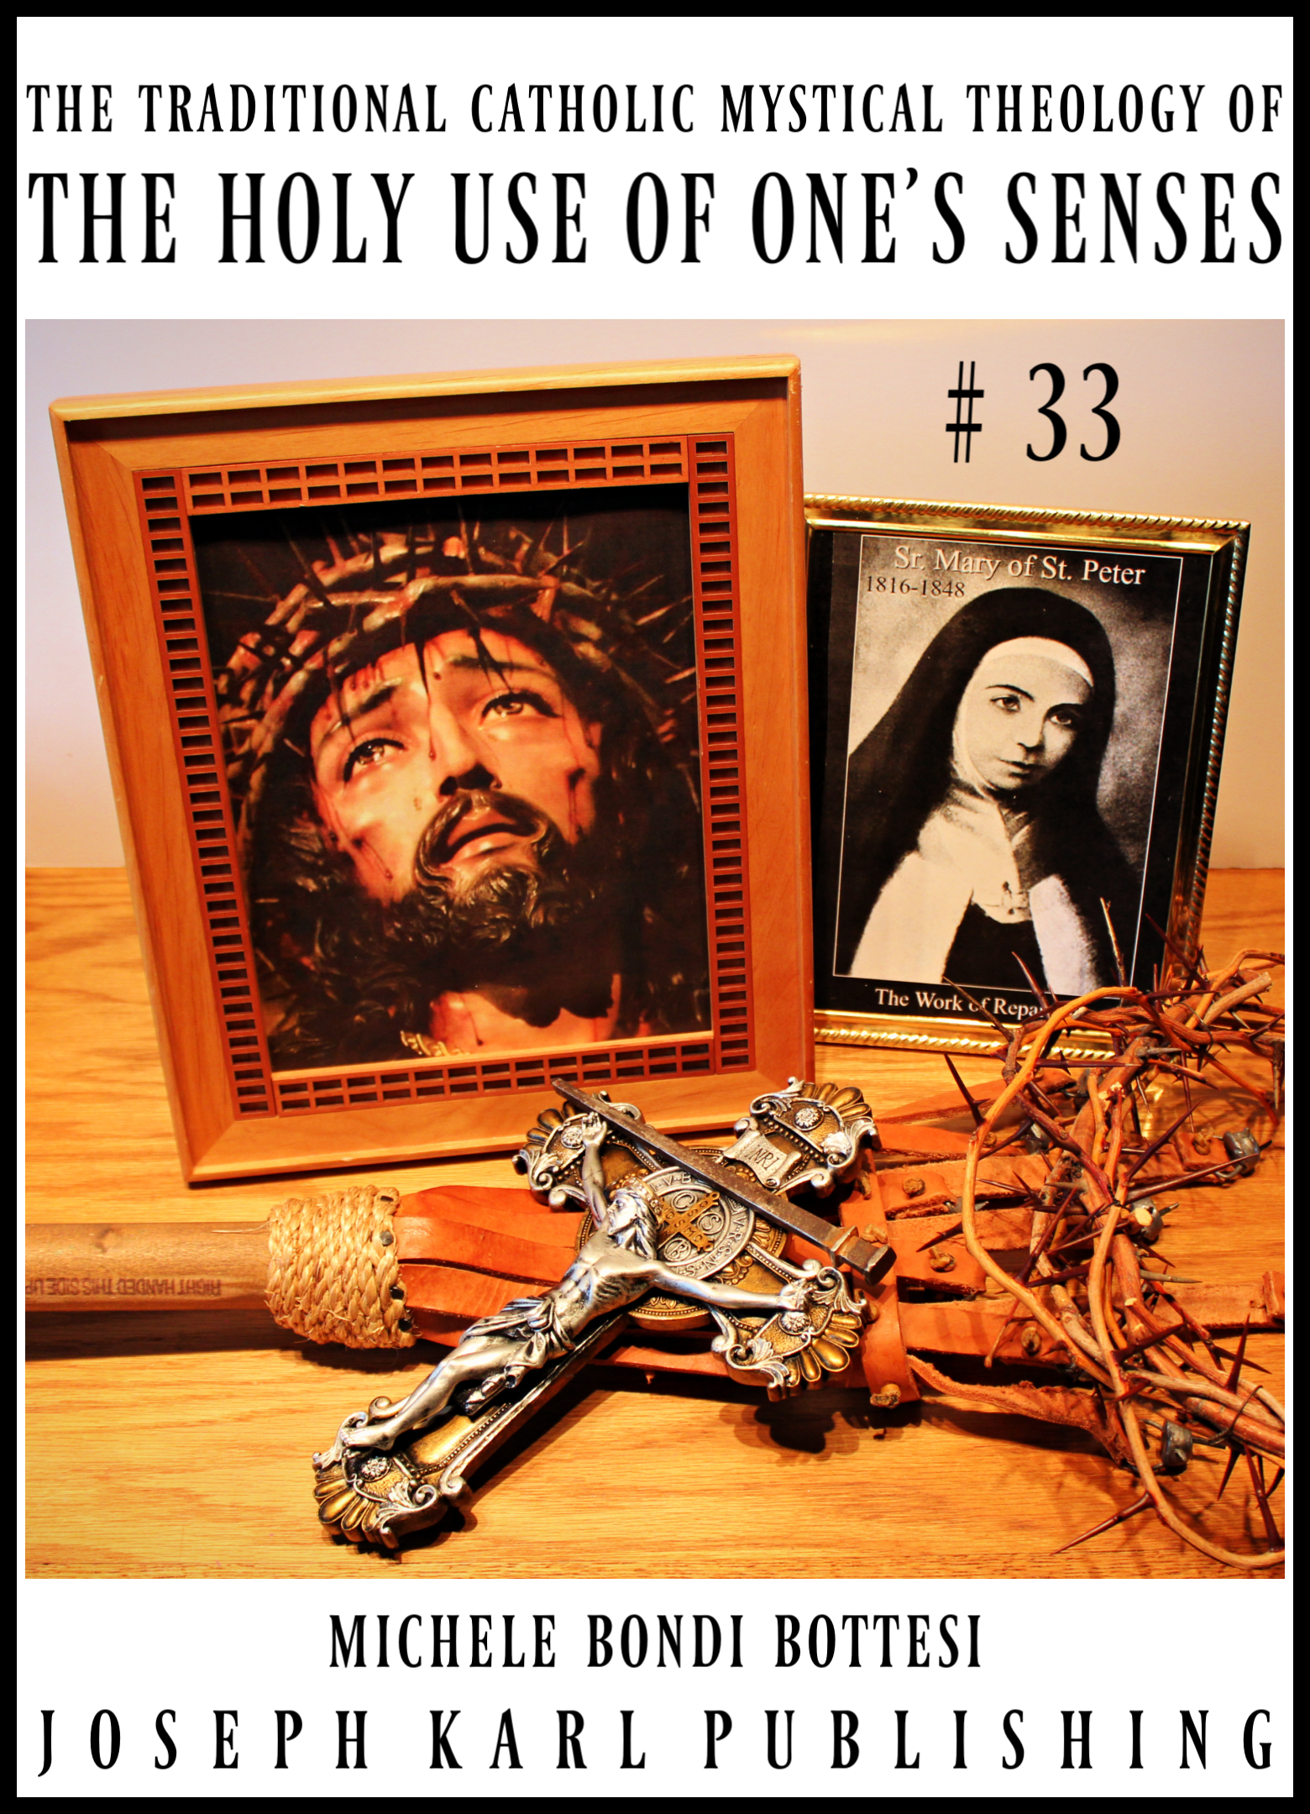
CONTENTS

1. Monarch Divine and the Incredible Dream Overnight
2. By George!
3. Selflessness Divine
4. Your Personal Pieta
5. Healing Reactions, Christ’s Sacred Priesthood, and I AM’s Work of Reparation tot h Holy Face of Jesus
6.A Request from Inside the Monstrance and the Daughter in the Dream Overnight on Mount Calvary
7. The Divine Purification of the Mind and Divine Payment Enough
8. Parched
9. Bringing Christ’s Purity of Intention to the Modern Day Workplace
10. Victory’s Eve
11. The Spectacular Defeat of Two High Ranking Demons on the Feast of the Sacred Heart of Jesus and the Two Concluding Words from Two People 2/2

MONARCH DIVINE

AND THE INCREDIBLE DREAM OVERNIGHT (33-1)

What a magnificently beautiful day here in Traditional Catholic suburban Detroit, for the sake of the whole world in our time.
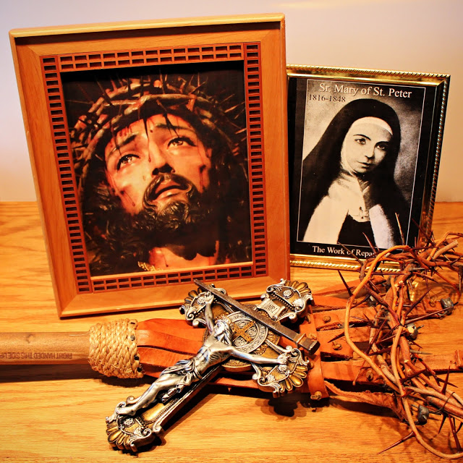

Typing very quickly in the parking lot before the nine hour workday, shedding tears of gratitude and devotion following a stunning sudden conversation with Perfection while on the way.
THE INCREDIBLE DREAM OVERNIGHT ON WEDNESDAY, JUNE 12, 2019: PROPERLY OUTFITTING/VESTING
You suddenly find yourself in this most recent dream inside a church that is both familiar and yet unfamiliar. Many people have gathered for what appears to be the Holy Sacrifice of the Mass but the atmosphere appears festive but also like both a circus and a performance.
Most people have no idea what is really going on and they are enjoying what is very clearly appealing to their senses.
While taking everything in with such awe and with wonder there inside the Modernist desecrated branch of Christ's Catholic Church in our time, a young adult man suddenly stands before you and he is wearing a black cassock but he is wearing it BACKWARDS.
He has come to you to have you fix it and you turn it around and help him dress properly.
THE CONVERSATION WITH PERFECTION WHILE ON THE WAY TO CHURCH AND HIS COMPARISON OF CHRIST'S PRIESTS WHO REFUSE TO TAKE UP HIS WORK OF REPARATION TO THE HOLY FACE OF JESUS TO PHARAOH IN MOSES' TIME WHO REFUSED TO LET GOD'S PEOPLE GO MEANING REFUSED TO SET THEM FREE, IMAGINER
Still working...
I AM ANNOUNCES WHILE DRIVING TO WORK THAT SOMETHING IS GOING TO HAPPEN THERE AFTER SOMETHING HAPPENED THERE YESTERDAY
This was clear as day in the supernatural, there in the natural inside your vehicle while drawing dear to the clinic where you now work helping properly care for people.
I AM'S STUNNING REVELATION AT THE SAME TIME AS THE EIGHT O'CLOCK TRADITIONAL TRIDENTINE HOLY SACRIFICE OF THE MASS AT SAINT JOSEPH'S
Still working...
A LUNCHTIME VISIT TO THE BLESSED SACRAMENT AT THE PERPETUAL EUCHARISTIC ADORATION CHAPEL AND THE LESSONS FROM THE HEART
Still working...

By George! (33-2)
Something very big is coming to Traditional Catholic Detroit for the sake of the whole world in our time.
THURSDAY, JUNE 13, 2019 IN SUBURBAN DETROIT
"By (God and Saint) George" is an old English oath invoked immediately before charging into battle as late as World War I.
This student teacher had a feeling the good Lord had something in mind for Father's Day which is being celebrated this Sunday and it began coming last night following a nine hour day helping suffering people at the clinic: intense physical suffering for Christ's Sacred Priesthood as needed in Modern Times.
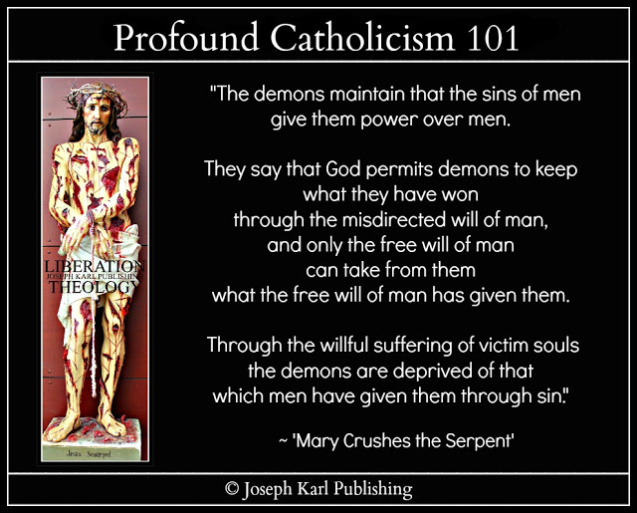

TRADITIONAL CATHOLIC SEARCH AND RESCUE 2019
The plan was to happily go to church this morning for the eight o'clock Traditional Tridentine Holy Sacrifice of the Mass and get much needed socks to wear at work but the suffering was brutal up until close to ten o'clock. Yet it was with a sense of great purpose and God was repeatedly told that He can have whatever He wants.
This student teacher can't believe what time it is and there is so much that needs doing before returning to caring for others this afternoon but so be it. God will see to it that all gets done in His most perfect timing.

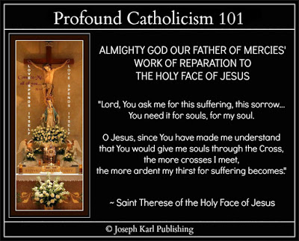Something is coming, something very big from On High here in Catholic Detroit through His Work of Reparation to the Holy Face of Jesus. He is pouring graces through His male leaders, first Christ's Traditional Catholic priests, and now other male leaders including the head chiropractic doctor at the clinic where I AM has His student teacher serving those in need of proper caring.

There is another one: a male leader who, from what this student teacher was told this morning during a conversation with Perfection, was chosen to help this student teacher.
No other man is as close to I AM's Work here in Traditional Catholic Detroit as he is and he isn't even Catholic.
Imaginer.
What wonders. No other man summoned to help with I AM's Work has had his courage.
He has been summoned by Almighty God to be a caring and chaste Saint Joseph in Modern Times, to look after Christ the Divine Infant of Detroit and His holy family meaning His people.
I am so grateful to our Triune God and to him.

Rest assured that this student teacher soul is very happy, and this mission to be a true disciple of Christ must cost one everything in imitation of our Divine Redeemer and His Holy Family for the greater honor and glory of our Triune God first and foremost and then for the sake of the whole world meaning all souls through all time including one's own poor soul, particularly souls in our time who are in grave peril.

"Heaven is rich enough to reward you." ~ Saint John Vianney, Patron Saint of Parish Priests
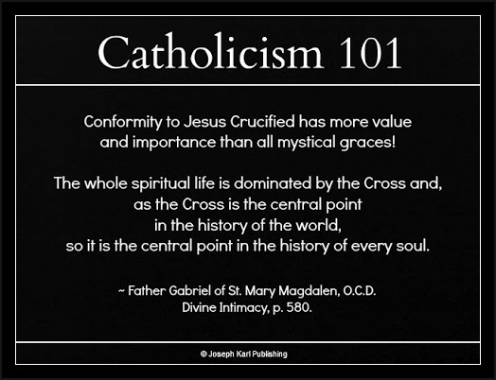

CHRIST'S SACRED PRIESTHOOD IS GOING TO RECEIVE ANOTHER OLIVE OIL CLEANSING THROUGH THE WORK OF REPARATION TO THE HOLY FACE OF JESUS ON FATHER'S DAY 2019
Imaginer. +
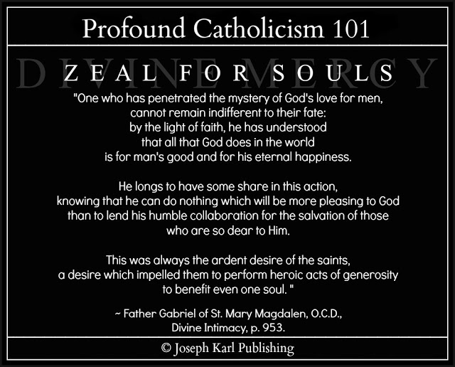

THE WORK OF REPARATION TO THE HOLY FACE OF JESUS

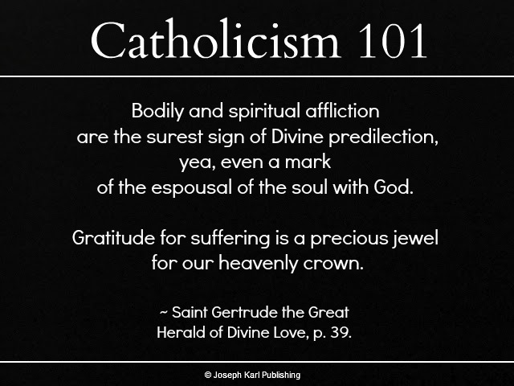

SELFLESSNESS DIVINE (33-3)
What an incredible supernatural wonder that was during the Traditional Tridentine Holy Sacrifice of the Mass on this Saturday of Reparative Atonement, on the day before Father's Day 2019, in the middle of a spectacular Search and Rescue Operation for Christ's Sacred Priest-Father-hood as needed in Modern Times. No wonder the forces of darkness kept whispering that there was no Holy Mass this morning. Oorah! +
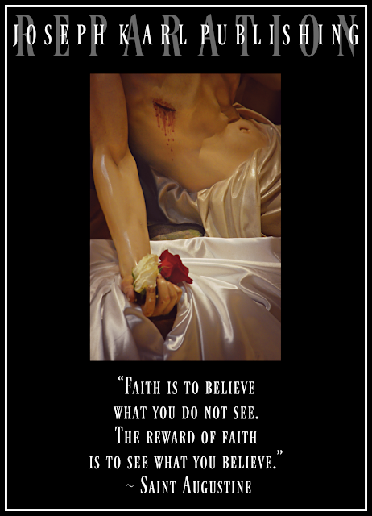

Typing notes in the parking lot as fast as these fingers can go in the precious moments before having to report to work for a few hours before heading back to Mount Calvary tonight for the sake of Christ's Sacred Priesthood as needed and today's Traditional Catholic Mystical Theology of the Proper Use of One's Senses lesson for every soul provides a stark reminder why.

THERE HAS BEEN TREMENDOUS SUFFERING SINCE THURSDAY AS TRADITIONAL CATHOLIC DETROIT ONCE AGAIN HEADS INTO BATTLE THROUGH THE SPENDING OF THE SELF IN IMITATION OF AND IN UNION WITH CHRIST CRUCIFIED AS ALMIGHTY GOD WILLS FOR THE SAKE OF FATHER PRIESTS IN NEED IN MODERN TIMES
Still working...
FRIDAY NIGHT: NOT AGAIN! ANOTHER SAINT BENEDICT CRUCIFIX IS SUDDENLY BROKEN
Something good must be coming.
LUCIFER SAYS THERE IS NO HOLY MASS THIS MORNING; DON'T BOTHER GOING
Something very good must be coming.
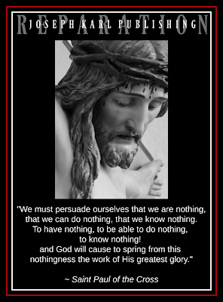
Still working...
WHILE ON THE WAY TO CHURCH IN THE HOLY NOTHINGNESS AND I AM'S HOMILY
Still working...
SELFLESSNESS DIVINE VERSUS HUMAN SACRIFICE (ABORTION)
Still working...
CHRIST'S SCOURGING AT THE PILLAR
Still working...
THE BLOOD SPLATTERED ON THIS STUDENT TEACHER'S GLASSES
Still working...
CHRIST'S CROWNING WITH THORNS
Still working...
SACRAMENTAL CONFESSION
Still working...
THE CONSECRATION AND CHRIST'S TRADITIONAL CATHOLIC PRIESTHOOD
Still working...
TRUE LOVE CRUCIFIED ON MOUNT CALVARY AND THE KEY PROVIDED TO TRADITIONAL CATHOLIC DETROIT IN MODERN TIMES, THROUGH CHRIST'S TRADITIONAL CATHOLIC SACRED PRIESTHOOD, FOR THE SAKE OF THE WHOLE WORLD
Still working...
FROM THE EXECUTION SITE TO THE SITE OF CHRIST'S CRUCIFIXION: JESUS CHRIST THE LAMB OF GOD WHO TAKES AWAY THE SINS OF THE WORLD IS OUR DIVINE REMEDY FOR ALL
Imaginer.
HOLY COMMUNION AND DIVINE UNION AND THEN A PROPER THANKSGIVING: BEAUTIFUL BEAUTIFUL BEAUTIFUL BEAUTIFUL
So unfathomably grateful.
WHILE AT WORK: TODAY'S LESSON CONTINUES AND ONCE AGAIN REITERATES HOW WE SHOULD BE KIND TO EVERYONE
And we should be kind to our Triune God above all.
THIS WORK IN OUR TIME IS IN ACTIVE HARD LABOR AGAIN AND THERE WILL BE A TRIP TO MOUNT CALVARY WHILE AT HOME INSIDE I AM'S DOMESTIC CHURCH FOR CHRIST'S SACRED PRIESTHOOD AS NEEDED FOR THE SAKE OF THE WHOLE WORLD IN OUR TIME.
Father's Day 2019 Search and Rescue. Oorah!

Your Personal Pieta (33-4)
This very deeply affecting and Marian to the Core Traditional Catholic Mystical Theology lesson for every soul from Traditional Catholic Detroit began on a Monday of Reparative Atonement morning while still in bed, just before arising to prepare for a ten hour day caring for the physically suffering who are in need of compassion.
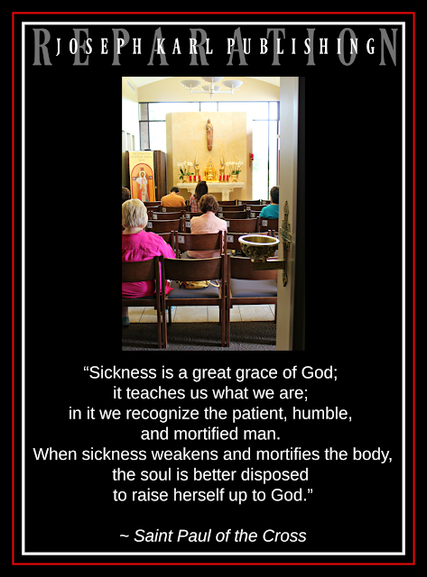

YOUR PERSONAL PIETA

And so the day begins while still in bed during very quiet and peaceful moments before the second Devotion to the Holy Face of Jesus, on the second floor.

All of a sudden the lesson begins with the moment of death when the crucified soul, held in the arms of the Immaculate Mother of God in imitation of and in union with Christ on Mount Calvary following His brutal execution by crucifixion for our sake, enters into eternal life.
What wonders, to then approach our Triune God in this manner!

And then while on the way to work the lesson suddenly continued; it can be generalized throughout each person's lifetime, with Our Lady holding us each time we die to ourselves as Almighty God wills, for the greater honor and glory of our Triune God first and foremost and then for the sake of all souls through all time, including one's own pour soul.
Just imagine sacrificial love that lavish.
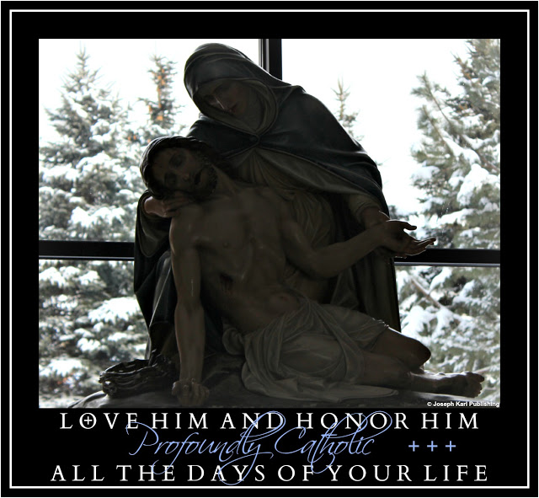

ALMIGHTY GOD OUR FATHER OF MERCIES'
WORK OF REPARATION TO THE HOLY FACE OF JESUS
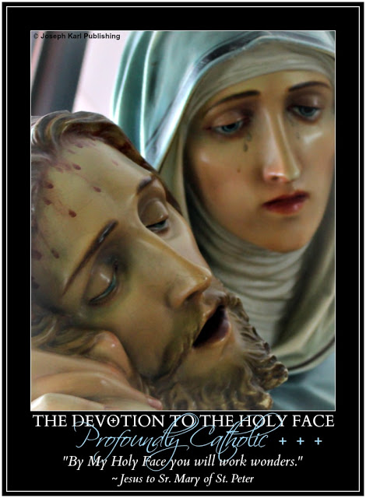

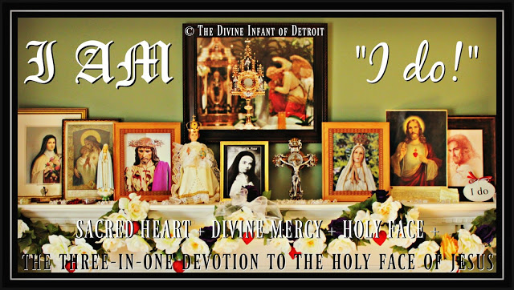

Healing Reactions, Christ's Sacred Priesthood, and Almighty God's Work of Reparation to the Holy Face of Jesus (33-5)
What does a reparative cleansing/detox reaction have to do with Christ's crucifixion, our Redemption, and I AM's Work of Reparation to the Holy Face of Jesus in Modern Times and every single precious, priceless, and immortal soul? Just guess.
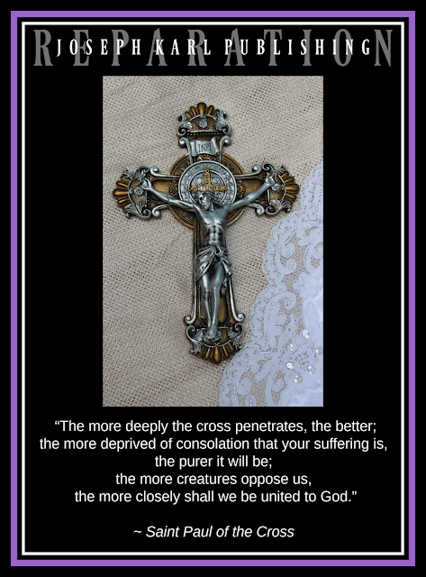

LATE IN THE EVENING ON WEDNESDAY NIGHT
The forces of darkness are very angry for some reason. Sore losers.
As in all things, may God's will be done and you have a feeling you know what it is.
I AM HAS THE TRADITIONAL TRIDENTINE HOLY SACRIFICE OF THE MASS SACRIFICED ON THIS TUESDAY OF REPARATIVE ATONEMENT IN TRADITIONAL CATHOLIC DETROIT AND INSTEAD THERE IS A TRIP TO MOUNT CALVARY IN THE FORM OF A HEALING REACTION THROUGH THE NIGHT AND FOR PART OF THE MORNING FOLLOWING A CLEANSING OF CHRIST'S SACRED PRIESTHOOD WITH OLIVE OIL ON SUNDAY FOR FATHER'S DAY 2019

As in all things, may God's will be done.

Everything that needs doing has to wait except for the scheduling of two house showings, one today and one tomorrow.
Then when I AM allows, the day in the natural is allowed to begin.
THE TRADITIONAL CATHOLIC MYSTICAL THEOLOGY LESSONS FOR EVERY SOUL CONTINUE ON MOUNT CALVARY BEFORE THE SMALLER, SECOND THREE-IN-ONE DEVOTION TO THE HOLY FACE OF JESUS ON THE SECOND FLOOR

Today's lesson has to do with the Work of Reparation to the Holy Face of Jesus and each person's God-given Holy Apostolate of Reparation.

Still working...
TRADITIONAL CATHOLIC SEARCH AND RESCUE 2019
Trying to remember the rest of the lesson before having to leave for work this afternoon.
STILL CAN'T REMEMBER THE REST OF THE LESSON
Hoping it is re-presented while on the way to work.
He'll see, and then so will we.
Another house showing came in; must vacuum before leaving for work.

THE WORK OF REPARATION TO THE HOLY FACE OF JESUS

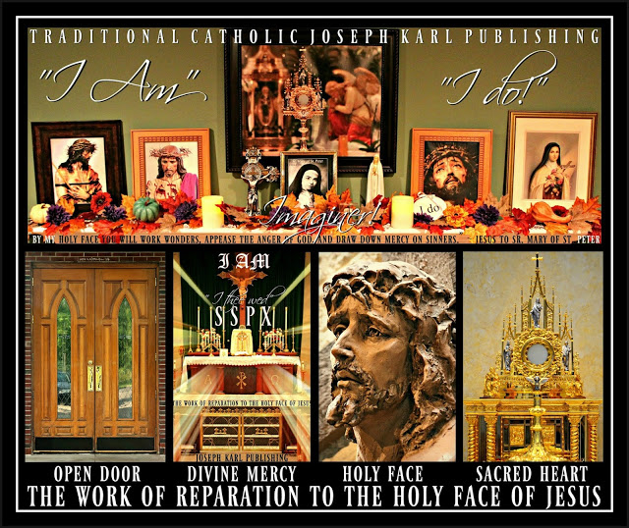

A Request from Inside the Monstrance and the Daughter in the Dream on Mount Calvary (33-6)
"A genuine smile is one of the greatest gifts of the heart." ~ Joseph Karl Publishing
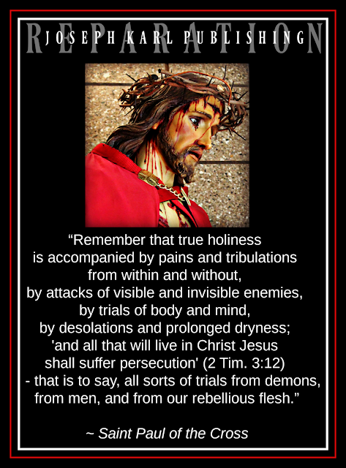

THURSDAY, JUNE 20, 2019 IN TRADITIONAL CATHOLIC SUBURBAN DETROIT
The plan was to get up and go to church for the celebration of the Traditional Tridentine Holy Sacrifice of the Mass at eight o'clock in the morning and then go to the grocery store before having to work this afternoon properly caring for the sick and suffering, but just like Tuesday morning two days ago, that isn't what happens.
Instead, I AM has you remain on Mount Calvary through most of the morning making reparation in union with Christ crucified for His Sacred Priesthood as needed for the sake of the whole world in our time.
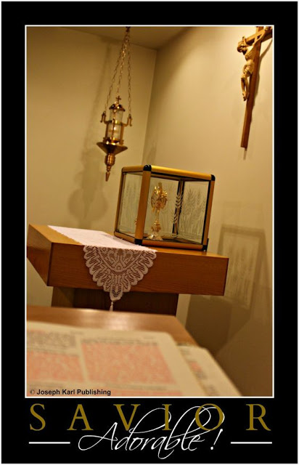
WHAT HAPPENED DURING A VISIT TO THE BLESSED SACRAMENT BETWEEN THE HOURS OF TWO AND THREE, DURING A LUNCH BREAK AT WORK, DURING A TEN HOUR DAY ON WEDNESDAY
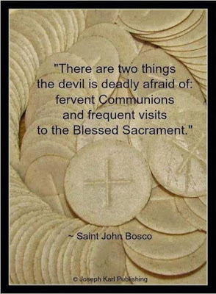How happy you were to be with our Divine Holy Redeemer in this manner and it took a long time to
get to him because of very heavy traffic.
After a time of restful and peaceful and restorative silence, Jesus in the Blessed Sacrament has you give Him the (accomplishing of) the most perfect will of Almighty God our Merciful Father.
This was very quiet and very understated in the natural but it was unfathomably powerful in the supernatural. Then there was a quiet departure and a return to work helping people.
THE DREAM OVERNIGHT
It was very spectacular and long and filled with many incredible details while on Mount Calvary unified with Christ crucified for His Sacred Priesthood as needed, for the sake of the whole world in our time.
As usual you followed along with such awe and with wonder after finding yourself in places that seemed unfamiliar and yet familiar. As usual this dream was loaded with metaphor.
THE WORLD OF ONE'S WORK, ONE'S HOLY APOSTOLATE OF REPARATION, AND THE HIGHLY INTELLIGENT LITTLE DAUGHTER
There were too many details in the dream to re-present in this lesson for every soul, so many things manifested and once again the dream was explained after being allowed by I AM to take leave of Mount Calvary mid morning.
More than one place was presented, and while at the first one which appeared unfamiliar and yet familiar, you found yourself having a new job working at what appeared to be the place where you have been getting your vehicle serviced and repaired for years.
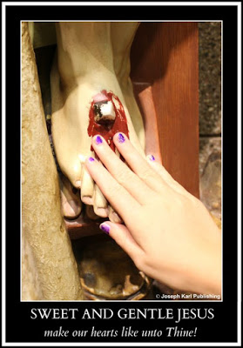
Again, it appears familiar and yet unfamiliar.
You are very content to be working here, and think to yourself that the people you know who work here are going to be very surprised to see you working here now also.
Then it is presented that you will be able to have your vehicle taken care of here also without cost because you now work here.
That is in a different area and there are also other areas to what appears not like a building per se but a small compound of service. In the area where you find yourself, you are caring for the whole world.
A VISIT FROM FAMILY
Then all of a sudden your family comes to visit.
As the events continue to unfold you continue to take so many details not only of what happens but what is presented in the natural all around you in with such awe and with wonder.
Also you continue to remain content and at peace.
ANOTHER CHILD, A LITTLE GIRL
Then it is manifested that you have another child (as in so many past dreams) in addition to your three now young adult children.
She is a precious little girl, and she is presented to you and as you take her presence in with such awe and with wonder, you realize you cannot care for her because you must work.
You then make plans to care for her while at work.
You look into the small face of this little girl and marvel at how much you love her.
It is revealed that this child has no father.
She was created by God through you alone.
You kiss the sweet face of the little girl many times, and then she begins getting older before your eyes.
Her hair also gets longer.
Then she begins speaking, and while old enough to talk she is still only about seven years old. This is important to note because what she says is incredibly intelligent.
Then you leave with her to take her to your family because they are going to help you look after her, and you go to a place that appears familiar and yet unfamiliar.
Again, you take many details there in with such awe and with wonder.
Then, after being allowed to arise with most of the morning having passed, the dream is explained very succinctly from On High.
The place where you work in the dream is a metaphor for where you now work helping properly restore and care for the sick and suffering, a place where you are receiving all the health care you need without cost because you work there, and the little girl with no biological father is Almighty God our Father of Mercies' Work of Reparation to the Holy Face of Jesus.
Your family is helping you care for her meaning they are helping you accomplish Almighty God's will as He wills it, through Christ's Traditional Catholic Sacred Priesthood, for the sake of the whole world in our time.
Again, the details of this Traditional Catholic Mystical Theology lesson for every soul are to be applied to each person and his or her vital, irreplaceable, indispensable, and God-given Holy Apostolate of Reparation in imitation of and in union with Christ crucified, first and foremost for the greater honor and glory of our Triune God, and then for the sake of the whole world.
ALMIGHTY GOD OUR FATHER OF MERCIES'
WORK OF REPARATION TO THE HOLY FACE OF JESUS

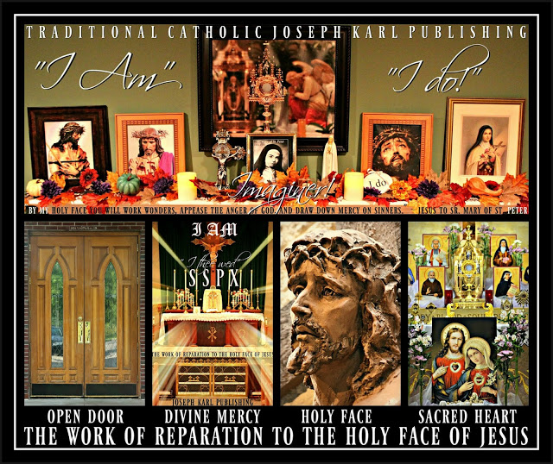

The Divine Purification of the Mind and Payment Enough (33-7)
The return to the Traditional Tridentine Holy Sacrifice of the Mass on this Saturday of Reparative Atonement just after the start of summer was absolutely BEAUTIFUL BEAUTIFUL BEAUTIFUL BEAUTIFUL. So grateful. +
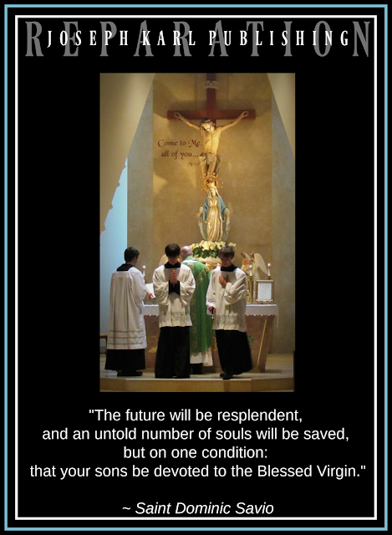

Still working during the precious few moments before having to work for a few hours properly tending to the sick and suffering.

The rest of this one will have to wait until after work.

THE NIGHT BEFORE IN THE GARAGE AFTER RETURNING HOME AFTER WORK
Before getting out of the vehicle inside the garage there is a strong sense of wanting to spray yourself with holy water in the bottle kept in the car.
Just after exiting the vehicle, something falls and lands right on your mid back. What a wonder that was.
Fortunately, the doctor adjusts your back while at work the next mid day. So grateful!
THE DIVINE PURIFICATION OF THE MIND AND THE BATTLE THAT TAKES PLACE THERE BETWEEN GOOD AND EVIL
How often when the forces of darkness visit the mind you say with tremendous annoyance, "I just want to get ready (or leave for church or do your work or get some sleep)!"
In other words, "Leave me alone."
The mind is a very important battlefield in the supernatural.
Remember, this series #33 of Traditional Catholic Mystical Theology lesson for every soul focuses on the holy use of one's senses.
This morning, our Lord is going to have you give Him your mind, meaning place it at His disposal and He is going to Divinely purify it as a means to this end.
Imaginer.
THE TRADITIONAL TRIDENTINE HOLY SACRIFICE OF THE MASS: WHAT JOY TO RETURN TO THE PEACE AND QUIET INSIDE THIS CHURCH AFTER HAVING BEEN AWAY FOR A WEEK MAKING REPARATION
So happy to be here. So happy!
IT IS VERY QUIET AND VERY PEACEFUL: WHAT A WEDDING
So happy to be here. So happy!
CLEANSING FOR CHRIST'S SACRED PRIESTHOOD AS NEEDED, CHRIST CRUCIFIED OUR REMEDY FOR ALL, AND THE INCREDIBLE OFFERING OF ONE'S MIND TO ALMIGHTY GOD IN UNION WITH CHRIST CRUCIFIED WHO PURIFIES IT RIGHT HERE ON MOUNT CALVARY
Imaginer.
THE MOST LAVISH WEDDING POSSIBLE: MONEY ISN'T BEING SPENT TO MAKE IT SO; INSTEAD THE SELF IS SPENT IN IMITATION OF AND IN UNION WITH CHRIST CRUCIFIED
Imagine love that lavish. What a Royal Wedding to Christ the Divine Bridegroom of every soul!
PAYMENT ENOUGH
That is how Christ manifested His Real Presence during this extraordinarily beautiful Divine Royal Wedding, as "PAYMENT ENOUGH."
Imaginer.
CHRIST IS MANIFESTED IN SO MANY MAGNIFICENTLY BEAUTIFUL WAYS FOLLOWING EUCHARISTIC ADORATION YESTERDAY DURING A LUNCH BREAK ON A TEN HOUR WORKDAY CARING FOR THE SICK
How sad you were to have to miss the Holy Sacrifice of the Mass that morning. However, there was Divine union with it taking place while on the way to work and the lesson that went with it, still working...
BEAUTIFUL BEAUTIFUL BEAUTIFUL BEAUTIFUL
And unfathomably penitential.
HONORING OUR LADY ON MOUNT CALVARY: OUR LADY OF GREAT GLADNESS
Our Lady of Sorrows is presented with I AM's Work of Reparation to the Holy Face of Jesus and the reparation made by each one in imitation of and in union with Christ Crucified on Mount Calvary, and is loved lavishly in honor of the Sacrifice of Himself which her Divine Son Jesus made and continues to make in the Blessed Sacrament as He just keeps coming and coming and coming and coming for our sake, imaginer.
THE WORK OF REPARATION TO THE HOLY FACE OF JESUS

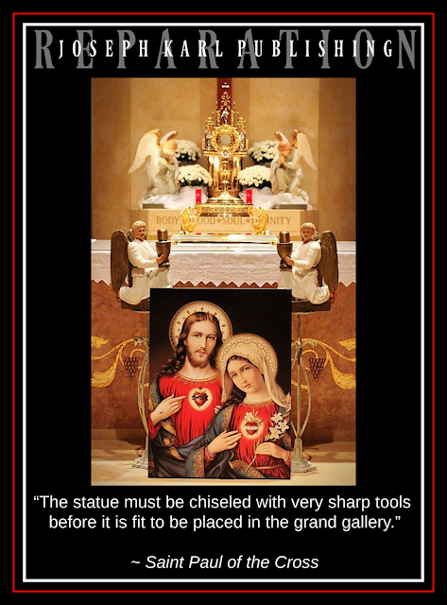

Parched: A Traditional Tridentine Holy Sacrifice of the Mass Unified with the Joy of the Immaculate Mother of God at Her Divine Son's Incarnation (33-8)
Extraordinaire.
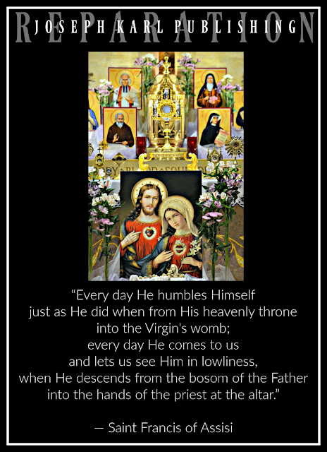

THERE IS ANOTHER EPIC DREAM OVERNIGHT WHILE MAKING REPARATION THAT IS VERY PENITENTIAL BUT NOT INTOLERABLY BRUTAL
Can't remember the dream, remember the suffering, and don't think you will be getting up to go to church before having to go to work this afternoon helping those who are suffering.
Show me Your will, O Lord.
Lord, I have so much to do today before going to work.
Last week's mornings off of work on Tuesday and Thursday last week were spent in the Lord's service making reparation for Christ's Sacred Priesthood has needed.
At the last possible minute this student teacher is up and going and after the Holy Sacrifice there will be a trip to the store to buy flowers to put in the yard and backyard, followed by a trip to the grocery store to buy food for the next few weeks.
THE TRADITIONAL TRIDENTINE HOLY SACRIFICE OF THE MASS ON TUESDAY, JUNE 25, 2019
So happy to be here. So happy!
BEAUTIFUL BEAUTIFUL BEAUTIFUL BEAUTIFUL
Still working...
PENITENTIAL PENITENTIAL PENITENTIAL PENITENTIAL
Exhausted during the Holy Sacrifice; completely spent in imitation of and in union with Christ.
AFTER A TIME OF PEACE AND QUIET IN THE PEACE AND QUIET IT IS REVEALED FROM ON HIGH THAT THIS IS A TRADITIONAL TRIDENTINE HOLY SACRIFICE OF THE MASS THAT IS UNIFIED WITH THE JOY OF THE IMMACULATE MOTHER OF GOD AT THE TIME OF CHRIST'S INCARNATION WHEN HE CAME, SO SMALL AS HE DOES ONCE AGAIN TODAY, FOR OUR SAKE - FOR THE GREATER HONOR AND GLORY OF GOD FIRST AND FOREMOST
So exhausted, so happy, so grateful.
PARCHED! HOLY COMMUNION
While at the Communion Rail receiving the Real Presence of Jesus in the Blessed Sacrament from the consecrated hands of the pastor celebrant Father priest something is manifested and then explained a little later while on the way to get flowers.
You are PARCHED and that is because of the lack of help from Christ's priests most closely associated with I AM's Work here in Traditional Catholic Detroit.
I AM'S
WORK OF REPARATION TO THE HOLY FACE OF JESUS

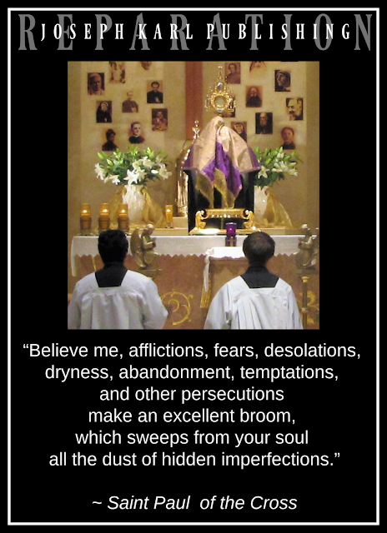

Bringing Christ's Purity of Intention to the Modern Day Workplace (33-9)
This very beautiful Traditional Mystical Theology lesson for every soul was presented while on the way to work and will be presented here after it, following a ten hour shift properly helping care for people who are suffering. It takes us back to the time of Christ which is our time also, to a Divine Carpenter King's workplace for our sake, for the greater honor and glory of Almighty God first and foremost. Were/are you there?
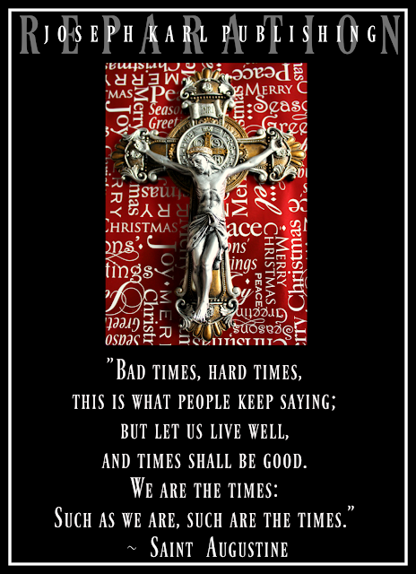

THE LESSON
Still working...
THANKS BE TO GOD FOR EUCHARISTIC ADORATION DURING LUNCH
Still working...
Something is happening in the supernatural; don't know what it is at the moment.

Victory's Eve (33-10)
There is intense spiritual combat on this the eve of the Feast of the Sacred Heart of Jesus here in Traditional Catholic Detroit, through Christ's Traditional Catholic Priesthood, for the sake of the whole world in our time. Victory is coming from the Heart, the Sacred Heart of our Redeemer, Restorer, Remedy for All, and the Divine Bridegroom of Every Soul. COSTLY MISSION. Oorah! +

It also doesn't care for money.
It has been a very tough two days.

I AM'S
WORK OF REPARATION TO THE HOLY FACE OF JESUS

The Spectacular Defeat of Two High Ranking Demons on the Feast of the Sacred Heart of Jesus and the Two Concluding Words from Two People 2/2 (33-11)
So grateful to our Triune God through the Maternal intercession of the Blessed Virgin Mary and the paternal intercession of holy father Saint Joseph that that severely penitential two day battle is over. Guess what it will lead to. Just guess. +
THERE ARE TWO SEVERELY PENITENTIAL DAYS AT WORK DURING WHICH THIS STUDENT TEACHER'S BACK LOCKED UP AND THE REPARATIVE SUFFERING KEPT HER FROM THE HOLY SACRIFICE OF THE MASS ON THURSDAY MORNING WHICH WAS IN AND OF ITSELF SEVERELY PENITENTIAL
Two of the young girls at work have been giving their newest colleague the business, a third one toned it down and by Thursday afternoon after arriving at the clinic to help properly care for the suffering this student teacher doused herself with holy water before going in and then placed the bottle inside the pocket of her scrubs. Then she sprayed herself after going in.
Fortunately one of the two kind young doctors adjusted this student teacher's back and neck late Wednesday afternoon following a ten hour workday there which relieved the unfathomable physical suffering but the supernatural had exploded with a ferocious two day battle.
The Feast of the Sacred Heart of Jesus, which is today, was fast approaching.
You had gone to the Immaculate Mother of God for assistance pertaining to this since Wednesday following the very helpful advice of the pastor who had given a Marian homily not too long ago about the importance of going to Our Lady, a lesson that included the eternal fate of Judas who didn't.
Let us never rely on ourselves and always look to God for help and guidance for everything, through the intercession of the Most Holy Mother of our Redeemer and also through the paternal intercession of Saint Joseph.
Once again it is clear that something is taking place beyond your understanding; things had been so happy and so peaceful at work until there was trouble from several young colleagues in the form of tremendous and unjustified disrespect.
God keep me humble was the prayer after spraying the self with Holy Water before exiting the vehicle, but that was not how it was going to play out during that four hour shift Thursday afternoon.
The plan is to keep one's head down and avoid trouble.
If I must say anything, Holy Spirit please provide the words.
Twice, once at the start of the busy day and then once at the very end there was some tough love pouring from this student teacher who was very content caring for the patients who came in.
The harshness and disrespect were no longer tolerable.
Professionalism in our narcissistic Modern Times is under assault almost everywhere.
Fortunately one young doctor took this student teacher servant aside at the very end of the day and showed real concern and healthy intelligence and also listened to the serious concerns of one who was sent there to properly care.
So while there is the issue of teaching and training people how to behave properly meaning properly mentoring one's colleagues while at work, there is also the issue of what clearly was another battle to defeat grave and sinister evil by Our Lady having a victim soul go to holy war against the demons. It was made clear on Thursday that there were more than one.
THE NIGHT IS VERY PENITENTIAL, PARTICULARLY IN THE SUPERNATURAL MEANING COMPARED TO THE NATURAL/PHYSICAL
How glad this student teacher servant to the sick is for two days off from work as the doctors will be gone, and that means there is hope of attending the Traditional Tridentine Holy Sacrifice of the Mass on Friday for the Great Feast of the Sacred Heart of Jesus!
By early morning it is not clear that you are going anywhere. You get up anyway rather than face the wrath of the dark forces while trying to rest in bed.
Then this student teacher almost falls in the shower.
Something very good must be coming.
I AM's domestic church Work of Reparation to the Holy Face of Jesus Chapel needs restoration; it looks a mess.
THE TRADITIONAL TRIDENTINE HOLY SACRIFICE OF THE MASS ON FRIDAY, JUNE 28, 2019 ON THE FEAST OF THE SACRED HEART OF JESUS
You hope while on the way to the church that it is a very quiet Holy Mass, not a crowded one.
What a relief to see that the parking lot isn't full.
THE CLUTTER MANIFESTED ON THE ALTAR IN THE SUPERNATURAL
The Traditional Tridentine Holy Sacrifice of the Mass is presented as the Divine Supernatural Remedy for the clutter plaguing the modernist desecrated branch of Christ's Catholic Church in our time and as the Holy Sacrifice continues this clutter disappears and proper order is seen as being restored to Christ's Catholic Church.
Remember, in 2017 I AM Divinely Supernaturally wed His Work of Reparation to the Holy Face of Jesus to Christ's SSPX for the sake of the whole world in our time after it had been thrown out of the modernist desecrated Slovak parish forever during Eucharistic Adoration by two arrogant priests (the pastor and associate pastor) and two stupid policemen, the very place where I AM had re-introduced it in the year 2012.
The Work of Reparation is paired with the Devotion to the Holy Face of Jesus which is three Traditional Catholic Devotions in One and includes the Devotions to the Sacred Heart of Jesus, to His Divine Mercy, and to His Holy Face.
IT IS VERY QUIET AND THEN THE FOLLOWING TAKES PLACE VERY QUIETLY
Before the Consecration, Jesus very quietly manifests that two high ranking demons are going to be defeated and they are drawn by the Divine Hand out of His Divine Sacred Heart unified as One with yours where they had been imprisoned by the Immaculate Mother of God and where thanks be to our Triune God they met with their defeat through I AM's Work of Reparation to the Holy Face of Jesus and the spending of the self as Almighty God willed, in imitation of and in union with Christ crucified on Mount Calvary.
Note that this took place the past two days in ways that defied human understanding, this was made very clear, and God had to be allowed to do as He willed which He was.
IT IS MADE CLEAR THAT THE DEFEAT OF THESE TWO HIGH RANKING DEMONS WILL LEAD TO THE WEAKENING OF THE DEMONS UNDERNEATH THEM
That means good things for souls enslaved to sin under their wicked influences.
TWO DEMONS DEFEATED ON THE FEAST OF THE SACRED HEART OF JESUS FOR THE TWO SACRED SPECIES OF THE BLESSED SACRAMENT: THE SACRED BODY OF JESUS AND HIS DIVINE PRECIOUS BLOOD
Imagine, at each soul's Royal Wedding to Christ our Redeemer, Restorer, Remedy for All, and the Divine Bridegroom of every soul.
PENITENTIAL PENITENTIAL PENITENTIAL PENITENTIAL
God's Sacrificial Love is the most powerful force in the universe, so strong that the bonds formed by Him and the Sacred Vows proclaimed in His Most Holy Name cannot ever be broken.
This true love that spends itself in imitation of and in union with Christ while unified with Him in three vital ways (Sacramentally, with His salvific mission, and with His reparative suffering) lasts forever.
EUCHARISTIC ADORATION WHILE RECEIVING HOLY COMMUNION
It was, receiving the Real Presence of Jesus in the Blessed Sacrament from the consecrated hands of the Traditional Catholic celebrant Father priest while kneeling at the Communion Rail before Christ's High Altar on Mount Calvary, indescribably BEAUTIFUL BEAUTIFUL BEAUTIFUL BEAUTIFUL.
So grateful.
AFTER HOLY COMMUNION, WHILE MAKING A PROPER THANKSGIVING
There is a time of such peace and quiet and serenity returns following that terrible time just prior to the demons' defeat.
What was that like to be with them in that way for two days? It was like being in hell where there was no love of God, no care for others, no professionalism, no proper education, no optimism, no hope, and no mercy ever, forever and ever.
Imaginer.
TWO WORDS FOLLOWED BY TWO WORDS
While on the way out, totally spent once again, you pass by the Father celebrant priest with I AM's umbrella and after both wave to one another, you say two words and then so does he.
"Thank you."
"You're welcome."
In our Triune God we totally trust.
Go, Team!
ALMIGHTY GOD OUR FATHER OF MERCIES'
WORK OF REPARATION TO THE HOLY FACE OF JESUS

